**Cloud Function and Pub/Sub – Assessment**

**Q1) Steps to export all the logs related to firewall rules to BigQuery for further analysis. Use console. (Only export to BigQuery, analysis not required). (1m)**

A1)

Step 1: In Stackdriver Logging, at the top of Log Exports page, select on Create export  
Step 2: Click on Edit Export  
Step 3: Enter the Sink name, service and destination

1. In Sink Service, we select a destination service, here we click on BigQuery.
2. In Sink Destination, select or create the particular dataset to receive the exported logs.

Step4: Click on Update Sink to create a sink  
  
To view the logs in BigQuery :-

Step1: GO to BigQuery UI  
Step 2: Select the dataset used as the sink's destination  
Step 3: Select one of the dataset's tables.

The log entries are visible on the Details tab.

**Q2) Configure Apache2 HTTP server on a GCE VM instance and setup an email alert notification which triggers when the health check of the instance fails. Use console. (1.5m)**

A2)

Policy alerts

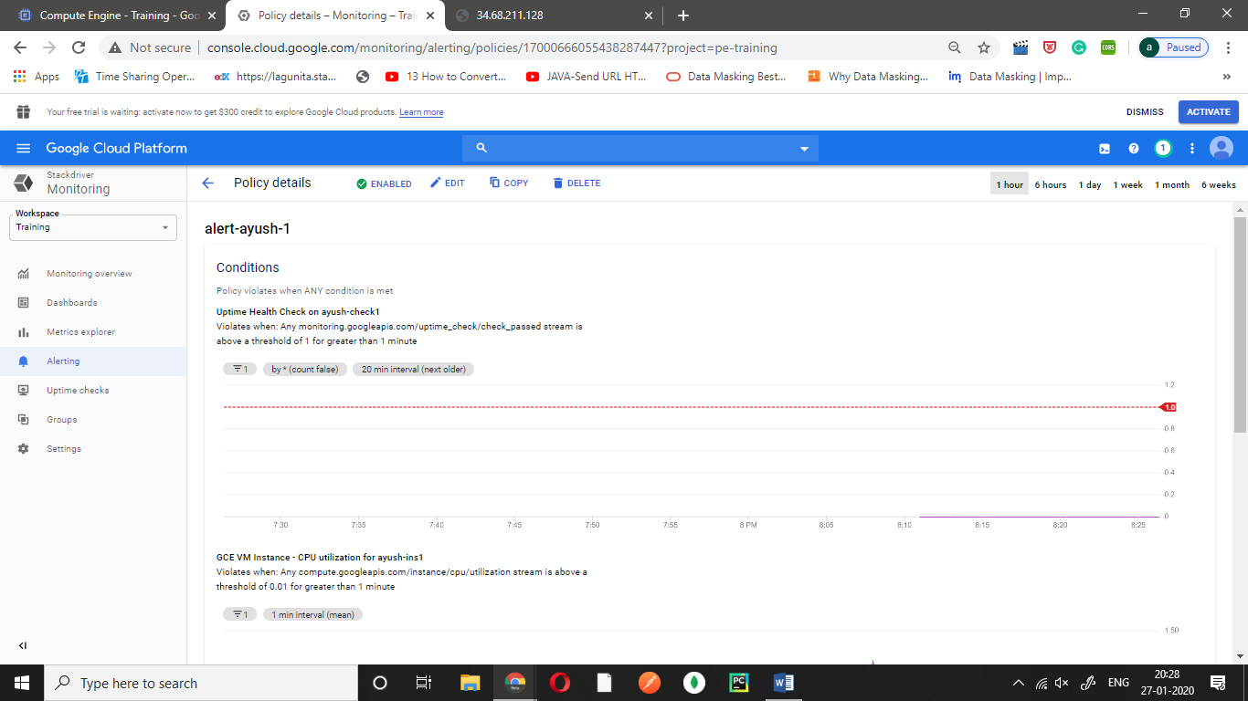

Email Alert 1

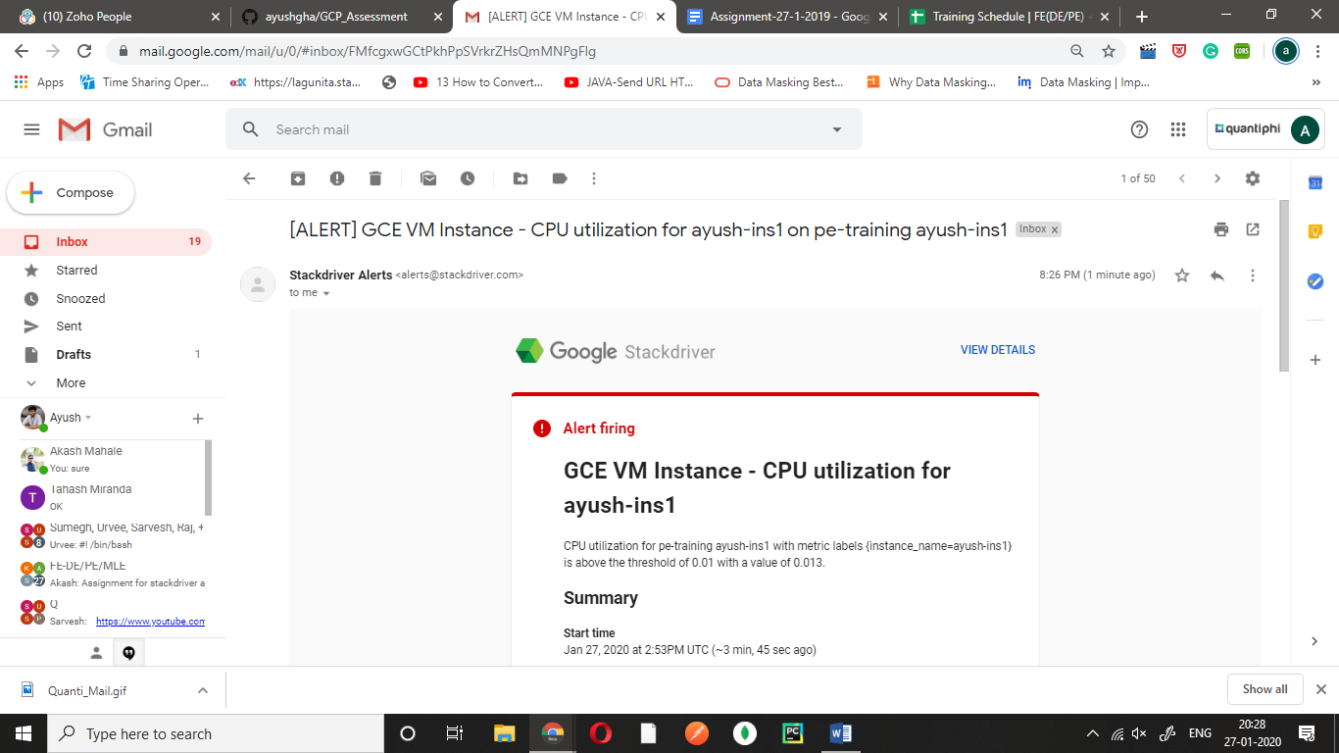

Email Alert 2 (Uptime check failed)

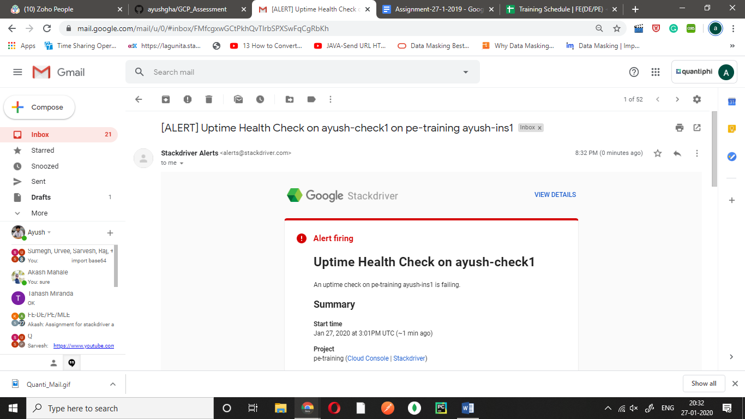

**Q3) Create a Cloud Function to convert the pub/sub message to json file and store it in GCS bucket  (2.5m)**

**Eg:**

**If message published is:  
{**

**"name":"test-file",**

**"content":'{"source": "pub/sub", "destination": "gcs"}'**

**}**

**Then there should be a file `test-file.json` in the destination bucket with the content value.**

A3)

Cloud function main.py code

import base64

from gcloud import storage

import os

import json

def hello_pubsub(event, context):

pubsub_message = base64.b64decode(event['data']).decode('utf-8')

print(type(pubsub_message))

print(pubsub_message)

list1 = pubsub_message.split(" ")

print(list1)

text = {

"name":list1[0],

"content":

{

"source":list1[1],

"destination":list1[2]

}

}

print(text)

filename = "/tmp/"+str(list1[0])+".json"

with open(filename, "w") as write_file:

json.dump(text, write_file)

client = storage.Client(project='Training')

bucket = client.get_bucket('ayush-bucket-1')

blob = bucket.blob('test_file.json')

blob.upload_from_filename(filename)

print("Done")

Published message to the topic

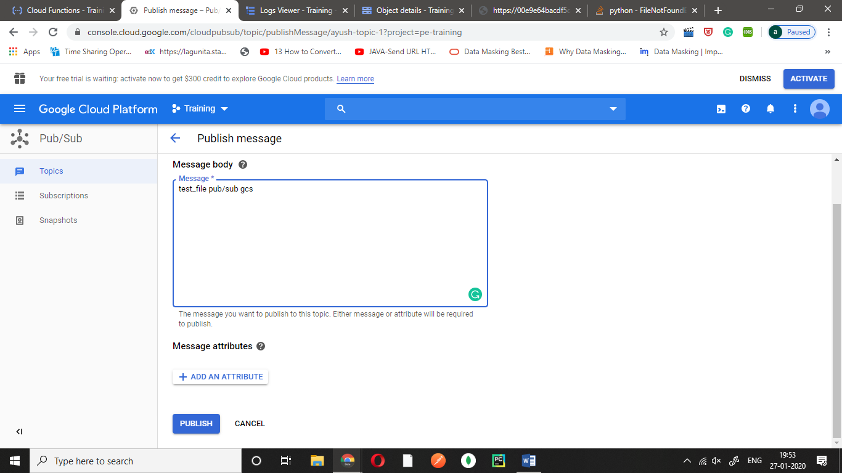

Log details

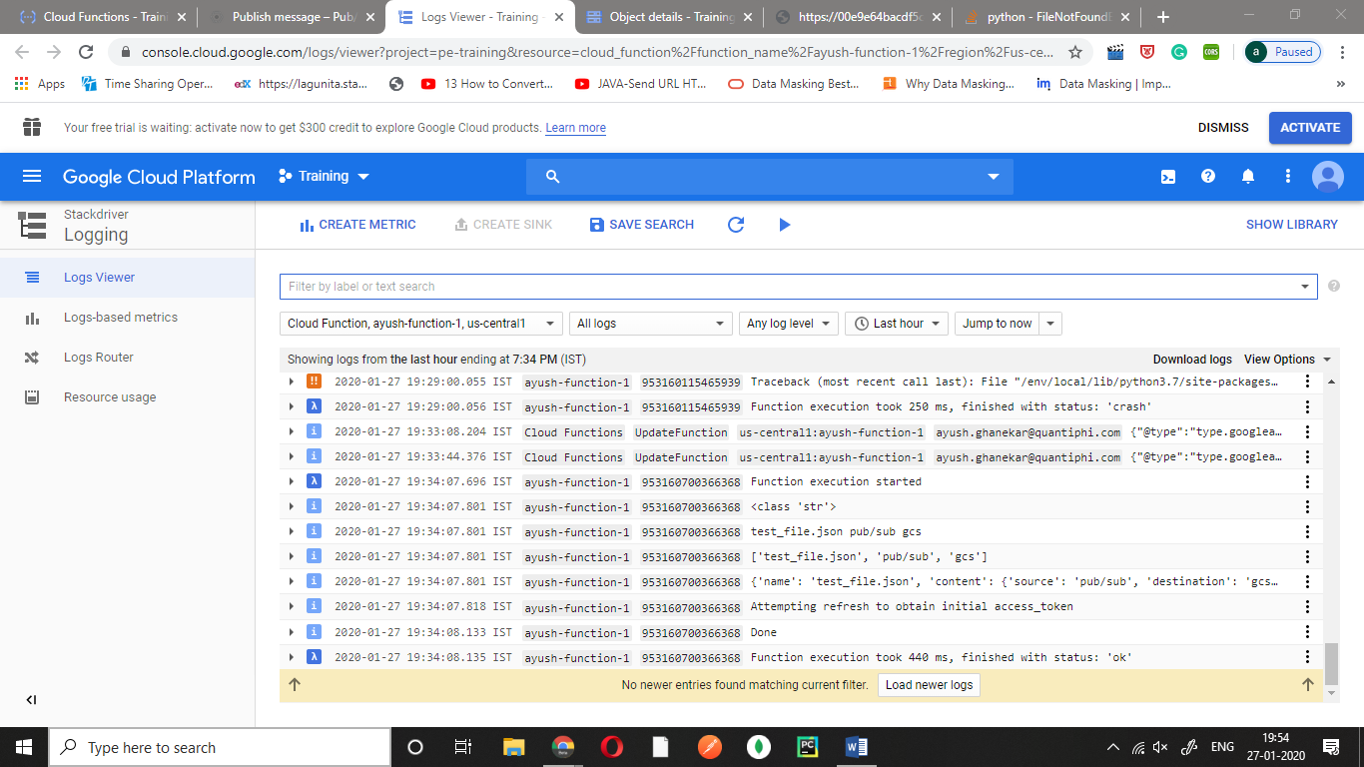

Object Storage

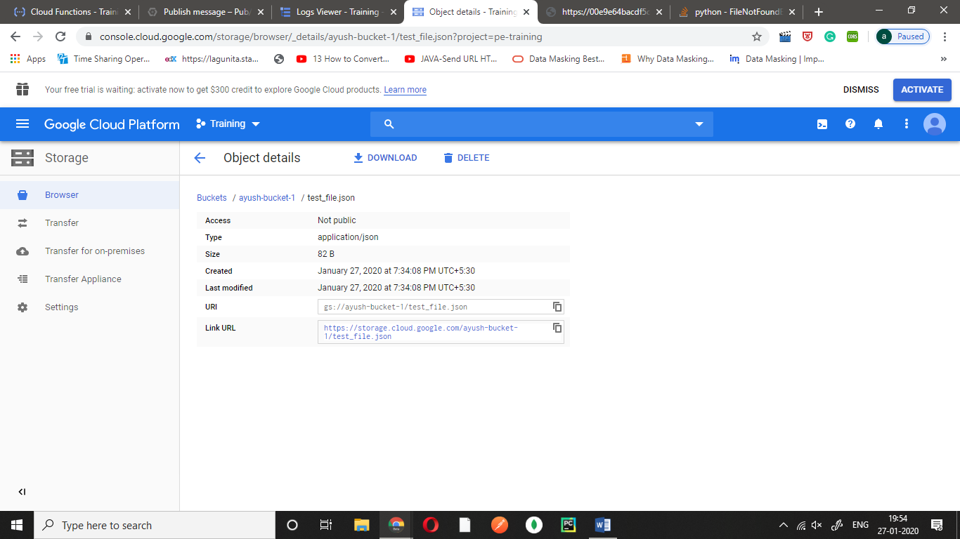

The JSON viewer

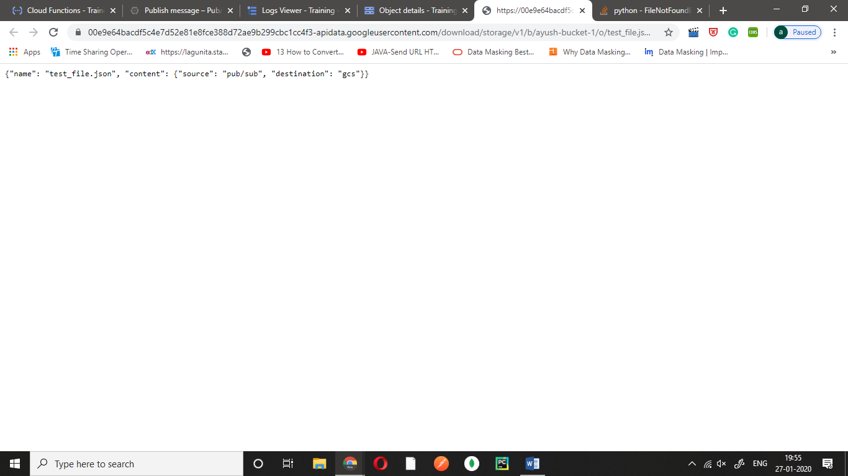

**OR**

**To directly take the JSON message as text in the pub/sub body and then load it as JSON in the file**

Code:

import base64

from gcloud import storage

import os

import json

def hello_pubsub(event, context):

pubsub_message = base64.b64decode(event['data']).decode('utf-8')

print(type(pubsub_message))

print(pubsub_message)

json_data = eval(pubsub_message)

print(json_data)

print(type(json_data))

filename = "/tmp/"+str(json_data['name'])+".json"

print(filename)

with open(filename, "w") as write_file:

json.dump(json_data, write_file)

client = storage.Client(project='Training')

bucket = client.get_bucket('ayush-bucket-1')

blob = bucket.blob(filename)

blob.upload_from_filename(filename)

print("Done")

Message in the form of text

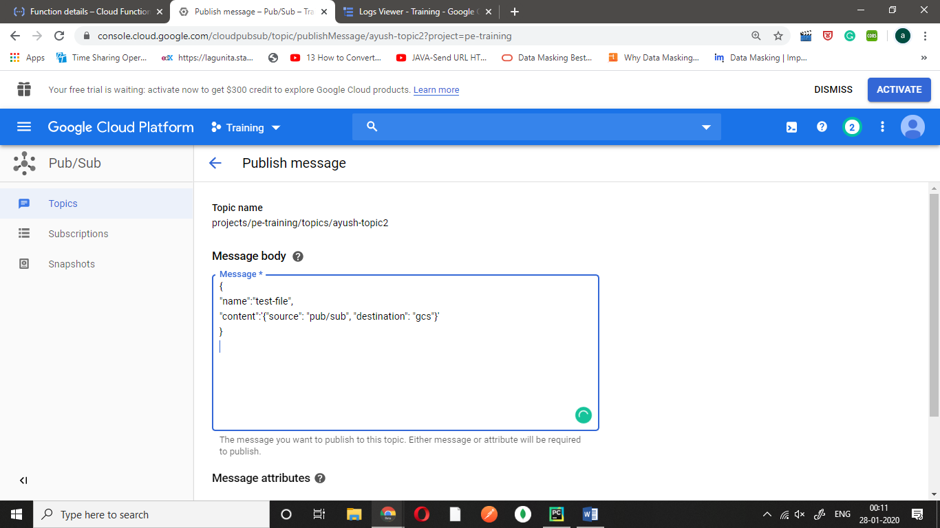

Logs

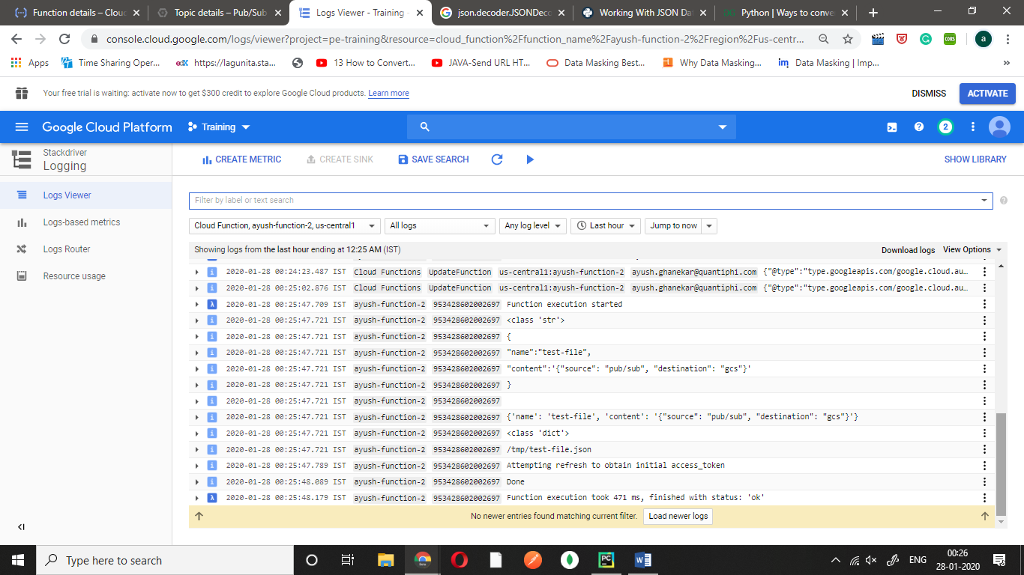

And likewise you will get the similar results in the same bucket.