**Assessment No 1 (IAM and S3)**

**Q1)** Create Lifecycle rule to move only files in logs folder to other storage class

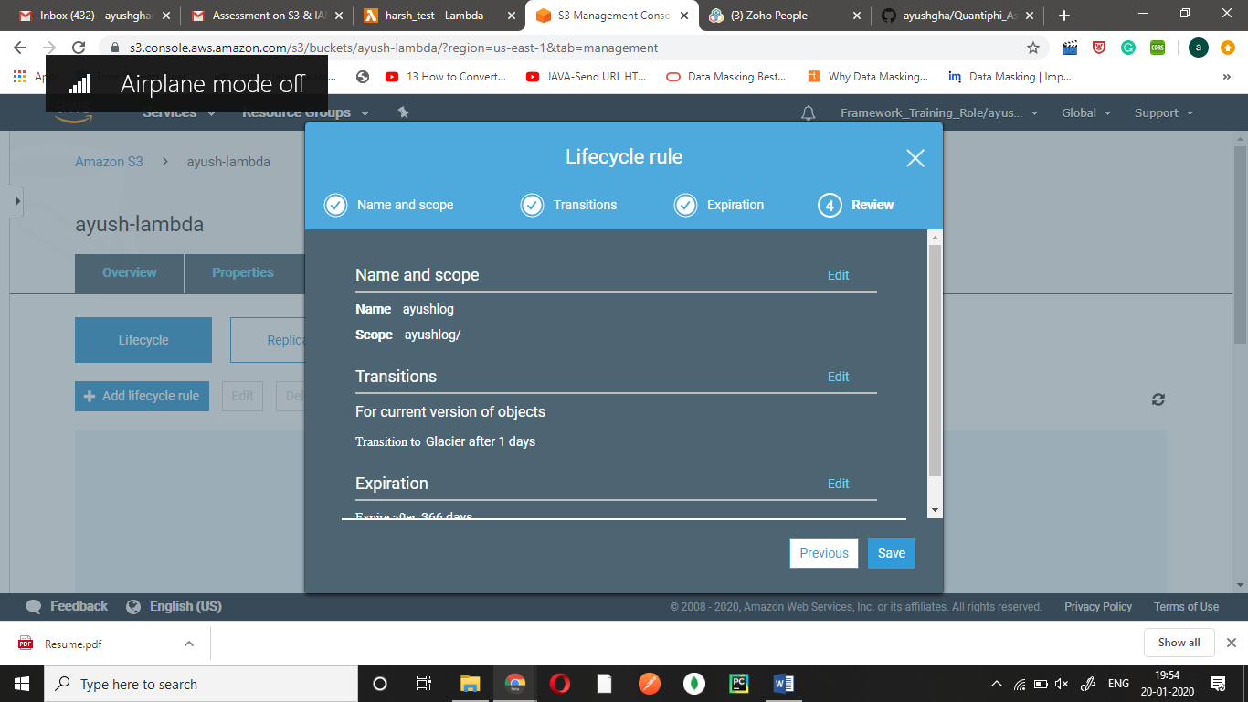

**Q2)** Set up CORS between two buckets in two different regions.

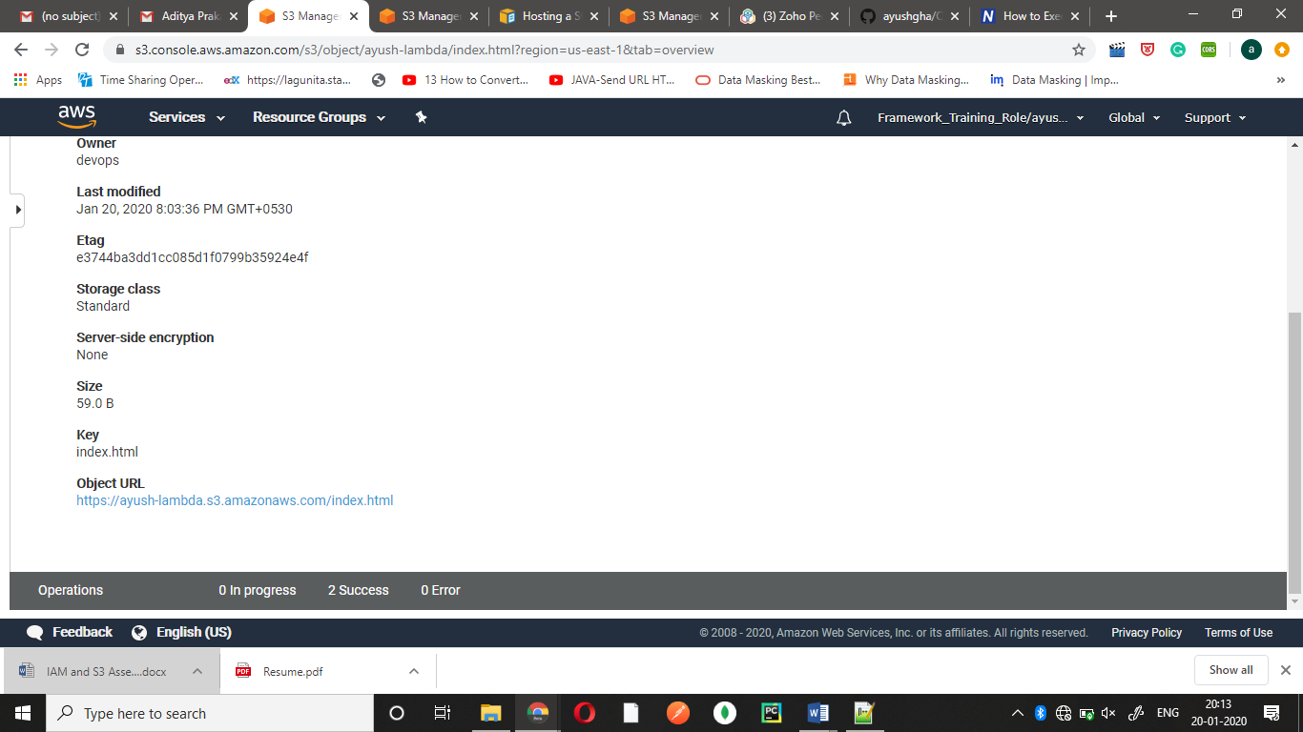

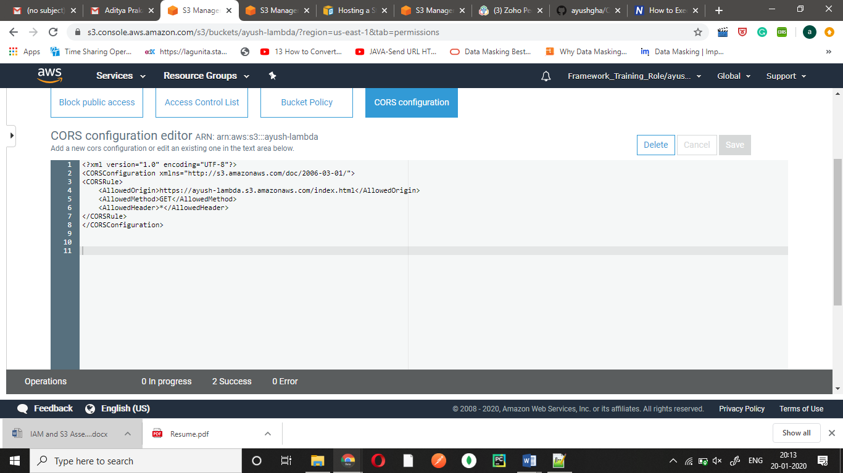

**Q3)** Create event notification to trigger lambda function (as and when put event occurs, use any existing lambda function.

**1)**

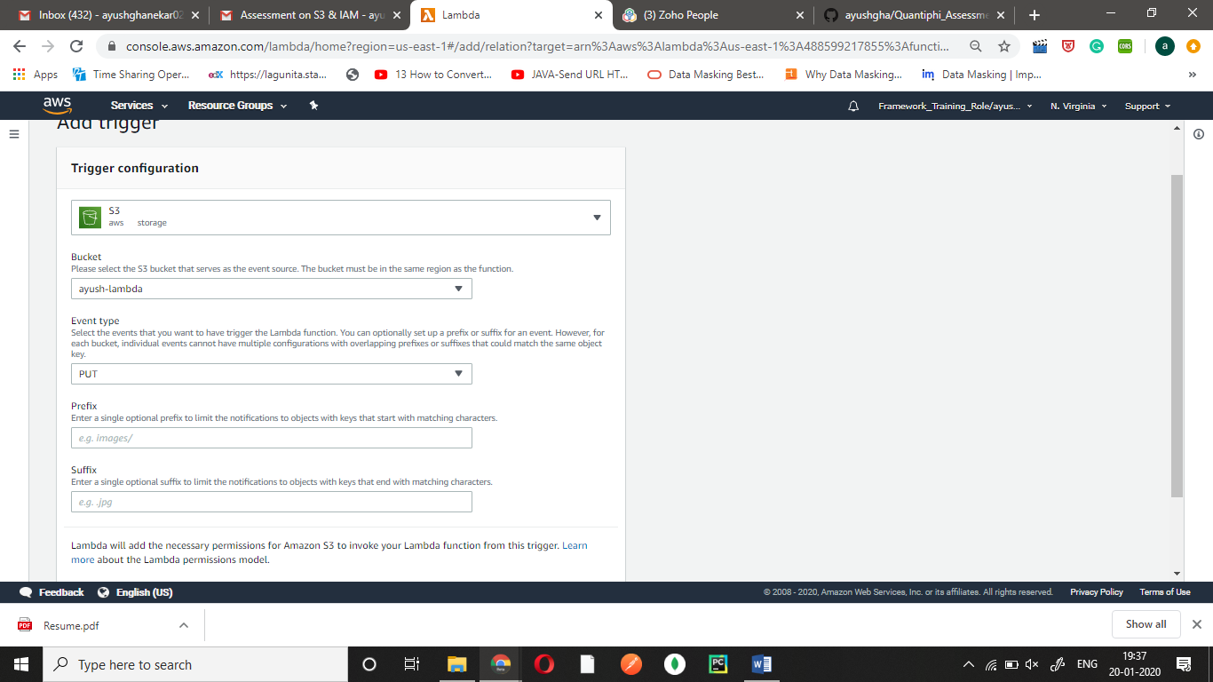

**2)**

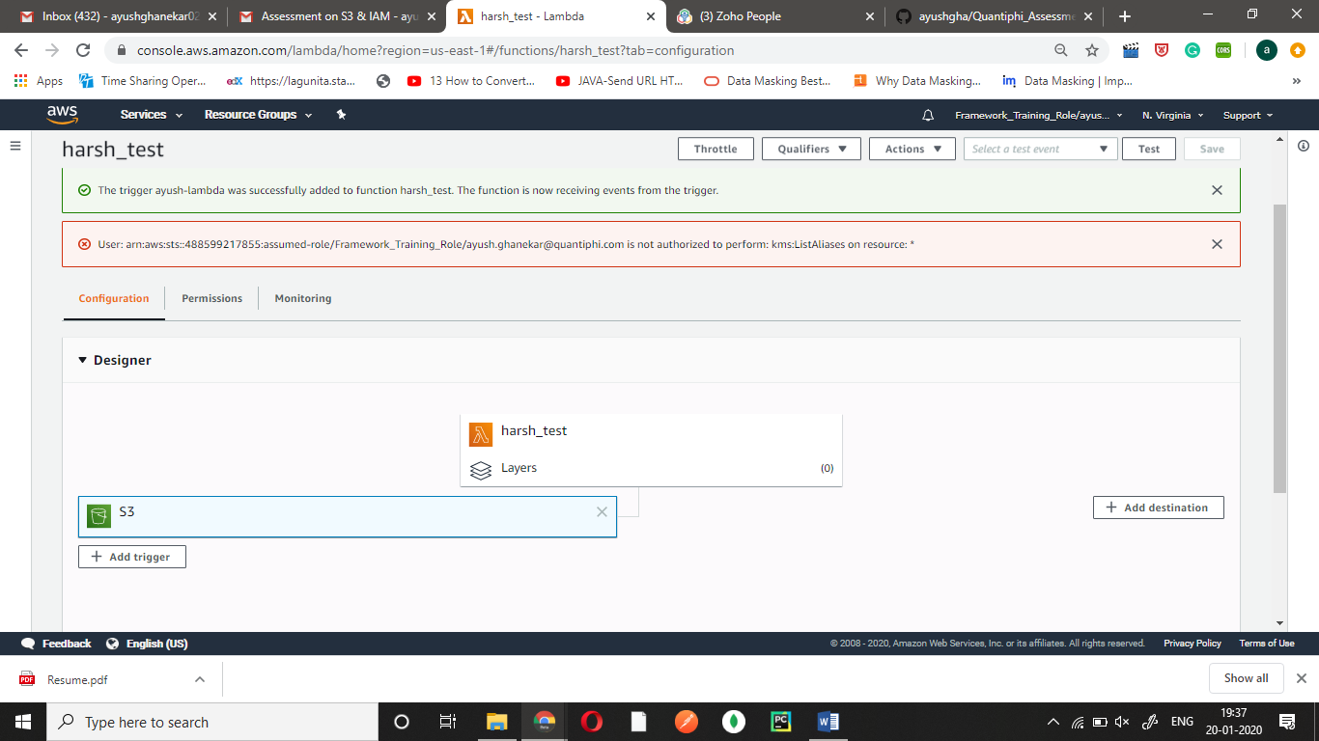

**3)**

