**Rash driving Analysis for Safety Enforcement (R.A.S.E.)**

**Minor Project Report**

By

Urvi Bhanushali

Roll No: 2016140005

Harsh Dave

Roll No:2016140010

Ayush Ghanekar

Roll No: 2016140015

Supervisor

Kailas.K.Devadkar



**Abstract**

The usage of vehicles is increasing daily in everyone’s lives. Most of the people break the rules of traffic and indulge in rash driving. Rash driving is extremely dangerous for all people involved: the driver, passengers, pedestrians and other vehicles on the road. If there are greater number of vehicles moving on a road, then there is a higher possibility of accident. Rash driving is a problem that goes undetected in status quo due to lack or any devices or technologies to detect it at every instance. It is extremely tough to detect it manually, and this poses as a big safety threat. In this paper we propose a detection system that can analyze gyrometer and accelerometer readings to conclusively decide whether a driver is operating their vehicle in an unsafe manner or not, viz a viz sudden breaking, sudden acceleration or crossing the speed limit. We make use of Raspberry Pi 3 Model B+ and similar IoT (Internet of Things) technologies to implement this system. Our final aim is to reduce incidents of rash driving to make a safer environment on roads and to reduce the number of accidents taking place.

Contents

1. Introduction 1

1.1. Motivation 1

1.2. Problem Statement 9

1.3. Challenges 10

1.4. Objectives 10

1.5. Outcomes 10

2. Literature Survey 11

3. Planning 12

3.1. Project Scope

3.2. Project Milestones

3.3. Project Timeline

4. Design 12

4.1. System Architecture

4.2. Functional Modelling

4.3. Behavioural Modelling

4.4. Structural Modelling

5. Implementation 18

5.1. Technologies Used 18

5.2. Prototype Implementation 29

5.3. Test Cases for Prototype 30

5.4. Plagiarism Report** 30

6. References 32

1. **Introduction**

**1.1 Motivation**

* Rash and reckless driving is one of the major causes of hazardous road accidents and usually goes unnoticed by the agencies.

* Rash driving usually follows a similar pattern across drivers and our aim is to identify this by the use of sensors present in the car and alert the user as well as related authorities (RTO, Police) before it leads to an accident.

**1.2 Problem Statement**

* Real-time rash and reckless driving behaviour monitoring is a cornerstone to improving driving safety.
* To improve driver’s awareness of their driving habits so as to prevent potential car accidents, we need to consider a real-time monitoring approach, which detects abnormal driving behaviours.
* More than 90 per cent of road deaths in 2017 were attributed to rash and negligent driving with the latest National Crime Research Bureau (NCRB) statistics revealing 1.5 lakh deaths in 1.35 lakh road accidents due to delinquent driving.
* Conventional solutions to this problem, such as police monitoring and speed cameras are a costly solution.

**1.3 Challenges**

* Our project (version 1) has two objectives, one, which is two analyse sudden brakes/acceleration and second, is to alert on crossing the speed limit – However for sensing both the parameters, they need to be connected to Raspberry pi is a static state, which is not possible as the project works dynamically. So we need at least 2 raspberry pi’s to show the proper working
* There were a lot of issues to control and understand the reading of the MPU6060 3-axis accelerometer.
* It is a difficult task to multitask the processes (to sense the speed limit and the sudden acceleration/brakes) and to synchronise them together.

**1.4 Objectives**

* The system will read gyro meter and accelerometer data to analyze the changes in speed and check for sudden breaking.
* It will also check for whether the driver is over speeding by accessing the geo-positional data of the vehicle to check for speed limit in particular area.
* The radius of turn will be checked, since larger the turn, riskier it would be and can possibly endanger the safety of the driver and those around them.
* This data will be compiled to form a point based system for each driver, where points are deducted for rash and negligent driving with penalties after every interval of point deduction.

**1.5 Outcomes**

* To alert the related authorities about rash driving, and hence create a database which informs them about rash drivers.
* To alert drivers about their rash driving, which will lead them to become more aware about road safety.
* To improve overall safety for both, drivers and those around them, and helps enforce traffic regulations in a more stringent fashion.

**2. Literature Survey**

**2.1 Paper 1**

**1) Title of IEEE Paper**

Overspeeding and Rash Driving Vehicle Detection System (https://ieeexplore.ieee.org/document/7899206/)

**2) Authors**

1. Vangala Praveen Kumar

2. Kampati Rajesh

3. Motike Ganesh

4. Ivaturi Ram Pavan Kumar

5. Sanjay Dubey

**3) When it was published?**

4-5 April 2014

**4) Where was it published?**

2014 Texas Instruments India Educators' Conference (TIIEC), Bangalore, India

**5) Which type of paper is it ?**

Experimental paper.

**6) How is it related to your project ?**

The speed of the vehicle is controlled dynamically i.e speed of vehicle can be locked as per area in which it is driven by interfacing electronic throttle rather than using mechanical speed lock systems.

**7) A Brief Summary of what you understood after reading the paper**

The system can be used to control the speed and rash driving electronically, by interfacing with electronic throttle accelerator and power steering of the vehicle. The data recorded from the hardware installed in car is compared with existing data in flash memory. Depending on the output of comparator, driving can be classified as rash or normal driving. They further extended the scope of project by suggesting the passing signal from the controller to the electronic throttle placed inside the vehicle to control the flow of fuel to the engine. Thus, the speed can be controlled and rash driving of the vehicle can be prevented.

**8) Compare existing paper with your project title**

Our system takes note of sudden brakes and accelerations and compares it with existing data using developer’s logic.

It takes into consideration all the parameters such as reason for breaking (to avoid crashing into another car) geo-location of the car, time in which the car gained acceleration , turn radius for zigzag driving (lane changing as well as zigzag pattern in same lane),etc.

It also sends notification to driver when protocol is broken and gives warning. It also analyzes the driving pattern and passes on the result to higher authority who can then take serious action to demote rash driving and prevent accidents.

**2.2 Paper 2**

**1) Title of Paper**

A Fair and Effective Driver Rating System for Developing Regions (https://ieeexplore.ieee.org/document/7945432/)

**2) Authors**.

1. Munshi Yusuf Alam, Sunny Saurav, Ratna Mandal (Computer Science and Engineering, National Institute of Technology, India, Durgapur)
2. Sujoy Saha, Subrata Nandi (Computer Science and Engineering, National Institute of Technology, India, Durgapur)
3. Sandip Chakraborty (Computer Science and Engineering, Indian Institute of Technology, India, Kharagpur)

**3) When it was published?**

12 June 2017

**4) Where was it published?**

2017 9th International Conference on Communication Systems and Networks (COMSNETS), Bangalore, India.

**5) Which type of paper is it?**

Experiment Research Paper

**6) How is it related to your project?**

The paper focuses on using various parameters such as changes in accelerometer, gyro sensors and GPS location along with using a methodology for fair and effective driver rating using a dynamic time warp (DTW) method, based on their behavioral observations as captured by smartphone sensors (GPS, accelerometer, light sensor etc.) to understand driving patterns and determine tendencies to drive rashly. This theme is similar to our project where the parameters of detection are the same.

**7) A Brief Summary of what you understood after reading the paper**

Existing literature seldom talks about precise quantitative measures to assess behaviors like rash driving during traffic analytics. Moreover, the subjective factors like broken road patches, high peak bumps (or some time known as speed breakers in some countries), poor night illumination etc. have not been taken into consideration in the existing driver rating systems. This paper develops a methodology for fair and effective driver rating using a dynamic time warp (DTW) method. The value, based on their behavioral observations as captured by smartphone sensors (GPS, accelerometer, light sensor etc.). Their algorithm, Dynamic Time Warping (DTW) is one of the algorithms for measuring similarity between two temporal sequences, which varies in speed, and hence is used to calculate the speed of users in different settings. Post this, they calculate a driver rating based on calculations that incorporate variables such as potholes, bumps, poor night lighting etc. Their algorithm DTW can capture and quantify the difference between the two series in a more clear and comprehensive way.

**8) Compare existing paper with your project title.**

Our project involves more sensors being used to detect rash driving more efficiently and not just ones used in smartphones, where as their project focuses more on using sensors to detect road conditions that lead to driving badly. Our project also implements a point based system which can reduce points bases on the offence, which they do too but we relay this information in realtime to the RTO authorities so they can take the required action after giving sufficient warning to the user.

Their project requires more sensitive geolocation that requires GIS Mapping, to identify road conditions, however since ours is in the prototype phase, we will use Google Maps API for geolocation.

**2.3 Paper 3**

**1) Title of Paper**

A System Design for Driving Behavior Analysis and Assessment (http://sci-hub.tw/https://ieeexplore.ieee.org/document/7917210/)

**2) Authors**

1. Jiayin Cen
2. Zhuowen Wang
3. Chao Wang

**3) When it was published?**

04 May 2017

**4) Where was it published?**

Chengdu, China

**5) Which type of paper is it?**

Experimental paper

**6) How is it related to your project?**

This paper also deals and talks about analysing the driving pattern and based on the the dynamic driving and background scoring, an overall score is calculate based on which the driver has to pay a certain penalty.

They have used the algorithm of Logistic Regression to analyse the driving pattern from the data from the sensors.

**7) A Brief Summary of what you understood after reading the paper**

In this paper, we propose a system architecture that aims to combine driver background data and driving data, in order to analyze and evaluate driving behaviors. To demonstrate the idea, we utilize logistic regression to analyze drive background data, apply the analytic hierarchy process and entropy weight technique to assess driving data, and output scores to indicate different levels of good/bad driving patterns. Potential applications of the system may include providing drivers with feedbacks to improve their driving behaviors, and offering references to personalized vehicle insurance, or active safety applications in IoV systems.

**8) Compare exiting paper with your project title**

This paper also deals and talks about analysing the driving pattern and based on the dynamic driving and background scoring, an overall score is calculate based on which the driver has to pay a certain penalty.

Our system is much more advanced in a way that is has more safety driven solutions to the collected data. It timely alerts the driver of the rash driving and on serious breaking of protocol it alerts it to the higher authorities (specifically the RTO).

**3. Planning**

**3.1. Project Scope**

The project is developed to analyze various aspects of a vehicle’s motion to determine whether rash driving has occurred or not. To do so, our project requires gyro meter and accelerometer readings that will be processed by a Raspberry Pi 3 Model B+ and a python code will compute the changes in these values. Using these values, changes in acceleration and speed can be determined to fulfill three primary goals: a. To check whether the vehicle is travelling within the speed limit, b. To check for sudden acceleration and c. To check for sudden braking. Since the project is on a smaller scale, our implementation is limited to smaller changes in values of speed. The aim of our project is to determine cases of rash driving and hence punish perpetrators appropriately, creating a safer environment for all stakeholders: drivers, their passengers and other members on a road.

**3.2. Project Milestones**

The first milestone would be setting up our hardware to adequately measure changes in various sensors such as gyrometer and accelerometer, so readings can be measured accurately and it can be verified whether the driver is within the speed limit or not.

The second milestone is to set up sensors and mount them on our dummy car so the changes on a particular vehicle can be measured without any discrepancies.

The third and final milestone is to measure changes in speed in all three dimensions, x,y and z. Only by accurately measuring change in speed, can sudden acceleration or deceleration be ascertained.

**3.3. Project Timeline**

The project will take an overall of 2 months to develop with initial 3 weeks going into determining the project requirements and making UML diagrams that are essential in actualizing the project. Post that, another 1 week to procure all the required hardware components and sensors required for analysis. Finally, one month goes into calibrating the hardware and coding in python to make sure the data is being passed correctly from the sensors to the Raspberry Pi and then being processed systematically. Thus, the project requires 2 months for completion.

**4. Design**

**4.1. System Architecture**

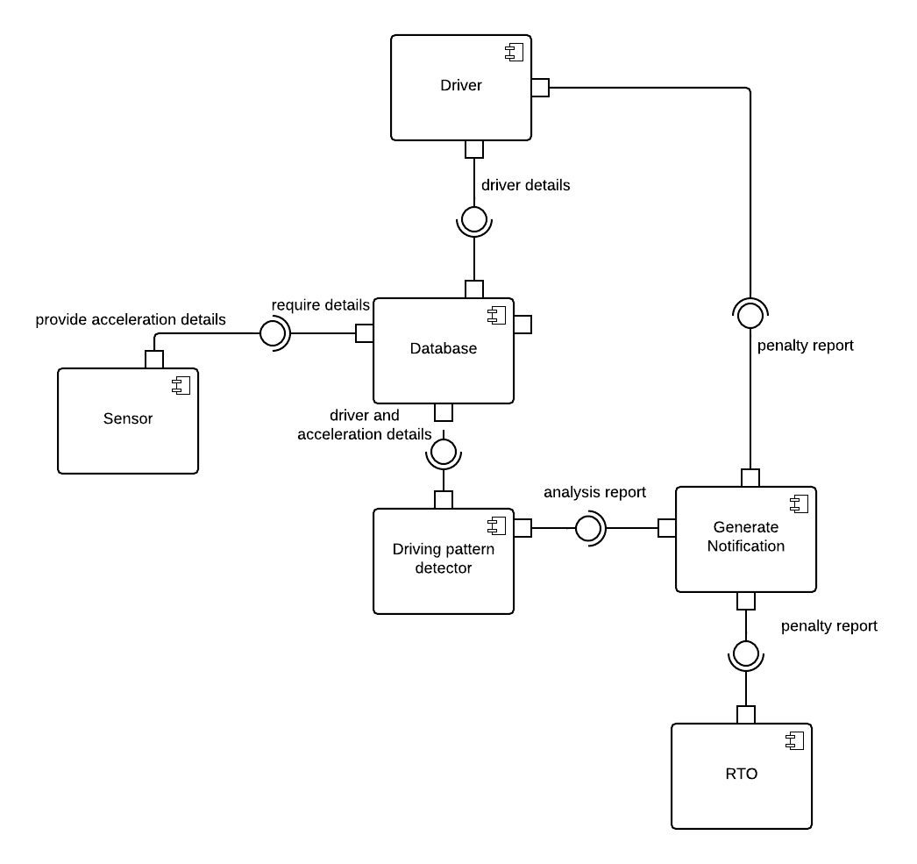

**4.2. Functional Modelling**

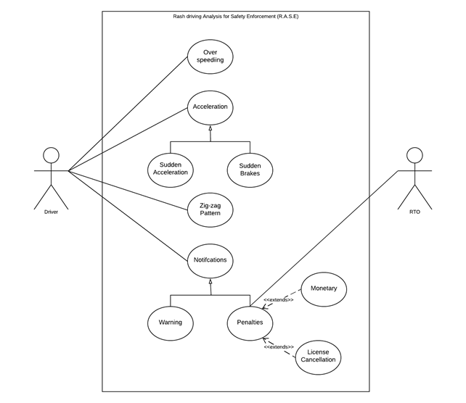

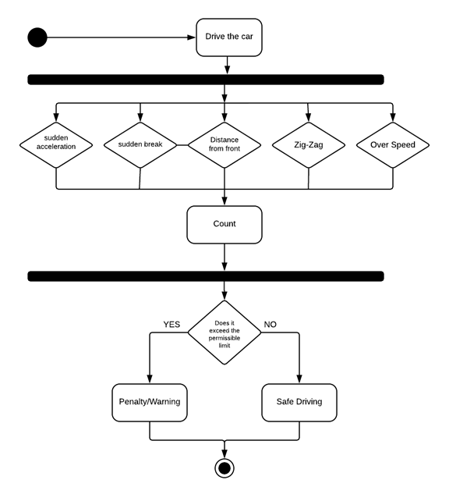**4.3. Behavioral Modelling**

**4.4. Structural Modelling**

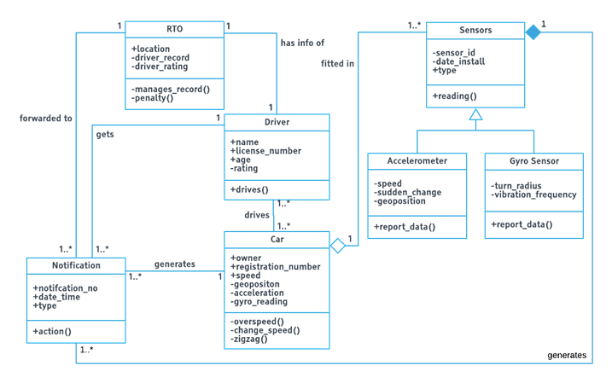

5. Implementation

5.1. Technologies Used

* Raspberry pi 3 model B+ ( With Wi-Fi and Bluetooth ) as RPi.GPIO
* MPU6050 (3-axis accelerometer)
* R studio
* Virtual Network Computing (VNC)
* Raspbian operating system
* puTTy (SSH connectivity)
* python 3

5.2. Prototype Implementation

1. Implementing the micro system in the Raspberry Pi 3 where the connectivity and communication of the hardware and software is established using smbus, i2cdetect, MPU6050 (3 axis accelerometer) modules in python 3.

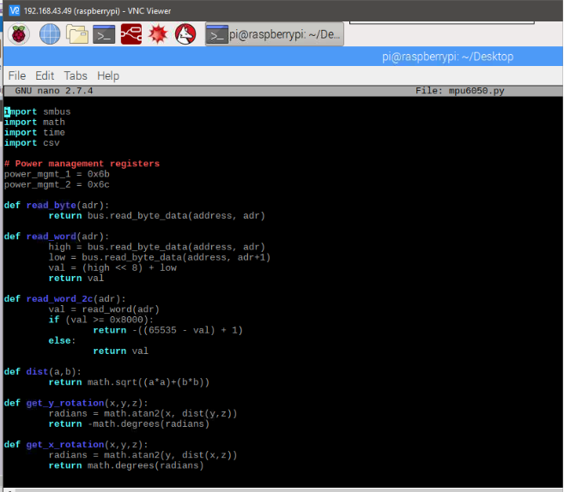

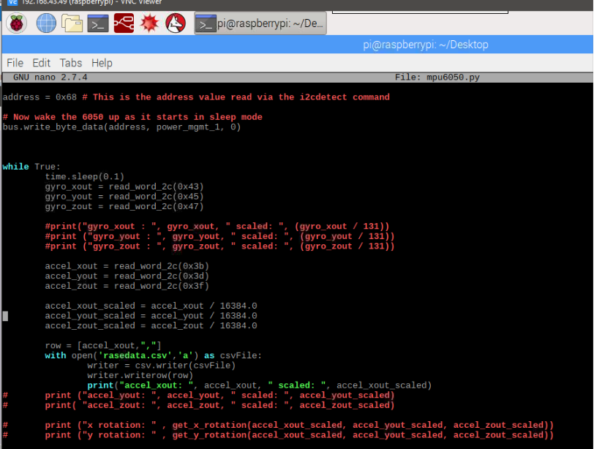

1. Once the connectivity and communication of the hardware and software is established, the MPU6050 starts sensing the acceleration of the parasite with respect to the set sensitivity (+2g).

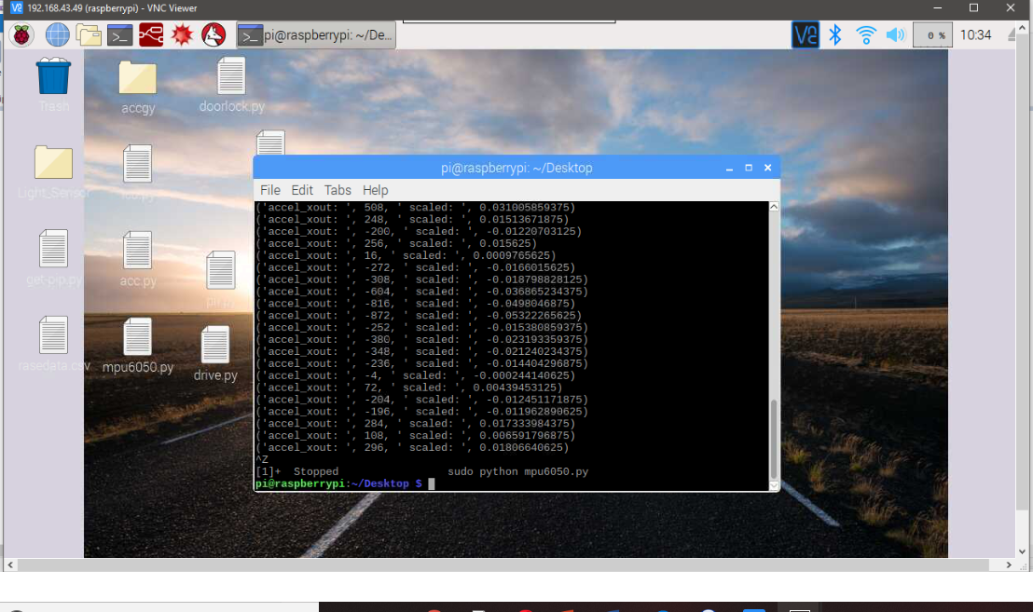

1. Based on the sensed values by the accelerometer, the values are statically put into the csv file and sent to the R analysing station where graphical analysis is done on the data, to show the variations and conclusion of the driving pattern.

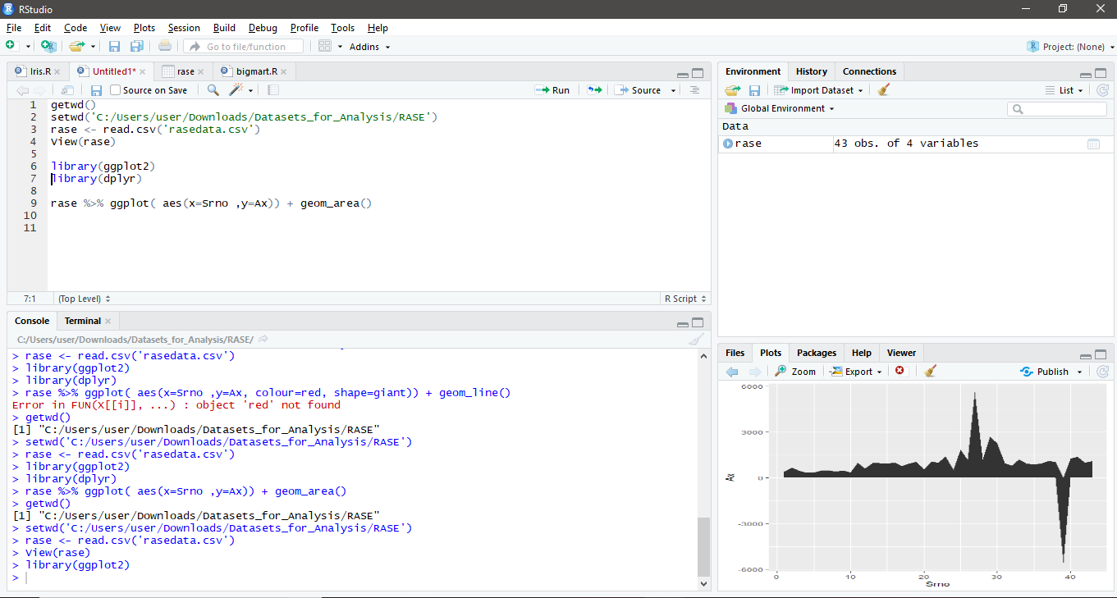

5.3. Test Cases for Prototype

References:

* + - 1. <https://playground.arduino.cc/Main/MPU-6050>
      2. <http://www.electronicwings.com/sensors-modules/mpu6050-gyroscope-accelerometer-temperature-sensor-module>
      3. <https://www.sunrom.com/p/gyro-accelerometer-sensor-3-axis-based-on-mpu-6050>
      4. <https://www.sunrom.com/p/gyro-accelerometer-sensor-3-axis-based-on-mpu-6050>
      5. <https://www.invensense.com/wp-content/uploads/2015/02/MPU-6000-Register-Map1.pdf>
      6. <http://ozzmaker.com/guide-to-interfacing-a-gyro-and-accelerometer-with-a-raspberry-pi/>
      7. <https://tutorials-raspberrypi.com/measuring-rotation-and-acceleration-raspberry-pi/>
      8. <https://stackabuse.com/reading-and-writing-csv-files-in-python/>
      9. <https://www.programiz.com/python-programming/working-csv-files>
      10. <http://www.sr.bham.ac.uk/~ajrs/R/r-plot_data.html>
      11. <http://www.sthda.com/english/wiki/be-awesome-in-ggplot2-a-practical-guide-to-be-highly-effective-r-software-and-data-visualization>