25. Generate the following series up to 10 terms:

a. 1, 8, 27, 64, 125 ........

b. 0, 3, 8, 15, 24, 35 .....

c. 1, 4, 7,10 ......

A

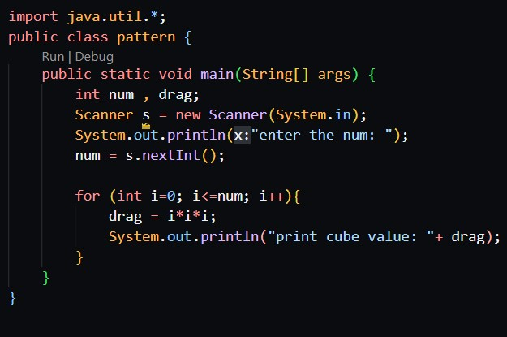

Output:

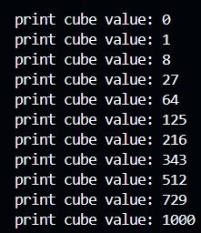

B

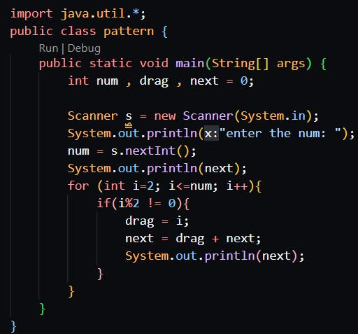

Output:

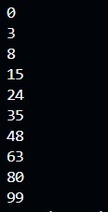

C

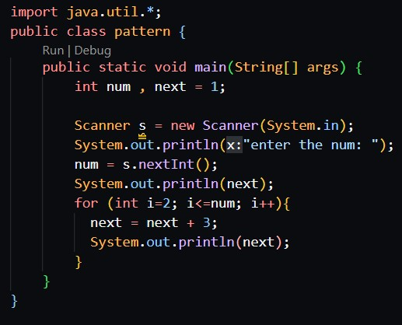

Output:

