B.Tech CSE (III YEAR - VI SEM) (2026-27)
DEPARTMENT OF COMPUTER SCIENCE ENGINEERING & APPLICATIONS


GLA UNIVERSITY
17km Stone, NH-2, Mathura-Delhi Road, P.O. Chaumuhan, Mathura - 281406 (Uttar Pradesh) India
PROJECT TITLE
Computer Vision Based Structural Concrete Crack Measurement Gauge (CrackGauge - AI-Assisted Concrete Crack Measurement and Monitoring System)

Team Leader: Manish Saini UR: 2415500282
Team Member 1: Ayush Gigras UR: 2415500119
Team Member 2: Sachin Chauhan UR: 2415500404

Mentor Name: Ms. Anuska Shukla
Signature: ______________________

Project Synopsis:
CrackGauge -AI-Assisted Concrete Crack Measurement and Monitoring System

Cover
- Project title: Computer Vision Based Structural Concrete Crack Measurement Gauge (CrackGauge)
- Team No: 124
- Institute / Course: GLA University, Mathura - B.Tech CSE[AIML] , Mini-Project
- Version: v1.0
- Date: 02 Sep 2026

1. Overview
Problem statement:
Structural concrete elements such as buildings, bridges, and pavements develop surface cracks over time due to aging, environmental exposure, loading conditions, and shrinkage. Manual inspection using handheld crack-width gauges or optical rulers is time-consuming, subjective, difficult to document consistently, and impractical for repeated inspection of the same location. Automated measurement is further complicated because concrete surfaces contain texture, aggregate, stains, shadows, and construction joints that can be mistaken for cracks by a naive detection algorithm.
Goal:
Build a portable, low-cost, computer-vision-based hardware and software system (CrackGauge) that captures calibrated close-range images of concrete surfaces and automatically estimates crack width, length, orientation, area, severity, and detection confidence, while maintaining a digital, timestamped inspection record.
Non-goals:
Replacing certified structural engineering assessment, detecting sub-surface or internal structural damage, and providing automated repair or safety-certification decisions in v1.
Value proposition:
CrackGauge combines controlled imaging, physical reference-scale calibration, crack segmentation, and geometric measurement in a single low-cost inspection workflow - replacing subjective, inspector-dependent manual readings with consistent, repeatable, algorithm-based measurements and digitally preserved inspection evidence.

2. Scope and Control

2.1 In-scope
- Portable hardware prototype for capturing close-range concrete surface images
- LED-based controlled illumination to minimise shadows and inconsistent lighting
- Crack detection and segmentation from concrete texture, stains, and visual noise
- Hessian/ridge-based filtering and adaptive thresholding for thin, elongated crack structures
- Crack width estimation via contour profiling and distance-transform analysis
- Crack length estimation via skeletonisation and geometric analysis
- Crack orientation via PCA-based geometric analysis
- Reference-based calibration to convert pixel measurements into millimetres
- Colour-coded visualisation of detected cracks and measurements
- Timestamped digital inspection records with images, measurements, and severity data
- Exportable PDF inspection report

2.2 Out-of-scope
- Mobile Android application
- On-device AI inference
- Advanced deep-learning segmentation models
- Automated crack-type classification
- GPS-based inspection location mapping and cloud-based inspection database
- 3D surface reconstruction and drone-based infrastructure inspection integration

2.3 Assumptions
- Cracks are visible on the concrete surface and accessible for close-range imaging
- A known-size reference calibration marker can be placed within the camera's field of view
- Users maintain the fixed camera-to-surface distance defined by the hardware spacer

2.4 Constraints
- Measurement accuracy depends on camera resolution, camera distance, lighting, focus, and surface orientation
- Concrete texture and crack visibility affect detection and calibration accuracy
- Academic project timeline (8-week schedule)

2.5 Dependencies
- Raspberry Pi 4 / smartphone / USB camera hardware platform
- OpenCV, NumPy, SciPy, scikit-image processing libraries
- ArUco / physical reference marker for calibration
- ReportLab for PDF report generation

2.6 Acceptance criteria and sign-off
- GIVEN a captured image with a reference marker in frame WHEN the calibration routine runs THEN pixel measurements are converted to millimetres
- GIVEN a concrete surface image WHEN the crack detection pipeline runs THEN crack regions are segmented and distinguished from surface texture, stains, and shadows
- GIVEN a detected crack WHEN measurement is complete THEN width, length, orientation, area, and severity are reported with a confidence score
- GIVEN a completed inspection WHEN the user requests a report THEN a PDF inspection report is generated and stored digitally
Stakeholder | Role | Decision area | Signature/Approval | Date
Ms. Anuska Shukla | Mentor | Scope, final acceptance
Manish Saini | Team Lead | Release readiness
Sign-off table

3. Stakeholders and RACI
Activity | Responsible (R) | Accountable (A) | Consulted (C) | Informed (I)
Requirements | Manish Saini | Manish Saini | Mentor | Team
Hardware Design | Ayush Gigras | Manish Saini | Mentor | Team
CV Pipeline & Software | Manish Saini & Sachin Chauhan | Manish Saini | Mentor | Team
Testing & Calibration | Sachin Chauhan | Manish Saini | Mentor | Team
Release / Demonstration | Manish Saini | Manish Saini | Mentor | Dept

4. Team and Roles
Member | Role | Responsibilities | Key skills | Contact
Manish Saini | Team Lead / CV & Software | Architecture, computer-vision pipeline, integration | Python, OpenCV, MERN, AI/ML | manish.saini_cs.aiml24@gla.ac.in
Ayush Gigras | Hardware | Camera/LED rig, calibration marker, enclosure | Embedded systems, Raspberry Pi | ayush.gigras_cs.aiml24@gla.ac.in
Sachin Chauhan | Testing & Reporting | Evaluation, calibration accuracy, PDF reporting | Testing, documentation | sachin.gla_cs.aiml24@gla.ac.in

5. Week-wise Plan and Assignments
Week | Planned Work | Deliverable | Status
Week 1 | Requirement analysis, research, and hardware planning | Requirements doc | Planned
Week 2 | Hardware prototype development and image acquisition | Working capture rig | Planned
Week 3 | Image preprocessing and crack enhancement | Preprocessing module | Planned
Week 4 | Hessian filtering, adaptive thresholding, and segmentation | Segmentation module | Planned
Week 5 | Crack width, length, and orientation measurement | Measurement module | Planned
Week 6 | Calibration and physical measurement validation | Calibrated pipeline | Planned
Week 7 | Web dashboard, database, and PDF reporting | Dashboard + reports | Planned
Week 8 | Testing, validation, documentation, and final demonstration | Final demo, report | Planned

6. Users and UX

6.1 Personas
- Site Inspector: Needs a fast, portable way to capture and log crack measurements on-site without specialised equipment.
- Structural/Civil Engineer: Needs consistent, comparable measurement data across inspection dates to track crack progression.

6.2 Top User Journeys
Inspector → Position device at fixed distance with reference marker in frame → Capture image under LED illumination → System detects and measures crack → Inspector reviews results on dashboard → PDF report generated and stored

6.3 User Stories
- As a site inspector, I want an automated crack measurement so that I can avoid subjective manual readings and save inspection time.
- As a civil engineer, I want timestamped digital records so that I can compare crack progression across inspection dates.

6.4 Accessibility & Localization
- Simple, mobile-friendly web dashboard
- Colour-coded visual output for quick interpretation
- English language support

7. Market and Competitors
Approach | Target users | Key features | Strengths | Weaknesses | Our differentiator
Manual crack-width gauges/rulers | Site inspectors | Handheld visual comparison | Low cost, simple | Subjective, inspector-dependent, no digital record | Automated, repeatable, calibrated measurement
General structural health monitoring (SHM) systems | Institutional/industrial users | Sensor-based monitoring, dashboards | Continuous monitoring, established | Expensive, complex installation | Low-cost, portable, camera-based alternative
Generic crack-detection mobile apps | General users | Photo-based crack detection | Easy to use, free/cheap | No physical calibration, no accurate measurement | Reference-based calibration for real-world mm measurements

7.2 Positioning
CrackGauge positions itself as a low-cost, portable, computer-vision-based alternative to both purely manual inspection and expensive industrial SHM systems, focused on calibrated, repeatable, and digitally documented crack measurement.

8. Objectives and Success Metrics
- O1: Detection quality - Achieve a target Precision/Recall/F1 score on the test image set by the evaluation milestone (KPI: Precision, Recall, F1)
- O2: Segmentation quality - Achieve a target Intersection over Union (IoU) and Dice score on labelled test images (KPI: IoU, Dice score)
- O3: Measurement accuracy - Keep Mean Absolute Error (MAE) and Relative Error within an acceptable range versus a physical reference gauge (KPI: MAE, RMSE, relative error)
- O4: Calibration reliability - Achieve a high calibration success rate and repeatable measurements across repeated inspections of the same crack (KPI: calibration success rate, repeatability)

9. Key Features
Feature | Description | Priority | Acceptance criteria
Crack Detection & Segmentation | Detects thin, elongated crack structures using Hessian/ridge filtering and adaptive thresholding, separating cracks from texture and stains. | Must | GIVEN a concrete surface image WHEN processed THEN a binary crack mask is produced
Crack Width Measurement | Estimates local and average crack width via distance-transform analysis on the skeletonised crack mask. | Must | GIVEN a segmented crack WHEN measured THEN max/average width in mm is reported
Crack Length Measurement | Estimates crack length via skeletonisation and path-length analysis. | Must | GIVEN a segmented crack WHEN measured THEN length in mm is reported
Crack Orientation | Determines dominant crack orientation using PCA on skeleton pixel coordinates. | Should | GIVEN a segmented crack WHEN analysed THEN orientation angle is reported
Physical Calibration | Converts pixel measurements to millimetres using a known-size reference marker (optionally ArUco-based). | Must | GIVEN a reference marker in frame WHEN detected THEN a pixel-to-mm scale factor is computed
Digital Reporting | Web dashboard and exportable PDF report showing images, measurements, severity, and confidence. | Should | GIVEN a completed inspection WHEN requested THEN a PDF report is generated

10. Expected Outcomes
- A functional portable prototype for concrete crack image acquisition
- Automated detection and segmentation of visible surface cracks
- Estimation of crack length, maximum width, average width, and orientation
- Pixel-to-millimetre conversion through reference-based calibration
- Visual representation of detected crack regions (colour-coded overlays)
- Basic severity classification (Low / Medium / High)
- Digital storage of timestamped inspection records
- PDF-based inspection reports
- A working foundation for future crack-progression monitoring

11. Innovation / Novelty
The proposed system combines low-cost hardware with computer-vision-based measurement in a single inspection workflow. Unlike conventional manual inspection, it reduces manual measurement effort, provides repeatable image-based measurements, digitally preserves inspection evidence, offers visual crack segmentation, and enables comparison of inspections over time using affordable cameras rather than specialised industrial equipment.
The core novelty lies in combining controlled imaging, physical calibration, crack segmentation, and geometric measurement together in one low-cost pipeline - rather than simply detecting whether a crack exists, as most consumer crack-detection tools do.

12. Architecture

12.1 High-Level Architecture
The prototype hardware follows a linear imaging chain: the camera and LED ring provide controlled illumination of the concrete surface, which contains the crack and calibration marker. The captured image is transferred from the Raspberry Pi to a laptop via Wi-Fi or USB, where the computer-vision engine performs analysis and produces the final measurements.

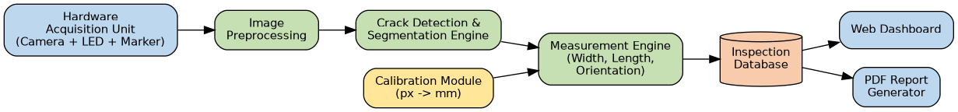
Figure: System Block Diagram (end-to-end data flow)

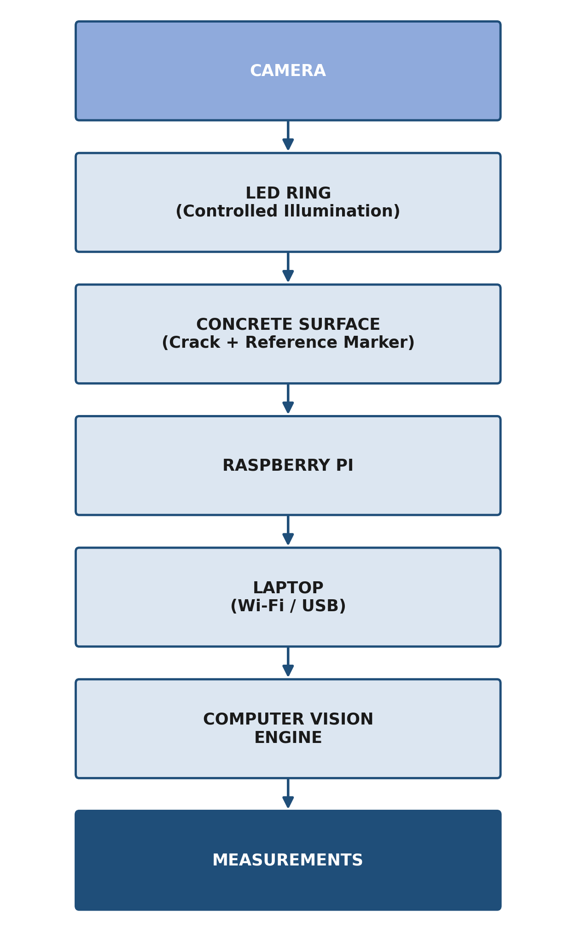

Figure: Hardware Architecture / Imaging Chain
The captured image is processed using Python and OpenCV through a preprocessing, detection, and measurement pipeline:

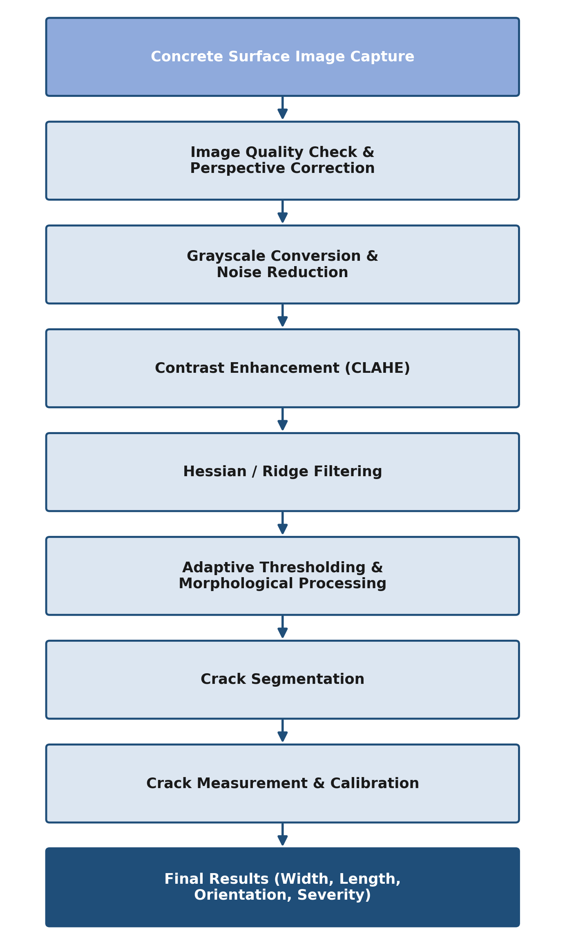
Figure: Computer Vision Processing Pipeline

On the software side, a React-based frontend communicates with a FastAPI backend, which invokes the computer-vision engine built on OpenCV, NumPy, and scikit-image. Crack analysis results are stored in a database and used to generate PDF inspection reports.

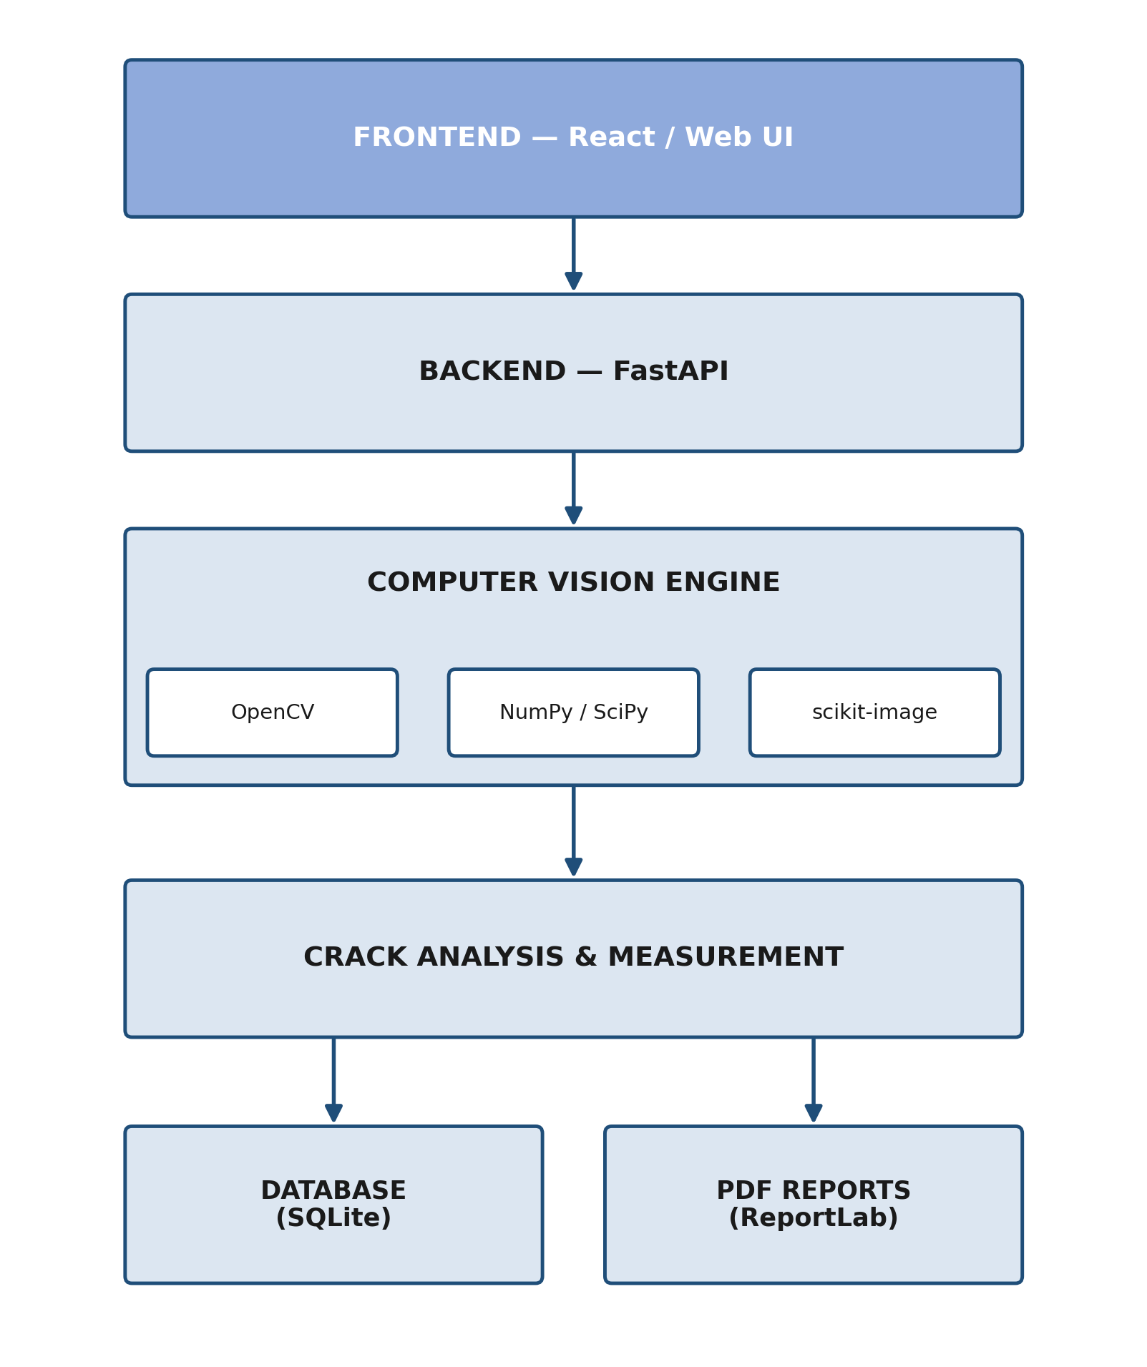
Figure: Software Architecture (Layered View)

12.2 Technology Stack
Category | Technology
Programming Language | Python
Computer Vision | OpenCV
Numerical Processing | NumPy, SciPy
Image Processing | scikit-image
Backend | FastAPI
Frontend | React
Database | SQLite
Hardware | Raspberry Pi 4 / Smartphone
Camera | Pi Camera / USB Camera / Microscope
Calibration | ArUco / Reference Marker
Reporting | ReportLab
Optional AI | PyTorch / Lightweight Segmentation Model

12.3 Proposed Hardware Components
Component | Purpose
Raspberry Pi 4 | Controller and image-processing device
Camera Module | Image acquisition
LED Ring | Controlled illumination
ArUco / Reference Marker | Physical scale calibration
Fixed Spacer | Maintaining consistent camera distance
3D-Printed Enclosure | Portable device body
Power Bank | Portable power supply
Optional USB Microscope | High-resolution hairline crack inspection

12.4 Estimated Hardware Cost (Prototype BOM)
Component | Approx. Qty | Approx. Cost (INR)
Raspberry Pi 4 (4GB) | 1 | 5,000 - 6,000
Pi Camera Module / USB Camera | 1 | 800 - 2,000
LED Ring Light | 1 | 300 - 600
ArUco / Printed Reference Marker | 1 | Negligible
Fixed-distance Spacer (3D-printed) | 1 | 200 - 400
3D-Printed Enclosure | 1 | 300 - 700
Power Bank | 1 | 800 - 1,200
Optional USB Microscope | 1 | 1,500 - 3,000
Total (approx.) | - | 9,000 - 14,000
Figures are indicative and will be refined once components are finalised; this keeps the prototype well within a typical academic mini-project budget compared to industrial crack-monitoring instruments.

12.5 Algorithm Workflow
The end-to-end measurement algorithm proceeds through the following steps, from image capture to report generation:
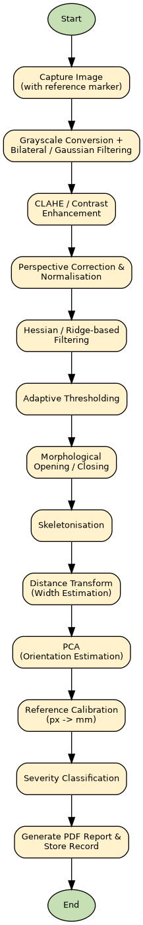

Figure: Crack Detection and Measurement Algorithm Flowchart

13. Data Design

13.1 Core Entities
- Inspection Record
- Crack Measurement
- Calibration Reference
- Inspector/User
Inspection data is stored digitally with timestamps to support future comparison and long-term crack-progression monitoring.

13.2 Data dictionary
Entity | Field | Type | Notes
InspectionRecord | id | UUID | Primary key
InspectionRecord | timestamp | DateTime | Date/time of inspection
CrackMeasurement | width_mm | Decimal | Max/average width
CrackMeasurement | length_mm | Decimal | Skeleton path length
CrackMeasurement | orientation_deg | Decimal | PCA-derived angle
CrackMeasurement | severity | Enum | Low/Medium/High
CalibrationReference | scale_px_per_mm | Decimal | Derived from reference marker

13.3 Privacy, Retention, Backup, and DR
- Inspection images and records are stored locally/digitally for the academic prototype; no personally identifiable information is required for crack data itself
- Nightly backups recommended once deployed beyond prototype stage

14. Technical Workflow Diagrams
The following diagrams are included to explain system behaviour to the panel - from user interaction down to internal data flow and state changes:
- System Block Diagram (Figure, Section 12.1)
- Hardware Architecture / Imaging Chain (Figure, Section 12.1)
- Computer Vision Processing Pipeline (Figure, Section 12.1)
- Software Architecture - Layered View (Figure, Section 12.1)
- Algorithm Flowchart (Figure, Section 12.5)
- Use Case Diagram (below)
- Data Flow Diagram - Level 0 (below)
- State Transition Diagram (below)
- Crack Width Estimation via Skeleton and Distance Transform (below)

14.1 Use Case Diagram
The Site Inspector is the primary actor interacting with the system across the full inspection workflow, from image capture through report generation.
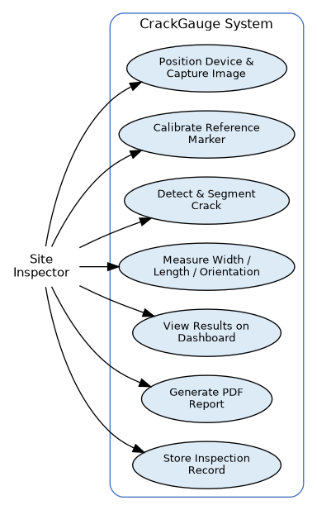
Figure: Use Case Diagram

14.2 Data Flow Diagram (Level 0)
The context-level DFD shows how image and calibration data flow from the inspector, through the processing system, into the inspection database, and out as a PDF report to the mentor/panel.
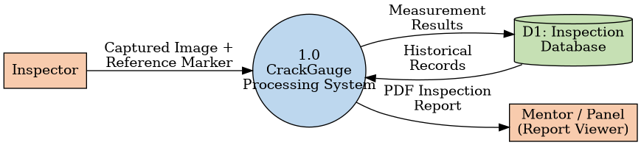
Figure: Data Flow Diagram (Level 0)

14.3 State Transition Diagram
Each inspection moves through a defined sequence of states from image capture to final storage, ensuring every crack measurement is fully processed and recorded before the next inspection begins.
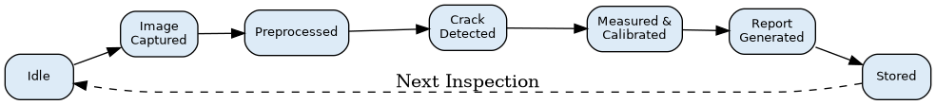
Figure: State Transition Diagram for a Single Inspection

14.4 Crack Width Estimation Detail
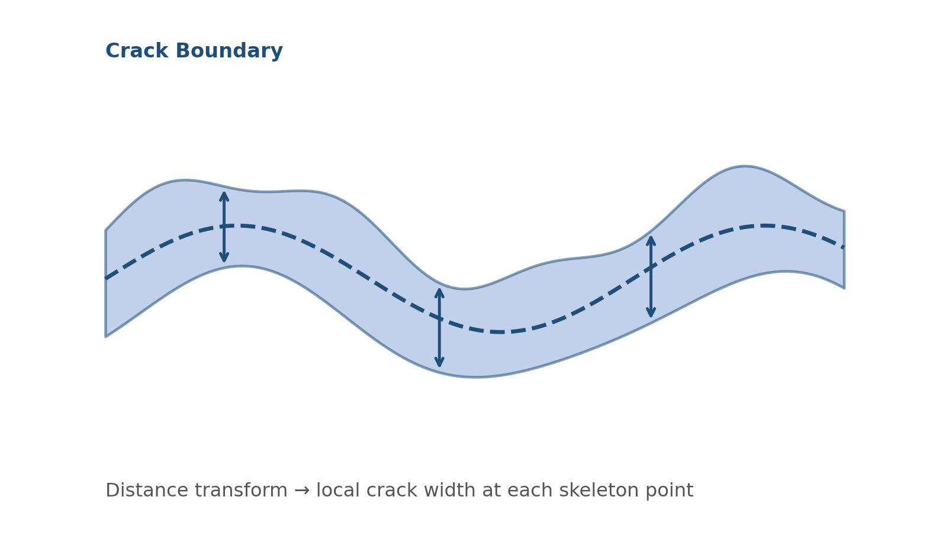
Figure: Crack Width Estimation via Skeleton and Distance Transform
A distance transform applied to the crack mask allows local width to be estimated as the distance between the skeleton and the crack boundary at each point, enabling calculation of maximum width, average width, and width variation along the crack.

15. Quality: NFRs and Testing

15.1 Non-functional requirements
Metric | Target | Measurement
Detection quality | High Precision/Recall/F1 | Precision, Recall, F1 Score
Segmentation quality | High IoU/Dice | Intersection over Union, Dice Score
Measurement accuracy | Low MAE/RMSE | Mean Absolute Error, RMSE, relative error
Processing time | Acceptable per-image latency | Wall-clock processing time
Calibration reliability | High success rate | Calibration success rate, repeatability

15.2 Test plan
Area | Type | Owner | Approach
Detection & Segmentation | Accuracy testing | Manish Saini | Precision/Recall/F1, IoU, Dice against labelled images
Measurement | Accuracy testing | Sachin Chauhan | Compare predicted vs. actual width/length against physical gauge
Hardware & Calibration | Field testing | Ayush Gigras | Repeatability across repeated captures

15.3 Environments
Development → Prototype field testing → Final demonstration

16. Security and Compliance

16.1 Data handling
- Inspection images and measurement data stored locally / on the project database
- Access to the dashboard restricted to project team and mentor during development

16.2 Compliance
Academic project; follows institute policy; no third-party data sharing.

17. Delivery and Operations

17.1 Release plan
Prototype demo and PDF report generation at project submission; incremental feature rollout across the 8-week timeline.

17.2 Communication plan
Regular team sync and weekly status update to the mentor (Ms. Anuska Shukla); demonstration at the end of each major milestone.

18. Risks and Mitigations
Risk | Probability | Impact | Mitigation | Owner
Inconsistent lighting/camera distance affecting accuracy | Medium | High | Fixed spacer, LED ring, controlled imaging setup | Ayush Gigras
Texture/stains misclassified as cracks | Medium | Medium | Hessian/ridge filtering, adaptive thresholding, morphological cleanup | Manish Saini
Calibration marker misplacement or misdetection | Low | Medium | ArUco-based automatic marker detection | Sachin Chauhan
Schedule slip within 8-week timeline | Medium | High | Weekly milestones, scope freeze on core features | Manish Saini

19. Research and Evaluation

19.1 Literature Review / Study of Existing Approaches
Conventional inspection relies on visual observation and manual measurement using crack-width gauges or optical rulers - subjective, hard to document consistently, and inconvenient for repeated inspection. Existing structural health monitoring systems are accurate but expensive and complex to install. This motivated CrackGauge, a low-cost, portable, camera-based measurement system:

Manual Inspection (Traditional) | CrackGauge (Proposed System)
Visual estimation using handheld crack-width gauges | Automated measurement via calibrated computer vision
Subjective, inspector-dependent readings | Consistent, repeatable, algorithm-based readings
Paper-based or informal record-keeping | Timestamped digital records with PDF reports
Difficult to compare inspections over time | Enables direct comparison across inspection dates
Requires specialised gauges/instruments | Uses low-cost, portable camera-based hardware
Approach | Typical Method | Limitation | Used in CrackGauge?
Simple edge detection | Canny / Sobel edge detector | Highly sensitive to texture, stains, and noise on concrete | No (too noisy alone)
Global thresholding | Fixed-intensity binarisation | Fails under uneven illumination across the surface | No (adaptive thresholding used instead)
Deep-learning segmentation | CNN-based pixel segmentation (e.g. U-Net) | Needs large labelled datasets and heavier compute; not ideal for a low-cost embedded prototype | Optional / future scope only
Ridge/Hessian filtering + adaptive threshold + skeleton/distance transform | Classical CV pipeline used in this project | Requires careful tuning but is lightweight, explainable, and runs on low-cost hardware | Yes (core pipeline)

Common computer-vision approaches to crack analysis, and why this project uses a hybrid classical-CV pipeline rather than a single technique, are summarised below:

19.2 Evaluation Using Reference Data
CrackGauge measurements will be compared against a physical reference or manual crack-width gauge, for example:
Actual Width | Predicted Width
1.00 mm | 1.08 mm
1.50 mm | 1.43 mm
2.00 mm | 2.12 mm

19.3 User Feedback
Mentor and peer feedback will be collected on measurement clarity, ease of use, and reliability of the reporting dashboard, guiding improvements to the detection and measurement pipeline.

19.4 KPI Tracking
Key metrics tracked include detection precision/recall, segmentation IoU/Dice, measurement MAE/RMSE, processing time per image, and calibration success rate, to ensure reliability and guide continuous improvement

20. Appendices

20.1 Glossary
- AI: Systems simulating human intelligence.
- CV: Computer Vision - extracting information from images.
- IoU: Intersection over Union - a segmentation accuracy metric.
- MAE / RMSE: Mean Absolute Error / Root Mean Square Error - measurement accuracy metrics.
- PCA: Principal Component Analysis, used to determine crack orientation.
- ArUco marker: A fiducial marker used for automatic scale calibration.

20.2 References
- OpenCV: https://opencv.org
- scikit-image: https://scikit-image.org
- NumPy: https://numpy.org
- React: https://react.dev
- FastAPI: https://fastapi.tiangolo.com
- ReportLab: https://www.reportlab.com

