tensor(560649, device='cuda:0')

391 / 79

epoch started: 1

23:00:09.395970

training acc : 0.30272 loss : tensor(1.6214, device='cuda:0', grad_fn=<NllLossBackward>)

training epoch ended: 23:00:31.727968

validation error acc : 0.4192 loss : tensor(1.3659, device='cuda:0', grad_fn=<NllLossBackward>)

validation epoch ended: 23:00:34.074684

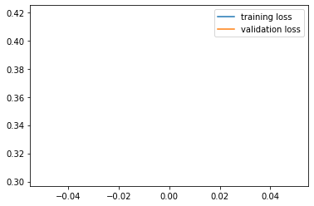

epoch started: 2

23:00:34.220384

training acc : 0.42424 loss : tensor(1.5308, device='cuda:0', grad_fn=<NllLossBackward>)

training epoch ended: 23:00:56.566705

validation error acc : 0.4738 loss : tensor(2.5899, device='cuda:0', grad_fn=<NllLossBackward>)

validation epoch ended: 23:00:58.935724

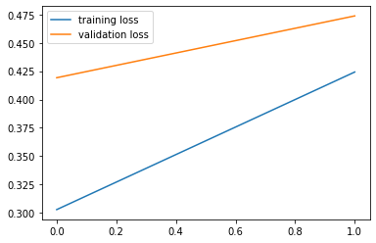

epoch started: 3

23:00:59.093705

training acc : 0.48672 loss : tensor(1.2210, device='cuda:0', grad_fn=<NllLossBackward>)

training epoch ended: 23:01:21.462733

validation error acc : 0.5407 loss : tensor(1.0367, device='cuda:0', grad_fn=<NllLossBackward>)

validation epoch ended: 23:01:23.821797

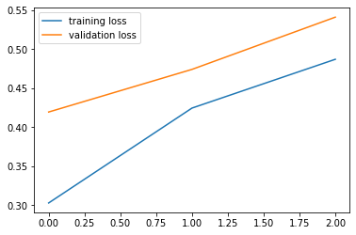

epoch started: 4

23:01:23.991633

training acc : 0.53304 loss : tensor(1.2870, device='cuda:0', grad_fn=<NllLossBackward>)

training epoch ended: 23:01:46.322428

validation error acc : 0.5541 loss : tensor(1.0170, device='cuda:0', grad_fn=<NllLossBackward>)

validation epoch ended: 23:01:48.707792

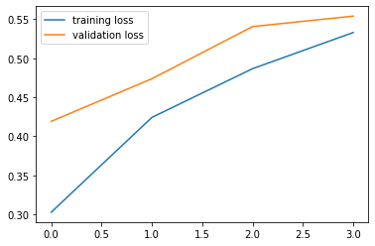

epoch started: 5

23:01:48.856081

training acc : 0.5654 loss : tensor(1.3142, device='cuda:0', grad_fn=<NllLossBackward>)

training epoch ended: 23:02:11.338234

validation error acc : 0.3766 loss : tensor(22.9423, device='cuda:0', grad_fn=<NllLossBackward>)

validation epoch ended: 23:02:13.696206

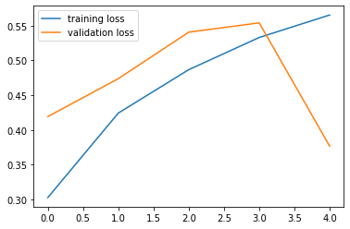

epoch started: 6

23:02:13.854218

training acc : 0.53832 loss : tensor(0.9093, device='cuda:0', grad_fn=<NllLossBackward>)

training epoch ended: 23:02:36.248109

validation error acc : 0.5895 loss : tensor(1.0807, device='cuda:0', grad_fn=<NllLossBackward>)

validation epoch ended: 23:02:38.659740

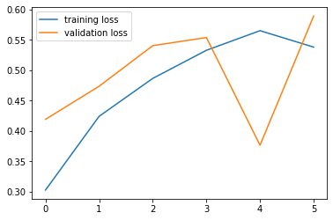

epoch started: 7

23:02:38.818382

training acc : 0.6023 loss : tensor(1.0722, device='cuda:0', grad_fn=<NllLossBackward>)

training epoch ended: 23:03:01.290481

validation error acc : 0.6279 loss : tensor(0.8999, device='cuda:0', grad_fn=<NllLossBackward>)

validation epoch ended: 23:03:03.707137

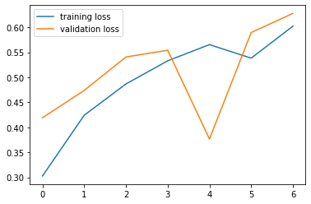

epoch started: 8

23:03:03.871115

training acc : 0.62782 loss : tensor(0.9972, device='cuda:0', grad_fn=<NllLossBackward>)

training epoch ended: 23:03:26.442347

validation error acc : 0.6337 loss : tensor(0.9039, device='cuda:0', grad_fn=<NllLossBackward>)

validation epoch ended: 23:03:28.827209

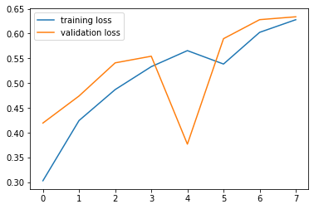

epoch started: 9

23:03:28.988128

training acc : 0.6425 loss : tensor(1.0138, device='cuda:0', grad_fn=<NllLossBackward>)

training epoch ended: 23:03:51.440900

validation error acc : 0.6624 loss : tensor(1.6305, device='cuda:0', grad_fn=<NllLossBackward>)

validation epoch ended: 23:03:53.815022

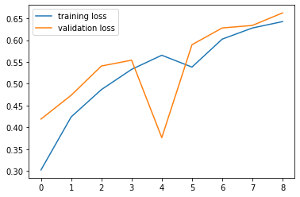

epoch started: 10

23:03:53.982615

training acc : 0.66266 loss : tensor(0.9056, device='cuda:0', grad_fn=<NllLossBackward>)

training epoch ended: 23:04:16.488819

validation error acc : 0.6803 loss : tensor(1.0174, device='cuda:0', grad_fn=<NllLossBackward>)

validation epoch ended: 23:04:18.883518

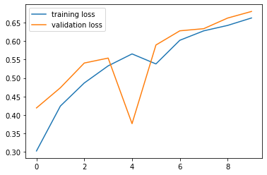

epoch started: 11

23:04:19.036681

training acc : 0.67922 loss : tensor(1.0967, device='cuda:0', grad_fn=<NllLossBackward>)

training epoch ended: 23:04:41.432688

validation error acc : 0.676 loss : tensor(0.8096, device='cuda:0', grad_fn=<NllLossBackward>)

validation epoch ended: 23:04:43.856147

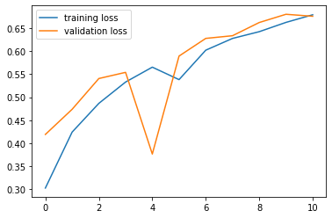

epoch started: 12

23:04:44.031572

training acc : 0.68476 loss : tensor(0.9222, device='cuda:0', grad_fn=<NllLossBackward>)

training epoch ended: 23:05:06.420735

validation error acc : 0.6912 loss : tensor(0.8741, device='cuda:0', grad_fn=<NllLossBackward>)

validation epoch ended: 23:05:08.793901

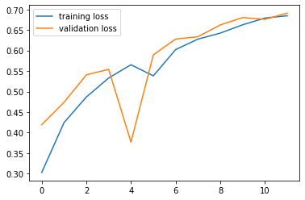

epoch started: 13

23:05:08.947139

training acc : 0.69758 loss : tensor(1.0317, device='cuda:0', grad_fn=<NllLossBackward>)

training epoch ended: 23:05:31.513461

validation error acc : 0.7036 loss : tensor(0.6360, device='cuda:0', grad_fn=<NllLossBackward>)

validation epoch ended: 23:05:33.887233

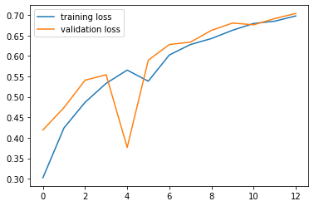

epoch started: 14

23:05:34.045365

training acc : 0.70464 loss : tensor(0.8498, device='cuda:0', grad_fn=<NllLossBackward>)

training epoch ended: 23:05:56.321005

validation error acc : 0.6962 loss : tensor(0.5166, device='cuda:0', grad_fn=<NllLossBackward>)

validation epoch ended: 23:05:58.704691

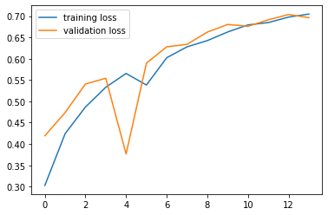

epoch started: 15

23:05:58.862950

training acc : 0.71704 loss : tensor(0.8494, device='cuda:0', grad_fn=<NllLossBackward>)

training epoch ended: 23:06:21.080695

validation error acc : 0.7212 loss : tensor(1.2281, device='cuda:0', grad_fn=<NllLossBackward>)

validation epoch ended: 23:06:23.450085

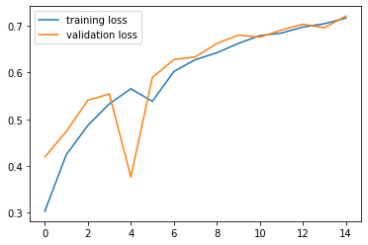

epoch started: 16

23:06:23.596556

training acc : 0.7264 loss : tensor(0.6664, device='cuda:0', grad_fn=<NllLossBackward>)

training epoch ended: 23:06:45.926612

validation error acc : 0.7396 loss : tensor(0.7792, device='cuda:0', grad_fn=<NllLossBackward>)

validation epoch ended: 23:06:48.319454

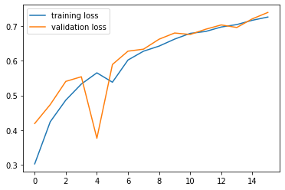

epoch started: 17

23:06:48.469791

training acc : 0.72976 loss : tensor(0.8582, device='cuda:0', grad_fn=<NllLossBackward>)

training epoch ended: 23:07:10.725310

validation error acc : 0.7408 loss : tensor(0.5818, device='cuda:0', grad_fn=<NllLossBackward>)

validation epoch ended: 23:07:13.107334

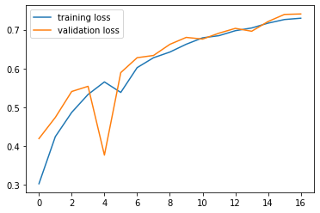

epoch started: 18

23:07:13.256996

training acc : 0.73928 loss : tensor(0.5854, device='cuda:0', grad_fn=<NllLossBackward>)

training epoch ended: 23:07:35.676433

validation error acc : 0.7524 loss : tensor(0.5107, device='cuda:0', grad_fn=<NllLossBackward>)

validation epoch ended: 23:07:38.076650

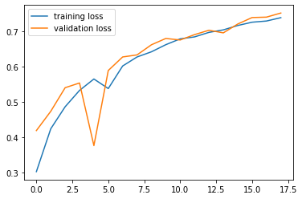

epoch started: 19

23:07:38.230650

training acc : 0.74752 loss : tensor(0.5511, device='cuda:0', grad_fn=<NllLossBackward>)

training epoch ended: 23:08:00.825998

validation error acc : 0.7415 loss : tensor(0.3249, device='cuda:0', grad_fn=<NllLossBackward>)

validation epoch ended: 23:08:03.237263

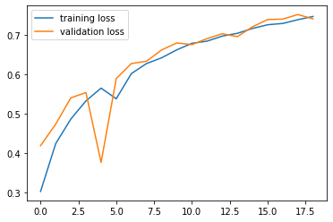

epoch started: 20

23:08:03.388870

training acc : 0.75168 loss : tensor(0.6659, device='cuda:0', grad_fn=<NllLossBackward>)

training epoch ended: 23:08:25.839012

validation error acc : 0.7492 loss : tensor(0.4343, device='cuda:0', grad_fn=<NllLossBackward>)

validation epoch ended: 23:08:28.250698

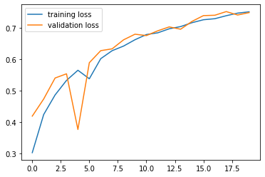

epoch started: 21

23:08:28.396993

training acc : 0.75762 loss : tensor(0.7885, device='cuda:0', grad_fn=<NllLossBackward>)

training epoch ended: 23:08:50.895942

validation error acc : 0.7445 loss : tensor(0.5450, device='cuda:0', grad_fn=<NllLossBackward>)

validation epoch ended: 23:08:53.283629

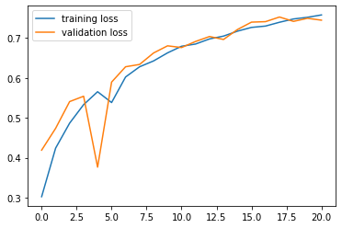

epoch started: 22

23:08:53.429121

training acc : 0.76236 loss : tensor(0.6242, device='cuda:0', grad_fn=<NllLossBackward>)

training epoch ended: 23:09:15.978276

validation error acc : 0.7556 loss : tensor(0.6396, device='cuda:0', grad_fn=<NllLossBackward>)

validation epoch ended: 23:09:18.351043

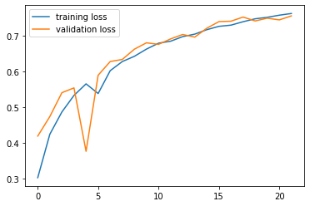

epoch started: 23

23:09:18.493896

training acc : 0.77048 loss : tensor(0.5234, device='cuda:0', grad_fn=<NllLossBackward>)

training epoch ended: 23:09:41.163224

validation error acc : 0.7529 loss : tensor(0.5819, device='cuda:0', grad_fn=<NllLossBackward>)

validation epoch ended: 23:09:43.593541

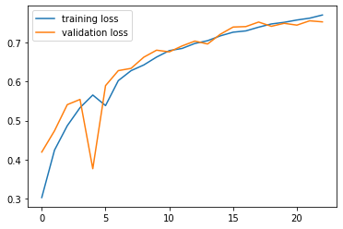

epoch started: 24

23:09:43.730214

training acc : 0.77148 loss : tensor(0.6077, device='cuda:0', grad_fn=<NllLossBackward>)

training epoch ended: 23:10:06.326470

validation error acc : 0.7673 loss : tensor(0.5545, device='cuda:0', grad_fn=<NllLossBackward>)

validation epoch ended: 23:10:08.739316

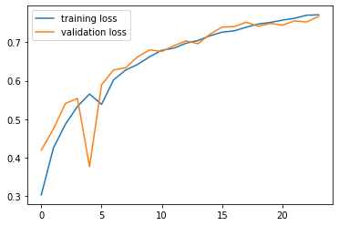

epoch started: 25

23:10:08.892494

training acc : 0.77498 loss : tensor(0.6419, device='cuda:0', grad_fn=<NllLossBackward>)

training epoch ended: 23:10:31.627398

validation error acc : 0.7512 loss : tensor(0.6931, device='cuda:0', grad_fn=<NllLossBackward>)

validation epoch ended: 23:10:34.034103

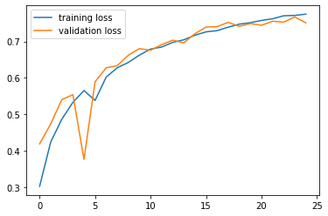

epoch started: 26

23:10:34.184790

training acc : 0.78084 loss : tensor(0.6819, device='cuda:0', grad_fn=<NllLossBackward>)

training epoch ended: 23:10:57.008644

validation error acc : 0.7686 loss : tensor(0.3032, device='cuda:0', grad_fn=<NllLossBackward>)

validation epoch ended: 23:10:59.445405

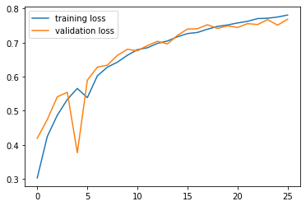

epoch started: 27

23:10:59.589803

training acc : 0.78284 loss : tensor(0.5014, device='cuda:0', grad_fn=<NllLossBackward>)

training epoch ended: 23:11:22.120776

validation error acc : 0.7706 loss : tensor(0.3281, device='cuda:0', grad_fn=<NllLossBackward>)

validation epoch ended: 23:11:24.494257

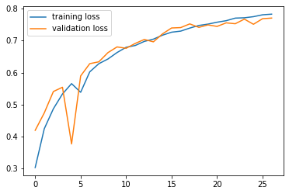

epoch started: 28

23:11:24.634587

training acc : 0.78778 loss : tensor(0.5848, device='cuda:0', grad_fn=<NllLossBackward>)

training epoch ended: 23:11:47.031855

validation error acc : 0.7645 loss : tensor(0.5298, device='cuda:0', grad_fn=<NllLossBackward>)

validation epoch ended: 23:11:49.397416

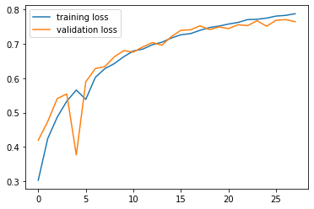

epoch started: 29

23:11:49.539655

training acc : 0.7901 loss : tensor(0.7093, device='cuda:0', grad_fn=<NllLossBackward>)

training epoch ended: 23:12:11.934861

validation error acc : 0.7713 loss : tensor(0.5208, device='cuda:0', grad_fn=<NllLossBackward>)

validation epoch ended: 23:12:14.343919

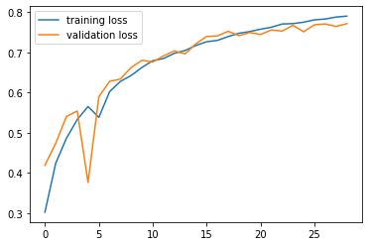

epoch started: 30

23:12:14.516898

training acc : 0.79136 loss : tensor(0.6756, device='cuda:0', grad_fn=<NllLossBackward>)

training epoch ended: 23:12:37.212953

validation error acc : 0.7863 loss : tensor(0.3099, device='cuda:0', grad_fn=<NllLossBackward>)

validation epoch ended: 23:12:39.653765

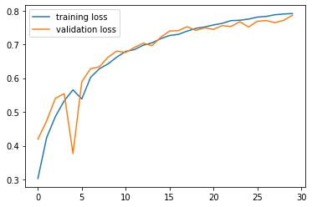

epoch started: 31

23:12:39.806415

training acc : 0.79716 loss : tensor(0.6592, device='cuda:0', grad_fn=<NllLossBackward>)

training epoch ended: 23:13:02.364700

validation error acc : 0.7757 loss : tensor(0.6326, device='cuda:0', grad_fn=<NllLossBackward>)

validation epoch ended: 23:13:04.833252

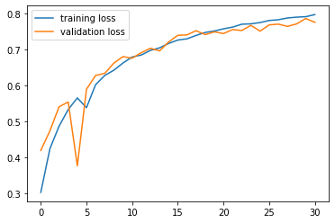

epoch started: 32

23:13:04.987623

training acc : 0.799 loss : tensor(0.5481, device='cuda:0', grad_fn=<NllLossBackward>)

training epoch ended: 23:13:27.712340

validation error acc : 0.7914 loss : tensor(0.7034, device='cuda:0', grad_fn=<NllLossBackward>)

validation epoch ended: 23:13:30.154407

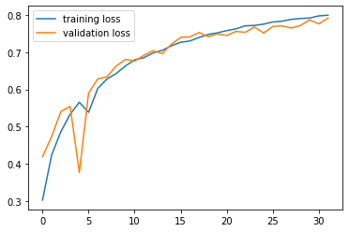

epoch started: 33

23:13:30.312964

training acc : 0.80218 loss : tensor(0.6379, device='cuda:0', grad_fn=<NllLossBackward>)

training epoch ended: 23:13:52.957532

validation error acc : 0.7816 loss : tensor(0.5934, device='cuda:0', grad_fn=<NllLossBackward>)

validation epoch ended: 23:13:55.425909

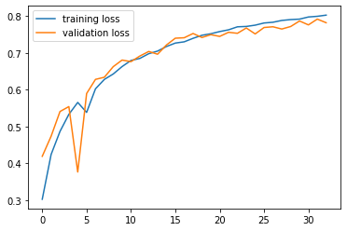

epoch started: 34

23:13:55.572522

training acc : 0.80424 loss : tensor(0.6147, device='cuda:0', grad_fn=<NllLossBackward>)

training epoch ended: 23:14:18.162843

validation error acc : 0.7884 loss : tensor(0.5330, device='cuda:0', grad_fn=<NllLossBackward>)

validation epoch ended: 23:14:20.614013

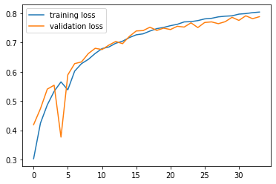

epoch started: 35

23:14:20.768873

training acc : 0.80728 loss : tensor(0.3606, device='cuda:0', grad_fn=<NllLossBackward>)

training epoch ended: 23:14:43.300898

validation error acc : 0.7795 loss : tensor(0.4909, device='cuda:0', grad_fn=<NllLossBackward>)

validation epoch ended: 23:14:45.746780

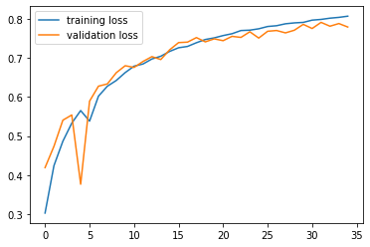

epoch started: 36

23:14:45.925526

training acc : 0.80944 loss : tensor(0.5305, device='cuda:0', grad_fn=<NllLossBackward>)

training epoch ended: 23:15:08.594574

validation error acc : 0.775 loss : tensor(0.3661, device='cuda:0', grad_fn=<NllLossBackward>)

validation epoch ended: 23:15:10.955365

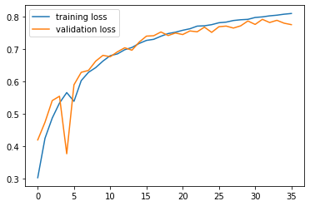

epoch started: 37

23:15:11.108821

training acc : 0.80846 loss : tensor(0.6245, device='cuda:0', grad_fn=<NllLossBackward>)

training epoch ended: 23:15:33.746360

validation error acc : 0.7864 loss : tensor(0.6703, device='cuda:0', grad_fn=<NllLossBackward>)

validation epoch ended: 23:15:36.205377

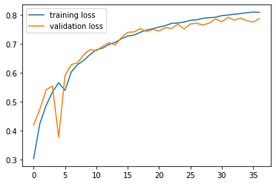

epoch started: 38

23:15:36.350971

training acc : 0.81172 loss : tensor(0.5024, device='cuda:0', grad_fn=<NllLossBackward>)

training epoch ended: 23:15:58.902300

validation error acc : 0.7825 loss : tensor(0.3731, device='cuda:0', grad_fn=<NllLossBackward>)

validation epoch ended: 23:16:01.286518

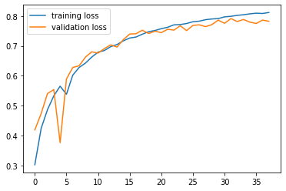

epoch started: 39

23:16:01.439254

training acc : 0.81486 loss : tensor(0.4896, device='cuda:0', grad_fn=<NllLossBackward>)

training epoch ended: 23:16:24.278811

validation error acc : 0.7898 loss : tensor(0.3689, device='cuda:0', grad_fn=<NllLossBackward>)

validation epoch ended: 23:16:26.678866

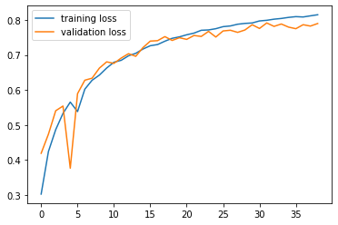

epoch started: 40

23:16:26.840772

training acc : 0.81434 loss : tensor(0.5030, device='cuda:0', grad_fn=<NllLossBackward>)

training epoch ended: 23:16:49.471945

validation error acc : 0.7938 loss : tensor(0.3403, device='cuda:0', grad_fn=<NllLossBackward>)

validation epoch ended: 23:16:51.878500

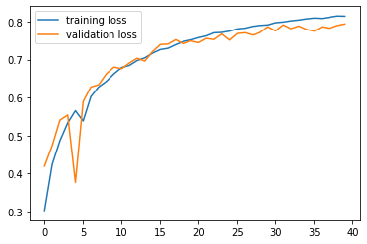

epoch started: 41

23:16:52.037154

training acc : 0.81896 loss : tensor(0.3798, device='cuda:0', grad_fn=<NllLossBackward>)

training epoch ended: 23:17:14.678377

validation error acc : 0.791 loss : tensor(0.2263, device='cuda:0', grad_fn=<NllLossBackward>)

validation epoch ended: 23:17:17.134599

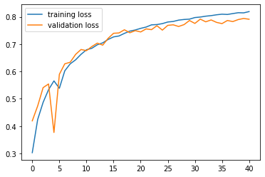

epoch started: 42

23:17:17.292730

training acc : 0.82086 loss : tensor(0.5216, device='cuda:0', grad_fn=<NllLossBackward>)

training epoch ended: 23:17:39.914698

validation error acc : 0.7996 loss : tensor(0.7053, device='cuda:0', grad_fn=<NllLossBackward>)

validation epoch ended: 23:17:42.352913

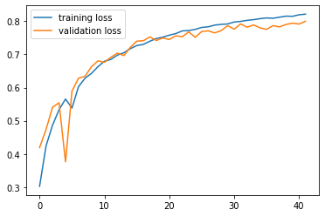

epoch started: 43

23:17:42.502212

training acc : 0.821 loss : tensor(0.4439, device='cuda:0', grad_fn=<NllLossBackward>)

training epoch ended: 23:18:05.267903

validation error acc : 0.775 loss : tensor(0.4249, device='cuda:0', grad_fn=<NllLossBackward>)

validation epoch ended: 23:18:07.705970

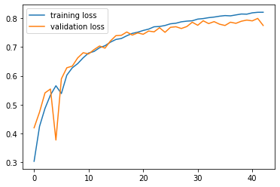

epoch started: 44

23:18:07.848029

training acc : 0.82362 loss : tensor(0.4216, device='cuda:0', grad_fn=<NllLossBackward>)

training epoch ended: 23:18:30.413398

validation error acc : 0.7781 loss : tensor(0.5082, device='cuda:0', grad_fn=<NllLossBackward>)

validation epoch ended: 23:18:32.806064

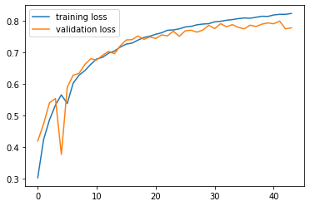

epoch started: 45

23:18:32.947672

training acc : 0.82546 loss : tensor(0.4323, device='cuda:0', grad_fn=<NllLossBackward>)

training epoch ended: 23:18:55.513403

validation error acc : 0.7983 loss : tensor(0.6429, device='cuda:0', grad_fn=<NllLossBackward>)

validation epoch ended: 23:18:57.926392

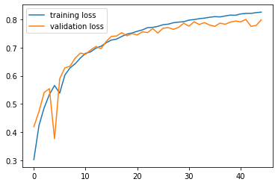

epoch started: 46

23:18:58.089643

training acc : 0.82706 loss : tensor(0.4670, device='cuda:0', grad_fn=<NllLossBackward>)

training epoch ended: 23:19:20.642823

validation error acc : 0.7937 loss : tensor(0.5006, device='cuda:0', grad_fn=<NllLossBackward>)

validation epoch ended: 23:19:23.016003

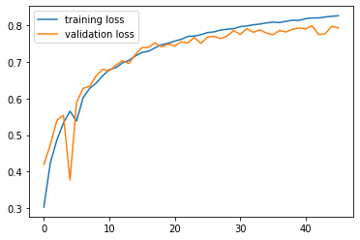

epoch started: 47

23:19:23.154795

training acc : 0.8288 loss : tensor(0.3245, device='cuda:0', grad_fn=<NllLossBackward>)

training epoch ended: 23:19:45.461295

validation error acc : 0.7907 loss : tensor(0.2182, device='cuda:0', grad_fn=<NllLossBackward>)

validation epoch ended: 23:19:47.837991

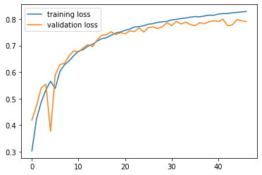

epoch started: 48

23:19:47.987643

training acc : 0.82806 loss : tensor(0.4414, device='cuda:0', grad_fn=<NllLossBackward>)

training epoch ended: 23:20:10.435800

validation error acc : 0.7976 loss : tensor(0.2863, device='cuda:0', grad_fn=<NllLossBackward>)

validation epoch ended: 23:20:12.811138

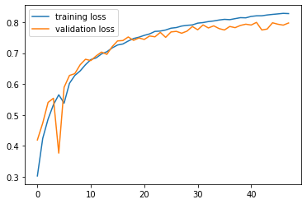

epoch started: 49

23:20:12.960847

training acc : 0.83042 loss : tensor(0.5858, device='cuda:0', grad_fn=<NllLossBackward>)

training epoch ended: 23:20:35.468872

validation error acc : 0.7877 loss : tensor(0.1897, device='cuda:0', grad_fn=<NllLossBackward>)

validation epoch ended: 23:20:37.861171

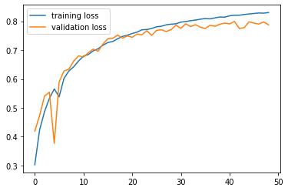

epoch started: 50

23:20:38.012285

training acc : 0.83224 loss : tensor(0.5041, device='cuda:0', grad_fn=<NllLossBackward>)

training epoch ended: 23:21:00.515347

validation error acc : 0.7885 loss : tensor(0.4849, device='cuda:0', grad_fn=<NllLossBackward>)

validation epoch ended: 23:21:02.937993

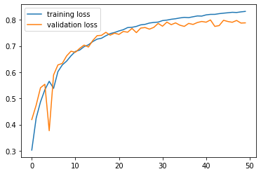

epoch started: 51

23:21:03.085341

training acc : 0.83392 loss : tensor(0.6441, device='cuda:0', grad_fn=<NllLossBackward>)

training epoch ended: 23:21:25.579484

validation error acc : 0.7949 loss : tensor(0.4687, device='cuda:0', grad_fn=<NllLossBackward>)

validation epoch ended: 23:21:27.972294

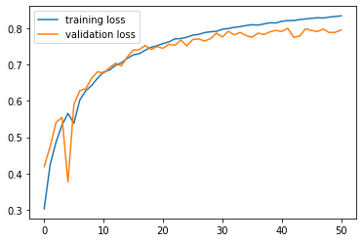

epoch started: 52

23:21:28.128289

training acc : 0.83372 loss : tensor(0.5361, device='cuda:0', grad_fn=<NllLossBackward>)

training epoch ended: 23:21:50.762491

validation error acc : 0.7694 loss : tensor(0.4079, device='cuda:0', grad_fn=<NllLossBackward>)

validation epoch ended: 23:21:53.124104

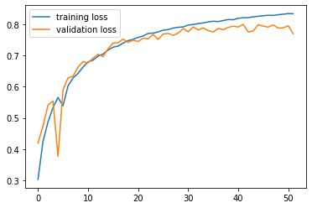

epoch started: 53

23:21:53.271822

training acc : 0.83512 loss : tensor(0.3294, device='cuda:0', grad_fn=<NllLossBackward>)

training epoch ended: 23:22:15.630785

validation error acc : 0.7992 loss : tensor(0.7105, device='cuda:0', grad_fn=<NllLossBackward>)

validation epoch ended: 23:22:18.013668

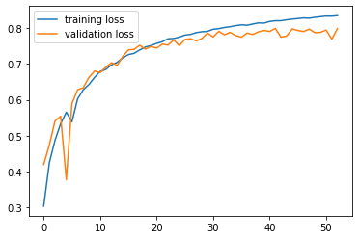

epoch started: 54

23:22:18.168738

training acc : 0.83684 loss : tensor(0.3853, device='cuda:0', grad_fn=<NllLossBackward>)

training epoch ended: 23:22:40.592059

validation error acc : 0.798 loss : tensor(0.7090, device='cuda:0', grad_fn=<NllLossBackward>)

validation epoch ended: 23:22:42.940020

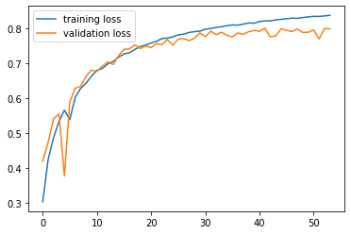

epoch started: 55

23:22:43.085324

training acc : 0.83998 loss : tensor(0.3453, device='cuda:0', grad_fn=<NllLossBackward>)

training epoch ended: 23:23:05.405068

validation error acc : 0.7963 loss : tensor(0.5197, device='cuda:0', grad_fn=<NllLossBackward>)

validation epoch ended: 23:23:07.811050

