tensor(761993, device='cuda:0')

391 / 79

epoch started: 1

22:09:00.675564

training acc : 0.42726 loss : tensor(1.3894, device='cuda:0', grad_fn=<NllLossBackward>)

training epoch ended: 22:09:31.520709

validation error acc : 0.5542 loss : tensor(1.3644, device='cuda:0', grad_fn=<NllLossBackward>)

validation epoch ended: 22:09:33.912480

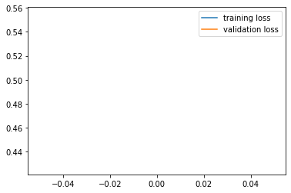

epoch started: 2

22:09:34.081397

training acc : 0.6382 loss : tensor(0.8582, device='cuda:0', grad_fn=<NllLossBackward>)

training epoch ended: 22:10:05.053458

validation error acc : 0.6531 loss : tensor(0.6401, device='cuda:0', grad_fn=<NllLossBackward>)

validation epoch ended: 22:10:07.499252

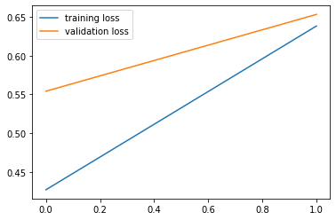

epoch started: 3

22:10:07.639704

training acc : 0.72146 loss : tensor(0.7114, device='cuda:0', grad_fn=<NllLossBackward>)

training epoch ended: 22:10:38.786536

validation error acc : 0.719 loss : tensor(0.6341, device='cuda:0', grad_fn=<NllLossBackward>)

validation epoch ended: 22:10:41.182256

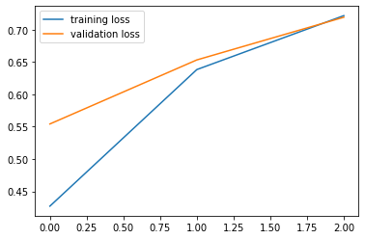

epoch started: 4

22:10:41.339452

training acc : 0.76164 loss : tensor(0.8376, device='cuda:0', grad_fn=<NllLossBackward>)

training epoch ended: 22:11:12.415170

validation error acc : 0.7333 loss : tensor(0.5708, device='cuda:0', grad_fn=<NllLossBackward>)

validation epoch ended: 22:11:14.843838

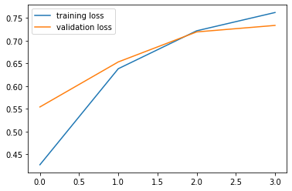

epoch started: 5

22:11:14.998496

training acc : 0.78558 loss : tensor(0.6492, device='cuda:0', grad_fn=<NllLossBackward>)

training epoch ended: 22:11:46.068585

validation error acc : 0.7307 loss : tensor(0.7083, device='cuda:0', grad_fn=<NllLossBackward>)

validation epoch ended: 22:11:48.481401

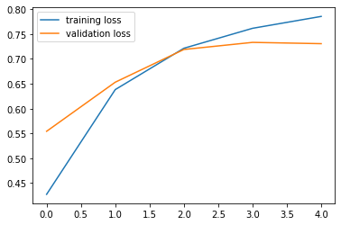

epoch started: 6

22:11:48.637955

training acc : 0.79438 loss : tensor(0.5314, device='cuda:0', grad_fn=<NllLossBackward>)

training epoch ended: 22:12:19.731806

validation error acc : 0.7687 loss : tensor(0.5098, device='cuda:0', grad_fn=<NllLossBackward>)

validation epoch ended: 22:12:22.092892

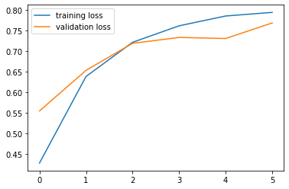

epoch started: 7

22:12:22.244602

training acc : 0.80834 loss : tensor(0.5665, device='cuda:0', grad_fn=<NllLossBackward>)

training epoch ended: 22:12:53.403554

validation error acc : 0.7506 loss : tensor(0.8812, device='cuda:0', grad_fn=<NllLossBackward>)

validation epoch ended: 22:12:55.805529

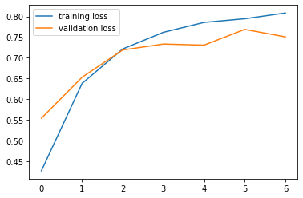

epoch started: 8

22:12:55.970161

training acc : 0.81418 loss : tensor(0.5162, device='cuda:0', grad_fn=<NllLossBackward>)

training epoch ended: 22:13:27.055940

validation error acc : 0.7464 loss : tensor(0.5770, device='cuda:0', grad_fn=<NllLossBackward>)

validation epoch ended: 22:13:29.432855

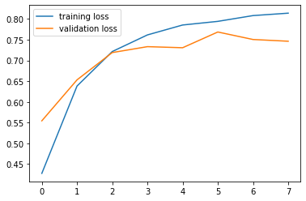

epoch started: 9

22:13:29.583235

training acc : 0.81924 loss : tensor(0.6015, device='cuda:0', grad_fn=<NllLossBackward>)

training epoch ended: 22:14:00.644747

validation error acc : 0.7574 loss : tensor(0.6895, device='cuda:0', grad_fn=<NllLossBackward>)

validation epoch ended: 22:14:03.049540

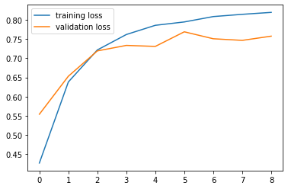

epoch started: 10

22:14:03.213920

training acc : 0.82442 loss : tensor(0.6281, device='cuda:0', grad_fn=<NllLossBackward>)

training epoch ended: 22:14:34.291362

validation error acc : 0.7995 loss : tensor(0.5040, device='cuda:0', grad_fn=<NllLossBackward>)

validation epoch ended: 22:14:36.732429

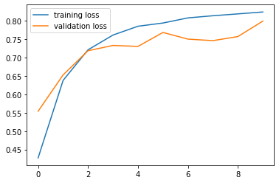

epoch started: 11

22:14:36.873574

training acc : 0.8267 loss : tensor(0.4236, device='cuda:0', grad_fn=<NllLossBackward>)

training epoch ended: 22:15:07.942697

validation error acc : 0.7651 loss : tensor(0.9193, device='cuda:0', grad_fn=<NllLossBackward>)

validation epoch ended: 22:15:10.389644

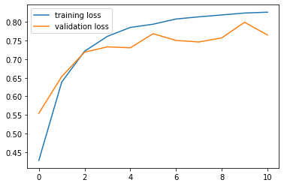

epoch started: 12

22:15:10.545762

training acc : 0.8332 loss : tensor(0.7495, device='cuda:0', grad_fn=<NllLossBackward>)

training epoch ended: 22:15:41.608320

validation error acc : 0.7831 loss : tensor(0.7064, device='cuda:0', grad_fn=<NllLossBackward>)

validation epoch ended: 22:15:44.052862

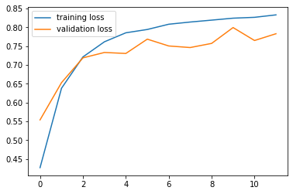

epoch started: 13

22:15:44.210513

training acc : 0.834 loss : tensor(0.5543, device='cuda:0', grad_fn=<NllLossBackward>)

training epoch ended: 22:16:15.265285

validation error acc : 0.8087 loss : tensor(0.6002, device='cuda:0', grad_fn=<NllLossBackward>)

validation epoch ended: 22:16:17.702542

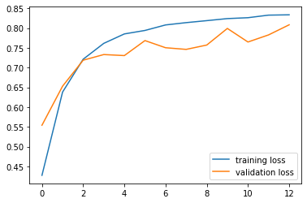

epoch started: 14

22:16:17.851918

training acc : 0.83966 loss : tensor(0.5257, device='cuda:0', grad_fn=<NllLossBackward>)

training epoch ended: 22:16:48.965872

validation error acc : 0.7611 loss : tensor(0.5174, device='cuda:0', grad_fn=<NllLossBackward>)

validation epoch ended: 22:16:51.417304

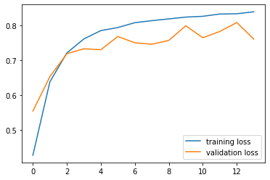

epoch started: 15

22:16:51.554664

training acc : 0.84058 loss : tensor(0.6904, device='cuda:0', grad_fn=<NllLossBackward>)

training epoch ended: 22:17:22.664590

validation error acc : 0.7655 loss : tensor(0.5497, device='cuda:0', grad_fn=<NllLossBackward>)

validation epoch ended: 22:17:25.142487

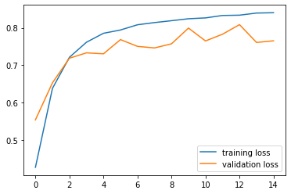

epoch started: 16

22:17:25.280844

training acc : 0.84168 loss : tensor(0.7006, device='cuda:0', grad_fn=<NllLossBackward>)

training epoch ended: 22:17:56.325729

validation error acc : 0.7703 loss : tensor(0.5448, device='cuda:0', grad_fn=<NllLossBackward>)

validation epoch ended: 22:17:58.795921

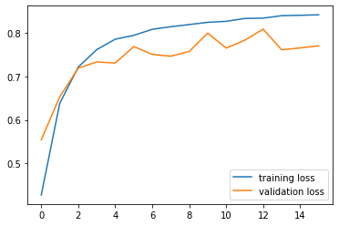

epoch started: 17

22:17:58.944517

training acc : 0.8452 loss : tensor(0.3597, device='cuda:0', grad_fn=<NllLossBackward>)

training epoch ended: 22:18:30.055466

validation error acc : 0.1101 loss : tensor(15.9524, device='cuda:0', grad_fn=<NllLossBackward>)

validation epoch ended: 22:18:32.482007

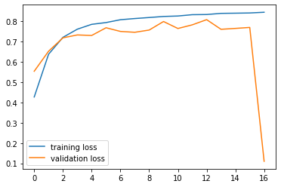

epoch started: 18

22:18:32.637045

training acc : 0.84332 loss : tensor(0.5002, device='cuda:0', grad_fn=<NllLossBackward>)

training epoch ended: 22:19:03.790086

validation error acc : 0.8158 loss : tensor(0.6039, device='cuda:0', grad_fn=<NllLossBackward>)

validation epoch ended: 22:19:06.243570

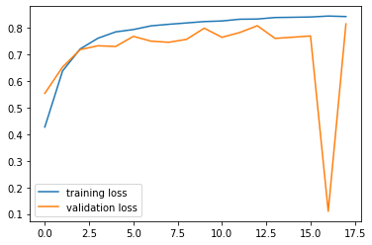

epoch started: 19

22:19:06.408689

training acc : 0.84932 loss : tensor(0.4844, device='cuda:0', grad_fn=<NllLossBackward>)

training epoch ended: 22:19:37.586803

validation error acc : 0.8062 loss : tensor(0.4098, device='cuda:0', grad_fn=<NllLossBackward>)

validation epoch ended: 22:19:40.064721

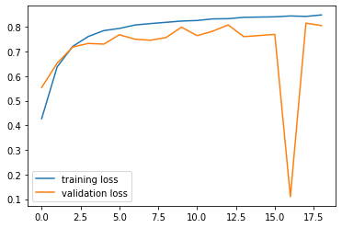

epoch started: 20

22:19:40.227109

training acc : 0.84746 loss : tensor(0.4098, device='cuda:0', grad_fn=<NllLossBackward>)

training epoch ended: 22:20:11.281843

validation error acc : 0.8079 loss : tensor(0.7825, device='cuda:0', grad_fn=<NllLossBackward>)

validation epoch ended: 22:20:13.796235

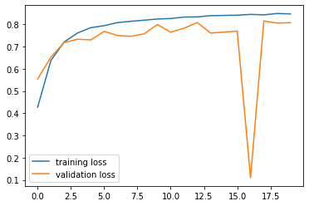

epoch started: 21

22:20:13.967759

training acc : 0.8479 loss : tensor(0.5390, device='cuda:0', grad_fn=<NllLossBackward>)

training epoch ended: 22:20:45.056275

validation error acc : 0.8081 loss : tensor(0.3712, device='cuda:0', grad_fn=<NllLossBackward>)

validation epoch ended: 22:20:47.528074

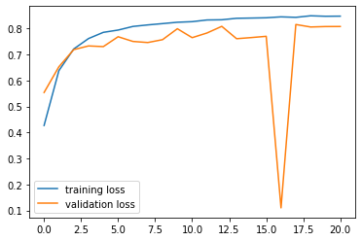

epoch started: 22

22:20:47.679464

training acc : 0.85164 loss : tensor(0.3914, device='cuda:0', grad_fn=<NllLossBackward>)

training epoch ended: 22:21:18.765485

validation error acc : 0.7681 loss : tensor(0.8913, device='cuda:0', grad_fn=<NllLossBackward>)

validation epoch ended: 22:21:21.242012

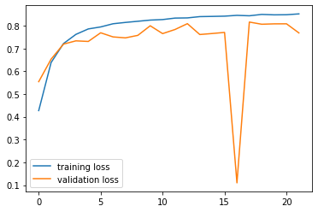

epoch started: 23

22:21:21.386346

training acc : 0.85254 loss : tensor(0.3789, device='cuda:0', grad_fn=<NllLossBackward>)

training epoch ended: 22:21:52.464522

validation error acc : 0.7887 loss : tensor(0.8280, device='cuda:0', grad_fn=<NllLossBackward>)

validation epoch ended: 22:21:54.867055

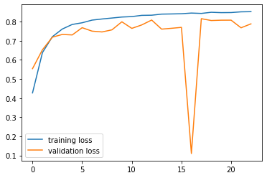

epoch started: 24

22:21:55.011798

training acc : 0.8517 loss : tensor(0.4051, device='cuda:0', grad_fn=<NllLossBackward>)

training epoch ended: 22:22:26.082772

validation error acc : 0.8164 loss : tensor(0.3661, device='cuda:0', grad_fn=<NllLossBackward>)

validation epoch ended: 22:22:28.457199

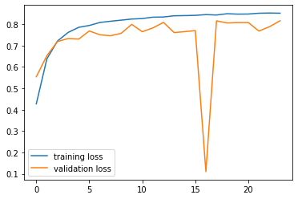

epoch started: 25

22:22:28.604769

training acc : 0.85188 loss : tensor(0.5757, device='cuda:0', grad_fn=<NllLossBackward>)

training epoch ended: 22:22:59.658437

validation error acc : 0.8226 loss : tensor(0.9474, device='cuda:0', grad_fn=<NllLossBackward>)

validation epoch ended: 22:23:02.102543

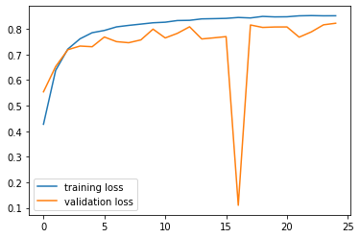

epoch started: 26

22:23:02.253791

training acc : 0.85494 loss : tensor(0.5554, device='cuda:0', grad_fn=<NllLossBackward>)

training epoch ended: 22:23:33.288309

validation error acc : 0.7705 loss : tensor(0.6989, device='cuda:0', grad_fn=<NllLossBackward>)

validation epoch ended: 22:23:35.695010

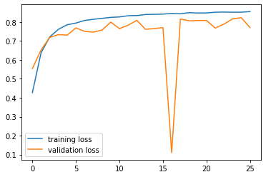

epoch started: 27

22:23:35.844491

training acc : 0.8521 loss : tensor(0.3103, device='cuda:0', grad_fn=<NllLossBackward>)

training epoch ended: 22:24:06.877427

validation error acc : 0.8054 loss : tensor(0.6417, device='cuda:0', grad_fn=<NllLossBackward>)

validation epoch ended: 22:24:09.308674

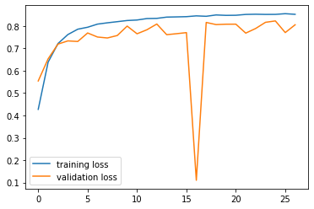

epoch started: 28

22:24:09.454951

training acc : 0.85814 loss : tensor(0.3752, device='cuda:0', grad_fn=<NllLossBackward>)

training epoch ended: 22:24:40.478126

validation error acc : 0.806 loss : tensor(0.3511, device='cuda:0', grad_fn=<NllLossBackward>)

validation epoch ended: 22:24:42.895291

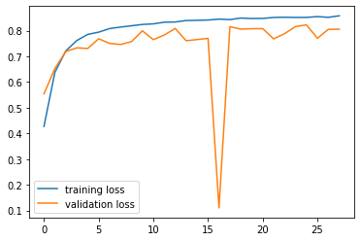

epoch started: 29

22:24:43.056847

training acc : 0.85694 loss : tensor(0.5082, device='cuda:0', grad_fn=<NllLossBackward>)

training epoch ended: 22:25:14.004001

validation error acc : 0.7997 loss : tensor(0.5958, device='cuda:0', grad_fn=<NllLossBackward>)

validation epoch ended: 22:25:16.427540

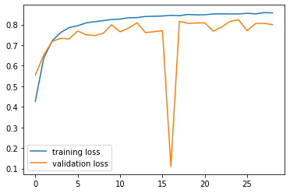

epoch started: 30

22:25:16.585875

training acc : 0.85612 loss : tensor(0.2362, device='cuda:0', grad_fn=<NllLossBackward>)

training epoch ended: 22:25:47.589410

validation error acc : 0.8021 loss : tensor(0.6934, device='cuda:0', grad_fn=<NllLossBackward>)

validation epoch ended: 22:25:50.089226

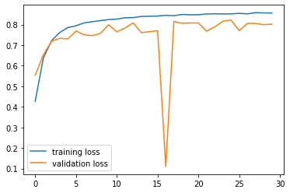

epoch started: 31

22:25:50.253659

training acc : 0.85506 loss : tensor(0.3730, device='cuda:0', grad_fn=<NllLossBackward>)

training epoch ended: 22:26:21.234353

validation error acc : 0.7623 loss : tensor(0.4387, device='cuda:0', grad_fn=<NllLossBackward>)

validation epoch ended: 22:26:23.835476

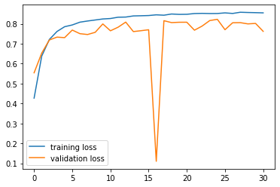

epoch started: 32

22:26:24.086489

training acc : 0.85602 loss : tensor(0.5532, device='cuda:0', grad_fn=<NllLossBackward>)

training epoch ended: 22:26:55.058070

validation error acc : 0.8089 loss : tensor(0.3389, device='cuda:0', grad_fn=<NllLossBackward>)

validation epoch ended: 22:26:57.568568

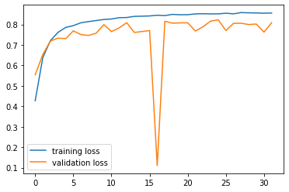

epoch started: 33

22:26:57.727172

training acc : 0.85686 loss : tensor(0.3003, device='cuda:0', grad_fn=<NllLossBackward>)

training epoch ended: 22:27:28.736538

validation error acc : 0.7505 loss : tensor(0.5949, device='cuda:0', grad_fn=<NllLossBackward>)

validation epoch ended: 22:27:31.278712

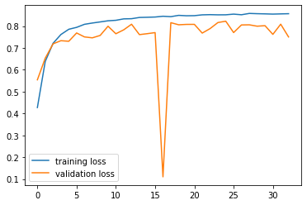

epoch started: 34

22:27:31.437752

training acc : 0.85912 loss : tensor(0.3632, device='cuda:0', grad_fn=<NllLossBackward>)

training epoch ended: 22:28:02.429018

validation error acc : 0.7673 loss : tensor(0.9272, device='cuda:0', grad_fn=<NllLossBackward>)

validation epoch ended: 22:28:04.921126

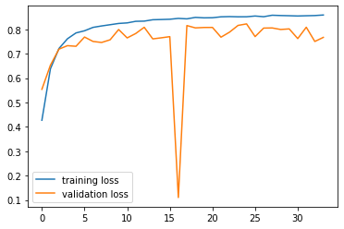

epoch started: 35

22:28:05.081994

training acc : 0.85976 loss : tensor(0.4567, device='cuda:0', grad_fn=<NllLossBackward>)

training epoch ended: 22:28:36.092339

validation error acc : 0.7211 loss : tensor(0.6473, device='cuda:0', grad_fn=<NllLossBackward>)

validation epoch ended: 22:28:38.505684

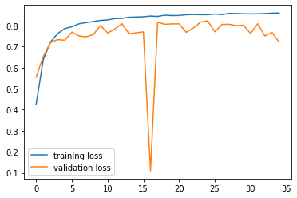

epoch started: 36

22:28:38.656702

training acc : 0.86042 loss : tensor(0.4657, device='cuda:0', grad_fn=<NllLossBackward>)

training epoch ended: 22:29:09.677757

validation error acc : 0.7219 loss : tensor(0.7755, device='cuda:0', grad_fn=<NllLossBackward>)

validation epoch ended: 22:29:12.132194

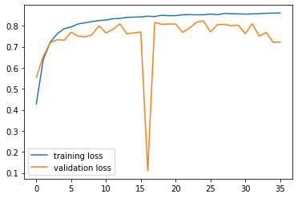

epoch started: 37

22:29:12.285388

training acc : 0.85782 loss : tensor(0.4305, device='cuda:0', grad_fn=<NllLossBackward>)

training epoch ended: 22:29:43.241687

validation error acc : 0.7819 loss : tensor(0.7113, device='cuda:0', grad_fn=<NllLossBackward>)

validation epoch ended: 22:29:45.658947

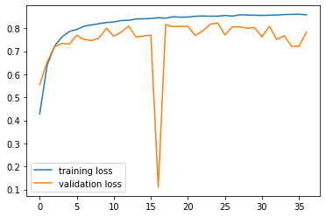

epoch started: 38

22:29:45.826164

training acc : 0.85854 loss : tensor(0.5014, device='cuda:0', grad_fn=<NllLossBackward>)

training epoch ended: 22:30:16.767842

validation error acc : 0.7923 loss : tensor(0.8751, device='cuda:0', grad_fn=<NllLossBackward>)

validation epoch ended: 22:30:19.200435

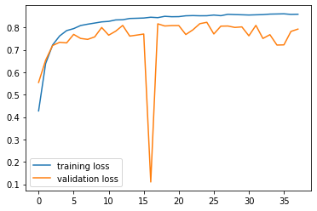

epoch started: 39

22:30:19.357222

training acc : 0.8571 loss : tensor(0.2163, device='cuda:0', grad_fn=<NllLossBackward>)

training epoch ended: 22:30:50.309619

validation error acc : 0.8079 loss : tensor(0.3917, device='cuda:0', grad_fn=<NllLossBackward>)

validation epoch ended: 22:30:52.784645

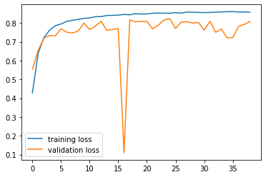

epoch started: 40

22:30:52.943907

training acc : 0.8598 loss : tensor(0.3887, device='cuda:0', grad_fn=<NllLossBackward>)

training epoch ended: 22:31:23.867107

validation error acc : 0.7774 loss : tensor(0.9045, device='cuda:0', grad_fn=<NllLossBackward>)

validation epoch ended: 22:31:26.277163

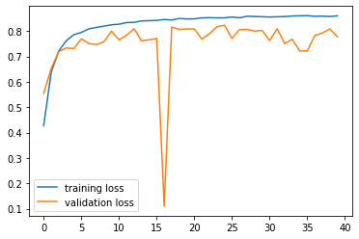

epoch started: 41

22:31:26.437566

training acc : 0.86118 loss : tensor(0.5051, device='cuda:0', grad_fn=<NllLossBackward>)

training epoch ended: 22:31:57.401427

validation error acc : 0.5356 loss : tensor(2.1018, device='cuda:0', grad_fn=<NllLossBackward>)

validation epoch ended: 22:31:59.852800

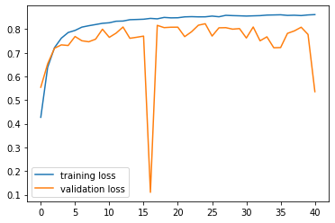

epoch started: 42

22:32:00.009353

training acc : 0.8599 loss : tensor(0.3229, device='cuda:0', grad_fn=<NllLossBackward>)

training epoch ended: 22:32:30.988883

validation error acc : 0.7229 loss : tensor(1.1077, device='cuda:0', grad_fn=<NllLossBackward>)

validation epoch ended: 22:32:33.393632

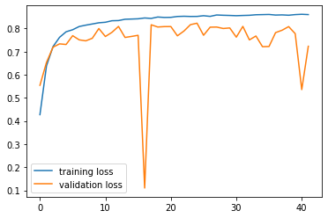

epoch started: 43

22:32:33.531814

training acc : 0.86218 loss : tensor(0.3870, device='cuda:0', grad_fn=<NllLossBackward>)

training epoch ended: 22:33:04.606662

validation error acc : 0.8111 loss : tensor(0.6319, device='cuda:0', grad_fn=<NllLossBackward>)

validation epoch ended: 22:33:07.036638

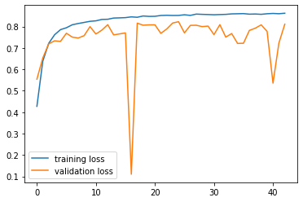

epoch started: 44

22:33:07.183123

training acc : 0.86346 loss : tensor(0.4524, device='cuda:0', grad_fn=<NllLossBackward>)

training epoch ended: 22:33:38.158025

validation error acc : 0.803 loss : tensor(0.5159, device='cuda:0', grad_fn=<NllLossBackward>)

validation epoch ended: 22:33:40.584032

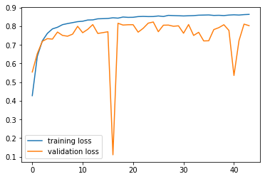

epoch started: 45

22:33:40.738451

training acc : 0.86082 loss : tensor(0.4979, device='cuda:0', grad_fn=<NllLossBackward>)

training epoch ended: 22:34:11.641193

validation error acc : 0.7827 loss : tensor(0.7781, device='cuda:0', grad_fn=<NllLossBackward>)

validation epoch ended: 22:34:14.043715

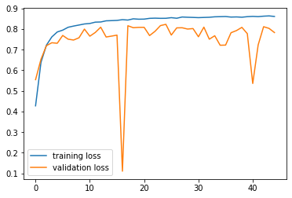

epoch started: 46

22:34:14.193861

training acc : 0.86296 loss : tensor(0.3184, device='cuda:0', grad_fn=<NllLossBackward>)

training epoch ended: 22:34:45.108305

validation error acc : 0.6795 loss : tensor(0.9137, device='cuda:0', grad_fn=<NllLossBackward>)

validation epoch ended: 22:34:47.496299

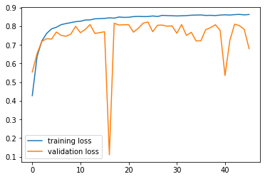

epoch started: 47

22:34:47.643449

training acc : 0.86508 loss : tensor(0.4254, device='cuda:0', grad_fn=<NllLossBackward>)

training epoch ended: 22:35:18.618726

validation error acc : 0.8131 loss : tensor(1.2239, device='cuda:0', grad_fn=<NllLossBackward>)

validation epoch ended: 22:35:21.087480

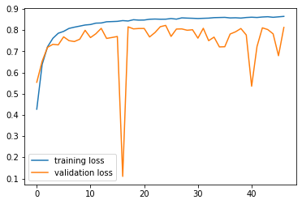

epoch started: 48

22:35:21.232422

training acc : 0.86286 loss : tensor(0.4488, device='cuda:0', grad_fn=<NllLossBackward>)

training epoch ended: 22:35:52.176763

validation error acc : 0.7849 loss : tensor(0.4856, device='cuda:0', grad_fn=<NllLossBackward>)

validation epoch ended: 22:35:54.622723

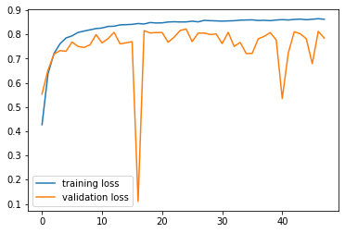

epoch started: 49

22:35:54.779468

training acc : 0.86316 loss : tensor(0.4498, device='cuda:0', grad_fn=<NllLossBackward>)

training epoch ended: 22:36:25.686892

validation error acc : 0.5266 loss : tensor(3.2600, device='cuda:0', grad_fn=<NllLossBackward>)

validation epoch ended: 22:36:28.085154

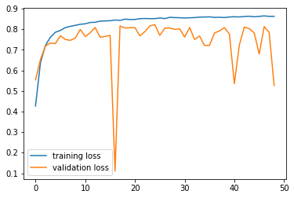

epoch started: 50

22:36:28.233998

training acc : 0.85904 loss : tensor(0.4551, device='cuda:0', grad_fn=<NllLossBackward>)

training epoch ended: 22:36:59.183992

validation error acc : 0.7887 loss : tensor(0.4818, device='cuda:0', grad_fn=<NllLossBackward>)

validation epoch ended: 22:37:01.572916

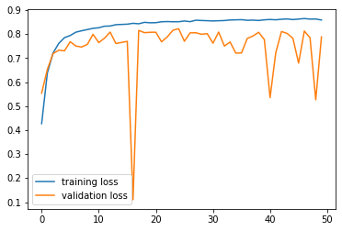

epoch started: 51

22:37:01.731605

training acc : 0.86408 loss : tensor(0.5665, device='cuda:0', grad_fn=<NllLossBackward>)

training epoch ended: 22:37:32.667164

validation error acc : 0.7442 loss : tensor(1.0649, device='cuda:0', grad_fn=<NllLossBackward>)

validation epoch ended: 22:37:35.148120

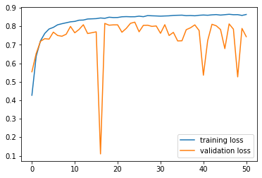

epoch started: 52

22:37:35.298173

training acc : 0.8622 loss : tensor(0.4941, device='cuda:0', grad_fn=<NllLossBackward>)

training epoch ended: 22:38:06.268441

validation error acc : 0.7786 loss : tensor(0.3639, device='cuda:0', grad_fn=<NllLossBackward>)

validation epoch ended: 22:38:08.636754

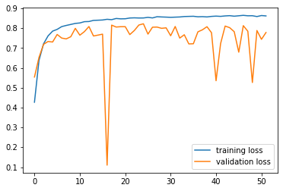

epoch started: 53

22:38:08.786503

training acc : 0.86274 loss : tensor(0.5911, device='cuda:0', grad_fn=<NllLossBackward>)

training epoch ended: 22:38:39.735645

validation error acc : 0.7665 loss : tensor(0.9469, device='cuda:0', grad_fn=<NllLossBackward>)

validation epoch ended: 22:38:42.127068

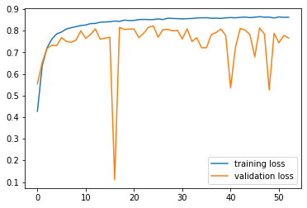

epoch started: 54

22:38:42.278696

training acc : 0.86586 loss : tensor(0.2487, device='cuda:0', grad_fn=<NllLossBackward>)

training epoch ended: 22:39:13.230719

validation error acc : 0.6927 loss : tensor(1.3365, device='cuda:0', grad_fn=<NllLossBackward>)

validation epoch ended: 22:39:15.603539

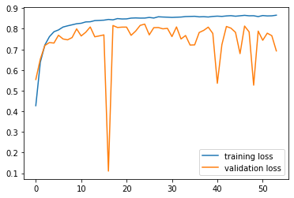

epoch started: 55

22:39:15.757106

training acc : 0.85062 loss : tensor(0.5050, device='cuda:0', grad_fn=<NllLossBackward>)

training epoch ended: 22:39:46.699394

validation error acc : 0.6256 loss : tensor(1.9909, device='cuda:0', grad_fn=<NllLossBackward>)

validation epoch ended: 22:39:49.094778

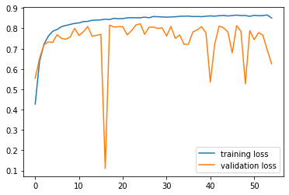

epoch started: 56

22:39:49.245469

training acc : 0.86124 loss : tensor(0.3404, device='cuda:0', grad_fn=<NllLossBackward>)

training epoch ended: 22:40:20.045368

validation error acc : 0.788 loss : tensor(0.7661, device='cuda:0', grad_fn=<NllLossBackward>)

validation epoch ended: 22:40:22.474548

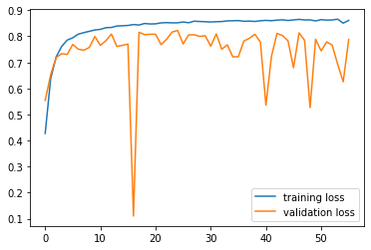

epoch started: 57

22:40:22.642188

training acc : 0.85084 loss : tensor(0.5212, device='cuda:0', grad_fn=<NllLossBackward>)

training epoch ended: 22:40:53.476875

validation error acc : 0.778 loss : tensor(0.8023, device='cuda:0', grad_fn=<NllLossBackward>)

validation epoch ended: 22:40:55.896671

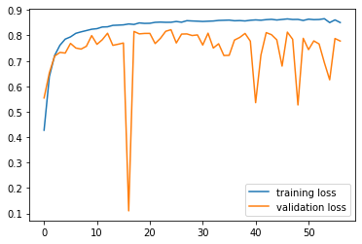

epoch started: 58

22:40:56.074401

training acc : 0.85692 loss : tensor(0.5089, device='cuda:0', grad_fn=<NllLossBackward>)

training epoch ended: 22:41:26.993646

validation error acc : 0.716 loss : tensor(1.4936, device='cuda:0', grad_fn=<NllLossBackward>)

validation epoch ended: 22:41:29.362530

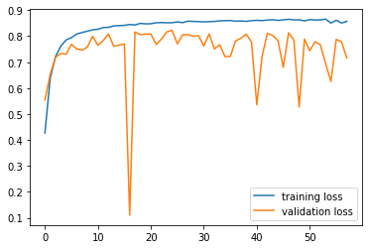

epoch started: 59

22:41:29.517268

training acc : 0.85742 loss : tensor(0.4299, device='cuda:0', grad_fn=<NllLossBackward>)

training epoch ended: 22:42:00.416094

validation error acc : 0.8247 loss : tensor(0.3341, device='cuda:0', grad_fn=<NllLossBackward>)

validation epoch ended: 22:42:02.791637

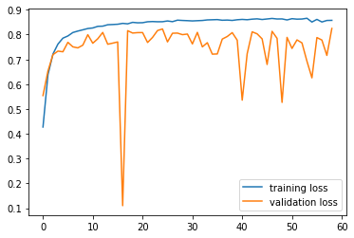

epoch started: 60

22:42:02.951000

training acc : 0.86368 loss : tensor(0.3664, device='cuda:0', grad_fn=<NllLossBackward>)

training epoch ended: 22:42:33.805783

validation error acc : 0.815 loss : tensor(0.5076, device='cuda:0', grad_fn=<NllLossBackward>)

validation epoch ended: 22:42:36.190747

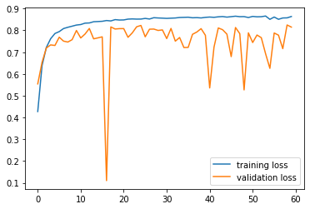

epoch started: 61

22:42:36.349920

training acc : 0.85958 loss : tensor(0.3948, device='cuda:0', grad_fn=<NllLossBackward>)

training epoch ended: 22:43:07.250953

validation error acc : 0.7493 loss : tensor(0.7299, device='cuda:0', grad_fn=<NllLossBackward>)

validation epoch ended: 22:43:09.622881

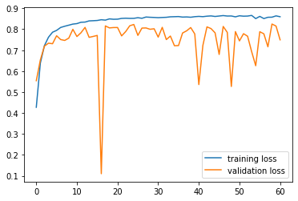

epoch started: 62

22:43:09.776287

training acc : 0.85988 loss : tensor(0.4740, device='cuda:0', grad_fn=<NllLossBackward>)

training epoch ended: 22:43:40.668176

validation error acc : 0.7614 loss : tensor(0.8159, device='cuda:0', grad_fn=<NllLossBackward>)

validation epoch ended: 22:43:43.084558

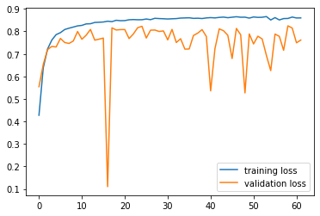

epoch started: 63

22:43:43.245830

training acc : 0.86074 loss : tensor(0.4499, device='cuda:0', grad_fn=<NllLossBackward>)

training epoch ended: 22:44:14.074674

validation error acc : 0.822 loss : tensor(0.5956, device='cuda:0', grad_fn=<NllLossBackward>)

validation epoch ended: 22:44:16.490750

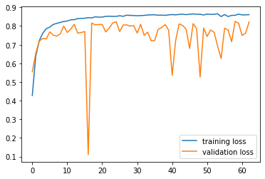

epoch started: 64

22:44:16.660710

training acc : 0.86388 loss : tensor(0.4864, device='cuda:0', grad_fn=<NllLossBackward>)

training epoch ended: 22:44:47.464932

validation error acc : 0.8014 loss : tensor(0.7123, device='cuda:0', grad_fn=<NllLossBackward>)

validation epoch ended: 22:44:49.917868

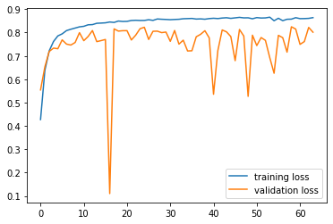

epoch started: 65

22:44:50.071600

training acc : 0.86012 loss : tensor(0.3522, device='cuda:0', grad_fn=<NllLossBackward>)

training epoch ended: 22:45:20.902538

validation error acc : 0.7407 loss : tensor(0.5695, device='cuda:0', grad_fn=<NllLossBackward>)

validation epoch ended: 22:45:23.387682

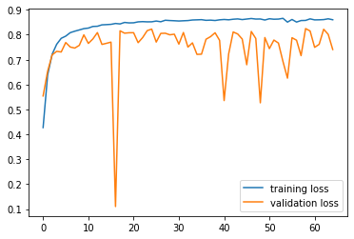

epoch started: 66

22:45:23.544283

training acc : 0.86522 loss : tensor(0.4293, device='cuda:0', grad_fn=<NllLossBackward>)

training epoch ended: 22:45:54.412793

validation error acc : 0.6702 loss : tensor(1.4538, device='cuda:0', grad_fn=<NllLossBackward>)

validation epoch ended: 22:45:56.814160

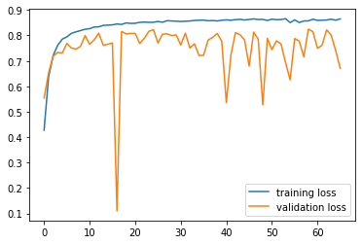

epoch started: 67

22:45:56.970242

training acc : 0.86448 loss : tensor(0.2987, device='cuda:0', grad_fn=<NllLossBackward>)

training epoch ended: 22:46:27.944491

validation error acc : 0.7396 loss : tensor(0.6744, device='cuda:0', grad_fn=<NllLossBackward>)

validation epoch ended: 22:46:30.282996

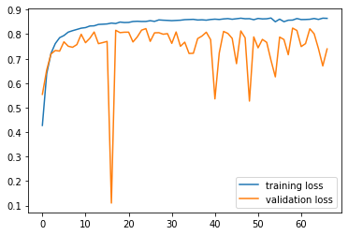

epoch started: 68

22:46:30.430554

training acc : 0.86228 loss : tensor(0.3618, device='cuda:0', grad_fn=<NllLossBackward>)

training epoch ended: 22:47:01.329232

validation error acc : 0.8184 loss : tensor(0.5269, device='cuda:0', grad_fn=<NllLossBackward>)

validation epoch ended: 22:47:03.753566

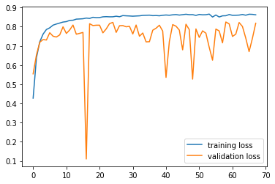

epoch started: 69

22:47:03.917294

training acc : 0.8627 loss : tensor(0.3865, device='cuda:0', grad_fn=<NllLossBackward>)

training epoch ended: 22:47:34.825029

validation error acc : 0.425 loss : tensor(2.7196, device='cuda:0', grad_fn=<NllLossBackward>)

validation epoch ended: 22:47:37.256158

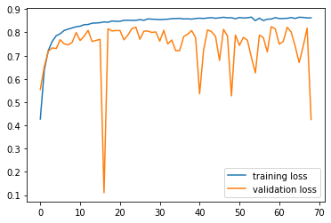

epoch started: 70

22:47:37.415808

training acc : 0.85954 loss : tensor(0.7126, device='cuda:0', grad_fn=<NllLossBackward>)

training epoch ended: 22:48:08.347016

validation error acc : 0.5233 loss : tensor(3.3839, device='cuda:0', grad_fn=<NllLossBackward>)

validation epoch ended: 22:48:10.751561

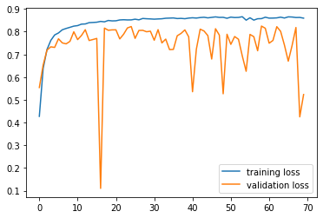

epoch started: 71

22:48:10.919103

training acc : 0.85796 loss : tensor(0.3179, device='cuda:0', grad_fn=<NllLossBackward>)

training epoch ended: 22:48:41.815797

validation error acc : 0.7578 loss : tensor(0.5506, device='cuda:0', grad_fn=<NllLossBackward>)

validation epoch ended: 22:48:44.259012

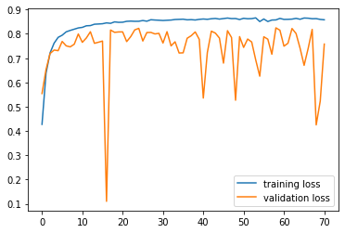

epoch started: 72

22:48:44.423195

training acc : 0.85952 loss : tensor(0.4637, device='cuda:0', grad_fn=<NllLossBackward>)

training epoch ended: 22:49:15.283398

validation error acc : 0.7804 loss : tensor(0.5334, device='cuda:0', grad_fn=<NllLossBackward>)

validation epoch ended: 22:49:17.723919

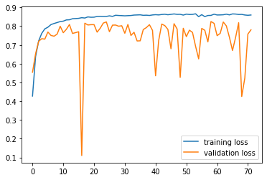

epoch started: 73

22:49:17.880216

training acc : 0.85816 loss : tensor(0.4023, device='cuda:0', grad_fn=<NllLossBackward>)

training epoch ended: 22:49:48.760250

validation error acc : 0.746 loss : tensor(1.2029, device='cuda:0', grad_fn=<NllLossBackward>)

validation epoch ended: 22:49:51.201231

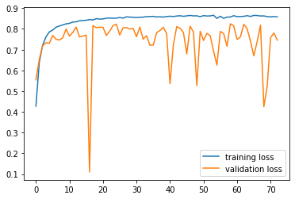

epoch started: 74

22:49:51.365394

training acc : 0.8551 loss : tensor(0.5322, device='cuda:0', grad_fn=<NllLossBackward>)

training epoch ended: 22:50:22.266148

validation error acc : 0.6326 loss : tensor(1.6631, device='cuda:0', grad_fn=<NllLossBackward>)

validation epoch ended: 22:50:24.772658

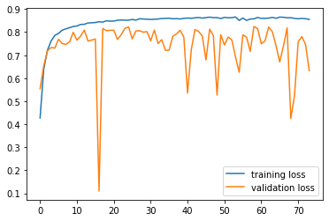

epoch started: 75

22:50:24.929630

training acc : 0.85018 loss : tensor(0.7993, device='cuda:0', grad_fn=<NllLossBackward>)

training epoch ended: 22:50:55.834504

validation error acc : 0.8311 loss : tensor(0.4131, device='cuda:0', grad_fn=<NllLossBackward>)

validation epoch ended: 22:50:58.255707

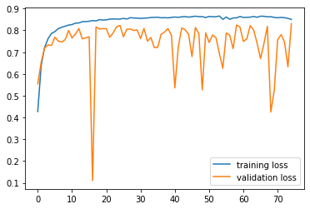

epoch started: 76

22:50:58.414192

training acc : 0.85502 loss : tensor(0.4486, device='cuda:0', grad_fn=<NllLossBackward>)

training epoch ended: 22:51:29.227067

validation error acc : 0.8353 loss : tensor(0.4965, device='cuda:0', grad_fn=<NllLossBackward>)

validation epoch ended: 22:51:31.648864

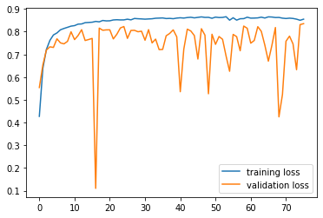

epoch started: 77

22:51:31.808920

training acc : 0.85498 loss : tensor(0.4939, device='cuda:0', grad_fn=<NllLossBackward>)

training epoch ended: 22:52:02.628886

validation error acc : 0.8172 loss : tensor(0.4036, device='cuda:0', grad_fn=<NllLossBackward>)

validation epoch ended: 22:52:05.042753

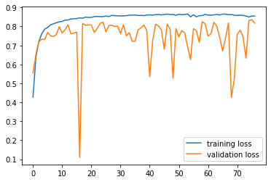

epoch started: 78

22:52:05.214079

training acc : 0.85666 loss : tensor(0.3237, device='cuda:0', grad_fn=<NllLossBackward>)

training epoch ended: 22:52:36.170350

validation error acc : 0.8222 loss : tensor(0.5112, device='cuda:0', grad_fn=<NllLossBackward>)

validation epoch ended: 22:52:38.659974

