**Creating a custom module**

In this guide, we will create a simple custom module that will add a person’s name and age to a file which resides on webserver1.

For this task, we will have below playbook:

-

name: Test Jinja2 Templating

hosts: webserver1

tasks:

- userdata: name=Gaurav age=18

Inside tasks, **userdata**will be the custom module which we will define in python language as userdata.py which takes arguments **name**and **age**. The name of the custom module and the filename should be the same.

Let’s have a look at the userdata.py script:

#!/usr/bin/python

import json

from ansible.module_utils.basic import AnsibleModule

import sys

def main():

module = AnsibleModule(

argument_spec = dict(

name = dict(required=True, type='str'),

age = dict(required=True, type='str'),

)

)

name = module.params['name']

age = module.params['age']

data = dict(

output="your data has stored successfully :-) ",

)

try:

file = open("/tmp/userdata.txt","r")

file.write(name+ "," + age + "\n")

module.exit_json(changed=True, success=data,msg=data)

except Exception as e:

module.fail_json(msg='something went wrong. :-(')

if __name__ == '__main__':

main()

In this script, we have to import AnsibleModule. And we need to define the variables **name** and **age**.

The output of this file on successful execution has to be defined in JSON format.

This python script will -

Open the “/tmp/userdata.txt” file in **write**mode

Write **name**and **age**in it

And will throw an exception in case of any error

**Running the playbook with Custom module**

**Prerequisites:**

By default, Ansible uses the modules from its default location. To make it use the custom module that you created, set the path of the module script by exporting it using below command:

export ANSIBLE_LIBRARY=</path/to/module script>

Once the custom module path is set, run the playbook using below command:

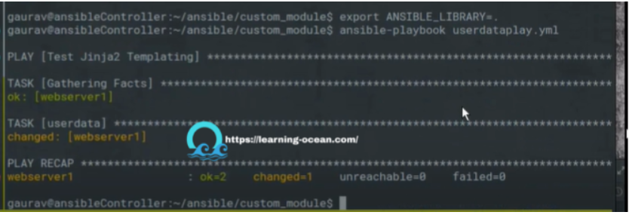

Verifying the same:

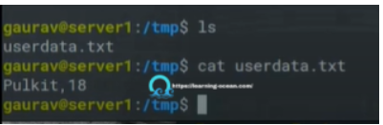

You can check more in detail about the custom modules in Ansible Documentation. There is much more that can be done with custom modules.