📋 Trading Discipline Guidelines Document

✅ General Trading Rules
1. Avoid Expiry Day Index Option Trades
- Do not trade in NIFTY/BANKNIFTY options on expiry day.
- Reason: Higher volatility and unpredictable price action, which can lead to rapid stop-loss hits and emotional decisions.

📊 India VIX Monitoring Strategy

🔍 India VIX Chart

🟥 Volatile VIX (Risky Zone) like below chart
- VIX shows frequent sharp ups and downs (like in chart above).
- Reflects uncertainty and sudden moves in the market.
- ⚠️ Do not overtrade.
- ⚠️ Expect more SL hits and unexpected reversals.
- ⚠️ Trade with reduced lot size and tighter SL.

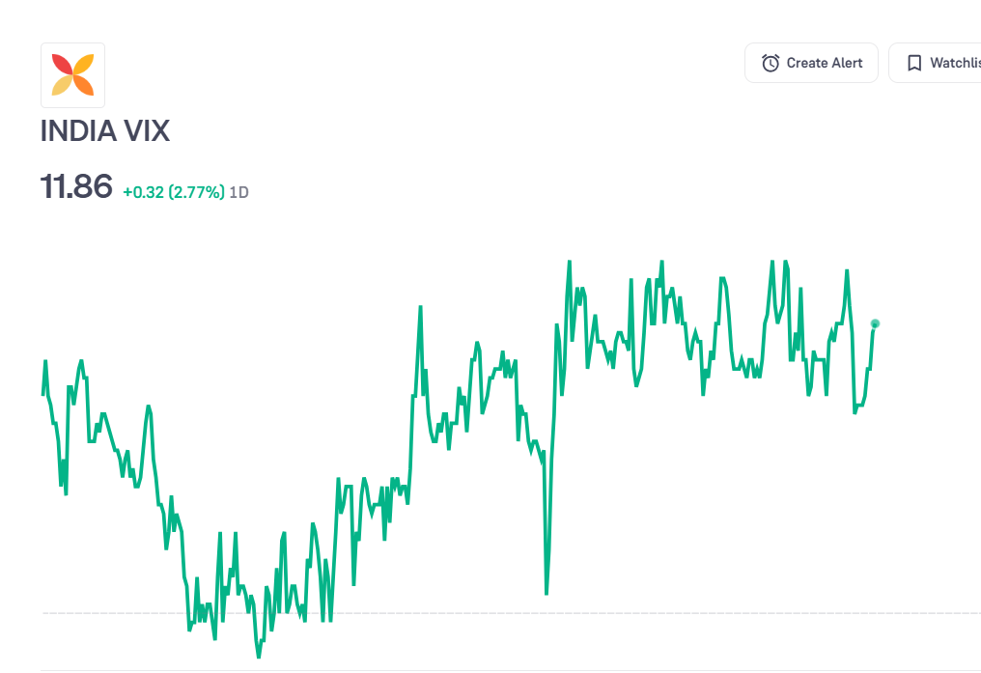

🟩 Stable VIX (Safe Zone) like below chart
- VIX value remains range-bound or moves smoothly.
- Indicates stable market conditions.
- ✅ Safe to trade.
- ✅ You may take slightly more trades with confidence.
- ✅ SL hits are less frequent.
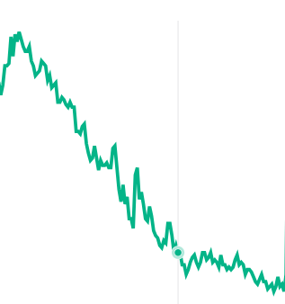

🧠 Discipline During Trading
1. Avoid Frequent Trades
- Enter a position, then pause and observe market behavior.
- Trade less, but with more accuracy.
2. Mid-Day Halts
- After 2-3 trades, take a break and re-evaluate.
- Don’t enter impulsive trades due to FOMO or revenge trading.
3. Focus on Direction
- Use tools like moving averages or trend indicators to confirm direction before placing trades.

💡 Tips for Consistency
- Track VIX daily before markets open.
- Use alerts for VIX crossing certain thresholds (e.g., above 13 or below 11).
- Maintain a trading journal to log VIX vs. trade success rate.

