**LAB ASSIGNMENT-03**

1. To find Largest of Three Numbers

#!/bin/bash

read -p "Enter first number: " a

read -p "Enter second number: " b

read -p "Enter third number: " c

if (( a >= b && a >= c )); then

echo "$a is the largest."

elif (( b >= a && b >= c )); then

echo "$b is the largest."

else

echo "$c is the largest."

Fi

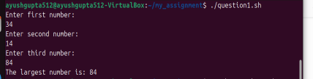

1. To find a year is leap year or not.

#!/bin/bash

read -p "Enter a year: " year

if (( (year % 4 == 0 && year % 100 != 0) || (year % 400 == 0) )); then

echo "$year is a leap year."

else

echo "$year is not a leap year."

Fi

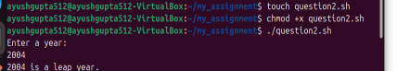

1. To input angles of a triangle and find out whether it is valid triangle or not

#!/bin/bash

read -p "Enter angle1: " a

read -p "Enter angle2: " b

read -p "Enter angle3: " c

sum=$((a + b + c))

if (( sum == 180 && a > 0 && b > 0 && c > 0 )); then

echo "Valid Triangle"

else

echo "In**valid** Triangle"

**fi**

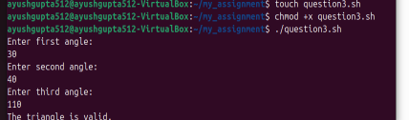

1. To check whether a character is alphabet, digit or special character.

#!/bin/bash

read -p "Enter a character: " ch

if [[ $ch =~ [A-Za-z] ]]; then

echo "Alphabet"

elif [[ $ch =~ [0-9] ]]; then

echo "Digit"

else

echo "Special Character"

fi



1. To calculate profit or loss

#!/bin/bash

read -p "Enter cost price: " cp

read -p "Enter selling price: " sp

if (( sp>cp )); then

echo "Profit of $((sp - cp))"

elif (( sp<cp )); then

echo "Loss of $((cp - sp))"

else

echo "No Profit No Loss"

fi

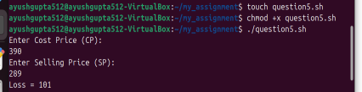

1. To print all even and odd number from 1 to 10

#!/bin/bash

echo "Even numbers:"

fori in {1..10}; do

if (( i % 2 == 0 )); then

echo -n "$i "

fi

done

echo -e "\nOdd numbers:"

fori in {1..10}; do

if (( i % 2 != 0 )); then

echo -n "$i "

fi

done

echo

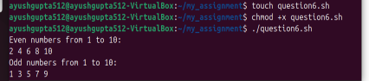

1. To print table of a given number

#!/bin/bash

read -p "Enter a number: " n

fori in {1..10}; do

echo "$n x $i = $((n * i))"

done

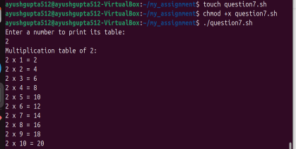

1. To find factorial of a given integer

#!/bin/bash

read -p "Enter a number: " num

fact=1

for ((i=1; i<=num; i++)); do

fact=$((fact * i))

done

echo "Factorial of $num is $fact"

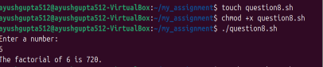

1. To print sum of all even numbers from 1 to 10.

#!/bin/bash

sum=0

fori in {1..10}; do

if (( i % 2 == 0 )); then

sum=$((sum + i))

fi

done

echo "Sum of even numbers from 1 to 10 is $sum**"**



1. To print sum of digit of any number.

#!/bin/bash

read -p "Enter a number: " num

sum=0

while (( num> 0 )); do

digit=$((num % 10))

sum=$((sum + digit))

num=$((num / 10))

done

echo "Sum of digits is $sum"

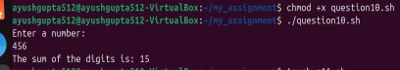

11. To make a basic calculator which performs addition, subtraction, Multiplication,

Division

#!/bin/bash

echo "Enter two numbers:"

read a

read b

echo "Choose operation: + - * /"

read op

case $op in

+) echo "$a + $b = $((a + b))" ;;

-) echo "$a - $b = $((a - b))" ;;

\*) echo "$a * $b = $((a * b))" ;;

/) echo "$a / $b = $((a / b))" ;;

*) echo "Invalid operation" ;;

Esac

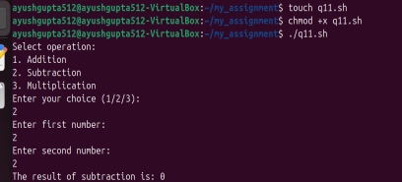

1. To print days of a week.

#!/bin/bash

days=("Sunday" "Monday" "Tuesday" "Wednesday" "Thursday" "Friday" "Saturday")

for day in "${days[@]}"; do

echo "$day"

done

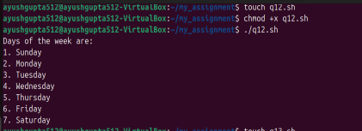

13. To print starting 4 months having 31 days.

#!/bin/bash

months=("January" "March" "May" "July")

echo "Months with 31 days:"

for month in "${months[@]}"; do

echo "$month"

done

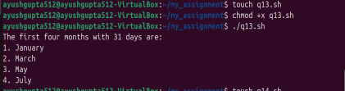

14. Using functions,

a. To find given number is Amstrong number or not

#!/bin/bash

is_armstrong() {

num=$1

sum=0

temp=$num

while (( temp > 0 )); do

digit=$((temp % 10))

sum=$((sum + digit * digit * digit))

temp=$((temp / 10))

done

if (( sum == num )); then

echo "$num is an Armstrong number."

else

echo "$num is not an Armstrong number."

fi

}

read -p "Enter a number: " n

is_armstrong $n

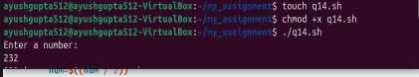

b. To find whether a number is palindrome or not

#!/bin/bash

is_palindrome() {

num=$1

rev=0

temp=$num

while (( temp > 0 )); do

digit=$((temp % 10))

rev=$((rev * 10 + digit))

temp=$((temp / 10))

done

if (( rev == num )); then

echo "$num is a palindrome."

else

echo "$num is not a palindrome."

fi

}

read -p "Enter a number: " n

is_palindrome $n



c. To print Fibonacci series upto n terms  
#!/bin/bash

fibonacci() {

n=$1

a=0

b=1

echo "Fibonacci series up to $n terms:"

for (( i=0; i<n; i++ )); do

echo -n "$a "

fn=$((a + b))

a=$b

b=$fn

done

echo

}

read -p "Enter number of terms: " n

fibonacci $n

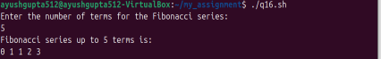

d. To find given number is prime or composite

#!/bin/bash

is_prime() {

num=$1

if (( num<= 1 )); then

echo "$num is neither prime nor composite."

return

fi

for (( i=2; i*i<=num; i++ )); do

if (( num % i == 0 )); then

echo "$num is composite."

return

fi

done

echo "$num is prime."

}

read -p "Enter a number: " n

is_prime $n

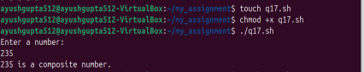

e. To convert a given decimal number to binary equivalent

#!/bin/bash

decimal_to_binary() {

num=$1

binary=""

while (( num> 0 )); do

binary=$((num % 2))$binary

num=$((num / 2))

done

echo "Binary: $binary"

}

read -p "Enter decimal number: " n

decimal_to_binary $n

