**LAB ASSIGNMNET-2**

**Part 1:**

**Outputs the following commands:**

**1.pwd 2.cd 3. ls 4.mkdir**

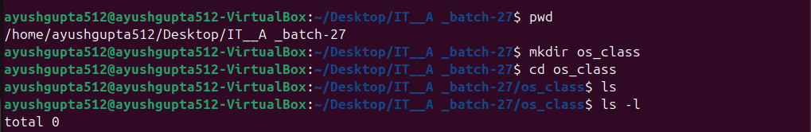

**5.rm**



**6.touch 7.hostname 8. Cat 9.echo**

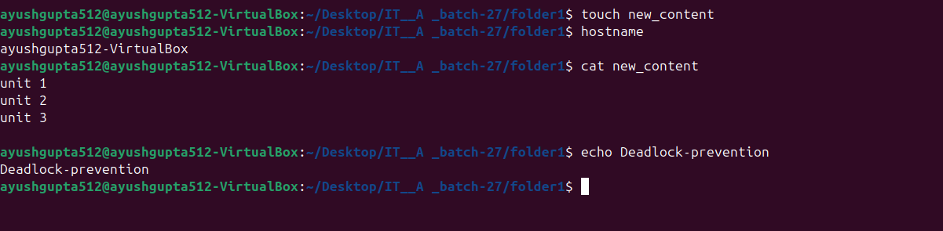

**10. chmod 11.mv**

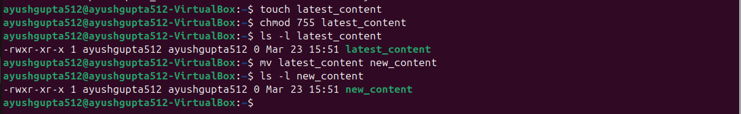

**12. grep 13. Fgrep**

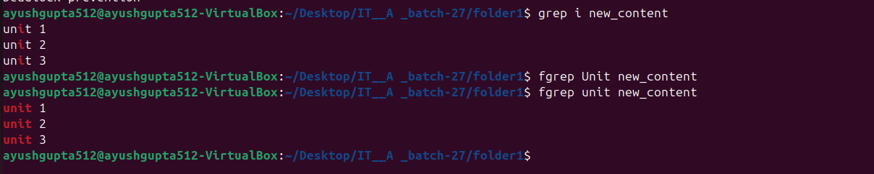

**14. cp 15. More 16. Less**



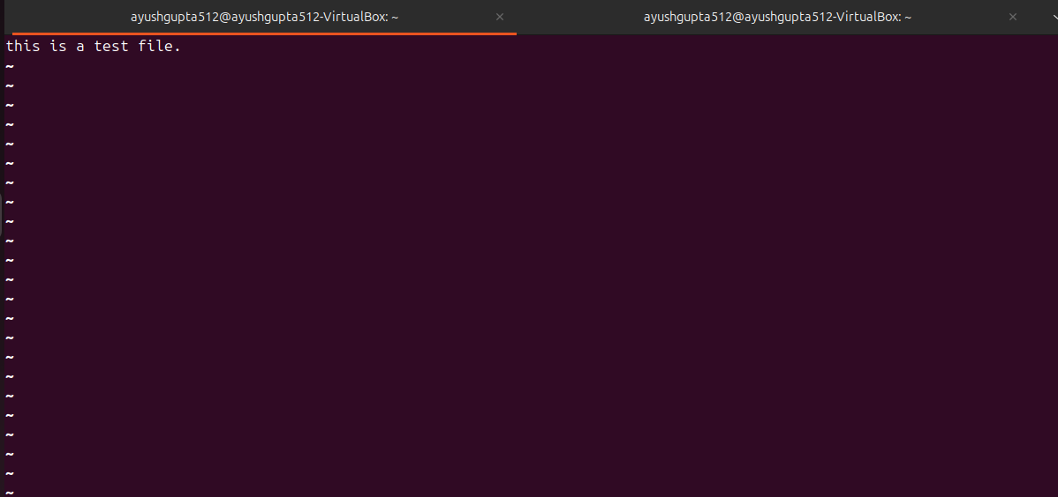

**17.wc 18.awk 19. head 20. tail**

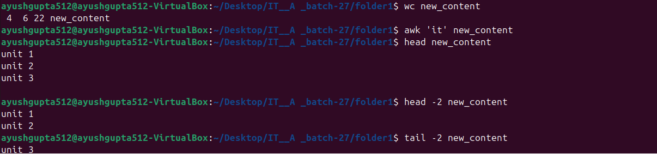

**Part 2:**

1. How to navigate to a Specific Directory?

* You can use the cd(change directory)command:

cd /path/ to /directory

* To navigate to the home directory:

cd ~

* To go up one directory level:

cd ..

2. How to see detailed information about files and directories using ls?

* You can use ls –l to get a detailed listing:

ls -l

* To also include hidden files(those starting with a dot),use:

ls -la

3. How to create multiple directories in Linux using 'mkdir command?

* You can create multiple directories withone command like this:

mkdir dir1 dir2 dir3

* To create a parent directory and its subdirectories in one go:

mkdir –p parent/child1 parent/child2

4. How to remove multiple files at once with rm?

* You can remove multiple files by specifying them:

rm file1 file2 file3

* To remove all files in a directory(use with caution):

rm *

5. Can rm be used to delete directories?

* yes rm can delete directories ,but you need to use the –r(recursive) option:

rm –r directory_name

6. How Do You Copy Files and Directories in Linux?

* To copy files:

Cp source_file destination_file

* To copy directories recursively:

Cp -r source_directory destination_directory

7. How to Rename a file in Linux Using the mv Command?

* You can rename a file using mv:

mv old_filename new_filename

8. How to Move Multiple files in Linux Using mv Command?

* You can move multiple files at once:

mv file1 file2 file3 destination_directory

9. How to Create Multiple Empty Files by Using Touch Command in Linux ?

* You can create multiple empty files with:

touch file1 file2 file3

10. How to View the Content of Multiple Files in Linux ?

* You can use the cat command to view the content:

Cat file1 file2 file 3

* Alternatively use less or more for large files:

Less file1 file2 file3

11. How to Create a file and add content in Linux Using cat Command ?

* You can create a new file and add content with cat:

Cat > filename

* Then type the command and press ctrl+D to save and exit.

12. How to Append the Contents of One File to the End of Another File using cat command ?

* Use the >> operator to append:

cat file1 >> file2

13. How to use cat command if the file has a lot of content and can't fit in the terminal ?

* Use less or more with the cat command:

cat file | less

14. How to Merge Contents of Multiple Files Using 'cat' Command ?

* You can concatenate(merge) files using cat:

Cat file1 file2 > merged_file

15. How to use cat Command to Append to an Existing File ?

* You can append the output to an existing file:

cat file1 >> existing_file

16. What is "chmod 777", "chmod 755" and "chmod +x "or "chmod a+x"?

* chmod is used to change file permissions.
* chmod 777: Gives full read, write and execute permission to the owner, groups and others.
* chmod 755: Gives full permissions to the owner ,and read/execute permissions to the group and others.
* chmod +x

17. How to find the number of lines that matches the given string/pattern ?

* you can use grep with the –c option to count the number of matching lines:

grep -c “pattern” filename

* this will return the number of lines in the file that contain the pattern.

18. How to display the files that contains the given string/pattern?

* To search for files containing a pattern, you can use grep with the –l option:

grep -l “pattern” *

* This will list the names of all files that contain the given pattern in the current directory.

19. How to show the line number of file with the line matched?

* You can use grep with the –n option to display the line numbers of the matching lines:

grep -n “pattern” filename

* This will show each matching line along with its line number.

20. How to match the lines that start with a string using grep ?

* You can use grep with the ^ anchor to match lines that start with the string:

grep “ ^pattern “ filename

* This will match lines where the pattern appears at the beginning.

21. Can the 'sort' command be used to sort files in descending order by default?

* No, the sort command sorts files in ascending order by default. To sort in descending order, you need to use the -r (reverse) option:

sort -r filename

* This will sort the contents of the file in reverse (descending) order.

22. How can I sort a file based on a specific column using the 'sort' command?

* You can sort a file based on a specific column using the -k option to specify the column number:

sort -k < column_number> filename

* For example, to sort by the second column:

sort -k 2 filename

* If you want to sort numerically, use the -n option:

sort -k 2 -n filename

* You can also combine -r to sort in reverse order:

sort -k 2 -n -r filename

Top of Form

Bottom of Form