ENTERTANIER

INTRODUCTION:-

A **film**, also called a **movie**, **motion picture**, **moving picture**, **theatrical film**, or **photoplay**, is a series of still images that, when shown on a screen, create the illusion of moving images.

This optical illusion causes the audience to perceive continuous motion between separate objects viewed in rapid succession. The process of filmmaking is both an art and an industry. A film is created by photographing actual scenes with a motion-picture camera, by photographing drawings or miniature models using traditional animation techniques, by means of CGI and computer animation, or by a combination of some or all of these techniques, and other visual effects.

Entertanier is a APP to book your movie ticket that allows you to book your seat of any movie that you want to see in decided hall in your City.

This is the modern Era everybody likes to do task which is easy and Online booking is the easiest and secure task to do.This App is easy to handle and secure to use.

SCREEN 1:-

You Need To Open PROJECT.py file to starts this app.

This Page Gives Splash screen it gives the Information that who Worked on this app

To Go to next page you have to hover Cursor on the image of developer.

SCREEN 2:-

Welcome to the app this is the first Page of the App this is the Start page .

Here you have A picture just to empress the user to make interface look good

Below that you have 2 Buttons that Allows you either to book your ticket to view your booking status if you have Booked:--

To Book your ticket you Have to go to ‘START YOUR BOOKING’ Button.

Or

To Check you’re Booking history to have to go to “CHECK YOUR BOOKING STATUS” Button.

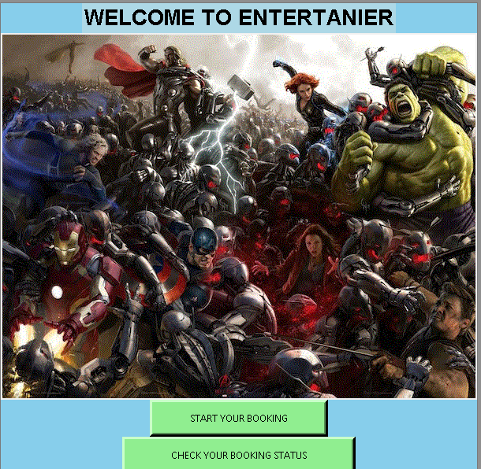

SCREEN 3:--

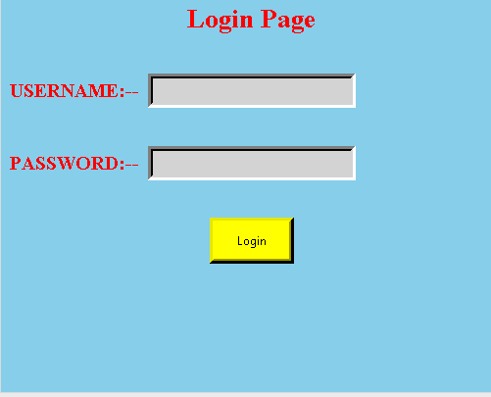

This is Screen 3 This is a Login page that allows you to login into the app

You cannot Leave these Entry empty,or any of the Entry Empty.

If Any of the Entry is left blank this Shows the Error message box

That Shows you that there is a box left blank.

After You Entry Login id and password it takes you to next screen.

Login Id = any(not fixed)

Password = any (not fixed)

Then press Button Login to go to next Screen to book your ticket.

SCREEN 4;--



This is The Page where you have to Enter the city in which to want to book your

TICKET.

After Entering the city name press Search that brings you to the next page.

SCREEN 5:--

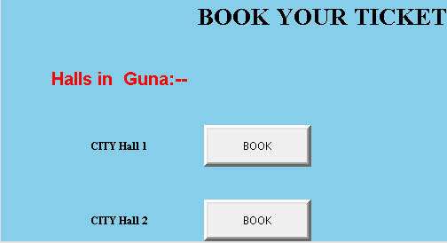

This Screen Show you How many halls are there in Your city then you have to decide in which hall you have want to book then press the BOOK button in front of the HALL no .

SCREEN 6:--

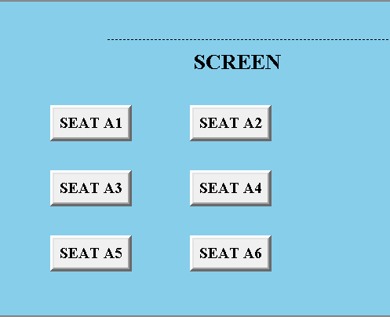

Press the seat no that you want to book.

SCREEN 7:-

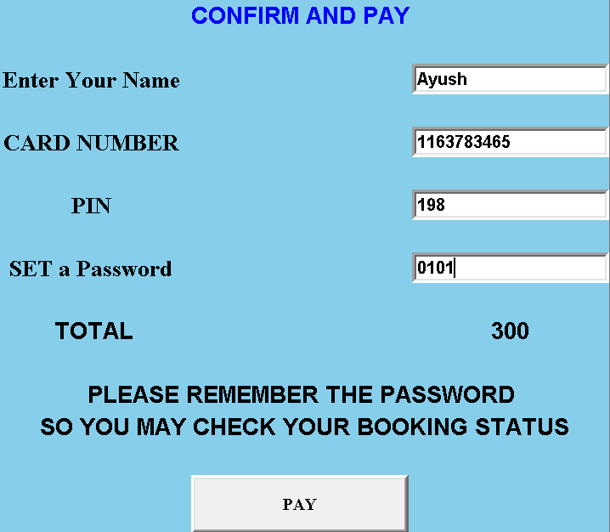

Enter your All details as demanded to book and pay.

THEN press Pay to BOOK your Ticket and remember the password that you put in the last entry because that is used in The time to checking status.

SCREEN 8:--



Go back in the home window by restarting app or if don’t closed it.

Then press CHECK YOUR BOOKING STATUS to check.

SCREEN 9:--

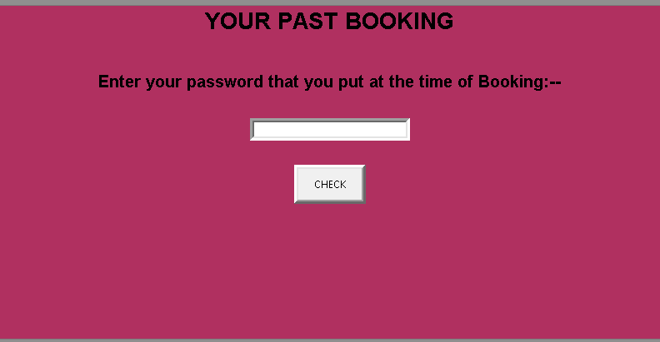

Enter the Password that you made at the time of payment and then press Check.

SCREEN 10:--

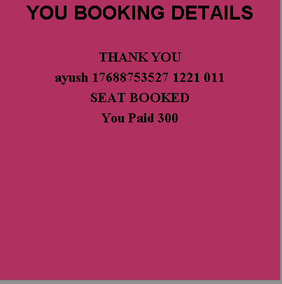

THIS is LAST Screen this show your Booking Histroy.

DATABASE:--

Project100.db is the file that contain my database.

Table name is Login19.

It contains:--

1. Name varchar(20)
2. Cardno number(15)
3. Pin number(15)
4. Password number(15)

The last Screen of booking Payment stores information in the table.

CREATED BY:--

AYUSH SRIVASTAVA

171B041

B2--BX