Freight Rate Model: Validation and Split Approach
Ayush Shekhar | Spotter ML Engineer assessment

1. Summary
The final model is a gradient-boosted tree model on log(rate) for the load-specific part (distance, pickup/delivery location, equipment, weight, quote_signal), plus a small linear term for the market level and a time trend. On out-of-time validation (train on the past, predict the next two months, five times) it averages 2.08% MAPE / $48 MAE, compared with 2.62% / $61 for the same GBM without the linear term. The final model was retrained on all clean January to October loads before predicting November and December.

2. How I split and validated the data
train_test.csv runs from 1 Jan to 31 Oct 2025, and validation.csv covers 1 Nov to 31 Dec 2025. So the real job is a forecast one to two months past the last label, and I set the validation up to look the same. A random K-fold split would put loads from the same day on both sides of the split. The model then picks up each day's market level from the training rows and looks better than it really is. I checked this: a random 5-fold CV gave about 1.8% MAPE for a model that scores about 3.0% when tested on later months.
I used a rolling-origin (expanding window) split. For each cutoff from 1 May to 1 Sep, the model is trained on every load before the cutoff and tested on the two calendar months after it. That gives five test windows (May-Jun through Sep-Oct). They cover months where the market was rising, peaking, falling and flat, so a model that only works in one regime shows up. Every model and feature choice below was made on these folds. I never looked at validation.csv predictions to tune anything.
There was one more thing to test. Eight cities (Allentown, Charlotte, Chicago, Jackson, Knoxville, Laredo, Norfolk, San Diego) only exist in validation.csv, and about 12% of the validation loads touch one of them. To check that case I removed 8 random cities completely from training (3 repeats), trained on data before September, and compared the error on Sep-Oct loads that touch those cities with loads that don't.
Metrics: MAPE is the main one because rates go from about $150 to over $8,000, and a $50 miss means very different things at each end. I also report MAE, RMSE and mean log bias, since a forecast that is systematically high or low is a separate problem from noisy predictions. Mislabelled rows (section 3) are excluded from the test folds too, so the numbers measure error against realistic rates.

3. Data issues I found and what I did
Issue | Handling
Wrong target values | 677 rows (1.4%) have a rate that is about 0.2-0.4x or 3-5x what the rest of the data says for that distance and equipment. There is nothing between 0.5x and 2x outside the main body, so these look like unit or data-entry errors, not real market moves. I flag them with an L1-loss GBM (outliers don't pull it around) where |log residual| > 0.4, and drop them from training.
Negative weight | 292 train / 145 validation rows. The absolute value behaves exactly like a normal weight, so I use abs(weight).
Capped weight | About 1,200 rows sit at exactly 47,500 lb and about 30 at 5,000 lb. These look like clip limits, so I kept them as they are.
Missing weight | 300 / 165 rows. Left as NaN. HistGradientBoosting learns its own branch for missing values.
Missing market_index | 374 / 249 rows. Filled with that day's mean index. The row value is basically the daily level plus noise.
Coordinates | Several coordinates are shifted or clipped (Boston and Providence both at lon -69.5, Laredo at lat 25.5, Shreveport and New Orleans only 7 miles apart). Each city still has exactly one coordinate pair, and rates follow the recorded distance column, so I trust distance and use lat/lon only as a relative location.
December chart inputs | This file has only city names and no market columns. I look up coordinates from the city table, and for each date I use that day's mean market_index and quote_signal from the validation loads.

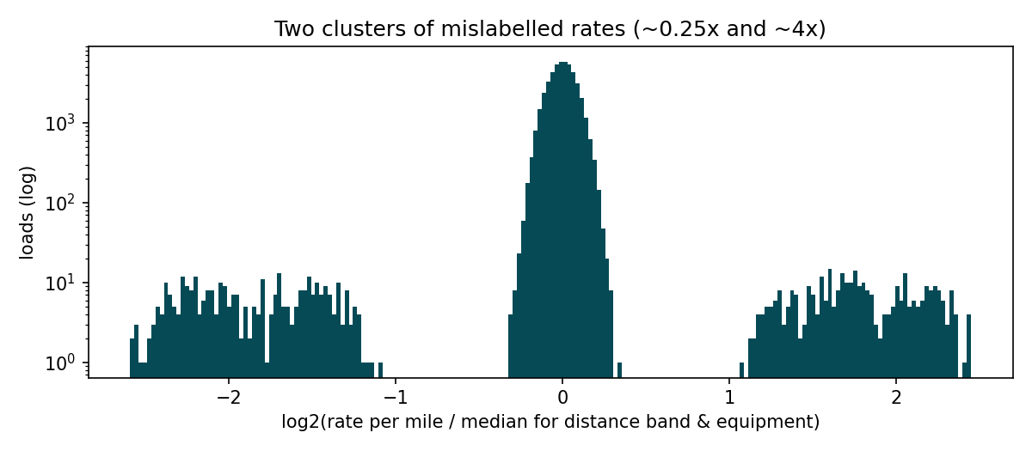
Rate per mile relative to the median for its distance band and equipment. The two small clusters far from 0 are the mislabelled rows.

4. What drives the rate
Distance is most of it. Rate per mile falls from about $2.6 under 250 miles to about $1.8 above 2,000 miles. Flatbed runs about 8% over dry van and reefer about 13%. Weight adds roughly 10% between 5k and 45k lb.
The time pattern is the interesting part. The average rate level of a day follows that day's mean market_index, and on top of that there is a slow upward drift of a few percent a year. Same-day index plus a linear trend explains about 80% of the day-to-day movement in rate level. I tried lagged and smoothed versions of the index and they added nothing.
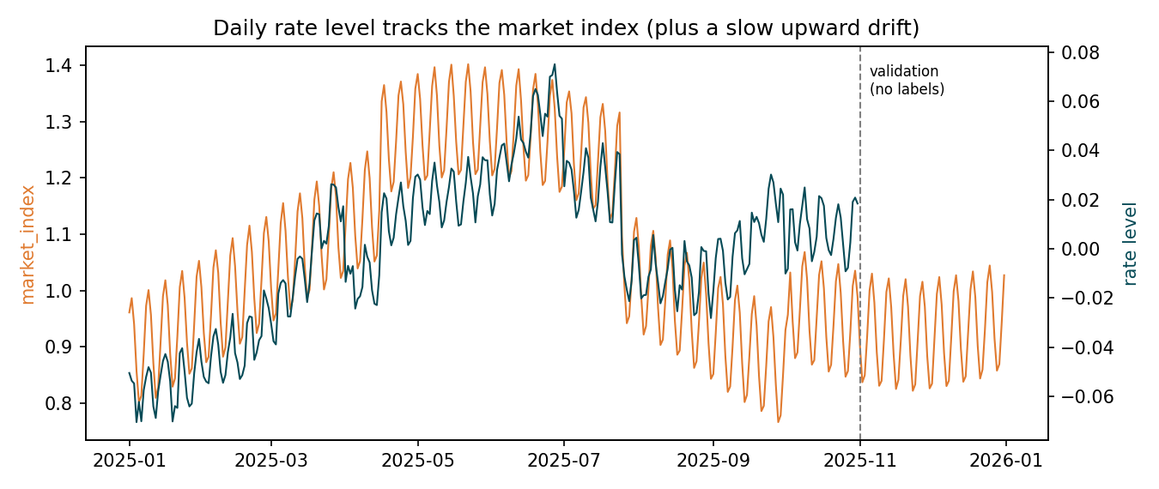
Daily mean market_index (orange) against the daily rate level after removing load effects (teal).

5. Model choice
My first model was a single GBM with market_index as a normal feature. It did worse out-of-time than a GBM that ignored the market completely. Between April and July the index is high and so is the season, so the trees learn 'index around 1.3 means mid-year' instead of a smooth price effect. A tree also can't carry a trend past the last date it saw. Adding a date feature made this worse, not better (table below).
So I split the model in two. The GBM handles the load-level structure, which is genuinely non-linear (the distance taper, equipment premiums, regional differences, and quote_signal mattering mostly on short hauls). A linear term on log(rate) takes the daily market index, the daily mean quote_signal and a time trend. The two parts are fitted by backfitting: fit the GBM on the target minus the linear part, refit the linear part on the GBM residuals, and repeat three times. Lanes are described by coordinates instead of city IDs, so the new validation cities borrow from nearby cities instead of falling back to a global average.
Settings: 1,500 trees, learning rate 0.05, 31 leaves, min 20 rows per leaf, early stopping off so runs are reproducible. Things I tried that didn't help or made it worse: L1 loss for the main model, bagging several seeds, a bigger tree size, equipment-specific market slopes, day-of-week terms, and smoothed or lagged market features.

6. Validation results
Average over the five rolling-origin windows (* = final model):
Model | MAPE % | MAE $ | RMSE $ | Bias %
GBM: load features only | 2.62 | 61.03 | 96.40 | -1.04
GBM: load + market_index as tree feature | 3.04 | 69.76 | 101.13 | -2.29
GBM: load + market + date trend as tree features | 3.36 | 80.58 | 121.93 | -1.39
GBM + linear market/trend offset * | 2.08 | 47.97 | 75.66 | -0.26

MAPE % by test window:
Test months | GBM + linear term * | GBM + market + date | GBM + market | GBM, load only
May-Jun | 1.70 | 3.25 | 2.31 | 2.59
Jun-Jul | 1.62 | 3.18 | 2.63 | 2.30
Jul-Aug | 2.89 | 4.28 | 3.19 | 3.55
Aug-Sep | 2.60 | 3.75 | 3.32 | 3.20
Sep-Oct | 1.61 | 2.32 | 3.75 | 1.47

The final model is best in 4 of 5 windows and has the smallest bias. The one window it doesn't win is Sep-Oct. There the market sat close to its January level, so ignoring it cost nothing. The biggest errors for every model are in Jul-Aug, where there is a level drop around 25 July that the market index doesn't fully explain, and August loads are noisier in general. To see how much of the error is timing, I replaced the predicted daily level with the true one. That only brought MAPE down to about 2.0%, so most of what's left is load-level noise rather than the market level.
Unseen-city check (8 cities removed from training, 3 repeats):
Sep-Oct loads | MAPE % | MAE $
held-out cities | 1.80 | 41.71
seen cities | 1.63 | 36.65

Loads touching a never-seen city are only slightly worse than the rest, so I'm comfortable predicting the 12% of validation loads that involve one of the new cities.

7. December prediction for the fixed lane (score.py output)
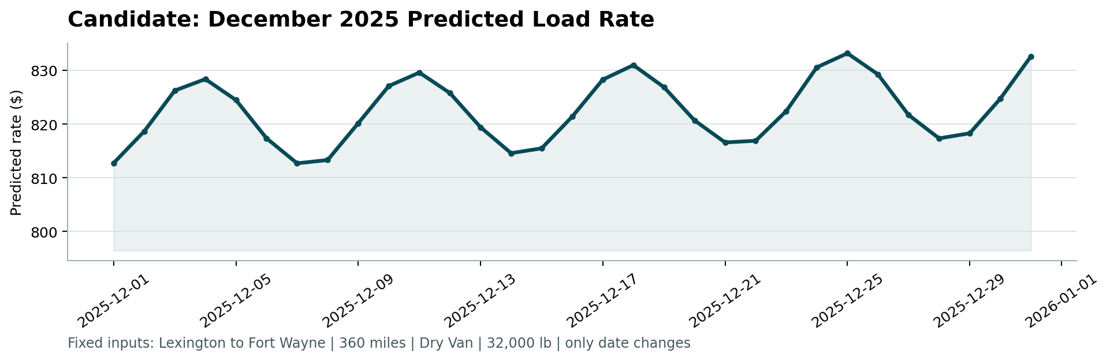
Lexington to Fort Wayne, 360 mi, Dry Van, 32,000 lb, only the date changes.
The predictions run from $813 to $833. For comparison, the dry-van loads on this lane in training were between $758 and $934, with most around $770-$870. The weekly shape (higher mid-week, lower at weekends) comes from the December market index in validation.csv, which follows the same weekly cycle as the rest of the year. The slight rise across the month is the learned trend. Nothing in the training data covers late-December holidays, so the model has no holiday effect, and I'd treat Christmas week as the least reliable part of the chart.

8. What I'd do next
With more time or data I'd look at: a full year of history to learn real seasonality and holidays instead of a linear trend; finding out where the 0.25x / 4x labels come from (if it's a units issue they could be corrected instead of dropped); prediction intervals, since noise varies by month and distance; and retraining every month as new loads come in, because the trend estimate rests on only ten months.

