- Do not edit/delete any heading or section with red text.
- Type /paste you answers in relevant sections (below Final Answer (in all questions , Approach (wherever required ) and Charts & tables (wherever required)) of the solution
- Link to submission guidelines
- Please note that submission not following the guidelines will not be accepted

OBJECTIVE QUESTIONS

Question 1: What is the total no. of tables present in the data?

Solution:

Final Answer (if any):
2 tables: the original Data table and the Cleaned data table.

Approach (if any):
the two data tables used in the project: Data and Cleaned data.

Charts & Tables (if any):
- Table / Chart Name:
Data and Cleaned Data

- Description:
These contain the original dataset and the cleaned dataset used for further analysis.

Question 2: What is the total no. of attributes present in the data?

Solution:

Final Answer (if any):
There are 35 attributes present in the data.

Approach (if any):
I counted all the actual data column headings in the Data table. The index column was not counted as an attribute. Each remaining column represents one attribute.

Charts & Tables (if any):
- Table / Chart Name:
Data Table
- Description:
The dataset contains 35 attributes covering users, calls, consultations, gurus, payments, statuses, timings, and ratings.

Question 3: The data consists of some inconsistent and missing values so ensure that the data used for further analysis is cleaned.

Solution:

Final Answer (if any):
The data was cleaned by checking duplicates, invalid ratings, negative call durations, guru names, consultation types, and missing values before analysis.

Approach (if any):
I copied the original data, checked for duplicates, cleaned invalid ratings and negative durations, standardized guru names, checked consultation types, and handled blanks appropriately.

Charts & Tables (if any):
- Table / Chart Name:
Cleaned Data

- Description:
The cleaned dataset used for further analysis.

Question 4: What is the change in daily call volume day by day and also find the average daily call volume.

Solution:

Final Answer (if any):
The average daily call volume is 250.24 calls. The daily change is calculated by comparing each day’s call volume with the previous day’s volume.

Approach (if any):
- Calculate the total calls for each day.
- Calculate the change as: Current Day Call Volume − Previous Day Call Volume.
- The first day has no previous day, so its change is N/A.
- Calculate the average of the daily call volumes.

Charts & Tables (if any):
- Table / Chart Name:

Average Daily Call Volume | 250.24

Date | Daily Call Volume | Change in Call Volume
01-Dec-2023 | 372 | N/A
02-Dec-2023 | 333 | -39
03-Dec-2023 | 383 | 50
04-Dec-2023 | 364 | -19
05-Dec-2023 | 253 | -111
06-Dec-2023 | 254 | 1
07-Dec-2023 | 254 | 0
08-Dec-2023 | 138 | -116
09-Dec-2023 | 288 | 150
10-Dec-2023 | 430 | 142
11-Dec-2023 | 424 | -6
12-Dec-2023 | 358 | -66
13-Dec-2023 | 348 | -10
14-Dec-2023 | 226 | -122
15-Dec-2023 | 276 | 50
16-Dec-2023 | 258 | -18
17-Dec-2023 | 185 | -73
18-Dec-2023 | 233 | 48
19-Dec-2023 | 209 | -24
20-Dec-2023 | 178 | -31
21-Dec-2023 | 159 | -19
22-Dec-2023 | 163 | 4
23-Dec-2023 | 241 | 78
24-Dec-2023 | 232 | -9
25-Dec-2023 | 258 | 26
26-Dec-2023 | 255 | -3
27-Dec-2023 | 242 | -13
28-Dec-2023 | 181 | -61
29-Dec-2023 | 258 | 77
30-Dec-2023 | 180 | -78
31-Dec-2023 | 157 | -23
01-Jan-2024 | 115 | -42
02-Jan-2024 | 196 | 81
03-Jan-2024 | 107 | -89

- Description:
Shows the daily call volume and the change in call volume from the previous day.

Question 5: Which months experienced the highest and lowest call volumes?

Solution:

Final Answer (if any):
Highest: December 2023 — 8,090 calls
Lowest: January 2024 — 418 calls

Approach (if any):
The monthly call counts were compared using the Monthly Calls table. December 2023 had 8,090 calls, while January 2024 had 418 calls.

Charts & Tables (if any):
- Table / Chart Name:

Highest Call Volume | 8090
Lowest Call Volume | 418
Highest Volume Month | Dec-2023
Lowest Volume Month | Jan-2024
Month | Monthly Call Volume
Dec-2023 | 8090
Jan-2024 | 418

- Description:
Shows the total number of calls recorded for each month and helps identify the
highest and lowest monthly call volumes.

Question 6: What is the total operational cost for that month?

Solution:

Final Answer (if any):
The month with the highest call volume was December 2023, and the total operational cost for that month was 93,786.16.

Approach (if any):
I identified December 2023 as the highest-call-volume month from the monthly call-volume analysis and then referred to the Operational Cost table for that month.

Charts & Tables (if any):
- Table / Chart Name:

Month | Operational Cost
Dec-23 | 93786.16

- Description:
Shows the operational cost for the corresponding month.

Question 7: What is the average number of calls handled per agent per day?

Solution:

Final Answer (if any):
The average number of calls handled per agent per day is 1.88 calls.

Approach (if any):
Total Calls = 8,508
Number of Agents = 133
Number of Days = 34

Average Calls per Agent per Day = Total Calls / (Number of Agents × Number of Days)

Charts & Tables (if any):
- Table / Chart Name:
Metric | Value
Total Calls | 8508
Number of Agents | 133
Number of Days | 34
Average Calls per Agent per Day | 1.88

- Description:
Shows the average number of calls handled by each agent per day.

Question 8: How many repeat callers are there, and what percentage of total calls do they represent?

Solution:

Final Answer (if any):
There are 1,277 repeat callers, and they represent 57.35% of the total calls.

Approach (if any):
A PivotTable was created using uid as the row field and Count of uid as the value, with consultationType filtered to Call. The repeat-caller analysis and percentage are taken directly from the values shown in the Excel analysis.

Charts & Tables (if any):
- Table / Chart Name:
Number of repeat callers are | 1277
Total Calls | 8508
Total No. of repeat calls | 3629
% of repeat callers are | 57.35%

Category | Value
Repeat Calls | 3629
Other Calls | 4879

- Description:
The chart shows the distribution between Repeat Calls (3,629) and Other Calls (4,879).

Question 9: What are the total sales generated by the call centre for each product category?

Solution:

Final Answer (if any):
The total sales generated by the call centre for each product category (Consultation Type) are:

- Call: ₹168,520.62
- Chat: ₹45,494.68
- Complementary: ₹0.00
- Public_live_Call: ₹50.60

- Total Sales: ₹214,065.90

Approach (if any):
The net sales amount was summed for each Consultation Type using the SUMIF function.
Charts & Tables (if any):
- Table / Chart Name:
Consultation Type | Total Sales
Call | 168520.6183
Chat | 45494.68333
Complimentary | 0
Public_live_Call | 50.597

- Description:
Shows the total sales generated by the call centre for each consultation type.

Question 10: How many calls were made for each user ID and guru ID?

Solution:

Final Answer (if any):
The number of calls was calculated for each User ID and Guru ID combination. The Pivot Table shows the call count for every User ID–Guru ID combination. Overall, the dataset contains 28,027 calls.

Approach (if any):
A Pivot Table was created with User ID and Guru ID as row fields and Count of _id as the value. This counts the number of calls made by each user to each guru.

Charts & Tables (if any):
- Table / Chart Name:
user guru Count of_id

- Description:
The table shows the number of calls made for each User ID and Guru ID combination, with the overall total of 28,027 calls.

Question 11: What is the correlation between call duration and customer satisfaction?

Solution:

Final Answer (if any):
The correlation between call duration and customer satisfaction is 0.4529, indicating a very weak positive relationship.

Approach (if any):
Used the CORREL function to calculate the correlation between Clean Duration and Clean Rating:

=CORREL('Cleaned data'!AK2:AK20693,'Cleaned data'!AJ2:AJ20693)

Charts & Tables (if any):
- Table / Chart Name:

- Description:
Shows the relationship between call duration and customer satisfaction rating.

Question 12: Which guru has the highest and lowest customer satisfaction scores?

Solution:

Final Answer (if any):
The highest customer satisfaction score is 7.5, achieved by Tarot Mystical and Astro Pujaa Rai.
The lowest customer satisfaction score is 0, achieved by Tarot Rittika.

Approach (if any):
- Created a PivotTable using Guru Name as the row field.
- Used Rating as the value field and calculated Average of Rating.
- Compared the average customer satisfaction scores for all gurus.
- The maximum average rating is 7.5, with two gurus tied at this score.
- The minimum average rating is 0, for Tarot Rittika.

Charts & Tables (if any):
- Table / Chart Name:

Row Labels | Average of rating
Vandana Bhutani | 4.957746479
Usha Siingh | 2.15
Tarrot Ria | 5
Tarot Yashita | 3.762711864
Tarot Vedika | 4.049342105
Tarot Swati | 1.857142857
Tarot Surbi | 3.47826087
Tarot Supriya Suri | 1.45045045
Tarot Sunita | 2.861111111
Tarot Srishti | 4.87037037
Tarot Shilpa P | 2.952380952
Tarot Shakti | 3.48
Tarot Seema | 2.836734694
Tarot SampritaP | 3.111111111
Tarot Rushali | 2.6
Tarot Rupika | 2.846560847
Tarot Rupanshi | 3.631578947
Tarot Riya | 2.416666667
Tarot Rittika | 0
Tarot Ria | 2.984615385
Tarot Rhea | 4.822222222
Tarot Raghavi | 1.925373134
Tarot Rachana | 3.549800797
Tarot Punam | 0.859477124
Tarot Priyal | 4
Tarot Priya S | 3.925
Tarot preet | 3
Tarot Pooja | 2.181818182
Tarot Oormika | 5.4
Tarot Nipamani | 1.723404255
Tarot Neha R | 1.886075949
Tarot Mystical | 7.5
Tarot Muskaan | 2.506329114
Tarot Monika | 4
Tarot Meera | 3.869565217
Tarot Mamta D | 3.487603306
Tarot Leena | 2.069767442
Tarot Keshmin | 1.235294118
Tarot Kaashvi | 2.936507937
Tarot Ittishri | 1.203821656
Tarot Harleen | 3.565217391
Tarot Gurpreet Kaur | 3.650641026
Tarot Gurpreet | 3.146
Tarot Gauri | 3.388508892
Tarot Gargi | 2.765765766
Tarot Esha | 4.117647059
Tarot Diva Poonam | 5.462686567
Tarot Daljit | 3.511904762
Tarot Chanchal singh | 3.333333333
Tarot Chanchal | 3.696428571
Tarot Bibhuti | 3.666666667
Tarot Bee Riya | 2.36204576
Tarot Barbiie | 3.090909091
Tarot Aritra C | 3.14159292
Tarot Ari | 3.854166667
Tarot Anshu | 4
Tarot Ankita | 5.75
Tarot Akshay | 2.738636364
Tarot Aadhvik | 3.169934641
Swami Chandreshwaranand��G | 5
Super Guru Ji | 1.819148936
Shalini Sharma | 4.2
RAKESH KAUSHIK | 2.590909091
Manorma Singh | 3.235294118
Kaveshii Chauhaan | 1.953488372
Himanshu Pandey | 2.375
gurucool support | 1.4
Gopi Vans | 4.333333333
Dr. Shrey | 3.473684211
Dr. Pratibha | 2.5
Dr. Harish | 1.286419753
Dr. Balkrisna | 3.029850746
Dr Balkrisna | 2.593886463
Daljit Kaur | 5.945945946
Astro Yogendra | 1.006802721
Astro Yashi | 2.333333333
Astro Vishwajeet | 2.683950617
Astro Uma Kant | 2.863192182
Astro Trisha | 5.424324324
Astro Swami G | 4.652173913
Astro Sushil S | 0.851851852
Astro Sukhdip | 4.146341463
Astro Sujata S | 2.895927602
Astro sree valli | 1.626373626
Astro Sonam S | 3.719414894
Astro Smarti M | 3.789473684
Astro Shweta | 3.334782609
Astro Shalini | 3.417108251
Astro Seema | 3.398347107
Astro SavitriDevi | 4.324324324
Astro Savita S | 3.689655172
Astro Saraswat | 5.611111111
Astro Sanjeev | 2.74829932
Astro Sakthi | 2.537241379
Astro Ruchi | 4.442728443
Astro Rohan S | 1.5
Astro Rhea | 3.5
Astro Reema | 5.9
Astro Rajiv B | 2.580645161
Astro Rajesh S | 1.798295455
Astro R J S | 1.452229299
Astro Pulkit S | 4
Astro Pujaa Rai | 7.5
Astro preeti | 3.909090909
Astro Prashant | 3.447368421
Astro Nisha | 3.275862069
Astro Niddhi Guptaa | 4.5
Astro Neetu | 2.505813953
Astro Naksh | 2.202614379
Astro Mukesh | 3.222222222
Astro Meena | 3.660818713
Astro Manish SM | 4.352941176
Astro Manish S | 5.048780488
Astro Mahesh S | 1.830508475
Astro Lakshmi | 4.134920635
Astro Krishna | 2.725
Astro Krishaa | 3.330379747
Astro K Ojha | 0.102272727
Astro Jha Guruji | 3.869565217
Astro Jha | 2.972677596
Astro Himanshu | 4.210526316
Astro Gurdeep | 2.923076923
Astro Dr Shrey | 3.559322034
Astro Dr Ravindra | 1.846296296
Astro Dr Harish | 2.805555556
Astro Dr Balkrisna | 4.20657277
Astro Divya | 3.479166667
Astro Deepti | 3.4
astro chandan | 1
Astro Brejesh | 1.894392523
Astro Ashok | 4.172859451
Astro Ankita C | 2.846153846
Astro Anju | 3.333333333
Astro Anil Shukla | 1.577777778
Astro Anaya | 2.875
Astro Akash | 2.75
Astro Aishwarya | 3.555555556
Astro Aditya N | 3.706484642
Astro Aditya Jhha | 3.142857143
Astro Aditya | 1.946078431
Astro Aacharya Dev | 3
Astro Aabhishek | 3.486842105
Aham T | 4.785714286
Acharya Shastri | 3.428571429
Acharya Divyansh | 0.387387387
Acharya Dev | 2.516666667
Acharya Arti S | 4
Aachary Prateek | 3.109589041
Grand Total | 2.93463446

Column1 | guru name | rating
Highest customer satisfaction score | Tarot Mystical | 7.5
Lowest customer satisfaction score | Tarot Rittika | 0.00

Highest customer satisfaction score | Astro Pujaa Rai | 7.5

- Description:
This table/chart compares the average customer satisfaction rating of each guru and identifies the gurus with the highest and lowest scores.

Question 13: What is the average customer satisfaction score by month?

Solution:

Final Answer (if any):
The average customer satisfaction score was 2.68 in January and 2.95 in December. Overall, the average customer satisfaction score was 2.93.

Approach (if any):
Created a PivotTable using Month (createdAT) in Rows and Average of Rating in Values. The average rating was calculated separately for each month.

Charts & Tables (if any):
- Table / Chart Name:

Row Labels | Average of rating
Jan | 2.68
Dec | 2.95
Grand Total | 2.93463446

- Description:
Shows the average customer satisfaction rating for January and December.

Monthly Results:
January: 2.68
December: 2.95
Overall Average: 2.93

Question 14: How many categorical columns are there in the data? [Search about categorical and continuous data, and try to answer this question]

Solution:

Final Answer (if any):
There are 22 categorical columns in the data.

Categorical Columns:
1. _id
2. user
3. chatStatus
4. guru
5. guruName
6. consultationType
7. website
8. refundStatus
9. isWhiteListUser
10. queue
11. freeCall
12. freeChat
13. statementEntryId
14. callChannel
15. callIvrType
16. callStatus
17. CallSid
18. astrologerCallStatus
19. region
20. userCallStatus
21. createdAT
22. updatedAt

Approach (if any):
The data was reviewed column by column and categorical variables were identified as fields representing labels, categories, statuses, identifiers, or other non-continuous classifications. Numerical measures such as amount, netAmount, timeDuration, chatSeconds, and rating were treated as quantitative variables.

Charts & Tables (if any):
- Table / Chart Name:
Categorical Columns Summary

- Description:
Shows the number and names of categorical columns identified in the dataset.

SUBJECTIVE QUESTIONS

Question 1: Should the investment be used to hire more agents, improve training programs, or upgrade call center technology?

Solution:

Approach:
The decision was based on the average calls handled per active agent-day, peak daily call volume, and average customer satisfaction. These metrics were used to assess workload, peak-period demand, and service quality before deciding where investment would have the greatest operational impact.

Charts & Tables:
- Table / Chart Name:

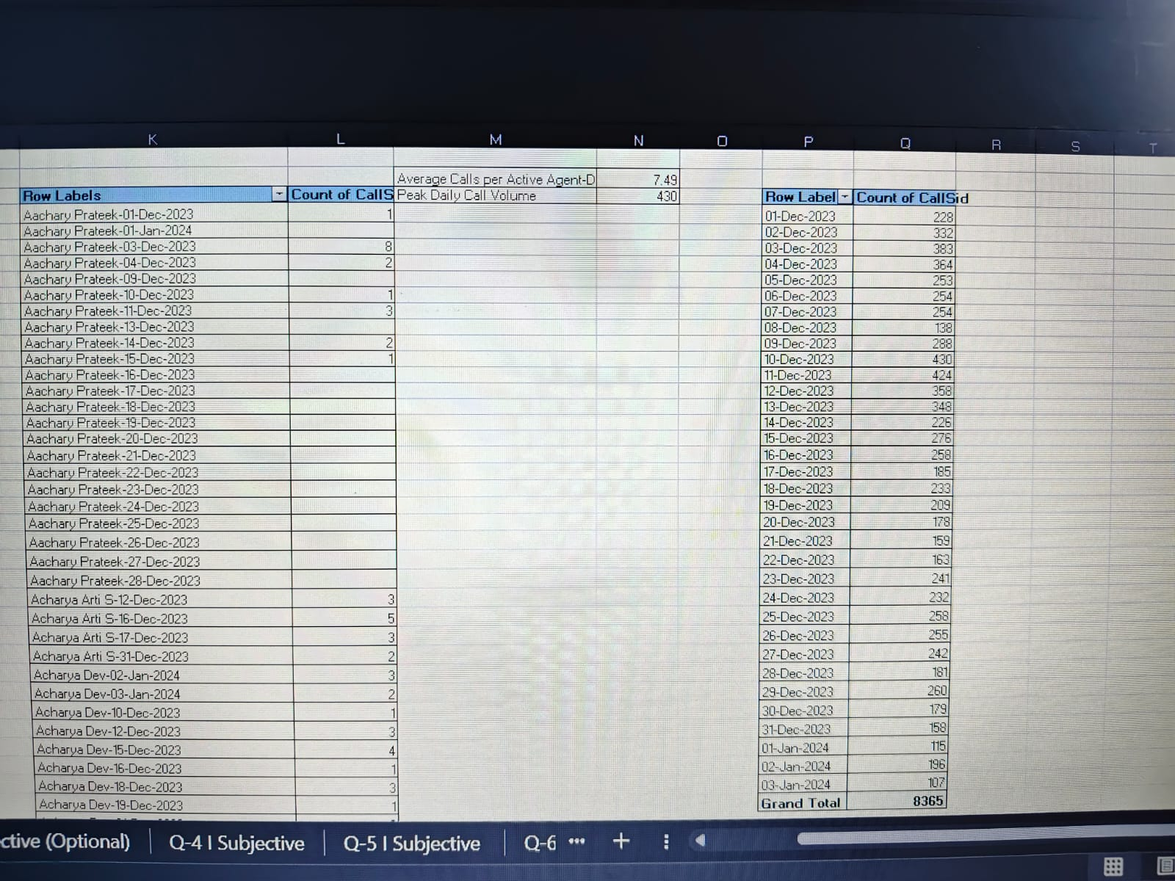

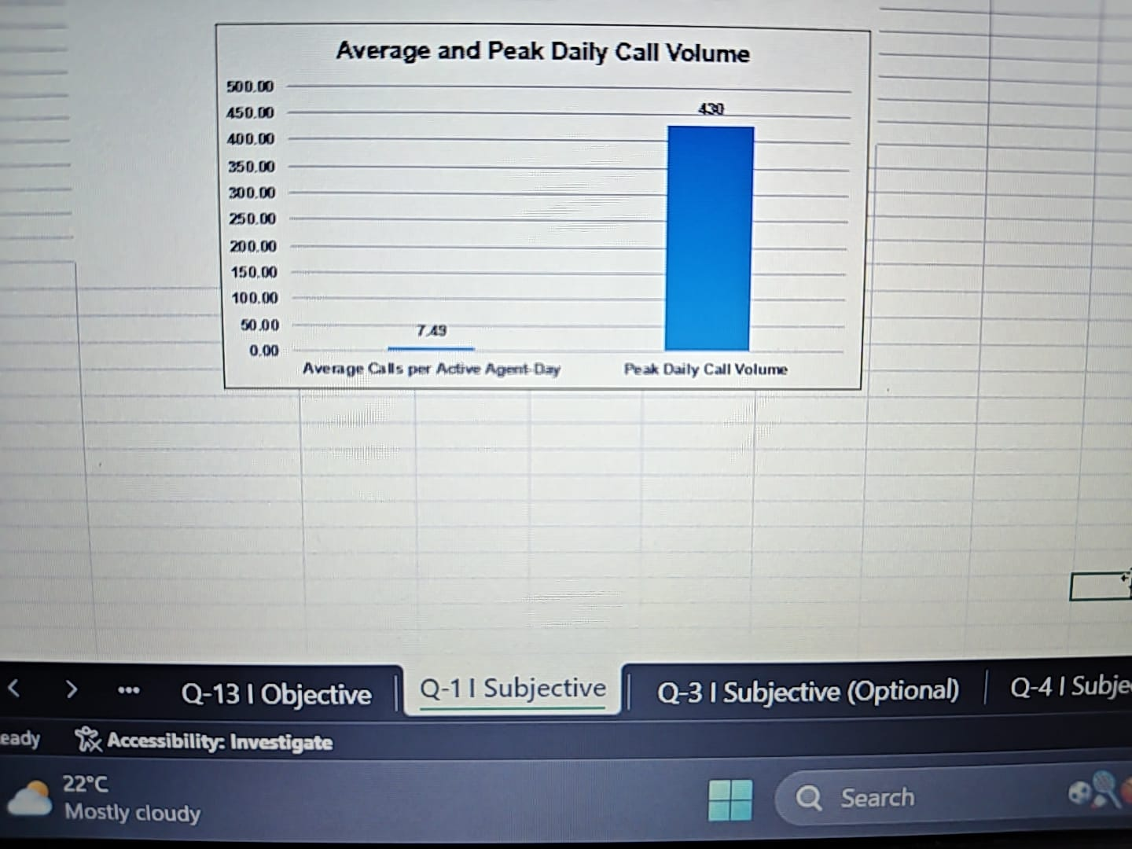

- Description:
The chart compares the average calls handled per active agent-day with the peak daily call volume.

Insights:
- Average calls per active agent-day: 7.49
- Peak daily call volume: 430 calls
- Average customer satisfaction: 3.96/8
- Peak demand indicates that additional capacity may be required during high-volume periods.
- The data does not strongly support hiring agents across the board.

Recommendations:
- Prioritize targeted training to improve agent performance and customer satisfaction.
- Improve processes and call-center technology to handle peak demand efficiently.
- Add agents selectively during peak periods rather than increasing staffing across the board.
- Use flexible staffing and monitor workload and satisfaction before making further hiring decisions.

Question 2: What are the potential risks of each investment option (hiring, training, technology upgrades), and how can they be mitigated?

Name the chart/spreadsheet function you will use for solving the problem.

Solution:

Approach:
The investment options were evaluated by considering the workload and demand indicators in the data. The analysis shows an average of 7.49 calls per active agent-day and a peak daily call volume of 430 calls. These figures indicate that capacity, employee performance, and service continuity should be considered when evaluating hiring, training, and technology investments.

Charts & Tables:
- Table / Chart Name:

- Description:
The analysis compares the major risks associated with each investment option and the actions that can be taken to reduce those risks.

Insights:
1. Hiring More Agents:
The main risks are higher fixed salary costs, possible under-utilization during periods of lower demand, and recruitment or onboarding time. However, the peak daily volume of 430 calls indicates that additional capacity may be required during high-demand periods.

2. Improving Training Programs:
Training involves cost and employee time, and productivity may temporarily decrease while employees attend training. However, targeted training can improve agent handling capacity, consistency and service quality.

3. Upgrading Call Center Technology:
Technology upgrades may involve high initial investment, implementation disruption, integration problems and employee adaptation requirements. The benefits may also take time to materialize.

Recommendations:

- For hiring, use workload and peak-demand data to determine staffing requirements and consider phased hiring rather than increasing staff all at once.
- For training, focus on targeted training for areas where agent performance or call handling needs improvement, and conduct training during lower-demand periods.
- For technology upgrades, introduce changes through a pilot or phased implementation and monitor costs, system performance and service quality before expanding.
- Because the data shows a peak daily call volume of 430 and an average of 7.49 calls per active agent-day, investment decisions should be based on actual workload trends rather than only on total call volume.

Chart/Spreadsheet Function:
Risk Matrix using Probability × Impact, supported by PivotTable/Excel charts for comparing workload and investment-related indicators.

Question 3: How does AstroSage's call center performance compare to AstroGuru's average call volume, customer satisfaction, and agent performance?

Will you use any aggregation function or a visualization here to solve the problem?

Solution:
Approach:
Used aggregation functions to calculate AstroSage’s average daily call volume, average customer satisfaction, and average calls per active agent-day. The workbook contains only AstroSage data and does not contain equivalent AstroGuru benchmark data, so a direct numerical comparison with AstroGuru cannot be calculated.
Charts & Tables:
- Table / Chart Name:

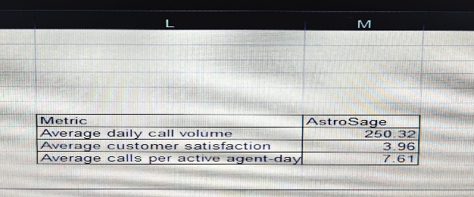

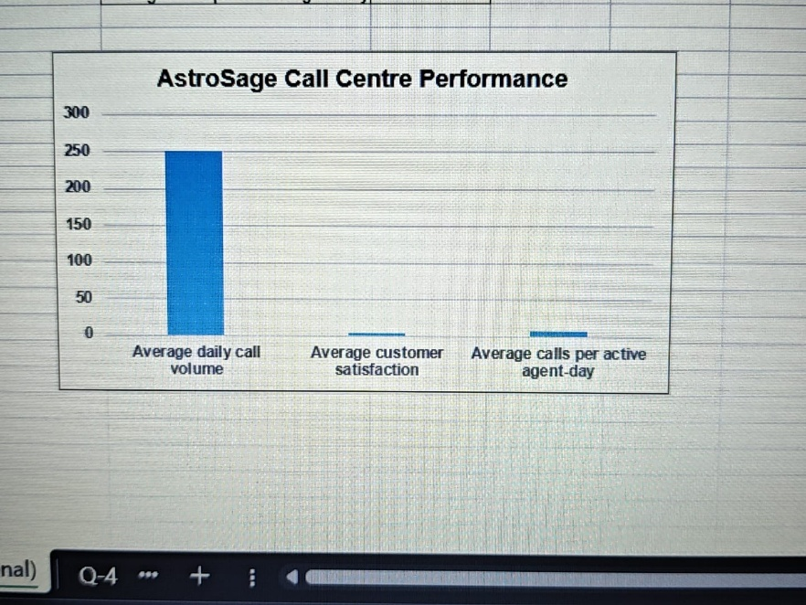

- Description:
The table and column chart show AstroSage’s average daily call volume, average customer satisfaction, and average calls per active agent-day. These metrics provide the baseline for comparison with AstroGuru when equivalent AstroGuru data becomes available.

Insights:
- AstroSage handles an average of 250.32 calls per day.
- The average customer satisfaction score is 3.96 out of 8.
- Each active agent handles an average of 7.61 calls per day.
- These figures represent AstroSage’s overall call volume, customer satisfaction, and agent workload.

Recommendations:
- Use the AstroSage values as a baseline and obtain equivalent AstroGuru data before making a direct comparison.
- Continue monitoring call volume, customer satisfaction, and agent workload to identify performance changes over time.

Functionality Used:

  - AVERAGE / AVERAGEIFS — for average call volume and customer satisfaction.
  - Aggregation/PivotTable — for summarizing the performance metrics.
  - Column Chart — for visualizing the AstroSage performance metrics.

Question 4: How can the call center improve its handling of peak call periods to ensure high customer satisfaction?

Mention the functionality you will use for giving the suggestions, will it be any aggregated function or a visualization?

Solution:

Approach:
I analyzed the hourly call-volume and customer-satisfaction data using a PivotTable. Count of _id was used to measure call volume, while Average of Clean Rating was used to measure customer satisfaction. A Combo Chart (Column + Line) was used to visualize both measures by hour and identify peak periods.

Charts & Tables:
- Table / Chart Name:

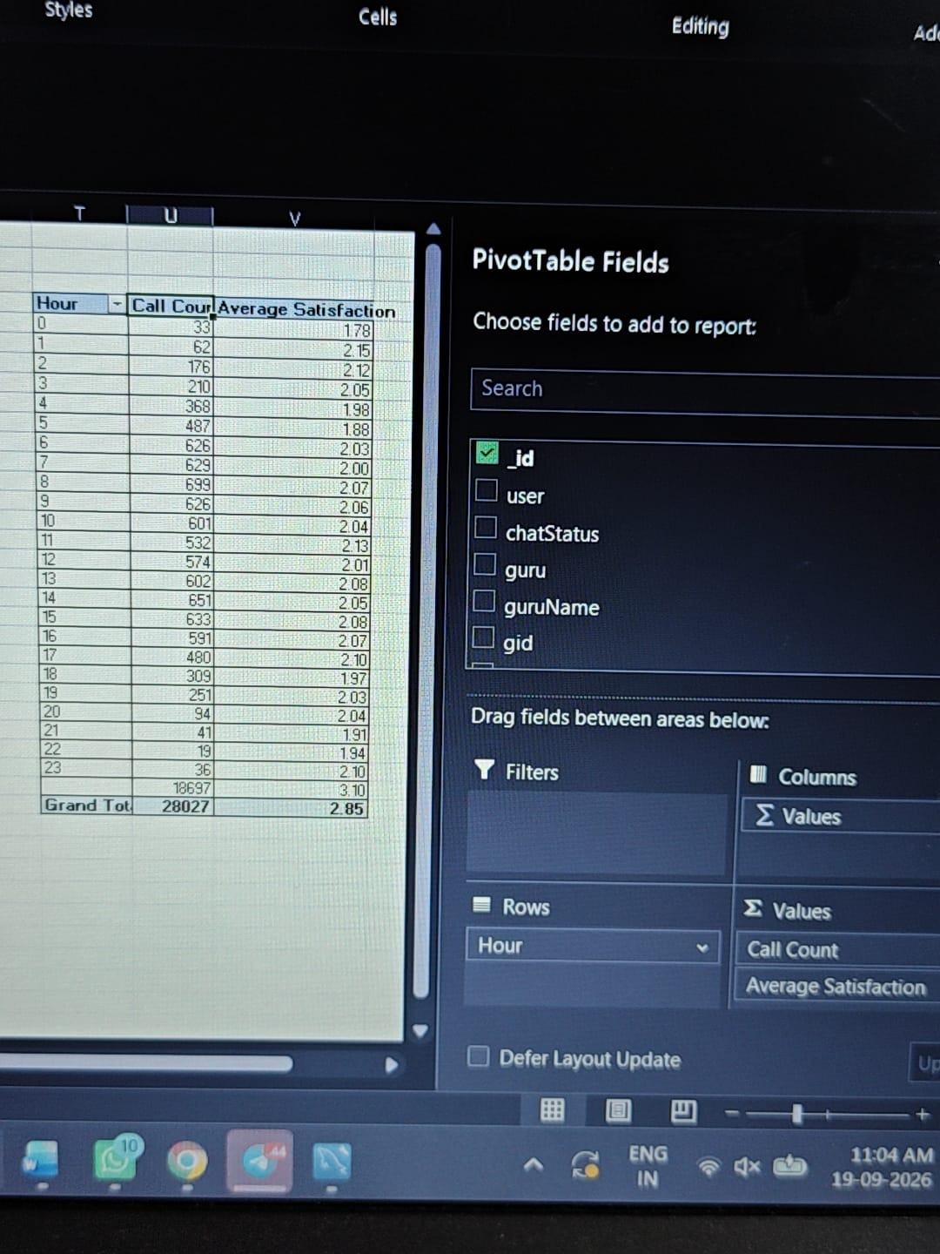

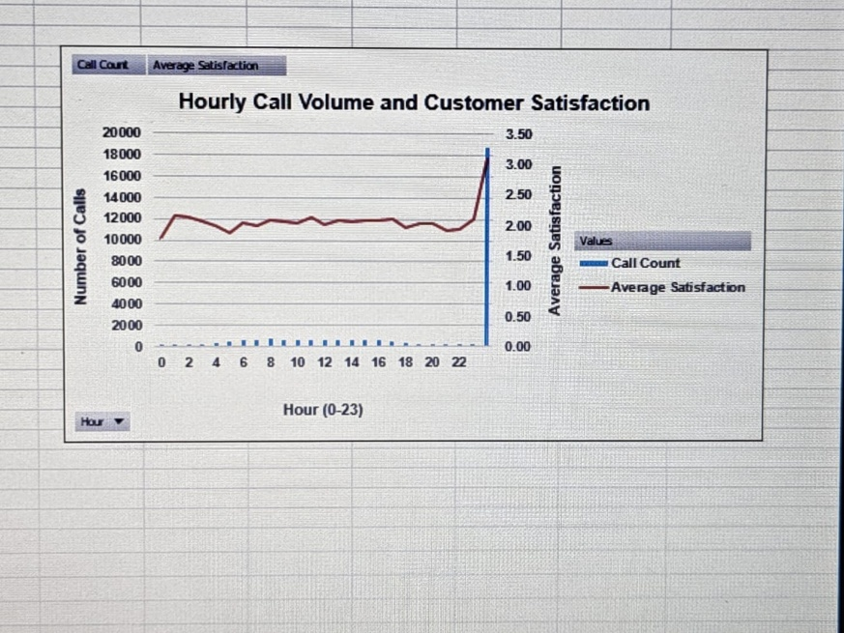

- Description:
The PivotTable shows the number of calls and average customer satisfaction for each hour from 0–23. The chart compares hourly call volume with average satisfaction to identify high-demand periods.

Insights:
- The highest call volume occurs at 08:00 with 699 calls.
- Other high-volume periods include 14:00 (651 calls), 15:00 (633 calls), 07:00 (629 calls), and 09:00 (626 calls).
- The average customer satisfaction across all calls is approximately 2.85.
- During the major peak hours, average satisfaction is around 2.00–2.08, indicating that customer experience should be closely monitored when call volumes are high.
- Call volume is concentrated mainly between 07:00 and 16:00.

Recommendations:
- Increase agent availability during the 07:00–16:00 peak period, particularly around 08:00.
- Use staggered shifts and scheduled breaks to maintain sufficient coverage.
- Keep backup/flexible agents available during high-volume hours.
- Monitor customer satisfaction during peak periods and take corrective action if satisfaction declines.
- Use the hourly trend regularly for staffing and capacity planning.

Functionality Used:

- PivotTable – Count of _id → Hourly call-volume aggregation
- PivotTable – Average of Clean Rating → Hourly customer-satisfaction aggregation
- Combo Chart (Column + Line) → Visualization of call volume and satisfaction
- Peak-hour analysis → Staffing recommendation

Question 5: Based on historical data, what strategic initiatives should be prioritized to improve efficiency and customer satisfaction?

Solution:

Approach:
I used a PivotTable with the Average aggregation function. consultationType was placed in Rows, website was placed in Columns, and rating was placed in Values and summarized using Average. This allows customer satisfaction to be compared across different consultation types and platforms. The results were then visualized using a PivotChart for easier comparison.

Charts & Tables:
- Table / Chart Name:

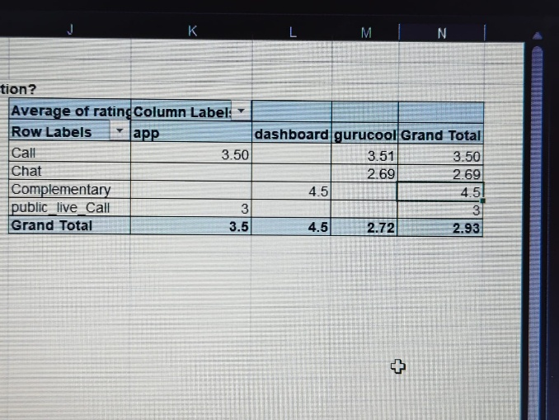

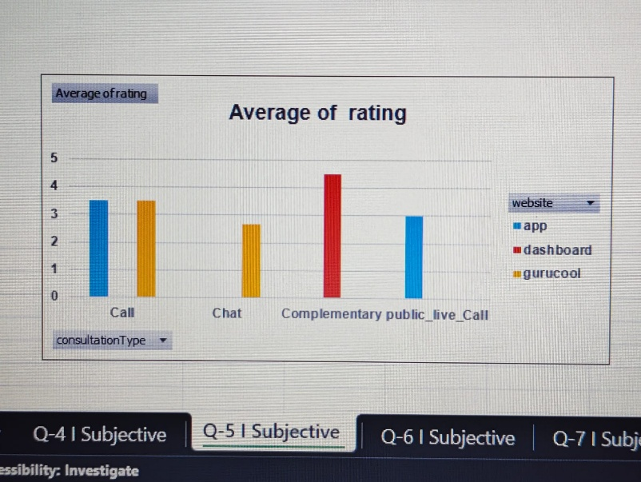

- Description:
The PivotTable and PivotChart compare the average customer rating for each consultation type across the available platforms: app, dashboard, and gurucool.

Insights:
- Call: Average rating is 3.50 overall; app = 3.50 and Gurucool = 3.51.
- Chat: Average rating is 2.69, indicating comparatively lower satisfaction.
- Complementary: Dashboard shows an average rating of 4.50.
- public_live_Call: App shows an average rating of 3.00.
- Platform-level overall averages shown in the PivotTable are app = 3.50, dashboard = 4.50, Gurucool = 2.72, with an overall average of 2.93.

Recommendations:
- Investigate the reasons for the comparatively low ratings for Chat, particularly on Gurucool, and improve the customer experience for this combination.
- Provide targeted training and quality monitoring for consultation types/platforms showing lower average ratings.
- Analyse the practices associated with higher-rated combinations, such as Complementary on the dashboard, and identify practices that can be applied where appropriate.
- Continue monitoring ratings by consultation type and platform using the PivotTable to identify changes in customer satisfaction over time.
- Combine this satisfaction analysis with call-volume and operational metrics before making staffing or efficiency decisions, since this Q5 PivotTable primarily measures customer ratings, not operational efficiency directly.

Functionality Used:

PivotTable → Average of Rating → PivotChart (Column Chart).

Question 6: What can be the key factors contributing to high customer satisfaction scores, and how can these be leveraged to improve overall performance?

What is the basis for the suggestions? And mention how you decided if the satisfaction score affects the ratings.

Solution:

Approach:
The analysis compares the Average of Clean Rating and Average of Clean Duration across different websites/platforms and consultation types. The comparison is based on the PivotTable created from the cleaned data. This helps identify combinations of platform, consultation type, rating and call duration associated with higher or lower customer satisfaction.

Charts & Tables:
- Table / Chart Name:

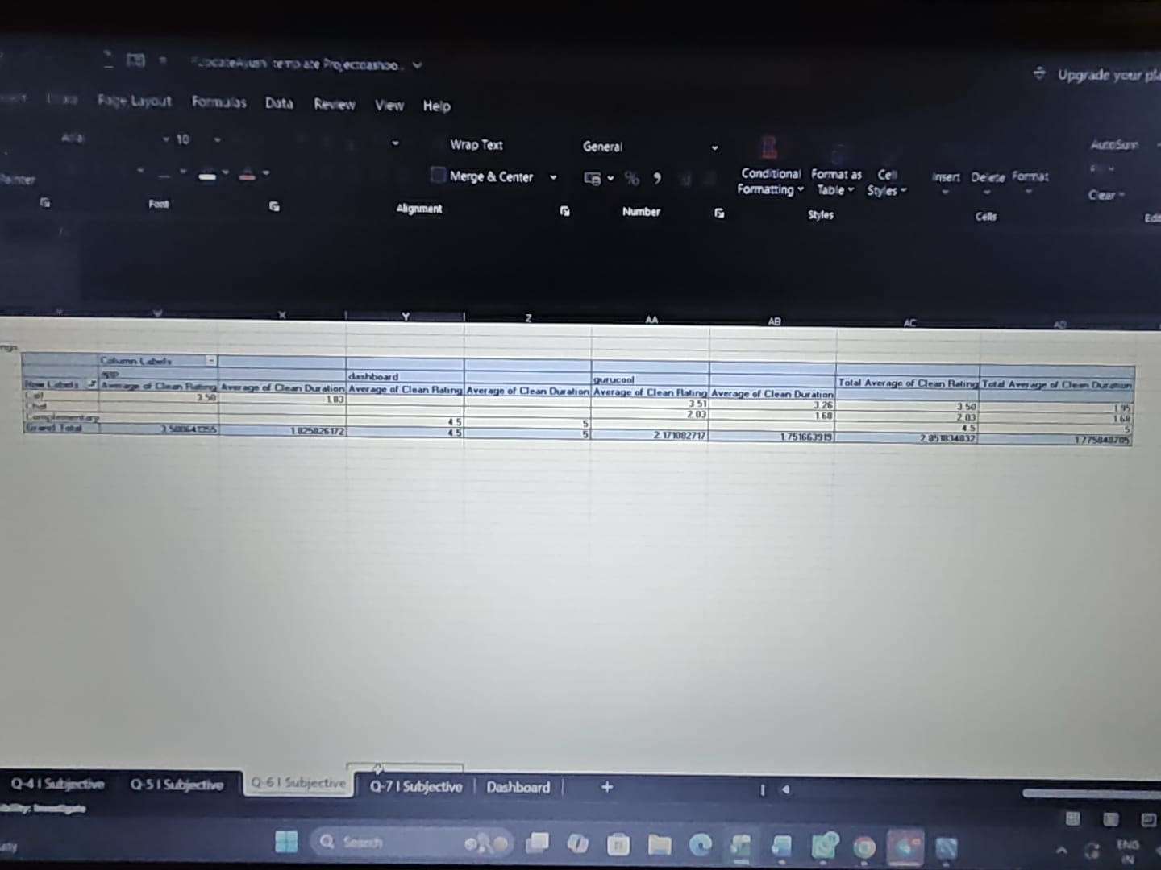

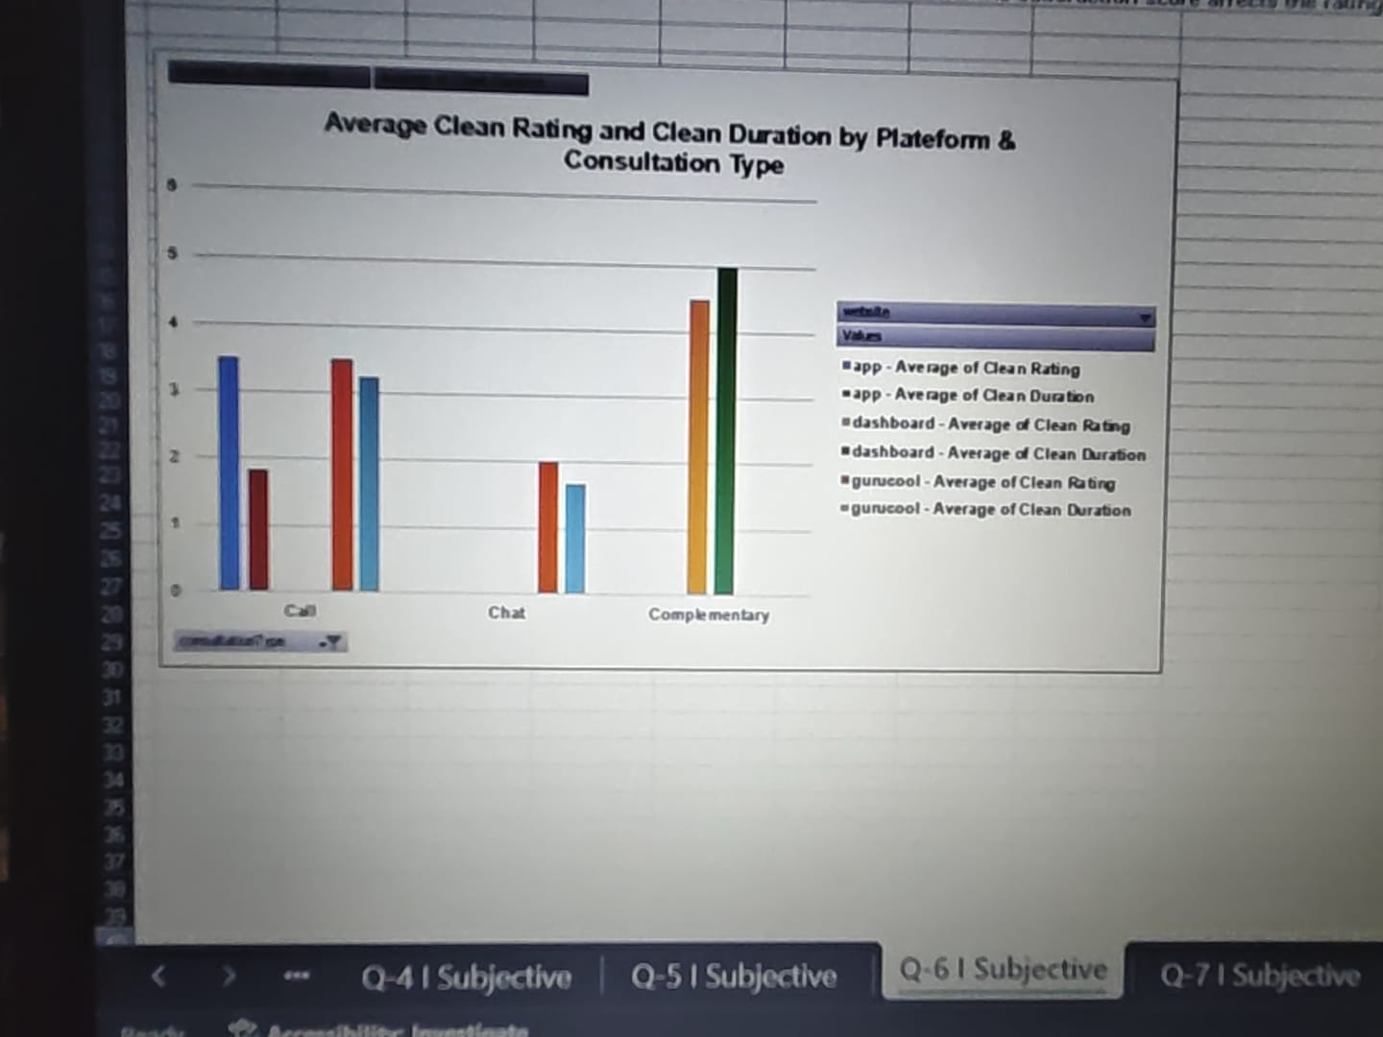

- Description:
The PivotTable and chart compare the average Clean Rating and average Clean Duration for each consultation type across app, dashboard and gurucool platforms.

Insights:
- The overall average Clean Rating is approximately 2.85, while the overall average Clean Duration is approximately 1.78.

- Dashboard–Complementary has the highest observed combination, with:
- Clean Rating = 4.50
- Clean Duration = 5.00

- App–Call has:
- Clean Rating = 3.50
- Clean Duration ≈ 1.83

- GuruCool–Call has:
- Clean Rating ≈ 3.51
- Clean Duration ≈ 3.26

- GuruCool–Chat has a lower Clean Rating of approximately 2.03, with Clean Duration approximately 1.68.

- At the platform level, the PivotTable shows average Clean Rating of approximately:
- Dashboard: 4.50
- App: 3.50
- GuruCool: 2.17

- How I decided whether satisfaction affects ratings:

- The basis was the comparison between Average Clean Rating and Average Clean Duration for each platform–consultation combination.

- The data shows that higher ratings can occur with longer interaction duration in some combinations—for example, Dashboard–Complementary has a rating of 4.50 and duration of 5.00. However, the relationship is not consistent across all combinations. For example, GuruCool–Chat has a lower rating (2.03) despite having a duration of about 1.68.

- Therefore, the PivotTable supports an association/comparison, but it does not establish that duration causes higher ratings. A row-level correlation or statistical analysis would be required to prove the effect.

Recommendations:
- Study the Dashboard–Complementary experience to identify practices associated with its higher rating.
- Investigate the lower-rated GuruCool–Chat combination and identify areas for improving the customer experience.
- Monitor both Clean Rating and Clean Duration together, rather than treating longer interactions automatically as better.
- Use the higher-performing platform/consultation combinations as benchmarks for improving lower-performing combinations.
- Continue monitoring these metrics by platform and consultation type to identify changes in customer satisfaction over time.

Question 7: How should the call center balance the workload among agents to ensure optimal performance and avoid burnout?

Mention your approach and spreadsheet function for the answer.

Solution:

Approach:
I analyzed the workload of each agent using the Count of userCallStatus and Average of Clean Duration from the Q7 PivotTable. Higher call counts indicate higher workload, while average call duration helps identify agents who may be spending more time per interaction. I used the PivotTable to compare workload across agents and identify agents requiring workload balancing.

Charts & Tables:
- Table / Chart Name:

Clean Guru Name | Count of userCallStatus | Average of Clean Duration
Aachary Prateek | 37 | 1.362425229
Acharya Arti S | 8 | 1.580769231
Acharya Dev | 26 | 2.678055556
Acharya Divyansh | 12 | 0.009493614
Acharya Shastri | 3 | 1.333333333
Aham T | 86 | 2.838095238
Astro Aabhishek | 21 | 0.391885965
Astro Aacharya Dev | 3 | 0.114583333
Astro Aditya | 76 | 1.904040404
Astro Aditya Jhha | 6 | 1.428571429
Astro Aditya N | 136 | 2.543109764
Astro Aishwarya | 15 | 6.947222222
Astro Akash | 2 | 1.220833333
Astro Anaya | 10 | 0.578125
Astro Anil Shukla | 11 | 1.346846847
Astro Anju | 5 | 6.455555556
Astro Ankita C | 5 | 1.526751282
Astro Ashok | 216 | 2.909925061
Astro Brejesh | 338 | 0.890279384
astro chandan | 5 | 0.060229219
Astro Deepti | 3 | 1.233333333
Astro Divya | 351 | 2.707312868
Astro Dr Balkrisna | 88 | 2.557663928
Astro Dr Harish | 6 | 0.32179537
Astro Dr Ravindra | 175 | 1.119204261
Astro Dr Shrey | 32 | 0.443691149
Astro Gurdeep | 12 | 1.691666667
Astro Himanshu | 24 | 2.355969298
Astro Jha | 8 | 0.078142077
Astro Jha Guruji | 3 | 0.189130435
Astro K Ojha | 4 | 0
Astro Krishaa | 459 | 2.005446053
Astro Krishna | 180 | 0.462969335
Astro Lakshmi | 105 | 2.585846561
Astro Mahesh S | 11 | 1.001659896
Astro Manish S | 2 | 3.997111111
Astro Manish SM | 8 | 4.458333333
Astro Meena | 101 | 1.969017728
Astro Mukesh | 3 | 4.297414815
Astro Naksh | 66 | 1.27788671
Astro Neetu | 93 | 1.351310756
Astro Niddhi Guptaa | 1 | 5.983333333
Astro Nisha |  | 0
Astro Prashant | 4 | 0.216402632
Astro preeti |  | 0
Astro Pujaa Rai |  | 3.05115
Astro Pulkit S |  | 0
Astro R J S | 42 | 0.866135881
Astro Rajesh S | 109 | 0.77180465
Astro Rajiv B | 66 | 0.970881226
Astro Reema |  | 3.921818333
Astro Rhea | 2 | 0.055
Astro Rohan S | 1 | 0
Astro Ruchi | 412 | 3.039233199
Astro Sakthi | 75 | 1.529889957
Astro Sanjeev | 178 | 1.252397299
Astro Saraswat | 14 | 3.038888889
Astro Savita S | 7 | 0.566810345
Astro SavitriDevi | 36 | 2.592664677
Astro Seema | 221 | 2.930082195
Astro Shalini | 864 | 2.340038805
Astro Shweta | 24 | 0.389057971
Astro Smarti M | 15 | 1.631578947
Astro Sonam S | 211 | 2.723776465
Astro sree valli | 6 | 0.001648352
Astro Sujata S | 130 | 1.367280274
Astro Sukhdip | 8 | 3.681081667
Astro Sushil S | 6 | 0.298765432
Astro Swami G | 2 | 1.324564493
Astro Trisha | 229 | 3.274812734
Astro Uma Kant | 107 | 1.609296825
Astro Vishwajeet | 99 | 1.372653679
Astro Yashi | 1 | 2.441666667
Astro Yogendra | 66 | 0.337635791
Daljit Kaur | 8 | 4.327276727
Dr Balkrisna | 323 | 2.097990341
Dr. Balkrisna | 27 | 1.892597512
Dr. Harish | 51 | 0.266872428
Dr. Pratibha | 2 | 4
Dr. Shrey | 38 | 1.331578947
Gopi Vans | 4 | 1.836111111
gurucool support |  | 0.685983333
Himanshu Pandey | 15 | 1.543278161
Kaveshii Chauhaan | 5 | 0.543478261
Manorma Singh | 63 | 1.890565942
RAKESH KAUSHIK | 16 | 2.779905303
Shalini Sharma | 2 | 0.6
Super Guru Ji | 29 | 0.294480691
Swami Chandreshwaranand��G | 3 | 2.946666667
Tarot Aadhvik | 159 | 2.018409586
Tarot Akshay | 64 | 1.538825758
Tarot Ankita | 3 | 3.7051
Tarot Anshu | 2 | 0.366666667
Tarot Ari | 146 | 3.552000543
Tarot Aritra C | 83 | 2.671875
Tarot Barbiie | 5 | 1.686363636
Tarot Bee Riya | 105 | 0.623255283
Tarot Bibhuti | 3 | 1.055555556
Tarot Chanchal | 45 | 1.157738095
Tarot Chanchal singh | 19 | 1.622222222
Tarot Daljit | 44 | 2.74754902
Tarot Diva Poonam | 63 | 3.524875622
Tarot Esha | 11 | 1.549094608
Tarot Gargi | 37 | 0.815315315
Tarot Gauri | 512 | 1.687632495
Tarot Gurpreet | 323 | 1.983582158
Tarot Gurpreet Kaur | 23 | 2.202049038
Tarot Harleen | 8 | 1.652421739
Tarot Ittishri | 88 | 0.740764331
Tarot Kaashvi | 96 | 2.211531852
Tarot Keshmin | 6 | 0.556084397
Tarot Leena | 9 | 1.543639606
Tarot Mamta D | 60 | 3.033438786
Tarot Meera | 16 | 1.770289855
Tarot Monika | 3 | 1.8
Tarot Muskaan | 50 | 2.556853583
Tarot Mystical | 2 | 4.883333333
Tarot Neha R | 9 | 1.378997222
Tarot Nipamani | 1 | 0.002448519
Tarot Oormika | 4 | 1.783333333
Tarot Pooja |  | 0.002629167
Tarot preet | 50 | 1.791842771
Tarot Priya S | 13 | 2.574285714
Tarot Priyal |  | 2.221375
Tarot Punam | 46 | 0.273529412
Tarot Rachana | 18 | 1.83972095
Tarot Raghavi | 11 | 1.19774
Tarot Rhea | 6 | 3.180643889
Tarot Ria | 20 | 1.520101695
Tarot Rittika |  | 0
Tarot Riya | 12 | 1.273913043
Tarot Rupanshi |  | 0
Tarot Rupika | 186 | 2.305125819
Tarot Rushali | 3 | 1.276666667
Tarot SampritaP | 2 | 0.025925926
Tarot Seema | 248 | 2.021378758
Tarot Shakti | 72 | 2.125166667
Tarot Shilpa P | 4 | 2.045484314
Tarot Srishti | 44 | 5.043034591
Tarot Sunita | 19 | 1.016302778
Tarot Supriya Suri | 19 | 0.836018318
Tarot Surbi | 2 | 0.002173913
Tarot Swati | 30 | 1.836458333
Tarot Vedika | 33 | 3.126731812
Tarot Yashita | 42 | 2.499152542
Tarrot Ria |  | 3.017606667
Usha Siingh | 69 | 0.998319489
Vandana Bhutani | 120 | 2.89178744
Grand Total | 9345 | 1.775837629

Agent | Call Count
Astro Shalini | 864
Tarot Gauri | 512
Astro Krishaa | 459
Astro Ruchi | 412
Astro Divya | 351
Astro Brijesh | 338
Dr Balkrisna | 323

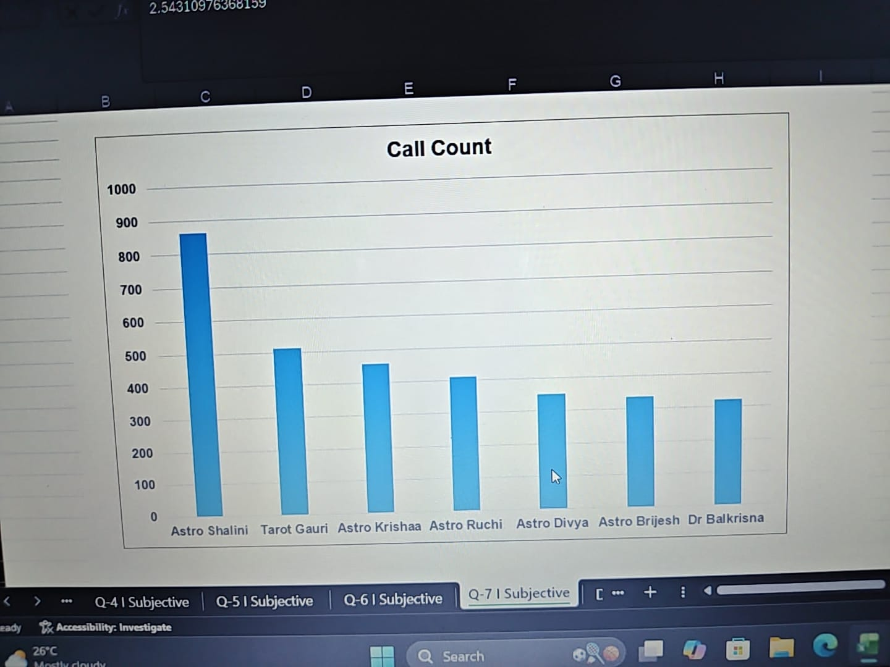

- Description:
The PivotTable shows each Guru/agent's call count and average Clean Duration.The accompanying Call Count chart highlights agents handling relatively high numbers of calls.

Insights:
- The overall average Clean Duration is approximately 1.78.
- Total recorded userCallStatus count is 9,345.
- Workload is uneven across agents.
- The highest call volumes in the analyzed list are:
- Astro Shalini – 864 calls
- Tarot Gauri – 512 calls
- Astro Krishaa – 459 calls
- Astro Ruchi – 412 calls
- Astro Divya – 351 calls
- Astro Brijesh – 338 calls
- Dr Balkrisna – 323 calls

- These seven agents together account for about 34.9% of the 9,345 recorded calls, indicating that a substantial portion of the workload is concentrated among a relatively small group of agents.
- Average Clean Duration varies considerably between agents, so workload should not be assessed using call count alone.

Recommendations:
- The call center should monitor both call volume and average Clean Duration when allocating incoming calls.
- Agents handling substantially higher workloads can be given additional support or have some incoming calls redistributed to agents with lower workloads.
- Average interaction duration should also be monitored so that workload redistribution does not negatively affect service quality.
- Workload can then be reviewed periodically using the PivotTable.

Spreadsheet functions / Excel analysis used:

PivotTable – Count of userCallStatus
PivotTable – Average of Clean Duration
AVERAGE — to calculate average Clean Duration
COUNT/Count of userCallStatus — to measure workload

Question 8: What new technologies or tools could be implemented to enhance call center operations and customer service?

Solution:

Approach:
I analyzed the call-status distribution and agent workload to identify operational areas where technology could improve efficiency and customer service. The analysis focuses on reducing unsuccessful interactions, improving call routing, monitoring agent workload, and providing better customer and agent support.

Charts & Tables:
- Table / Chart Name:
Call & Chat Status

- Description:
This chart shows the distribution of completed and other call outcomes such as busy, cancelled, failed and no-answer interactions. It helps identify areas where technology can improve call handling and routing.

Insights:
- The call center handled 9,345 interactions.
- 7,621 interactions were completed, while 439 were busy, 992 were cancelled, 86 failed and 207 were no-answer.
- The presence of unsuccessful or incomplete interactions indicates an opportunity to improve call routing, availability and follow-up.
- Agent workload is not evenly distributed. For example, Astro Shalini handled 864 calls, while several other agents handled considerably fewer calls.
- Therefore, technology can be used not only to improve customer service but also to distribute workload more effectively and monitor operational performance.

Recommendations:
  - Implement an improved IVR and Automatic Call Distribution (ACD) to route customers to the appropriate available agent and reduce busy/no-answer interactions.
  - Introduce real-time call-center dashboards to monitor call volume, call status, waiting time, agent workload and customer ratings.
  - Use Workforce Management (WFM) tools to identify peak periods and distribute incoming calls among available agents more effectively.
  - Integrate a CRM system so agents can access customer information and previous interactions while handling calls, reducing repeated questioning and improving service continuity.
  - Implement call-quality monitoring and recording tools to identify service issues and provide targeted training to agents.
  - Use AI-based agent assistance and automated call summaries to reduce manual work and help agents handle customer queries more efficiently.
  - Set automated alerts for high waiting times, busy periods, missed calls and failed interactions so supervisors can respond quickly.
  - Monitor the technology using dashboard KPIs such as completed-call percentage, busy/no-answer calls, average call duration, customer rating and agent workload to determine whether the technology is improving performance.

  - Functionality Used:
  - PivotTable aggregation (COUNT) + dashboard visualization + comparative analysis.
  - The underlying project documentation similarly identifies call-status and workload data as the basis for recommendations around routing, monitoring, CRM, quality tools and AI assistance.

  - The main technology priorities should be intelligent call routing, real-time monitoring, workforce-management tools, CRM integration and AI-based agent assistance. These tools directly address the observed busy, cancelled, failed and no-answer interactions while also helping manage uneven agent workloads.

Question 9: What metrics should be included in the final dashboard to comprehensively view call center performance and guide investment decisions?

Solution:

Approach:
I reviewed the call centre data and selected metrics covering the major areas of performance: call volume, revenue, customer satisfaction, call duration, consultation type, website/platform usage, call outcomes, time-based demand and agent performance. These metrics provide a comprehensive view of operational efficiency, customer experience and financial performance and can support data-based investment decisions.

Charts & Tables:
- Table / Chart Name:
AstroSage Call Centre Performance Dashboard

- Description:
The dashboard combines KPI cards, PivotTables and charts to monitor call volume, revenue, customer satisfaction, call duration, consultation types, website distribution, call status, hourly demand, daily call volumes and guru performance.

Key Metrics to Include:

- Total Calls – measures the overall workload handled by the call centre.
- Total Revenue – measures the financial contribution generated from consultations.
- Average Rating – indicates the overall customer satisfaction level.
- Average Call Duration – helps monitor the average time spent handling interactions and agent workload.
- Revenue by Consultation Type – shows the financial contribution of Call, Chat and other consultation types.
- Call & Chat Status – shows completed, busy, cancelled, failed and no-answer interactions and helps identify operational issues.
- Call Distribution by Hour – identifies periods of higher demand and can support staffing decisions.
- Day-by-Day Call Volume – shows changes in workload over time and helps identify high-demand days.
- Website/Platform Distribution – shows how interactions are distributed across platforms such as app, dashboard and gurucool.
- Rating-Wise User Distribution – shows the distribution of customer ratings and helps monitor customer experience.
- Rating-Wise Guru Distribution – helps understand the distribution of ratings across consultants.
- Top 10 Gurus by Call Count – identifies consultants handling higher interaction volumes and supports workload monitoring.

Insights:
- Total Calls provides an overall measure of call-centre workload.
- Revenue and revenue by consultation type help understand the financial contribution of different services.
- Average Rating provides an important customer-experience indicator.
- Average Call Duration helps monitor interaction efficiency and workload.
- Call-status analysis identifies completed as well as unsuccessful interactions such as busy, cancelled, failed and no-answer calls.
- Hourly and daily call-volume analysis helps identify demand patterns and supports capacity planning.
- Guru-level metrics help identify workload concentration and support performance monitoring.
- Combining these metrics gives management a broader view rather than relying on a single KPI. The project document likewise recommends using call volume, rating, agent workload, revenue and call-status metrics together when considering staffing, training or technology investments.

Recommendations:
- Keep Total Calls, Total Revenue, Average Rating and Average Call Duration as the main KPI cards.
- Continue monitoring Call & Chat Status to identify unsuccessful interactions and areas requiring operational improvement.
- Use hourly and daily call-volume trends to plan staffing during periods of higher demand.
- Monitor guru workload and call counts to identify workload concentration.
- Track revenue by consultation type to understand the financial contribution of different services.
- Use the Website, Consultation Type and Date/Day slicers to allow management to examine performance under different conditions.
- Use these metrics together when making decisions regarding technology, staffing, training and customer-service improvements.

Functionality Used:
PivotTables, COUNT, SUM, AVERAGE, data aggregation, charts/visualizations and interactive slicers.

Question 10: How would you allocate a 1 crore rupee investment to optimize operational efficiency, enhance customer satisfaction, and boost profitability, and what analysis-based recommendations would you offer to support this?

[you have to give bullet pointers to answer this question]

Solution:

Approach:
The ₹1 crore investment should be allocated according to the operational issues identified from the call-status, rating, call-volume, revenue, and agent-workload analysis.
Priority should be given to improving unsuccessful interactions, customer experience, workforce efficiency, and data-driven decision-making.
The proposed allocation is designed to improve operational efficiency while supporting customer satisfaction and profitability.

Charts & Tables:
- Table / Chart Name:

  - Call & Chat Status
  - Rating-Wise User Distribution
  - Call Distribution Over Hours
  - Day-by-Day Call Volumes
  - Revenue Generated by Consultation Type
  - Rating-Wise Guru Distribution
  - Top 10 Gurus

- Description:
- These dashboard views show interaction outcomes, customer ratings, peak call periods, revenue contribution, and agent workload.
- Together, they identify areas where investment in technology, workforce management, customer support, and performance monitoring can improve call-center operations.

Insights:
- The call center handled 28,027 interactions overall.
- 7,621 interactions were completed, while 439 were busy, 992 were cancelled, 86 failed, and 207 were no-answer in the Call & Chat Status analysis.
- The overall average Clean Rating is approximately 2.85, indicating scope for improving customer experience.
- Call volumes vary by hour and day, making workforce scheduling and capacity planning important.
- Agent workload is uneven; for example, Astro Shalini handled 864 interactions, indicating the need for better workload balancing.
- Recorded revenue is approximately ₹2.14 lakh, with the largest contribution coming from Call consultations.
- Therefore, investment should focus on reducing unsuccessful interactions, improving service quality, balancing agent workload, and increasing efficient revenue-generating interactions.

Recommendations: — ₹1 Crore Investment Allocation:

-₹25 lakh (25%) – AI, IVR & Automatic Call Distribution
- Improve IVR and ACD to route customers to suitable available agents.
- Reduce busy, cancelled and no-answer interactions.
- Use AI-based routing and automated customer assistance for common queries.

-₹20 lakh (20%) – Workforce Management & Real-Time Monitoring
- Implement workforce-management tools based on hourly and daily call-volume patterns.
- Improve agent scheduling during high-volume periods.
- Monitor call volume, waiting time, agent workload and service performance in real time.

-₹15 lakh (15%) – CRM & Customer-Service Technology
- Strengthen CRM integration so agents can access customer information and previous interactions.
- Reduce repeated questioning and improve service continuity.
- Enable better customer follow-up.

-₹15 lakh (15%) – Quality Monitoring & Customer Experience
- Implement call-quality monitoring and recording.
- Analyse low-rated interactions to identify service problems.
- Introduce systematic feedback and quality-assurance processes to improve the average rating.

-₹10 lakh (10%) – Agent Training & Performance Development
- Train agents in communication, problem-solving and effective call handling.
- Use workload and rating data to identify agents requiring additional support.
- Reduce dependence on a small number of heavily utilized agents.

-₹10 lakh (10%) – Analytics & Business Intelligence
- Strengthen dashboards for monitoring revenue, ratings, call status, consultation type, website, hourly volume and agent performance.
- Use data to identify profitable consultation types and operational bottlenecks.
- Establish KPI tracking for management decisions.

-₹5 lakh (5%) – Contingency & Continuous Improvement
- Reserve funds for unexpected technology requirements, system upgrades and pilot projects.
- Review performance periodically and redirect investment toward initiatives producing measurable improvements.

Total Investment = ₹1 crore (₹100 lakh).

Expected Outcome:

- Lower busy, cancelled, failed and no-answer interactions.
- Better matching of staffing with peak call periods.
- More balanced agent workload.
- Improved customer ratings and service quality.
- Better visibility into revenue and operational KPIs.
- Greater use of automation and CRM can reduce manual work and support more efficient customer handling.
- Continuous dashboard-based monitoring can help management evaluate whether the investment is improving efficiency, customer satisfaction and profitability.

Important: The ₹1 crore split above is a proposed investment plan based on the patterns in Excel analysis. The dataset does not contain actual implementation costs or ROI figures, so the exact amounts cannot be claimed as calculated from the data.

