AC Current Isolation from Total Load Signal
ML Internship Assignment — Electrical Data Analysis
Data: 22–23 June 2024 | 5,575 samples | ~24 hours | Voltage: ~240–253 V

1. Data Overview
The dataset captures one full day of electrical readings from a single room, sampled approximately every 2 minutes. Each record contains a Unix millisecond timestamp, voltage (V), and total room current (A).
- 5,575 total samples spanning 22 Jun 18:30 to 23 Jun 18:28 (~24 hours)
- Voltage ranges 240–253 V — standard Indian residential single-phase supply
- Current spans 0.02 A to 25.4 A — a ~1,000× dynamic range indicating multiple load types
- Mean current = 1.78 A, but median = only 0.09 A — indicating most readings are low-load background

2. Full 24-Hour Current Signal
The plot below shows the total current over the entire day. AC-ON periods (above the 5 A threshold) are highlighted in red; background load periods are in blue.

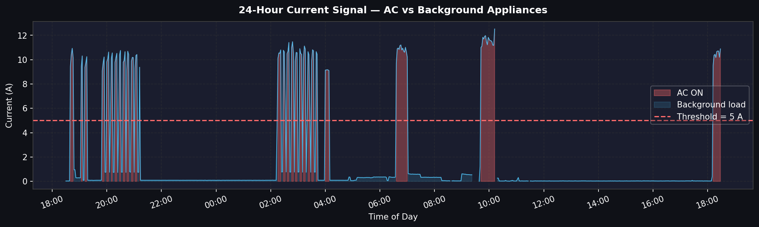
Fig. 1: 24-hour current signal resampled to 2-min medians. Red fill = AC ON; blue fill = background. Dashed line = 5 A threshold.

3. Current Distribution — Bimodal Separation
The histogram below confirms the key finding: there is a near-empty gap between ~0.4 A and ~8 A. The two load regimes are completely separable by a simple threshold.

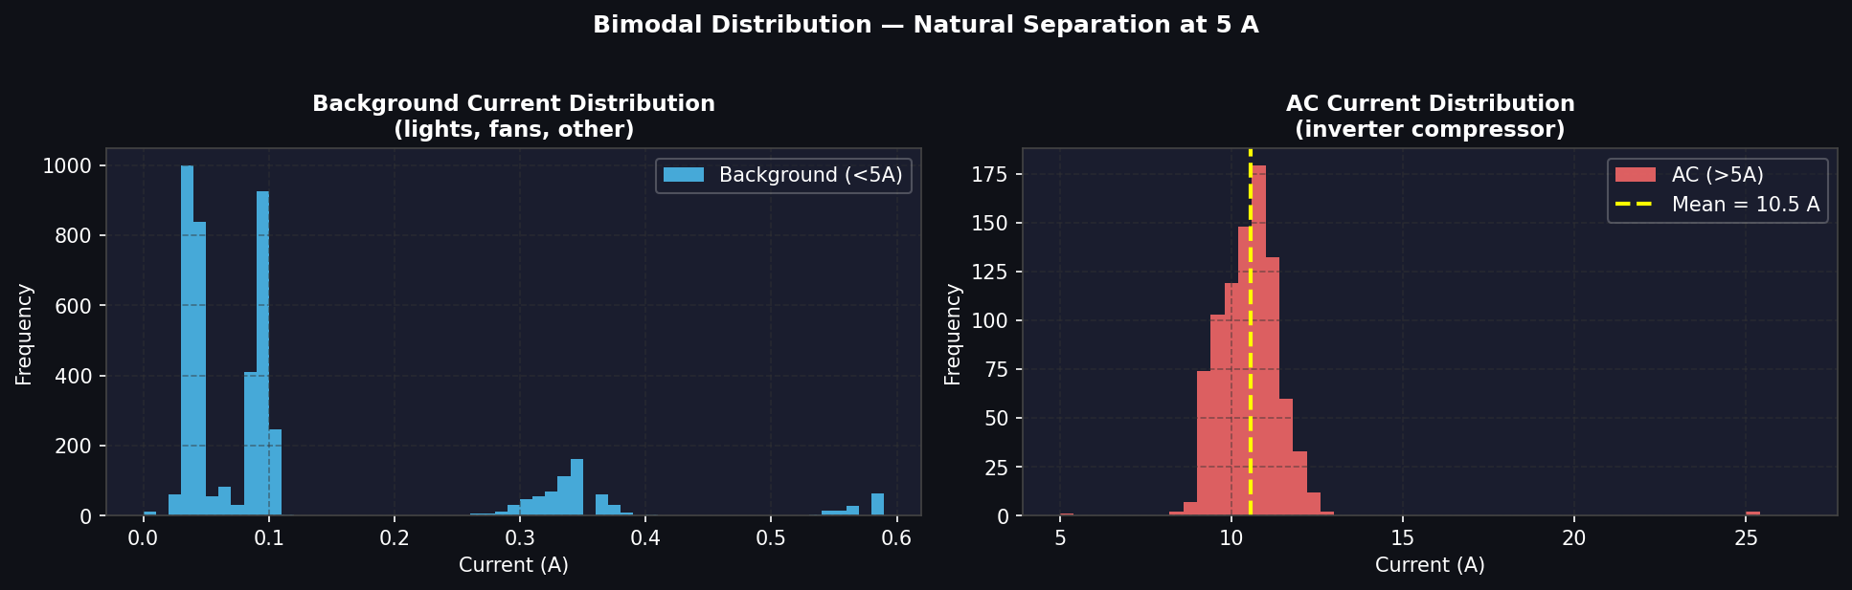
Fig. 2: Left — background appliance current clusters tightly below 0.4 A. Right — AC current clusters around 9–12 A (inverter modulation). The yellow dashed line marks the mean AC current (~10.5 A).
This bimodal structure is the physical basis of the isolation approach. A non-inverter AC would show a hard on/off step; the smooth unimodal cluster seen here confirms an inverter-type compressor that modulates speed continuously.

4. AC Usage Pattern by Hour
The charts below show when during the day AC was active, and how power consumption breaks down by load type across each hour.

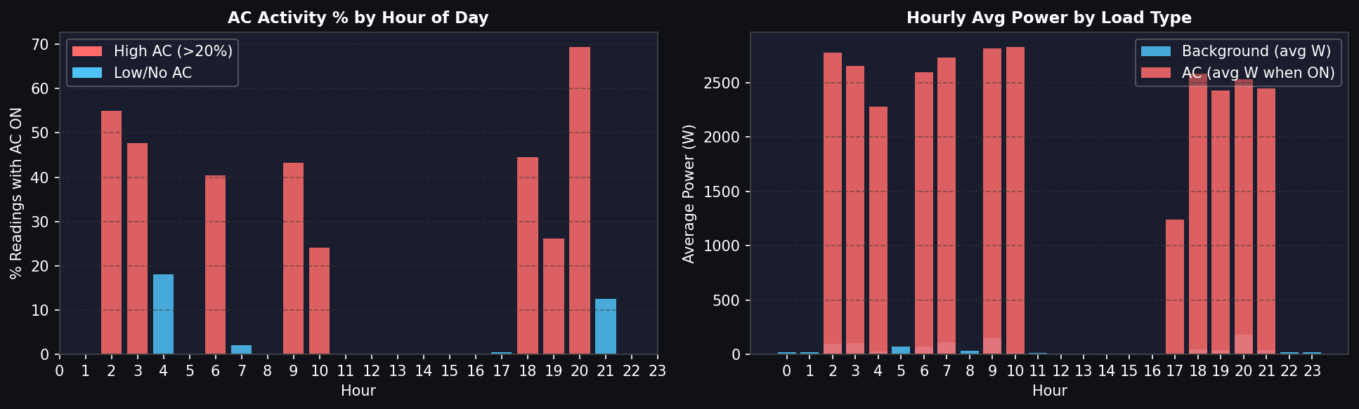
Fig. 3: Left — % of readings with AC ON per hour. Right — avg power split by load type. Hours 18–21 (evening arrival) and 02–04 (peak night heat) show strongest AC activity.
Usage is consistent with a June summer day in India: the room is unoccupied or naturally ventilated during the day, with heavy cooling needed in the evening and again late at night when outdoor temperatures peak.

5. Proposed Method to Isolate AC Consumption

Step 1 — Threshold Segmentation
Apply a hard threshold at 5 A. The wide gap in the distribution (0.4 A to 8 A) gives ample safety margin:
- AC current = total current if I > 5 A
- Background = total current if I ≤ 5 A

Step 2 — Background Baseline Estimation
During AC-ON periods, background loads (fans, lights) are still running but hidden under the AC signal. To cleanly remove them:
- Compute hourly median of current during AC-OFF windows for each hour of the day
- Interpolate / forward-fill this baseline into AC-ON time slots
- Isolated AC current = total current − estimated background baseline

Step 3 — Power Conversion & Smoothing
- Multiply isolated current × voltage to get AC power in Watts
- Apply a 3–5 min rolling median to smooth inverter micro-fluctuations
- Flag startup spikes (I > 18 A, duration < 30 s) separately as compressor inrush

6. Isolated AC Signal (After Background Subtraction)
The two-panel chart below shows the before (raw total current) and after (isolated AC current) of the proposed method applied to the dataset.

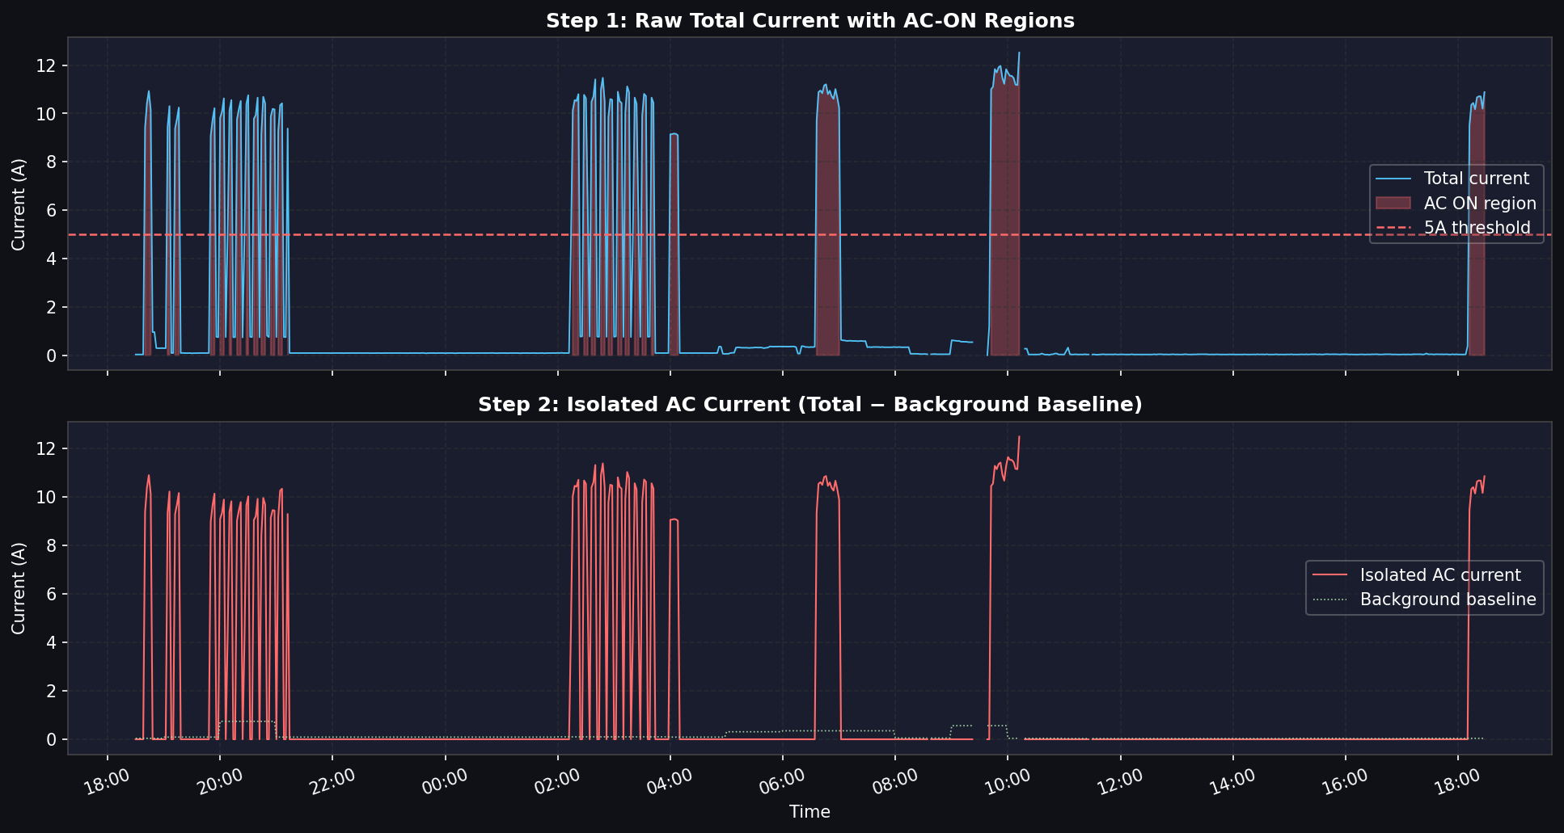
Fig. 4: Top panel — raw total current with AC-ON regions. Bottom panel — isolated AC current after subtracting hourly background baseline. Green dotted line = interpolated background estimate.

7. Key Metrics Summary
Metric | Value
Data Period | 22 Jun 2024 18:30 – 23 Jun 2024 18:28 (24 hrs)
Total Readings | 5,575 samples
AC Avg Current | ~10.5 A
AC Avg Power | ~2,617 W (2.6 kW)
Background Avg Current | ~0.15 A (lights, fans, etc.)
Background Avg Power | ~37.6 W
AC Active (% of day) | ~15.7% of total readings
Proposed AC Threshold | > 5 A (clear bimodal gap)
AC Type Estimate | Inverter (unimodal, low CV)
Likely AC Size | 1.5–2 ton (~1,500–2,000 W nameplate)

8. Conclusion
The total current signal contains a naturally separable AC signature. The ~70× magnitude difference between AC operation (~10.5 A) and background loads (~0.15 A) creates a clean bimodal distribution with virtually no overlap, making a 5 A threshold a highly reliable separator.
The smooth, unimodal AC current cluster (low coefficient of variation) confirms an inverter-type compressor — an important detail, as a non-inverter AC would require a different detection approach. Usage timing (evening + late-night peaks) aligns with June summer occupancy patterns in India.
The resulting isolated AC time-series — produced without any model training — is directly suitable as a labelled feature for downstream ML development.

orion-blue | ML Internship Assignment | June 2024 Data

