Classification of EEG signals for hand gripping motor imagery and hardware representation of neural states using Arduino-based LED sensors

Deepanshi Dabas1, Ayushi1, Mehak Lakhani1, Bharti Sharma1,

1 Maharaja Surajmal Institute of Technology, C-4 Janakpuri, Delhi, India, 110058

{deepanshidabas123, ayushi773478, lakhanimehak23}@gmail.com,

bhartisharma@msit.in

**Abstract.**This study aims to classify the multi-frequency EEG signals associated with motor-imagery while performing a carefully devised motor-imagery task of gripping left/right hand for rehabilitation application. EEG-based Brain Computer Interface incorporates recording and classification of the transient EEG changes during different imagery tasks. For rehabilitation of gripping and release movement, 10 healthy right-handed volunteers (7 males and 3 females with mean age:21.3 years) participated in the EEG investigation using 32-Channel Brain product system. The volunteers performed the motor-imagery cued tasks in random order. EEG data was processed to calculate relative alpha-band power for each motor-imagery trial block from channels C3 and C4 to be passed as feature vectors for classification of the brain states. After a comparative analysis, SVM classification algorithm provided the highest accuracy of 75% and the binary output was interfaced with Arduino Uno component to reciprocate left and right imaginary hand movement states using LED light bulbs.

**Keywords:** Brain Computer Interface, EEG, Support Vector Machines, Rehabilitation, Arduino

1 Introduction

A Brain Computer Interface (BCI) forms a direct link between the human brain and an external computational device. Training the patients suffering from neural disabilities, to initiate brain signals for controlling external devices, provides scope for extensive future development. Direct communication with devices to perform motor tasks, specifically using the brain signals of imagery aids in bypassing the shortcomings imposed on people with neurological disorders [1]. The electrical activity in the brain can be recorded using a non-invasive monitoring method, EEG (Electroencephalography). EEG measures voltage fluctuations within the neurons of the brain [2]. Such an EEG-based brain-computer interface (BCI) can be used to develop a simple binary command for the working of a robotic device. The processing pipeline followed by such a system is as follows, acquisition of EEG data, feature extraction, classification of the features and machine control as shown in figure 1. In this study, relative alpha band powers are computed for each motor imagery trial from both left channel (C3) and right channel (C4). Alpha band waves fall in the frequency range of 8-12 Hz and are present in a normal wakeful state with minimal activity as associated with motor imagination. These oscillations reflect cognitive states of the brain during imagery and are used as a feature to discriminate between the two classes.

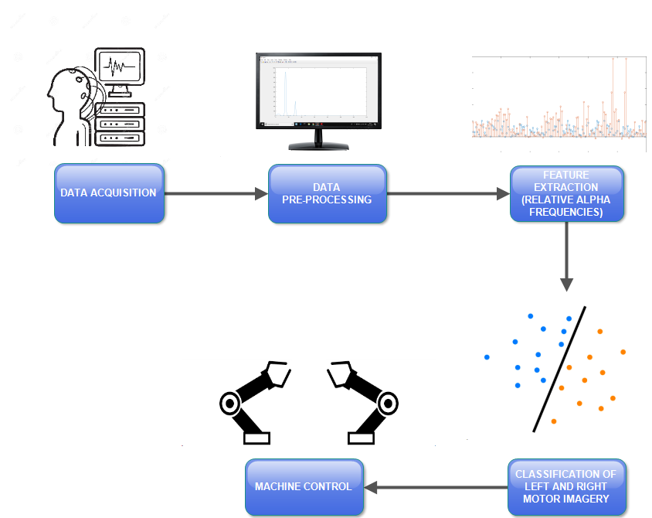

**Fig.1.** Timeline of proposed system

Classification of the two brain states is implemented using Naive Bayes, k-Nearest Neighbor, Support Vector Machines and Linear Discriminant Analysis. Naive Bayes classification model is used for predictive modeling and is based on Bayes theorem as shown in equation (1). It is assumed that all the features are independent of each other and have an equal contribution to the prediction of the result. It calculates the probabilities for the set of input values for each class and classifies as per the outcome with the highest probability.

|  |  |
| --- | --- |
| . | (**1**) |

In the k-Nearest Neighbor classification model, the combined vote of ‘k’ neighbors of an object decides the class that the object will fall into. The class of the object is computed locally and hence this model is sensitive to the local structure of the data. Support Vector Machine (SVM) classification model finds a hyperplane in an N-dimensional space that distinguishes between the classes of the data. N is the number of features of the dataset. The objective is to find the hyperplane that maximizes the margin between the classes. Linear Discriminant Analysis (LDA) computes the mean and variance of the data and makes predictions by estimating the probabilities for a set of input data for each class and chooses the outcome with the highest probability. These four classification models are being used extensively for discrimination of brain states for BCI systems. A comparative analysis for the accuracy of prediction amongst all the models was carried out to choose the model with most accurate predictions based on the relative alpha band power from both left and right channels. For left motor imagery, the output is predicted as 0 and as 1 for right motor imagery. Binary classification is implemented and the predicted values are passed as input to Arduino microcontroller component. The hardware representation of the left and right brain states is done using LED bulbs. For further implementation, the input digital signal used to illuminate the LED bulbs can be fed to robotic grippers to rehabilitate grip and release motor movement of left and right hands.

2 Literature Review

The reviewed EEG-based BCI articles accommodated a variety of goals. These goals can be categorized as (a) development/improvement of existing processing technologies such as developing optimal channel selection methods for motor-imagery-based BCIs [3] (b) development of new technologies such as new EEG recording system [4] (c) application based such as a brain switch for turning on/off a BCI system [5], a real-time drowsiness detection system [6] (d) review articles [7] and (e) evaluation of parameters affecting BCI system such as the such as the design of the electrode layout [8], impact of auditory distraction on BCI performance [9],relationship between motivation and P300 amplitudes [10]. A divergence of orientation towards practical application-based BCI systems is evident. This increase in trend is devoted to assisting people with disabilities, so they can express their intentions with externally controlled devices. BCI researchers have used features derived from PSD, ERP, wavelet coefficients, and adopted classification algorithms, such as LDA, SVM, Bayesian, NN. There are broadly two types of BCI systems in terms of functioning: offline and online systems. In the context of this study, the proposed system will operate in an offline environment and work towards the practical application approach.

**3 Methodology  
  
3.1 Data Acquisition**

10 healthy right-handed volunteers (7 males and 3 females with mean age: 21.3 years) participated in the EEG investigation using 32 Channel Brain product system. To improve the discrimination power of the two brain states (left versus right-hand movements), the volunteers were trained for the experiment beforehand using the same paradigm for a duration of 10 minutes and 30 seconds. They were asked to perform motor imagery gripping tasks(GO) for left/right hand and resting task (NO-GO) in a randomized manner. Both grip and release cues were provided to the volunteer for a duration of 4s each for left and right hands. Each trial was of a duration of 14s as depicted in figure 2.

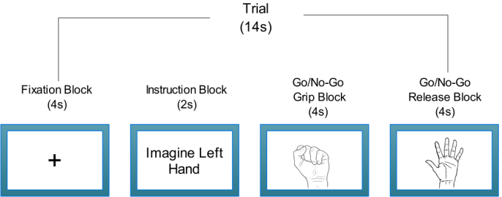

**Fig.2.** Illustration of trial block

**Table 1.** Literature survey to review EEG based BCI systems, the algorithms employed and their applications.

|  |  |  |  |  |
| --- | --- | --- | --- | --- |
| Author | Year | Algorithm | Key Idea | Pros & Cons |
| J. R. Wlpaw [et. al] | 2000 | EEG-based communication | EEG-based communication depends on successful interaction of two adaptive controllers | 1.Translates EEG  control into device control  2.Depends totally on muscle control |
| Lotte [et. al] | 2007 | Fuzzy Classifier | Briefly present the commonly employed algorithms and their critical properties | 1. Compares and assesses performance  2. Curse of dimensionality and bias-variance trade off |
| Jonathan R. Wolpaw [et. al] | 2004 | Adaptive algorithm | Identifying and focusing on the EEG features that the person is best able to control and encourages further improvement in that control | 1. Might control complex movements  2. Not necessary to implant electrodes for this application |
| Rajdeep Chatterjee[et. al] | 2016 | Support Vector Machines (SVM) and Multi-layered Perceptron (MLP) | Focuses on the classification of motor imagery of the left-right hand movements from a healthy subject | 1.Determines the right intention from brain activities and reflect them  2.Slow computation |
| K.E. Stephan [et. al] | 2016 | Bayesian model selection  and Generative Embedding | An overview of the emerging use of computational models for clinically relevant single-subject predictions | 1. Avoid erroneous interpretations of neuroimaging data  2. Assumes that features are independent |
| Jian Kui Feng [et. al] | 2019 | CSP rank selection method and Linear Discriminant Analysis(LDA) | Combines the multiband signal decomposition filtering and the CSP-rank channel selection methods to select significant channels, and then calculate the classification accuracy | 1. Improve classification accuracy  2. Large amount of redundant information, |
| Md.A.M.Joadder [et. al] | 2019 | Spatial Filtering Method and Linear Discriminant Analysis (LDA) classification | A novel SI based BCI framework is intro-duced to identify mental states and a new channel selection concept is also proposed for the same | 1. Efficacy of the method is confirmed by statistical and graphical analyses  2. Additional noise |
| Quadrianto Novi [et. al] | 2007 | Sub-band Common Spatial  Pattern (SBCSP) | Fine-tuned system is hardly repeatable by other research group so proposed a SBCSP framework, which provides an alternative solution to address this issue | 1.Achieves the best  accuracy  2. Problem of a time-consuming fine-tuning process in building a BCI for each subject |
| Benjamin Blankertz [et. al] | 2008 | Common Spatial Patterns(CSP) | To provide comprehensive information about CSP (Common Spatial Pattern), its application and discuss recent variants of CSP | 1.Low computational cost  2. Model selection and pre-processing issues or deterioration under outliers |
| Xiaogang Chen [et. al] | 2015 | Joint Frequency Phase  Modulation (JFPM) method | Demonstrates that BCIs can provide a truly naturalistic high-speed communication channel using noninvasively recorded brain activities | Low communication speed |
| M.Z. Ilyas [et. al] | 2015 | Regression Trees | An algorithm that automatically estimates the class of data as represented by a feature vector | 1.Does not require normalization of data  2.Calculation is complex |
| Fabien Lotte [et. al] | 2007 | k-NN | An algorithm that aims at automatically estimate the class of data as represented by a feature vector | 1. Very simple implementation.  2. Does not learn anything from the training data and simply uses the training data itself for classification |

3.2 Data Pre-processing

Following the acquisition of EEG data, the next step was pre-processing of the EEG data using MATLAB. The data was analyzed and processed for motion artifact removal, eye blinking and was down sampled to 250 Hz. It was then band pass filtered between 1 Hz to 50 Hz using a basic FIR filter. Re-referencing was carried out without the ECG channel. Wavelet based analysis gives a suitable base for the evaluation of EEG data. In the context of this study, we use the Discrete Wavelet Transform (DWT) to decompose the pre-processed EEG signal x[k] into its subsequent wavelet coefficients by shifting and scaling the parent signal. The primary task in DWT is to select the number of wavelet decomposition levels for the signal. The output of each level *j* is represented in the form of two signals: Detail ($D_{j}$) and Approximation ($A_{j}$), described in equation (2) and (3):

|  |  |
| --- | --- |
| $D_{j}\left[i\right]= \sum_{k}{x\left[k\right] .h[2 .i-k]}$. | (**2**) |
| $$A_{j}\left[i\right]= \sum_{k}{x\left[k\right] .l[2 .i-k]} .$$ | (3) |

where h[.] and l[.] are the high pass and low pass filters respectively. The above-mentioned procedure of generating *Dj* and *Aj* repeats as long as *j* does not surpass *jm* [11]. The algorithm for decomposition of EEG signal into its subsequent wavelet coefficients and extraction of relative alpha power for each trial block is explained as below:

for i = 1 to number of motor imagery trials

X = EEG.data(channel number, sample points)

Y = EEG.data(channel number, sample points)

waveletFunction = 'db8';

[C,L] = wavedec(X,Y,8,waveletFunction);

D5 = wrcoef('d',C,L,waveletFunction,5); %GAMMA

D6 = wrcoef('d',C,L,waveletFunction,6); %BETA

D7 = wrcoef('d',C,L,waveletFunction,7); %ALPHA

D8 = wrcoef('d',C,L,waveletFunction,8); %THETA

A8 = wrcoef('a',C,L,waveletFunction,8); %DELTA

D7 = wrcoef('d',C,L,waveletFunction,7); %ALPHA

POWER_DELTA = (sum(A8.^2))/length(A8);

POWER_THETA = (sum(D8.^2))/length(D8);

POWER_ALPHA = (sum(D7.^2))/length(D7);

POWER_BETA = (sum(D6.^2))/length(D6);

POWER_GAMMA = (sum(D5.^2))/length(D5);

Total = POWER_DELTA + POWER_BETA + POWER_ALPHA POWER_THETA +POWER_GAMMA;

RELATIVE_ALPHA=POWER_ALPHA/Total;

end

3.3 Feature Extraction

DWT decomposition technique represents EEG data as wavelet coefficients. Their coefficients are converted into features for the classification of brain states. The relative alpha band power was computed for every GO-grip motor imagery trial with 1000 sample points from channels C3 and C4. A clear distinction between the two brain states could be observed upon visualizing the relative alpha powers of each motor imagery gripping trial block from channels C3 and C4.

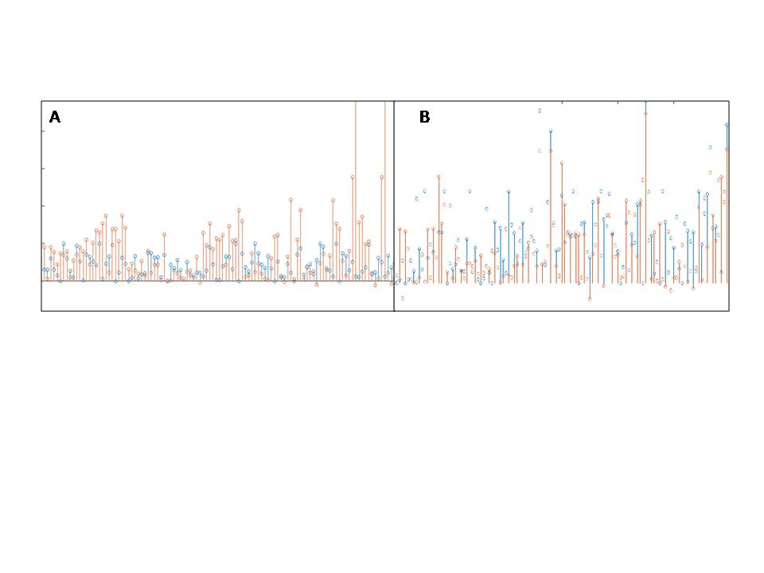

**Fig.3.** Plot of relative alpha powers from channel C3 (Blue) and C4 (Red) for trial blocks associated with motor imagery of left hand gripping (A) and right hand gripping (B)

**3.4 Classification**

The dataset was modeled using four classification algorithms to perform a comparative analysis on accord of accuracy and recall rate. Accuracy is used as an evaluation metric as it is defined as the ratio of the number of correct predictions made by the classifier to the number of predictions made. It can be computed from the confusion matrix obtained for each model. This metric works well when there are an equal number of samples for the two classes. Also, recall rate has been used as an evaluation metric as well, as it defines the number of true positives obtained in contrast to the total number of predictions. These two metrics have been obtained to cross-validate the hence obtained results and represented by equation (4) and (5).

|  |  |
| --- | --- |
| $Accuracy=\frac{Number of correct predictions}{Total Number of predicitons}$. | (**4**) |
| $Recall Rate=\frac{Number of true positives obtained}{Total Number of predicitons}$. | (**5**) |

**3.5 Hardware Implementation**

Two LED bulbs were connected to the Arduino component using a breadboard. The left LED bulb was illuminated on receiving a digital command of 0 and the right LED bulb for a digital command of 1. The hardware implementation represents the two classes of brain states during motor imagery of grip and releases movements and the digital signals can be used to control robotic grippers to rehabilitate grip movement for people with neurological disorders. The circuit diagram depicting the wired connections of the different hardware components is shown in figure 5.

**4 Results**

The classification accuracies observed were as follows, Naïve Bayes: 61.66%, LDA: 54.16%, k-NN: 54.6% and SVM: 75% using relative alpha power as a feature to separate the two brain states, as shown in table 2. Accuracy and recall rate have been used as evaluation metrics to perform a comparative analysis between the different models. The plots for accuracy and recall rates for the four classification models are depicted in figure 4. As it is evident from the results, SVM classifier gave maximum accuracy and recall rate, its predicted set of output values for left and right motor imagery gripping task was fed as input to Arduino Uno component to represent the two classes using light bulbs as shown in figure 5. The representation of motor imagery EEG signals for the gripping task in the form of digital input fed to the Arduino component extends application to further manipulation of hardware devices.

**Table 2.** Classification algorithms accuracy and recall rate results

|  |  |  |  |  |
| --- | --- | --- | --- | --- |
| CLASSIFICATION ALGORITHM | ACCURACY | | RECALL RATE | |
| Naïve Bayes | | 61.66 % | 0.68 |
| LDA | | 54.16 % | 0.44 |
| SVM | | 75% | 1.0 |
| k-NN | | 54.6 % | 0.44 |

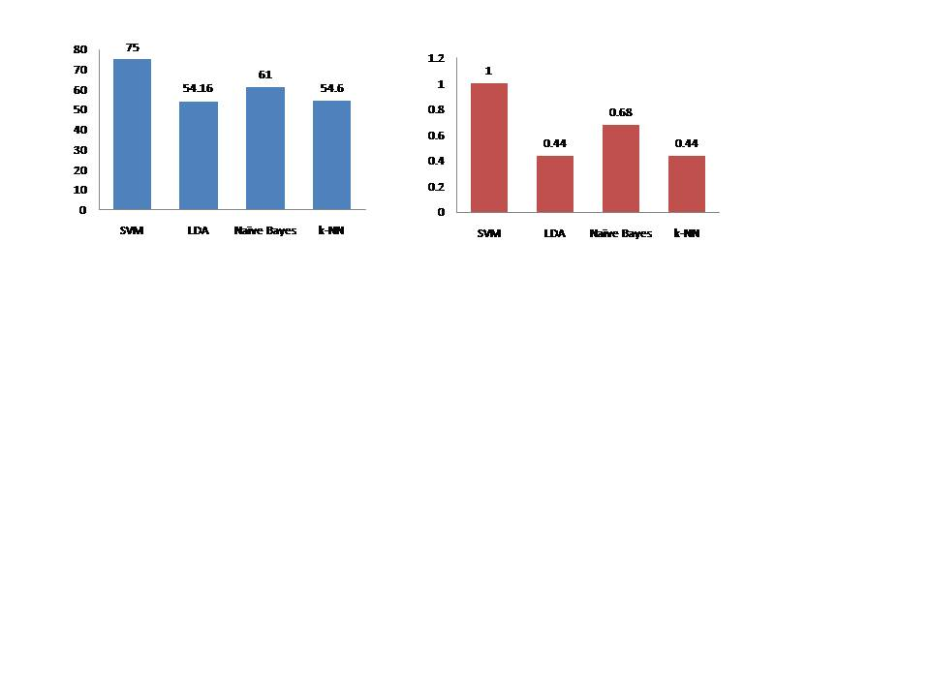

**Fig.4.** (Left) Accuracy percentages of the four classification algorithms employed in this study (Right) Recall Rates of the four classification algorithms employed in this study

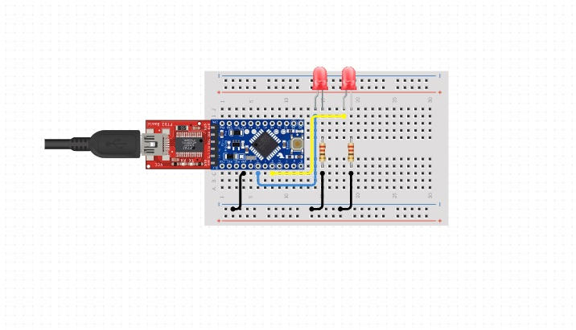

**Fig.5.** Arduino Uno microcontroller circuit diagram with breadboard, resistors, USB cable, connecting wires and two LED light bulbs

**5 Discussion**

BCI for neuro-rehabilitation involves the recording and decoding of local brain signals generated by the patient, as they try to perform an action based task or during a mental imagery task. The diversity of applications and range of inclusion of patients with neurological disorders speaks for its adaptable nature and demonstrates the scope of development in this area. Due to the complex nature of the brain data being acquired, constant efforts are made to devise tools and algorithms to improve upon the current systems. At every step, the data is being simplified without compromising its integrity to accurately interpret the imagery action performed by the volunteers and convert it to a binary command for machine control. SVM classifies the two brain states with the highest accuracy of 75% and was used to discriminate between left and right motor imagery state. The performance of the classifiers depends on several factors like the decomposition level for feature extraction using DWT, the relative performance of the subjects during motor imagery task, etc. Upon successful classification of the imaginative states of the human brain, while performing hand gripping task, these two brain states are further represented using the Arduino Uno toolkit with LED bulbs. This representation facilitates visualization of the converted digital signals interpreted from the brain. For future work, the predicted output can be translated as a digital input to control robotic grippers that could rehabilitate grip movement of the hands. [12, 13, 14, 15]

References

1. Daly, Janis J., and Jonathan R. Wolpaw. "Brain–computer interfaces in neurological rehabilitation." *The Lancet Neurology* 7.11 (2008): 1032-1043.
2. Henry, J. Craig. "Electroencephalography: basic principles, clinical applications, and related fields." *Neurology* 67.11 (2006): 2092-2092.
3. Tam, Wing-Kin, et al. "A minimal set of electrodes for motor imagery BCI to control an assistive device in chronic stroke subjects: a multi-session study." *IEEE Transactions on Neural Systems and Rehabilitation Engineering* 19.6 (2011): 617-627.
4. Gargiulo, Gaetano, et al. "A new EEG recording system for passive dry electrodes." *Clinical Neurophysiology* 121.5 (2010): 686-693.
5. Müller-Putz, Gernot R., et al. "Fast set-up asynchronous brain-switch based on detection of foot motor imagery in 1-channel EEG." *Medical & biological engineering & computing* 48.3 (2010): 229-233.
6. Li, Gang, and Wan-Young Chung. "A context-aware EEG headset system for early detection of driver drowsiness." *Sensors* 15.8 (2015): 20873-20893.
7. Hwang, Han-Jeong, et al. "EEG-based brain-computer interfaces: a thorough literature survey." *International Journal of Human-Computer Interaction* 29.12 (2013): 814-826.
8. Wang, Yijun, et al. "Design of electrode layout for motor imagery based brain--computer interface." Electronics Letters 43.10 (2007): 557-558.
9. Friedrich, Elisabeth VC, et al. "Impact of auditory distraction on user performance in a brain–computer interface driven by different mental tasks." *Clinical neurophysiology* 122.10 (2011): 2003-2009.
10. Kleih, S. C., Nijboer, F., Halder, S., & Kübler, A. (2010). Motivation modulates the P300 amplitude during brain–computer interface use. *Clinical Neurophysiology*, *121*(7), 1023-1031.
11. Kevric, Jasmin, and Abdulhamit Subasi. "Comparison of signal decomposition methods in classification of EEG signals for motor-imagery BCI system." *Biomedical Signal Processing and Control* 31 (2017): 398-406.
12. Lotte, Fabien. "A tutorial on EEG signal-processing techniques for mental-state recognition in brain–computer interfaces." Guide to Brain-Computer Music Interfacing. Springer, London, 2014. 133-161.
13. Aghaei, Amirhossein S., Mohammad Shahin Mahanta, and Konstantinos N. Plataniotis. "Separable common spatio-spectral patterns for motor imagery BCI systems." *IEEE Transactions on Biomedical Engineering* 63.1 (2015): 15-29.
14. Pfurtscheller, Gert, et al. "Mu rhythm (de) synchronization and EEG single-trial classification of different motor imagery tasks." *NeuroImage* 31.1 (2006): 153-159.
15. Babiloni, F., et al. "Linear classification of low-resolution EEG patterns produced by imagined hand movements." *IEEE Transactions on Rehabilitation engineering* 8.2 (2000): 186-188.