Product Design
Team Name | Elite
Project Name | Elektoo
Team Members | Aman Rai  Ayushi Goyal  Prachi Agrawal  Vinay Singh

Design Model
Search | Class state  - Generate a concrete query from the input typed in by the user.  Class behavior  - Method named “Generate_query is implemented by this class.
Search Query Box | Class state  - Process the query given by user as per the search query box parameters.  Class behavior  - Methods implemented includes auto-correct, auto-complete, spelling and grammar check, ambiguous query resolving.
Choice Matrix | Class state  - Process the query as per the selection/deselection by the user in the choice matrix.  Class behavior  Methods implemented includes  - updating the matrix on every select and deselect in the choice matrix  - Restore the initial state of the matrix on user's choice.
User | Class state  - Provides an option before the user to select the mode of search i.e. “search query box” or “choice matrix”.  Class behavior  Methods implemented includes  - Retrieving information from the system as per the user's wish.
Query | Class state  - Provides methods for formulating the user input into a concrete query to fetch data from the database.  Class behavior  Methods implemented includes  - Tokenization is splitting entire sentence into individual words to formulate the query and normalization is simply converting the entire query into lowercase english alphabets.
Display | Class state  - Displaying the desired results as per user's wish.  - Also displaying the count of available results corresponding to user's input query.  Class behavior  Methods implemented includes  - “Search_results” and “count_results”.
System | Class state  - To update the database (as per the earning system requirements).  - Fetching results from the database .  Class behavior  Methods implemented includes  - “update_database” to update the database, “Render_results” to get the results for the input query.
.
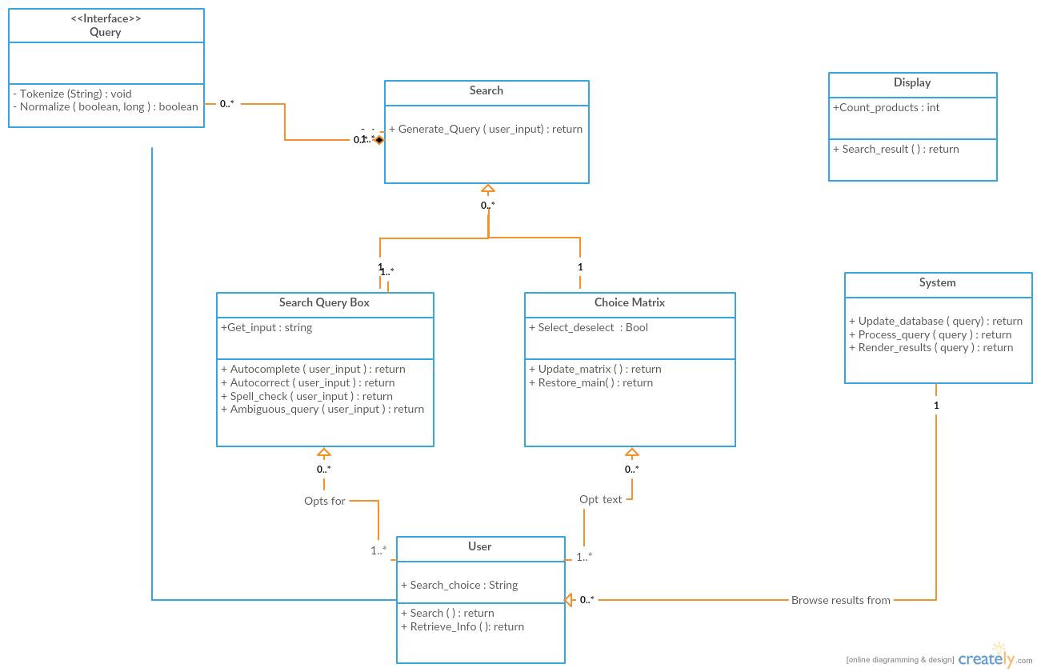

Sequence Diagram(s):

Autocomplete
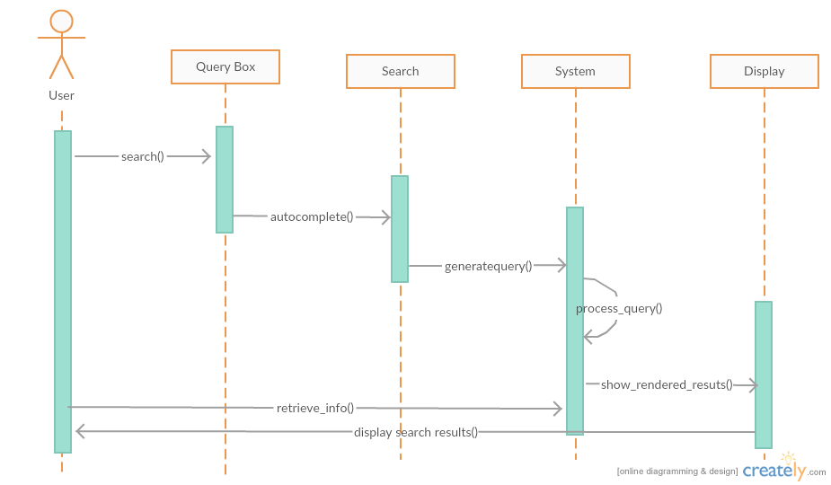

Autocorrect
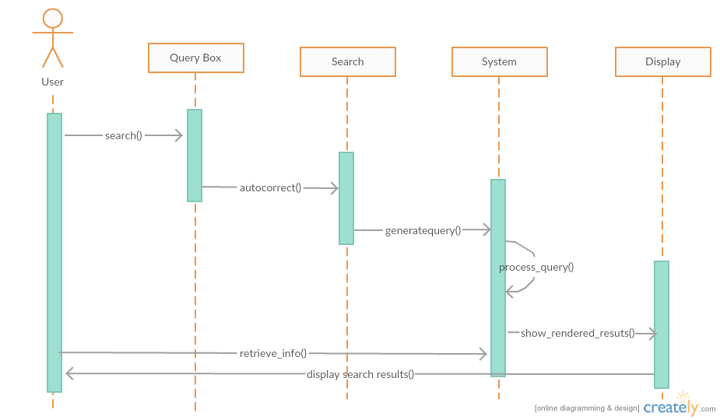

Resolve Ambiguity
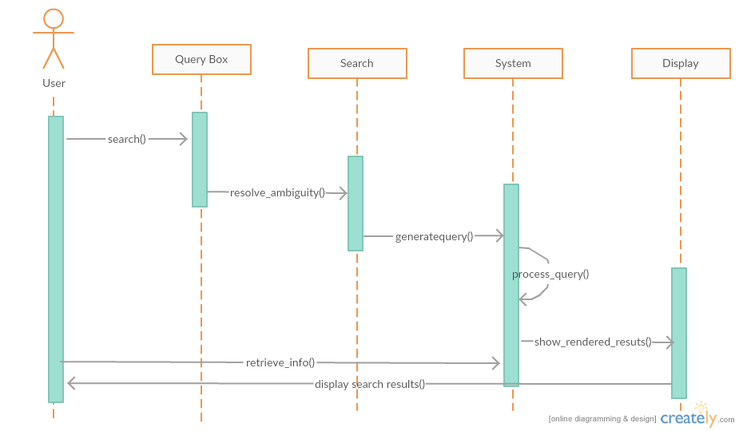
Update matrix
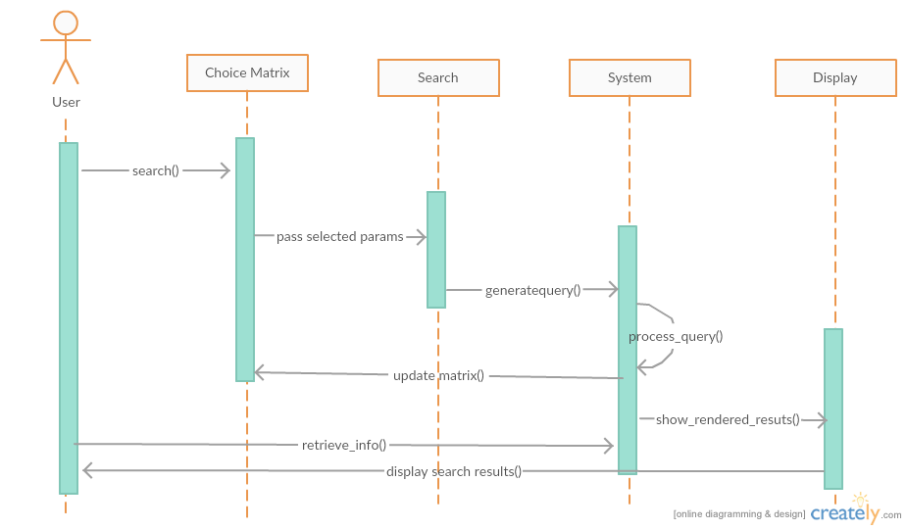

Design Rationale

Processing The Query

For project “Elektoo” it is required for us to implement a search query box and a choice matrix which will be helpful for the customers to navigate through commodities (mainly mobile phones for now) in E-commerce .
The main problem related to the search box was to generate an algorithm which could convert the input given by the user into rationale sql query to fetch results from the database . This step involves two processes -

a) Tokenization (along with normalization)

b) Parametrization
First of all the entire query is converted into lowercase english alphabets and then processed. (Normalization)
The search query is then tokenized and individual words are stored as the elements of an array. This can be achieved by splitting the query considering white-spaces as delimiter. One important assumption is that the the query will have rationale keywords separated by a space i.e. the user is will not make mistakes while giving the input.
Next, we need to identify the list of important parameters for a given commodity and store their index. A mobile phone for example will have company name,brand name , price , camera size and many other parameters.
These parameters will have a list of identifiers to detect them . For example 'price' parameter will have a list which will contain “related” keywords like { amount , rs, money} as identifiers.
After identifying all the parameters , operators associated with these parameters are searched for . The operators are identified through keywords. For example '<' operator is identified by keywords {less than, below, under, etc}. An important assumption made here is that operators associated with a parameter will be present in a given range of the parameter index. The value of the parameters is then looked for using the same logic as operators. The values are stored in a matrix and the query is generated using this matrix.
The matrix generated will roughly contain 3 rows namely as Parameter , operator and values

Example- “Asus phone below 20000rs and camera-size 5px”

Parameter | phone | Price | Camera-size
Operator | '=' | < | '='
Values | Asus | 200000 | 5

The above matrix could be implemented in the following way-
We will create a JSON object for each of the parameter values and enter the 'operator - value' pair at a given specific index . In this way multiple operator query could be resolved. A simple example will clear it further .

Asus phone having price between 10000 and 20000.

In this example we have a keyword “between” which implies both '>=' and '<=' so we can resolve this by creating a simple JSON object of parameter 'price'

var Price={
price:[
{operator :'<',value:20000},
{operator :'>',value:10000}

]
}
Price.price[0].operator and Price.price[0].value will give us the operator , value pair if we have multiple operators for a parameter.

While processing a query if we come across a parameter with no value then we do not consider it for quering .

For example – Phone with price lessthan 20000 rs
Here parameter phone does not have a value , therefore we do not create a JSON object for it . Therefore our query will just result into .
“select * from <tablename> where 'price' < 20000 rs”

If we come across a parameter and find out the value of the parameter but do not come across an operator for the given parameter, we will substitute the operator as '=' .

For example- Samsung phone with price 20000rs.
Here we don't have an operator for parameter 'phone' and parameter 'price'.So our JSON will look like this.

Var Price={
price:[
{operator :'=',value:20000},

]
}

var Phone={
phone:[
{operator :'=',value:'Samsung'},

]
}
The query is then generated by going through each of these JSON objects .
To generate the query, we initialize a string “s” as -
s=”select * from <tablename> where “;
Now we start building up the query by joining the parameter value with 'where' clause and then appending the corresponding operator and value pair
For example in the case mentioned above , the query will be built up as
s=”select * from <tablename> where phone=”Asus” and”;
then again iterating for the second parameter and so on , the entire concrete query is built up.

Correction of misspelt words
We can possibly apply some heuristic approach in which we could save all the
misspelt words and map it to a single correct word .
In this way we will have a N-1 mapping for misspelt words with the correct words
The list of all these misspelt words can have a possible list of keywords .
Let's consider a simple Example .
{Sam,Sung,Sasung}
Sasung
Samsug Samsung
Samnung
Sanung
The list of misspelt words could also be updated with user inputs.
The keywords stored for this mapping could be used for auto-correction as well.

Assumptions for query algorithm:

1. All words should be space separated, i.eSam. the query should not be of the form,“ Samsungphonewith price less then2000rs”.
2. Autocomplete feature woould not be implemented on “sentence level”. i.e. if user types “ Samsung phone with “, then there won’t be query completion as
“Samsung phone with price 10000 rs” or “Samsung phone with 13mp camera” , etc.
Although autocomplete would be available to complete a “word”. For example,
if user types “Sam” then a dropdown list would pop up with suggestions of the words having “Sam” as the prefix in them.
e.g. “sam”
samsung .However this search would also be at a restricted level. For example is the user types only “s” then there won’t be any suggestions for word completion. The user is required to type at least a minimum of around 34 characters for the system to identify the “related words”.
3. There should not be any spelling error in the query typed by the user.
e.g. “ samsumg phone below 20000 rs”.
Although our search engine would display a list suggested words (as mentioned in the previous point) , but is user’s wish to either correct the word by utilizing the suggestions or ignore the suggestions.
4. It is assumed that the query that the user types is in context with the system’s database.
The query should not contain junk words, as it would lead to ambiguity while processing it.
For example, as our database is restricted to “mobile phones” ,so the user is not expected to give the query as “ Television with price less than 40000 rs.”
5. Images related to the product will not be displayed in the first place (as is a case in

search engines like”google”) . Image and “other details” about a product would only be available once the user clicks on the link for that product. The initial display would only contain links for specific products.
6. There should not be repetition of words in the query, e.g. “ Samsung phone phone with 12 mp camera”.
7. Only english language would be supported by the system.

Choice Matrix
The main thing here to implement in the Search Matrix and finding algorithms to make queries every time the matrix is updated(i.e every time there is a selection/deselection of any tab in any of the rows).

Assumptions:
1. Initially implementing only for phones.
2. Each company have some phone having specification needed to fill up the matrix.
3. After selection/deselection of any of the tabs in any row, the whole matrix will get updated.

Constraint:
1. From each row only one tab can be selected at a time.
2. for price and screen-size we are using ranges of values.
3. Every row will have its own reserved variable, and a “Selected” variable.
4. Query will include the rows private variable constrains only if the “Selected” variable of that row is “True”.
The steps involved in here to implement the same is as follows:
we keep reserved variables related to every row (i.e 'PL' and 'PH' for price, 'ram' for RAM,etc.. ),and a “Selected” variable for all the rows. Initially keep the reserved variable of all the rows as null and the “Selected” variable as “False”. So when initially the Matrix is loaded for any specific product(here phone) brand, for all rows there will run a MySql query command to fill up the different columns in the specific rows.

Price | 05-10k | 11-15k | 16-20k | 21-25k | ….
Screen-Size | 4.5-5” | 5-5.5” | 5.5-6” | 6-6.5” | ….
Camera | 3Mpx | 4Mpx | 8Mpx | 10Mpx | ….
RAM | 256MB | 512MB | 1GB | 2GB | ….
Internal Memory | 2GB | 4GB | 8GB | 16GB | ….

Since each and every matrix is brand specific so will have to deal with showing ranges for prices and camera-sizes. For solving this problem we'll keep two variables for each price(as 'Phone_L', 'Phone_H') and for camera-size(as 'Cam_L' and 'Cam_H') to store the lowest and highest values for each of the rows. And ones the that is determined the matrix will be filled as per having range =(Highest-Lowest)/(total_columns).
Since the “Selected” variable for all the rows is “False” initially so the query will not have any constraints and will limit the output as per the number of rows available.
The query to update any row will be something like:
“select <rowname> from <tablename> where” + “some constraints”.
after that for each row query it will check whether any of the variables of the rest of the rows have been updated(first check whether “Selected” is “True”), if yes then it will include it in that query and fetches the data as per the selected tabs(i.e the updated variables of the rows). Once a tab in a row is selected all the other tabs of that row will be disabled.
Fro eg.
Finding an Apple phone of range 21-25k having screen-size in 5-5.5”(let's say apple company have this size range).
When the User selects the 21-25K range the 'PL' and 'PH' will be updated Phone_H=25k and Phone_L=21k. The matrix is now updated with other row values having the price range in the selected one.

Price |  |  |  | 21-25k

Will check the “selected” variables state first. The query for the other rows would be like:
“select <rowname> from <tablename> where price<Phone_H and price>Phone_L”
and the row in which the tab is selected is not updated until its again deselected which makes the “Selected” variable again “False”.
After selecting the 5-5.5” screen-size tab the rows except the Price will be updated as per the two selections made till(i.e the Price and Screen-Size).The Screen-Size row will be shown only the selected tab, others disabled.
Now the state of the Matrix would be something like this:

Price |  |  |  | 21-25k | ….
Screen-Size |  | 5-5.5” |  |  | ….
Camera | 8Mpx | 10Mpx | 14Mpx | 18Mpx | ….
RAM | 1GB | 2GB | 4GB | 8GB | ….
Internal Memory | 8GB | 16GB | 32GB | 64GB | ….

Similarly user selects the other tabs in other rows. Or he/she can proceed directly from here to the list of products having so mentioned specifications. Saving the state of the Matrix is also an important aspect which makes user to return to the last updated matrix once he wants to comes back from the item list page.

