Product Design
Team Name | Elite
Project Name | Elektoo
Team Members | Aman Rai  Ayushi Goyal  Prachi Agrawal  Vinay Singh

Design Model
Search | Class state  - Generate a concrete query from the input typed in by the user.  Class behavior  - Method named “Generate_query is implemented by this class.
Search Query Box | Class state  - Process the query given by user as per the search query box parameters.  Class behavior  - Methods implemented includes autocorrect, autocomplete, spelling and grammar check, ambiguous query resolving.
Choice Matrix | Class state  - Process the query as per the selection/deselection by the user in the choice matrix.  Class behavior  Methods implemented incudes  - updating the matrix on every select and deselect in the choice matirx  - Restore the initial state of the matrix on user's choice.
User | Class state  - Provides an option before the user to select the mode of search i.e. “search query box” or “choice matrix”.  Class behavior  Methods implemented incudes  - Retrieving information from the system as per the user's wish.
Query | Class state  - Provides methods for formulating the user input into a concrete query to fetch data from the database.  Class behavior  Methods implemented incudes  - Tokenization is splitting entire sentence into individual words to formulate the query and normalizaiton is simply converting the entire query into lowercase english alphabets.
Display | Class state  - Displaying the desired results as per user's wish.  - Also displayign the count of available results corresponding to user's input query.  Class behavior  Methods implemented incudes  - “Search_results” and “count_results”.
System | Class state  - To update the database (as per the earning system requirements).  - Fetching results from the database .  Class behavior  Methods implemented incudes  - “update_database” to update the databse, “Render_results” to get the results for the input query.
.
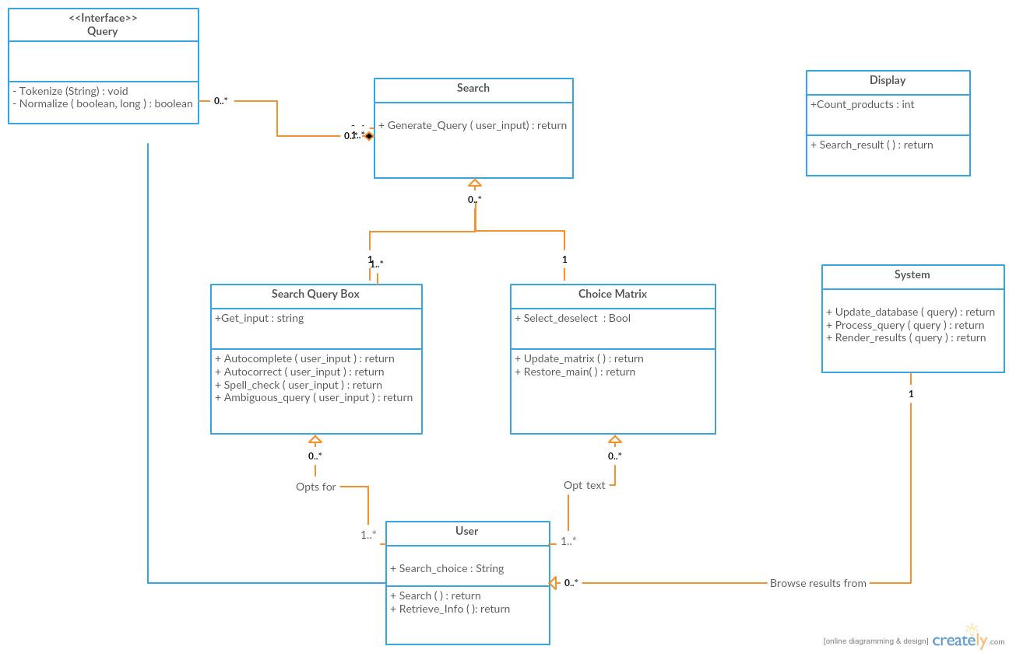

Sequence Diagram(s):

Autocomplete
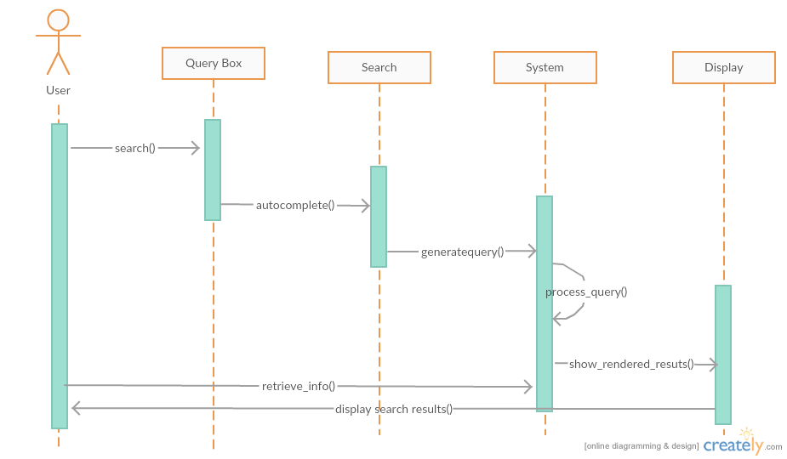

Autocorrect
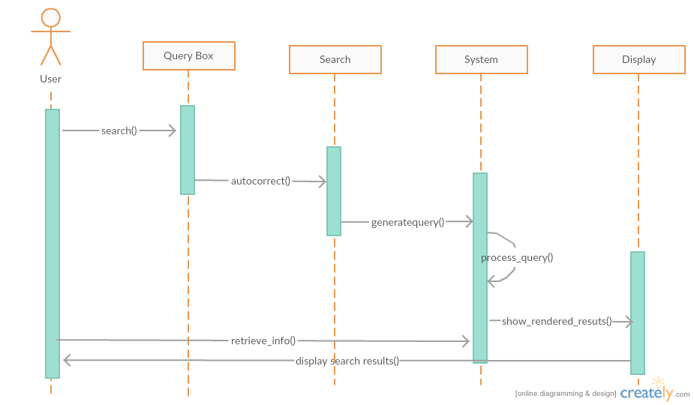

Resolve Ambiguity
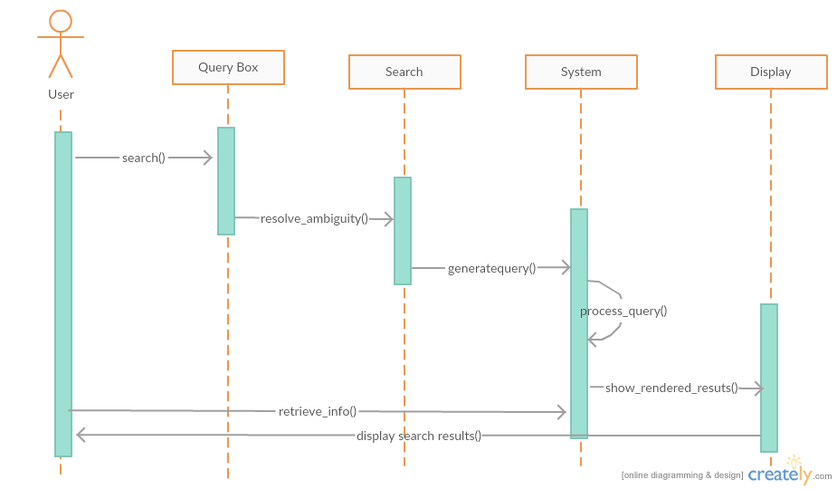
Update matrix
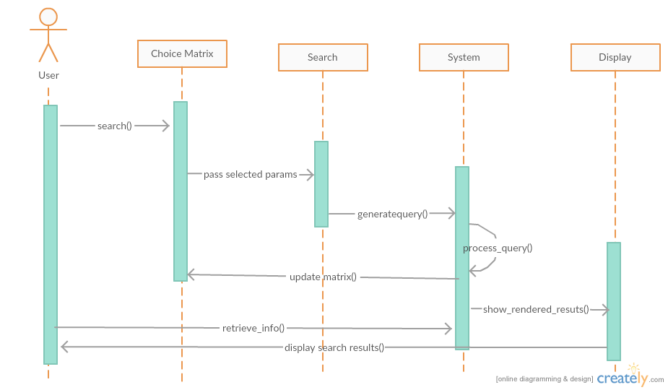

Design Rationale

For project “Elektoo” it is reuired for us to implement a search query box and a choice matrix which will be helpful for the customers to navigate through commodities (mainly mobile phones for now) in E-commerce .
The main problem related to the search box was to generate an algorithm which could convert the input given by the user into rationale sql query to fetch results from the database . This step involves two processes -

a) Tokenization (along with normalization)

b) Parametrization
First of all the entire query is converted into lowercase english alphabets and then processed. (Normalization)
The search query is then tokenized and individual words are stored as the elements of an array. This can be achieved by splitting the query considering whitespaces as delimiter. One important assumption is that the the query will have rationale keywords separated by a space i.e. the user is will not make mistakes while giving the input.
Next, we need to identify the list of important parameters for a given commodity and store their index. A mobile phone for example will have company name,brand name , price , camera size and many other parameters.
These parameters will have a list of identifiers to detect them . For example 'price' parameter will have a list which will contain “related” keywords like { amount , rs, money} as identifiers.
After identifying all the parameters , operators associated with these parameters are searched for . The operators are identified through keywords.For example '<' operator is identified by keywords {lessthan, below, under, etc}. An important assumption made here is that operators associated with a parameter will be present in a given range of the parameter index. The value of the parameters is then looked for using the same logic as operators. The values are stored in a matrix and the query is generated using this matrix.
The matrix generated will roughly contain 3 rows namely as Parameter , operator and values

Example- “Asus phone below 20000rs and camerasize 5px”

Parameter | phone | Price | Camerasize
Operator | '=' | < | '='
Values | Asus | 200000 | 5

The query is then generated with the help of this matrix.
To generate the query, we initialize a string “s” as -
s=”select * from <tablename> where “;
Now we start building up the query by appending all the three rows for a column starting from column no.2 til the last column and then appending the keyword “and” everytime.
For example in the case mentioned above , the query will be built up as
s=”select * from <tablename> where phone=”Asus” and”;
then again interating for the second column and so on , the entire concrete query is built up.

The main thing here to implement in the Search Matrix and finding algorithms to make queries every time the matrix is updated(i.e every time there is a selection of any tab in the rows).
The steps involved in here to implement the same is as follows:
we keep some variables related to all the rows (i.e 'PL' and 'PH' for price, 'S' for screen size,etc.. ),and a “Selected” variable for all the rows. Initilaly keep them as null and the “Selected” variable as “False”. So when initially the Matrix is loaded for any specific product(here phone) brand, for all rows there will run a MySql query command to fill up the different columns in the specific rows.
Price | 05-10k | 11-15k | 16-20k | 21-25k | ….
Screen-Size | 4.5-5” | 5-5.5” | 5.5-6” | 6-6.5” | ….
Camera | 3Mpx | 4Mpx | 8Mpx | 10Mpx | ….
RAM | 256MB | 512MB | 1GB | 2GB | ….
Internal Memory | 2GB | 4GB | 8GB | 16GB | ….

Since each and every matrix is brand specific so will have to deal with showing ranges for prices and camera-sizes. For solving this problem we'll keep two variables for each price(as 'PL', 'PH') and for camera-size(as 'Cam_L' and 'Cam_H') to store the lowest and highest values for each of the rows. And ones the that is determined the matrix will me filled as per having range of (Highest-Lowest)/(total_columns).
Since the “Selected” variable for all the rows is “False” initially so the query will not have any constraints and will limit the output as per the number of rows available.
The query to update any row will be something like:
“select <rowname> from <tablename> where”;
after that for each row query it will check whether any of the variables of the rest of the rows have been updated(first check whether “Selected” is “True”), if yes then it will include it in that query and fetches the data as per the selected tabs(i.e the updated variables of the rows). For each row we can only select one tab(i.e one value/range) after all the other tabs of that row will be disabled.

Fro eg.
Finding an Apple phone of range 21-25k having screen-size in 5-5.5”(let's say apple company have this size range).
When the User selects the 21-25K range the 'PL' and 'PH' will be updated PH=25k and PL=21k. The matrix is now updated with other row values having the price range in the selected one.
Price |  |  |  | 21-25k

Will check the “selected” variables state first. The query for the other rows would be like:
“select <rowname> from <tablename> where price<PH and price>PL”
and the row in which the tab is selected is not updated until its again deselected which makes the “Selected” variable again “False”.
After selecting the 5-5.5” screen-size tab the row except the Price will be updated as per the two selections made till(i.e the Price and Screen-Size).
Now the state of the Matrix would be something like this:
Price |  |  |  | 21-25k | ….
Screen-Size |  | 5-5.5” |  |  | ….
Camera | 3Mpx | 4Mpx | 8Mpx | 10Mpx | ….
RAM | 256MB | 512MB | 1GB | 2GB | ….
Internal Memory | 2GB | 4GB | 8GB | 16GB | ….

Similarly user selects the other tabs in other rows. Or he/she can proceed directly from here to the list of products having so mentioned specifications. Saving the state of the Matrix is also an important aspect which makes the user the user to return to the last updated matrix once he comes back from the item list page.

