WEEK 3 INTERNSHIP PROJECT

STATISTICAL ANALYSIS AND
HYPOTHESIS TESTING IN PYTHON

Titanic Passenger Dataset
Submitted By
Ayushi

Internship / Task:
Statistical Analysis and Hypothesis Testing

Tools & Technologies
Python | Pandas | SciPy | Statsmodels | Matplotlib | Seaborn

Project Type
Statistical Analysis / Hypothesis Testing

September 2026

WEEK 3 STATISTICAL ANALYSIS PROJECT
STATISTICAL ANALYSIS AND HYPOTHESIS TESTING IN PYTHON
Dataset: Titanic Passenger Dataset
Tools Used: Python, Pandas, SciPy, Statsmodels, Matplotlib, Seaborn
Project Type: Statistical Analysis / Hypothesis Testing

- Project Overview
Statistical analysis and hypothesis testing are essential techniques for determining whether patterns observed in data represent meaningful statistical evidence or may have occurred by chance. This Week 3 project focuses on applying statistical methods in Python to investigate relationships and differences within the Titanic Passenger Dataset.
The analysis goes beyond descriptive observations by formulating specific, testable hypotheses and evaluating them using formal statistical tests. The study investigates three main questions: whether passenger gender was significantly associated with survival, whether the average fare differed between survivors and non-survivors, and whether average fare differed significantly across passenger classes.
To answer these questions, three major statistical approaches were applied. The Chi-Square Test of Independence was used to examine the relationship between two categorical variables, gender and survival. Welch's Independent Two-Sample T-Test was used to compare the mean fares of survivors and non-survivors. One-Way ANOVA was used to determine whether mean fares differed among the three passenger classes. Since ANOVA identifies whether at least one group differs but does not specify which groups are different, Tukey's HSD post-hoc test was also applied for pairwise comparisons.
The analysis was performed using Python libraries including Pandas, SciPy, Statsmodels, Matplotlib, and Seaborn. A significance level of α = 0.05 was used for hypothesis testing, and a 95% confidence interval was calculated for the difference in mean fare between survivors and non-survivors.
The project combines statistical testing, numerical evidence, visualization, and interpretation to determine whether the formulated hypotheses are supported by the data. The findings are presented with appropriate statistical reasoning rather than relying only on visual patterns or descriptive comparisons.

- Research Problem
The Titanic dataset contains information about passengers, including demographic characteristics, passenger class, fare, and survival status. Descriptive analysis can reveal visible differences between passenger groups, but such differences alone do not determine whether the observed patterns are statistically meaningful. A formal statistical investigation is therefore required to distinguish meaningful relationships and group differences from patterns that could have occurred due to random variation.
This study focuses on three specific research problems:
  - Gender and Survival:
Is passenger gender significantly associated with survival status? The dataset contains categorical information for both gender and survival, making it possible to formally test whether the observed difference in survival outcomes between male and female passengers represents a statistically significant association.
  - Fare and Survival:
Is there a statistically significant difference between the average fare paid by passengers who survived and those who did not survive? Comparing the group means allows the analysis to determine whether the observed difference in fares is statistically significant rather than simply a descriptive difference.
  - Fare and Passenger Class:
Do average passenger fares differ significantly among 1st, 2nd, and 3rd class passengers? Since passenger class contains three groups, an analysis of variance is required to determine whether the differences among their mean fares are statistically significant.
These research problems were selected because they represent three different types of statistical investigation: a relationship between categorical variables, a comparison of two independent group means, and a comparison of means across multiple groups. This provides a broader application of statistical hypothesis testing and allows the project to demonstrate how different statistical methods can be selected according to the structure of the research question and the type of data being analyzed.
The statistical tests are evaluated using a significance level of 0.05. The results will be used to determine whether the corresponding null hypotheses should be rejected or whether there is insufficient statistical evidence to reject them.

- Hypothesis Formulation
A hypothesis is a testable statement about a relationship, difference, or pattern that can be evaluated using statistical evidence. In this project, three hypotheses were formulated based on the research problems identified in the previous section. For each research question, a null hypothesis (H₀) and an alternative hypothesis (H₁) were defined before conducting the statistical analysis.
The null hypothesis represents the assumption that there is no statistically significant relationship or difference, while the alternative hypothesis represents the presence of a statistically significant relationship or difference. All hypotheses were evaluated at a significance level of α = 0.05.

  - Hypothesis 1: Gender and Survival
- Null Hypothesis (H₀): Passenger gender and survival status are independent of each other.
- Alternative Hypothesis (H₁): Passenger gender and survival status are significantly associated with each other.
- Statistical Test: Chi-Square Test of Independence
- Significance Level: α = 0.05
The Chi-Square Test of Independence was selected because both gender and survival status are categorical variables. The test determines whether the observed distribution of survival outcomes across genders differs significantly from what would be expected if the two variables were independent.

  - Hypothesis 2: Fare and Survival
- Null Hypothesis (H₀): The mean fare of survivors is equal to the mean fare of non-survivors.
- Alternative Hypothesis (H₁): The mean fare of survivors is significantly different from the mean fare of non-survivors.
- Statistical Test: Welch's Independent Two-Sample T-Test
- Significance Level: α = 0.05
Welch's t-test was selected because fare is a continuous numerical variable and survival divides passengers into two independent groups. The test evaluates whether the difference between the two group means is statistically significant without requiring the assumption of equal population variances.

  - Hypothesis 3: Fare and Passenger Class
- Null Hypothesis (H₀): The mean fare is equal across 1st, 2nd, and 3rd passenger classes.
- Alternative Hypothesis (H₁): At least one passenger class has a significantly different mean fare.
- Statistical Test: One-Way Analysis of Variance (ANOVA)
- Significance Level: α = 0.05
One-Way ANOVA was selected because fare is a continuous numerical variable and passenger class contains three independent groups. If the ANOVA produces a statistically significant result, Tukey's HSD post-hoc test will be used to determine which specific pairs of passenger classes differ significantly.

- Dataset Description
The dataset used for this project is the Titanic Passenger Dataset, a publicly available dataset containing information about passengers who travelled on the RMS Titanic. The dataset provides demographic, travel, and survival-related information that can be used to investigate relationships between passenger characteristics and survival outcomes.
For this statistical analysis, the cleaned version of the dataset prepared during the previous data analysis stage was used. After data cleaning and removal of duplicate records, the dataset contained 780 passenger records and 14 variables. The cleaned dataset contained no remaining missing values or duplicate records, providing a consistent basis for the statistical analysis.
  - Important Variables
The dataset contains several variables describing passenger characteristics and outcomes. The major variables relevant to this project are:
      - survived: Indicates whether the passenger survived (1) or did not survive (0).
      - sex: Passenger gender, categorized as female or male.
      - pclass: Passenger class, categorized as 1st, 2nd, or 3rd class.
      - fare: The fare paid by the passenger, represented as a continuous numerical variable.
      - age: Passenger age.
      - sibsp: Number of siblings or spouses aboard the Titanic.
      - parch: Number of parents or children aboard.
      - embarked: Port of embarkation.

  - Variables Used for Statistical Testing
Different variables were selected according to the requirements of each hypothesis:
Hypothesis | Variables | Variable Type | Statistical Test
Gender and Survival | sex, survived |  | Chi-Square Test
  Categorical + Categorical
Fare and Survival | fare, survived | Continuous + Categorical | Welch's T-Test
Fare and Passenger Class | fare, pclass | Continuous + Categorical | One-Way ANOVA
The Chi-Square analysis uses gender and survival because the objective is to determine whether two categorical variables are associated. The Welch's T-Test uses fare and survival because it compares the average value of a continuous variable between two independent groups. The ANOVA uses fare and passenger class because it compares the average value of a continuous variable across three independent groups.
This variable selection ensures that each statistical method is matched appropriately to the structure of the research question and the type of data being analyzed.

- Methodology
The methodology was designed to systematically evaluate the three research questions and determine whether the observed relationships or differences in the Titanic dataset were statistically significant. The analysis followed a structured process consisting of data preparation, selection of appropriate statistical tests, calculation of statistical measures, visualization of the data, and interpretation of the results.
Python was used as the primary analytical environment. Pandas was used for data loading, organization, grouping, and preparation. SciPy was used to perform the Chi-Square Test, Welch's Independent Two-Sample T-Test, and One-Way ANOVA. Statsmodels was used for Tukey's HSD post-hoc analysis. Matplotlib and Seaborn were used to create visualizations supporting the statistical findings.
A significance level of α = 0.05 was established before evaluating the hypotheses. Therefore, a p-value below 0.05 was considered statistically significant, leading to rejection of the corresponding null hypothesis. A p-value equal to or greater than 0.05 was interpreted as insufficient evidence to reject the null hypothesis.
The methodology also considers the importance of effect interpretation rather than relying only on statistical significance. Statistical results are therefore reported together with descriptive values, confidence intervals where applicable, visual evidence, and practical interpretation.

  - Data Preparation
The cleaned Titanic dataset prepared during the previous stage of the project was used as the input for statistical analysis. The dataset contained 780 passenger records and 14 variables after the cleaning process. The relevant variables were selected according to each research question.
For the Chi-Square analysis, sex and survived were converted into a frequency-based contingency table. For the Welch's T-Test, fare values were separated into two independent groups based on survival status: survivors and non-survivors. For the One-Way ANOVA, fare values were divided into three groups according to passenger class: 1st, 2nd, and 3rd class.
The data preparation step ensured that each statistical test received variables in an appropriate format and that the analysis was based on the same cleaned dataset throughout the study.

  - Chi-Square Test of Independence
The Chi-Square Test of Independence was used to determine whether passenger gender and survival status were statistically associated. This test is appropriate when both variables are categorical and the objective is to determine whether the distribution of one variable differs according to the categories of another variable.
In this analysis, sex was treated as the categorical explanatory variable and survived was treated as the categorical outcome variable. A contingency table was created to summarize the observed number of survivors and non-survivors for each gender category.
The Chi-Square test compares the observed frequencies in the contingency table with the expected frequencies that would be obtained if gender and survival were independent. A large difference between observed and expected frequencies results in a larger Chi-Square statistic and provides evidence against the assumption of independence.
The hypotheses for this test were:
H₀: Passenger gender and survival status are independent.
H₁: Passenger gender and survival status are significantly associated.
The test was performed using the chi2_contingency() function from the SciPy library. The test statistic, p-value, and degrees of freedom were recorded for interpretation. Since the significance level was established at α = 0.05, a p-value below 0.05 would provide sufficient evidence to reject the null hypothesis.
The Chi-Square test assumes that the observations are independent and that the expected frequencies are sufficiently large for the test approximation to be appropriate. The contingency table in this analysis contains sufficiently large group counts, supporting the use of the test.
    - Analytical Procedure
- Create a contingency table using sex and survived.
- Calculate the observed frequencies for each gender-survival combination.
- Calculate the expected frequencies under the assumption of independence. Apply the Chi-Square Test of Independence using SciPy.
- Compare the resulting p-value with the significance level of 0.05.
- Reject or fail to reject H₀ based on the statistical decision rule.
- Interpret the result together with the observed survival counts and supporting visualization.

  - Welch's Independent Two-Sample T-Test
Welch's Independent Two-Sample T-Test was used to determine whether the mean fare differed significantly between passengers who survived and those who did not survive. The test is appropriate because the research question involves comparing the mean of a continuous numerical variable between two independent groups.
In this analysis, fare was the continuous variable being compared, while survived was used to divide the observations into two groups: survivors (survived = 1) and non-survivors (survived = 0).
Welch's version of the independent two-sample t-test was selected instead of the standard Student's t-test because Welch's test does not assume that the two groups have equal population variances. This makes it a suitable choice when the variability of fares may differ between survivors and non-survivors.
The hypotheses for the test were:
H₀: The mean fare of survivors is equal to the mean fare of non-survivors.
H₁: The mean fare of survivors is significantly different from the mean fare of non-survivors.
The test was performed using the ttest_ind() function from SciPy with equal_var=False, which specifies Welch's t-test. The resulting t-statistic and p-value were recorded and compared with the predefined significance level of α = 0.05.
The test assumes that the two groups are independent and that the dependent variable is measured on a continuous scale. Although passenger fare is not perfectly normally distributed, the relatively large number of observations in both groups makes the mean comparison more suitable for interpretation than relying only on visual differences.
A p-value below 0.05 would provide sufficient evidence to reject H₀ and conclude that the group means are statistically different. However, a statistically significant difference in fare should be interpreted as an association or group difference and not as evidence that fare itself caused a passenger's survival outcome.
Analytical Procedure
    - Separate passengers into survivor and non-survivor groups using the survived variable.
    - Calculate the mean fare for each group.
    - Apply Welch's Independent Two-Sample T-Test using SciPy.
    - Obtain the t-statistic and p-value.
    - Compare the p-value with α = 0.05.
    - Determine whether the null hypothesis should be rejected or not rejected.
    - Compare the statistical result with the fare distribution visualization.

  - 95% Confidence Interval for Mean Fare Difference
A 95% confidence interval was calculated to estimate the plausible range for the difference between the population mean fares of survivors and non-survivors. The confidence interval complements the Welch's t-test by providing information about the magnitude and uncertainty of the estimated mean difference.
In this analysis, the difference between the sample mean fare of survivors and the sample mean fare of non-survivors was calculated first. The standard error of this difference was then estimated using the group-specific sample variances and sample sizes. Because Welch's t-test does not assume equal population variances, the Welch-Satterthwaite approximation was used to determine the appropriate degrees of freedom. The critical t-value was then used to construct the 95% confidence interval.
The hypotheses associated with the mean comparison remain:
H₀: The mean fare of survivors is equal to the mean fare of non-survivors.
H₁: The mean fare of survivors is significantly different from the mean fare of non-survivors.
A 95% confidence interval that does not contain zero provides evidence that the difference between the two population means is statistically different from zero at the 5% significance level. The interval should be interpreted as a range of plausible values for the population mean difference, rather than as a statement that there is a 95% probability that the fixed population parameter lies within this particular interval.
      - Analytical Procedure
        - Calculate the sample mean fare for survivors.
        - Calculate the sample mean fare for non-survivors.
        - Calculate the difference between the two sample means.
        - Estimate the standard error using the separate group variances.
        - Calculate the Welch-Satterthwaite degrees of freedom.
        - Obtain the critical t-value for a 95% confidence level.
        - Calculate the lower and upper confidence limits.
        - Determine whether zero falls within the resulting interval.
        - Interpret the confidence interval together with the Welch's t-test result.

  - One-Way Analysis of Variance (ANOVA)
One-Way Analysis of Variance (ANOVA) was used to determine whether the mean passenger fare differed significantly among the three passenger classes: 1st class, 2nd class, and 3rd class. ANOVA is appropriate when a continuous numerical variable is being compared across three or more independent groups.
In this analysis, fare was treated as the continuous dependent variable, while pclass was used as the grouping variable. The three groups represented the different passenger classes. The analysis therefore evaluated whether the variation between the class-level mean fares was sufficiently large relative to the variation within the individual groups.
The hypotheses for the ANOVA were:
H₀: The mean fare is equal across 1st, 2nd, and 3rd passenger classes.
H₁: At least one passenger class has a significantly different mean fare.
The ANOVA was performed using the f_oneway() function from SciPy. The resulting F-statistic and p-value were compared with the significance level of α = 0.05.
The F-statistic represents the ratio of between-group variation to within-group variation. A relatively large F-statistic indicates that the differences between group means are large compared with the variation within the groups. A statistically significant p-value provides evidence against the assumption that all group means are equal.
If the ANOVA produces a p-value below 0.05, the null hypothesis is rejected, indicating that at least one group mean differs significantly. However, ANOVA does not identify which particular groups are different. Therefore, a Tukey's HSD post-hoc test is required after a significant ANOVA result to perform pairwise comparisons while controlling the family-wise error rate.
The analysis should be interpreted as evidence of differences in average fares among passenger classes and not as evidence of a causal relationship between passenger class and fare.
      - Analytical Procedure
        - Divide the fare observations according to passenger class.
        - Calculate the mean fare for each passenger class.
        - Compare the variation between class-level means with the variation within each class.
        - Apply One-Way ANOVA using SciPy.
        - Obtain the F-statistic and p-value.
        - Compare the p-value with α = 0.05.
        - Reject or fail to reject the null hypothesis based on the statistical decision rule.
        - If the ANOVA is significant, perform Tukey's HSD post-hoc test to identify the specific class pairs that differ.

  - Tukey's HSD Post-Hoc Test
When a One-Way ANOVA produces a statistically significant result, it establishes that at least one group mean is different but does not identify which specific groups are responsible for the difference. Therefore, Tukey's Honestly Significant Difference (HSD) post-hoc test was used to perform pairwise comparisons among the three passenger classes.
Tukey's HSD compares every pair of passenger classes while controlling the family-wise error rate. This is important because performing several independent pairwise tests can increase the probability of obtaining a statistically significant result by chance. Tukey's procedure adjusts the comparisons so that the overall error rate is controlled.
The pairwise comparisons in this analysis were:
- 1st Class vs 2nd Class
- 1st Class vs 3rd Class
- 2nd Class vs 3rd Class
For each comparison, the adjusted p-value was examined at the significance level of α = 0.05. A p-value below 0.05 indicates a statistically significant difference between the corresponding pair of class mean fares, while a p-value equal to or greater than 0.05 indicates insufficient evidence of a statistically significant difference.
Tukey's HSD was implemented using the pairwise_tukeyhsd() function from the Statsmodels library. The results were used to identify the specific passenger-class pairs contributing to the significant overall ANOVA result.
    - Analytical Procedure
        - Use the passenger-class groups and their corresponding fare values from the ANOVA analysis.
        - Perform Tukey's HSD pairwise comparisons using Statsmodels.
        - Compare 1st class with 2nd class.
        - Compare 1st class with 3rd class.
        - Compare 2nd class with 3rd class.
        - Examine the adjusted p-value and confidence interval for each comparison.
        - Determine whether each pairwise difference is statistically significant at α = 0.05.
        - Use the post-hoc results to explain which passenger-class groups contribute to the significant ANOVA finding.

  - Statistical Decision Rule
A consistent statistical decision rule was applied across the hypothesis tests in this study. The significance level was set at α = 0.05, meaning that results with a p-value below 0.05 were considered statistically significant.
The following decision criteria were used:
- If p-value < 0.05: Reject the null hypothesis (H₀).
- If p-value ≥ 0.05: Fail to reject the null hypothesis (H₀).
Rejecting the null hypothesis indicates that the observed evidence is sufficiently strong, under the assumptions of the statistical test, to support the alternative hypothesis. Failing to reject the null hypothesis does not prove that the null hypothesis is true; it indicates that the available evidence is insufficient to establish a statistically significant effect or association at the selected significance level.
For the Welch's t-test, the 95% confidence interval was additionally considered. If the confidence interval for the mean difference excluded zero, this provided supporting evidence that the population mean difference was statistically different from zero.
For the One-Way ANOVA, a significant result indicated that at least one group mean differed from the others. Tukey's HSD was then used to determine which specific pairs of groups showed statistically significant differences.
Statistical significance was interpreted together with the magnitude of observed differences, confidence intervals, and visual evidence. This approach helps prevent conclusions from being based solely on p-values and provides a more complete interpretation of the statistical findings.

  - Statistical Software and Reproducibility
The statistical analysis was implemented in Python to ensure that the calculations and procedures could be reproduced systematically. Pandas was used for data handling, SciPy was used for the primary statistical tests, and Statsmodels was used for the Tukey HSD post-hoc analysis. Matplotlib and Seaborn were used to create supporting visualizations.
The analysis script contains the data loading, statistical calculations, confidence interval calculation, post-hoc testing, and visualization procedures. Using a documented Python workflow allows the analysis to be repeated on the cleaned dataset and makes the statistical results traceable to the implemented methodology.

- Statistical Results and Visualizations
The statistical analysis was conducted using the cleaned Titanic Passenger Dataset to evaluate the three hypotheses formulated in this study. The analysis combines descriptive statistics, formal hypothesis testing, confidence interval estimation, post-hoc comparison, and data visualization to provide evidence-based conclusions.
The Chi-Square Test of Independence was used to examine the association between passenger gender and survival status. Welch's Independent Two-Sample T-Test was used to compare the mean fare of survivors and non-survivors, followed by a 95% confidence interval for the estimated mean difference. One-Way ANOVA was used to compare mean fares across the three passenger classes, and Tukey's HSD post-hoc test was applied to identify which specific class pairs differed significantly.
For each analysis, the statistical result is interpreted in relation to the corresponding hypothesis and significance level of α = 0.05. Supporting visualizations are also included to demonstrate the underlying data patterns and provide a clearer understanding of the numerical findings.
The purpose of this section is not only to report statistically significant results but also to explain their magnitude, practical meaning, and limitations. This provides a more complete interpretation of the evidence rather than relying solely on p-values.

  - Chi-Square Test of Independence: Gender and Survival
The first hypothesis investigated whether passenger gender was significantly associated with survival status. The Chi-Square Test of Independence was selected because both variables are categorical. The analysis used the observed frequencies of male and female passengers across the two survival categories.
The contingency table showed that among female passengers, 216 survived and 76 did not survive. Among male passengers, 106 survived and 382 did not survive. These observed frequencies show a substantial difference in survival outcomes between the two gender groups even before applying the formal statistical test.
The Chi-Square test produced a test statistic of χ² = 203.6143, with 1 degree of freedom, and a p-value of 3.3973 × 10⁻⁴⁶. This p-value is far below the predefined significance level of 0.05.
Therefore, the null hypothesis that gender and survival are independent is rejected. The statistical evidence strongly supports the alternative hypothesis that passenger gender and survival status were significantly associated in the analyzed dataset.
The magnitude of the observed difference is also important. Female passengers accounted for 216 of the 292 female passengers, whereas male passengers accounted for 106 of the 488 male passengers among the cleaned dataset. In percentage terms, the survival rate was approximately 73.97% for females compared with 21.72% for males, representing a difference of approximately 52.25 percentage points.
This large difference, together with the extremely small p-value, indicates that the gender-survival pattern is unlikely to be explained by random sampling variation alone under the independence assumption. However, the Chi-Square result establishes an association, not causation. Other factors such as passenger class, age, and fare may also have contributed to differences in survival outcomes.
    - Visual Evidence: Survival Counts by Gender
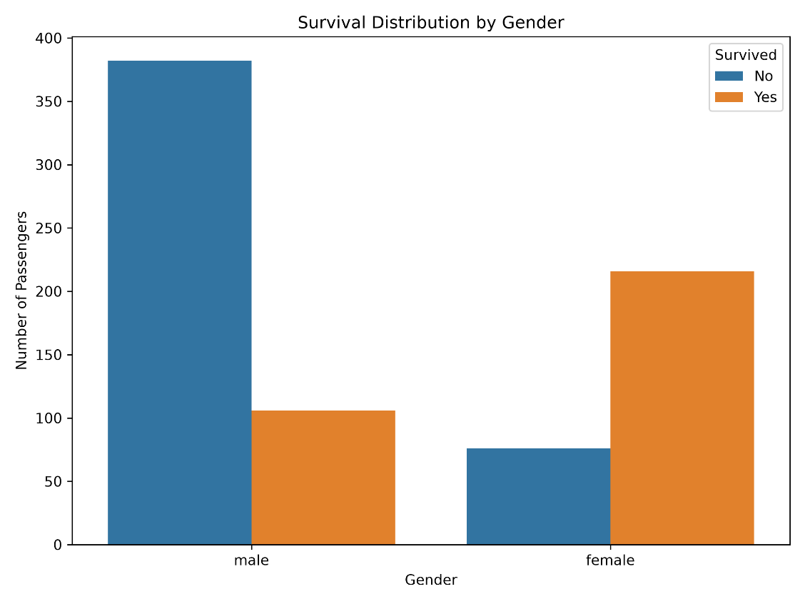
Figure 1: Survival Counts by Gender
    - Statistical Interpretation
The visualization supports the numerical findings of the Chi-Square analysis. Female passengers show a much larger number of survivors relative to non-survivors, while the opposite pattern is visible among male passengers. The statistical test confirms that this difference is not merely a visual observation but represents a statistically significant association between gender and survival in the dataset.

  - Welch's Independent Two-Sample T-Test: Fare and Survival
The second hypothesis examined whether the average fare differed significantly between passengers who survived and passengers who did not survive. Since fare is a continuous numerical variable and survival creates two independent groups, Welch's Independent Two-Sample T-Test was used.
The descriptive results show a clear difference between the two groups. The mean fare among survivors was 50.19, whereas the mean fare among non-survivors was 24.03. Therefore, the observed difference in sample means was approximately 26.17 fare units, with survivors paying substantially higher fares on average.
The Welch's t-test produced a t-statistic of 6.3778 and a p-value of 4.6422 × 10⁻¹⁰. Since this p-value is substantially smaller than the significance level of 0.05, the null hypothesis that the two population means are equal is rejected.
The result provides strong statistical evidence that the mean fares of survivors and non-survivors were significantly different in the analyzed dataset. The direction of the difference is also clear from the descriptive statistics: the survivor group had the higher average fare.
This finding is important because it demonstrates why statistical testing is more informative than simply comparing two averages. Although the sample means appear different, the Welch's t-test provides formal evidence that the observed difference is unlikely to be explained by random variation alone under the test assumptions.
However, the result should not be interpreted as evidence that paying a higher fare directly caused a passenger to survive. Fare may be related to other characteristics, particularly passenger class, which is also strongly connected with fare. Therefore, the result establishes a statistically significant group difference, not a causal relationship.

    - Visual Evidence: Fare Distribution by Survival Status
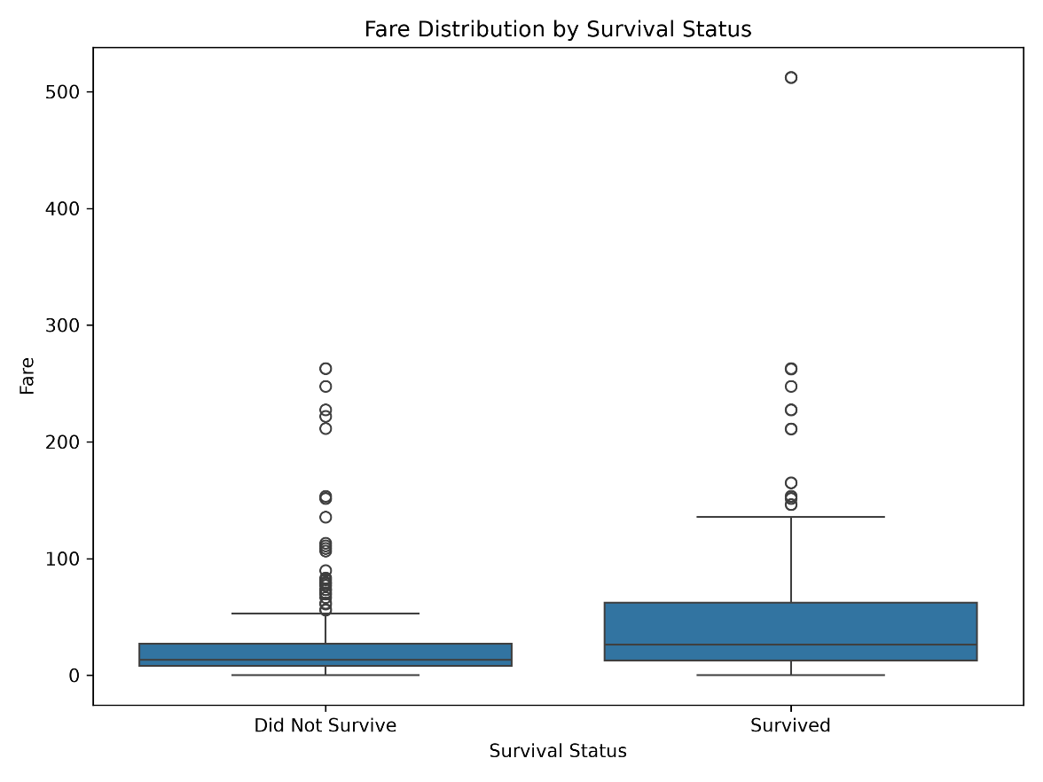
Figure 2: Fare Distribution by Survival Status

    - Statistical Interpretation
The boxplot provides visual support for the statistical result by showing that the fare distribution of survivors is generally positioned above that of non-survivors. The difference in central tendency is consistent with the calculated means of 50.19 and 24.03. The visualization also shows variation and individual observations within each group, demonstrating that the two distributions are not identical even though some overlap exists.

  - 95% Confidence Interval for Mean Fare Difference
To further evaluate the difference in mean fare between survivors and non-survivors, a 95% confidence interval was calculated for the difference between the two group means. The confidence interval provides additional information about the estimated magnitude and uncertainty of the difference identified by the Welch's t-test.
The estimated mean fare difference between survivors and non-survivors was 26.17 fare units. The corresponding 95% confidence interval ranged from 18.10 to 34.23. This indicates that the plausible range for the population mean difference, based on the statistical procedure used, lies between these two limits.
An important feature of this interval is that zero is not included. A value of zero would represent no difference between the two population means. Since the entire interval is above zero, the result supports the conclusion that the mean fare of survivors was higher than the mean fare of non-survivors.
The confidence interval is also consistent with the Welch's t-test result, which produced a very small p-value of 4.6422 × 10⁻¹⁰. Both pieces of evidence point in the same direction: the observed difference in mean fares is statistically significant at the 5% significance level.
The confidence interval is useful because it provides more information than statistical significance alone. The estimated difference is not simply classified as significant or non-significant; the interval also communicates the uncertainty surrounding the estimated difference. Nevertheless, this interval should not be interpreted as evidence that fare caused the difference in survival outcomes.
    - Numerical Evidence
Then make a 3-row, 2-column table:
Measure | Result
Mean fare difference | 26.17
95% Confidence Interval | 18.10 to 34.23
Interval contains zero? | No

    - Interpretation
The confidence interval provides strong supporting evidence for the Welch's t-test finding. The estimated difference is positive, and even the lower confidence limit is above zero. Therefore, the analysis indicates that survivors had a higher average fare than non-survivors in the studied dataset.

  - One-Way ANOVA: Fare and Passenger Class
The third hypothesis examined whether the average passenger fare differed significantly among the three passenger classes. Since passenger class contains three independent groups and fare is a continuous numerical variable, One-Way ANOVA was used to compare the group means.
The descriptive analysis showed substantial differences in average fare across the three classes. The mean fare for 1st class passengers was 85.16, compared with 21.89 for 2nd class and 13.67 for 3rd class passengers. The difference between the 1st class mean and the lower-class means is particularly large, suggesting that passenger class is strongly associated with the amount of fare paid.
The One-Way ANOVA produced an F-statistic of approximately 209.46 and a p-value of 1.7449 × 10⁻⁷³. The p-value is substantially smaller than the significance level of 0.05. Therefore, the null hypothesis that the mean fares are equal across all three passenger classes is rejected.
The ANOVA result provides strong statistical evidence that the average fare was not the same across the three passenger classes. However, the ANOVA result alone cannot determine which specific class pairs are significantly different. Therefore, a Tukey HSD post-hoc analysis was conducted to investigate the pairwise differences.
    - Visual Evidence: Fare Distribution by Passenger Class

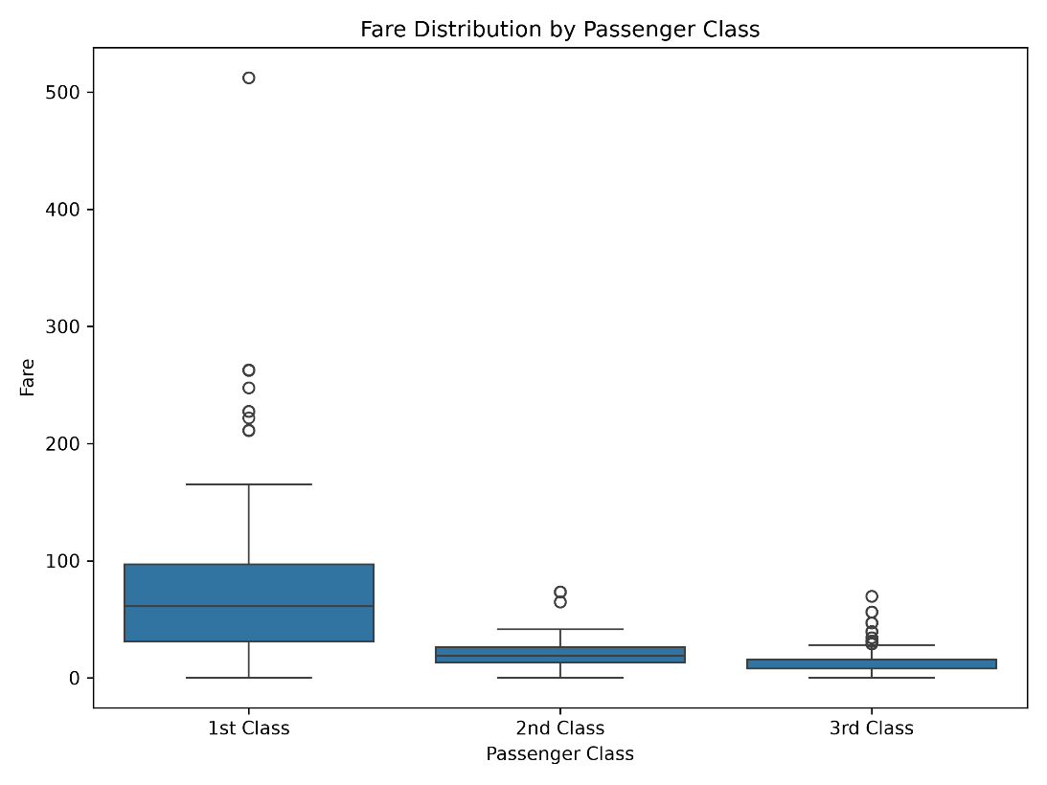
Figure 3: Fare Distribution by Passenger Class

    - Interpretation of the ANOVA Result
The boxplot visually supports the ANOVA findings by showing a clear difference in the central distribution of fares across passenger classes. 1st class passengers generally paid considerably higher fares, while 3rd class passengers had the lowest fare distribution. The large separation between the group distributions is consistent with the very large F-statistic and extremely small p-value.
However, because ANOVA only establishes that at least one group mean differs, a post-hoc comparison is necessary to determine exactly which passenger-class pairs show statistically significant differences.

  - Tukey's HSD Post-Hoc Test: Pairwise Comparison of Passenger Classes
Since the One-Way ANOVA established that average fares differed significantly among the passenger classes, a Tukey's Honestly Significant Difference (HSD) post-hoc test was conducted to identify which specific class pairs were responsible for the overall difference.
The Tukey HSD test performs pairwise comparisons while controlling the family-wise error rate, making it appropriate after obtaining a statistically significant ANOVA result. The analysis compared the mean fares of 1st class, 2nd class, and 3rd class passengers at a significance level of α = 0.05.
The results showed that the mean fare difference between 1st and 2nd class was statistically significant, with a mean difference of approximately 63.27 and an adjusted p-value below 0.001. The 95% confidence interval for this difference ranged from approximately 52.97 to 73.57, which does not include zero.
The comparison between 1st and 3rd class was also statistically significant. The mean difference was approximately 71.49, with an adjusted p-value below 0.001. The 95% confidence interval ranged from approximately 63.09 to 79.89, again excluding zero.
In contrast, the comparison between 2nd and 3rd class was not statistically significant at the 0.05 level. The mean difference was approximately 8.22, with an adjusted p-value of 0.0896. The 95% confidence interval ranged from approximately -17.39 to 0.95 and included zero. Therefore, there is insufficient statistical evidence to conclude that the average fares of 2nd and 3rd class were different in this pairwise comparison.
These results provide more specific evidence than the overall ANOVA test. The significant ANOVA result was primarily explained by the substantially higher fares associated with 1st class. Both comparisons involving 1st class were statistically significant, whereas the difference between 2nd and 3rd class was not statistically significant at the chosen significance level.
    - Numerical Evidence
Class Comparison | Mean Difference | Adjusted p-value | 95% Confidence Interval | Significant at α = 0.05?
1st vs 2nd | 63.27 | < 0.001 | 52.97 to 73.57 | Yes
1st vs 3rd | 71.49 | < 0.001 | 63.09 to 79.89 | Yes
2nd vs 3rd | 8.22 | 0.0896 | -17.39 to 0.95 | No

  - Statistical Decision Summary
The results of all statistical tests provide strong evidence against the corresponding null hypotheses, except for the specific 2nd versus 3rd class comparison identified by the Tukey HSD post-hoc test.
For the relationship between gender and survival, the Chi-Square Test produced a p-value of 3.3973 × 10⁻⁴⁶, which is far below the significance level of 0.05. Therefore, the null hypothesis of independence was rejected, indicating a statistically significant association between gender and survival status.
For the comparison of fare between survivors and non-survivors, Welch's T-Test produced a p-value of 4.6422 × 10⁻¹⁰. The null hypothesis of equal mean fares was therefore rejected. The estimated mean difference was 26.17, with a 95% confidence interval from 18.10 to 34.23, indicating that the average fare was significantly higher among survivors in this dataset.
For passenger class, the One-Way ANOVA produced an F-statistic of approximately 209.46 and a p-value of 1.7449 × 10⁻⁷³. The null hypothesis that all three class means were equal was rejected. The subsequent Tukey HSD analysis showed statistically significant differences between 1st and 2nd class and between 1st and 3rd class, while the difference between 2nd and 3rd class was not statistically significant.
Overall, the statistical evidence supports the three research questions by demonstrating a significant gender-survival association, a significant difference in fare between survival groups, and significant differences in fare across passenger classes. However, these results represent statistical associations and group differences within the Titanic dataset and should not be interpreted as proof of causal relationships.
  - Survival Rate by Gender
In addition to the survival-count comparison, the survival rate was examined separately for each gender to provide a normalized comparison between the groups. This is important because comparing only the number of survivors can be affected by differences in the number of male and female passengers.
The analysis showed that the survival rate for female passengers was approximately 73.97%, whereas the survival rate for male passengers was approximately 21.72%. The difference between the two survival rates was approximately 52.25 percentage points.
The large difference in survival rates provides practical context for the Chi-Square test result. While the Chi-Square test established that gender and survival were statistically associated, the survival-rate visualization shows the magnitude and direction of the observed difference more clearly. The result indicates that female passengers had a substantially higher observed survival rate than male passengers in the analyzed dataset.
However, this visualization describes an association rather than a causal relationship. Other factors, including passenger class, age, family circumstances, and access to evacuation opportunities, may also have influenced survival outcomes.
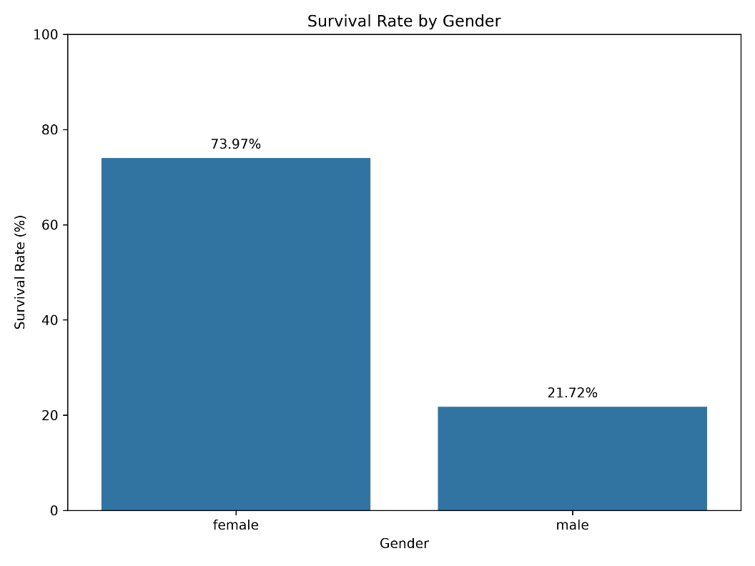
Figure 4: Survival Rate by Gender
    - Interpretation
The bar chart provides a direct percentage-based comparison between male and female passengers. The approximately 73.97% survival rate for females compared with 21.72% for males demonstrates a substantial difference between the two groups. This visual evidence is consistent with the Chi-Square statistic of 203.6143 and the extremely small p-value of 3.3973 × 10⁻⁴⁶, strengthening the interpretation that the observed gender-survival association is statistically significant.
  - Fare Distribution by Survival Status
The distribution of passenger fares was further examined using a histogram with kernel density estimation (KDE), separated by survival status. Unlike the boxplot, which primarily summarizes the central tendency and spread of the groups, the histogram provides a clearer view of the overall shape and concentration of the fare distributions.
The visualization shows that most passengers were concentrated in the lower fare range, while a smaller number of passengers paid substantially higher fares. The distribution also indicates that the fare values were positively skewed, with relatively few high-fare observations extending the distribution toward larger values.
The distribution of fares among survivors was generally shifted toward higher fare values compared with non-survivors. This visual pattern is consistent with the difference in mean fare observed in the Welch's T-Test. Survivors had an average fare of approximately 50.19, compared with approximately 24.03 for non-survivors, resulting in a mean difference of 26.17.
The histogram therefore provides additional evidence supporting the numerical comparison, while also showing why the fare variable should not be interpreted only through its mean. The presence of highly variable and skewed fare values is an important limitation when interpreting group-level averages.
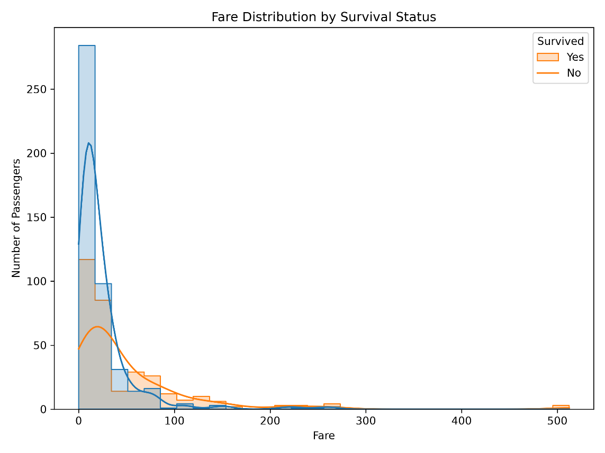
Figure 5: Fare Distribution by Survival Status
    - Interpretation
The histogram demonstrates that fare values were unevenly distributed and that a relatively small number of passengers paid considerably higher fares. The survivor distribution showed greater concentration toward higher fare values than the non-survivor distribution. This pattern is consistent with the Welch's T-Test result and supports the conclusion that the two survival groups had statistically different average fares.

- Overall Findings and Hypothesis Evaluation
The statistical analysis provided clear quantitative evidence for evaluating the three hypotheses formulated in this study. The results demonstrate that the observed differences and relationships in the Titanic dataset are statistically meaningful at the 0.05 significance level.
Hypothesis 1 – Gender and Survival: The Chi-Square Test produced a chi-square statistic of 203.6143 with 1 degree of freedom and a p-value of 3.3973 × 10⁻⁴⁶. Since the p-value is substantially below 0.05, the null hypothesis was rejected. The observed survival rates also showed a large difference: approximately 73.97% of female passengers survived compared with 21.72% of male passengers. Therefore, the data provides strong evidence of an association between gender and survival status.
Hypothesis 2 – Fare and Survival: Welch's T-Test produced a t-statistic of 6.3778 and a p-value of 4.6422 × 10⁻¹⁰. The null hypothesis of equal mean fares was rejected. Survivors had an average fare of approximately 50.19, while non-survivors had an average fare of approximately 24.03, giving a mean difference of 26.17. The 95% confidence interval for this difference was 18.10 to 34.23, which does not include zero. This provides strong evidence that the average fare differed between the two survival groups.
Hypothesis 3 – Fare and Passenger Class: The One-Way ANOVA produced an F-statistic of approximately 209.46 and a p-value of 1.7449 × 10⁻⁷³. The null hypothesis that the three passenger-class means were equal was rejected. The mean fares were 85.16 for 1st class, 21.89 for 2nd class, and 13.67 for 3rd class. Tukey's HSD further showed significant differences between 1st and 2nd class and between 1st and 3rd class, while the 2nd versus 3rd class comparison was not statistically significant at the 0.05 level.
Overall, all three research questions produced statistically significant overall findings. The strongest evidence was observed for the association between gender and survival and for differences in fare across passenger classes, as reflected by their extremely small p-values. However, statistical significance should not be interpreted as proof of causation. The Titanic dataset is observational, and other passenger characteristics and circumstances may have influenced the observed outcomes.
  - Key Statistical Findings
Hypothesis | Statistical Test | Test Statistic | p-value | Decision
Gender and Survival | Chi-Square Test | χ² = 203.6143 | 3.3973 × 10⁻⁴⁶ | Reject H₀
Fare and Survival | Welch's T-Test | t = 6.3778 | 4.6422 × 10⁻¹⁰ | Reject H₀
Fare and Passenger Class | One-Way ANOVA | F ≈ 209.46 | 1.7449 × 10⁻⁷³ | Reject H₀

The summary table shows that all three statistical tests produced p-values substantially below the significance level of 0.05. Therefore, the null hypothesis was rejected for each overall research question. The results provide strong statistical evidence of an association between gender and survival, a difference in average fare between survivors and non-survivors, and differences in average fare across passenger classes.

  - Practical Interpretation of Results
The statistical results provide meaningful insights into the passenger characteristics associated with the Titanic outcomes. The gender analysis showed a substantial difference in survival rates, with approximately 73.97% of female passengers surviving compared with 21.72% of male passengers. This difference of approximately 52.25 percentage points indicates that survival outcomes were strongly associated with gender in the analyzed dataset.
The fare analysis showed that survivors paid an average fare of approximately 50.19, compared with 24.03 among non-survivors. The estimated difference of 26.17 indicates a substantial difference in average fare between the two groups. The 95% confidence interval, from 18.10 to 34.23, provides additional evidence that the difference was consistently positive in the analyzed sample.
The passenger-class analysis showed an even clearer difference in average fare. First-class passengers had an average fare of 85.16, compared with 21.89 for second class and 13.67 for third class. The ANOVA result confirmed that these differences were statistically significant overall. Tukey's HSD analysis further showed that the significant differences were specifically between first and second class and between first and third class, while the second-versus-third-class difference was not statistically significant.
These findings demonstrate why statistical testing is important in data analysis. Although descriptive statistics can show visible differences between groups, hypothesis testing provides quantitative evidence for determining whether those differences are statistically significant. At the same time, statistical significance does not establish a causal relationship. The results should therefore be interpreted as evidence of associations and group differences within the Titanic dataset rather than as proof that one variable directly caused another.

  - Limitations of the Statistical Analysis
Although the statistical tests produced strong evidence for the research questions, several limitations should be considered when interpreting the results.
First, the Titanic dataset is observational rather than experimental. Therefore, the statistical associations identified in this analysis cannot be interpreted as direct causal relationships. For example, the significant association between gender and survival does not mean that gender alone caused the difference in survival outcomes.
Second, the fare variable shows substantial variation between passengers and is not perfectly normally distributed. Although Welch's T-Test was selected because it does not require the assumption of equal population variances, the underlying distribution of fare should still be considered when interpreting the results.
Third, One-Way ANOVA assumes independent observations, approximately normally distributed outcomes within groups, and reasonably similar variances across groups. The fare data contain considerable variation, particularly within passenger classes. Therefore, the ANOVA findings should be interpreted with awareness of these assumptions.
Fourth, statistical significance does not necessarily indicate practical or causal importance. Very small p-values demonstrate strong evidence against the null hypotheses under the statistical model, but they do not by themselves explain why the observed differences occurred.
Finally, the analysis considered only selected variables and statistical relationships. Other passenger characteristics, such as age, family-related variables, and embarkation information, may also have contributed to survival outcomes. Therefore, the findings should be considered within the scope of the variables and tests included in this project.

  - Scientific and Business Implications
The findings of this statistical analysis demonstrate how hypothesis testing can be used to convert descriptive patterns into statistically supported conclusions. From a scientific perspective, the analysis shows the importance of selecting a statistical test according to the type of variables and research question. The Chi-Square Test was appropriate for examining the relationship between categorical variables, Welch's T-Test was used to compare two independent group means, and One-Way ANOVA was used to compare means across three passenger classes. The use of Tukey's HSD further demonstrated how significant overall differences can be investigated through specific pairwise comparisons.
From a business and decision-making perspective, the results illustrate how statistical evidence can help identify meaningful differences between customer or population segments. For example, the large difference in survival rates between male and female passengers and the substantial difference in average fares across passenger classes show that segment-level analysis can reveal important patterns that may not be visible from overall averages alone.
The analysis also demonstrates the importance of combining statistical significance with practical interpretation. A decision-maker should not rely only on a p-value but should also consider the magnitude of the observed difference, confidence intervals, variability within groups, and the limitations of the dataset. This approach can support more reliable and evidence-based decision-making.
Although the Titanic dataset is historical and does not represent a current business environment, the analytical approach used in this project is applicable to real-world business problems such as comparing customer segments, testing differences in sales or revenue, and identifying statistically significant relationships between categorical factors and outcomes.

- Conclusion
This project successfully demonstrated the application of statistical analysis and hypothesis testing using Python on the cleaned Titanic Passenger Dataset. Unlike descriptive analysis alone, the study used formal statistical tests to determine whether observed relationships and differences were statistically meaningful.
Three major research questions were investigated. The Chi-Square Test of Independence examined the relationship between passenger gender and survival status and produced a chi-square statistic of 203.6143 with a p-value of 3.3973 × 10⁻⁴⁶. The result provided strong evidence of a statistically significant association between gender and survival.
Welch's Independent Two-Sample T-Test was used to compare the average fare paid by survivors and non-survivors. Survivors had an average fare of 50.19, compared with 24.03 for non-survivors. The estimated mean difference was 26.17, with a 95% confidence interval from 18.10 to 34.23. The t-statistic of 6.3778 and p-value of 4.6422 × 10⁻¹⁰ provided strong evidence that the average fares differed between the two groups.
One-Way ANOVA was used to compare average fares across passenger classes. The mean fares were 85.16 for 1st class, 21.89 for 2nd class, and 13.67 for 3rd class. The ANOVA produced an F-statistic of approximately 209.46 and a p-value of 1.7449 × 10⁻⁷³, indicating a statistically significant difference among the class means. Tukey's HSD showed significant differences between 1st and 2nd class and between 1st and 3rd class, while the difference between 2nd and 3rd class was not statistically significant.
The visualizations strengthened the statistical analysis by showing the observed patterns in survival rates, fare distributions, and passenger-class differences. Together, the numerical results, confidence interval, post-hoc analysis, and visual evidence provide a comprehensive evaluation of the research questions.
Overall, the hypotheses concerning gender and survival, fare and survival, and fare across passenger classes were supported by statistically significant overall findings. However, the results should be interpreted as associations and group differences rather than causal relationships because the Titanic dataset is observational. The project demonstrates how appropriate statistical testing can provide stronger and more evidence-based conclusions from real-world data.

- Python Code Implementation
  - Code Implementation
The statistical analysis was implemented in Python using Pandas, SciPy, Statsmodels, Matplotlib, and Seaborn. Pandas was used to load and organize the cleaned Titanic dataset, while SciPy was used for the Chi-Square Test, Welch's T-Test, confidence interval calculations, and One-Way ANOVA. Statsmodels was used to perform the Tukey HSD post-hoc analysis. Matplotlib and Seaborn were used to generate the supporting visualizations.
The Python program loaded the cleaned dataset, performed the statistical tests, calculated descriptive statistics and the 95% confidence interval, generated the Tukey HSD comparisons, and saved five high-resolution visualization files.
  - Statistical Analysis Code
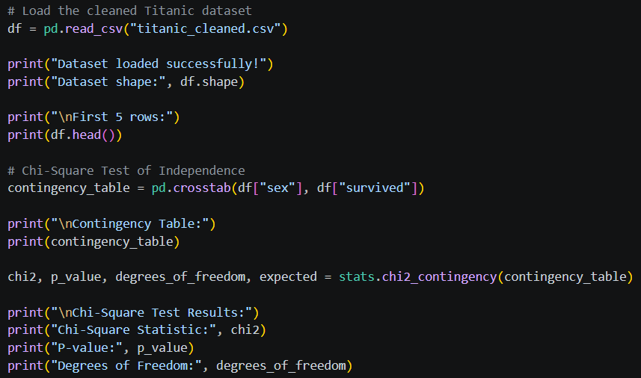
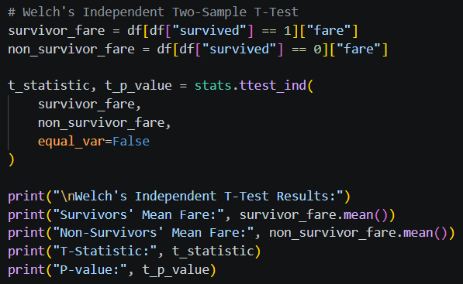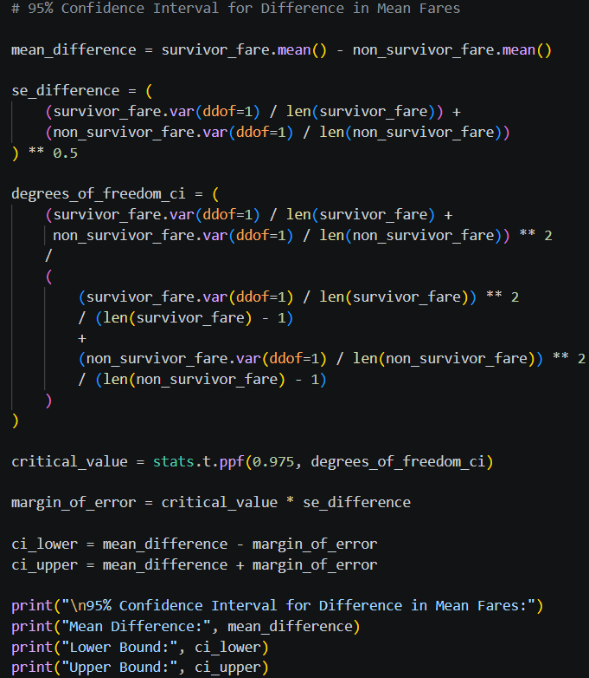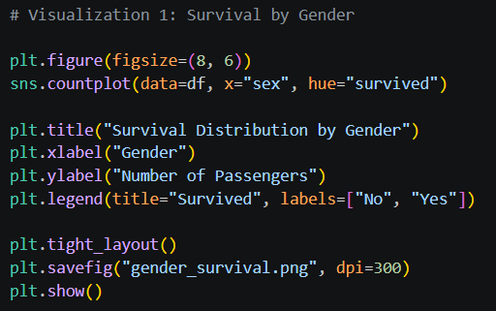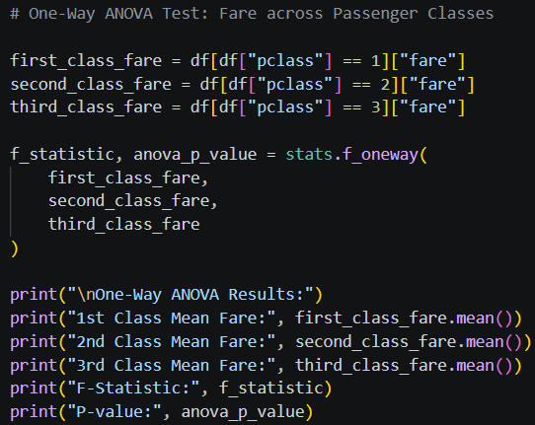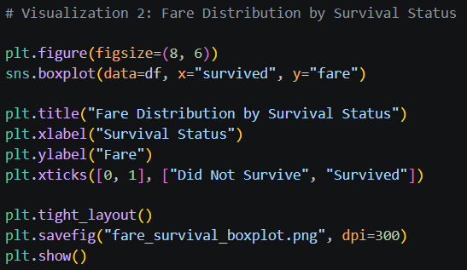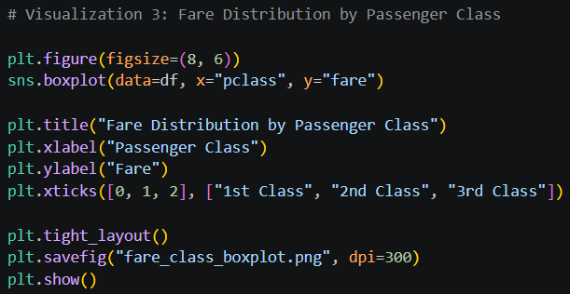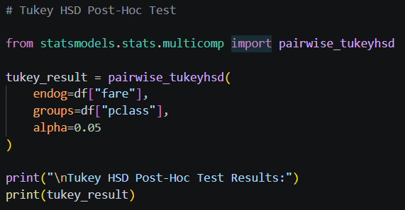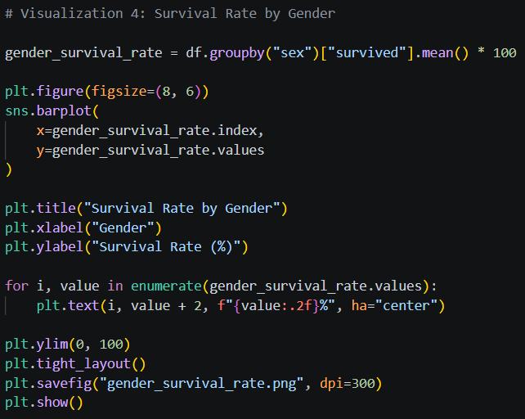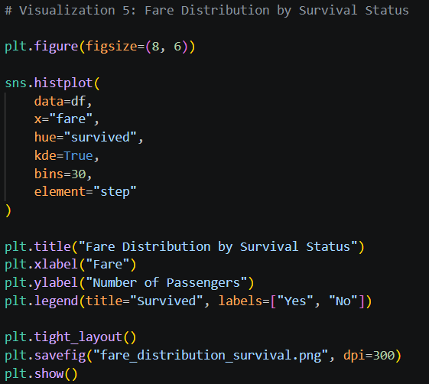
  - Visualization Files
No. | Visualization | File Name
1 | Survival Distribution by Gender | gender_survival.png
2 | Fare Distribution by Survival Status – Boxplot | fare_survival_boxplot.png
3 | Fare Distribution by Passenger Class | fare_class_boxplot.png
4 | Survival Rate by Gender | gender_survival_rate.png
5 | Fare Distribution by Survival Status – Histogram | fare_distribution_survival.png

- GitHub Repository
  - Project Repository
The complete Week 3 Statistical Analysis and Hypothesis Testing project has been maintained in a GitHub repository. The repository contains the Python implementation, cleaned dataset, generated visualization files, and supporting project materials. Maintaining the project on GitHub provides a structured and reproducible way to organize the analysis and demonstrate the implementation of the statistical methods used in this project.
GitHub Repository:
https://github.com/ayushi2004-data/Week3_Statistical_Analysis

  - Repository Contents

File / Folder | Description
week3_analysis.py | Python script containing the statistical tests, calculations, and visualization code
titanic_cleaned.csv | Cleaned Titanic dataset used for the statistical analysis
gender_survival.png | Visualization of survival counts by gender
fare_survival_boxplot.png | Boxplot comparing fare distributions of survivors and non-survivors
fare_class_boxplot.png | Boxplot showing fare distributions across passenger classes
gender_survival_rate.png | Visualization comparing survival rates by gender
fare_distribution_survival.png | Histogram showing fare distributions by survival status
Week 3 Report | Documentation of the hypothesis formulation, methodology, statistical results, interpretations, and conclusions

  - Reproducibility and Project Organization
The project files have been organized to make the statistical analysis easier to understand, review, and reproduce. The Python script contains the complete analytical workflow, including data loading, statistical testing, confidence interval calculation, post-hoc analysis, and visualization generation. The cleaned dataset is included as the input data used for the analysis, while the generated visualization files provide graphical evidence for the statistical findings. This organization allows the analysis process to be followed from the dataset through statistical testing and final interpretation.

- Project Outcome
This project successfully demonstrated the practical application of statistical analysis and hypothesis testing using Python. The analysis progressed from a cleaned dataset to clearly formulated hypotheses, appropriate statistical test selection, numerical calculations, supporting visualizations, and evidence-based interpretation. The project provided practical experience in using statistical methods to evaluate relationships and differences in real-world data rather than relying only on descriptive observations.
The project also strengthened practical understanding of different statistical techniques and their appropriate applications. The Chi-Square Test was used for categorical variables, Welch's T-Test for comparing two independent group means, and One-Way ANOVA for comparing means across multiple groups. Tukey's HSD post-hoc test was additionally used to identify specific group differences after a significant ANOVA result. These methods helped demonstrate how statistical evidence can be used to support conclusions while considering p-values, confidence intervals, effect magnitude, variability, and test assumptions.
Overall, the project provided practical experience in conducting a complete statistical analysis workflow in Python. It demonstrated the importance of selecting appropriate statistical methods, interpreting statistical evidence correctly, supporting conclusions with visualizations, and recognizing the limitations of observational data. The completed project combines technical implementation with statistical reasoning and clear documentation, providing a strong foundation for applying hypothesis testing and data analysis techniques to future datasets and real-world analytical problems.

