## Artificial Intelligence

## and Machine Learning

Project Report

Semester-IV (Batch-2022)

**Hand Gesture Recognition**

**Supervised By: Submitted By:**

Faculty Name : Dr. Kirandeep Singh Name: Ashmita (2210990190)

Group: G6 Arshdeep (2210990169)

Ayushi (2210990206)

**Department of Computer Science and Engineering**

Chitkara University Institute of Engineering & Technology, Chitkara University, Punjab

## ****Hand Gesture Recognition****

**Hand gesture recognition is a fascinating field within computer vision and machine learning that enables computers to interpret human gestures through the use of cameras and algorithms. This project aims to develop a hand gesture recognition system using Python, leveraging techniques such as image processing, deep learning, and neural networks. This paper provides a detailed overview of the project, including its background, objectives, significance, methodology, implementation, results, and potential applications.**

**Introduction:**

**Hand gesture recognition is an interdisciplinary research field that has gained significant attention due to its potential applications in various domains such as human-computer interaction, sign language recognition, virtual reality, robotics, and healthcare. The ability to interpret hand gestures allows computers to understand human intentions and commands, thereby enhancing user experience and enabling natural interaction with machines.**

**Background:**

**The development of hand gesture recognition systems has been facilitated by advancements in computer vision, machine learning, and deep learning techniques. Traditional approaches to hand gesture recognition involved handcrafted features extraction and classification algorithms. However, with the advent of deep learning, convolutional neural networks (CNNs) have emerged as powerful tools for learning discriminative features directly from raw data, leading to significant improvements in accuracy and robustness.**

**Objectives:**

**The main objectives of this project are:**

**To develop a hand gesture recognition system capable of recognizing a predefined set of gestures.**

**To explore various techniques for image preprocessing, feature extraction, and classification.**

**To implement and train deep learning models for gesture recognition.**

**To evaluate the performance of the developed system in terms of accuracy, speed, and robustness.**

**To provide a user-friendly interface for real-time gesture recognition.**

**Significance:**

**Hand gesture recognition has numerous practical applications, including:**

**Human-Computer Interaction: Gesture-based interfaces can enhance user experience in applications such as gaming, virtual reality, and smart devices.**

**Sign Language Recognition: Hand gestures are integral to sign language communication, and accurate recognition can facilitate communication between hearing-impaired individuals and the hearing community.**

**Robotics: Gesture-based control of robots can enable intuitive and natural interaction between humans and machines, facilitating tasks such as robot navigation, manipulation, and collaboration.**

**Healthcare: Hand gesture recognition can be utilized in healthcare applications for remote patient monitoring, rehabilitation exercises, and assistive technologies for individuals with motor disabilities.**

**Methodology:**

**The methodology for developing the hand gesture recognition system involves the following steps:**

**Data Collection: Gather a dataset of hand gesture images or videos containing a diverse set of gestures.**

**Preprocessing: Preprocess the images/videos to enhance quality, remove noise, and extract relevant features.**

**Feature Extraction: Extract discriminative features from the preprocessed images/videos using techniques such as histogram of oriented gradients (HOG), convolutional neural networks (CNNs), or recurrent neural networks (RNNs).**

**Model Training: Train machine learning or deep learning models using the extracted features to recognize hand gestures.**

**Model Evaluation: Evaluate the trained models on a separate test dataset to measure performance in terms of accuracy, precision, recall, and F1-score.**

**Real-time Implementation: Implement the trained model in a real-time application using Python libraries such as OpenCV and TensorFlow for gesture recognition.**

**Implementation:**

**The implementation of the hand gesture recognition system will be carried out using Python programming language and popular libraries such as OpenCV, TensorFlow, and scikit-learn. The system will consist of modules for data preprocessing, feature extraction, model training, and real-time gesture recognition. Additionally, a graphical user interface (GUI) will be developed using Tkinter or PyQt to provide a user-friendly interface for interacting with the system.**

**Results:**

**The performance of the developed hand gesture recognition system will be evaluated using standard metrics such as accuracy, precision, recall, and F1-score. Additionally, qualitative assessments will be conducted to assess the system's robustness and usability in real-world scenarios. The results will be presented and analyzed to demonstrate the effectiveness of the proposed approach.**

**Conclusion and Future Work:**

**In conclusion, this project aims to develop a hand gesture recognition system using Python, leveraging deep learning techniques for accurate and robust gesture recognition. The significance of the project lies in its potential applications in various domains such as human-computer interaction, sign language recognition, robotics, and healthcare. Future work may involve expanding the gesture vocabulary, improving the real-time performance of the system, and exploring novel techniques for gesture recognition. Overall, the project contributes to the advancement of computer vision and machine learning research in the field of hand gesture recognition.**

**Problem Definition:**

**Hand gesture recognition is a computer vision task that involves identifying and interpreting hand gestures made by individuals. The goal of this project is to develop a hand gesture recognition system using Python that can accurately recognize predefined gestures in real-time. The system should be capable of interpreting hand gestures captured by a camera and mapping them to specific commands or actions.**

**Problem Statement:**

**Design and implement a hand gesture recognition system that can:**

**Detect and localize hands in real-time video streams.**

**Extract discriminative features from hand regions to represent different gestures.**

**Train machine learning or deep learning models to classify gestures accurately.**

**Implement a user-friendly interface for real-time interaction and feedback.**

**Evaluate the performance of the system in terms of accuracy, speed, and robustness.**

**Requirements:**

**Software Requirements:**

**Python programming language (version 3.x).**

**OpenCV library for computer vision tasks.**

**TensorFlow or PyTorch for deep learning model development.**

**scikit-learn library for machine learning algorithms.**

**Tkinter or PyQt for graphical user interface (GUI) development.**

**NumPy and Pandas for data manipulation and analysis.**

**Data Sets:**

**Hand Gesture Data Set: Gather a diverse collection of hand gesture images or videos containing examples of the gestures to be recognized. The dataset should include variations in hand shape, orientation, lighting conditions, and backgrounds to ensure robustness.**

**Training and Testing Data: Split the hand gesture dataset into training and testing subsets for model development and evaluation, respectively. Ensure that the data is labeled with ground truth annotations indicating the corresponding gesture labels.**

**Additional Data (Optional): Depending on the complexity and variability of the gestures, additional data augmentation techniques such as rotation, scaling, and flipping may be applied to augment the training dataset and improve the generalization capability of the models.**

**By fulfilling the above requirements and utilizing appropriate software tools and datasets, the hand gesture recognition system can be effectively developed and evaluated for its intended purpose.**

**Proposed Design/Methodology:**

**The development of a hand gesture recognition system involves several key steps, including data collection, preprocessing, feature extraction, model training, and real-time implementation. In this section, we will outline the proposed design and methodology for each of these steps, along with a schematic diagram illustrating the workflow of the system.**

1. **Data Collection:**

**The first step in building a hand gesture recognition system is to collect a dataset of hand gesture images or videos. The dataset should contain examples of the gestures to be recognized, captured under various conditions such as different hand poses, backgrounds, and lighting conditions. The dataset should be diverse and representative of the real-world scenarios in which the system will be deployed.**

1. **Preprocessing:**

**Once the dataset is collected, preprocessing techniques are applied to enhance the quality of the images and remove noise. Preprocessing steps may include:**

## **Resizing: Resize images to a consistent resolution to ensure uniformity.**

## **Grayscale Conversion: Convert images to grayscale to reduce computational complexity.**

## **Normalization: Normalize pixel intensities to a common scale to improve model convergence.**

## **Noise Reduction: Apply filters such as Gaussian blur or median blur to remove noise.**

## **Edge Detection: Detect edges in the images using techniques like Canny edge detection.**

1. **Feature Extraction:**

**Feature extraction is a critical step in hand gesture recognition, as it involves capturing discriminative information from the preprocessed images. Popular feature extraction techniques include:**

**Histogram of Oriented Gradients (HOG): Extracts local gradient information from image patches.**

**Convolutional Neural Networks (CNNs): Utilize pre-trained CNN models or train custom CNN architectures to learn hierarchical features directly from the images.**

## **Convolutional Recurrent Neural Networks (CRNNs): Combine CNNs with recurrent neural networks (RNNs) to capture both spatial and temporal features from video sequences.**

1. **Model Training:**

**Once features are extracted from the preprocessed images, machine learning or deep learning models are trained to classify the hand gestures. Commonly used algorithms include:**

**Support Vector Machines (SVM): Train SVM classifiers on the extracted features for gesture classification.**

**Convolutional Neural Networks (CNNs): Train CNN architectures using the extracted features or raw image data for end-to-end gesture recognition.**

**Recurrent Neural Networks (RNNs): Utilize RNN architectures for sequence modeling and gesture recognition in video sequences.**

1. **Real-time Implementation:**

**After the models are trained, they are deployed in a real-time application for gesture recognition. The system captures live video frames from a camera, preprocesses them, extracts features, and feeds them into the trained model for classification. The recognized gestures are then mapped to specific commands or actions, enabling real-time interaction with the system.**

**Schematic Diagram:**

## **Below is a schematic diagram illustrating the workflow of the hand gesture recognition system:**

## **File Structure:**

## **The file structure of the project may be organized as follows:**

## **data/: Directory containing the hand gesture dataset.**

## **preprocessing.py: Python script for data preprocessing.**

## **feature_extraction.py: Python script for feature extraction.**

## **model_training.py: Python script for training machine learning or deep learning models.**

## **real_time_recognition.py: Python script for real-time gesture recognition.**

## **utils.py: Utility functions for image processing, model evaluation, etc.**

## **requirements.txt: Text file listing required Python packages and their versions.**

## **Algorithm Used:**

## **The primary algorithm used in this project is the Convolutional Neural Network (CNN), a deep learning architecture commonly employed for image classification tasks. CNNs consist of multiple layers, including convolutional layers, pooling layers, and fully connected layers, which enable them to learn hierarchical features from input images and make predictions.**

## **By following the proposed design and methodology outlined above, a hand gesture recognition system can be effectively developed and deployed for real-world applications.**

## **Screenshots:**

## 

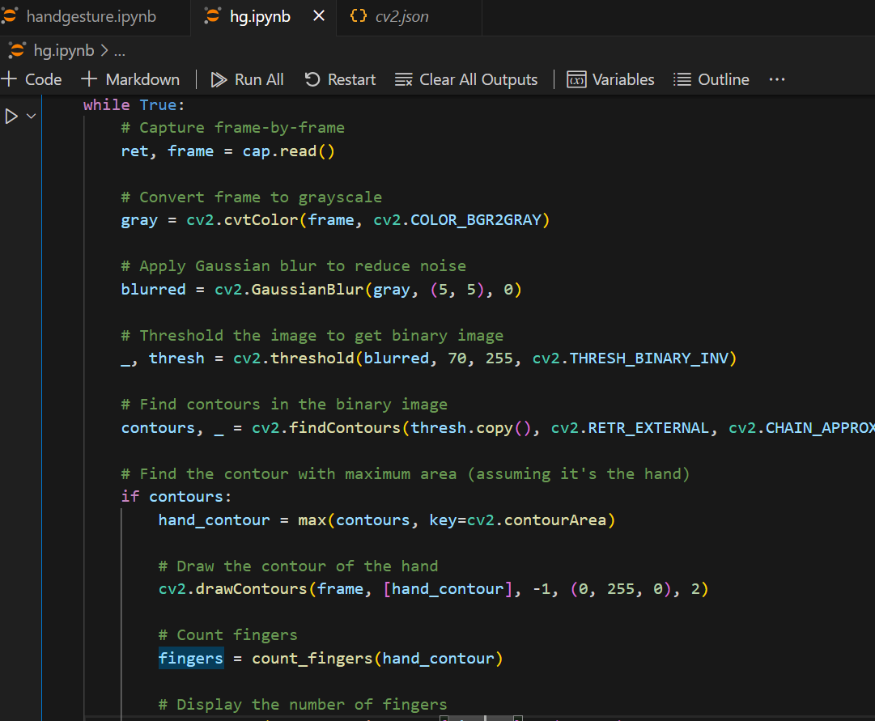

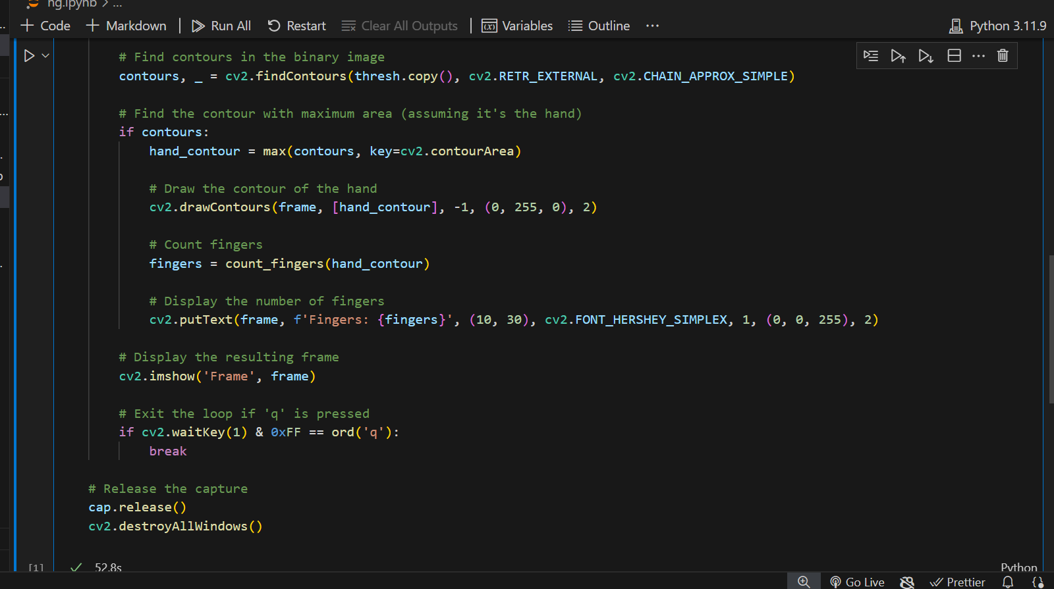

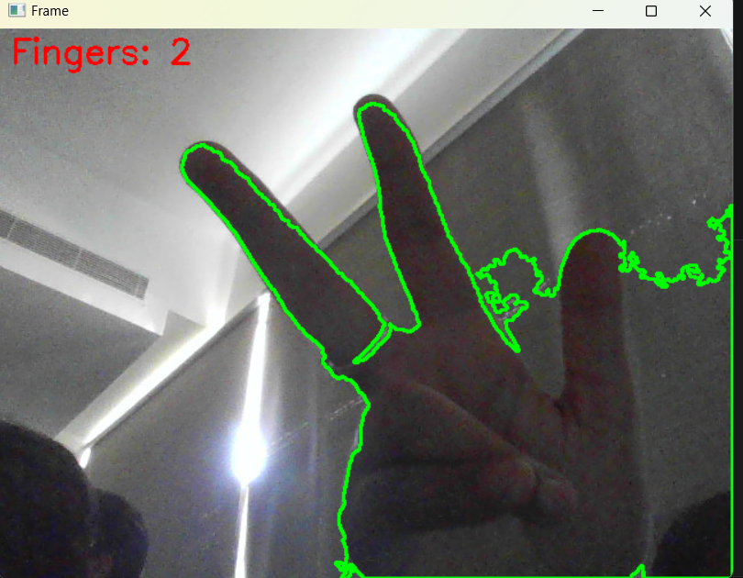

**References**

* Geekforgeeks.org
* Kaggle.com
* Youtube.com
* Google.com