# E-Library (Console based App)

## Book Management

### Add Book

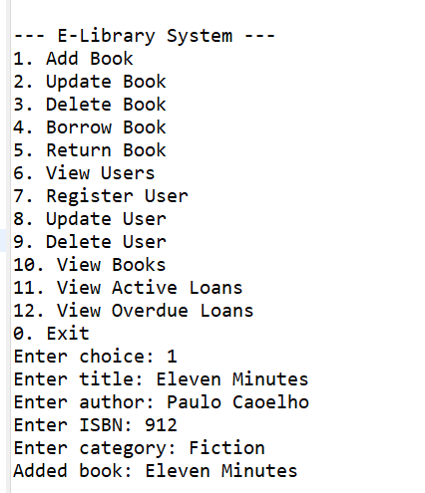

### Update Book

### View Book

### Delete Book

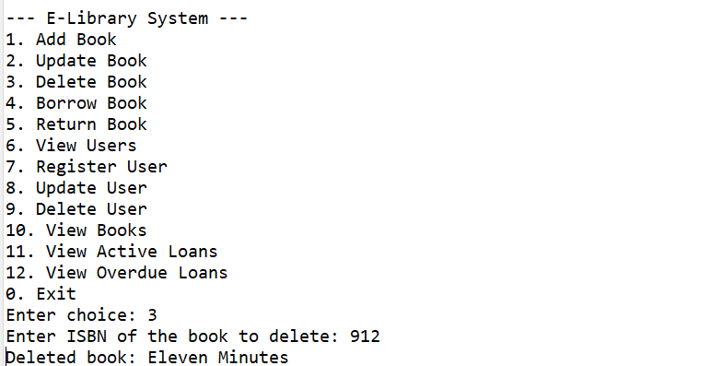

## User Management

### Register User

### Update User

### View User List

### Delete User

## Loan Processing

### Borrow Book

### Active Loans

### Return Book

## Notifications

#### Send notification if due date is approaching soon or is overdue.



