- About Project Division
Tesla Transformers' Projects Division specializes in executing turnkey projects for the construction of grid substations and transmission lines up to the 400 kV class, encompassing design, supply, construction, installation, testing, and commissioning. ​
Established in 1985, the Projects Engineering & Consultancy Division leverages TESLA’s extensive experience in the design, manufacturing, erection, testing, and commissioning of power and distribution transformers and related equipment. Over the years, the division has successfully completed numerous projects across 11 kV, 33 kV, 132 kV, 200 kV and 400 kV classes for a diverse clientele, including electrical utilities, Indian Railways, telecom companies, power supply undertakings, government departments, public and private organizations, and international customers. ​
With in-house manufacturing capabilities for key substation equipment such as power and distribution transformers, HT and LT switchgears, control panels, busbars, and bus ducts, TESLA is well-equipped with the necessary machinery, tools, testing equipment, and skilled manpower to efficiently execute contracts up to the 400 kV class.
2.) Project Strength
​Tesla Transformers' Projects Division offers comprehensive solutions tailored to meet diverse electrical needs, ensuring seamless project management and execution for enhanced customer satisfaction. Our key strengths include:​
- Single-Point Responsibility: We provide end-to-end services encompassing design, supply, construction, installation, testing, and commissioning of grid substations and transmission lines up to the 400 kV class. This integrated approach ensures streamlined communication and accountability throughout the project lifecycle. ​
- Experienced Workforce: Our team comprises highly qualified and experienced professionals, including engineers adept in the erection, testing, and commissioning of turnkey projects for grid substations and transmission lines ranging from 11 kV to 400 kV. ​
- Efficient Project Execution: We employ modern and efficient methodologies to ensure project completion within committed timelines, aligning with our clients' desired commissioning schedules. ​
- In-House Engineering: Our dedicated engineering team delivers detailed designs tailored to customer specifications, ensuring that all technical requirements are meticulously addressed. ​
- Quality Assurance: Adhering to stringent quality system procedures, we ensure that all projects meet global standards and customer expectations, resulting in cost-effective and timely commissioning. ​
- ISO Certifications: Tesla Transformers is certified under ISO 9001:2015 for Quality Management Systems, ISO 14001:2015 for Environmental Management Systems, and ISO 45001:2018 for Occupational Health and Safety Management Systems. These certifications underscore our commitment to maintaining high standards across all facets of our operations. ​
- Extensive Procurement Network: Leveraging a vast database of global and indigenous sources, we ensure the procurement of high-quality materials and equipment, contributing to the overall excellence of our projects.
- Prompt After-Sales Service: We offer various maintenance packages for transformers and complete substations, ensuring minimal disruption and sustained operational efficiency for our clients.

  - Our Strategy
Tesla Transformers' Projects business strategy focuses on achieving profitable growth through:​
- Strategic Partnerships and Alliances: Collaborating with key players in the power, energy, and civil infrastructure sectors to enhance market presence and deliver comprehensive solutions.​
- Targeted Infrastructure Projects: Concentrating efforts on select organizations and projects that align with our expertise and strategic objectives.​
- Continuous Quality Improvement: Striving to elevate quality standards through ongoing enhancement of production methods and processes.​
- Customer Satisfaction: Prioritizing high-level service commitments to meet and exceed customer expectations.​
- Flexibility: Maintaining adaptability in operations to respond effectively to evolving market demands and customer needs.​
- Strong Leadership: Demonstrating bold decision-making and adherence to unconventional strategies that set us apart in the industry.​

  - Capacity & Capabilities
​Tesla Transformers' Projects Division offers comprehensive, single-window solutions for all electrical requirements, encompassing design and execution through to project completion. Our key capacities and capabilities include:​
- Substation Construction: Expertise in constructing both indoor and outdoor substations of 33 kV, 132 kV, 220 kV, and 400 kV classes.​
- Transmission Line Construction: Capability to build low, medium, and extra-high voltage (EHV) transmission lines up to 400 kV class.​
- System Upgrades: Proficiency in augmenting, renovating, and modernizing existing substations and transmission lines to enhance performance and capacity.​
- Infrastructure Development: Construction of buildings, roads, and comprehensive infrastructure setups, with or without integrated electrical works, tailored to project specifications.​
- Internal Electrification: Implementation and modernization of internal electrification systems for both new and existing industrial plants, ensuring compliance with current standards and efficiency requirements.​
- Power Plant Construction: Experience in constructing hydro and geothermal power plants, contributing to sustainable energy initiatives.​
- Consultancy Services: Providing expert consultancy for system improvements, organizational setup, and strategies for enhancing power and energy efficiency.​
These capabilities position Tesla Transformers as a reliable partner for executing complex electrical and infrastructure projects with precision and excellence.

  - Our Clients
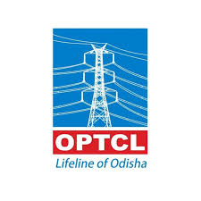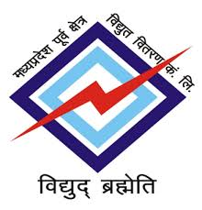
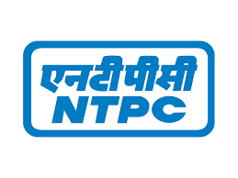
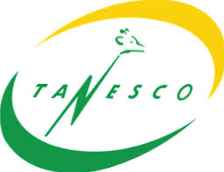


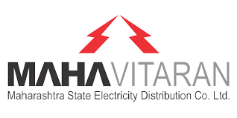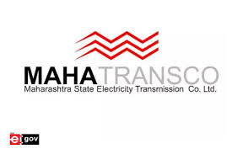

  - Project Gallery
PICs attached in mail

