ConsumerShield
AI-Powered Consumer Complaint & Emerging Issue Intelligence
Prepared by: CJ
IBM SkillsBuild Data Analytics with AI Academic Internship
Conducted by BharatCares, in association with AICTE

1. Abstract
ConsumerShield is a data analytics and NLP project that analyzes publicly available consumer financial complaint data from the CFPB (Consumer Financial Protection Bureau). It combines KPI reporting, trend analysis, NLP-based theme detection, a machine learning classifier, semantic similarity search, and a cautious emerging-issue detection method to turn raw complaint text into actionable business insight.

2. Problem Statement
Financial institutions and regulators receive very large volumes of free-text consumer complaints. Manually reading and categorizing them to identify recurring problems, track how issues evolve over time, and spot emerging risks is impractical at scale. This project builds an automated pipeline to do this using data analytics and natural language processing.

3. Objectives
- Summarize the complaint dataset into clear, decision-relevant KPIs
- Detect recurring complaint themes from free-text narratives using NLP
- Build a similar-complaint semantic search capability
- Analyze how complaint volume trends over time
- Detect potential emerging issues while avoiding false alarms
- Summarize complaint patterns by company, responsibly

4. Dataset
Source: CFPB Consumer Complaint Database (archived narratives), publicly available at consumerfinance.gov/data-research/consumer-complaints.
File used: CCDB_Export_5_September_2023_through_March_2024.zip, covering the period September 2023 to March 2024.
Note: CFPB stopped publishing new complaint narratives after 14 August 2026. This project uses the previously published historical archive, which remains publicly downloadable.
Key fields used: Date received, Product, Sub-product, Issue, Sub-issue, Consumer complaint narrative, Company, State, Timely response.

5. Data Cleaning
- Filtered to complaints that include a written narrative (required for NLP)
- Took a random sample of 40,000 narratives for text analysis (full-dataset NLP was not practical within the project timeline)
- Converted Date received to a proper date type and derived a month field for trend analysis
- Removed CFPB's 'XXXX' privacy-redaction placeholders and numeric noise from narrative text before topic modeling

6. Exploratory Data Analysis — KPIs
("What is happening?")
Metric | Value
Total complaints (full file) | 945,532
Complaints with narrative | 318,804 (33.7%)
Timely response % | 99.5%
Top product | Credit reporting or other personal consumer reports
Top issue | Incorrect information on your report

7. Trend Analysis
("How is it changing?") Monthly complaint volume for the sampled narratives:
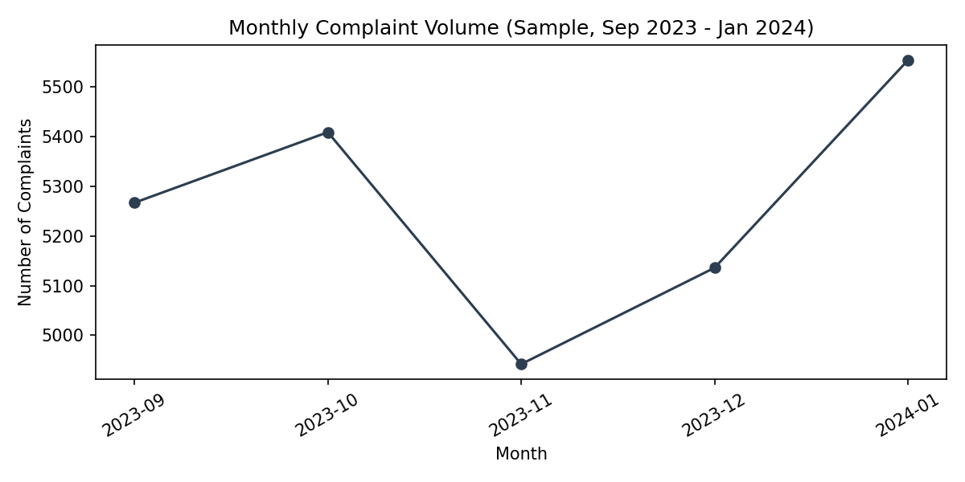
Complaint volume in the sample stayed within a fairly narrow band of roughly 4,900-5,600 per month from September 2023 to January 2024, with no dramatic single-month spike.

8. NLP Methodology — Theme Detection
("Why?" — Driver Analysis) Text was cleaned and vectorized using TF-IDF, then grouped into 8 clusters using KMeans. Each cluster was manually labeled based on its top terms:
Theme | Label
Theme 0 | Legal / FCRA Dispute Language
Theme 1 | Late Payment Reporting Issues
Theme 2 | Debt / Loan Account Disputes
Theme 3 | Identity Theft & Fraud
Theme 4 | Credit Reporting Consent / Legal Citations
Theme 5 | Complaint Process Frustration
Theme 6 | Fraudulent Accounts & Inquiries
Theme 7 | Validation Requests to Credit Bureaus
A Logistic Regression classifier was also trained on TF-IDF features to predict the complaint Product directly from narrative text, achieving 88.1% accuracy on a held-out test set.

9. Semantic Similarity — Similar Complaint Search
Given a new complaint description, the system retrieves the most similar historical complaints using TF-IDF cosine similarity. For example, querying "money was deducted but transaction failed" returns complaints about failed payments, card disputes, and account-access problems across multiple products — demonstrating cross-product semantic matching rather than simple keyword search.

10. Emerging Issue Detection
("What could go wrong?") The most recent two months in the sample were compared against all prior months for each issue category. To avoid noise from very small categories, only issues with at least 30 recent complaints were considered.
Issue | Change vs. prior period | Recent volume
Written notification about debt | +90.0% | 524
Attempts to collect debt not owed | +41.1% | 606
Repossession | +19.4% | 41
Closing your account | +13.1% | 63
Applying for a mortgage or refinancing | +11.1% | 37

11. Validation (False-Alarm Safeguards)
- A minimum recent-volume threshold (30 complaints) filters out small-sample noise
- Results are explicitly labeled 'Potential Emerging Issue - Review Required', never 'Confirmed Problem'
- This follows CFPB's own guidance that the complaint database is not a statistical sample of all consumer experiences and should not be over-interpreted

12. Company Analysis
Company-level complaint counts are reported alongside each company's top issue, without adjusting for company size or market share. Per CFPB guidance, raw complaint volume should not be used to label a company as the 'worst' - larger companies naturally receive more complaints.
The three major credit bureaus (TransUnion, Equifax, Experian) account for the largest share of complaints in this sample, consistent with credit reporting being the dominant product and issue category overall.

13. SQL Analysis
The cleaned sample was loaded into an in-memory SQLite database to demonstrate SQL-based aggregation for product distribution and monthly trend, satisfying the internship's SQL analytics component alongside the pandas-based analysis above.

14. Dashboard (Power BI - Future Scope)
Two CSV exports were generated from this analysis - powerbi_monthly_trend.csv and powerbi_company_summary.csv - intended for direct import into Power BI to build an interactive multi-page dashboard (Executive Overview, Consumer Problems, Emerging Issues, Company Analysis). Building the full Power BI report was scoped as future work given the project timeline; it is not required for this internship's submission.

15. Results Summary
- 945,532 total complaints analyzed at the KPI level; 40,000-narrative sample used for NLP/ML
- 88.1% accuracy classifying complaint product from narrative text
- 8 distinct, human-labeled complaint themes identified via unsupervised clustering
- 2 potential emerging issues flagged for review with supporting evidence
- Working semantic similar-complaint search across the complaint corpus

16. Limitations
- NLP/ML analysis is based on a 40,000-complaint sample, not the full 945,532-row dataset
- CFPB states its complaint database is not a statistical sample of all consumer experiences
- Emerging-issue flags are statistical signals for human review, not confirmed problems
- Company complaint counts are not adjusted for company size or market share
- Data covers only September 2023 to March 2024; CFPB has since stopped publishing new narratives (from 14 August 2026)

17. Future Scope
- Replace TF-IDF with sentence embeddings for improved semantic similarity
- Build the full interactive Power BI dashboard using the exported CSVs
- Extend the approach to Indian consumer/banking complaint data for local relevance
- Add a GenAI/RAG layer for natural-language question answering over complaints

18. Conclusion
ConsumerShield demonstrates a complete consumer-complaint analytics pipeline - from raw text to KPIs, trends, NLP-driven themes, a machine learning classifier, semantic search, and responsibly-validated emerging-issue detection. It reflects the internship's core framework of KPIs, Trends, Drivers, Risk, and Action applied to a genuine, real-world consumer protection problem.

19. References
1. Consumer Financial Protection Bureau, Consumer Complaint Database - https://www.consumerfinance.gov/data-research/consumer-complaints/
2. scikit-learn documentation - https://scikit-learn.org/
3. pandas documentation - https://pandas.pydata.org/

