Q1. What is cherry-pick? Explain the use case of it also write steps to do it.

Explanation:

Cherry-picking in git means choosing a commit from one branch and

applying it to another branch.

It is mainly used if we don’t want to merge the whole branch and

we want some of the commits.

We just have to pick the commit number(hash) and apply it to the another branch.

Steps:

1. Created two different branches.

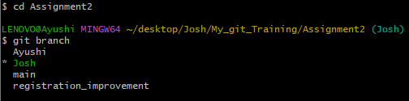

2.Create another file that you want to apply to another branch.

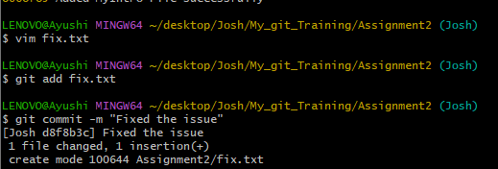

3. Now switch to another branch in which you want to apply a particular feature.

Copy the unique commit hash of that feature file and use the cherry-pick command and apply to the respective branch.

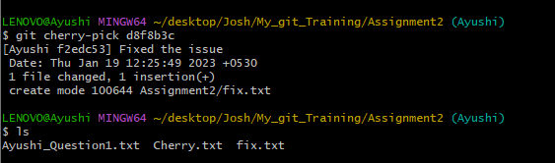

**4. Now it will show the feature file into another branch applied.**

