**3.  How to combine two commits into one commit? For Example, you have 4 different commits C1, C2, C3, and  C4 and you to combine C2 and C3 into one single commit.**

**Attempt 1:**

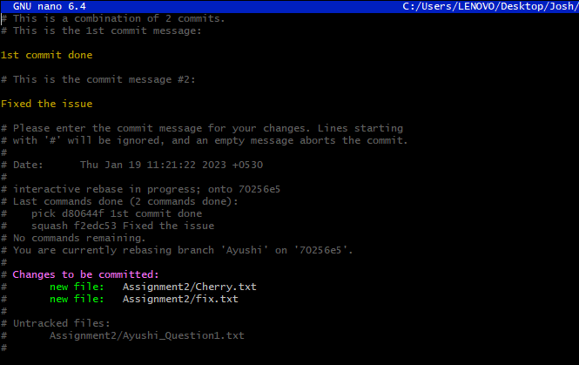

**Attempt 2:**

