**5. Difference between --force push and --force-with-lease, You have to show the use of both, also you have to show in what scenario --force-with-lease is used?**

* **--force push**

It does not consider changes pushed by other developers to the remote repository. The command will override the repo based on the state of your local repository.

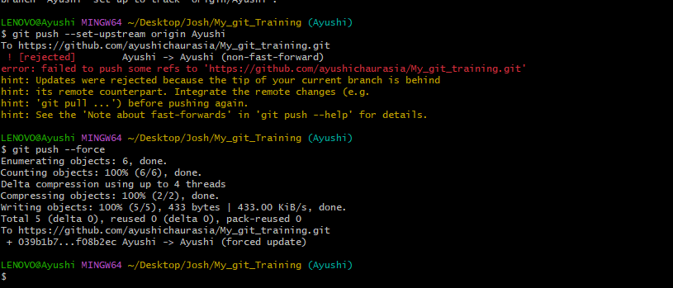

* **--force-with-lease**

This command comes in handy when several developers are sharing a remote repository. We use it when publishing our changes to avoid discarding changes pushed by other developers.

It will not allow other developer to over write the same file and push it to the remote.

It will throw a warning or an error when try to re-write the same file on remote repository.

So I created a text file in remote repository and tried to modify the same file in local, and when I pushed it again to remote repository, it throws an error.

