**VANDERWALL EQUATION OF STATE FOR FORMALDEHYDE**

# CHE221A COMPUTATIONAL ASSIGNMENT-1 AYUSHI GOYAL

# Submitted To- Prof. Vishal Agrawal Roll No.-180182

**INTRODUCTION**

The van der Waals equation was proposed in the year 1873. It was a first step towards taking into account interaction forces which are acting between real gases molecules.

The equation of state of the perfect gas refers to a gas consisting of point like items which do not interact with one another.

Instead of this van der Waals proposed an equation

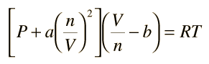

where a and b are the so-called van der Waals constants and which have different values for each gas.

The b correction takes into account the fact that, according to van der Waals. The real gas molecules can move not in the total volume occupied by the gas, but only in a part of this volume which is defined by subtracting what he called the molecules own volume. The correction a/ν2 —proportional to the square of density-takes into account the attraction forces existing between gas molecules. According to the van der Waals assumption, these forces decrease the pressure against the vessel walls, because the molecules which are close to the wall are subjected to attraction of other molecules.

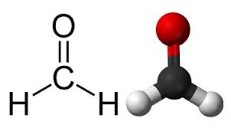FORMALDEHYDE

ANTOINE EQUATION:

log10(P) = A − (B / (T + C))

P = vapour pressure (bar)

T = temperature (K)

FOR TEMPERATURE RANGES:( 163.76K - 250.86K)

A = 4.28176

B=959.43

C=-29.758

<https://webbook.nist.gov/cgi/cbook.cgi?ID=C50000&Mask=4&Type=ANTOINE&Plot=on>

VANDERWAAL’S CONSTANT PARAMETERS FOR ETHANE:

a= 7.356bar L2/mol2

b= 0.06425 L/mol

<https://drjvazque.files.wordpress.com/2017/08/propiedades-criticas.pdf>

# LOGIC OF THE CODE

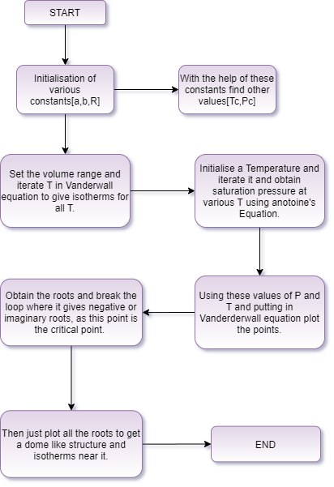

# BEHAVIOUR OF EOS AT VARIOUS TEMPERATURE

GRAPH FOR VANDERWAAL EQUATION OF STATE OBTAINED BY USING SAME ALGORITHM.

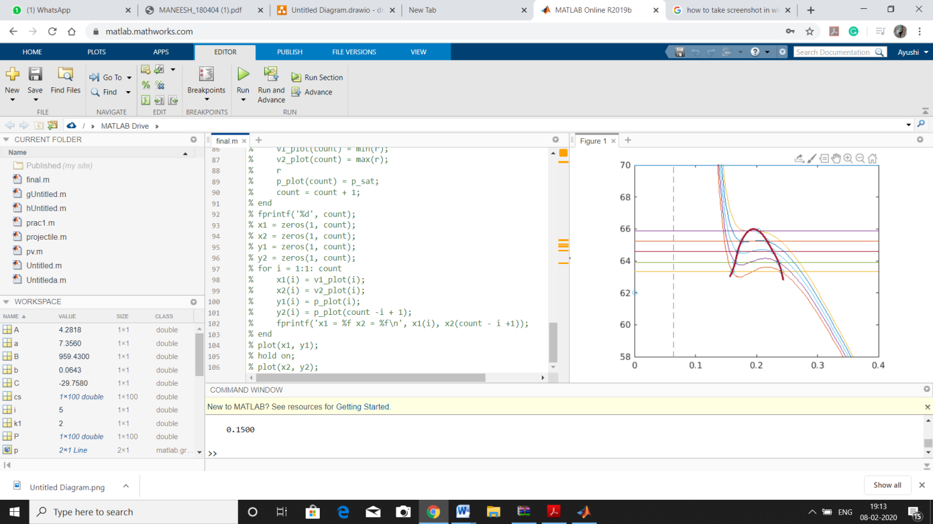

As the temperature increases, the values ν1 and ν2 get closer and finally at the critical point all three roots coincide at the critical volume νc. At higher temperatures only one root of the van der Waals equation remains real, the two other being imaginary. The point where all the three values of volumes become equal is known as the critical point.

i) At(T < Tc) Below the critical temperature, the isotherms in the region follow a cubic trend. In this region, the isotherms have two roots at a particular pressure(saturation pressure). This is the liquid-vapour saturation region.

ii) At(T =Tc) At the critical temperature, the distinct roots merges into a single root. This point of inflection is the critical point. At this point ( ) T and δP/ δV ( T ) vanishes.

iii) At(T > Tc) Above the critical temperature the curve seems to have no real root. Physically above the critical temperature, there is no distinction between the solid-liquid-gas phases.

MATLAB CODE

clc; clear all; close all

a = 7.356;

b = 0.06425;

R = 0.0821;

Tc = (8*a)/(27*R*b);

Pc = a/(27*b*b);

sp=[63.33 63.91 64.57 65.22 65.87]; %using antoine for vanderwaals

% Vcoef = [Pc -(Pc*b)-(R*Tc) a -a*b];

% r = roots(Vcoef);

% r = real(r);

% plot(r(1),Pc,'*');

% roooot = r(1);

% hold on;

% V = linspace(0,10);

% figure(1);

p=70; % Critical pressure from literature

fplot(p);

for T= 409:1:413

i=T-408;

hold on;

syms v;

fplot(R*T/(v-b) - a/(v^2),[0 0.4]);

xlim([0 0.4])

ylim([58 70])

V = linspace(0.1,0.4);

hold on

A = 4.28176;

B = 959.43;

C = -29.758;

p_sat = 57.669;

fplot(sp(i));

hold on

Prfunc = @(V) (R*T./(V - b) - a./(V.^2)-sp(i));

P = Prfunc(V);

cs = P.*circshift(P,-1,2); % Product Negative At Zero-Crossings

xc = V(cs <= 0); % Values Of ‘x’ Near Zero Crossings

for k1 = 1:length(xc)

zeros(k1) = fzero(Prfunc, xc(k1)); % Use ‘xc’ As Initial Zero Estimate

end

sv(i*2)=zeros(1); %saving the first and third root in the saturation region

sv(i*2+1)=zeros(3);

% plot(V,P);

zeros

hold on;

end

y=[62 63.32 63.32 63.91 63.91 64.57 64.57 65.22 65.22 65.87];

sv(1)=0.15

sv(11)=[];

x=sv;

plot(sv,y,'o');

xx = 0.15:.001:0.25;

yy = spline(x,y,xx);

p=plot(x,y,'o',xx,yy);

p(2).LineWidth=2;

hold on

%for i= 0:10

%T = 165 + 9*i;

%A = 4.28176;

%B = 959.43;

%C = -29.758;

%P(i) = power(10,(A-(B/(C+T))));

%y = [P -(b*P-R*T) a -a*b];

%r = roots(y);

%v(1) = min(r);

%v(2) = max(r);

%plot([V(1), v(2)], [P,P])

%end

% Antoine equation parameters

% A = 4.28176;

% B = 959.43;

% C = -29.758;

% p_plot = zeros(1,1000000);

% v1_plot = zeros(1,1000000);

% v2_plot = zeros(1,1000000);

% count = 1;

% for t = 164: 1.0: Tc

% temp = (A - (B/(C + t)));

% p_sat = power(10,(A - (B/(C + t))));

% % 1, c2, c1, c0 are the coefficients of the cubic equation in volume i.e.

% % V^3 + c2 * V^2 + c1 * V + c0 = 0

% y = [p_sat -(b*p_sat+R*t) a -a*b];

% r = roots(y)

% v1_plot(count) = min(r);

% v2_plot(count) = max(r);

% r

% p_plot(count) = p_sat;

% count = count + 1;

% end

% fprintf('%d', count);

% x1 = zeros(1, count);

% x2 = zeros(1, count);

% y1 = zeros(1, count);

% y2 = zeros(1, count);

% for i = 1:1: count

% x1(i) = v1_plot(i);

% x2(i) = v2_plot(i);

% y1(i) = p_plot(i);

% y2(i) = p_plot(count -i + 1);

% fprintf('x1 = %f x2 = %f\n', x1(i), x2(count - i +1));

% end

% plot(x1, y1);

% hold on;

% plot(x2, y2);