**Experiment – 4**

**Aim:** Learn the use of chmod command and vi text editor.

**The “chmod” command modifies the read, write and execute permissions of specified files.**

The octal digits used for assigning permissions are as follows:

|  |  |  |
| --- | --- | --- |
| **Octal Digit** | **Permissions** | **3-Character Display** |
| 7 | Read, write, execute | rwx |
| 6 | Read, write | rw- |
| 5 | Read, execute | r-x |
| 4 | Read | r-- |
| 3 | Write, Execute | -wx |
| 2 | Write | -w- |
| 1 | Execute | --x |
| 0 | none | - |

**Example :** (1 way)chmod 711 test.sh (Owner – u, Group – g, Others – o)

**ugo**

(Another way) chmod ugo+rwx test.sh

**+--x**

**Program 1:** Creating hello.sh file in a directory with your name and giving permission to owner only using chmod command.

**ls**

**mkdir Ayushi**

**cd Ayushi**

**cat > hello.sh**

**#!/bin/bash**

**echo “Hello World”**

**chmod u+rwx hello.sh**

**./hello.sh**

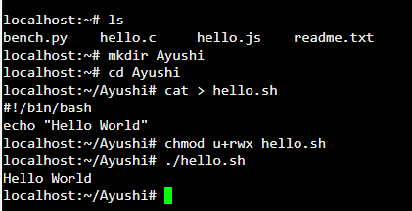

**Program 2:** Creating vi text editor file namely test.sh.

**vi test.sh**

**I for insert**

**#!/bin/bash**

**var1=”hello”**

**var2=”Your name”**

**echo $var1 $var2**

**Esc for escape**

**:wq for save and exit**

**Chmod u+rwx test.sh**

**./test.sh**

