**Shell – Final Case Study Assessment**

**Scenario: Streamline Solutions Inc. - Optimizing Software Deployment**

**Project Management Setup:**

Creating a Project Board (Epic)

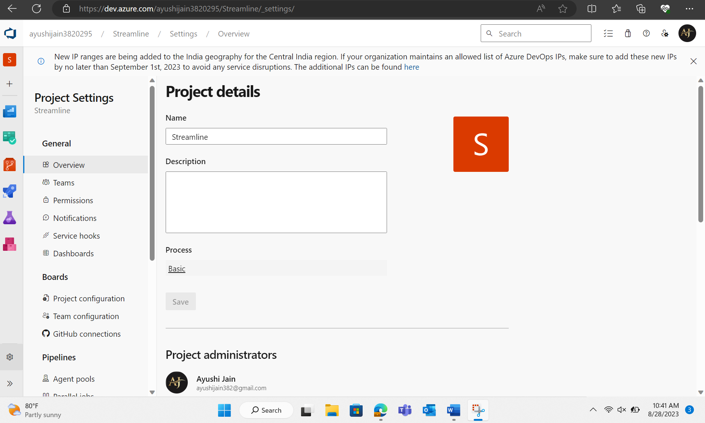

Backlogs Board (issues)

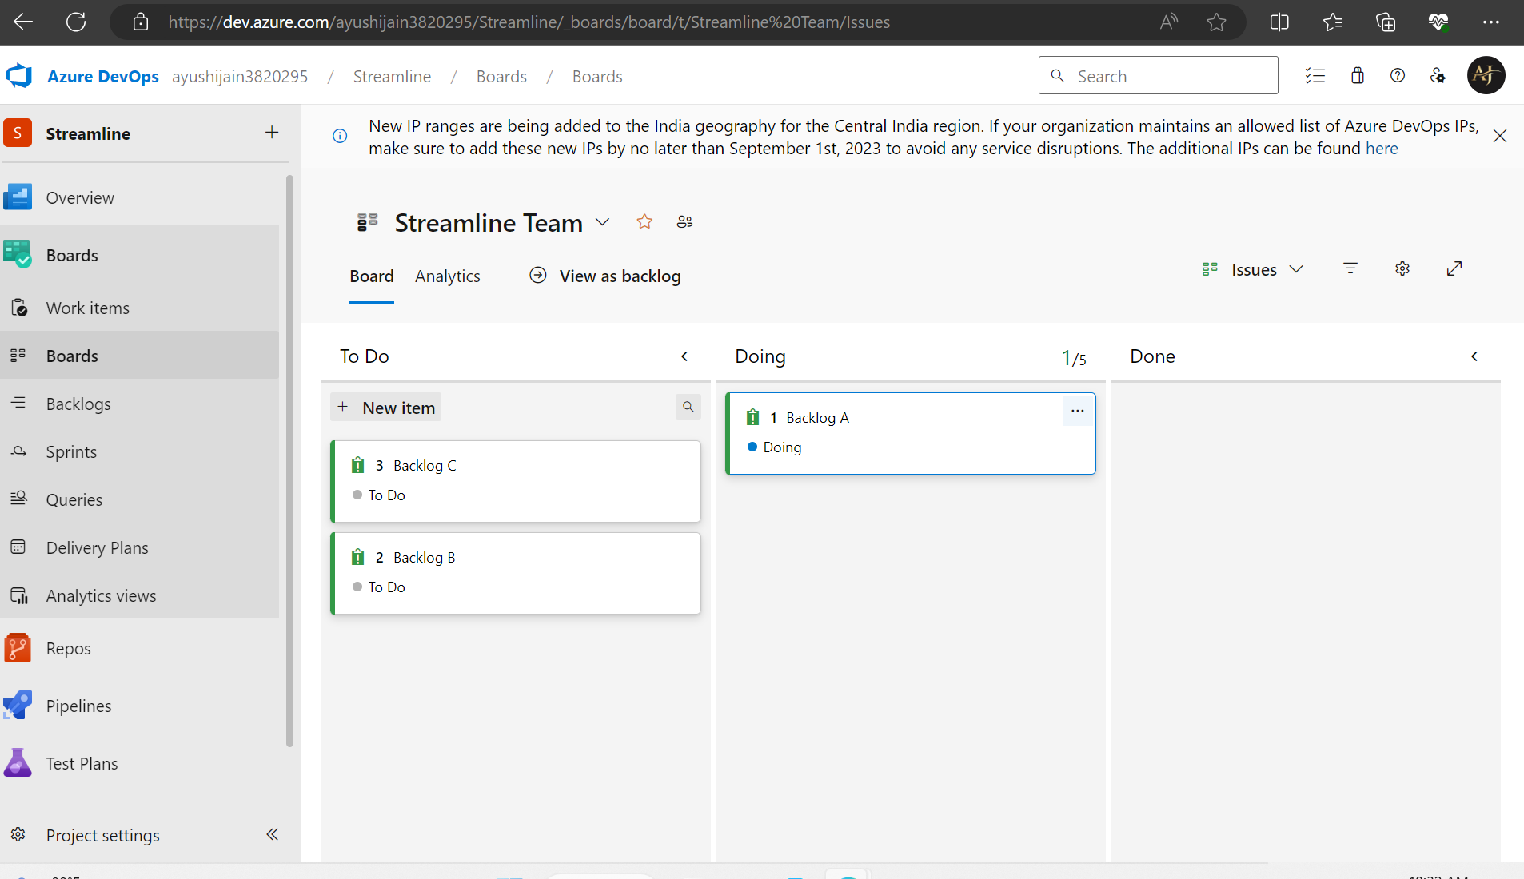

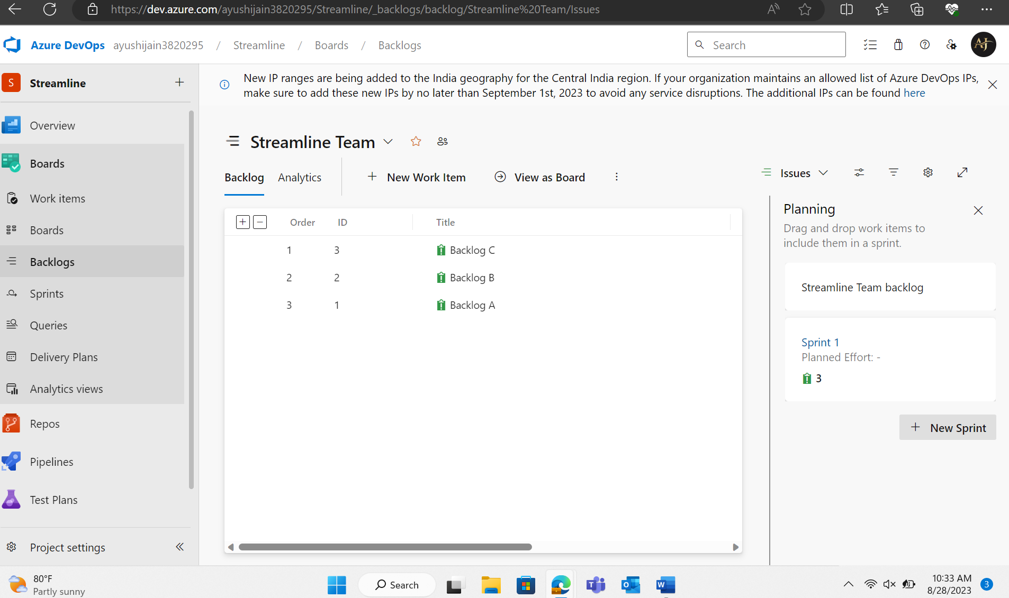

Sprints/Iterations

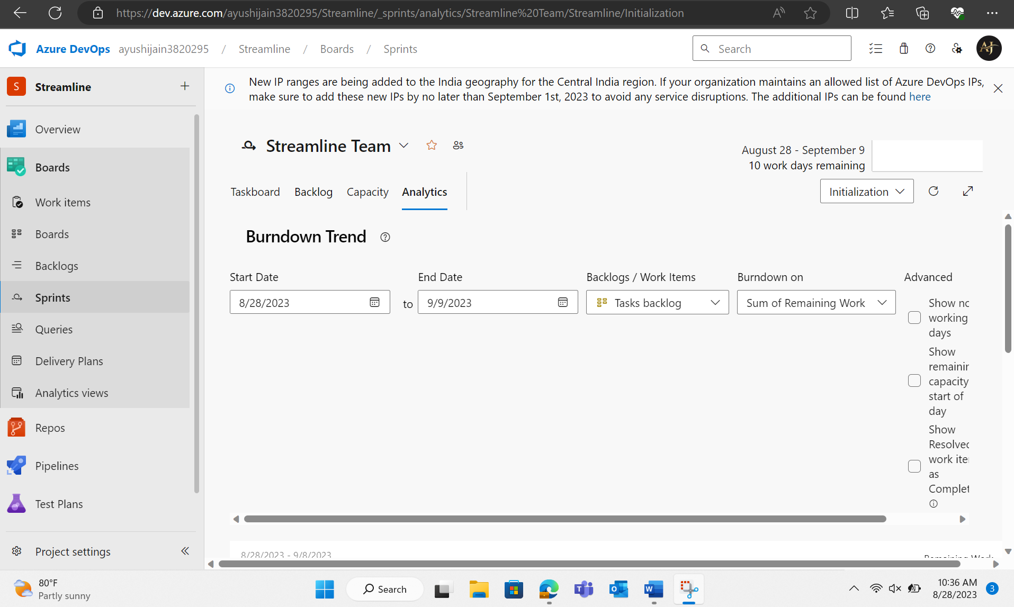

Tasks Board

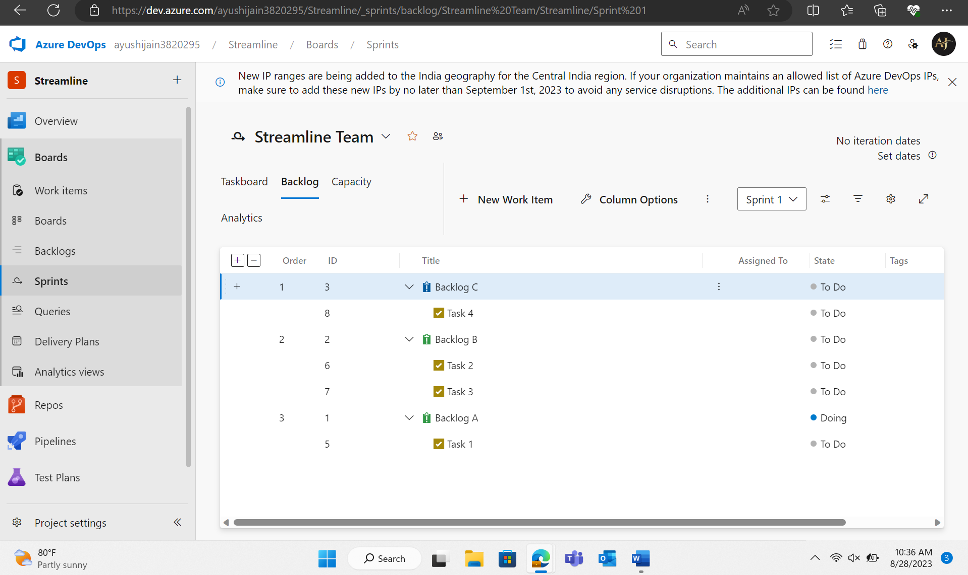

**GitHub Repository and Feature Branching:**

Fork the given repository

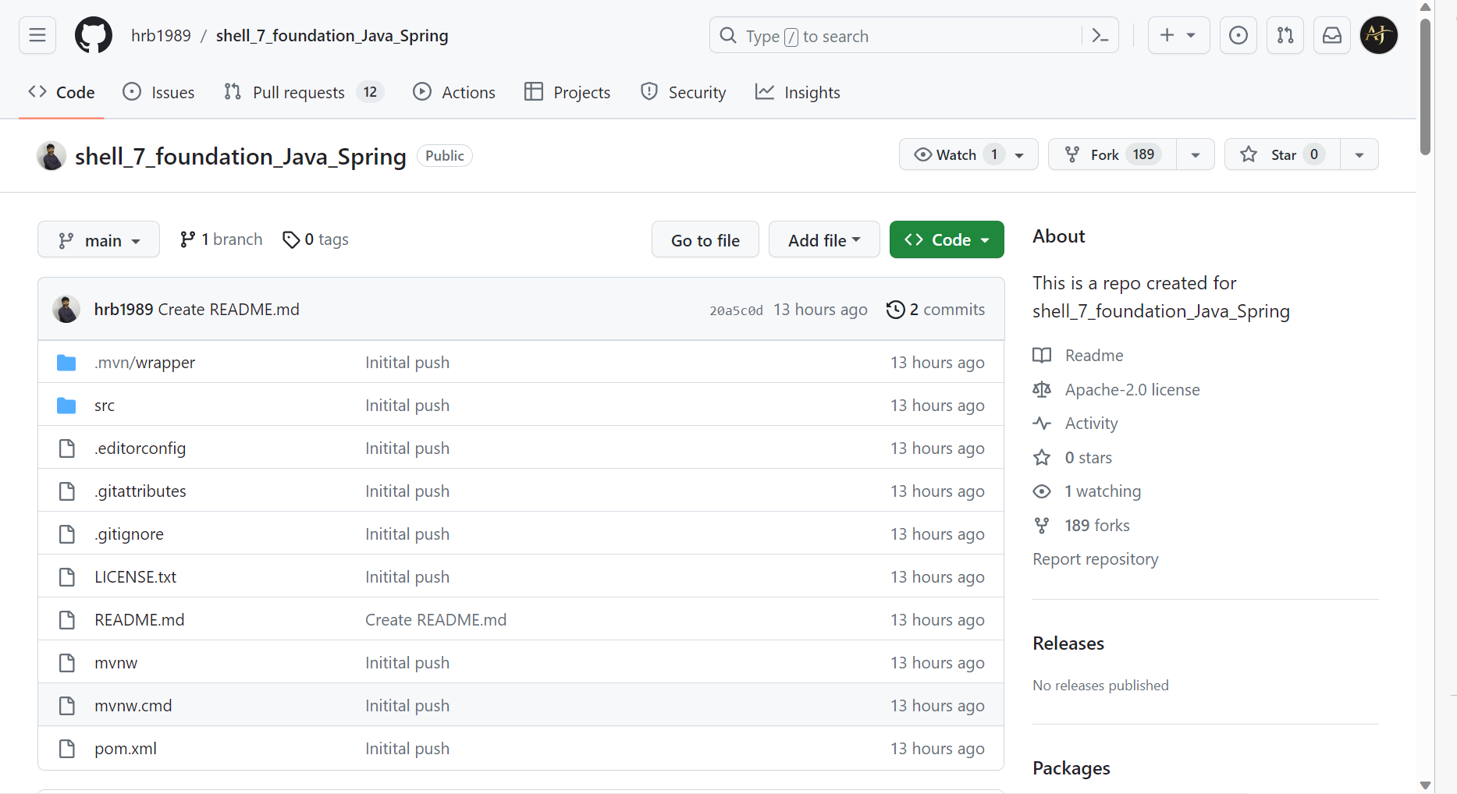

**Generating pull request**

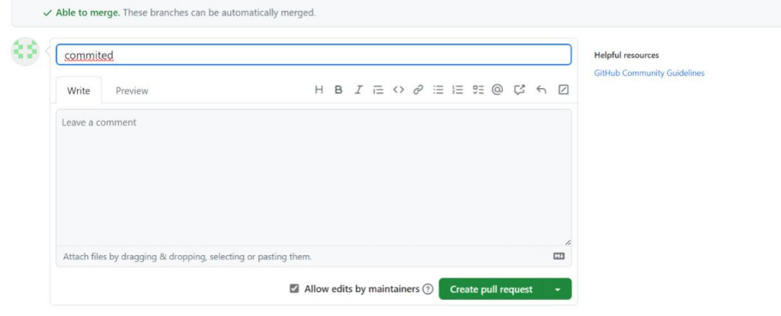

Creating a new folder

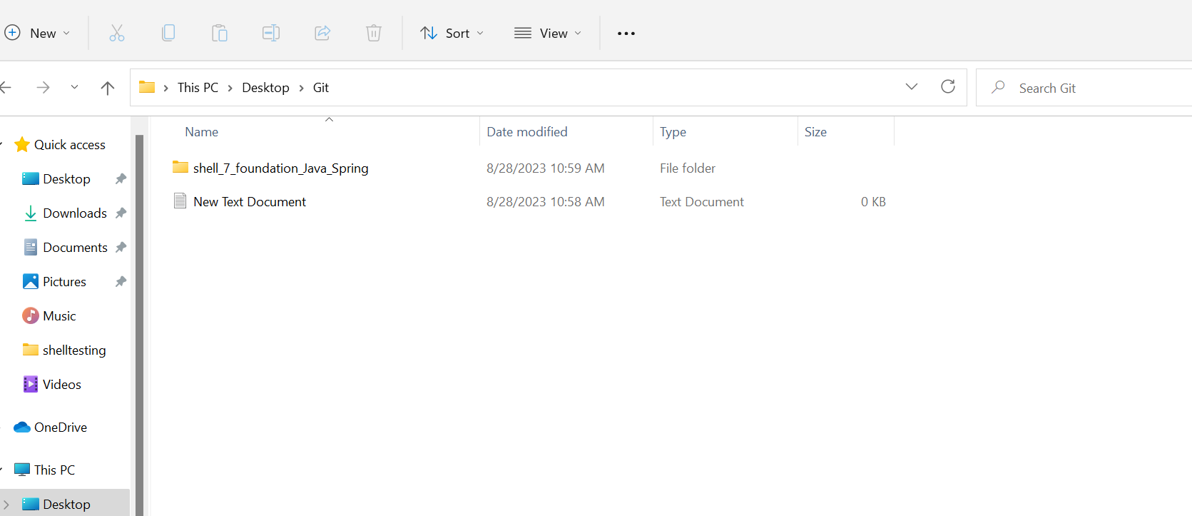

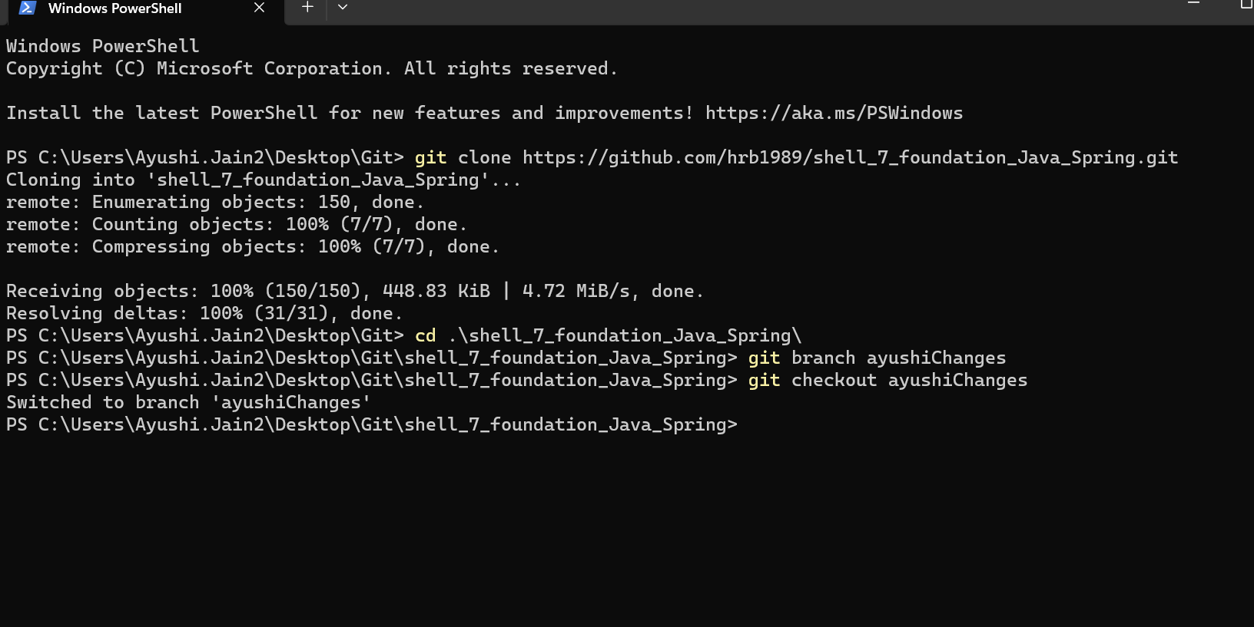

**Azure VM Configuration:**

Creating a vm

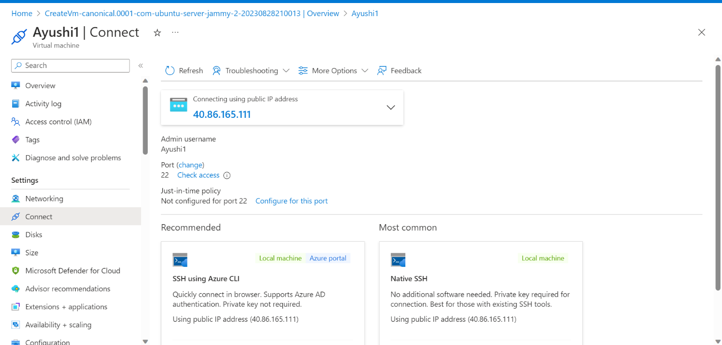

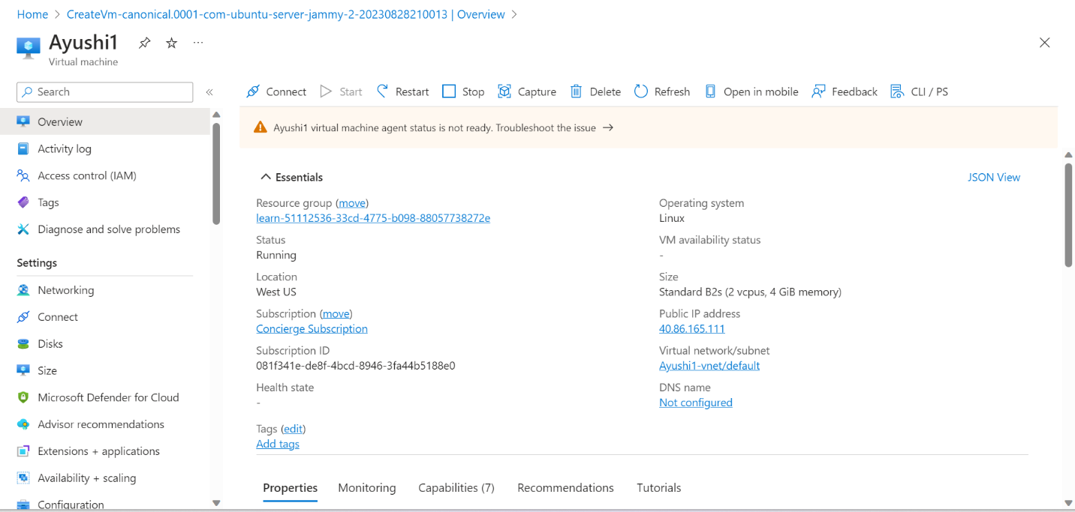

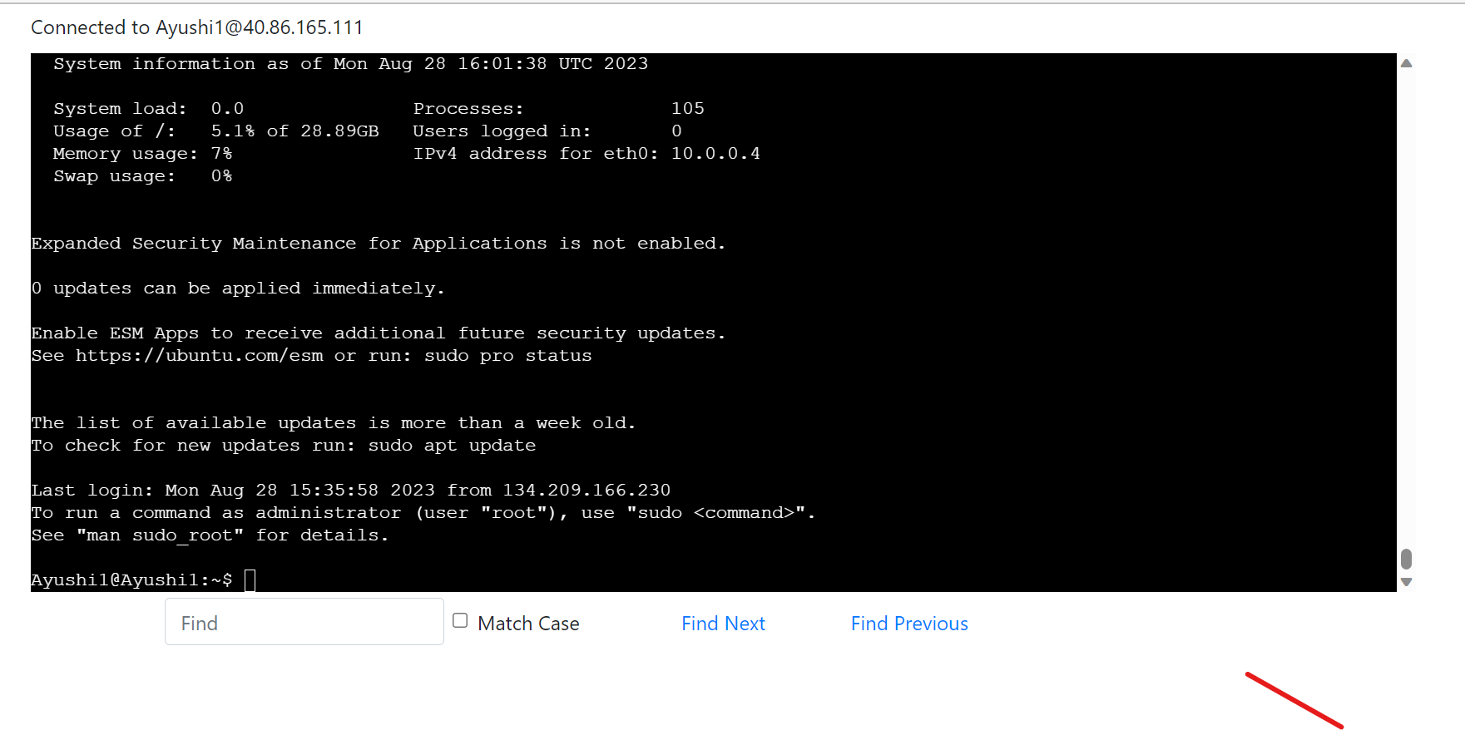

**GitHub Activities and Actions**

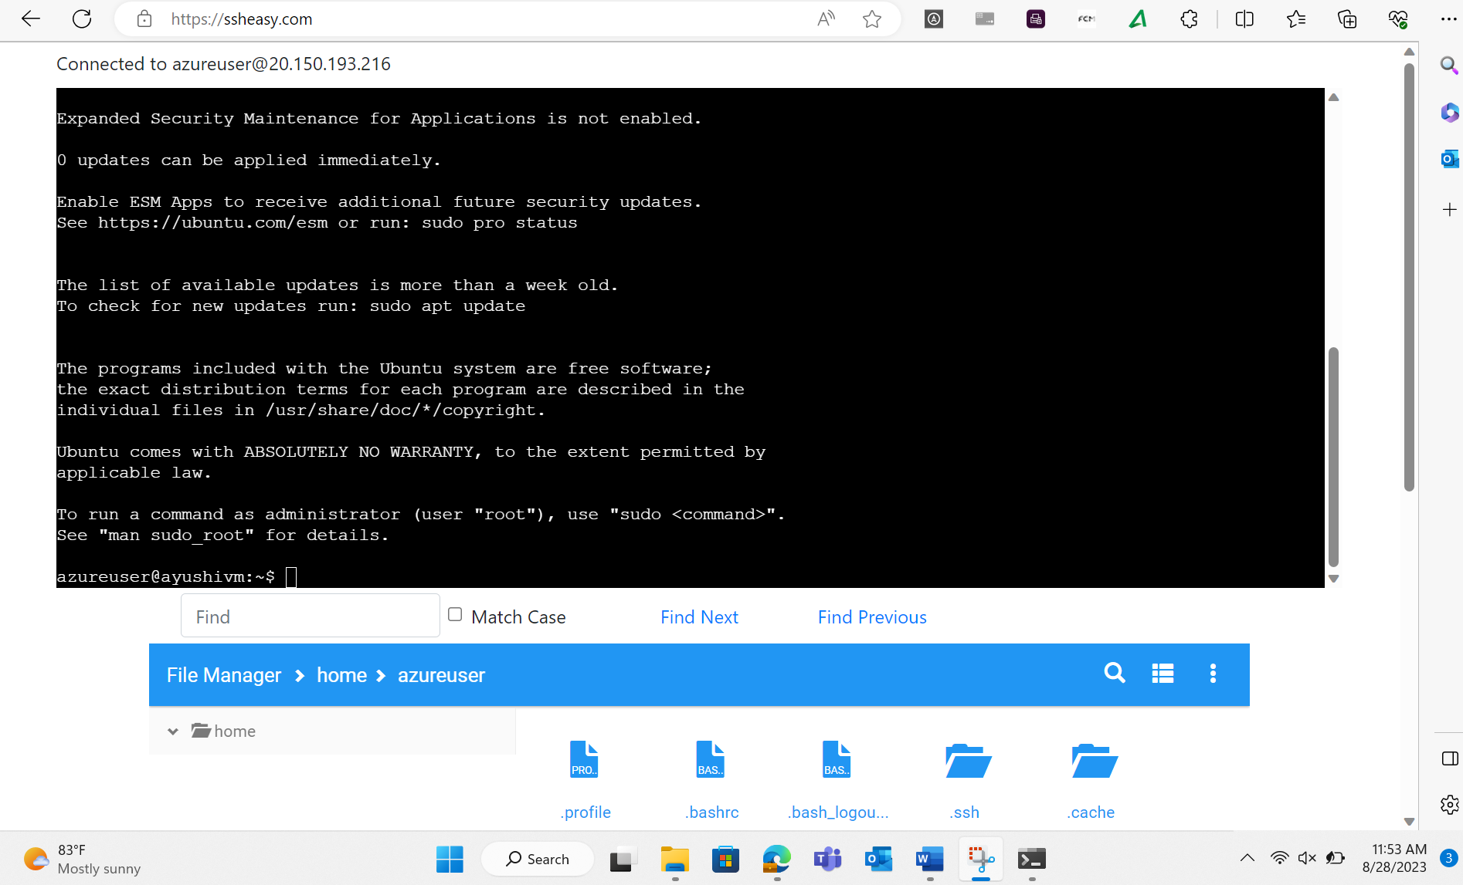

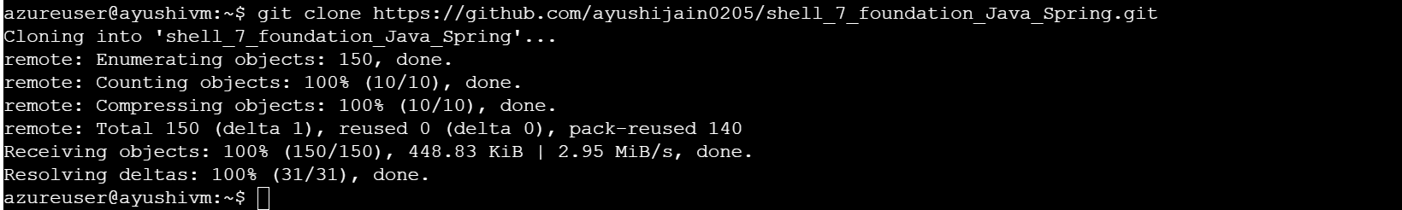

**Maven-Based Build Process:**

Installing maven

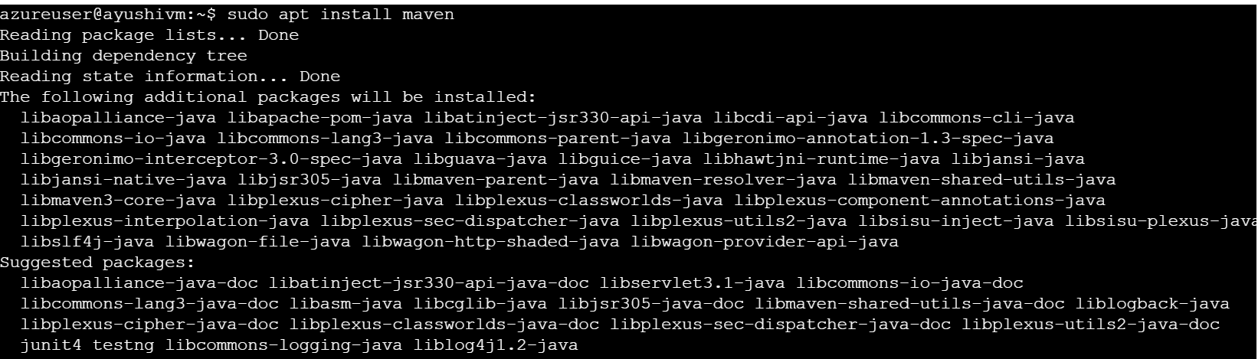

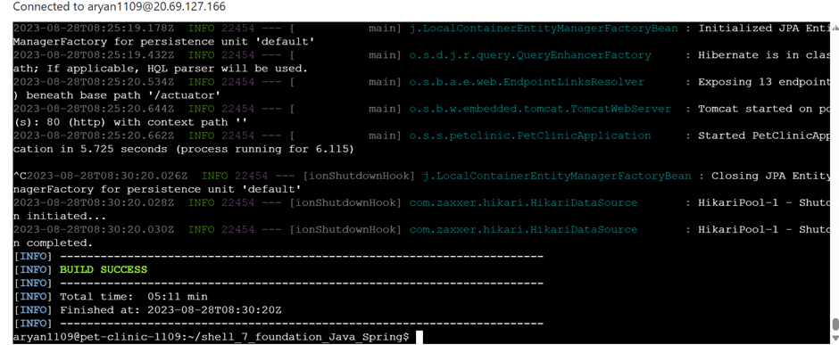

**Prometheus Monitoring Integration:**

Installing Prometheus

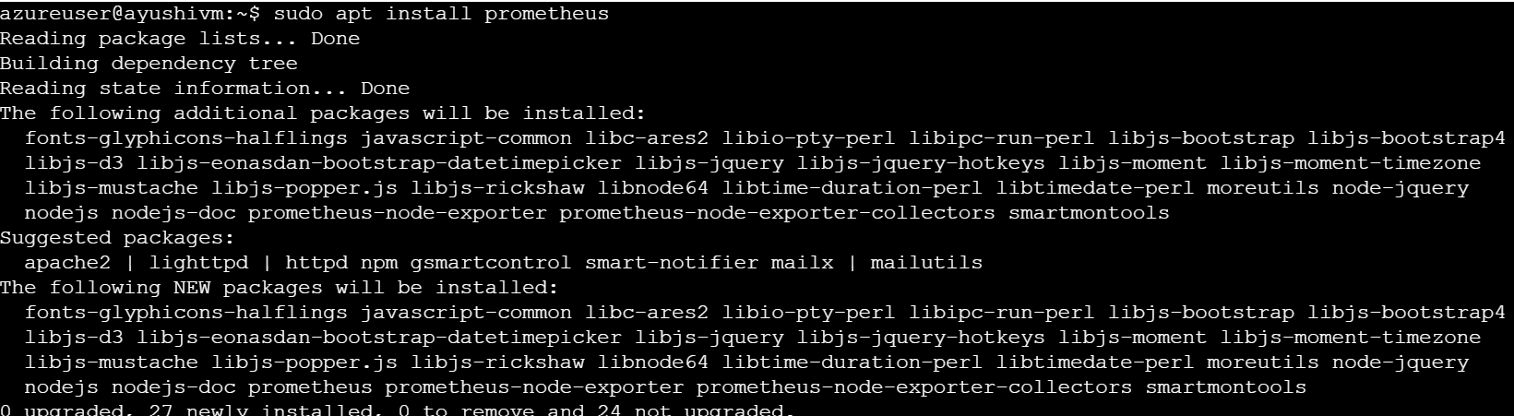

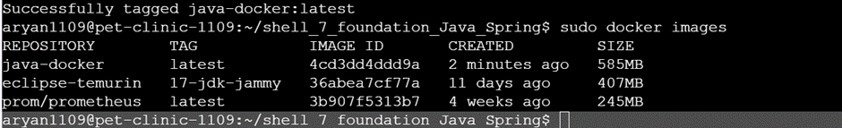

**Docker Containerization:**

Installing docker

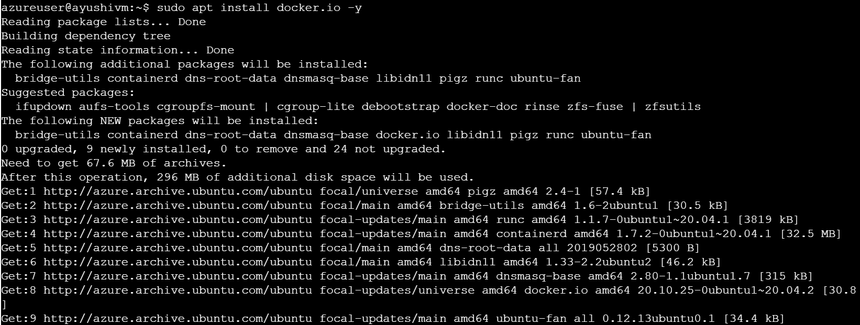

**Azure Web App Configuration:**

**Create and deploy web app in Azure**

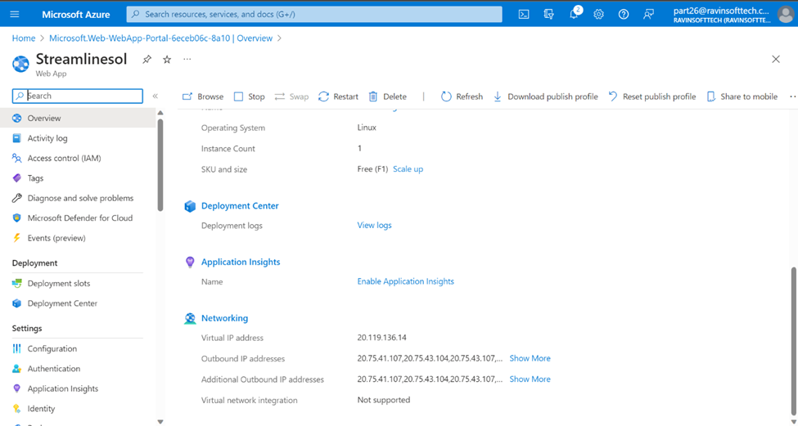

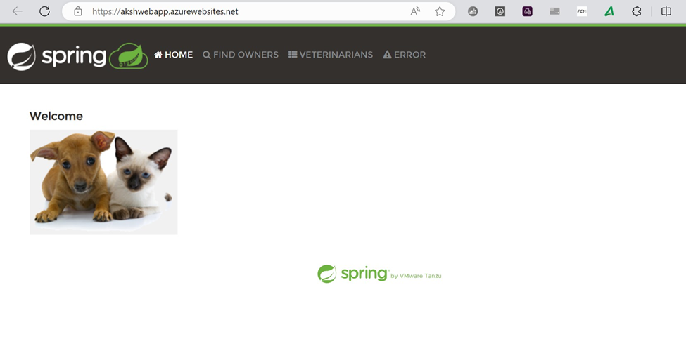

**Local Testing of Azure Web App:**

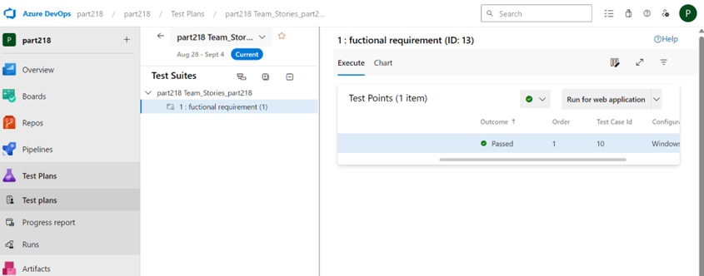

**Azure Boards Task and Sprint Closure:**

