**INTERNSHIP PROJECT REPORT**

(Project Term January-April, 2019)

**Case Management Portal**

Submitted by

**Ayushi Jain**

**Registration Number :11508715**

**Course Code:CSE 441**

Under the Guidance of

**Mr. Aditya Bakshi (Assistant Professor at Lovely Professional University) Sruthi S (Project Manager at Cognizant Technology Solutions)**

**School of Computer Science and Engineering**



**DECLARATION**

I hereby declare that the project work entitled Case Management Portal is an authentic record of my own work carried out as requirements of Internship for the award of B.Tech degree in Computer Science and Engineering from Lovely Professional University, Phagwara, under the guidance of Aditya Bakshi, during January to April 2019. All the information furnished in this project report is based on my own intensive work and is genuine.

Ayushi Jain

11508715

(Signature of Student )

Date:19/04/2019

**CERTIFICATE**

This is to certify that the declaration statement made by this student is correct to the best of my knowledge and belief. She has completed Project under my guidance and supervision. The present work is the result of her original investigation, effort and study. No part of the work has ever been submitted for any other degree at any University. The Project is fit for the submission and partial fulfillment of the conditions for the award of B.Tech degree in Computer Science and Engineering from Lovely Professional University, Phagwara.

**Mr. Aditya Bakshi**

**Assistant Professor**

**School of Computer Science and Engineering,**

Lovely Professional University, Phagwara, Punjab.

**Acknowledgment**

I take this opportunity to present my votes of thanks to all those guidepost who really acted as lightening pillars to enlighten my way throughout this project that has led to successful and satisfactory completion of this study. I am really grateful to Mr. Aditya Bakshi for providing me with an opportunity to undertake this project and providing me with all the facilities. I am highly thankful to sir for his active support, valuable time and advice, whole-hearted guidance, sincere cooperation and painstaking involvement during the study and in completing the assignment of preparing the said case study within the time stipulated. Lastly, I am thankful to all those, particularly the various friends, who have been instrumental in creating proper, healthy and conductive environment and including new and fresh innovative ideas for me during the project, without their help, it would have been extremely difficult for me to prepare.

**Index**

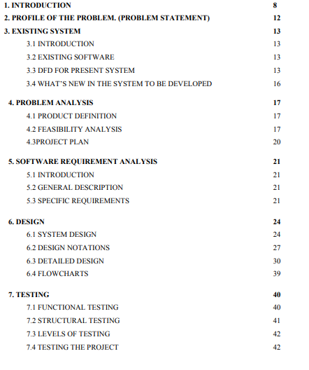

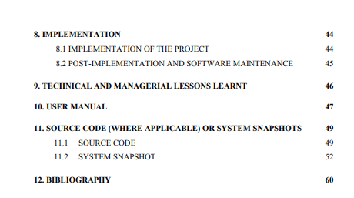

**1.1 Objective**

Case Management Portal is a digital platform where customers can directly contact to their service provider by creating case notes. Case Management portal makes it easy for customers as well as service provider to communicate with each other and get their issues resolved within short span of time avoiding time delay. The use of cases will vary depending on your type of organization. Typically, cases are used to track and resolve different types of customer issues. When cases are surfaced via a portal, users can create or even comment on cases themselves, bypassing the need to speak directly with people in your organization. It will allow service provider also to keep track of all the request generated by their customers and can also get their feedback for performance.

Case management technologies help organisations not only to improve customer service but also helps them to analyse their performance in a better way. Case Management Portal is used to track and resolve different types of customer issues. The use of cases will vary depending on your type of organization. In this case Management portal their will be three modules one for customers, one for admin and other for service provider.

In First Module of Case Management portal for customers users are not allowed to register themselves, they can only be registered by the admin. To register themselves they need admin support. Admin will provide them with credentials to login to this portal. Customers can add case notes along with description. Customers can also review and update any of the information originally provided in the case record. Customers can easily add case notes, and can also update that information in the case record. These notes can optionally include attachments useful info for resolving the case at hand which will add watermark at the time of downloading. Customers can delete their case note whenever they want.

Case Management portal Second Module contains service provider module. In this module service provider will be able to raise access request after successful registration by admin a mail containing user credentials will be send to email id as entered by service provider. Service Provider will be able to change the status of case note according to them but will not be able to update note or delete it.

In Third Module of Case Management portal for admin as users are not allowed to register themselves, they can only be registered by the admin. To register themselves they need admin support. Admin will provide them with credentials to login to this portal.

Admin can download all the details of request in form of excel File. Admin can also review and update any of the information originally provided in the case record.

**2. Profile Problem**

Case Management Portal is a digital platform where customers can get their issues resolved easily within specific time period. This project will be helpful for service based companies to keep track of their customers requirement in an efficient way. Manually keeping track is a tedious task , this portal will allow service based companies to manage their client request in a secure, easier and efficient way. Using this portal customers and service providers can communicate with each other easily. Customers can clearly specify their requirement by adding case note along with description and other details. Various other features are also available using which they can get their requirement fulfilled in accurate way and more efficiently.

**3.Existing System**

**3.1 Introduction**

Case management Portal will allow customers as well as service provider to keep track of request. It will allow customers to raise request to get their requirement fulfilled by service provider. Using this portal customers and service providers can communicate with each other easily. Customers can clearly specify their requirement by adding case note along with description and other details. Customers can directly contact to their service provider by creating case notes. It will allow service provider also to keep track of all the request generated by their customers and can also get their feedback for better performance

**3.1About Software**

In this case Management portal there are three modules one for customers ,one for admin and other for service provider.

In first Module customer can generate a request by creating a case note.

**Raise Request *–***A pop up dialog box will open on clicking Raise Request Tab. This dialog box will contain a form which will allow customers to raise a request for getting authorization to use this portal. On submitting the form admin will receive request to create credentials for customer..

**About*–*** The details of the admins is provided here.

**Contact*–*** The Contact details of the admins is provided here mail can also be sent from here containing message by user.

**Home*–*** On clicking the Home tab user will be redirected to landing page.

**Login*–*** On clicking the Login tab pop up dialog box will open which will allow customer to login to the portal using credentials.

**Create new case note *–*** On clicking the new note button a form will be displayed which will allow customers to add their request along with description and other details. A case id will be generated automatically whenever customer create new note.

**Updating case note *–*** On clicking the update note button a form will be displayed which will allow customers to change their request details.

**Delete case note *–*** On clicking the delete note button particular note will get deleted permanently.

**View Request –** After Customer Logs In they will be redirected to page where they can view all request.

**Add Document -** On clicking the add ducumnet button a pop up will be displayed which will allow users to add documents

**Show Files –** This will list all the file uploaded by user

**Download Files -** On clicking the name of file displayed in show file view , file will get downloaded.

**Log Out–** On click Log Out Tab Customer will be logged off from this portal.

In Second Module service provider can update status of request.

**Login –** On click Login Tab Service Providers can get themselves authenticated to use the portal.

**Home–** On clicking Home tab service providers will be redirected to landing page.

**View Request –** After user Logs In they will be redirected to page where they can view all requests.

**Update Status*–***On click Update tab Service Provider can update the status of request.

**Give Rights*–***Create credentials for service provider and send it via email id.

**Show Files –** This will list all the file uploaded by user

**Download Files -** On clicking the name of file displayed in show file view,file will get downloaded.

**Log out –** The user will logged out of their profile.

In Third Module admin module can grant access requests

**Login –** On click Login Tab Service Providers can get themselves authenticated to use the portal.

**Home–** On clicking Home tab service providers will be redirected to landing page.

**View Access Request –** After user Logs In they will be redirected to page where they can view all requests.

**Download Document-** On clicking download icon , details of all the case notes can be downloaded in form of excel.

**Log out –** The user will logged out of their profile.

.

.

**3.2DFD**

DFD LEVEL 0



User input

USER Case Manag ment

e

Result



**3.4 What’s there to be developed?**

This is just a basic structured of what I wanted to implement in actual. There are a lot of functionalities which can be added. Case Management portal is only keeping track of request of users and is able to create new request. Functionalities like screen sharing can be implemented which will assure service provider that requirements of customers are fulfilled .They can show a demo to customers after updation and can get clear idea about their requirement. We can implement a online tool wherein service provider can operate the customers local machine and updation can be done directly on their server. Analysis of request can be done using machine learning tool.

**4. Problem Analysis**

**4.1 Product Definition**

In this case Management portal there are three modules one for customers, one for Admin other for service provider. In first Module customer can generate a request by creating a case note and uploading files.

In Second Module service provider can view all request and can update status of request.

In Third Module Admin can grant access requests and can download documented form.

**4.2 Feasibility Analysis**

**Technical feasibility:**

The current system is working fine. The basic functionalities which are provided in above section are working well. Customers can generate request which will be sent to service provider portal.

**Schedule feasibility:**

Project was completed within estimated time frame.

**4.3 Project Plan**

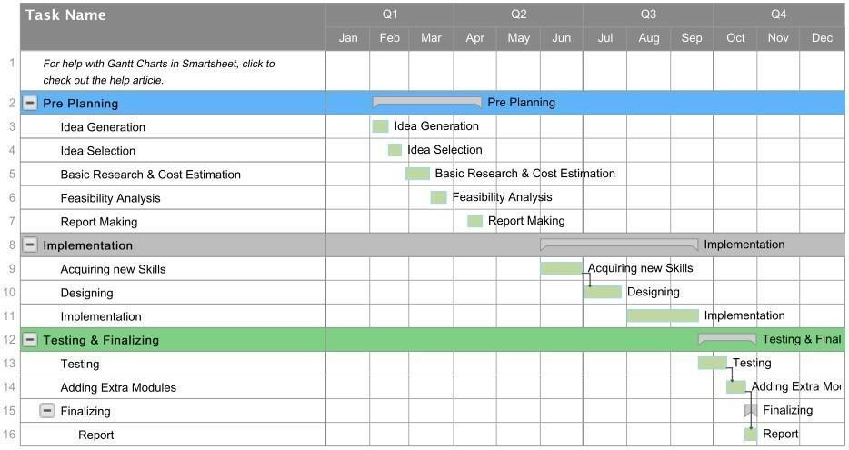

**5.1 Introduction**

Case management Portal will allow customers as well as service provider to keep track of request. It will allow customers to raise request to get their requirement fulfilled by service provider. Using this portal customers and service providers can communicate with each other easily. Customers can clearly specify their requirement by adding case note along with description and other details.

**5.2 General Description**

Case Management Portal is implemented using spring boot, angular 7 and My SQL as database*.* Case management technologies help organisations not only to improve customer service but also helps them to analyse their performance in a better way. Case Management Portal is used to track and resolve different types of customer issues. The use of cases will vary depending on your type of organization. In this case Management portal their will be three modules one for customers , one for admin and other for service provider. In first Module customer can generate a request by creating a case note. In second module service provider can view requests and can give rights to customer who have requested for right to access this portal. In third module admin can grant access and will have all the access rights.

**5.3.1 Functional Requirements**

**Functional requirement 1:**

**Description:** Initial Display

**Input:** Click on Log In

**Processing:** Execute a query at the backend.

**Output:** Display the result

**Authorization:** All

**Functional requirement 2:**

**Description:** Home

**Input:** NONE

**Processing:** Backend processing **Output:** Landing page will be displayed **Authorization:** NONE

**Functional requirement 3: Description:** Log in

**Input:** User name and password

**Processing:** Validate the user name and password if valid result is success else results in failure. Checks whether the user is a service provider or a customer.

**Output:** Display the result

**Authorization:** Admin, Service Providers and Customers.

**Description:** If result of Log in is failure.

**Output:** Redirected again to same page.

**Functional requirement 5:**

**Description:** If result of Log in is success.

**Output:** Display the Customers Requests screen for customers,in case of service provider display that module

**Authorization:** Admin , Service Providers and Customers.

**Functional requirement 6: Description:** Request

**Input:** User name ,email and role

**Processing:** store the request and send to admin

**Output:** Display the result

**Authorization:** Only Service Providers and Customer

**Functional requirement 7: Description:** If request is failure. **Output:** Redirected to same Page

**Functional requirement 8:**

**Description:** Contact us **Input:** username, message

**Processing:** Backend processing

**Output:** Contact us page will be displayed

**Authorization:** NONE

**Description:** Create new case note

**Input:** User name , user id ,case id, case name, case Description

**Processing:** Store all the details in database.

**Output:** Display the result

**Authorization:** Only Customers

**Functional requirement 10: Description:** Update

**Input:** User name , user id ,case id, case name, case Description

**Processing:** Update all the details in database.

**Output:** Display the result

**Authorization:** Only Customers

**Functional requirement 11: Description:** Delete

**Processing:** Delete the case in database. **Output:** Display the result **Authorization:** Only Customers

**Functional requirement 12: Description:** Update status **Input:** Status

**Processing:** Update Status in database **Output:** Display the result **Authorization:** Only Service Providers

**Description:** Give Rights

**Input:** User Email with auto generated password **Processing:** Store credentials in database **Output:** Display the result

**Authorization:** Only Service Providers

**Functional requirement 14: Description:** About us **Input:** NONE

**Processing:** Backend processing

**Output:** About us page will be displayed

**Authorization:** NONE

**Functional requirement 15:**

**Description:** Documentation

**Input:** details in database

**Processing:** Backend processing

**Output:** Excel will be dowloaded

**Authorization:** NONE

**Functional requirement 16:**

**Description:** Add document **Input:** File

**Processing:** Backend processing

**Output:** File will be stored to database

**Authorization:** NONE

**5.3.2 Non-Functional Requirements**

**5.3.2.1 Performance Requirements**

1.It must be able to perform in adverse conditions

2.Uninterrupted Interrupted connections

3.High data transfer rate

**5.3.2.2 Safety Requirements**

1.Data must be consistent.

2.Data must be safe from all physical menaces like: steal , theft , etc.

3.Database must follow AAA rules of security

4.Integrity must be maintained

5.There must be an emergency back-up of data in case of system failure

6.Database must be divided in fragments

7.All the open protocols , ports must be kept closed from being Hacked . 8.It should not respond redirections 9.It must contain cache.

10.Avoid traffic collision

11.Platform swap must not be there

12.Web Crawlers must be there for predictions.

13.Database must be properly configured

14.Database must not respond to irrelevant SQL Injections

**5.3.2.3 Security Requirements**

1.Users accessibility is censured in all the ways

2.Users are advised to change their password

3.Users are advised not to tell their password

4.Users are advised to enter their password secretly.

**5.3.2.4 Software Quality Analysis**

1.Availability

2.Security

3.Maintainability

**5.3.2.4.1 Availability:** The software and its resources must be available to the user at each and every point of time

**5.3.2.4.2 Security:** The software must be secured enough to keep user’s

details confidential.

**5.3.2.4.3 Maintainability:** The software must be maintained properly in order to avoid inconvenience. to the user.

**5.3.3 Hardware Requirements**

As it is an application that needs backend processing, so it was

necessary to have a high end configuration system. Minimum p4

processor Minimum 2

GB ram etc.

**5.3.4 Software Requirement**

Node Js

Visual Studio Code

Eclipse IDE

My SQL Wokbench

My SQL Server

Web Browser

**5.3.5 Cost**

The project was feasible enough to start from scratch so no cost was spent.

**6.Design**

**6.1 System Design**

**6.1.1 Use Case Diagram –**

Access Request

Files

SIGN IN

Customer

Create

Admin

Edit

Display

Delete

Service Provider

Update

Status

**6.2 DESIGN NOTATIONS**

**Name Description**

**1.** This is representing a strong entity.

These are also called as parent entity since they may have weak entities depending on them. They also contain primary key which distinguish each occurrence from other.

**2.** This is representing a weak entity.

Weak entities depend on other entity type. They do not have any primary key and have meaning only with their parent entity.

Relationship entity. This shows how an entity is related to the another



entity.



**3.**

**4.** This is weak relationship. A connection between weak entity and its owner.



**5.** This is representing symbol for attribute.

These are the characteristics of an entity, a one to one or many to many relationship.

Multivalued attribute are those that can take more than one value.

**6.**

**6.3 DETAILED DESIGN**

**6.3.1 E R Customer’s Diagram:**

Email Password

Username

Phone no

Customer

BELONG

BELONGBELONG

BELONG

Case Management

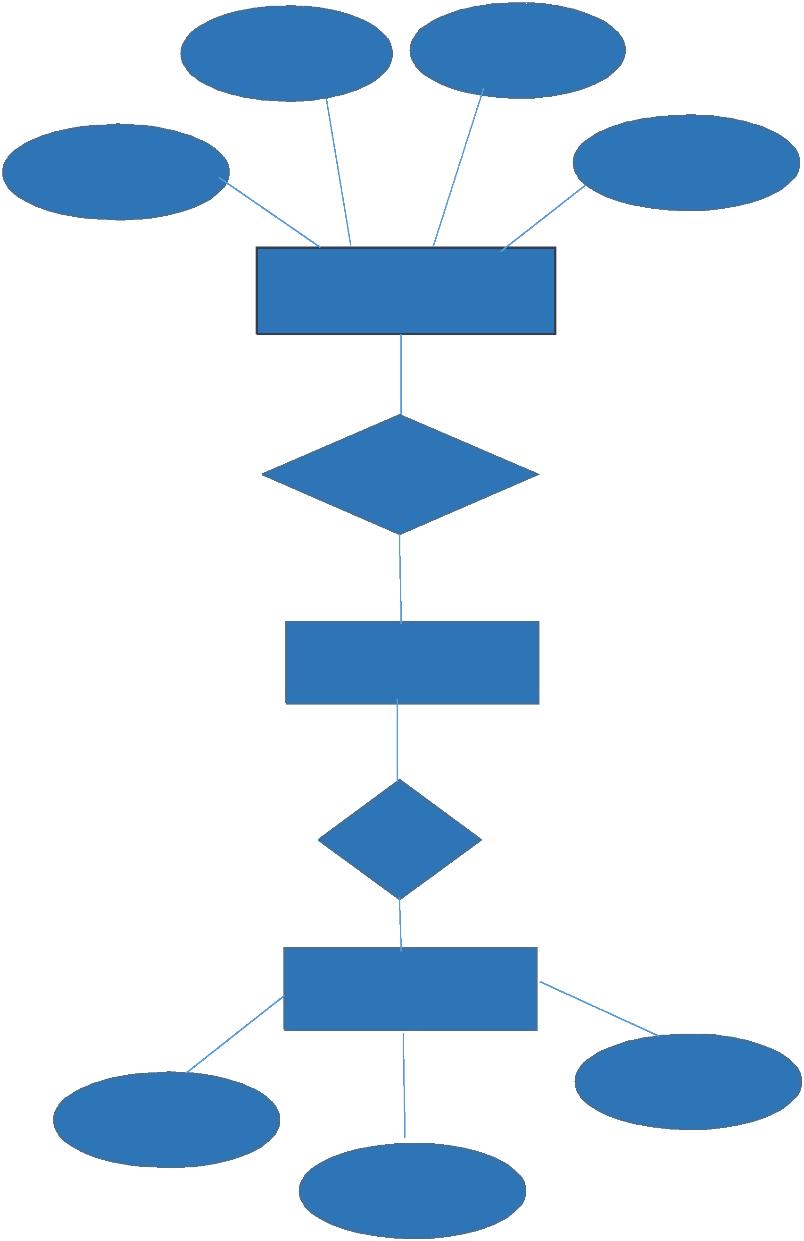

Has

Dashboard

Display board

Edit

Delete

Create

**6.3.2 E R Service Provider’s Diagram**

Email Password

Username

Phone no

Service Provider

BELONG

Case Management

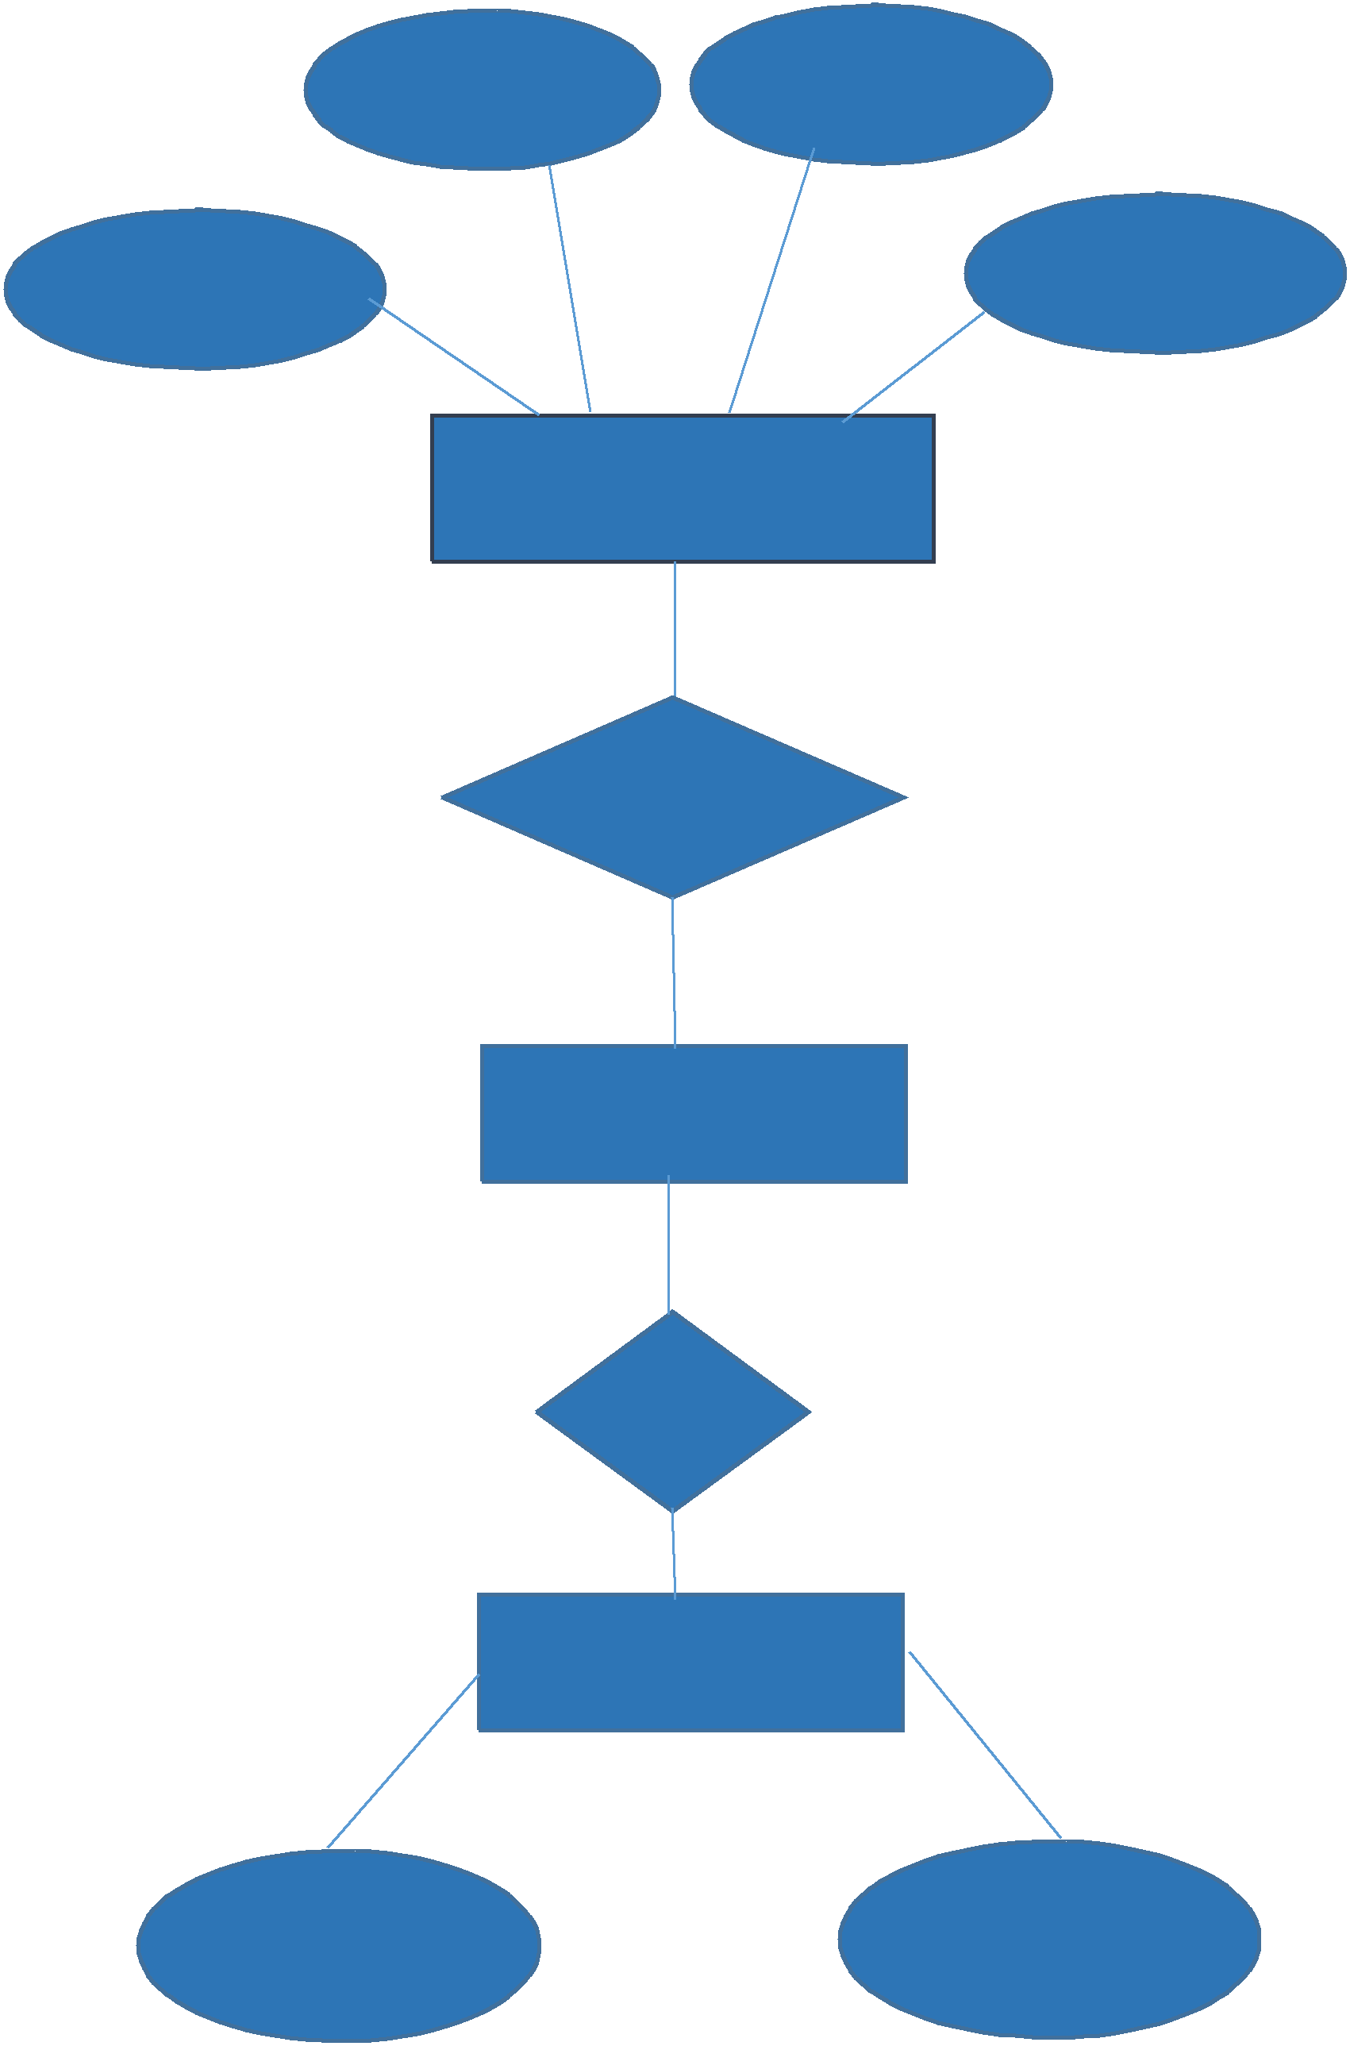

Has

Display board

File Update

**6.3.3 E R Admin’s Diagram**

Email Password

Username

Phone no

Admin

BELONG

Case Management

Has

Display board

Grant Access Customer

View

**6.4 FLOWCHART**

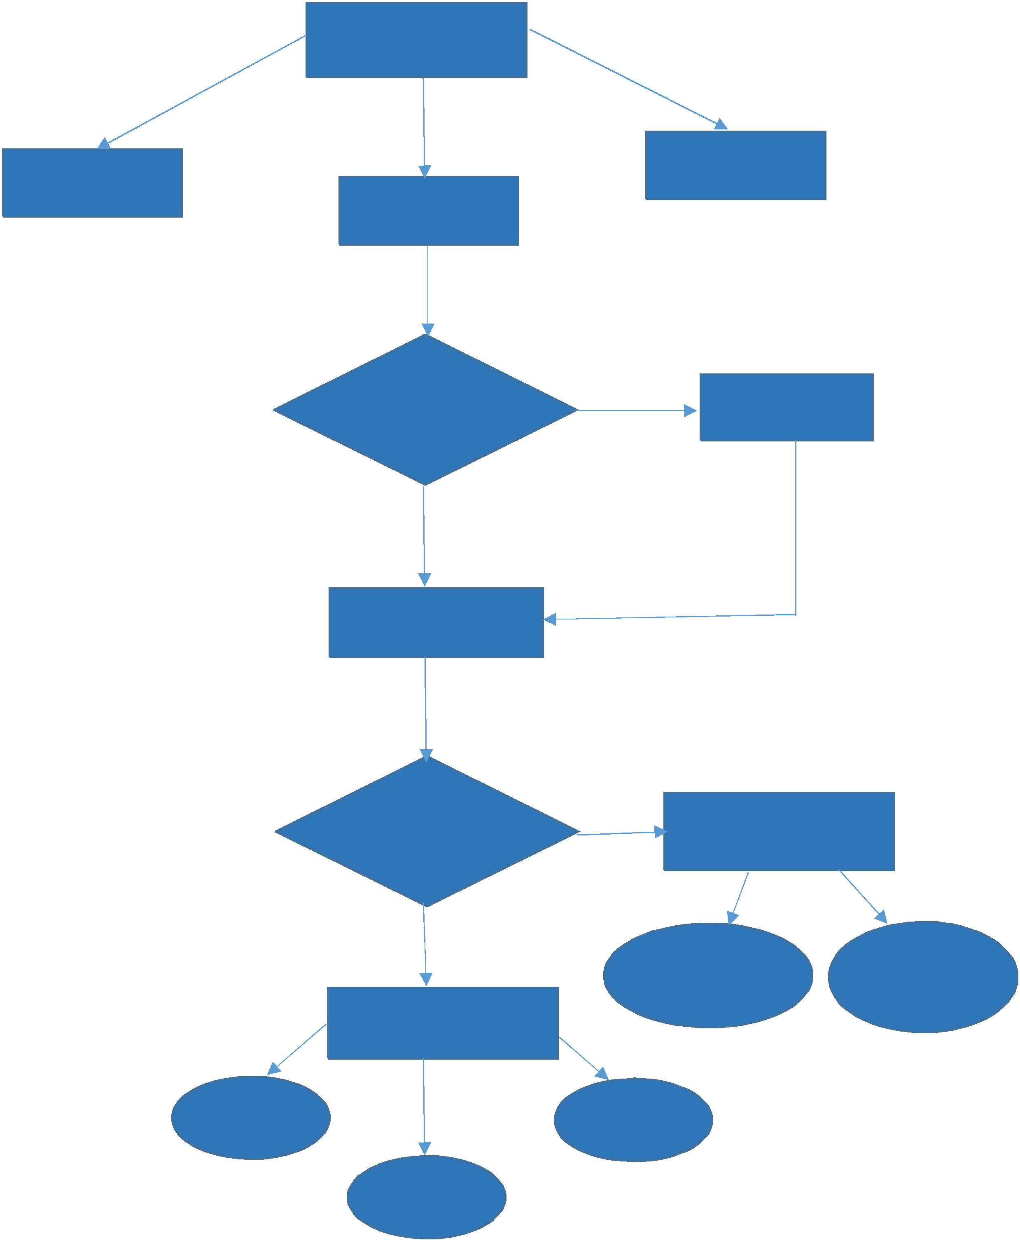

START

ABOUT

HOME

CONTACT

If Admin?

No

Access Request

Yes

LOGIN

If Customer?

No PROVIDER Display

Yes

CUSTOM

Customer Display

Show Files

Give

Rights

Create

Edit

Delete

**7. Testing**

Testing phase is a very important for a successful system. In this phase before implementing the new system into operation, for eliminating bugs a test run of the system is done. After completing codes for the whole programs of the system, a test plan should be developed and run one given set of test data. Using the test data subsequent test run are carried out. The software engineering process can be viewed as a spiral. Initially system engineering The software engineering process can be viewed as a spiral. Initially system engineering describes the role of software and leads to software requirement analysis where the describes the role of software and leads to software requirement analysis where the information domain, functions, behaviour, performance, constraints and validation criteria information domain, functions, behaviour, performance, constraints and validation criteria for software are established. Moving inside along the for software are established. Moving inside along the spiral, we come to design and spiral, we come to design and finally finally to coding. To develop computer software we spiral in along rationalizes that reduce the to coding. To develop computer software we spiral in along rationalizes that reduce the level of abstraction on each turn.

**7.1 Types**

7.1.1Unit testing

It is a method by which individual units of source code, sets of one or more program modules collectively with associated control data, usage procedures, and operating procedures, are tested to determine whether they are fit for use. Intuitively, one can view a unit as the smallest testable part of an application. In procedural programming a unit can be an entire module but is more commonly an individual function. In object-oriented programming a unit is an entire interface but could be an individual method. Unit test is created by programmers or by white box testers during the development process.

Each test case is independent from the others: substitutes like method stubs, mock objects can be used to assist testing a module in isolation. Unit tests are typically written and run by software developers to ensure that code meets its design and behaves as intended. Its implementation can vary from being very manual to being formalized as part of build automation.

**7.1.2 Integration Testing**

It is the phase in software testing in which individual software modules are combined and tested as a group. It occurs after unit testing and before validation testing. Integration testing takes as its input modules that have been unit tested, groups them in larger aggregates, applies tests defined in an integration test plan to those aggregates, and delivers as its output the integrated system ready for system testing.

**7.1.3 Program test**

After the programs, have been coded, compiled and carried out to working conditions, they must be independently tested with the prepared test data. Any unwanted happening should be noted and debugged.

**7.1.4 System Test**

When the program test for each of the programs of the system is written and errors are removed then system test is complete. At this stage the test is done on actual data. The complete system is put into execution on the actual data. At every stage of the execution, the output of the system is studied. During the outcome analysis, it may be found that the outputs are not matching the estimated output of the system. In such situation, the bugs or errors in the particular programs are recognized and are fixed and further verified for the expected output.

When it is confirmed that the system is running error-free, the users are called with their own real data so that the system could be presented running as per their requirements.

**7.2 Test cases**

**7.2.1 Access Request**

**Test to pass:** - Name should contain only alphabet, email id should be valid.

**Test to fail:** - if name will contain other than alphabet, email id is not valid, mobile number will contain anything other than number, password minimum length is not upto six character.

**7.2.2 Login**

**Test to pass:** - user should enter a registered email id and password should match with the saved password.

**Test to Fail:** - if user will enter a not registered email id or password will be incorrect.

**7.2.3 Create Case Note**

**Test to pass:** - If the functions that are added in the form of individual module works properly

**7.2.3.1 Add**

**Test to pass** :- It passed the test if the text is added successfully and displayed on the screen

**Test to fail** :- If the text typed in the form is not added.

**7.2.3.2 Delete**

**Test to pass** :- It passed the test if the text is deleted successfully.

**Test to fail** :- If the selected text is not deleted

**7.2.3.3 Update**

**Test to pass** :- It passed the test if the text is updated successfully.

**Test to fail** :- If the selected text is not updated

**7.2.3.4 Display**

**Test to pass** :- It passed the test if the text is displayed successfully.

**Test to fail** :- If the details not displayed properly

**7.2.4 Give Rights**

**Test to pass:** - Service Provider should be email to register customer

**Test to Fail:** - If Customer email id is not valid

**7.2.5 Update Status**

**Test to pass:** - Status updated

**Test to Fail:** - Status not updated

**7.2.6 Upload File**

**Test to pass:** - File Uploaded

**Test to Fail:** - Empty File or file not supported

**8.Implementation**

**8.1 Implementation of the project**

Case Management Portal is created by first designing the User Interface then backend using spring boot and have used MY SQL for database. I have Used swagger for testing purpose. First separate basic modules for created then they were integrated with user interface part to make it presentable. All the modules created were part of training which were later integrated by me as a complete project.

**8.2 Conversion Plan**

The project is developed in stages. All this functionalities implemented was included in my training which was later developed as project to learn the usability of all that functionalities.

**8.3 Post Implementation and Software Maintenance**

After implementing the project there are few things that need to be maintained regularly. Their should be proper track of performance of service provider in form of proper visualization instead of monitoring it manually. Response should be as fast as possible.

**8.3.1 Software Maintenance**

Maintenance is the enigma of system development. It holds the software industry captive, tying up programming resources. Analysts and programmers spend more time maintaining programs than they writing them. Maintenance is not considered an extremely important in the life of a software product.

**8.3.1.1 Corrective Maintenance**

After the implementation, correcting the residual errors if any. If such errors are discovered, the source of it should be detected and removed. This phenomenon falls under corrective maintenance.

**8.3.1.2 Perfective Maintenance**

Sometimes changes have to be done according to the user requirements. This type of changes to the software is called perfective maintenance.

**8.3.1.3 Adaptive Maintenance**

Software often must be upgraded and enhanced to include more features and provide more services. This also requires modification of software.

**8.3.1.4 Preventive Maintenance**

Preventive maintenance involves performing activities to prevent the occurrence of errors. It tends to reduce the software complexity thereby improving program, understanding ability and increasing software maintainability. It comprises documentation updating, code optimization, and code restructuring.

**9.Project Legacy**

**9.1 Current Status of the project**

The current status of the project describes what the project is doing currently. Smart Class is an application which has two types of users –service provider and customers. Both of them are provided with different interfaces. The first page has only the navigation bar and a button which redirects the user for the signup form. The navigation bar has options like log in, sign up, home, about us and contact us for service provider but customers will be refrained from registering themselves.

**Access Request–** Sign up Option only authorized for Admin. A pop up dialog box will appear on clicking the request button. It will ask for the username, password and email. It also some validations for the fields and also checks whether the user is existing or a new one. If the user is existing then it will prevent him from signing up again. The confirmation is also sent after the user has successfully signed to their given email account and a message also will be sent to them.

**Log in –** A pop dialog box will appear which will ask for the username and the password which the user has already set. If the username and the password matches with any existing user then only the user will be logged in.

**About us –** The details of the admins is provided here.

**Contact us –** The contact details is also provided and users can sent message to admin.

**Home –** It will be redirected to the main page once this option will be selected.

Once the user logged in, based on the role of the user i.e. whether the user is service provider or customer the corresponding dashboard will be opened.

**Customers dashboard –** It will have four options edit, delete, display and create **Create–**Customers will be able to add details as well as description of their issues as case notes. **Delete–** Customers will be able to delete their case note.

**Update–**Customers will be able to update the case not whenever required

**display–** All the case notes added by customers are displayed

**Log out –** The user will logged out of their profile after clicking this options.

**Service Providers dashboard –** It will have three options update, display and give rights **Update Status–**Service Provider will be able to update the status of customers request. **display–** All the case notes added by customers are displayed

**Log out –** The user will logged out of their profile after clicking this options.

**Admin’s dashboard –** It will have three options update, display and give rights

**Change case note details-**can perform all operations which was possible for customers.

**View Files-**can view all the uploaded files

**Update Status–**Service Provider will be able to update the status of customers request. **display–** All the case notes added by customers are displayed

**Give Rights–** Service Provider can register user and can sent credentials via email.

**Log out –** The user will logged out of their profile after clicking this options.

**9.2 Remaining Areas of concern**

There are certain things that are not working in the way we wanted them to work. I could not add feature of online solving issue by operating customers system.

**9.3 Technical and Managerial lessons learnt**

By developing this project I have learnt many things like different languages. Learning spring boot and angular in a short span of time was difficult but was useful. Learnt how to implement things with a better approach . It was difficult to handle all the three levels myself but it gave me full stack knowledge and also improved my skills to manage things all alone.

**10.User Manual**

**Home:**It will redirect to the home page.

**Login**: If you are already registered then you have to login through your id. By clicking on login you can login to your account.

**About Us**: It will give you brief information about us.

**Contact Us**: If you want to contact us our contact details are provided here for you.

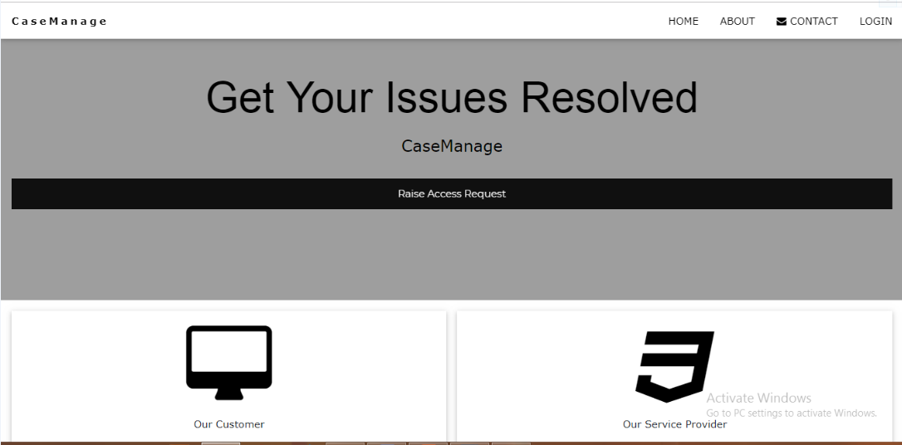

On clicking **About us** tab details of admin will be displayed

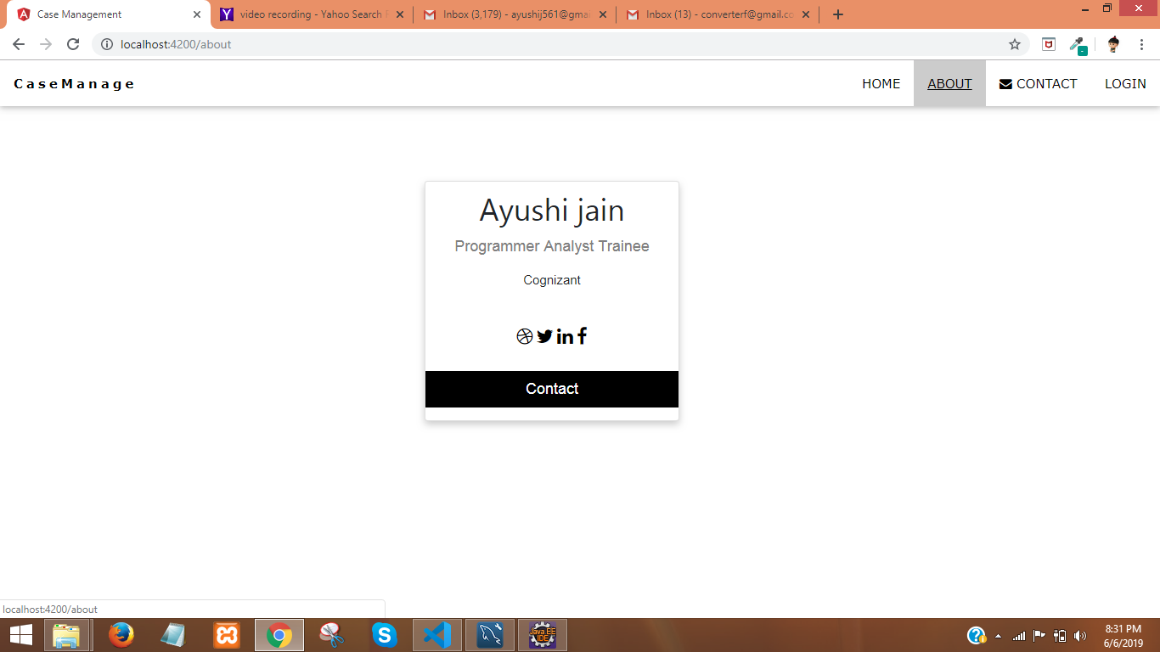

On clicking **Contact Us** a page will be displayed which will allow user to send message to admin.

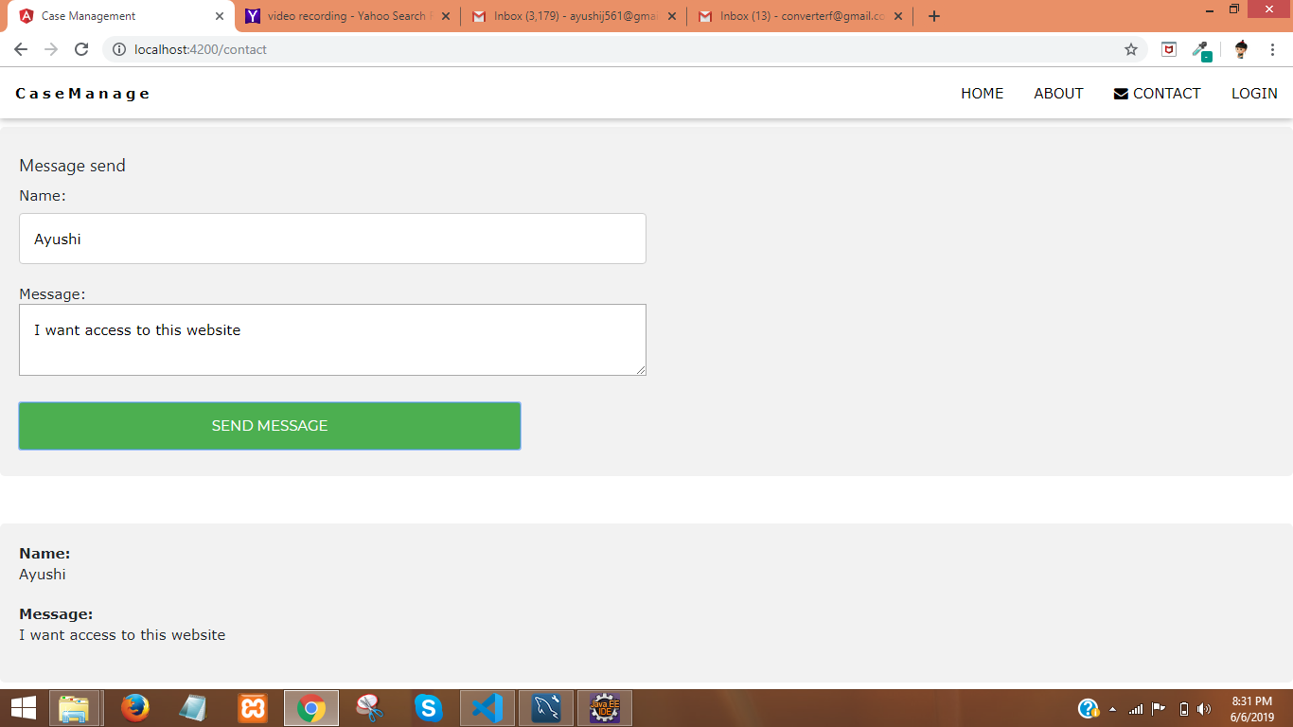

Mail send to Admin’s Email id by the user

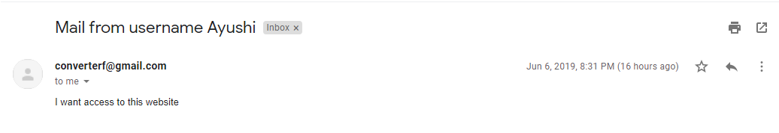

User will have to raise request to access the portal. On clicking **Raise Request Tab** a pop will be displayed using which request can be raised.

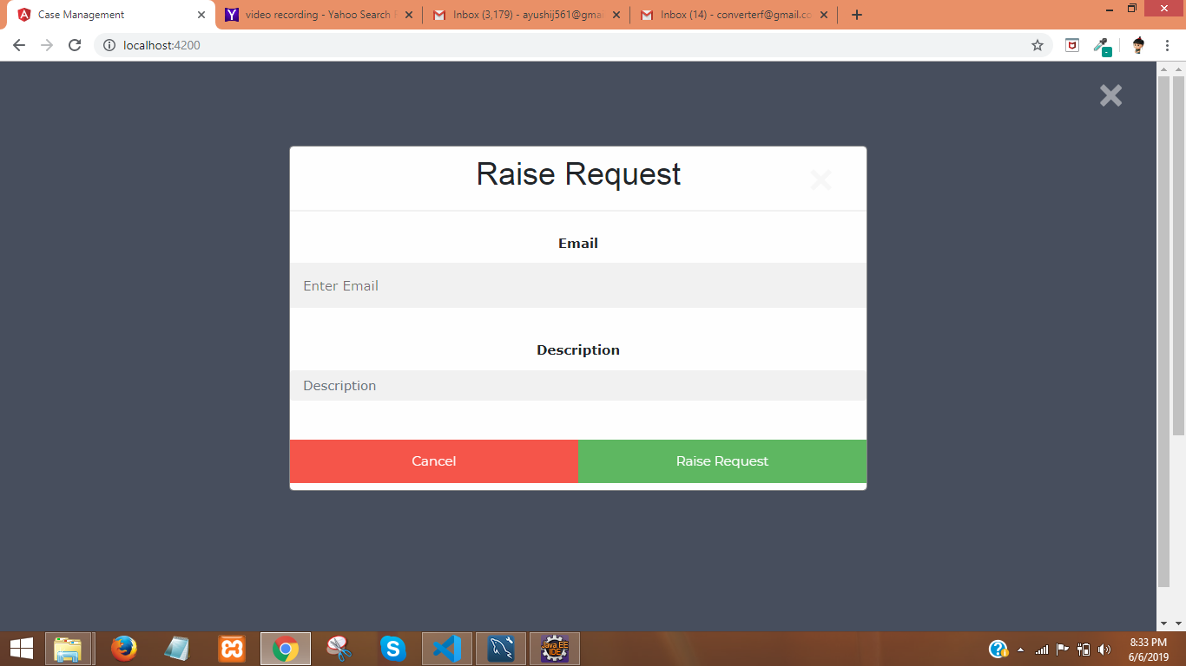

Email sent containing login credentials

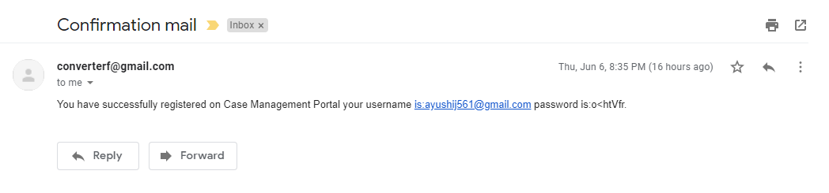

Message sent to registered Mobile Number

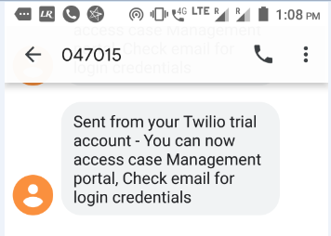

On clicking **Login Tab** a pop will be displayed which will allow user to enter credentials according to which dashboard will be displayed

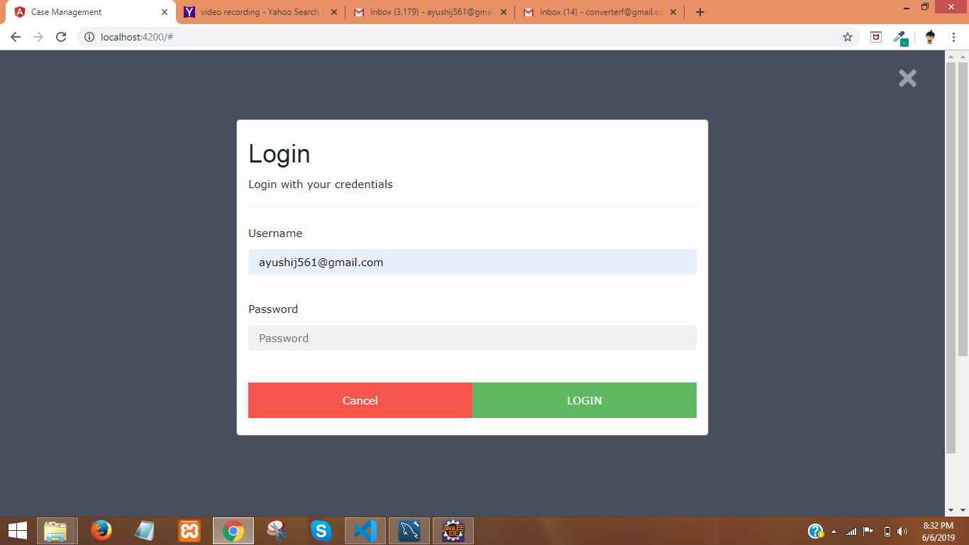

**Customer’s Dashboard**

Dashboard containing various option will be displayed

**Create Note**- create case note by entering all the details as well as file can be uploaded.

**Edit Note**- created case note can be edited

**Delete Note**-case note can be deleted

**Documents-c**anupload document,view list of documents uploaded and can download files

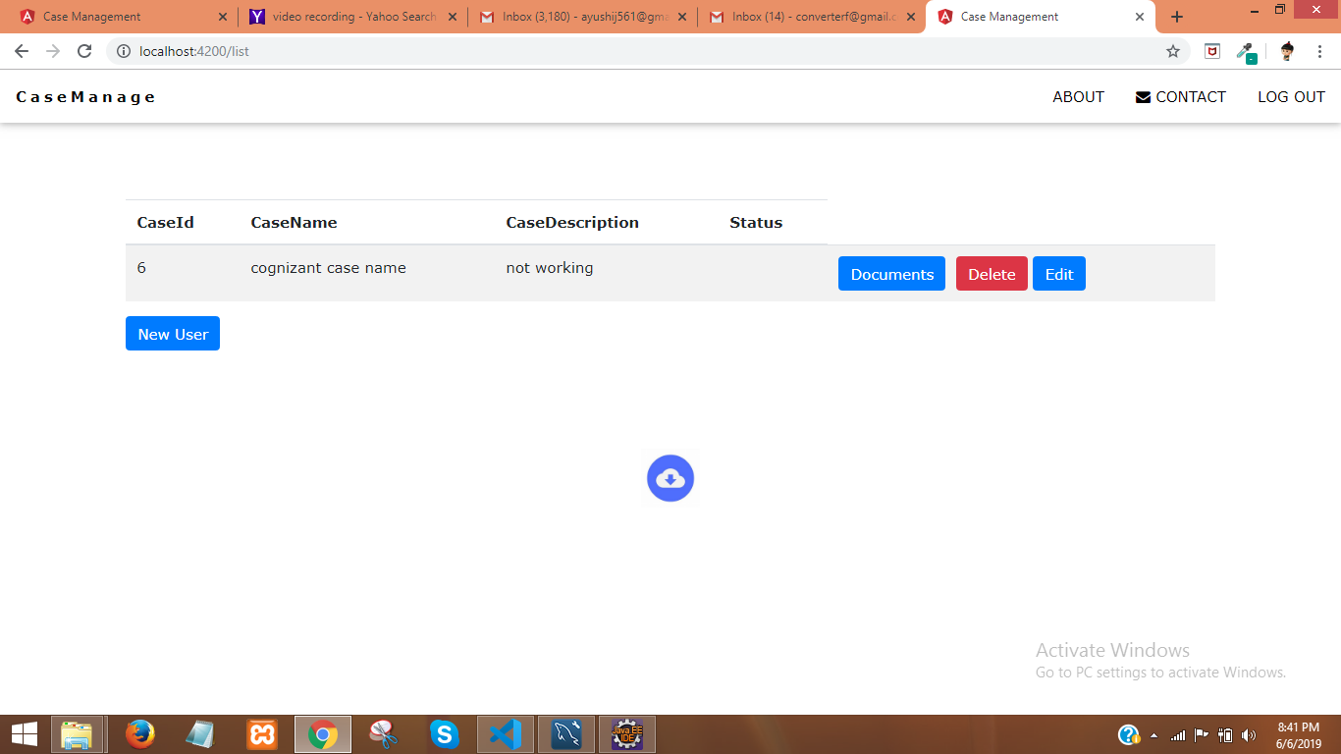

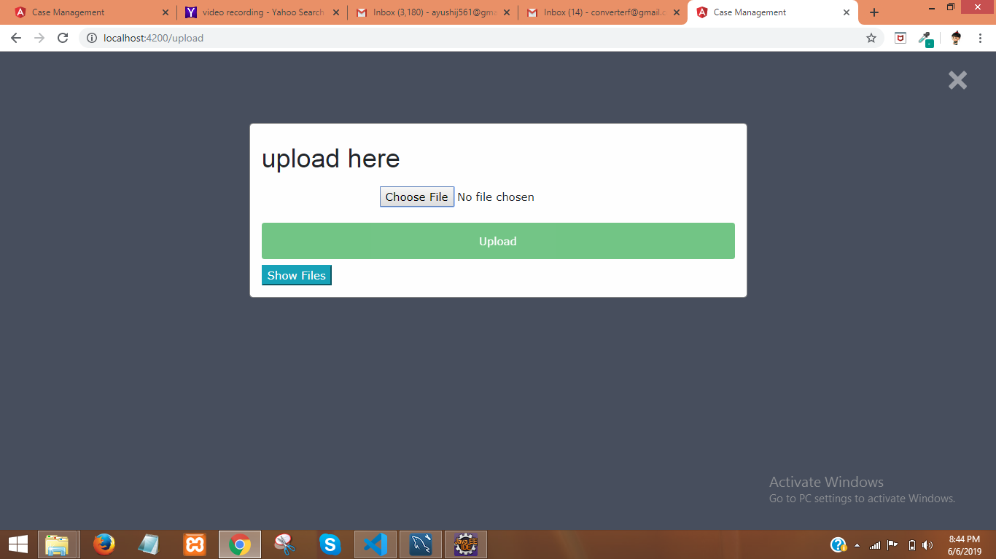

**Service Provider’s Dashboard**

Dashboard containing various option will be displayed

**Update Status**- can update the status of case note

**View Files-**can view the uploaded Files and download them.

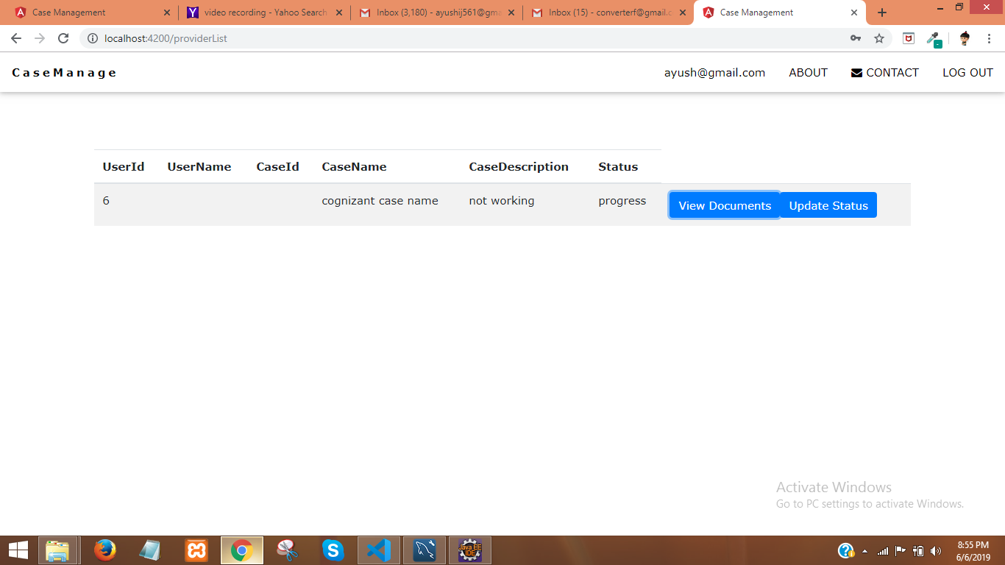

**Admin’s Dashboard**

Dashboard containing various option will be displayed

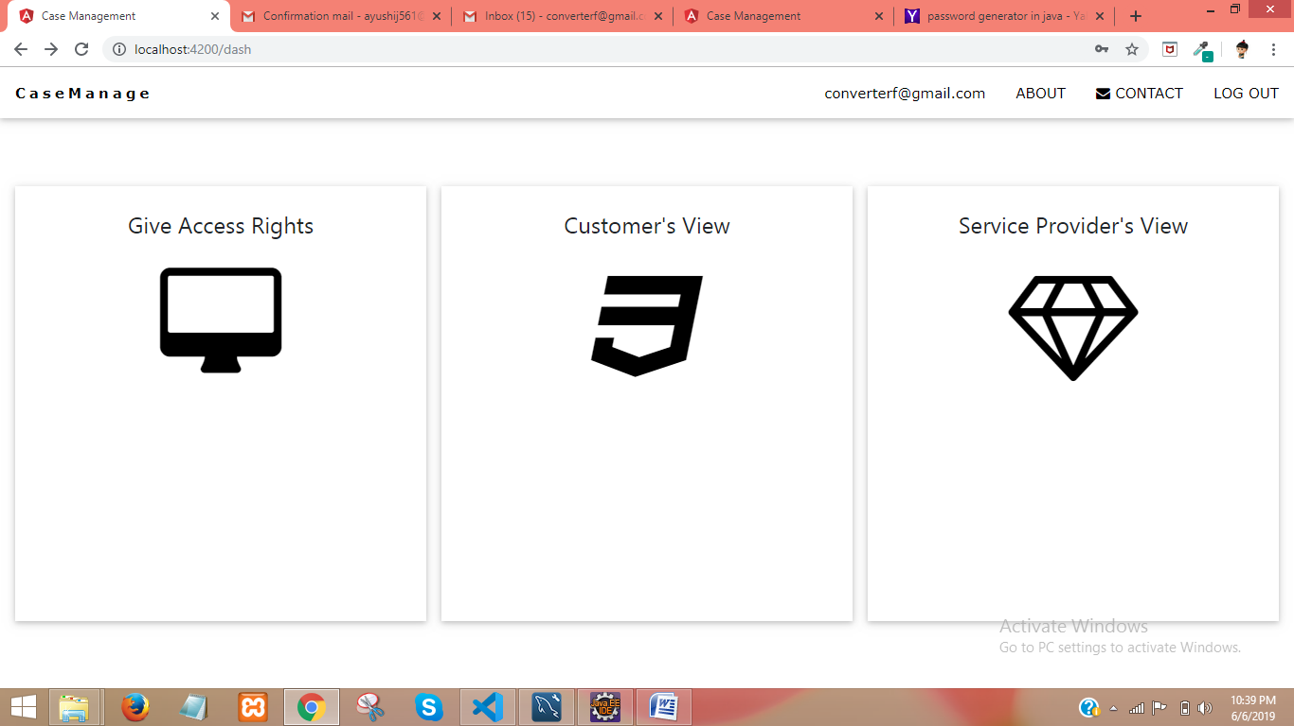

**Grant Access Request-can** grant rights to access the portal to user

**Customer’s View**-Can perform all operations which customers can do

**Service Provider’s View**-Can perform all operations which service provider can do

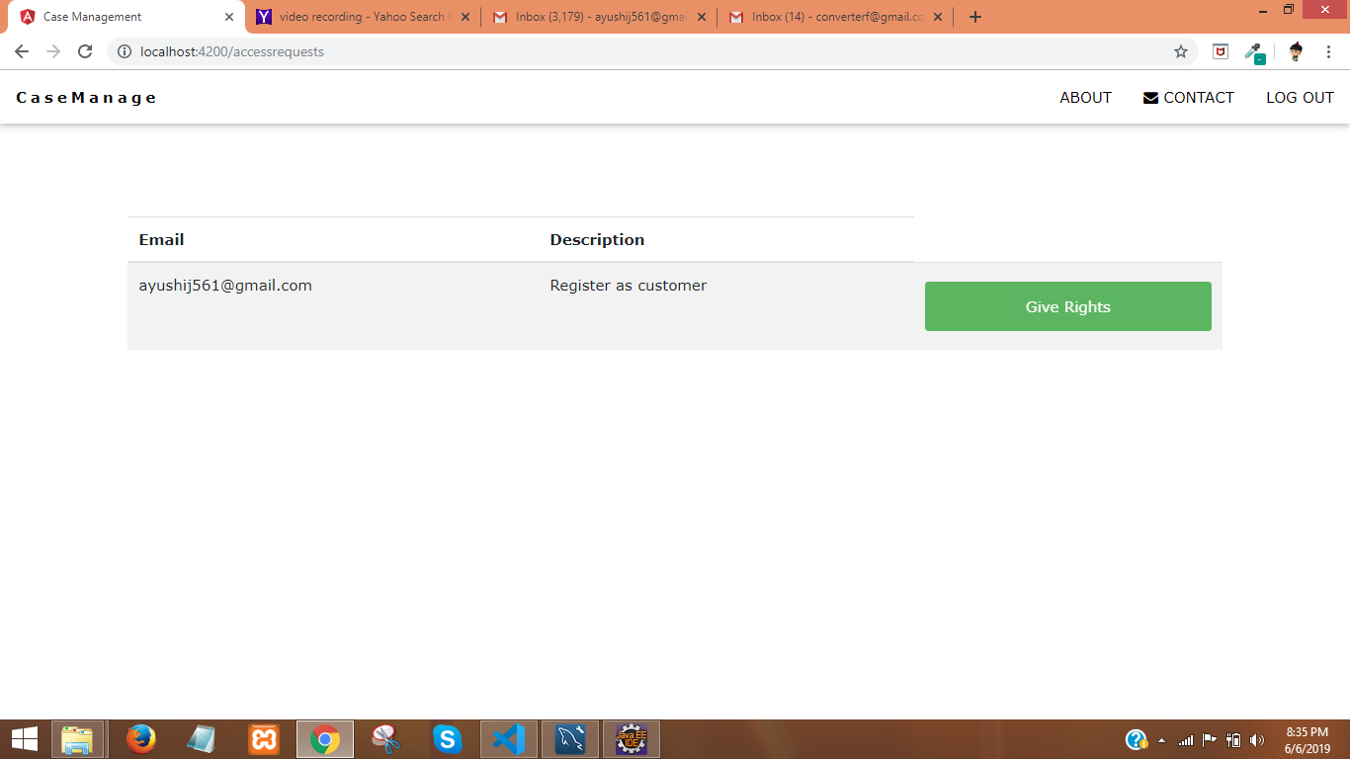

**Documentation Download**

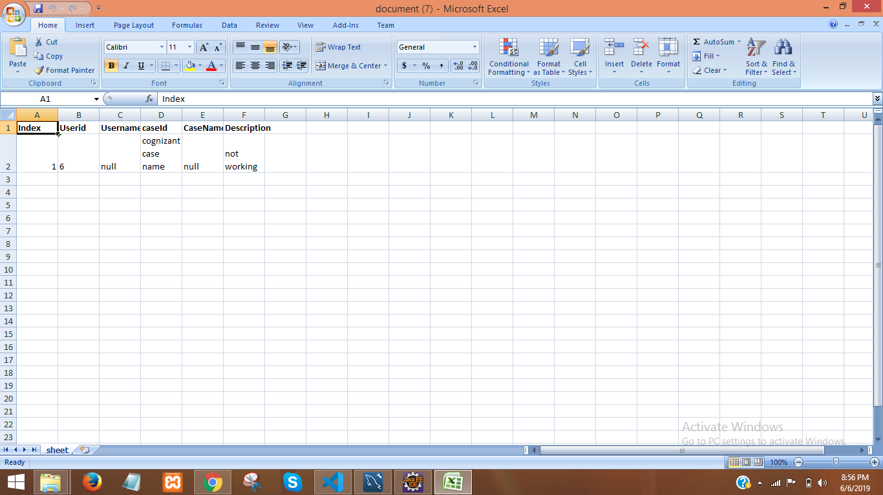

**10.Bibliography**

[**https://www.uml-diagrams.org/use-case-diagrams.html**](https://www.uml-diagrams.org/use-case-diagrams.html) [**https://www.smartdraw.com/entity- relationship-diagram/**](https://www.smartdraw.com/entity-relationship-diagram/) [**https://www.guru99.com/software-testing-introduction- importance.html**](https://www.guru99.com/software-testing-introduction-importance.html) [**https://www.javatpoint.com/php-tutorial**](https://www.javatpoint.com/php-tutorial) [**https://www.wordstream.com/blog/ws/2017/10/04/Help Boxs**](https://www.wordstream.com/blog/ws/2017/10/04/chatbots)[**https://www.analyticsvidhya.com/learning-paths-data-science-businessanalytics-business- intelligence-big-data/tableau-learning-path/**](https://www.analyticsvidhya.com/learning-paths-data-science-business-analytics-business-intelligence-big-data/tableau-learning-path/)

[**https://www.smartdraw.com/flowchart/**](https://www.smartdraw.com/flowchart/)

[**https://www.w3schools.com/css/**](https://www.w3schools.com/css/)[**https://www.geeksforgeeks.org/**](https://www.geeksforgeeks.org/)[**https://www.udemy.com/ https:/**](https://www.udemy.com/)[**/www.youtube.com/**](http://www.youtube.com/)