Assignment-6

1.Find the sum of array of elements.
import java.util.Scanner;

public class ArraySum {
public static void main(String[] args) {

Scanner sc = new Scanner(System.in);

System.out.print("Enter the number of elements: ");
int n = sc.nextInt();

int[] arr = new int[n];
int sum = 0;

System.out.println("Enter " + n + " elements:");

for (int i = 0; i < n; i++) {
arr[i] = sc.nextInt();
sum = sum + arr[i];
}

System.out.println("Sum of array elements = " + sum);

sc.close();
}
}
Output

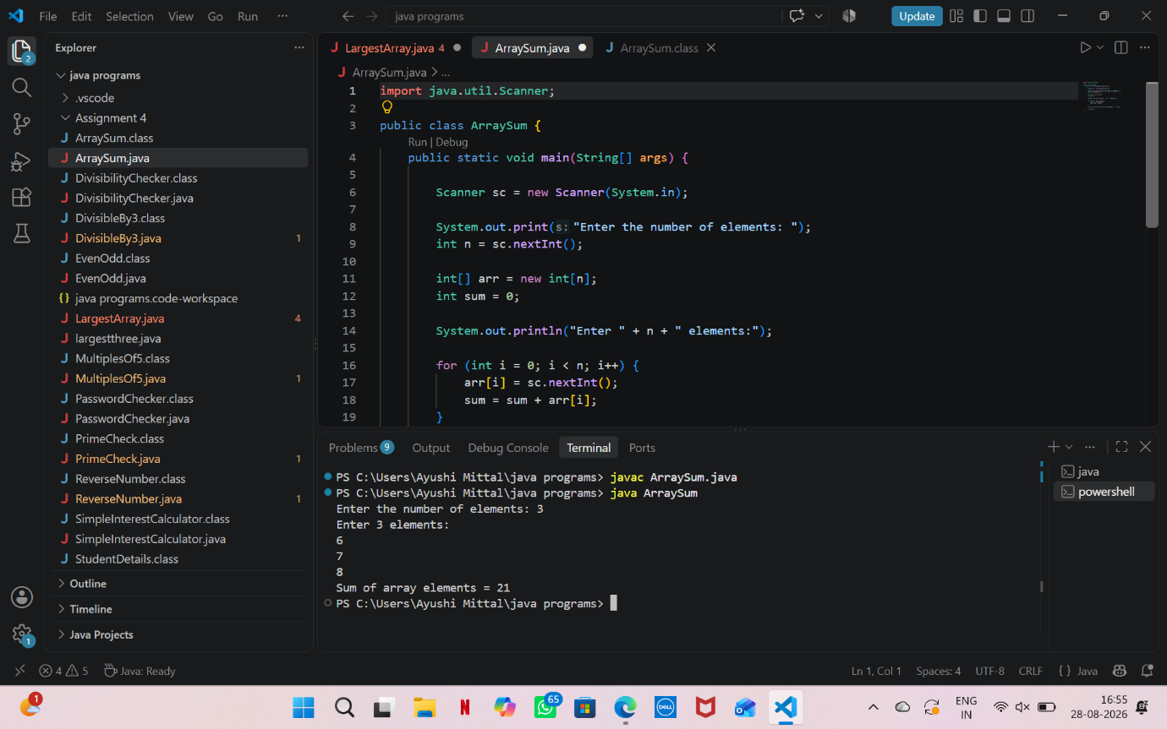

2. Find largest element in an array.
import java.util.Scanner;

public class LargestArray {
public static void main(String[] args) {

Scanner sc = new Scanner(System.in);

System.out.print("Enter number of elements: ");
int n = sc.nextInt();

int[] arr = new int[n];

System.out.println("Enter array elements:");

for (int i = 0; i < n; i++) {
arr[i] = sc.nextInt();
}

int largest = arr[0];

for (int i = 1; i < n; i++) {
if (arr[i] > largest) {
largest = arr[i];
}
}

System.out.println("Largest element = " + largest);

sc.close();
}
}
OUTPUT
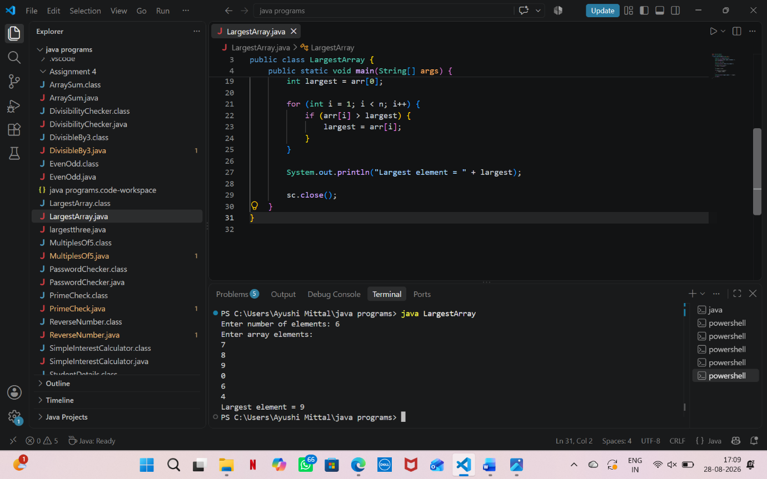

3. Search an Element in an Array.
import java.util.Scanner;

public class SearchArray {
public static void main(String[] args) {

Scanner sc = new Scanner(System.in);

System.out.print("Enter number of elements: ");
int n = sc.nextInt();

int[] arr = new int[n];

System.out.println("Enter array elements:");

for (int i = 0; i < n; i++) {
arr[i] = sc.nextInt();
}

System.out.print("Enter element to search: ");
int search = sc.nextInt();

boolean found = false;

for (int i = 0; i < n; i++) {
if (arr[i] == search) {
System.out.println("Element found at position " + (i + 1));
found = true;
break;
}
}

if (!found) {
System.out.println("Element not found");
}

sc.close();
}
}
OUTPUT:
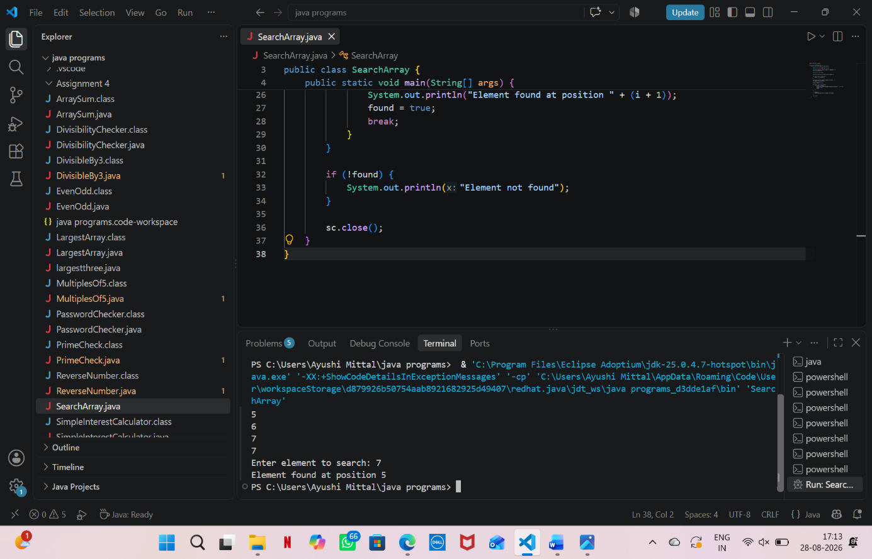

4. Reverse an Array.
import java.util.Scanner;

public class ReverseArray {
public static void main(String[] args) {

Scanner sc = new Scanner(System.in);

System.out.print("Enter number of elements: ");
int n = sc.nextInt();

int[] arr = new int[n];

System.out.println("Enter array elements:");

for (int i = 0; i < n; i++) {
arr[i] = sc.nextInt();
}

System.out.println("Reversed array:");

for (int i = n - 1; i >= 0; i--) {
System.out.print(arr[i] + " ");
}

sc.close();
}
}
OUTPUT
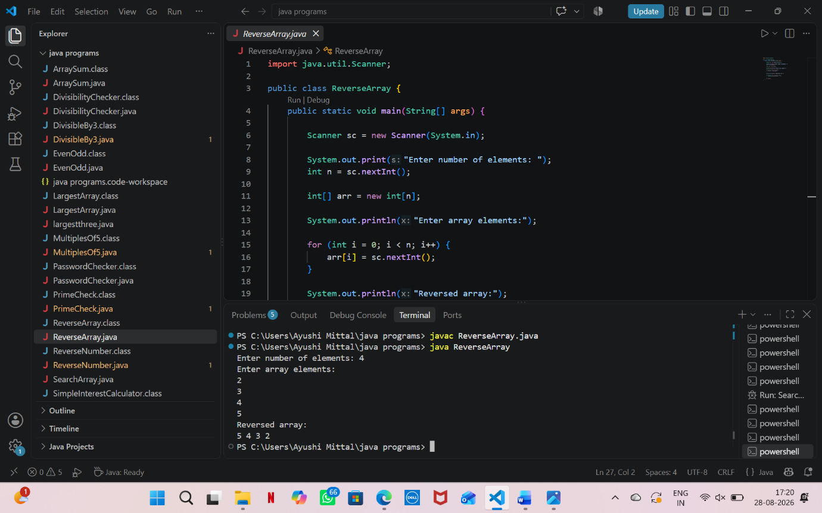

5. Count Occurrence of an Element in an Array
import java.util.Scanner;

public class CountOccurrence {
public static void main(String[] args) {

Scanner sc = new Scanner(System.in);

System.out.print("Enter number of elements: ");
int n = sc.nextInt();

int[] arr = new int[n];

System.out.println("Enter array elements:");

for (int i = 0; i < n; i++) {
arr[i] = sc.nextInt();
}

System.out.print("Enter element to count: ");
int element = sc.nextInt();

int count = 0;

for (int i = 0; i < n; i++) {
if (arr[i] == element) {
count++;
}
}

System.out.println("Occurrence of " + element + " = " + count);

sc.close();
}
}
OUTPUT:
