ASSIGNMENT -8
Part A: Understanding of Theory Concept
Q1. Write the definition of Polymorphism and explain why it is important in Object-Oriented Programming.
Polymorphism is an important concept of Object-Oriented Programming (OOP) that means "one name, many forms.
Polymorphism is important because it:
- Makes programs more flexible.
- Supports code reusability.
- Makes code easier to maintain.
- Allows one interface/method to be used for different behaviors.
Q2. Explain the following types of Polymorphism with suitable examples:
- Compile-Time Polymorphism (Static Polymorphism)
- Also called Static Polymorphism.
- It is achieved using Method Overloading.
- The compiler decides which method should be called during compilation.
- Example :
class Calculator {
int add(int a, int b) {
return a + b;
}
int add(int a, int b, int c) {
return a + b + c;}
}
- Run-Time Polymorphism (Dynamic Polymorphism)
Run-time polymorphism is achieved through method overriding. The method that will execute is decided at runtime

EXAMPLE:
class Animal {

void sound() {
System.out.println("Animal makes a sound");
}
}
class Dog extends Animal {
void sound() {
System.out.println("Dog barks");
}
}
public class Main {
public static void main(String[] args) {
Animal obj = new Dog();
obj.sound();
}
}
Q3. Explain Method Overloading.
- Definition of Method Overloading
Method Overloading means having multiple methods with the same name but different parameter lists in the same class.
It is an example of Compile-Time Polymorphism.
- Rules of Method Overloading
  - The method name must be the same.
  - The parameter list must be different.
  - Number of parameters
- Data type of parameters
- Order of parameters:
Changing only the return type is not sufficient for method overloading.
Methods can have different access modifiers while being overloaded.
- Different ways to overload a method
By changing the number of parameters
By changing the data type
By changing the data type
- Why changing only the return type is not considered Method Overloading
Changing only the return type is not considered method overloading because Java identifies methods using their name and parameter list, not the return type.
For method overloading, the number, type, or order of parameters must be different
- Difference between Method Overloading and Method Overriding
Method Overloading | Method Overriding
- Same class generally | - Parent and child classes
- Same method name | - Same method name
- Parameters must be different | - Parameters must be same
- Compile-time polymorphism | - Run-time polymorphism
- Inheritance is not required | - Inheritance is required
- Return type can be different if parameter list differs | - Return type must generally be same/covariant
- Example: add(int,int) and add(int,int,int) | - Child class provides its own version of parent method

Part B: Programming Questions
1. Calculator Addition
Create a class Calculator and overload the add() method to perform the following operations:
- Add two integers.
- Add three integers.
- Add two decimal numbers.
- Create an object of the class and call all overloaded methods.
class Calculator {
int add(int a, int b) {
return a + b;
}
int add(int a, int b, int c) {
return a + b + c;
}
double add(double a, double b) {
return a + b;
}
}

public class CalculatorDemo {
public static void main(String[] args) {
Calculator obj = new Calculator();
System.out.println("Addition of two integers: " + obj.add(10, 20));
System.out.println("Addition of three integers: " + obj.add(10, 20, 30));
System.out.println("Addition of two decimal numbers: " + obj.add(10.5, 20.5));
}
}

OUTPUT
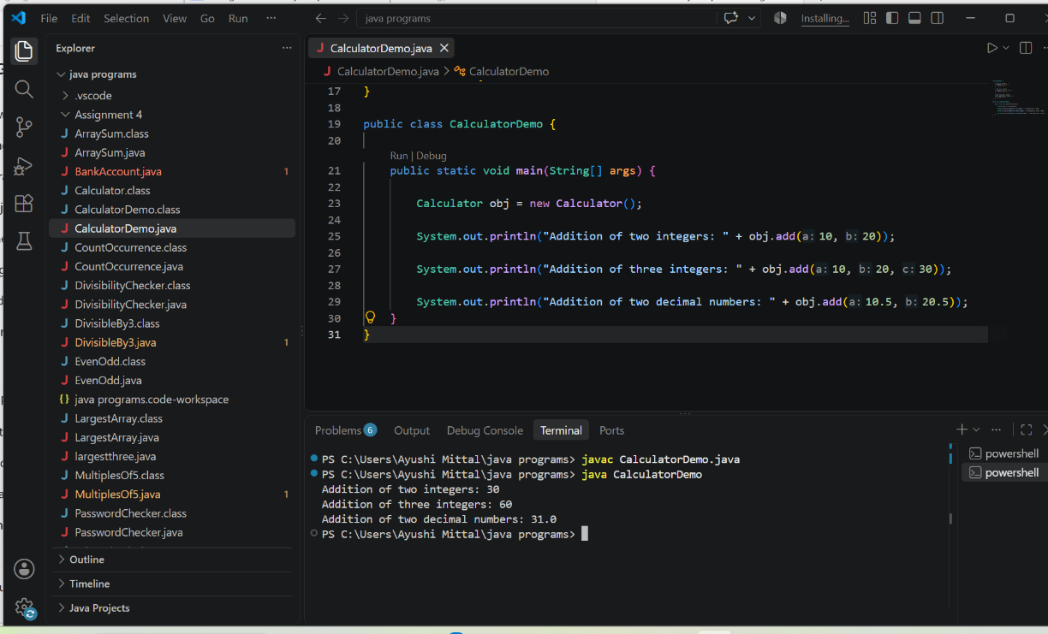

2. Create a class Display and overload the show() method to display student information in different formats:
- Display only the student's name.
- Display the student's name and age.
- Display the student's name, age, and marks.
Create an object and call all versions of the show() method.

Class Display {
void show(String name) {
System.out.println("Student Name: " + name);
}
void show(String name, int age) {
System.out.println("Student Name: " + name);
System.out.println("Age: " + age);
}
void show(String name, int age, double marks) {
System.out.println("Student Name: " + name);
System.out.println("Age: " + age);
System.out.println("Marks: " + marks);
}
}
public class DisplayDemo {
public static void main(String[] args) {

Display obj = new Display();
obj.show("Ayushi");
System.out.println();
obj.show("Ayushi", 18);
System.out.println();
obj.show("Ayushi", 18, 89.5);
}
}
OUTPUT
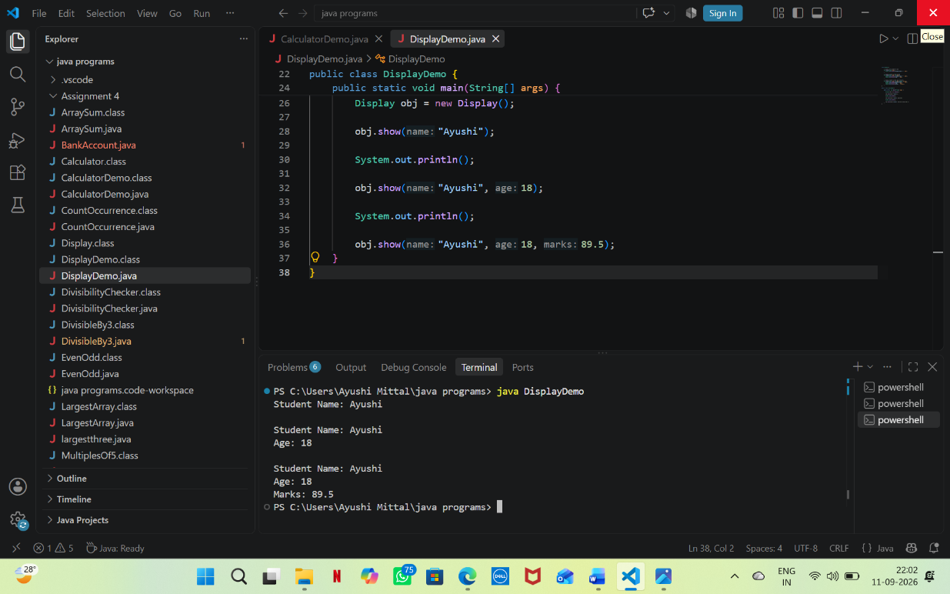
3. Find Maximum
Create a class and overload the max() method to find:
- Maximum between two integers.
- Maximum between three integers.
- Maximum between two decimal numbers.
Display the result for each method call.

class Maximum {
int max(int a, int b) {
if (a > b)
return a;
else
return b;
}
int max(int a, int b, int c) {
if (a >= b && a >= c)
return a;
else if (b >= a && b >= c)
return b;
else
return c;
}
double max(double a, double b) {
if (a > b)
return a;
else
return b;
}
}

public class MaximumDemo {
public static void main(String[] args) {
Maximum obj = new Maximum();
System.out.println("Maximum between two integers: " + obj.max(10, 25));
System.out.println("Maximum between three integers: " + obj.max(10, 25, 15));
System.out.println("Maximum between two decimal numbers: " + obj.max(15.5, 12.8));
}
}
OUTPUT
