Assignment-10
1. What are Wrapper Classes in Java? Explain why Java provides Wrapper Classes.
Wrapper Classes are special classes in Java that convert primitive data types into objects.
Java provides a wrapper class for each primitive data type.
Why does Java provide Wrapper Classes?
Wrapper classes are useful because:
- Collections like ArrayList store objects, not primitive data types.
- They allow primitive values to be used where an object is required.
- They provide useful methods for converting and working with values.
- They support Autoboxing and Unboxing.
- They can represent a value as an object.
2. Write the corresponding Wrapper Class for each primitive data type:
Primitive Data Type | Wrapper Class
byte | Byte
short | Short
int | Integer
long | Long
float | Float
double | Double
char | Character
boolean | Boolean

3. Differentiate between:
- Primitive Data Type
- Wrapper Class
Primitive Data Type | Wrapper Class
- Stores a simple value directly. | - Stores a primitive value as an object.
- It is not an object. | - It is a class/object type.
- Generally uses less memory. | - Generally requires more memory because it is an object.
- Cannot be used directly in collections like ArrayList. | - Can be used in collections.
- Does not provide methods. | - Provides useful methods.
- Example: int, char | - Example: Integer, Character

4. What is Autoboxing? Explain with a suitable example.
Autoboxing is the automatic conversion of a primitive data type into its corresponding Wrapper Class object.
Java automatically performs this conversion.
Example:
public class AutoboxingExample {
public static void main(String[] args) {
int number = 10;
Integer obj = number;
System.out.println("Primitive value: " + number);
System.out.println("Wrapper object: " + obj);
}
}
5. What is Unboxing? Explain with a suitable example.
Unboxing is the automatic conversion of a Wrapper Class object into its corresponding primitive data type.
Example:
public class UnboxingExample {
public static void main(String[] args) {
Integer obj = 20;
int number = obj;
System.out.println("Wrapper object: " + obj);
System.out.println("Primitive value: " + number);
}
}

6. What is the difference between:Integer.parseInt()
andInteger.valueOf()?
Integer.parseInt() | Integer.valueOf()
- Converts String into a primitive int. | - Converts String into an Integer object.
- Return type is int. | - Return type is Integer.
- Example: int x = Integer.parseInt("100"); | - Example: Integer x = Integer.valueOf("100");
- Mainly used when a primitive integer is required. | - Used when an Integer object is required.

Part B – Basic Programming
1. Primitive and Wrapper Variables
Create a Java program that declares variables for all 8 primitive data types and their corresponding Wrapper Classes.
Example:int → Integer
double → Double
char → Character
boolean → Boolean
Display the values of both primitive and Wrapper variables.

Code-
public class PrimitiveWrapperExample {
public static void main(String[] args) {
byte byteValue = 10;
short shortValue = 100;
int intValue = 1000;
long longValue = 10000L;
float floatValue = 10.5f;
double doubleValue = 99.99;
char charValue = 'A';
boolean booleanValue = true;
Byte byteWrapper = 10;
Short shortWrapper = 100;
Integer intWrapper = 1000;
Long longWrapper = 10000L;
Float floatWrapper = 10.5f;
Double doubleWrapper = 99.99;
Character charWrapper = 'A';
Boolean booleanWrapper = true;
System.out.println("----- Primitive Values -----");
System.out.println("byte: " + byteValue);
System.out.println("short: " + shortValue);
System.out.println("int: " + intValue);
System.out.println("long: " + longValue);
System.out.println("float: " + floatValue);
System.out.println("double: " + doubleValue);
System.out.println("char: " + charValue);
System.out.println("boolean: " + booleanValue);
System.out.println("\n----- Wrapper Values -----");
System.out.println("Byte: " + byteWrapper);
System.out.println("Short: " + shortWrapper);
System.out.println("Integer: " + intWrapper);
System.out.println("Long: " + longWrapper);
System.out.println("Float: " + floatWrapper);
System.out.println("Double: " + doubleWrapper);
System.out.println("Character: " + charWrapper);
System.out.println("Boolean: " + booleanWrapper);
}
}
OUTPUT-
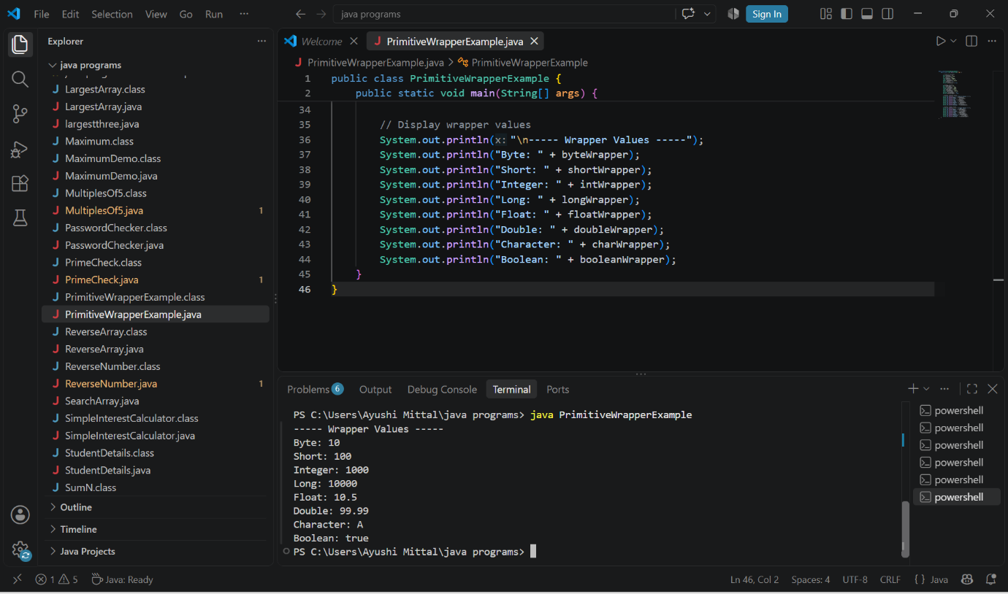

2. Autoboxing Demonstration
Create a program to demonstrate .
Convert the following primitive values into Wrapper objects:int
double
char
boolean
Display the values after conversion.
Example:int number = 100;
Integer obj = number;
Code-
public class AutoboxingExample {
public static void main(String[] args) {
int number = 100;
double price = 99.50;
char grade = 'A';
boolean status = true;
Integer obj1 = number;
Double obj2 = price;
Character obj3 = grade;
Boolean obj4 = status;
System.out.println("Integer Wrapper: " + obj1);
System.out.println("Double Wrapper: " + obj2);
System.out.println("Character Wrapper: " + obj3);
System.out.println("Boolean Wrapper: " + obj4);
}
}
Output:
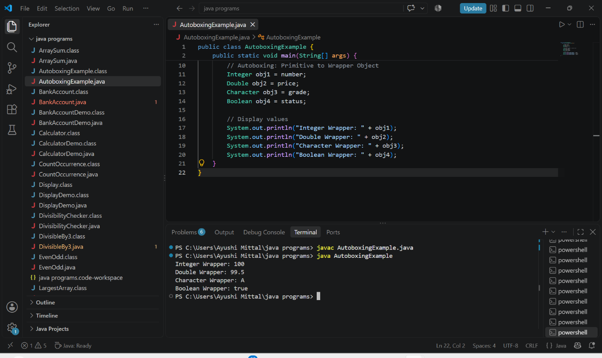

3. Unboxing Demonstration
Create a program to demonstrate .
Convert the following Wrapper objects into primitive values:Integer → int
Double → double
Character → char
Boolean → boolean
Display the converted values.

Code:-
public class UnboxingExample {
public static void main(String[] args) {
Integer obj1 = 100;
Double obj2 = 99.50;
Character obj3 = 'A';
Boolean obj4 = true;
int number = obj1;
double price = obj2;
char grade = obj3;
boolean status = obj4;
System.out.println("Integer to int: " + number);
System.out.println("Double to double: " + price);
System.out.println("Character to char: " + grade);
System.out.println("Boolean to boolean: " + status);
}
}
Output-
