Blockchain Mini-Project Report
NGO Donation Transparency Tracker
A Blockchain-Based dApp for Transparent NGO Donations and Expenditures
By
Udit Ahuja 2303007
Tejashwini Gowda 2303053
Ayushi Negi 2303114
Shivendra Patil 2303129
Class: C1 Batch: C11
Group No: 4
Computer Engineering Department
Thadomal Shahani Engineering College
University of Mumbai
2026-2027

1. Project Title
NGO Donation Transparency Tracker: A Blockchain-Based Decentralised Application for Transparent NGO Donations and Expenditures, implemented as a Solidity smart contract on a local Hardhat Ethereum network with a web frontend connected to MetaMask.

2. Introduction
A blockchain is a distributed, append-only ledger in which each block stores the hash of the previous one and is replicated across all nodes, so an earlier record cannot be altered without being rejected by the network [1]. Ethereum adds smart contracts: public programs whose rules every node executes identically, allowing a contract to hold funds and release them only under coded conditions that no party can override [2]. An uneditable public record and unbypassable rules are exactly what NGO financial reporting lacks.
In this decentralised application (dApp), NGOs create fundraising causes and donors send ETH directly to a smart contract instead of to the NGO. Funds leave the contract only through payments that pass an automatic audit, including a compulsory, never-reused receipt, and go straight to the supplier. Every donation and expenditure is permanently recorded, so anyone can verify the amount raised, spent and remaining for any cause.

3. Problem Statement
India has an estimated 3.3 million registered NGOs, yet fewer than 10% file annual financial returns and only about 17,000 to 35,000 hold a valid FCRA licence, so most operate with little or no independent financial audit [3], [4]. A Bain & Company survey found that 50% of donors could not identify an NGO they considered credible enough to donate to [5], even though the CAF India Giving study found that 72% of Indian adults donate every year, with a median donation of ₹5,000 [6]. Giving is widespread, but donors rely almost entirely on unverifiable NGO statements.
The core problem is that donors have no way to verify that their donation was used as claimed: NGO reporting is typically a self-reported PDF published months after collection, with no independent audit trail. This is a trust and transparency gap, the absence of a tamper-proof, publicly verifiable record of how donated funds are received and spent, which the project closes by moving both the record and the money onto a blockchain.

4. Proposed Solution
A smart contract replaces the self-reported statement: it holds the donated funds and enforces how they are spent, so each cause's record is generated by its own transactions and cannot be altered. The rules below are enforced by the contract code, not by policy:
- Ownership by creation: whoever creates a cause becomes its NGO, with no separate registration or whitelisting, and only that address can spend that cause's funds (onlyNGO modifier).
- Direct donations: donors pay the contract, not the NGO; each donation is recorded against the donor's address, and donations close once the goal is reached or the deadline passes.
- Automatic audit of spending: each expenditure needs a receipt PDF. The contract rejects it unless the receipt's SHA-256 hash is present and unused, the recipient is neither the NGO nor the owner, and funds suffice; the website also checks the amount and wallet written on the receipt. If all checks pass, the supplier is paid directly.
- Goal-based rules: spending opens only after the goal is reached; if the deadline passes first, each donor can withdraw their own contribution.
- Verification: anyone can check a receipt file against its on-chain hash; the owner can verify a creator as a registered organisation or an individual raising funds for a personal cause, and cannot create causes itself (onlyOwner).

5. Architecture of the System
The system has five components (Figure 1): the smart contract (Solidity), which stores all records, holds the ETH and enforces access control; the Hardhat network, a local Ethereum blockchain (chain ID 31337) that executes and records transactions; the frontend (HTML/CSS/JavaScript with ethers.js); MetaMask, which holds the user's key and signs transactions; and the end user (NGO, donor or owner), identified only by wallet address.
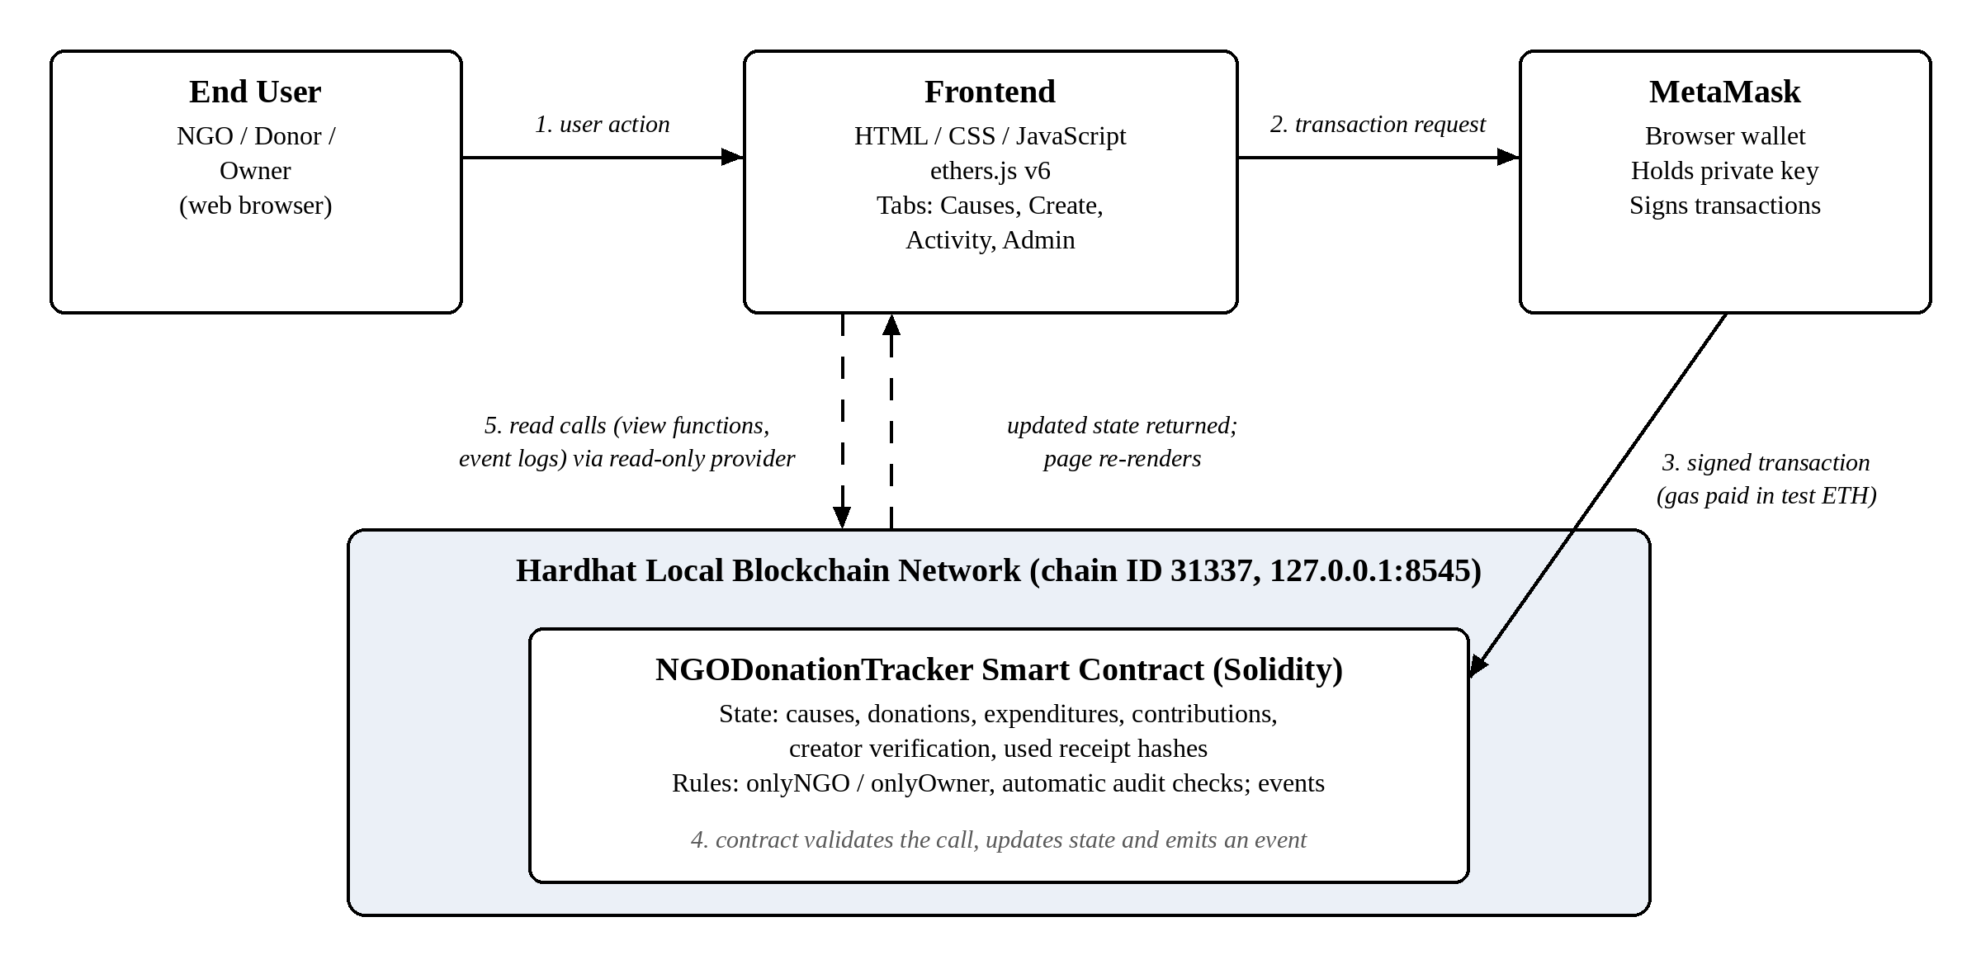
Figure 1: System architecture. Solid arrows: transaction path; dashed arrows: read calls.
Data flow. (1) The user acts in the frontend. (2) ethers.js passes the call to MetaMask for confirmation. (3) MetaMask signs and submits the transaction, paying gas in test ETH. (4) The contract checks its modifiers, updates state, transfers ETH if required and emits an event; any failed check reverts the whole transaction. (5) The frontend reads the new state through a read-only provider and re-renders; reading needs no wallet or gas.

6. Working / Implementation
The contract stores three structs in mappings keyed by cause ID (Table 1), plus mappings for per-donor contributions, creator verification and used receipt hashes.
Struct | Fields
Cause | id, ngo, title, description, category, goal, deadline, totalRaised, totalSpent, totalRefunded
Donation | donor, amount, timestamp
Expenditure | description, amount, recipient, receiptHash (compulsory), receiptURI, timestamp
Table 1: Core data structures.
Function | Caller | Behaviour
createCause() | Anyone except the owner (becomes NGO) | Validates the input and stores the cause
donate() payable | Anyone | Accepts ETH until the goal or deadline; records the donation
logExpenditure() | onlyNGO | Runs the audit checks (goal reached, receipt present and unused, no self-payment, sufficient balance), then pays the recipient and records it
claimRefund() | Donor | Returns the donor's contribution if the goal was missed by the deadline
getRemainingBalance(), getDonations(), getExpenditures() | Anyone (view) | Return balances and the full donation and expenditure history
Table 2: Main contract functions.
User flow. The NGO creates a cause; donors donate until the goal is reached; the NGO enters a payment with the supplier's receipt PDF; the website shows an audit checklist and enables payment only when every check passes; the contract re-checks its rules and pays the supplier, updating the totals for every viewer. A reused receipt or mismatched amount is rejected and nothing is paid.
Testing. All 26 automated Hardhat tests pass. Access control was tested by calling logExpenditure from accounts that did not create the cause, which the contract rejected with "Only the cause's NGO can do this"; payments with no receipt, a reused receipt or the NGO's own wallet as recipient were also rejected, and in every case no funds moved. In the manual demo, the two valid receipts (receipt1.pdf for 5 ETH and receipt2.pdf for 3 ETH) passed the audit and paid their suppliers, while the fake receipt3.pdf, which names the NGO's own wallet, was rejected (Section 9).

7. Tech Stack and Concepts Used
Technology | Purpose
Solidity 0.8.24 [7] | Smart contract language: on-chain logic, storage and fund custody
Hardhat 2 [8] | Compiling, deploying, local blockchain network and automated testing
MetaMask [10] | Wallet connection, user identity and transaction signing
HTML, CSS, JavaScript + ethers.js v6 [9] | Frontend user interface and contract interaction
pdf.js [11] | Reading receipt PDFs in the browser for the automatic audit
Table 3: Technology stack.
Concept | Use in the project
Smart contracts, payable functions | Contract holds all funds; donate() receives ETH with the call
Structs and mappings | Cause, Donation, Expenditure; per-cause and per-donor records
Access-control modifiers | onlyNGO and onlyOwner restrict who may call each function
Hashing | SHA-256 receipt fingerprints stored on-chain and marked as used
Transactions, gas, wallet identity | Every state change is a signed transaction; roles are determined by wallet address
Immutability, auditability, events | Permanent public records; events power the activity log
Table 4: Blockchain concepts applied.

8. Sources
- S. Nakamoto, "Bitcoin: A Peer-to-Peer Electronic Cash System," 2008. https://bitcoin.org/bitcoin.pdf
- V. Buterin, "Ethereum: A Next-Generation Smart Contract and Decentralized Application Platform," Ethereum White Paper, 2014.
- Central Bureau of Investigation, data on registered NGOs and filing of annual returns submitted to the Supreme Court of India, 2015.
- Ministry of Home Affairs, Government of India, FCRA Online Services: Registered Associations. https://fcraonline.nic.in
- Bain & Company and Dasra, "India Philanthropy Report," Bain & Company. https://www.bain.com/insights/topics/india-philanthropy-report/
- CAF India, "India Giving 2019: Insights into the Nature and Extent of Individual Giving in India," Charities Aid Foundation India, 2019.
- Solidity Documentation. https://docs.soliditylang.org
- Hardhat Documentation. https://hardhat.org/docs
- ethers.js v6 Documentation. https://docs.ethers.org/v6/
- MetaMask Developer Documentation; Ethereum Developer Documentation. https://docs.metamask.io; https://ethereum.org/en/developers/docs/
- Mozilla, pdf.js. https://mozilla.github.io/pdf.js/

9. Screenshots
The screenshots below were taken from the running application on the local Hardhat network, following the demo flow. The demo accounts are first imported into MetaMask; then the owner verifies the NGO, the NGO creates a cause, a donor funds it, and the NGO pays two suppliers using the demo receipts receipt1.pdf and receipt2.pdf. The fake receipt receipt3.pdf is then shown being rejected.
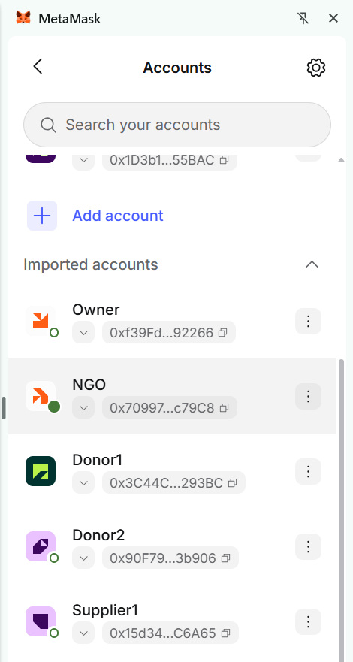
Figure 2: Hardhat test accounts imported into MetaMask, one per role.
Each role uses its own Hardhat test account: Owner (#0, 0xf39F…2266), NGO (#1, 0x7099…79C8), donors (#2 and #3) and Supplier1 (#4, 0x15d3…6A65); Supplier2 (#5) is further down the list. The website identifies each user only by the wallet address MetaMask connects, and every transaction is confirmed and signed in MetaMask.
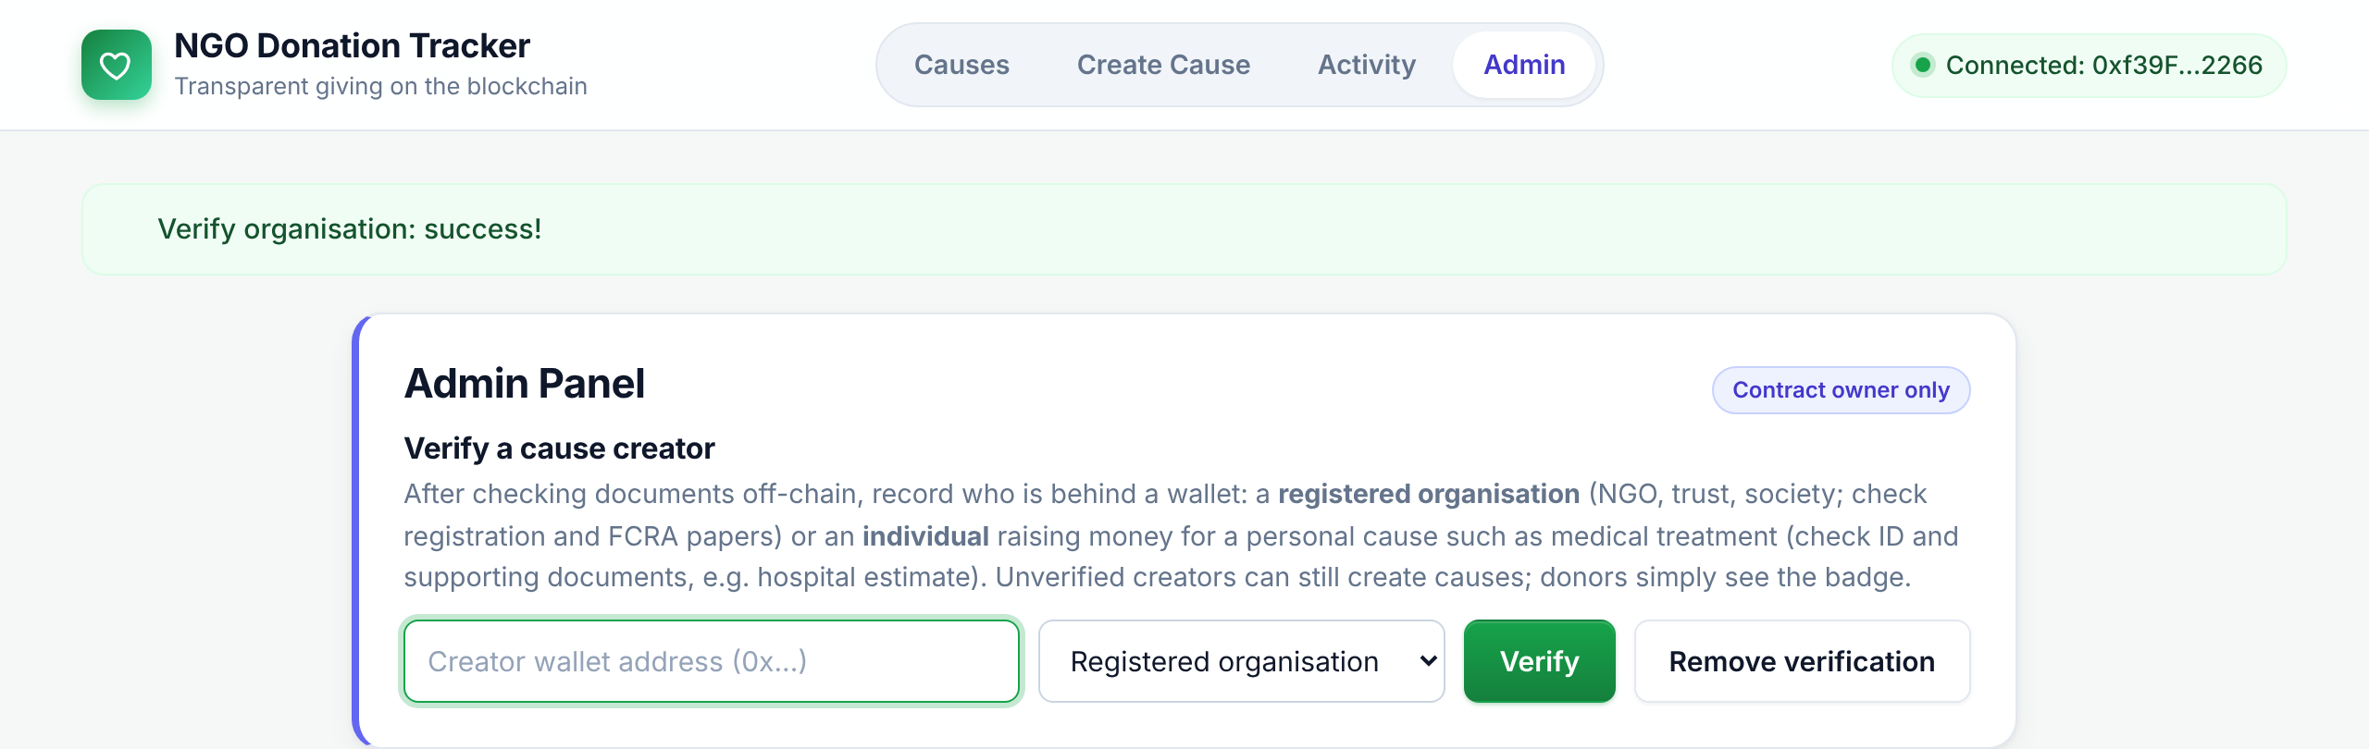
Figure 3: Admin panel: the owner verifies the NGO's wallet as a registered organisation.
Only the contract owner sees this tab. Verification only adds a badge; it does not block unverified creators.
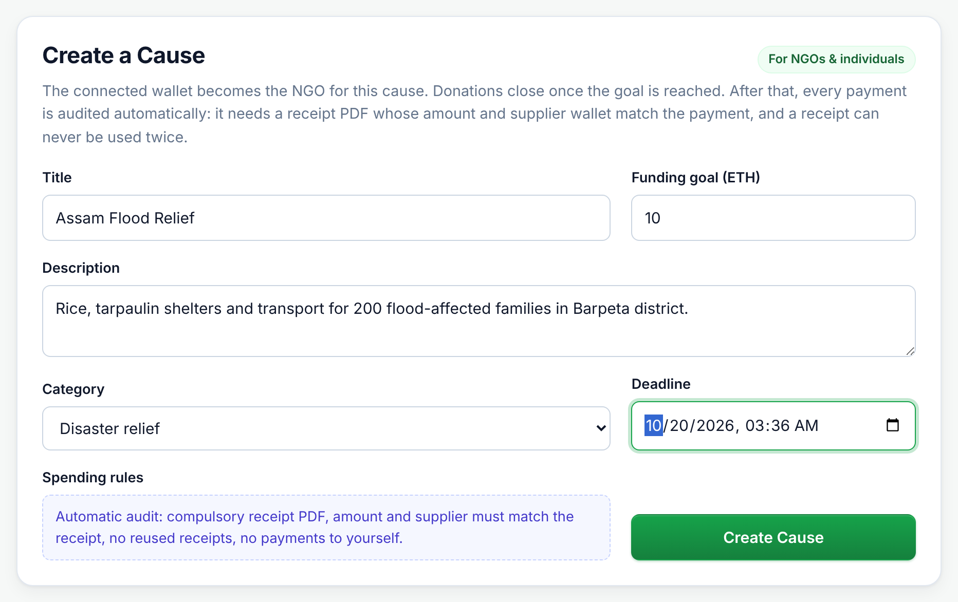
Figure 4: Create Cause form.
The NGO enters a title, goal, description, category and deadline. The spending rules are shown before the cause is created.
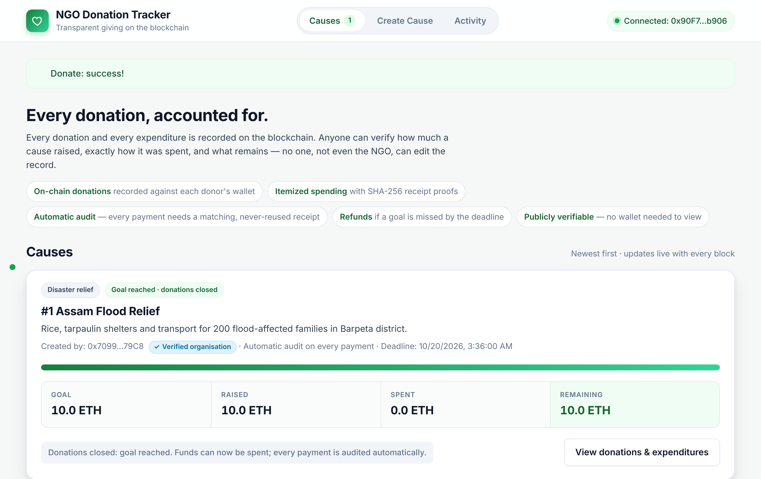
Figure 5: Cause after a donation reaches the goal; donations close and spending opens.
The progress bar is full, the donate box is removed and the Spend Funds panel appears for the NGO.
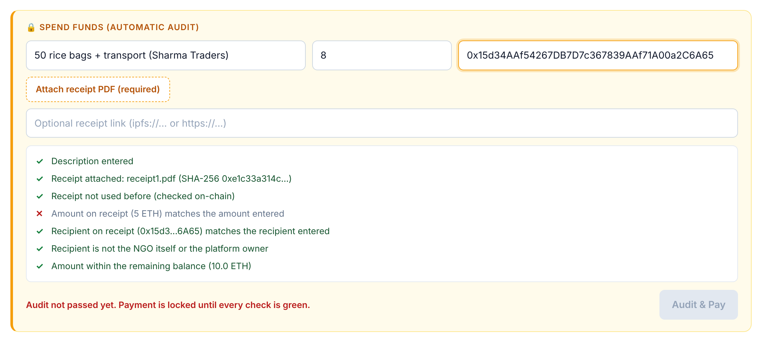
Figure 6: Automatic audit with a failed check: the amount entered does not match the receipt.
The audit checklist marks the mismatch in red and the Pay button stays locked, so no transaction can be sent.
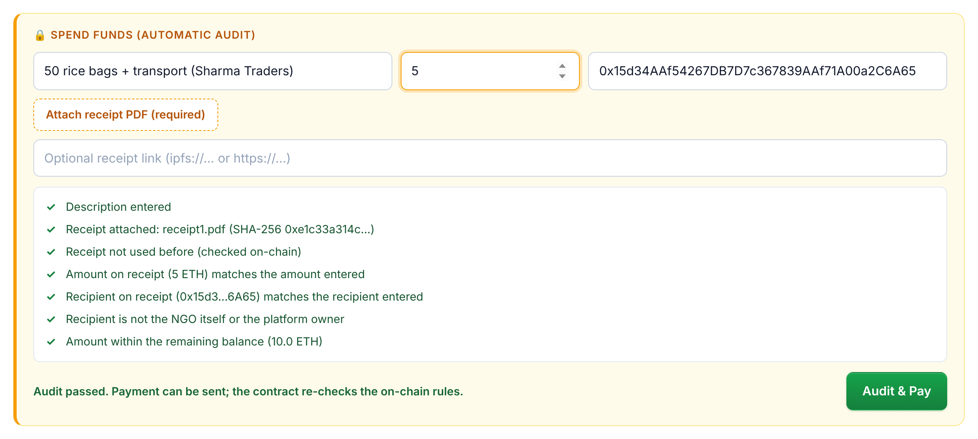
Figure 7: Automatic audit passed for receipt1.pdf; payment unlocked.
Every check is green: receipt attached and unused, amount and wallet match the PDF, recipient is not the NGO, and funds are sufficient.
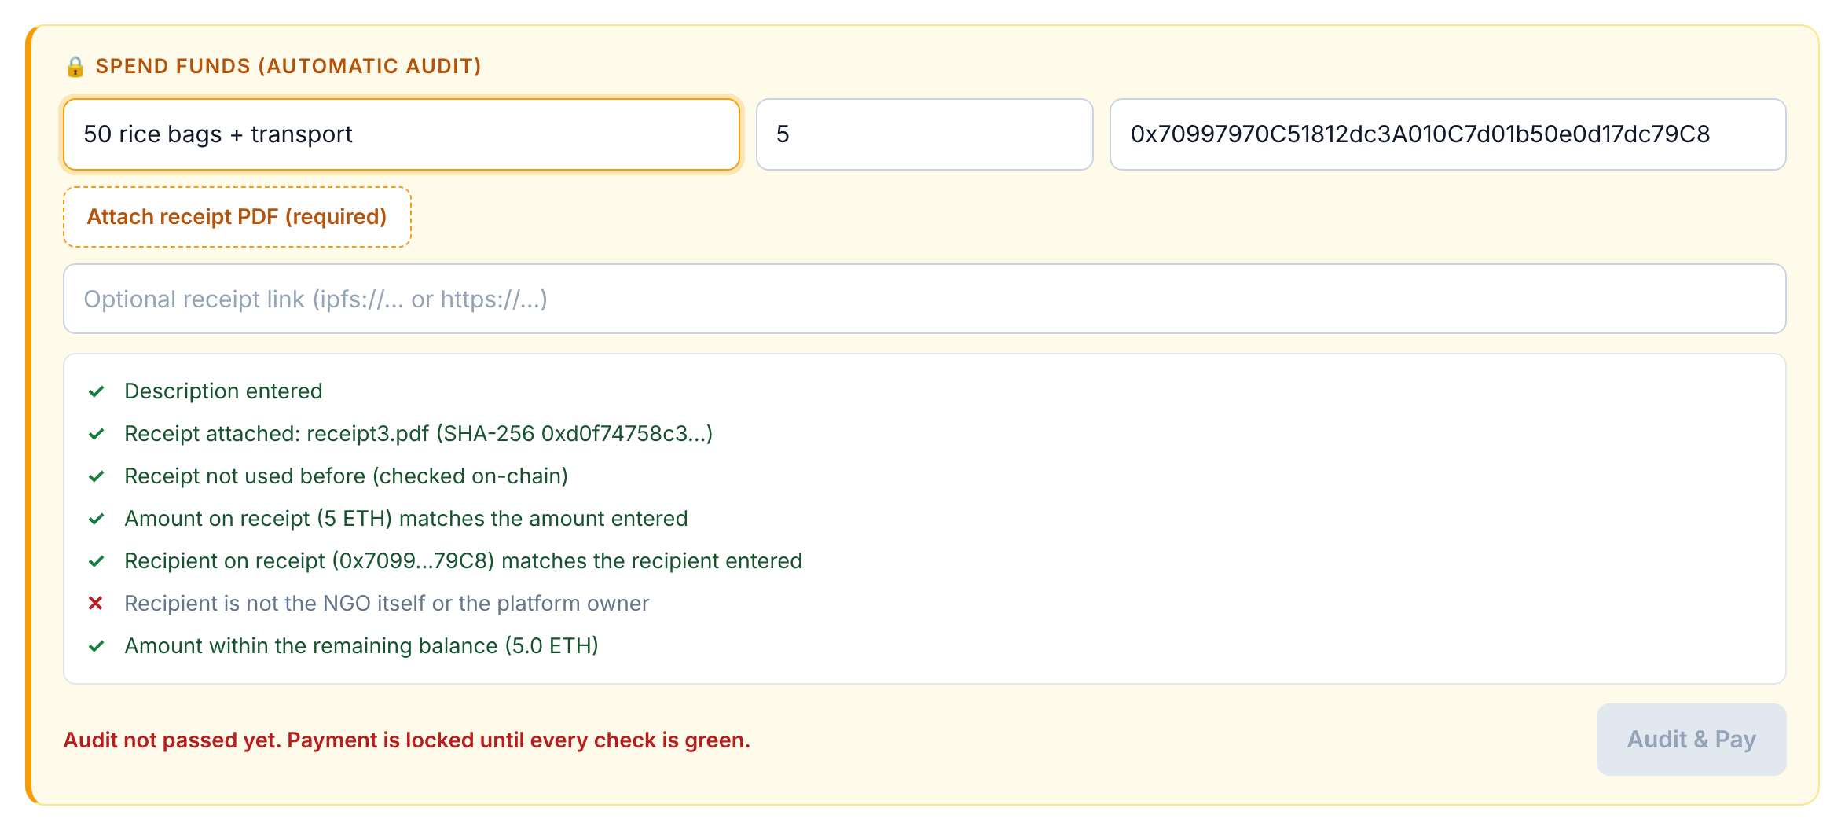
Figure 8: Fake receipt receipt3.pdf rejected by the automatic audit.
receipt3 is a tampered copy of receipt1 whose payment wallet is the NGO's own address. The self-payment check fails and payment stays locked; the contract would also reject it on-chain.
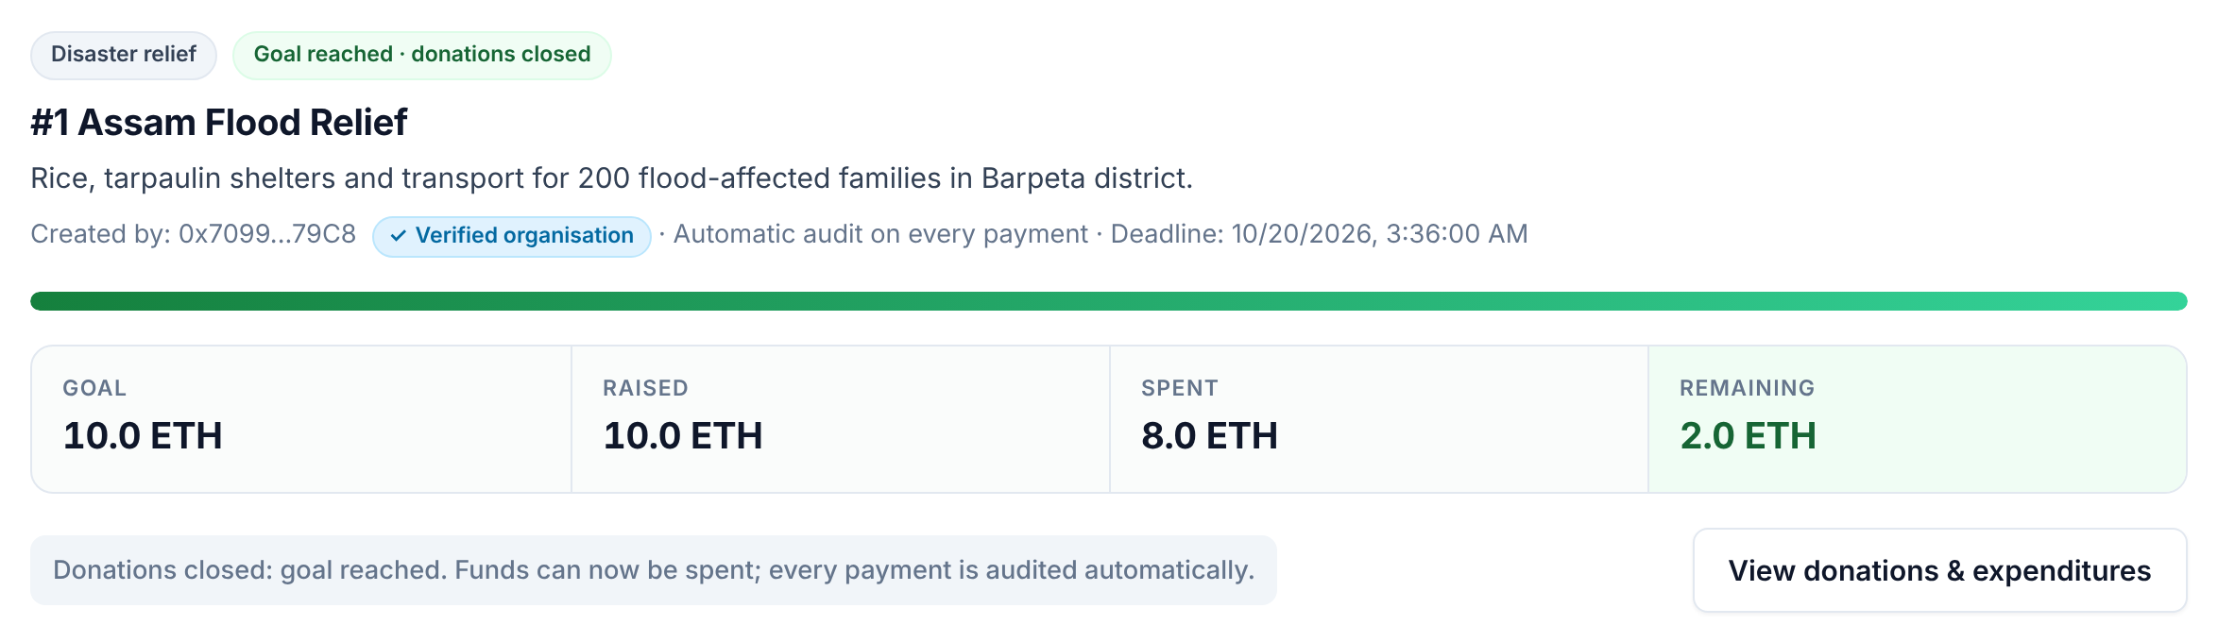
Figure 9: Cause card with goal, raised, spent and remaining totals.
After both payments: 10 ETH raised, 8 ETH spent, 2 ETH remaining. Totals update live for every viewer.
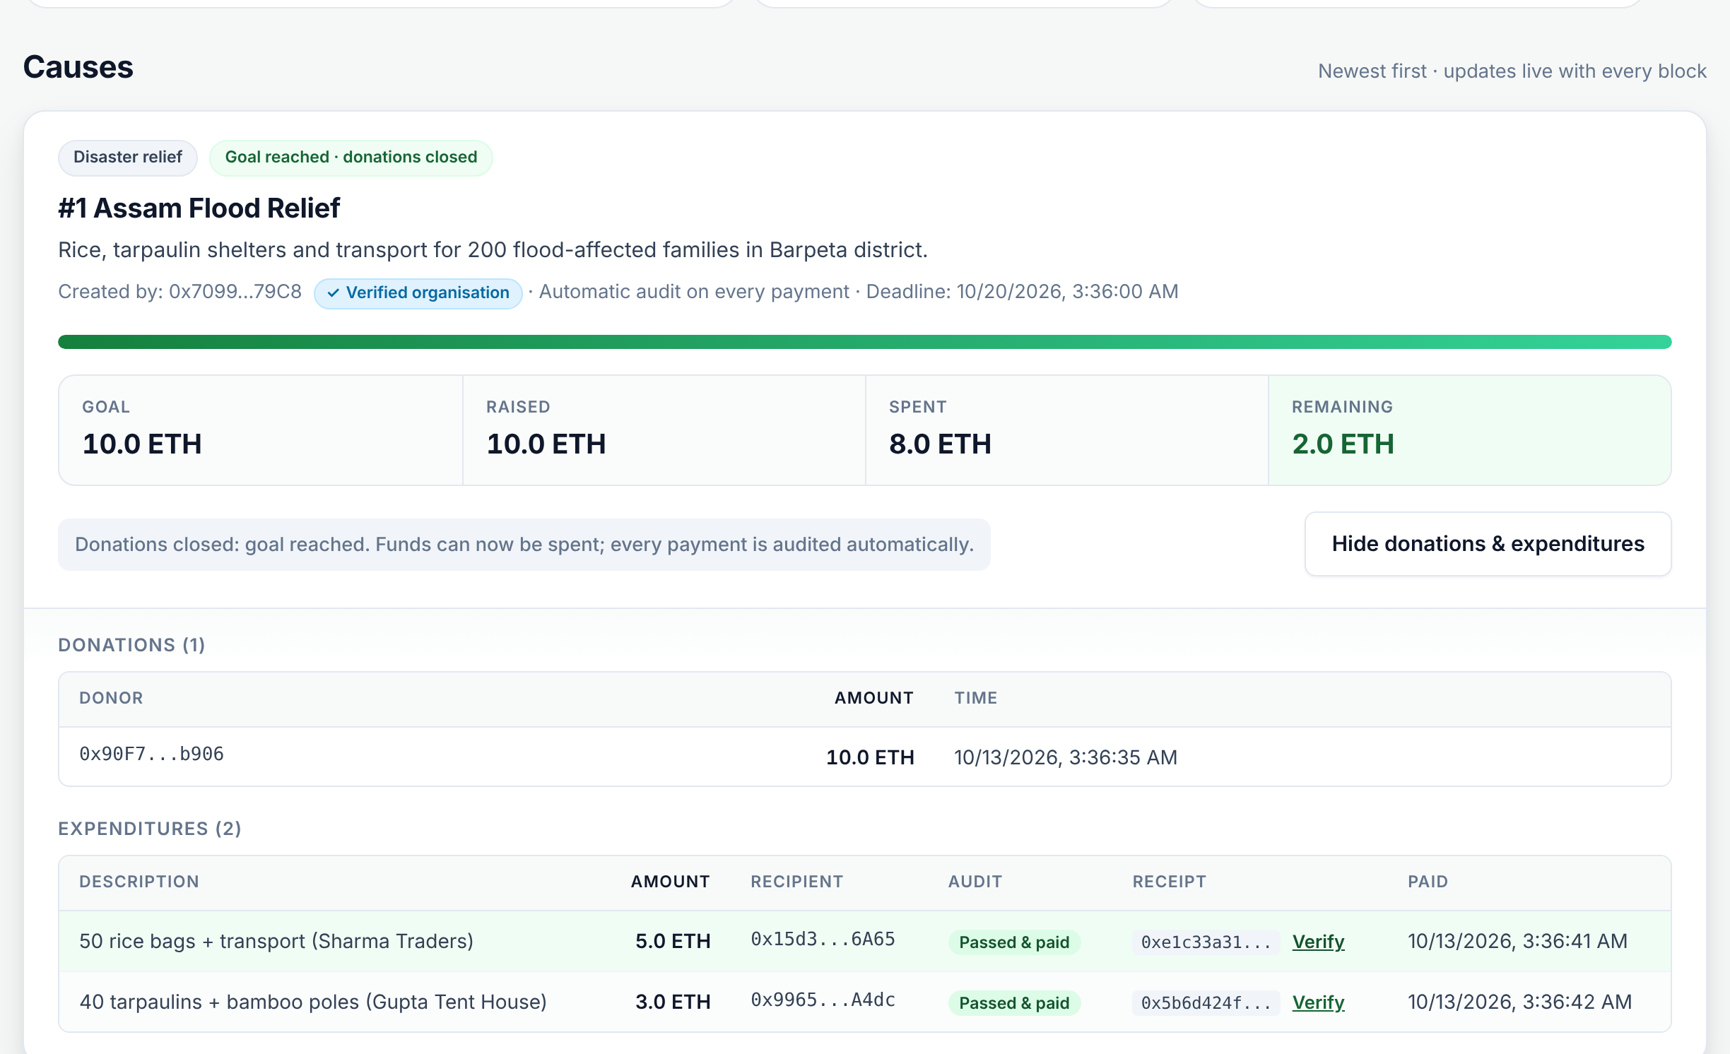
Figure 10: Donations and expenditures history with receipt fingerprints.
Each expenditure shows its amount, recipient, audit result and SHA-256 receipt hash. Anyone can click Verify and select a PDF to check it against the hash stored on-chain.
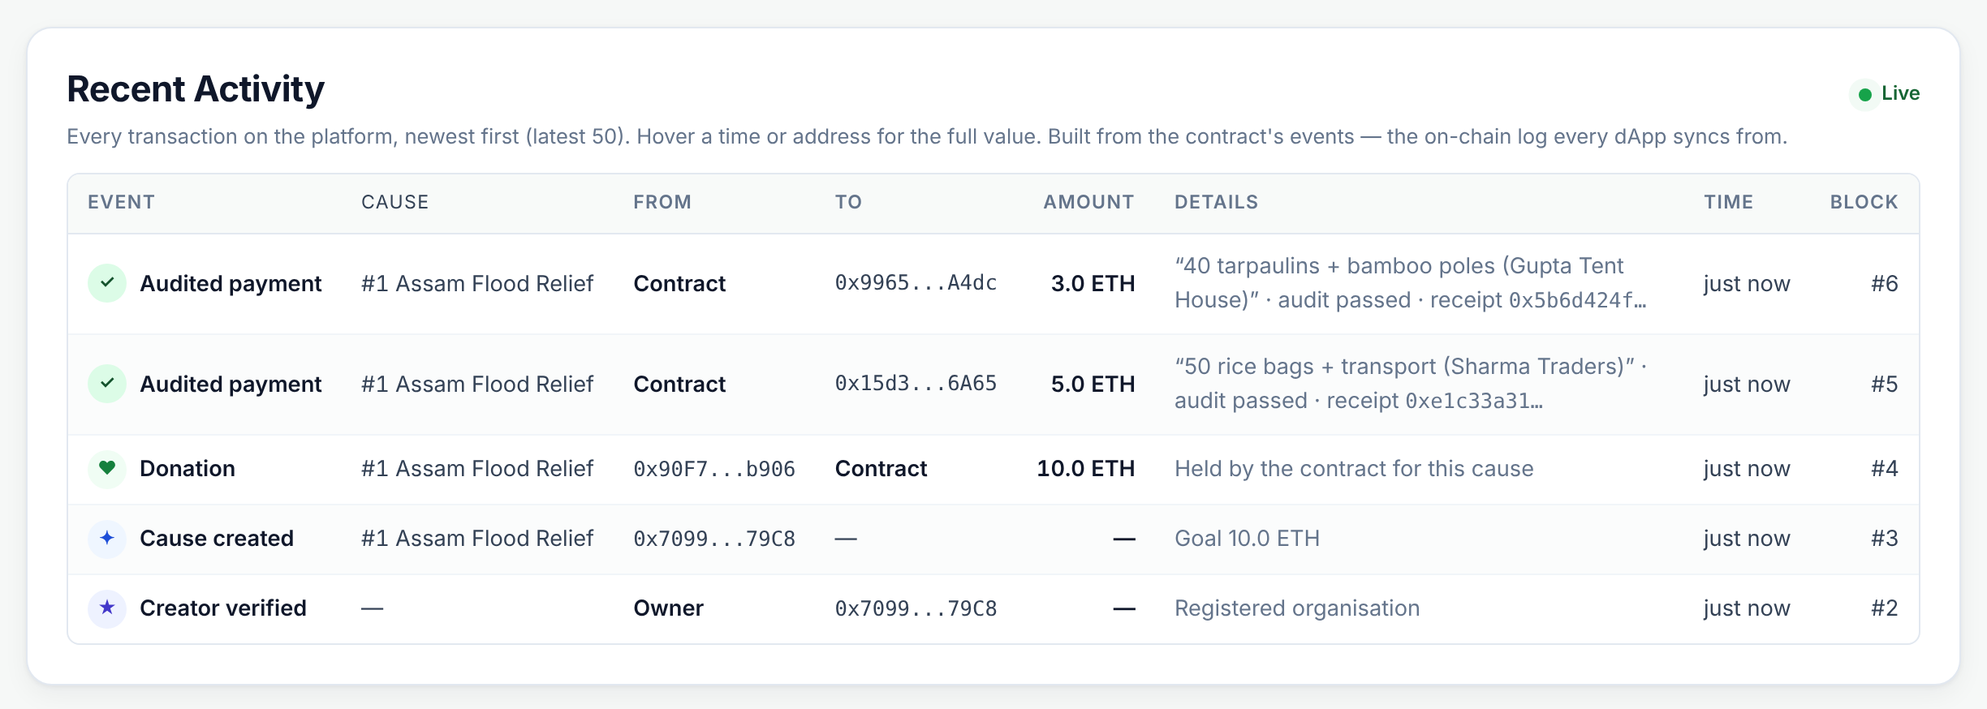
Figure 11: Recent Activity table built from contract events.
Every on-chain event is one row, newest first: event type, cause, from, to, amount, details, time and block number. Cause creation, verification, donations and audited payments can be checked at a glance.
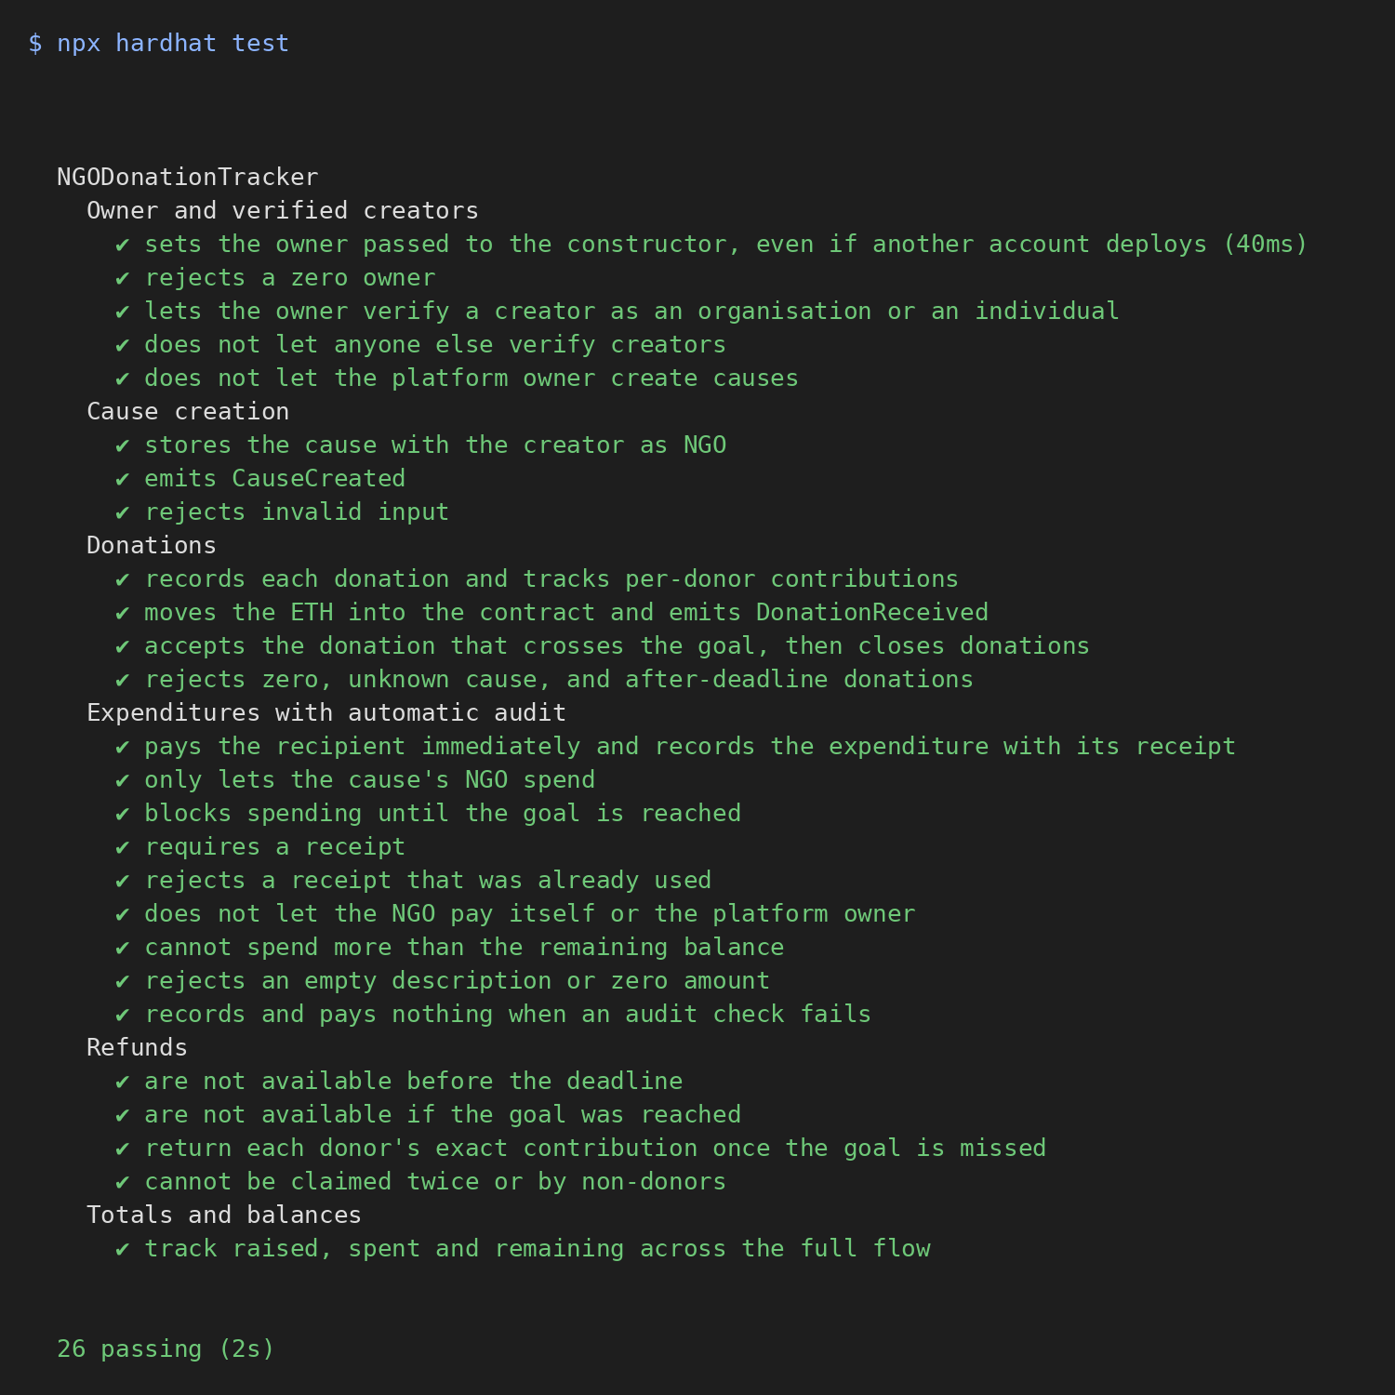
Figure 12: Hardhat test results (26 passing).
The automated tests cover owner verification, cause creation, donations, every audit rule, refunds and totals.

10. Conclusion
This project built and tested a dApp that makes NGO fundraising transparent by construction: a Solidity smart contract holds all donations, records every donation and expenditure immutably, releases funds only to a supplier after an automatic audit backed by a compulsory, single-use receipt, and refunds donors if a goal is missed, while a web frontend lets anyone inspect any cause's full financial history.
The project addresses a documented real-world problem: donors in India give widely but cannot verify how NGOs use their money, because reporting is delayed, self-reported and unaudited. Although tested only on a local Hardhat network, not a public one, and unable to confirm physical delivery of goods, the project proves its core claim: every unit of donated value can be traced from donor to recipient, by anyone, in a record that no party can alter.

