**Introduction to HTML/CSS**

**(Assignment - 4)**

Question 1.How are inline and block elements different from each other?

Answer: **Inline elements take up the particular space that is taken up by the amount of text that has been set by the user. By default it does not begin with a new line.**

**Eg. <span></span>**

**Block elements take up a whole line or the area present on the screen. They begin with a new line. It can even contain another block element**

**Eg. <div></div>, <p></p>**

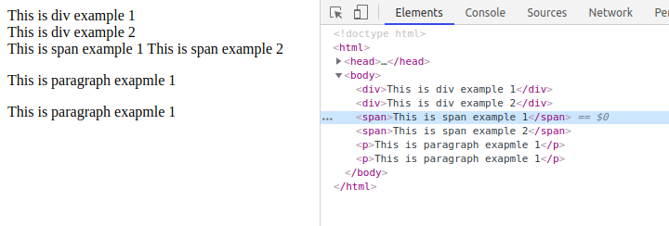

Question 2.Explain the difference between visibility:hidden and display:none .

Answer: **display:none means that the tag or element will not appear in the webpage neither any space will be allocated for the same.**

**visibility:hidden means that the tag or element will not appear in the webpage but some space will be allocated in webpage i.e it will be rendered just won’t be visible.**

Question 3. Explain the clear and float properties.

Answer: **Float describes which side should an element float or align itself with respect to another whereas clear defines which element can float in the webpage and on which side i.e if the position of an element is disturbed due to using float on another element clear stops that from happening.**

Question 4. Explain the difference between absolute, relative,fixed and static.

Answer: **All the above mentioned properties are a part of the position attribute.**

**Static: When an element is marked as static it does not move in any special way rather it is always positioned according to the normal page.**

**Relative: Once an element is tagged with this property it is moved or positioned relative to its original position when the size of the window is changed.**

**fixed: An element with this attribute is positioned relative to the viewport, which means it always stays in the same place even if the page is scrolled. The top, right, bottom, and left properties are used to position the element.**

**absolute: The element is positioned to relative to the nearest positioned ancestor. If no ancestor is present it is positioned based on the body of webpage**

Question 5. Write the HTML code to create a table in which there are 4 columns( ID , Employee Name, Designation, Department) and at least 6 rows. Also do some styling to it.

Answer:

<!DOCTYPE html>

<html>

<head>

<title>Q5 Table</title>

<style type="text/css">

td{text-align: center;}

</style>

</head>

<body>

<table border="1" style="width: 100%">

<thead>

<tr>

<th>ID</th>

<th>Employee Name</th>

<th>Designation</th>

<th>Department</th>

</tr>

</thead>

<tbody>

<tr>

<td style="color: blue; font-weight: bold;">001</td>

<td>ABC</td>

<td>PQR</td>

<td>XYZ</td>

</tr>

<tr>

<td style="color: blue; font-weight: bold;">002</td>

<td>QWE</td>

<td>RTY</td>

<td>XYZ</td>

</tr>

<tr>

<td style="color: blue; font-weight: bold;">003</td>

<td>UIO</td>

<td>PQR</td>

<td>XYZ</td>

</tr>

<tr>

<td style="color: blue; font-weight: bold;">004</td>

<td>ASD</td>

<td>LMN</td>

<td>AAA</td>

</tr>

<tr>

<td style="color: blue; font-weight: bold;">005</td>

<td>KJH</td>

<td>PQR</td>

<td>AAA</td>

</tr>

<tr>

<td style="color: blue; font-weight: bold;">006</td>

<td>DFG</td>

<td>ERT</td>

<td>MNB</td>

</tr>

</tbody>

</table>

</body>

</html>

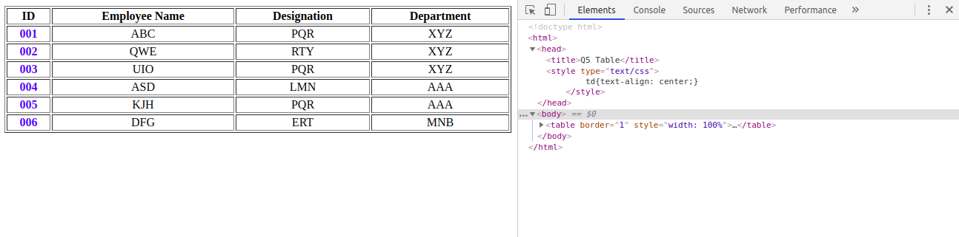

Question 6. Why do we use meta tags?

Answer: **Meta tags are important to be passed in a webpage for machine accessibility or SEO. These tags do not appear on the webpage but are used by web crawlers while scraping or searching.**

**The meta tags are used to specify page description, keywords, author of the document, last modified, and other metadata.**

Question 7. Explain box model.

Answer: **The CSS box model is basically a box that folds over each HTML component. It comprises: margin, border, padding and content. The picture beneath delineates the crate model:**

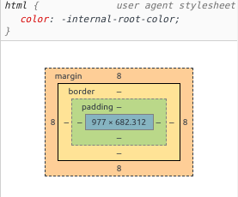

**Content: The content that has been entered in the element**

**Padding: The differentiating area or the space between the content and border**

**Border: The border that goes around padding and content**

**Margin: The area outside the border. This is transparent**

Question 8. What are the different types of CSS Selectors?

Answer: **There are primarily 5 types of CSS Selectors**

1. **CSS Element Selector : The element selector selects the HTML element by name.**
2. **CSS Id Selector: The id selector selects the id attribute of an HTML element to select a specific element. An id is always unique within the page so it is chosen to select a single, unique element.**
3. **CSS Class Selector: The class selector selects HTML elements with a specific class attribute. It is used with a period character . (full stop symbol) followed by the class name.**
4. **CSS Universal Selector: The universal selector is used as a wildcard character. It selects all the elements on the pages.**
5. **CSS Group Selector: The grouping selector is used to select all the elements with the same style definitions.**

Question 9. Define Doctype.

Answer: **Doctype is not an html language tag rather it instructs the web browser about what version of HTML will be used in the following code. This must be the very first thing that a developer must declare**

**Syntax: <!DOCTYPE HTML>**

Question 10. Explain 5 HTML5 semantic tags.

Answer: **Semantic tags were introduced in HTML5. These tags clearly describe the attributes meaning in a human and machine readable manner.**

1. **Section: Syntax - <section>....</section>  
    A section is a particular area or a part in a document generally with a heading in it.**
2. **Article: Syntax - <article>.....</article>  
    An article is an individual area in a document or webpage which should independently make sense some examples are - Newspaper article, Forum Post, Blog Post.**

1. **Header: Syntax - <header>.....</header>  
    Defines the header of a particular section. This should be used as a container element**

**for introductory content or giving a topic to a or section/article in a webpage.**

1. **Figure: Syntax - <figure>....</figure>  
    Used to add visuals such as images to the webpage. In HTML5, an image and a caption can be grouped together in a <figure> element**
2. **Aside: Syntax - <aside>......</aside>  
    Defines content aside from the page content like sidebar. content should be related to the surrounding content.**

Question 11. Create HTML for web-page.jpg (check resources, highest weightage for answers)

Answer: <https://github.com/ayushirohilla2020/ttn_exercise.git> - (html_ques_11.html)

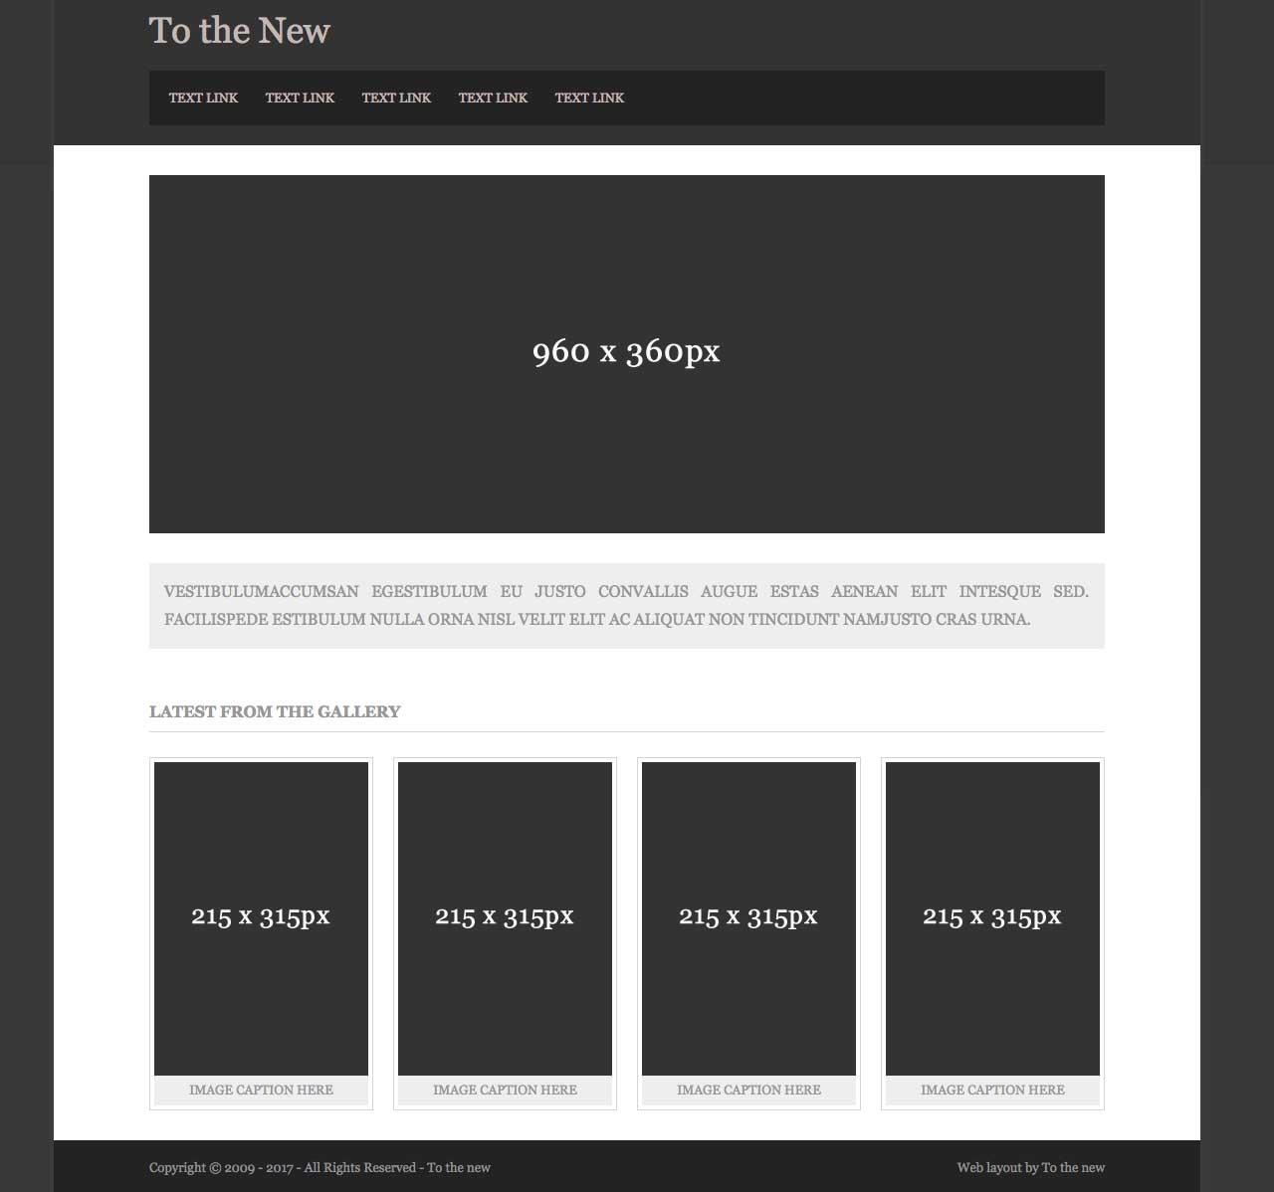

Question 12. Create HTML for form.png (check resources, highest weightage for answers)

Answer: <https://github.com/ayushirohilla2020/ttn_exercise.git>- - (html_ques_12.html)

