**ASSIGNMENT- 6**

**(INTRODUCTION TO JAVASCRIPT)**

**QUESTION 1- Prompt for amount, interest rate and no. of years and calculate simple interest.**

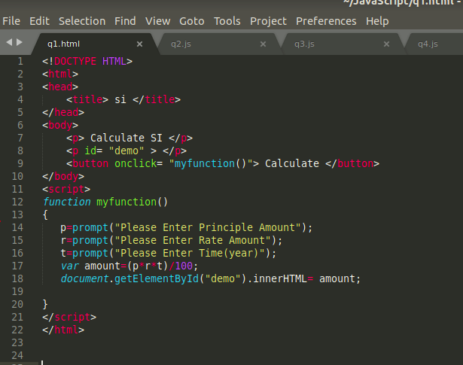

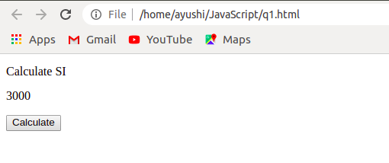

**QUESTION 2- To find whether a string is a palindrome or not.**

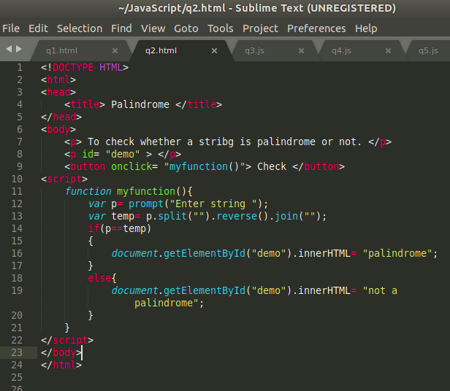

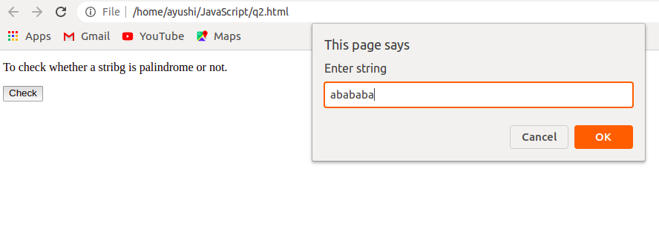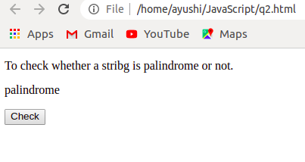

**QUESTION 3- Area of circle.**

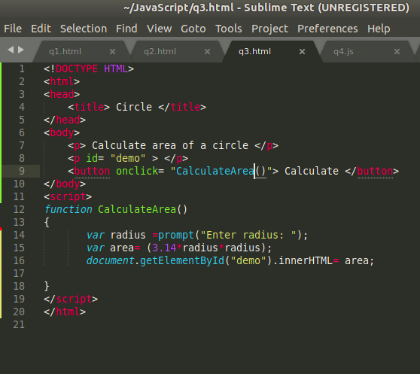

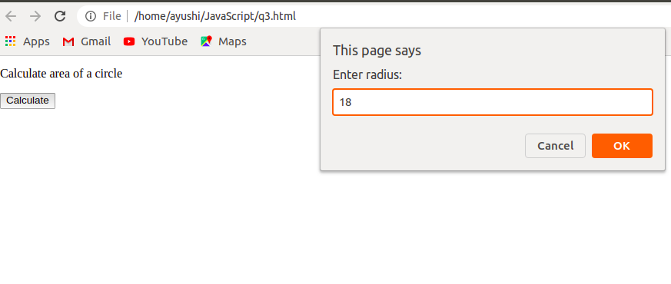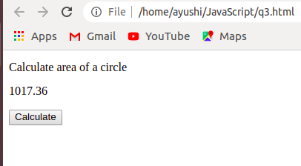

**QUESTION 4- Copy information of one object to another and log it to console.**

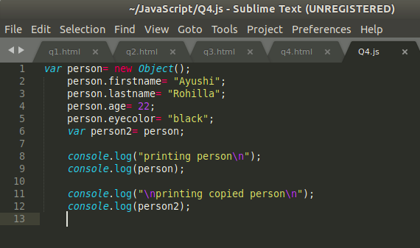

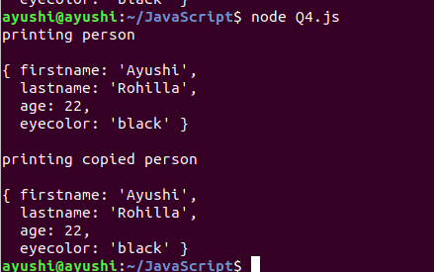

**QUESTION 5- Create a list of objects of Employee with info as follow :**

* **Name, age, salary ,DOB**

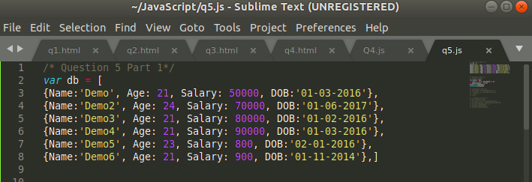

* **filter all employees with salary greater than 5000**

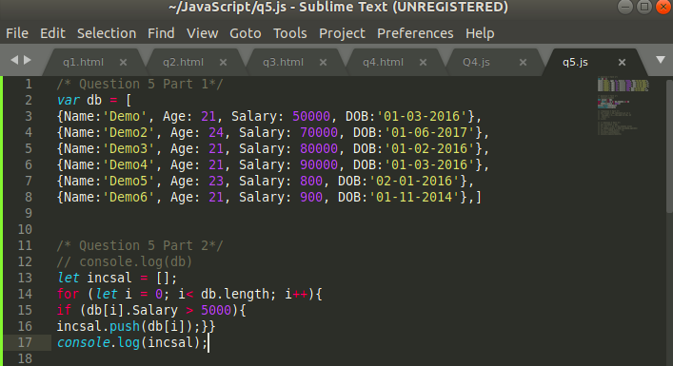

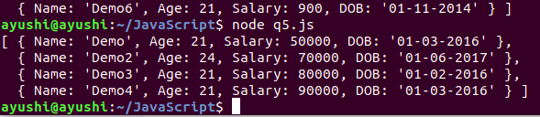

* **group employee on the basis of their age**

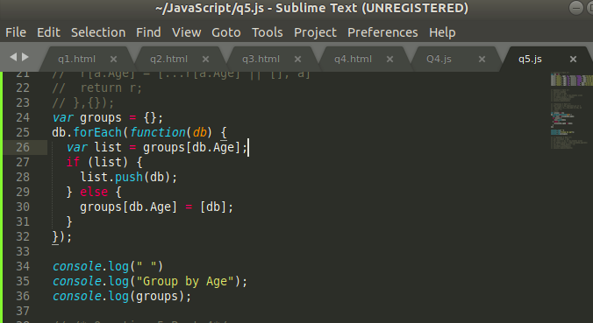

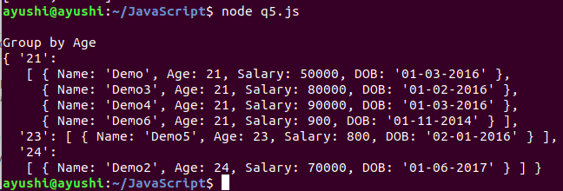

* **fetch employees with salary less than 1000 and age greater than 20. Then give them an increment 5 times their salary.**



