**ASSIGNMENT- 5**

**TWITTER BOOTSTRAP**

QUESTION 1- Write the HTML code to create a table in which there are 4 columns( ID , Employee Name, Designation, Department) and at least 6 rows. Also do some styling to it.

<!DOCTYPE HTML>

<html>

<head>

<title> bootstrap_ques5 </title>

</head>

<body>

<div>

<div>

<hr>

<h2> Table </h2>

<hr>

<table>

<thead>

<tr>

<th> Firstname </th>

<th> Lastname </th>

<th> E-mail </th>

<th> Phone </th>

</tr>

</thead>

<tbody>

<tr>

<td> Ayushi </td>

<td> Rohilla </td>

<td> ayu@ttn </td>

<td> 9999954471 </td>

</tr>

<tr>

<td> Tushar </td>

<td> Garg </td>

<td> tushar@ttn </td>

<td> 8877678989 </td>

</tr>

<tr>

<td> Nivedita </td>

<td> Sharma </td>

<td> nivedita@ttn </td>

<td> 8877678989 </td>

</tr>

<tr>

<td> Tarun </td>

<td> Sharma </td>

<td> tarun@ttn </td>

<td> 8444478989 </td>

</tr>

<tr style="background-color:yellow">

<td> Tarun </td>

<td> Sharma </td>

<td> tarun@ttn </td>

<td> 8444478989 </td>

</tr>

<tr>

<td> Priya </td>

<td> Sharma </td>

<td> priya@ttn </td>

<td> 8444423459 </td>

</tr>

<tr>

<td> Riya </td>

<td> Bansal </td>

<td> riya@ttn </td>

<td> 998878989 </td>

</tr>

</tbody>

</table>

</div>

</div>

</body>

</html>

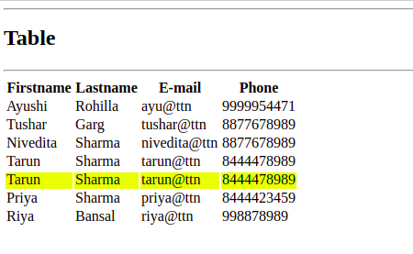

QUESTION 11. Create HTML for web-page.jpg (check resources, highest weightage for answers)

ANSWER- <https://github.com/ayushirohilla2020/ttn_exercise.git> - (question11_bootstrap.html)

QUESTION 12. Create HTML for form.png (check resources, highest weightage for answers)

ANSWER- <https://github.com/ayushirohilla2020/ttn_exercise.git> - (question12_bootstrap.html)