ASSIGNMENT- 2

(VERSION CONTROL)

QUESTION 1- Git Setup <https://confluence.atlassian.com/bitbucket/set-up-git-744723531.html>

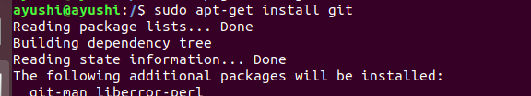

QUESTION 2- Initialize a Git Repository

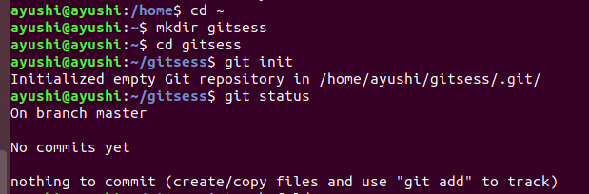

QUESTION 3- Add files to the repository

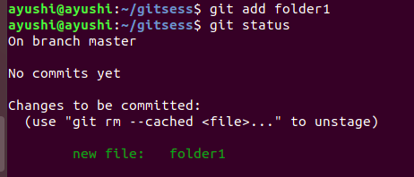

QUESTION 4- Unstage 1 file

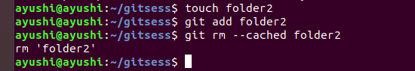

QUESTION 5- Commit the file

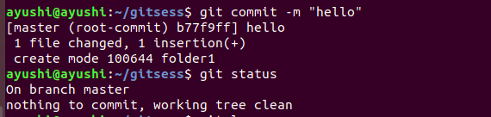

QUESTION 6- Add a remote

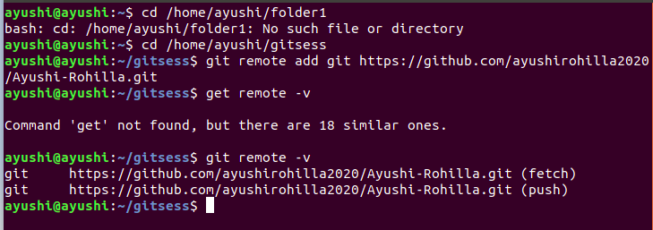

QUESTION 7- Undo changes to a particular file

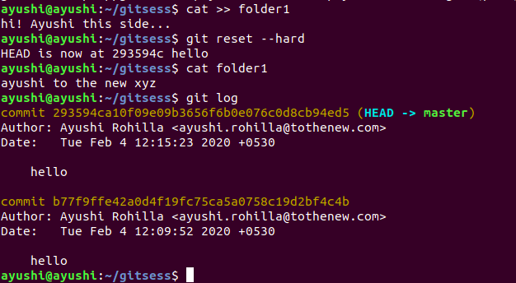

QUESTION 8- Push changes to Github

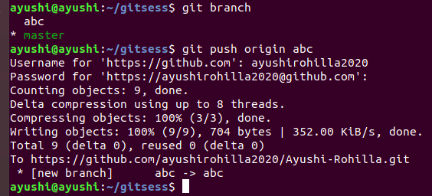

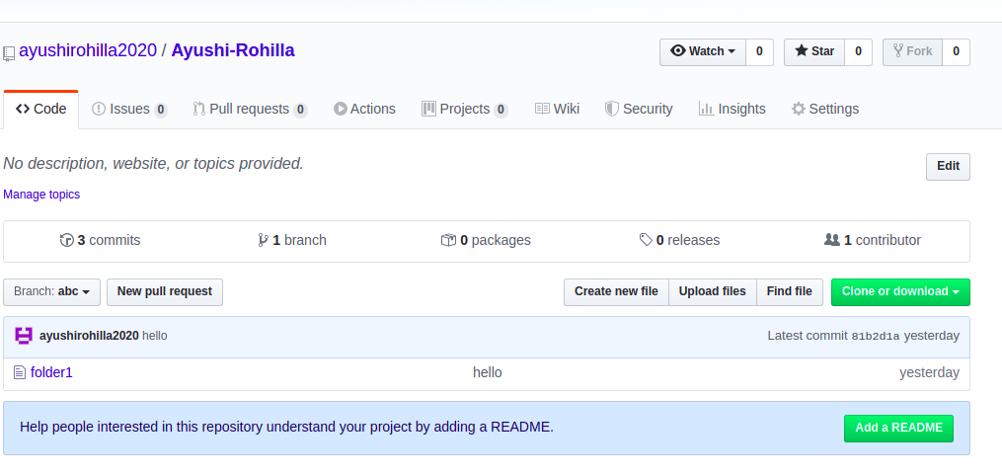

QUESTION 9- Clone the repository

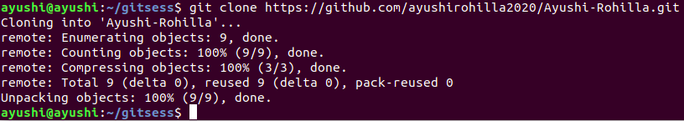

QUESTION 10- Add changes to one of the copies and pull the changes in the other.

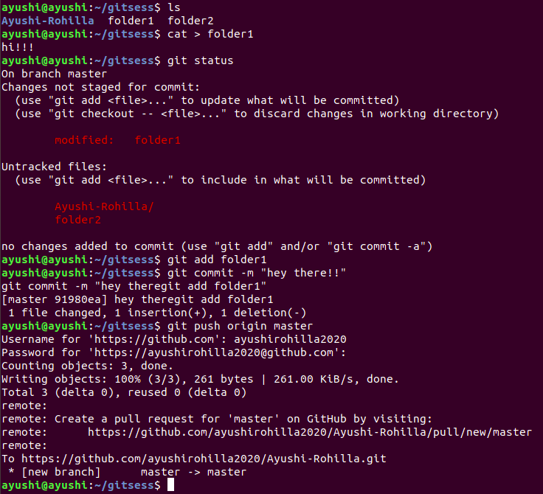

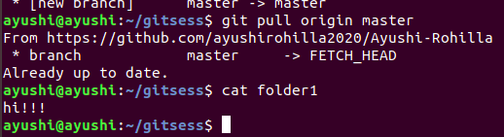

QUESTION 11- Check differences between a file and its staged version

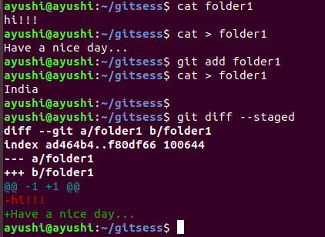

QUESTION 12- Ignore a few files to be checked in

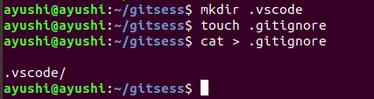

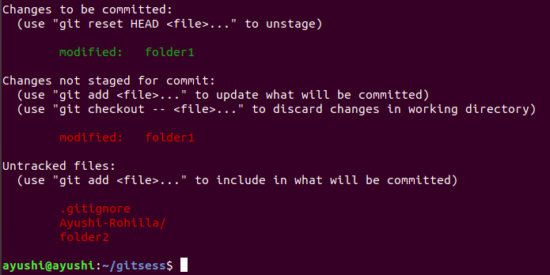

QUESTION 13- Create a new branch.

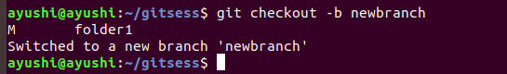

QUESTION 14- Diverge them with commits

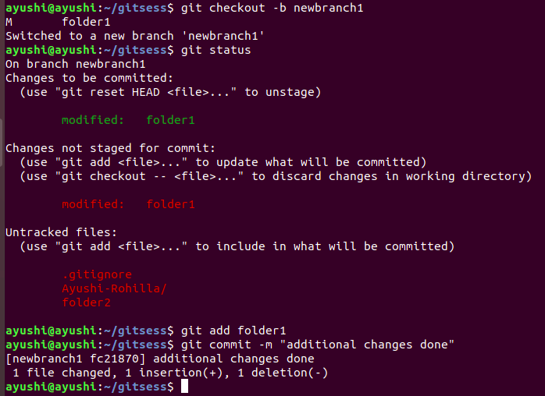

QUESTION 15- Edit the same file at the same line on both branches and commit

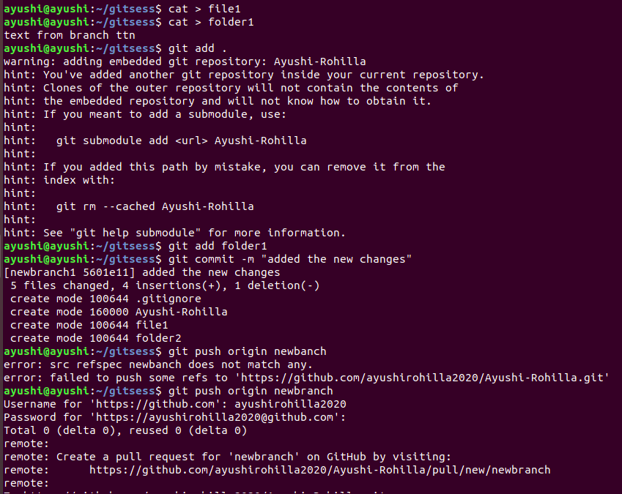

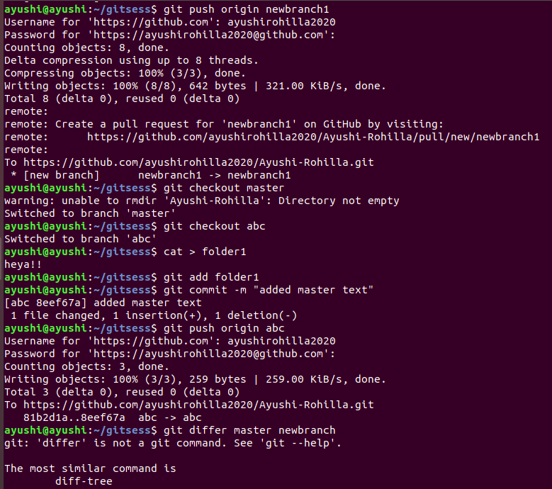

QUESTION 16- Try merging and resolve merge conflicts

QUESTION 17- Stash the changes and pop them

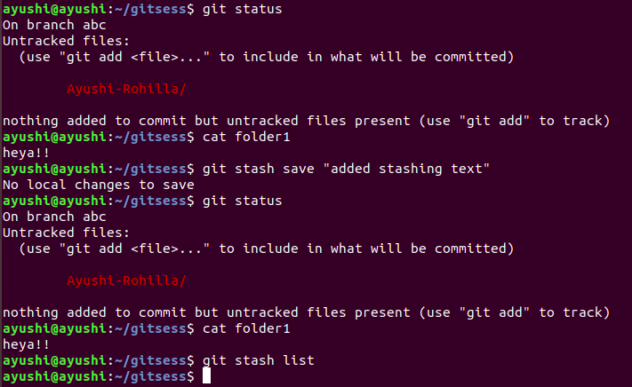

QUESTION 18- Add the following code to your .bashrc file : color_prompt="yes"

parse_git_branch() {

git branch 2> /dev/null | sed -e '/^[^*]/d' -e 's/* \(.*\)/(\1)/'

}

if [ "$color_prompt" = yes ]; then

PS1='\u@\h\[\033[00m\]:\[\033[01;34m\]\W\[\033[01;31m\] $(parse_git_branch)\[\033[00m\]\$ '

else

PS1='\u@\h:\W $(parse_git_branch)\$ '

fi

unset color_prompt force_color_prompt

