***BORROWIT***

E-asset management



*"Empowering Assets, Enriching Communities: Your Ultimate E-Asset Management Solution"*

Done by: Team 4

Ayushi Saxena

Arshiya Kaul

Archika Dixit

Divya Sharma

Nishant Dalai

Rishav Chaudhary

Rishav Wadhwa

Rashi Gupta

**Abstract:**

This comprehensive system encompasses critical components such as asset lending, overdue asset tracking, pending asset management, and user and admin login pages. Additionally, it facilitates asset purchase and payment processing, catering to both individual users and businesses alike.

Key features of the platform include secure user and admin login interfaces, automated lending and borrowing processes with notifications, robust asset tracking, and a user-friendly asset catalogue. Users can seamlessly manage their assets, request and approve lending, and conduct financial transactions with ease.

This innovative solution not only simplifies asset management but also enhances financial control by offering secure payment gateways and insightful reporting and analytics. With its mobile-responsive design, the E-Asset Management Website ensures accessibility from various devices.

Ultimately, this platform promotes efficient asset utilisation, transparency in lending and borrowing, and a collaborative community spirit by enabling users to share resources effectively. Whether for individuals seeking to lend or borrow assets or businesses optimising their asset management, this system offers a comprehensive, secure, and user-centric solution to streamline asset-related processes.

**Project Overview:**

The E-Asset Management Website is an innovative platform designed to streamline the management of assets in a digital environment. This comprehensive system is aimed at efficiently handling lending assets, monitoring overdue assets, managing pending assets, enabling user and admin login, facilitating asset purchases, and managing payments. The system is designed to cater to both individual and corporate users, offering a user-friendly and secure interface.

Key Components:

User Login: Allows registered users to access their accounts, view their assets, track lending and pending assets, and make payments.

Admin Login: Grants administrators access to the backend system for managing assets, user accounts, and overall platform functionality.

Asset Lending: Registered users can lend their assets to other users, defining lending terms, including duration and conditions.

Automated notifications and reminders for both lenders and borrowers ensure timely asset returns.

Overdue Asset Management:The system automatically tracks overdue assets, notifying both lenders and borrowers. Admins can intervene if necessary, facilitating conflict resolution.

Pending Asset Requests: Users can request assets from other users, pending approval from the lender.

Asset owners can review and approve/reject requests.

Asset Purchase: Users can browse a catalogue of available assets for purchase.

Purchase requests are forwarded to the asset owner for approval.

Payment Processing: Secure payment gateways enable users to make payments for asset purchases, overdue fines, or other fees. Payment history and receipts are stored for reference.

Key Features:

Asset Tracking: Detailed asset profiles with images, descriptions, and lending history.

User Profiles: Users can maintain profiles, track lending and borrowing history, and manage their assets.

Notifications: Automated email or in-app notifications for overdue assets, pending requests, and more.

Reporting and Analytics: Generate reports on asset utilisation, user activity, and financial data for administrators.

Security: Robust security measures, including encryption and user authentication, to protect user data and transactions.

Search and Filters: User-friendly search and filter options to find specific assets or users easily.

Mobile Responsiveness: Access the platform on various devices, ensuring a seamless user experience.

Benefits:

Efficient management of assets, reducing idle resources and increasing asset utilisation.

Transparent lending and borrowing processes with automated notifications and reminders.

Improved financial control with easy payment processing and reporting.

Enhanced user experience with a user-friendly interface.

Increased community collaboration and resource sharing.

Target Audience:

Individuals looking to share or lend their assets.

Small businesses or organisations interested in asset management.

Admins responsible for overseeing asset transactions.

**Problem Statement: E-Asset Management**

In today's digital age, the efficient management of assets remains a challenge for individuals and organisations alike. The lack of a unified, user-friendly, and secure platform for asset management poses several problems:

* Asset Underutilization: Many assets, such as tools, equipment, and resources, are underutilised or remain idle due to difficulties in lending, borrowing, or sharing among users. This leads to wasted resources and financial inefficiencies.
* Manual Tracking and Communication: Asset lending and borrowing are often managed manually or through inefficient, decentralised systems. Users struggle to keep track of lending terms, resulting in overdue assets, disputes, and miscommunication.
* Financial Control: For businesses and individuals, tracking payments, managing asset purchases, and handling overdue fines are complex and time-consuming tasks. This lack of financial control can lead to losses and disputes.
* Data Security Concerns: The absence of secure platforms for asset management raises concerns about data security and privacy. Users hesitate to share valuable asset information due to fears of data breaches or misuse.
* User-Friendliness: Existing asset management solutions often lack user-friendly interfaces, making it challenging for users to list, find, and manage assets efficiently.
* Lack of Transparency: Users and administrators often lack transparency in asset transactions, leading to disputes and trust issues within asset-sharing communities.

Solution Needed: The solution to these problems lies in the development of an E-Asset Management Website, a comprehensive platform that offers secure user and admin login, streamlined asset lending and borrowing, efficient asset purchase and payment processing, and robust asset tracking. This solution aims to simplify asset management, enhance financial control, and promote resource sharing while ensuring data security and user satisfaction.

By addressing these challenges, the E-Asset Management Website will provide users and organisations with a centralised, user-friendly, and secure platform to manage assets effectively, improve asset utilisation, and foster a sense of community and trust among users.

**Scope of the project:**

* User Management:
  + User registration and profile management.
  + Secure login/logout functionality for users and administrators.
  + User roles and permissions for different levels of access.
* Asset Management:
  + Creation and maintenance of asset profiles with details such as images, descriptions, and ownership information.
  + Asset categorization and tagging for easy search and filtering.
  + Asset lending and borrowing processes with automated notifications and reminders.
  + Overdue asset tracking and notifications.
  + Pending asset request management.
* Financial Transactions:
  + Secure payment gateway integration for asset purchases, overdue fines, and other fees.
  + Payment history tracking and receipt generation.
* Admin Dashboard:
  + Backend administrative interface for managing user accounts, assets, and system configurations.
  + Reporting and analytics tools for monitoring user activity, asset utilisation, and financial data.
* User Interface (UI) and User Experience (UX):
  + An intuitive and user-friendly web interface accessible from various devices (responsive design).
  + Easy navigation, search, and filter options for finding assets and users.
  + Notification system (email or in-app) for users and administrators.
* Security:
  + Robust security measures, including data encryption, to protect user data and financial transactions.
  + Secure authentication and authorization mechanisms.
* Documentation and Help Center:
  + User guides and documentation for using the platform effectively.
  + A help centre or support system for addressing user queries and issues.
* Scalability and Performance:
  + Scalable architecture to accommodate potential growth in user base and asset listings.
  + Performance optimization to ensure fast response times and minimal downtime.
* Testing and Quality Assurance:
  + Rigorous testing of the platform to identify and resolve any bugs or issues.
  + Quality assurance processes to ensure a smooth user experience.
* Deployment and Hosting:
  + Deployment of the website in a secure and reliable hosting environment.
  + Ongoing server maintenance and updates.
* Training and Support:
  + User training sessions or tutorials to help users understand and utilise the platform effectively.
  + Ongoing customer support to address user inquiries and technical issues.
* Compliance and Regulations:
  + Compliance with relevant data protection and privacy regulations.
  + Compliance with financial transaction and payment processing regulations (if applicable).

User Interface :

For Users:

* Homepage:
  + Users start on the homepage where they can choose to log in or sign up for a new account.
* Signup Page:
  + New users click on the "Sign Up" button on the homepage.
  + They are directed to the signup page where they provide required details like username, email, password, and additional profile information.
  + After submitting the form, they receive a confirmation email.
* Login Page:
  + Returning users click on the "Log In" button on the homepage.
  + They are directed to the login page where they enter their credentials (username and password).
  + Upon successful login, they are redirected to their personalised dashboard.
* User Dashboard:
  + The user dashboard is the central hub where users can manage their assets and transactions.
  + From the dashboard, users can navigate to various sections:
    - Overdue Assets: Users can view any overdue assets they are responsible for.
    - Add Assets: Users can list their own assets for lending or sale.
    - Billing Info: Users can access and update their billing information.
    - Asset Listings: Users can browse available assets and make lending requests.
    - Profile: Users can access and edit their profile information.
* Overdue Assets Page:
  + Users can access this page from their dashboard.
  + It displays a list of assets that are overdue or nearing their return dates.
  + Users can initiate the return process or request an extension if applicable.
* Add Assets Page:
  + Users can click on the "Add Assets" option from their dashboard.
  + They provide details about the asset they want to list, including images, descriptions, and lending terms.
* Billing Info Page:
  + Users can access and update their billing information, including payment methods and addresses.
  + This information is used for asset purchases and overdue fines.

For Admins:

* Homepage:
  + Admins start on the homepage and proceed to a separate admin login page.
* Admin Login Page:
  + Admins enter their credentials (username and password) to access the admin dashboard.
* Admin Dashboard:
  + The admin dashboard provides access to system management features:
    - User Management: Admins can manage user accounts, view user activity, and address user issues.
    - Asset Management: Admins can oversee asset listings, review lending and borrowing activity, and resolve disputes.
    - Reporting Tools: Admins can generate reports on system activity, financial transactions, and asset utilisation.
* Overdue Assets Page (Admin):
  + Admins can access a specialised view of the overdue assets page that provides an overview of all overdue assets across the system.
  + They can take necessary actions, such as sending notifications or resolving disputes.

The flow described ensures that both users and administrators can easily navigate between the homepage, login/signup pages, dashboard, overdue assets pages, add assets, and billing information pages, ensuring a user-friendly and efficient experience for all stakeholders in the E-Asset Management Website.

Snapshots of the working project:

Home Page UI:

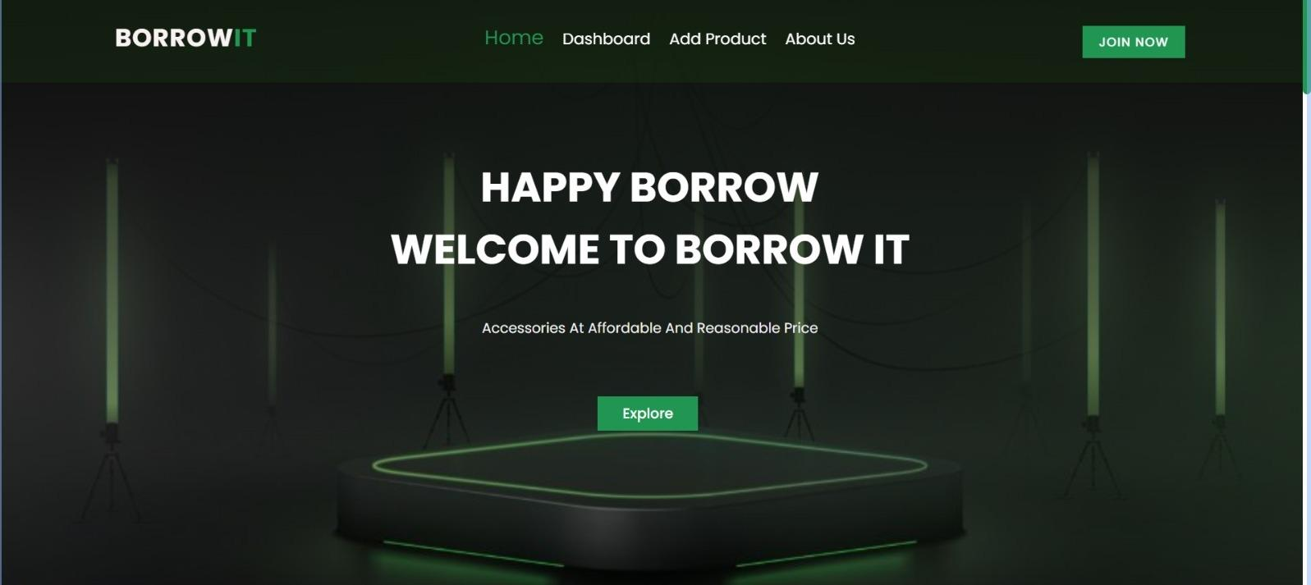

Login for Users: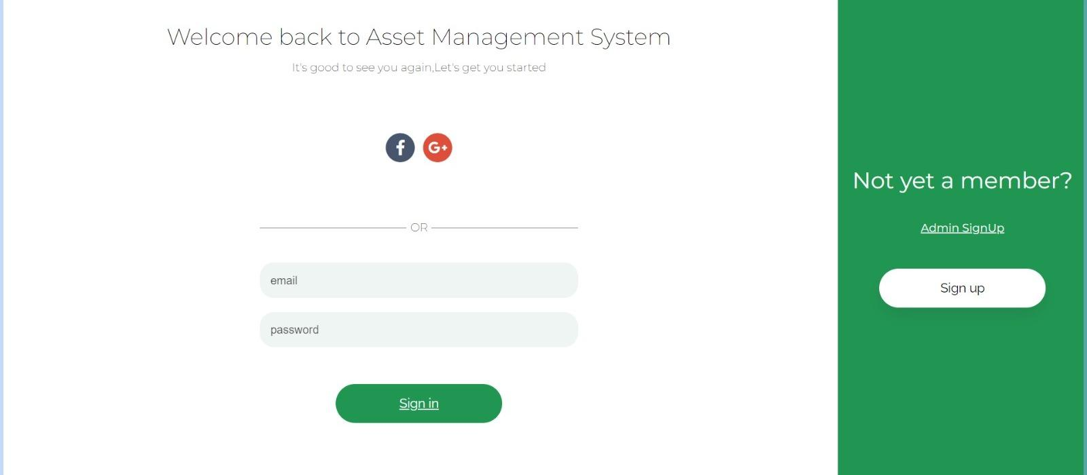

Asset Details:

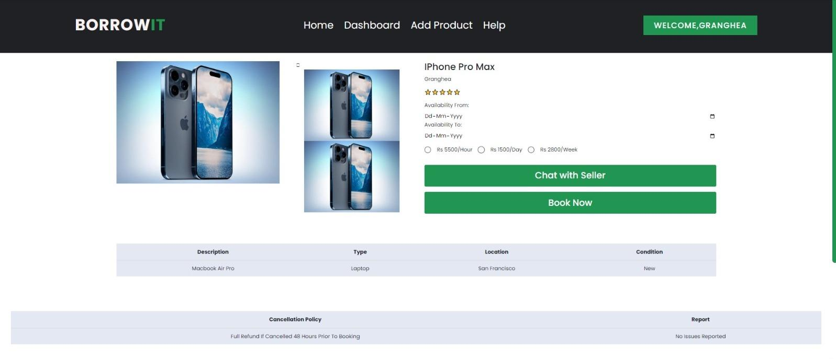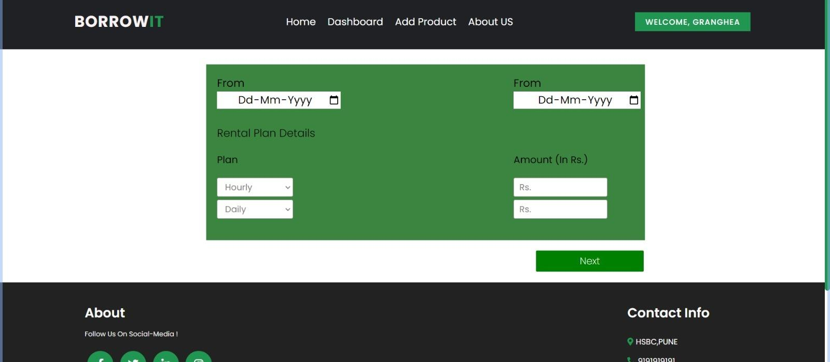

Booking request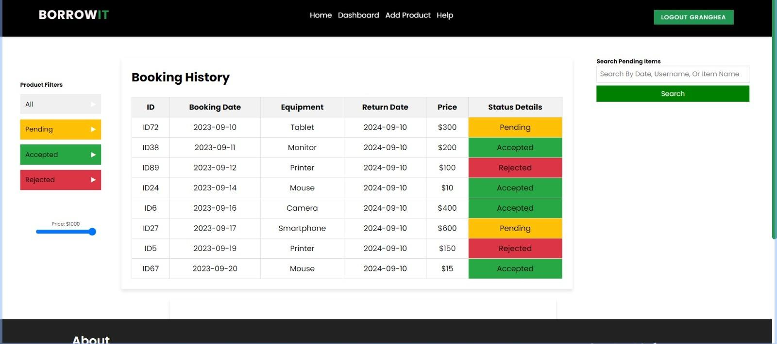Admin Dashboard 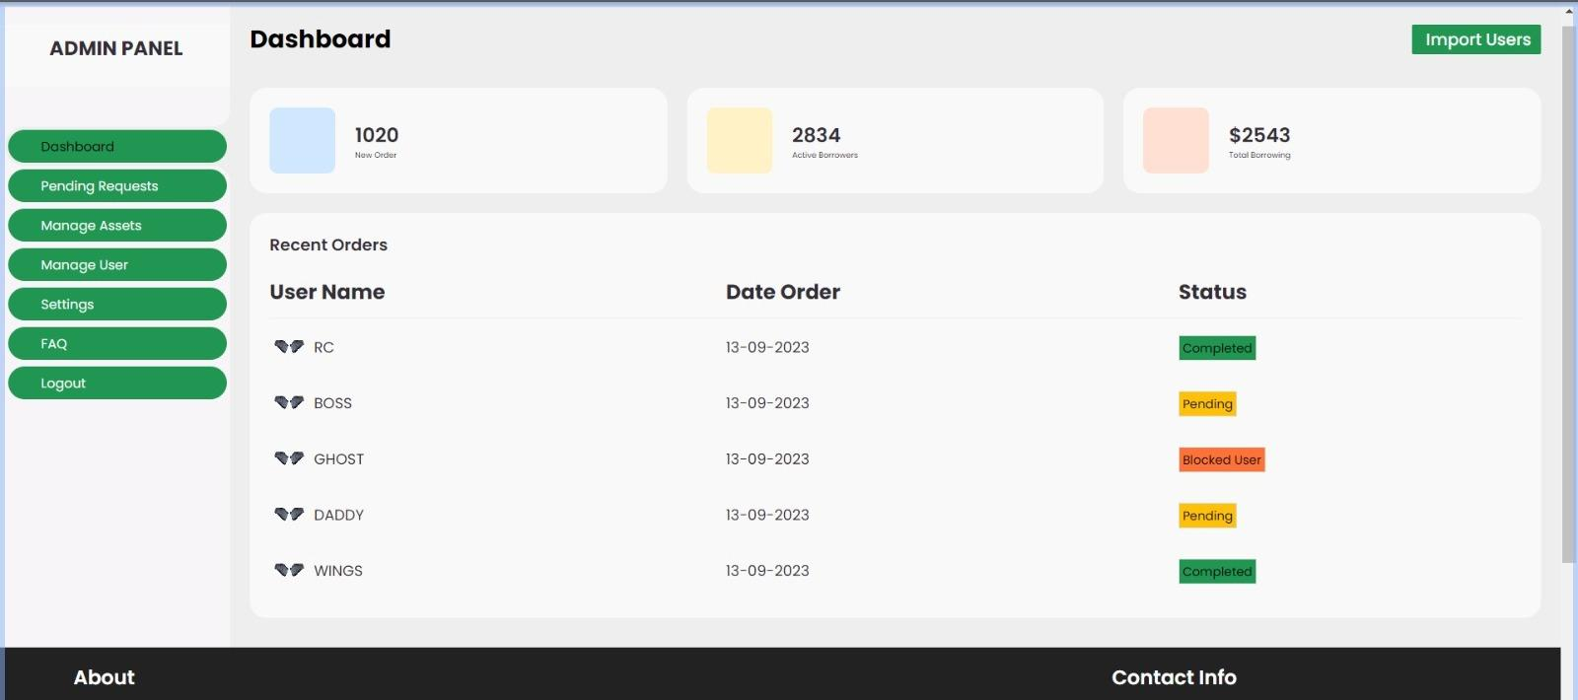

Pending Requests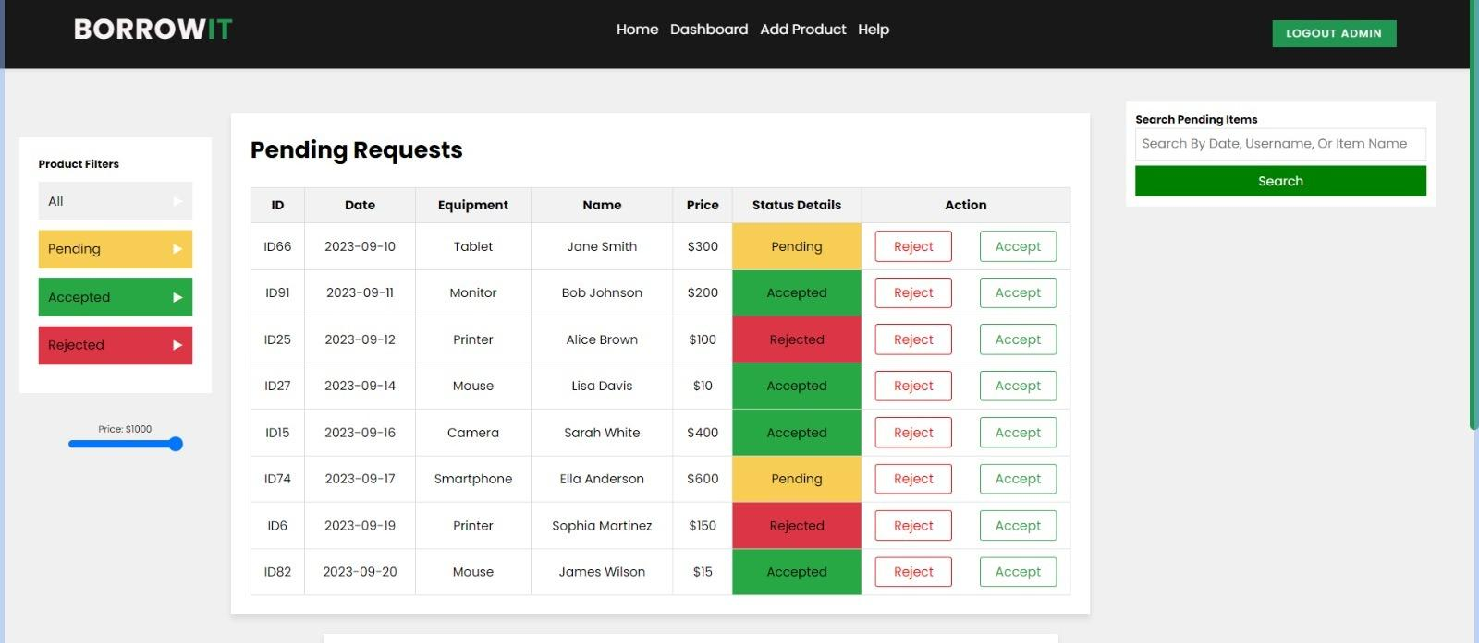Billing Page: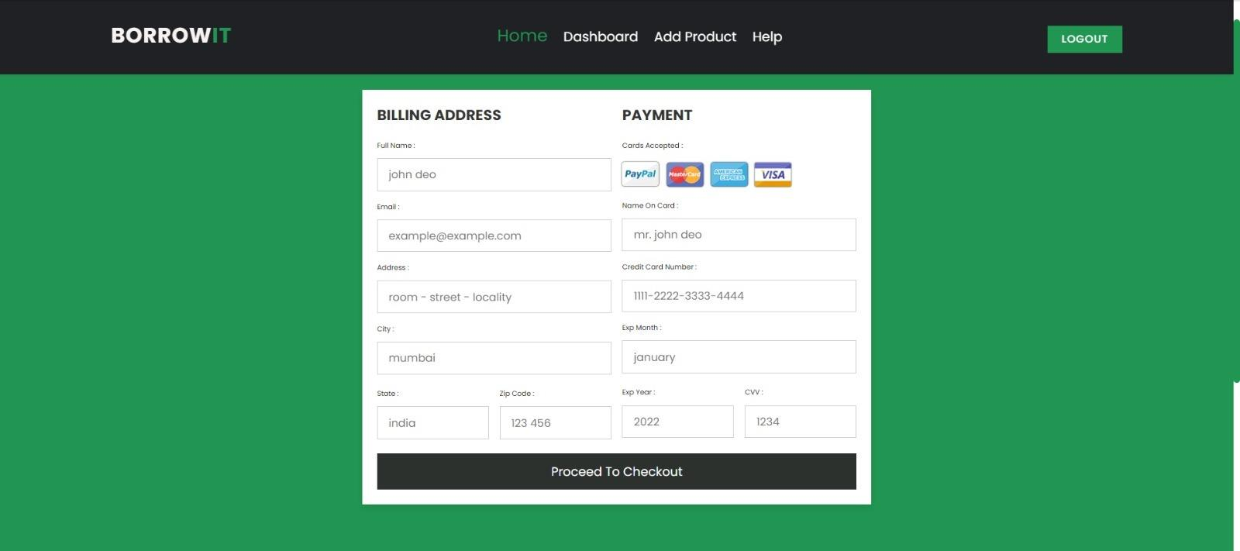

**Diagrams:**

Class Diagrams:

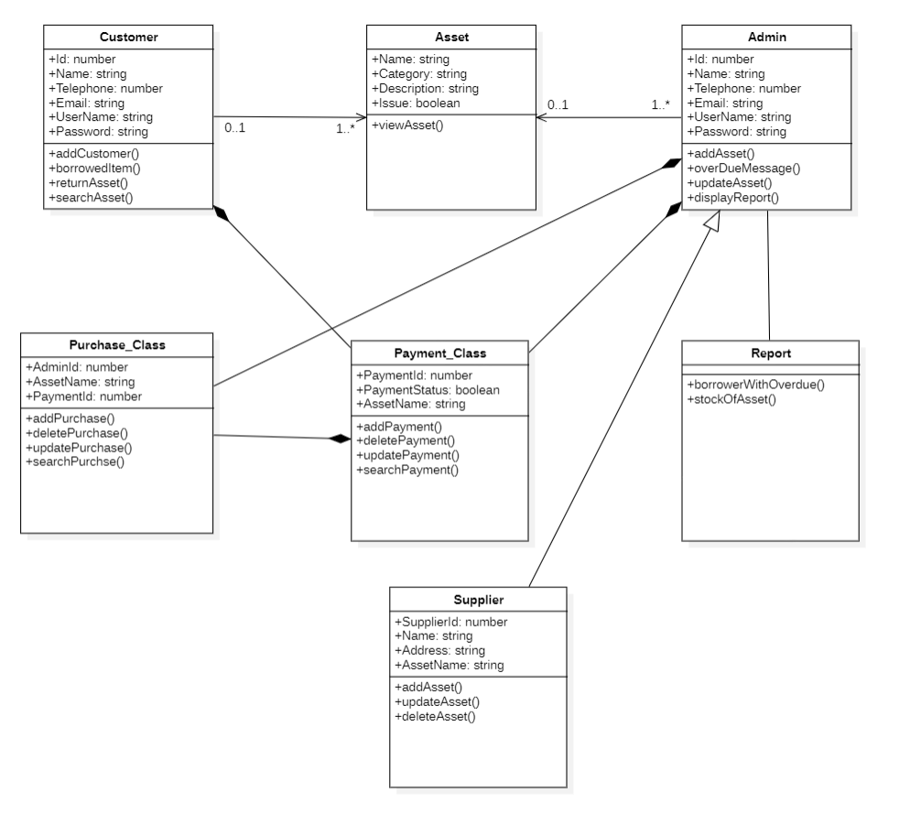

* Customer can have 0 or more Asset objects (ownership or borrowing).
* Admin manages multiple Customer and Asset objects.
* Purchase and Payment are related to Customer (1-to-many) as they record financial transactions.
* Report is associated with Admin, as Admins generate and view reports.
* Supplier supplies products, which may include assets listed in the system.

This class diagram provides a clear overview of the system's key components and their relationships. It serves as a blueprint for software developers to implement the E-Asset Management System, ensuring that the classes and their interactions are well-defined and aligned with the system's requirements.

Data Flow Diagram:

DFD LEVEL 0 :

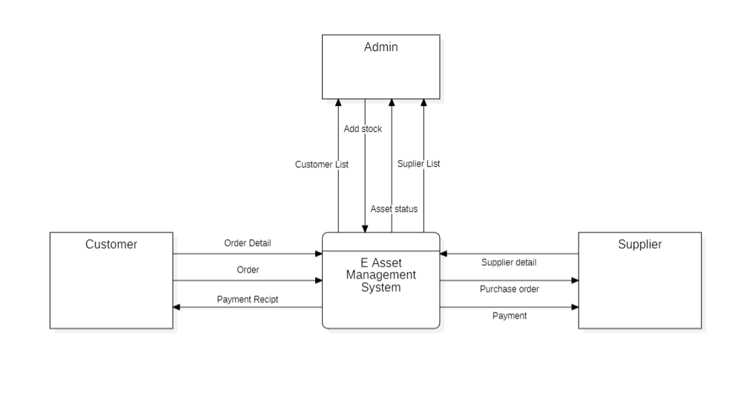

DFD LEVEL 1:

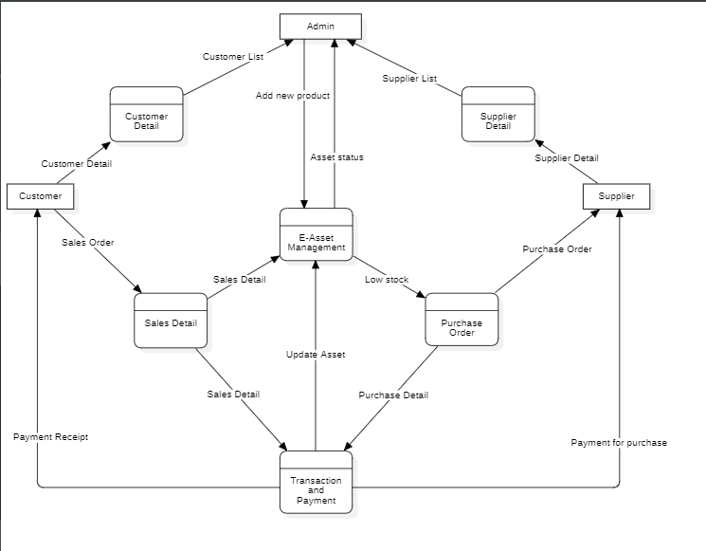

DFD LEVEL 2:

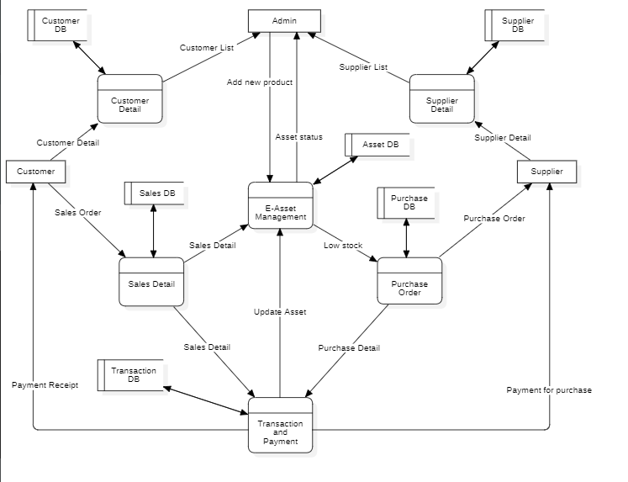

Use case Diagrams:

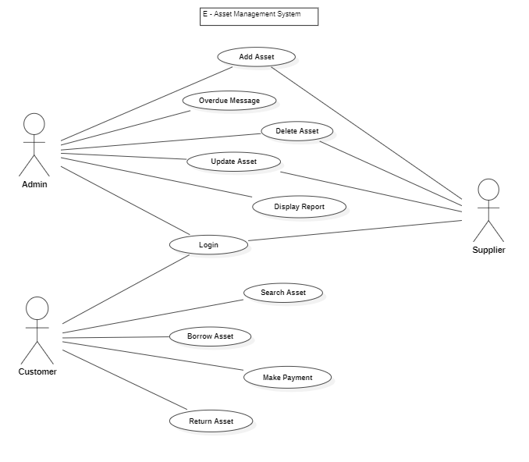

. In the context of the E-Asset Management System, a use case diagram:

Actors:

* Customer: Represents individuals or organisations using the system to manage assets, borrow, purchase, and make payments.
* Admin: Represents individuals responsible for overseeing and managing the system, including user management, asset management, and reporting.
* Supplier: Represents external entities that supply products, potentially including assets, to the system.

Use Cases:

* User Registration and Login:
  + Customer can register for an account.
  + Customer can log in.
  + Admin can log in.
* Asset Management:
  + Customer can create a new asset listing.
  + Customer can update or delete their asset listings.
  + Customer can browse and search for available assets.
  + Customer can request to borrow an asset.
  + Customer can return a borrowed asset.
* Financial Transactions:
  + Customers can make a payment for asset purchases or overdue fines.
  + Admin can view payment records.
* User Profile Management:
  + Customers can view and edit their profile information.
  + Admin can view and edit user profiles.
* Overdue Asset Management:
  + Customers can view their overdue assets.
  + Admin can manage overdue assets (send notifications, resolve disputes).
* Report Generation:
  + Admin can generate reports on asset utilisation, financial transactions, and system activity.
* Supplier Interaction:
  + Admin can interact with suppliers to manage product listings.

Relationships:

* Customer interacts with all use cases related to asset management, financial transactions, user profiles, and overdue asset management.
* Admin interacts with nearly all use cases, overseeing and managing the system, including user accounts, assets, reports, and supplier interactions.
* Supplier interacts with the system through Admin, supplying products (potentially including assets) and managing product listings.

This use case diagram provides a high-level overview of the interactions between actors and the system's functionalities within the E-Asset Management System. It serves as a valuable tool for understanding how different users and external entities interact with the system's features and processes.

**Project Outcome:**

The successful completion of the E-Asset Management Website project will yield a range of tangible outcomes that benefit both users and administrators. These outcomes include:

* A Fully Functional Website: The primary outcome is a fully operational E-Asset Management Website accessible via web browsers. Users can create accounts, manage assets, lend and borrow items, make payments, and access administrative features.
* User-Friendly Interface: Users will experience an intuitive and user-friendly interface that simplifies asset management tasks, making it easy to list, lend, borrow, purchase, and manage assets.
* Asset Management Capabilities: The platform will provide comprehensive asset management features, including asset profiles with images and descriptions, lending and borrowing functionality, and automated notifications for overdue assets and pending requests.
* Secure Payment Processing: Users will be able to make secure online payments for asset purchases and other fees, with payment history and receipts available for reference.
* User and Admin Authentication: Robust user and admin authentication mechanisms will ensure secure access to the platform, with role-based permissions and access controls in place.
* Administrative Control: Administrators will have access to a dedicated dashboard for managing user accounts, assets, and system configurations. They can also generate reports and monitor platform activity.
* Documentation and Help Center: Users will have access to comprehensive user guides and documentation to assist them in using the platform effectively. A help center or support system will be available to address user queries and issues.
* Scalable Architecture: The platform will be built on a scalable architecture, allowing for future growth in terms of user numbers and asset listings without significant performance degradation.
* High Security Standards: The project will implement robust security measures, including data encryption and compliance with relevant data protection and privacy regulations, to safeguard user data and transactions.
* Testing and Quality Assurance: Rigorous testing and quality assurance processes will ensure a stable and bug-free platform, delivering a seamless user experience.
* Deployment and Hosting: The website will be deployed on a secure and reliable hosting environment, with ongoing server maintenance and updates to ensure optimal performance.
* Training and Support: Users will receive training sessions or tutorials to facilitate their understanding of the platform. Ongoing customer support will address user inquiries and technical issues.
* Compliance: The platform will adhere to all relevant data protection, privacy, and financial transaction regulations, providing users with a compliant and secure environment.