DATA AND METHODOLOGY
To empirically estimate the short-run fiscal multiplier (k) for India, and assess on structural change introduced by the post-COVID-19 stimulus (2020–2024), this report uses quarterly data on Real Gross Domestic Product (GDP) at constant price and Government Final Consumption Expenditure (GFCE), taking base year as 2011-12 primarily sourced from the Reserve Bank of The data for this study comprises quarterly time series from FY2015 to FY2024. The selection of a Vector Autoregressive (VAR) approach situates GDP and GFCE, as they are interdependent, each affecting the other with lags(Perotti,2005) (Blanchard&Perotti,2002) . Economic activity and fiscal activity rarely occur at the same time, as the VAR framework allows for these delays. Economic activity and fiscal adjustments do not usually occur at the same time, so the VAR model allows for these time lags. The model estimates how past changes in government expenditure and output influence their current values, thus providing evidence on immediate patterns relating to overall impact. Two individual VAR(1) regressions are performed for each of the two sub-periods in order to assess whether a structural shift in fiscal effectiveness exists between the pre- and post-pandemic.
Real GDP represents the total inflation-adjusted value of goods and services produced in the economy, GFCE is the total spending by the government on goods and services for public use like salaries, defence, health and education. While GFCE does not include capital expenditure, our main aim is to see the effect of government spending with respect to COVID when government spending was more focused on health, social support and subsidies rather than capital formation. The two variables that we have considered in our model is the change in log of GDP and the change in log of GFCE for two time periods -pre and post COVID. The first difference of a logarithm approximates percentage change. Additionally, variables like GDP and GFCE have an increasing trend and hence this makes it non stationary. Taking log and differencing these variables ensures that the time series data is stationary.
Before going ahead with the VAR model, the stationarity of the time series data of GDP and GFCE is checked using Augmented Dickey Fuller test(ADF). This is done because non-stationarity leads to spurious regressions and makes the inferences unreliable. The ADF test results show that the pre and post covid GDP and GFCE time series are stationary.Considering the small sample size, only 20 values, the optimal lag length is 1.
The VAR model analyses two models :
$$Δln(GDP_{t}) =b_{0}+b_{1}Δln(GDP_{t-1})+b_{2}Δln(GFCE_{t-1})$$
$$Δln(GFCE_{t}) = a_{0}+a_{1} Δln(GDP_{t-1})+a_{2}Δln(GFCE_{t-1})$$
(This is a reduced-form VAR(1) system, capturing dynamic interdependencies without imposing prior causal structure.)
Once the estimates have been received, the stability of the model is considered. Stability of a model means that the model is behaving in a consistent, stable, and predictable way. Stability will assure that shocks have a short-lived effect, rather than escalating. A model is stable if the roots of the characteristic model are less than 1. This is used to ensure the impulsive response functions are valid. This is followed by a CUSUM test to check parameter stability i.e. whether the model’s estimated relationships remain consistent over time. This helps check whether any shocks disrupted the relationship between the variables. The Portmanteau test checks whether there exists any serial correlation between the residuals. The null hypothesis of this test is that there is no serial correlation between the residuals.
Following this, we do the Granger test to test whether a causality actually exists between GDP and GFCE. Next , the impulsive response functions are obtained which show how GDP growth reacts to increases to GFCE spending over the course of the next 8 quarters which is equivalent to 2 years. The IRF measures the dynamic effect of a one time one standard deviation shock in GFCE on GDP while holding everything else constant.This helps us see the effectiveness of Fiscal policy.The fiscal multiplier (k) measures how much the total output changes when there is a unit change in government spending.
$$k = \frac{ΔGDP}{Δ Government spending}$$
We can compute the fiscal multiplier by dividing the cumulative GDP response at time t to the Cumulative GFCE spending at time t.
$$Multiplier_{t}=\frac{cumulative GDP response_{t}}{cumulative GFCE response_{t}}$$
Lastly , we support our findings using the IS-LM model.
ANALYSIS AND INTERPRETATION
PRE COVID PERIOD (2015-19)
The VAR model output for pre covid period is given in table .
- Regression on change in log of GDP
Fig 4.1 : Regression Results for Change in Log of GDP of Pre COVID period
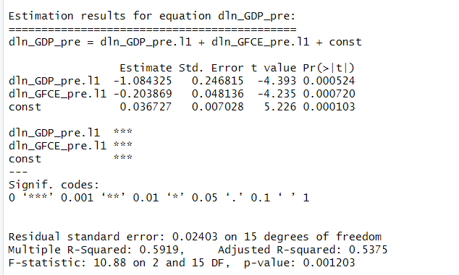
The model equation for pre covid period is given as:
$$Δln(GDP_{t}) =0.367-1.084Δln(GDP_{t-1})-0.204Δln(GFCE_{t-1})$$
The results from the VAR(1) model of pre COVID shows that GDP growth is significantly influenced by its own past value and by past growth in government . The estimated coefficient for past GDP growth is -1.08 and for past government spending is - 0.20. This tells that a 1% increase in GDP growth last period will lead to a 1.08% decrease in GDP growth the following period, holding all other values constant. Similarly, a 1% increase in government spending in the last period leads to a 0.20% decline in GDP growth in the following period while holding all other values constant.The constant term of 0.0376 is the average baseline GDP growth when all these lagged effects are balanced out.
The negative coefficients are surprising results. This implies that when the GDP or GFCE grew faster in the previous quarter, the GDP growth in the following quarter declined. This demonstrates a natural correction process where a period of GFCE growth is followed by a period of contraction, where the economy is stabilizing. The negative coefficient could reflect rational dynamics such as crowding out from increased borrowing from government which raises interest rates and crowds out private investment or lags measured adjustment process between policy actions and their impacts or just any policy response to increased government spending to avoid falling into a larger context of problems (like the central bank raises interest rates to help control inflation post-increased government spending). That said, negative coefficients more likely reflect cyclical mean reversion, output tends to revert to normal levels after a rapid growth period, rather than a literal contraction.
This model explains around 59% of the variation in GDP growth indicates a limited strong fit, and can be interpreted as the short term dynamics between economic growth and government spending.
- Regression on change in log of GFCE

Fig 4.2: Regression Result for Equation Change in Log GFCE for Pre COVID
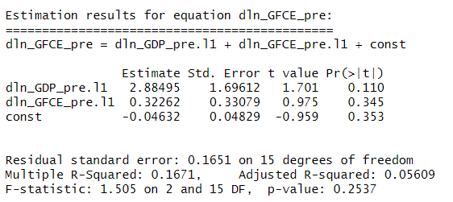
The model equation is given as:
$$Δln(GFCE_{t}) =-0.046+2.88 Δln(GDP_{t-1})+0.32Δln(GFCE_{t-1})$$
The second equation in the VAR(1) model explains how government spending growth behaves over time. The results show that GFCE is positively related to both past GDP growth and its own past growth. However these relationships are not statistically significant. We can see that the model is statistically insignificant (p value 0.25 >0.05) Overall, the results suggest that government spending growth does not systematically respond to past GDP or its own past values, and may instead be driven by other factors such as policy decisions, political priorities, or external circumstances rather than short-term economic movements.
- Diagnostic Checks
  - Model Stability

Fig 4.3.a: Model Stability of Pre COVID period
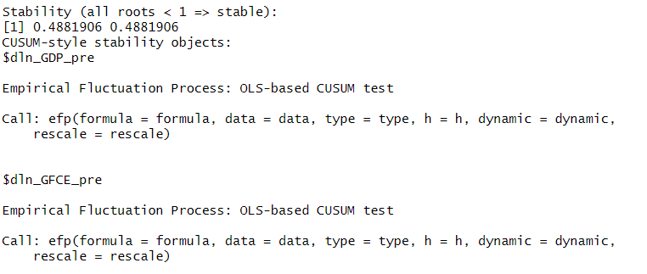
The roots of the characteristic polynomial are less than 1(0.488 , 0.488) hence the model is stable.The CUSUM test checks whether the model’s coefficient remains stable throughout the sample period. This model is structurally stable indicating that the relationships between GDP and GFCE did not change significantly over time.

  - Autocorrelation
Fig 4.3.b : Portmanteau test of Pre COVID test
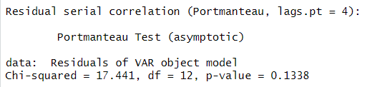
The Portmanteau test checks whether the residuals from the model are correlated across time. The null hypothesis states that there is no serial correlation between the residuals. The p value 0.13 > 0.05 hence we fail to reject the null hypothesis.
All diagnostic tests confirm that our pre covid model is stable and well behaved hence ensuring that the results are reliable.
- Grangers Causality test
Fig 4.4.a: Granger Causality Test for Pre COVID for GFCE
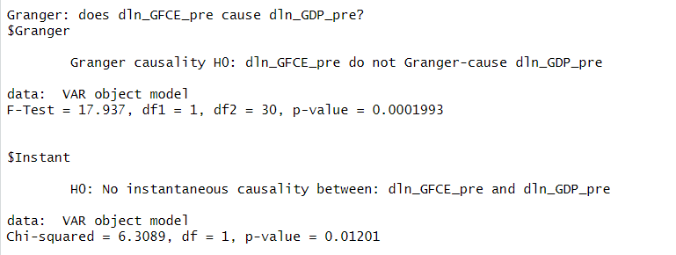
The Granger's Causality test tests whether the past GFCE growth can strongly predict future GDP growth. The null hypothesis is that GFCE growth does not cause GDP growth.The p value is 0.0002 <0.05 hence we reject the null hypothesis. The instant causality tests whether both variables have a significant relationship at the same time. The null hypothesis is that there is no significant relationship. The p value is 0.012<0.05 hence we reject the null hypothesis.The results show that changes in GFCE growth not only help predict future GDP growth but also have an immediate impact on it. This suggests that fiscal policy can strongly influence the economy.

Fig 4.4.b: Granger Causality Test for Pre COVID for GDP
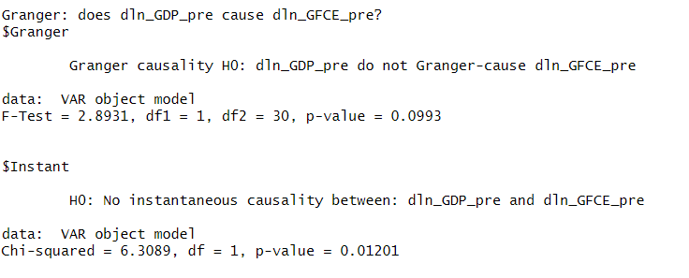
The causality test also shows that while GDP growth does not have a significant impact on influencing GFCE growth, there is strong evidence that there is an impact of GDP growth on GFCE growth in the same period.
- Impulsive Response Function
Fig 4.5: Impulsive Response Function for Pre COVID
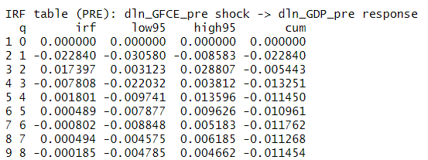
The impulse response function shows how GDP growth reacts when there is a sudden change in government spending.This helps us understand whether the fiscal policy has been more or less effective in influencing economic activity for the two time periods.
When government spending suddenly increases, there are no instantaneous effects .However, GDP growth drops a little bit in the first quarter by 2.28 % and then rises in the next quarter by 1.74 %and after that the effect is almost 0.
- Fiscal Multiplier
Fig 4.6: Fiscal Multiplier for Pre COVID
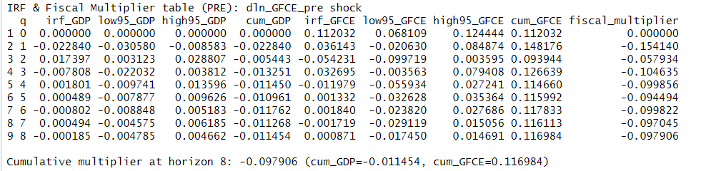
The fiscal multiplier measures how much GDP changes in response to a one unit change in GFCE. In this table, all the fiscal multipliers are negative across the 8 quarters. In the first quarter the multiplier is about -0.15 meaning that a 1 unit rise in GFCE will lead to a 0.15 decline in GDP. Over the next quarters, the multiplier fluctuates between -0.10 and -0.05. The cumulative fiscal multiplier at quarter 8 is -0.0979 indicating that over the span of two years an increase in government spending leads to a decline in output rather than an expansion.

POST COVID PERIOD (2020-24)
- Regression on the change in log of GDP
Fig 4.8: Regression Results for change in log of GDP
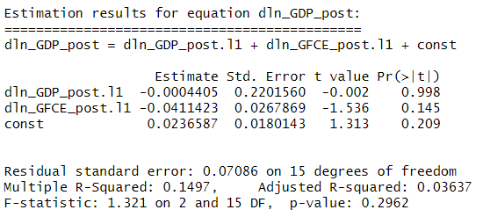
$$Δln(GDP_{t}) =0.0237-0.0004Δln(GDP_{t-1})-0.041Δln(GFCE_{t-1})$$
In the post COVID period, the relationship between GDP growth and GFCE growth is weak and statistically insignificant.The coefficient for the lagged government spending growth is -0.041 while that for lagged GDP is -0.00044. This tells that a 1% increase in GFCE growth in the previous quarter leads to a very small 0.041 drop in GDP growth.The R squared value of this model is very low 0.15 and the adjusted R squared is much lower 0.04, suggests that post-COVID growth dynamics were driven by non-fiscal factors such as exports, private investment recovery, or global demand cycles. The model is not statistically significant (p value 0.29>0.05), suggesting that fiscal impulses no longer translated into proportional output gains, possibly due to crowding out or offsetting monetary tightening.
- Regression on the change in log of GFCE
Fig 4.9: Regression Results for change in log of GFCE
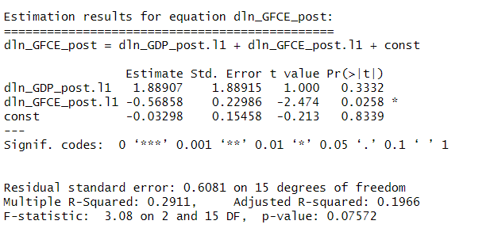
$$Δln(GFCE_{t}) =-0.032+1.889Δln(GDP_{t-1})-0.568 Δln(GFCE_{t-1})$$
This model analysis reveals that the government spending growth is mainly influenced by its own past variable rather than by GDP growth. The coefficient on lagged government spending growth is -0.57 and is statistically significant. This tells that a 1% increase in government spending last quarter will lead to a 0.57 % drop in the following period. This again suggests a correction pattern where growth in one period is followed by slowdown in next. The impact of lagged GDP is positive but not statistically significant indicating that the relationship is likely due to chance. The model has a moderate R squared value of 0.29. The model is not statistically significant (p value <0.07572)
- DIAGNOSTIC TESTS
  - Model Stability

Fig 4.10.a: Model Stability of Post Covid
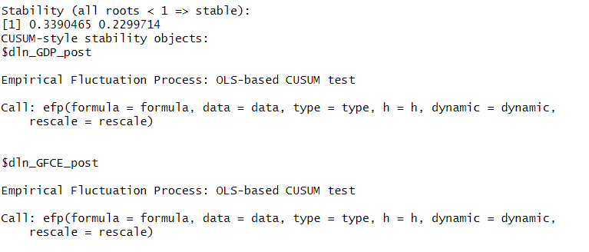
The roots of the characteristic polynomial are less than 1 (0.339,0.229) indicating that the model is stable. The CUSUM test shows structural stability and a consistent relationship between the variables.
The stability tests confirm that the model is properly specified and dynamically well behaved. This means that the lack of statistical significance is not due to model instability but rather shows real changes in the economic environment after COVID.
- Autocorrelation
Fig 4.10.b: Autocorrelation of Post Covid
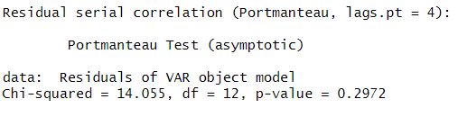
The portmanteau test checks if the model's residuals are correlated across time with the null hypothesis that there is no serial correlation between residuals. The p value > 0.05 hence we fail to reject the null hypothesis. The residuals behave like random noise.
- Granger’s causality test
Fig 4.11.a: Results for Granger casuality Test
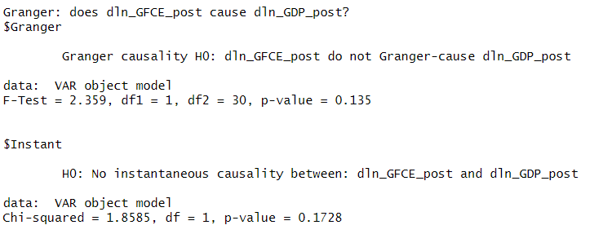
The Granger causality tests if there is no significant predictive relationship between government spending growth and GDP growth. The test shows that the past GFCE growth cannot significantly predict the future GDP growth (p value=0.135>0.05, fail to reject null hypothesis) additionally there is also no instantaneous impact(p value =0.1728>0.05, fail to reject null hypothesis). The absence of causality confirms a decoupling between fiscal consumption and output growth, reflecting a structural regime shift.
Fig 4.11.b: Results for Granger casuality Test
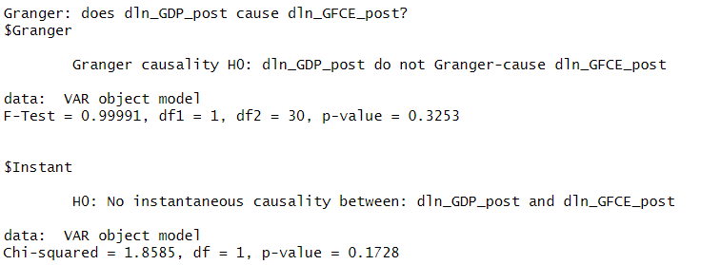
Similarly , GDP growth also does not have significant power to predict future GFCE growth.
- Impulsive response function
Fig 4.12:Results for response function
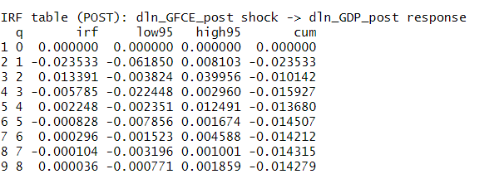
The impulse response results for the post COVID period shows how an increase in government spending impacts GDP growth. This assesses the effectiveness of fiscal policy. After the shock, there was no immediate impact on GDP growth. However, in the first quarter GDP growth falls by 2.3% followed by an increase by 1.33% in the 2nd quarter. After that the impact is almost 0.
- Fiscal Multiplier
Fig 4.13 : Fiscal Multiplier for Post COVID
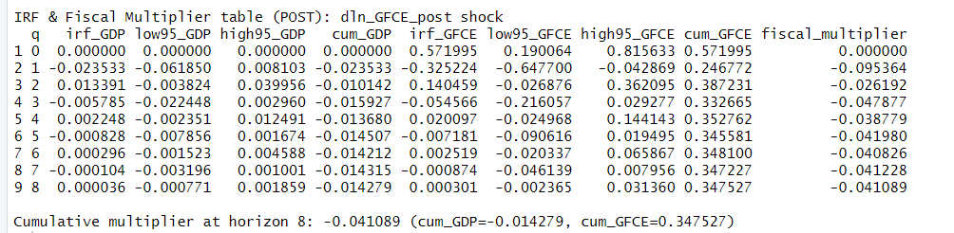
The fiscal multiplier after the shock remains negative throughout all the quarters and the magnitude is a bit smaller than the pre shock period. At the first quarter the multiplier is -0.095 suggesting that a 1 unit increase in GFCE will lead to a 0.095 decline in GDP. In the subsequent quarters, the multiplier fluctuates between -0.04 and -0.09. The cumulative multiplier at quarter 8 is -0.0411 that is the overall increase in government consumption leads to a small decline in GDP.
IMPORTANT RESULTS
- Negative fiscal multiplier
An important result of the multiplier is that it is negative. Firstly, India’s public borrowing was relatively high throughout 2015-2024 shown by its increasing fiscal deficit as a % of GDP. When the government increases its borrowing , it leads to a higher interest rate which discourages private investment which is a significant contributor to GDP hence showing a dip in GDP growth.
Table 4.1 : Fiscal Deficit Data from RBI
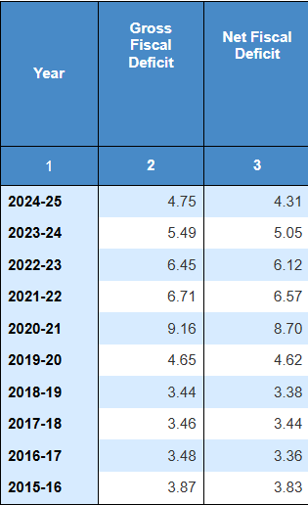
In this model we have considered GFCE which does not include government capital expenditure which has a stronger multiplier effect because it boosts demand and productivity. GFCE only includes spending to facilitate salaries , subsidies and goods and services.
Additionally , an increase in government spending raises the demand in the economy. However if the supply does not adjust to this increase there can be inflationary pressures. This is especially the case during post COVID when all production was at a standstill.The central bank responds by tightening the monetary policy or increasing the interest rate hence overthrowing the initial boost from fiscal expansion.
Government spending, especially on public projects, often takes time to translate into real economic activity. Delays in approvals, tendering, and execution mean that money allocated in one quarter may not generate output until later periods.
- Pre COVID vs Post COVID
The comparative analysis of the VAR models shows a drastic structural breakdown in India’s fiscal efficiency in the aftermath of structural reforms. During the Pre-COVID period (2015–2019), the GFCE relationship was -0.20, weak, also had some statistical significance: GFCE Granger Caused GDP growth and the IRF resulted in a temporary cyclical effect (down and then back up). The Granger Causality test confirms that GFCE growth significantly causes GDP growth both with and without lag. The impulse response function shows that after a sudden shock in government spending, GDP growth falls by 2.3 % in the first quarter then increases by 1.7% in the next and after that it becomes negligible.
For the post COVID model, the coefficients for lagged GDP and GFCE (-0.0004 and -0.0410 respectively) were statistically insignificant. This combined with the fact that model and parameter are stable suggests that there was a structural breakdown after the pandemic.The Granger causality tests further confirm this weakening link — government spending no longer Granger-caused GDP growth, and there was no instantaneous effect either. This suggests that although the government substantially increased its spending after COVID , these actions rather than stimulating growth act as stabilizers to prevent economic collapse. The impulse response function shows that after a sudden shock in government spending, GDP growth falls by 2.35% in the first quarter then increases 1.5% in the next and after that it becomes negligible.The fiscal multiplier for post COVID has a lesser negative impact than pre COVID.
Despite the almost same magnitude of multiplier, the actual difference lies in the strength of relationships. The empirical finding does not suggest that the government did not spend; rather it suggests the economic shock was so severe that GFCE became a negligible variable simply providing output stabilisation against collapse while the actual recovery was driven by unmeasured factors, such as massive CapEx and financial liquidity. The loss of explanatory power supports thinking of structural shifts in policy priorities and new economic dynamics after the COVID shock. The pre COVID economy showed stable and statistically significant output while the post COVID model showed weak and economically insignificant dynamics. This loss of explanatory power suggests a structural breakdown after COVID.

REFERENCES
Blanchard, O., & Perotti, R. (2002). An empirical characterization of the dynamic effects of changes in government spending and taxes on output. the Quarterly Journal of economics, 117(4), 1329-1368.
Handbook of Statistics on Indian Economy - Reserve Bank of India. (n.d.). https://share.google/2wGASQPt26kpmgRrn
Froyen, R. T. (2005). Macroeconomics : theories and policies / Richard T. Froyen. (8th ed.). Pearson/Prentice Hall.
Ganti, A. (2024, August 13). Fiscal Multiplier: Definition, formula, and example. Investopedia. https://www.investopedia.com/terms/f/fiscal-multiplier.asp
Perotti, R. (2005). Estimating the effects of fiscal policy in OECD countries. Available at SSRN 717561.

