Graphical Analysis of Macroeconomic Indicators
The study uses a graphical approach to analyze how the three macroeconomic variables respond to the COVID shock. We focus on the three periods: Pre COVID period (2004-2019), COVID period (2020) , and Post COVID period (2021-2024). A vertical reference line marks the onset of COVID 19 which makes it easier to compare the different periods. Plotting all three variables on the same graph enables direct comparison across indicators. This helps us understand how each variable responded in the three phases.

Adjustment Ratio
The study employs a graphical and numerical analysis of the year on year absolute changes in macroeconomic variables, specifically inflation and unemployment. First, the absolute year on year change for both the variables is calculated. Then their first difference is taken by differencing the value in the past year from the current year.

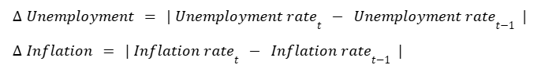

The use of absolute changes lets our study focus on the magnitude of fluctuations rather than the direction which makes it easier to compare the extent of variation across variables. The absolute changes are then plotted over the time period in order to see how strongly each indicator reacted . This comparative line graph shows a clear visualization of the volatility and responsiveness of each variable across the three phases - Pre COVID, during COVID, Post COVID.

Next, an Adjustment Ratio is constructed to measure the relative adjustment between the two variables. The formula is :

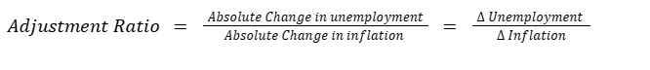

This measure standardizes and compares the relative responsiveness of the labour market and prices. An adjustment ratio greater than 1 indicates that unemployment adjusted more than inflation , thereby implying that the labour market bore the brunt of adjustment.This suggests the presence of price rigidities. An adjustment ratio less than 1 indicates that inflation adjusted more than unemployment, thereby implying that prices are more flexible, The adjustment ratio is also plotted over the time period to see which variable adjusted more before , during and after COVID.

Results
The COVID -19 pandemic in 2020 brought about a major macroeconomic disruption in India. Economic activity came to a sudden standstill thereby stopping production across sectors. As costs rose and revenues declined , firms were forced to lay off workers , especially those from informal sectors.Both global and domestic supply chains were severely disrupted , making COVID 19 a unique shock with both demand and supply components.

Results from Graphical Analysis
The line graph of GDP growth, inflation rate and unemployment rate over the years 2004-2024 is shown in Fig 1. The dashed vertical line marks the COVID-19 shock. Before COVID, the economy experienced a relatively stable and positive GDP growth fluctuating around 6-8%. In 2020, for the first time in the past two decades India experienced a negative GDP growth of -5.7 %. Thus, the economy suffered a structural break with GDP growth falling by approximately 9.6 percentage points from 2019 levels during COVID 19. Post COVID, GDP growth shows strong recovery with growth being around 9-10% before returning to a stable trend.

Fig 1 : Macroeconomic Indicators over Time Period (2004-2024)
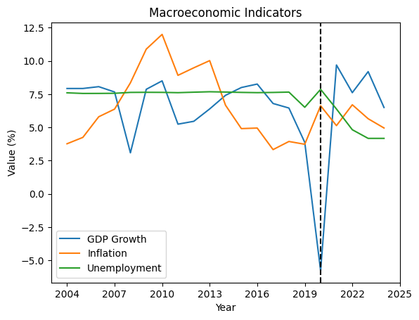

The unemployment rate remained flat and relatively stable at around 7.5% before the pandemic, implying that the labour market did not experience any major year to year fluctuations. During COVID, the unemployment rate rose to 7.86% . However, while there was a rise, the effect was not as large as expected based on the scale of decline in GDP. The rise was muted because the unemployment rate in our study only captures the formal sector. The informal sector which was the most affected by the pandemic were not included. Thus , our data does not show the actual impact on unemployment. After 2022, the rate began to show a gradual decline.

The inflation rate is the most volatile out of the three indicators , showing frequent peaks and dips throughout the time period. During COVID pandemic, rather than declining as per standard demand side theories when a recession occurs, it actually increases sharply to 6.62%. This is because COVID 19 was a unique exogenous shock that had both supply side disruptions and demand side contractions . There were severe supply side disruptions like supply chain breakdowns, mobility restrictions and lockdowns. These disruptions generated cost push inflation where the increased cost of doing businesses was passed onto consumers. Post COVID inflation declined as supply chains stabilized .The Table1 summarizes the way the three indicators behaved in the different periods.

Indicator | Pre Covid | During Covid | Post Covid
GDP growth | Fluctuates around 6-8% | Drops to negative value (-5.7%) | Strong recovery
Unemployment Rate | Stable around 7.5% | Rises to 7.86% | Declines
Inflation rate | Volatile | Increases unexpectedly | Fluctuates and remains somewhat elevated
Table 1 : Key Macroeconomic Indicators across Three Time Phases

Absolute Change in Unemployment vs Absolute Change in Inflation
Fig 2: Absolute Change in Unemployment vs Absolute Change in Inflation (2004-2024)
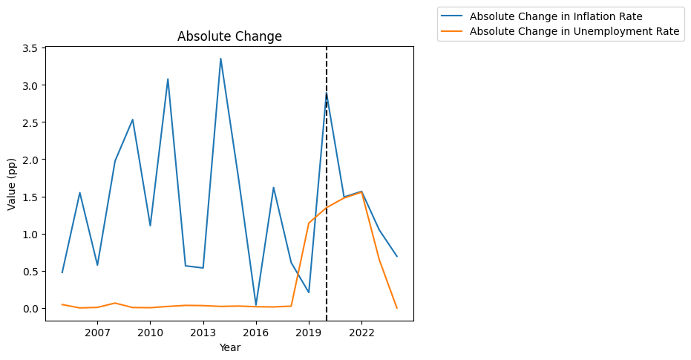
Fig 2 gives the line graph of the absolute year on year changes of unemployment and inflation rate over the years 2004-2024. Pre COVID , inflation rate has been very volatile fluctuating by 1-3 percentage points every year. The unemployment rate is almost zero showing that the labour market has been extremely stable. Together, this implies that in normal economic years, prices were relatively quick to adjust to economic changes rather than unemployment.

During COVID, both the variables saw a huge jump. The change in inflation (2.9 points) was much larger than the change in unemployment ( 1.35 points). This implies that prices actually moved more than jobs did. However, since COVID was a dual shock, it is difficult to see how inflation changed because the impact of supply side shock could not be controlled to see how prices behaved.

Post COVID, both the variables decline showing that the economy is finally stabilizing after the external shock.

Evidence from Adjustment Ratio

Fig 3: Adjustment Ratio over the Time Period (2004-2024)
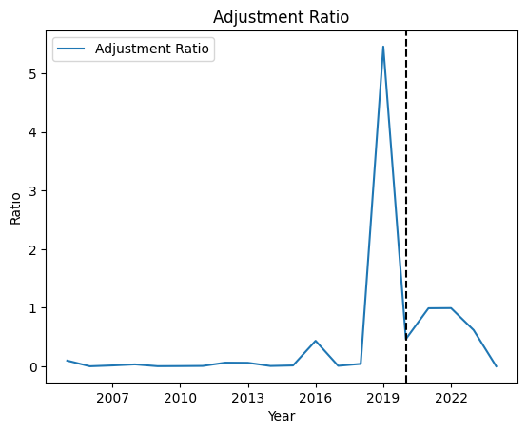
The Fig 3 shows the adjustment ratio across the years 2004-2024. Before COVID, the adjustment ratio is close to zero. This shows that in normal years, inflation fluctuated frequently while unemployment barely moved. Thus, the Indian economy adjusted through prices rather than the labour market during normal years. This was also observed in Fig 2. Only in 2019, the adjustment ratio is greater than 1 suggesting that prices are rigid and hence unemployment adjusts more than unemployment.

During the COVID shock, the ratio is about 0.46. The Table 2 shows that inflation increased by 2.89 pp while unemployment changed by 1.34 pp. The ratio being less than 1 implies that prices became flexible. However, this happened because the supply side shock forced prices to rise and hence creating cost push inflation that dominated over the effect of price stickiness.

The Adjustment ratio declined after COVID as the economy stabilized. This could be seen from the decline in absolute change in both the variables in Fig 2.

Year | Absolute Change in Inflation | Absolute Change in Unemployment | Adjustment Ratio
2019 | 0.20932 | 1.142 | 5.45
2020 | 2.893931 | 1.349 | 0.46
2021 | 1.49203 | 1.479 | 0.99
Table 2 : Adjustment Ratio (2019-2021)

