Fig 1: Impact of COVID-19 on India’s Digital Payments ( Dashboard)
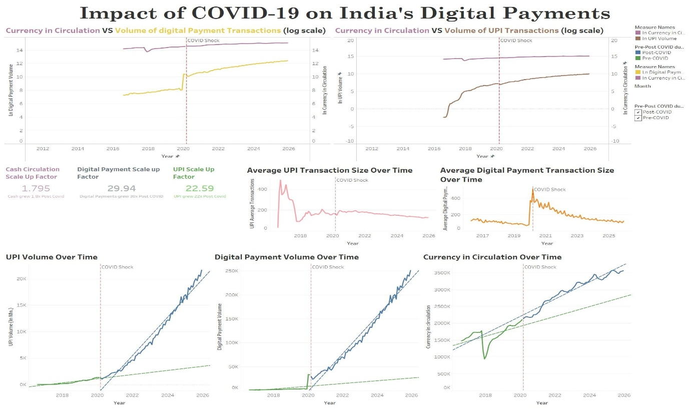

UPI Volume Over Time
The Fig 1 graph tracks the UPI volume (in millions) showing the pre covid as well as the post covid growth in transaction volume over the time period of 2016 to the present. The vertical dashed line represents the structural break of covid-19 shock.The green line, which shows the pre covid volume, has a steady upward growth trend. Following the covid shock the volume entered an aggressive steep growth phase, as shown by the blue line's sharper upward trajectory. UPI transaction volumes surged nearly 10-fold—from 2,000 to 22,000 over six years, marking a massive structural shift in digital payments adoption. The green and blue dotted lines show the trend line for Pre covid and post covid respectively.
The blue line crosses easily over the vertical dashed line without any break or gap between the trend line (green dashed line) and the actual post-COVID blue line. Although UPI volume later increased sharply, there is no visible immediate discontinuity at the COVID-19 break. Instead, the post-COVID series shows a much steeper trajectory, suggesting that the pandemic acted primarily as a trend accelerant, increasing the rate of UPI adoption without creating a clear vertical discontinuity in the time series.
Fig 1: UPI Volume over time
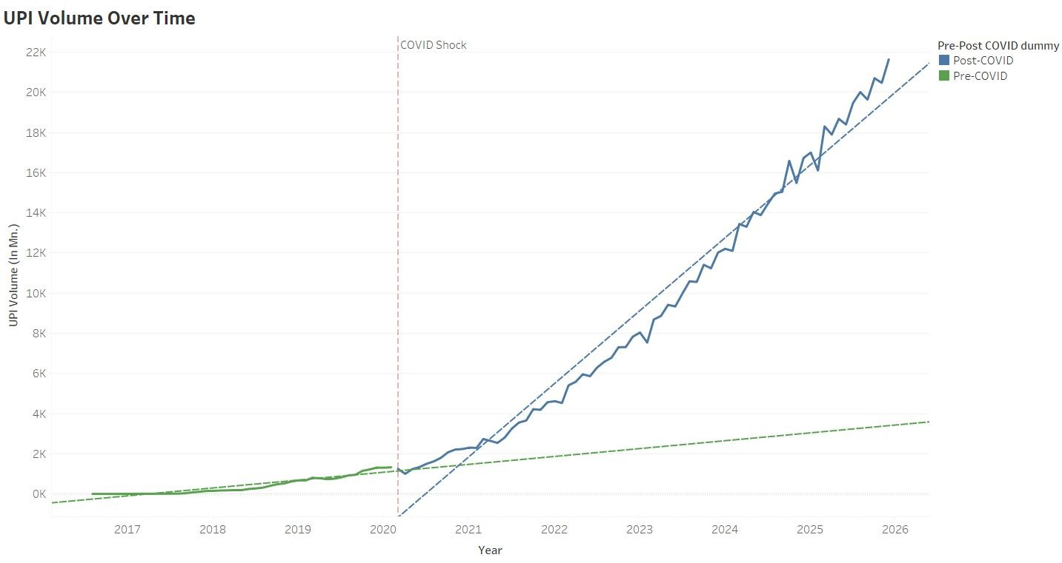

UPI Trend Over Time
The post-COVID UPI volume growth shows an upward trend, but the graph does not indicate a fundamental change in the way UPI transactions increased over time. The UPI system appears to have experienced substantial growth before and after the pandemic, with monthly growth rates declining from an average of 37.52% before COVID to 4.31% after COVID. The large increase in transaction volume therefore occurred alongside continued compounding of the existing upward trend.

Average UPI Transaction Size Over Time
The Fig 3 graph represents the average UPI transactions over the time. The average transaction size peaked in the early years of launch due to the ease of transactions and substituting for other high value digital payments like NEFT and RTGS. The retail adoption was still quite low. The drop in the average transactions intensified during 2017 , as volumes exploded (e.g., from millions to billions monthly) while value per transaction halved, driven by micro-payments from frequent retail usage further substituting currency. Post 2018 the graph shows a stable amount of UPI transactions over the time without any structural change during covid.
UPI's average monthly growth rate decelerated from a pre-COVID average of 37.52% to a post-COVID average of 4.31%. This indicates that the sharp increase in total UPI transaction volume was accompanied by a lower percentage growth rate over time.

Fig 3: Average UPI Transactions Size Over Time
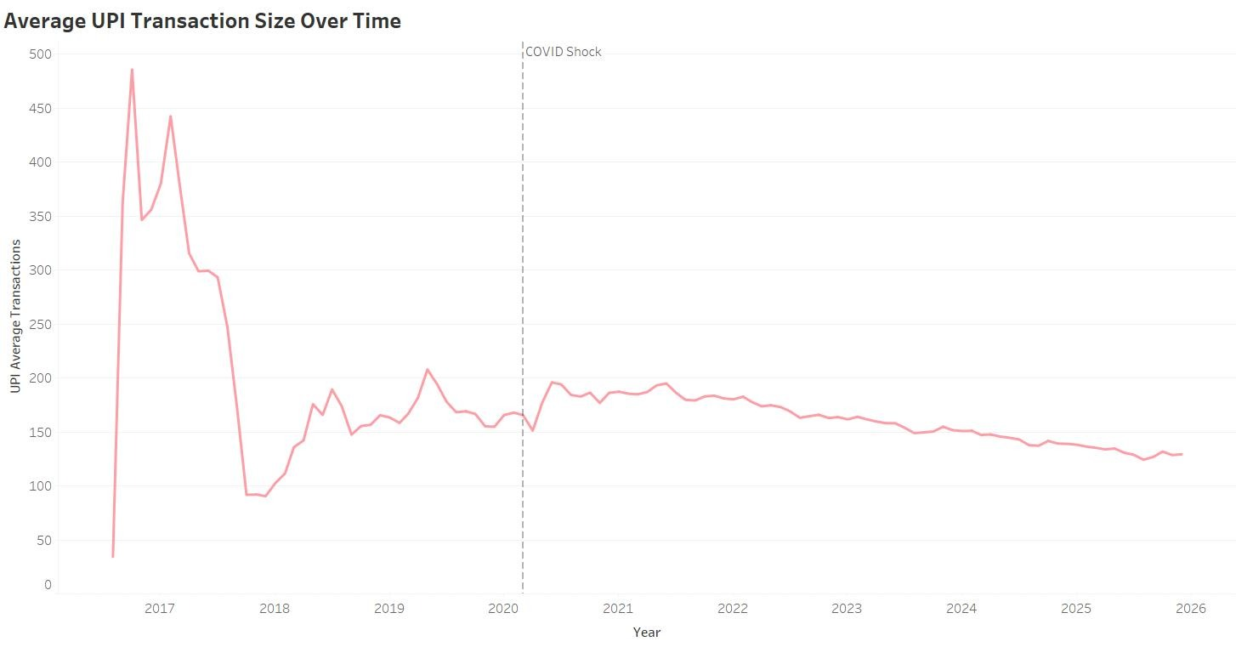

Digital Payment Volume Over Time
Fig 4:Digital Payment Volume Over Time
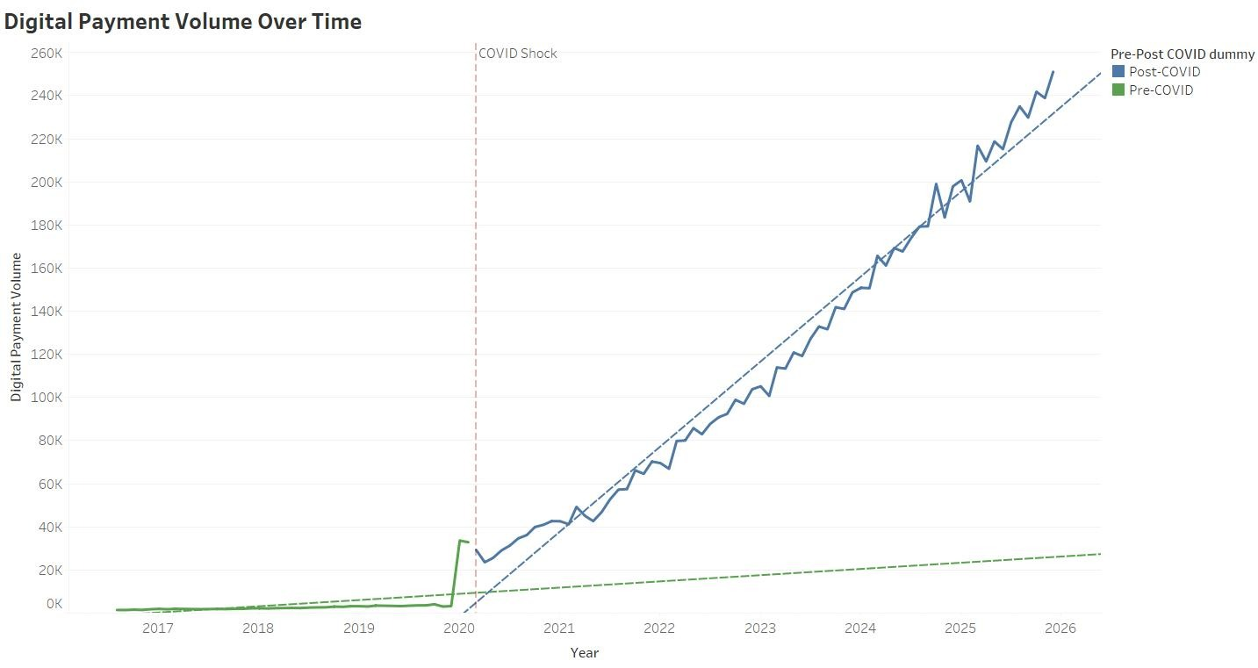
The above graph represents the digital payments volume of transactions. As evident from the graph, the green line pre covid shock starts low around 10-30k (in millions) from 2017-2019. Post covid adoption of digital payment spiked, rising exponentially about 6.5 times. The green and blue dotted lines show the trend line for Pre covid and post covid respectively. Covid lockdowns accelerated India's shift to contactless digital payments like UPI, onboarding millions of new users amid hygiene concerns and movement restrictions.
The ITS model graph visually shows a massive immediate level change in digital payment volumes around the COVID-19 break. The instantaneous jump around the vertical line reflects a sharp change in the series, with actual post-COVID volumes (blue) moving far above the pre-COVID trend/counterfactual line (green dashed).

Digital Payment Trend Over Time
The graph does not show a clear permanent change in the long-term growth pattern of total digital payment systems. The increase in digital payment volumes during the COVID period is followed by continued growth along the existing upward trajectory rather than a clearly different long-term slope.
The increase in digital payment volumes during the COVID period shows temporary growth which does not create permanent changes to existing long-term patterns. The research findings show different payment channels experienced different levels of impact from the pandemic. The total digital payment increases which were observed during the study period occurred because non-UPI payment methods such as NEFT and IMPS and cards and wallets had additional potential for growth and user adoption.
UPI had achieved complete market adoption before COVID-19 arrived because previous policy changes like demonetization had already established its usage. The pandemic did not change UPI's growth path because its expansion progressed normally. Previous research probably exaggerates the effect of COVID-19 on UPI expansion because researchers based their findings on digital payment research which examined total payment systems without identifying different payment methods.

Average Digital Payment Transaction Size Over Time
The Fig 6 graph illustrates average digital payments transactions size. The pre covid period was characterized by low and stable transaction sizes. This suggests that digital payments were slowly becoming retail-oriented. This was followed by a sharp spike ,of about 5 times, for the year of covid shock reflecting a fundamental change in the digital payment mix in India. The post covid timeline, after the structural break hit, the graph shows a volatile but persistent downward slope. By 2026, the average size has returned to a range of ₹100–₹150. This "reversion to the mean" indicates that as the economy reopened, the volume of small-value retail transactions finally began to outweigh the high-value institutional "shock" transactions.
Visually, the graph indicates a sharp change at the structural break. The immediate spike in average transaction values is followed by a volatile but persistent downward slope, with the series gradually moving back toward lower transaction sizes after the COVID period. The immediate spike can be viewed alongside the shift in the composition of digital payments toward high-value settlements during the shock.
Fig 6: Average Digital Payment Transaction Size Over Time
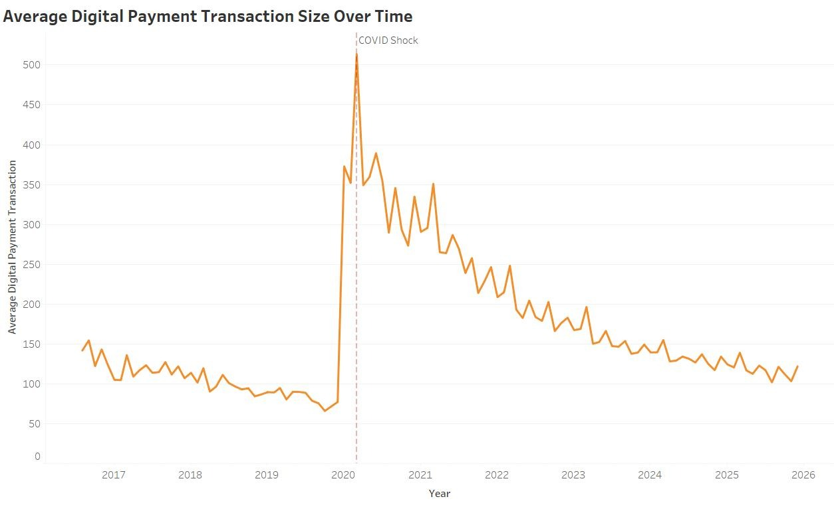

Extended Graphical Analysis: Key Performance Indicators
The Fig 7 graph displays the relationship between currency circulation and UPI transaction volume which uses a log scale to show their changes throughout different time periods while demonstrating how COVID-19 affected these two measures. The period before 2020 shows a continuous increase in currency circulation, except for a sudden dip due to demonetization, while UPI volume demonstrates rapid growth from its initial small value which shows that more people have begun using digital payment systems. UPI shows a short decline at the time of the COVID-19 shock which the vertical line indicates but then it quickly begins to grow because more people choose to use digital payment methods. The rate at which UPI was increasing is now at a decreasing rate. The volume of currency in circulation shows no major decrease as it keeps increasing through time. The data demonstrates that despite the growth of UPI, people in India still used cash, demonstrating how digital payments coexisted with cash systems in that country.
Fig 5.7.1: Currency in Circulation VS Volume of Transactions(log scale)
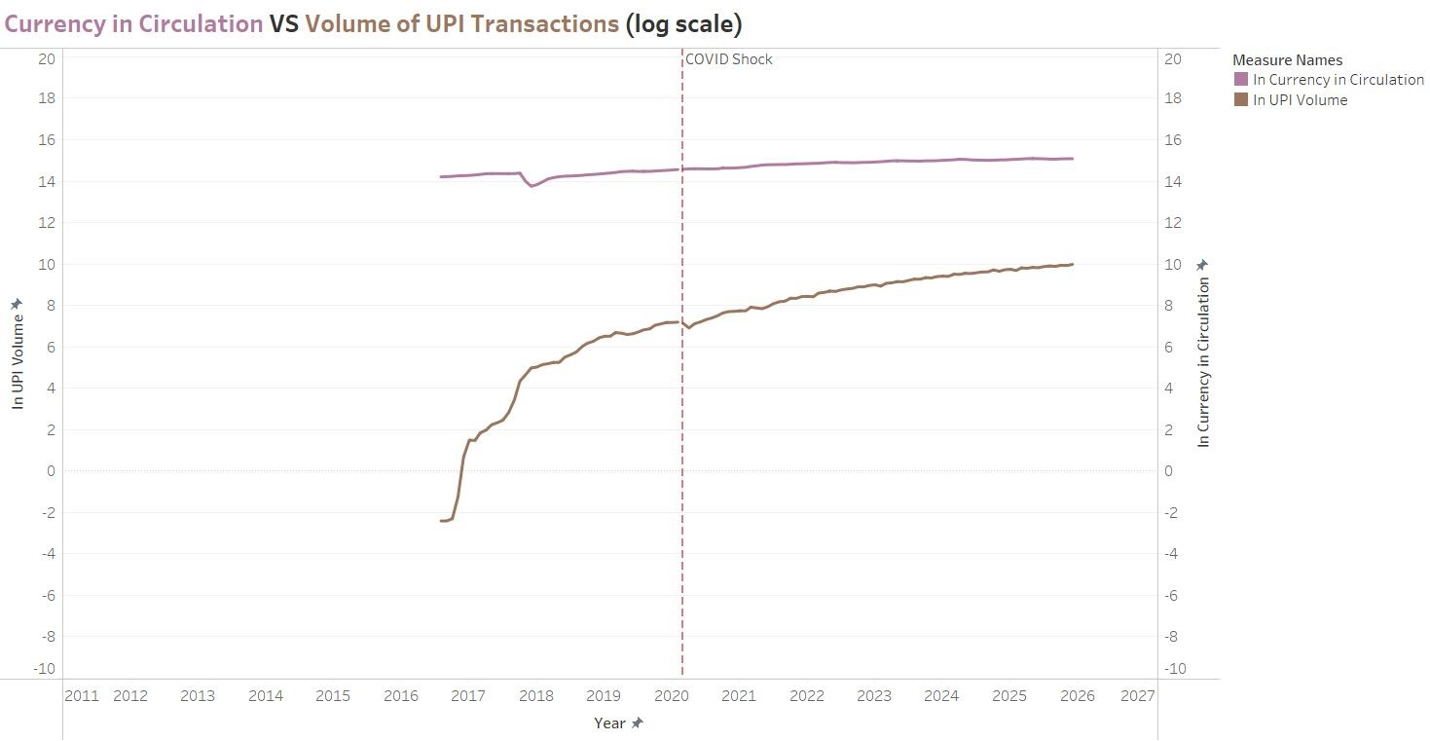
Fig 5.7.2: Currency in Circulation VS Volume of Digital Payment Transactions (log scale)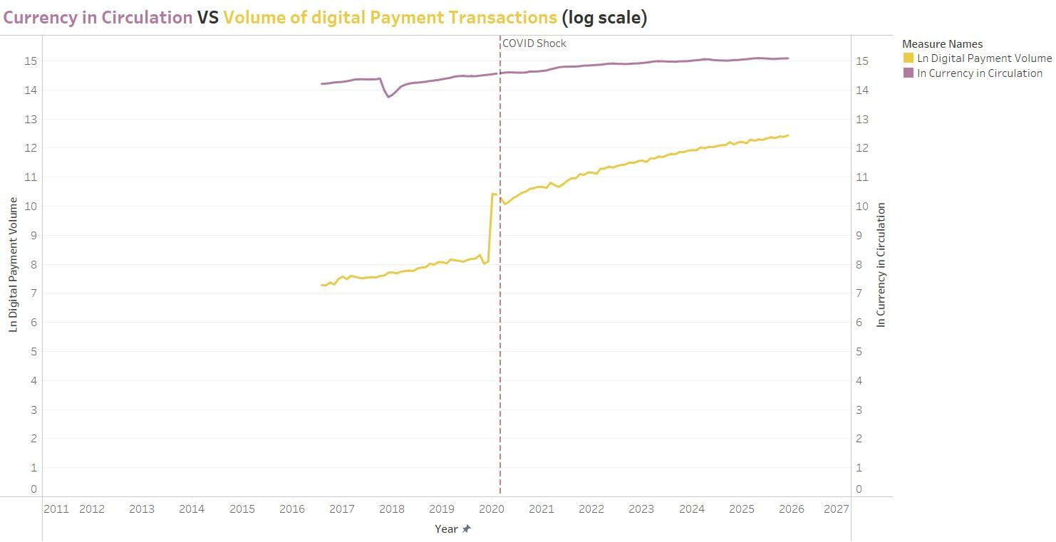
The Fig 5.7.1 graph shows the correlation between the amount of money in circulation and the total number of digital payment transactions over various time periods on a logarithmic scale.Before COVID-19, both show gradual growth, with digital payments increasing steadily. At the COVID shock (2020), digital payments experience a sharp jump, indicating a sudden shift toward contactless transactions. The amount of currency in circulation shows steady behavior with a slight upward trend. After the pandemic, digital payments growth rate has outpaced cash payments which show a slow increase. The data indicates that digital payments saw a major increase during the pandemic yet cash payments remained active which demonstrates that both payment methods exist together in India.
Fig 5.7.3: Currency in Circulation over time
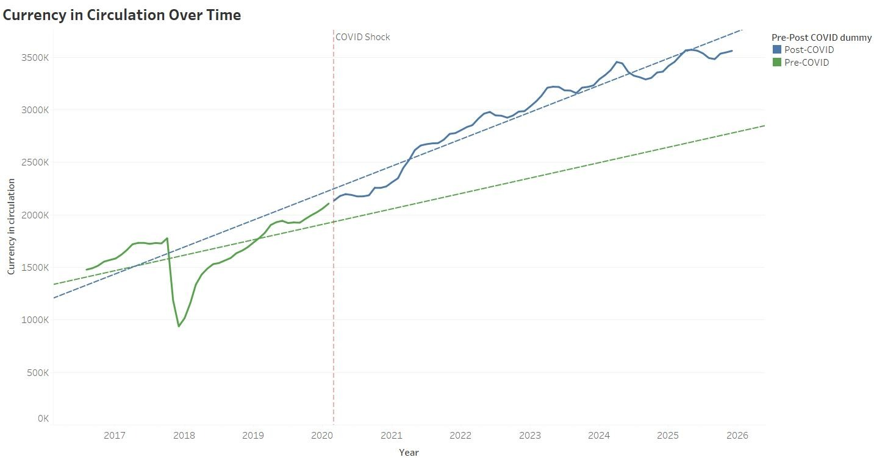
The graph displays the pattern of money in circulation from its status before the pandemic until its status after the pandemic. The period before 2020 saw a continuous increase in currency which faced a major decline during 2017 to 2018 because of demonetization but then experienced a recovery. The COVID-19 shock which appears as a vertical line on the graph leads to a faster increase in currency circulation which exceeds the pre-COVID rate of growth that exists along the dashed line. The line after COVID-19 shows continuous height above the expected trend which demonstrates that people needed more cash than organizations had planned. The findings demonstrate that people maintained cash usage during the pandemic despite increased digital payment adoption because they wanted to protect themselves from unknown dangers which demonstrates that cash retention remains vital for current economic systems.
Overall, the visualization of the dashboard shows that the pandemic’s impact was more pronounced in the digital payments ecosystem cumulatively than in UPI models specifically. Digital payments in terms of volume and transaction size show visible changes around the COVID period, while UPI follows an aggressively growing path. At the same time, the continued increase in currency circulation, even as digital payments expanded, indicates that India’s monetary system remained a combination of digital and cash-based payment activity.

