AI-Enhanced Food Supply Chain Traceability and Contamination Risk Prediction Using a Relational Database Management System
A. Kumari and S. Shekhar
School of Computer Science and Engineering, Vellore Institute of Technology, Vellore, India
ayushi.kumari2025b@vitstudent.ac.in , shorya.shekhar2025@vitstudent.ac.in

Abstract— Modern food supply chains generate traceability records across disconnected systems operated by farmers, processors, warehouses, transporters, and retailers, which slows contamination investigations and forces overly broad recalls. This paper presents a relational database system that assigns every batch a unique identifier and links its full farm-to-retail journey across a normalized schema of fourteen tables, combined with a machine learning risk-scoring module that flags contamination risk from storage, transport, and inspection-history features. On a synthetic dataset of 8,000 batch records, three classifiers were compared under a single protocol: identical class-balanced weighting, no hyperparameter tuning, and an operating threshold chosen by cross-validation on the training split alone to reach about 80% recall. The Random Forest used in the prototype reaches a ROC-AUC of 0.922 (95% CI 0.904–0.940) and detects 84.5% of contaminated batches (95% CI 79.0–89.8%) at 45.1% precision on the held-out test set. Gradient Boosting performs equivalently at its operating point (83.4% recall) with a slightly higher ROC-AUC of 0.933, and logistic regression is lower on both (76.2% recall, ROC-AUC 0.901), so no claim of Random Forest superiority is made. Prior inspection failures dominate the model's inputs, followed by storage duration. Unlike prior work that treats traceability and risk prediction as separate concerns, the proposed system keys the risk score directly to the same batch record used for traceability lookups, so that a batch's full movement history and its predicted contamination risk can be retrieved together from the same record. All model results are from synthetic data and do not establish real-world performance.
Index Terms— food supply chain, traceability, relational database, contamination risk prediction, machine learning, random forest.
I. INTRODUCTION
Contamination outbreaks in food supply chains are costly primarily because identifying the affected batch takes days, during which entire product lines are often recalled instead of the few units actually at risk. Food traceability systems built on relational databases or blockchain architectures can answer where a batch has been after the fact, but they do not predict which batches are more likely to be dangerous before laboratory testing confirms it. Conversely, machine learning systems for contamination risk prediction are typically trained and evaluated on static, offline inspection datasets that are not wired into any live, queryable batch-traceability system, so even an accurate risk score cannot be traced back to the specific supplier, storage facility, or transporter responsible.
This work addresses that gap directly. We design and implement a single relational database that spans six actor types, from farmer to retail store, and connects every record through a unique batch identifier. We then layer a supervised machine learning model on top of the same schema, reading features from the storage, transport, and inspection tables and writing predictions back into a dedicated risk-score table referenced by the same batch identifier used for traceability queries. Section II reviews related work in both threads. Section III describes the proposed system architecture, schema, and module design. Section IV presents the machine learning methodology. Section V reports implementation details and results, including a model comparison with uncertainty estimates and the limitations of evaluating on synthetic data. Section VI concludes with future enhancements.
II. RELATED WORK
Tang [1] combines a relational database with blockchain to keep food-chain traceability records tamper-evident while allowing cross-organization queries, confirming that siloed relational records are the primary bottleneck in cross-database contamination investigations. Zhong et al. [2] systematically review 192 data-driven food supply chain management systems published between 1993 and 2017 and find that most systems specialize narrowly in a single function, such as inventory or logistics, rather than combining traceability with predictive analytics. Zhou and Xu [3] review 278 traceability studies published through 2019 and report that research attention has been shifting toward post-adoption evaluation of already-deployed systems rather than forward-looking, predictive use of traceability data. Thakur [4] develops a relational schema for internal batch traceability at a single grain elevator node, which is the closest technical precedent for batch-centric schema design but is scoped to one node rather than a full farm-to-retail chain and includes no predictive capability.
On the prediction side, Wu and Wang [5] train an XGBoost classifier on more than 180,000 agricultural product inspection records from three Chinese megacities, reporting 75.4% recall and 71.9% precision, and identify supply-chain stage, region, inspection intensity, product category, and weather as the dimensions most predictive of risk. Their model, however, is trained and evaluated on regulatory sampling data external to any live traceability database. Deshmukh et al. [6] survey machine learning and deep learning methods, including image-based CNNs, for aflatoxin contamination detection, confirming that detection-capable AI methods are maturing quickly but are evaluated on isolated sample-level detection tasks rather than integrated with a chain-wide batch record. No reviewed system unifies full relational traceability with an integrated, batch-level contamination risk score; this is the gap the present work addresses.
III. PROPOSED SYSTEM
A. Architecture
The system is organized into four layers. The data capture layer is designed to receive records from farmers, processors, warehouses, transporters, and retailers; in the current prototype these records are loaded through scripts, and data-entry forms and authentication are not yet implemented. The relational database layer stores a normalized schema keyed throughout by a unique batch identifier. The AI risk engine layer reads features from the storage, transport, and inspection tables and writes a predicted risk score back into the database. The reporting layer exposes traceability lookups, QR-code generation, and risk scores through a Streamlit dashboard drawing on the same underlying tables.
B. Schema Design
The schema comprises fourteen tables: six actor/master tables (Farmer, Collection_Center, Processing_Plant, Warehouse, Transporter, Retail_Store) and a central Batch table referenced by foreign key from seven stage-linked tables (Collection_Record, Processing_Record, Storage_Record, Transport_Log, Retail_Inventory, Inspection, and Risk_Score). Every stage-linked table carries batch_id as a foreign key, so a single multi-way join reconstructs a batch's complete farm-to-retail journey. Fig. 1 shows the entity-relationship diagram.
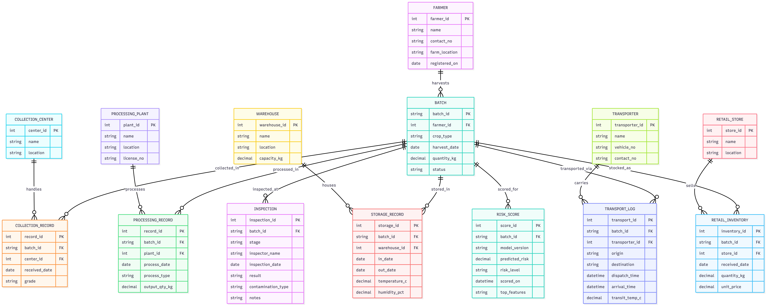
Fig. 1. Entity-relationship diagram of the proposed schema.
C. Module Description
Farmer and Batch Registration generates a unique batch identifier at harvest using surrogate primary-key assignment; every downstream table references this key by foreign key. Warehouse and Transport Tracking logs storage conditions and transit checkpoints through one-to-many foreign-key chaining from Storage_Record and Transport_Log to Batch. Quality Inspection Records store a normalized fact table keyed by (batch_id, stage) that supplies the prior-failure count used as a model input and is intended to become the label source once real inspection outcomes are available for training. Batch Traceability Query reconstructs a batch's full journey through LEFT JOINs across the collection, processing, storage, transport, retail and risk-score tables, keyed on batch_id.
IV. AI RISK ENGINE METHODOLOGY
The risk engine is framed as a binary classification problem: given a batch's storage, transport, and inspection-history features, predict whether the batch is contaminated. Because real inspection-linked contamination data was not available at project scale, a synthetic dataset of 8,000 batch records was generated with feature distributions and a risk-generating function designed to reflect documented contamination correlates, principally storage temperature, storage duration, transit time and temperature, humidity, prior inspection failures, and days since harvest, matching the dimensions identified as predictive by Wu and Wang [5]. The contamination prevalence is 11.3%. Because the labels are a function of the same inputs by construction, the results below show how well each model recovers the generating rule, not how it would perform on real batches. The nine model inputs and their sources in the database are listed in Table I.
Three classifiers were compared using scikit-learn 1.9.1 [7]: logistic regression on standardized numeric inputs, a Random Forest with 200 trees, and a Gradient Boosting classifier. All three use class-balanced weighting and otherwise default hyperparameters; no hyperparameters were tuned. They share one stratified 80/20 train-test split (random seed 42), giving 6,400 training and 1,600 test records, 181 of them contaminated.
Because a missed contaminated batch is materially more costly than an unnecessary inspection, each model is run at an operating threshold chosen from training data only: the highest threshold at which the out-of-fold recall in 5-fold stratified cross-validation on the training split is at least 80%. The test split was used once, for reporting. Uncertainty is quantified with 95% percentile bootstrap intervals over 2,000 resamples of the test set, including paired differences between models. Input influence is measured by permutation importance on the test set (drop in ROC-AUC, 20 repeats), which, unlike impurity-based importance, is not biased toward continuous or high-cardinality inputs.
TABLE I
Model Inputs and Their Sources in the Database
Model input | Type | Source in database
Crop type | Categorical | Batch
Supply-chain stage | Categorical | Batch status / journey records
Storage temperature (°C) | Numeric | Storage_Record
Storage duration (h) | Numeric | Storage_Record dates
Humidity (%) | Numeric | Storage_Record
Transit time (h) | Numeric | Transport_Log times
Transit temperature (°C) | Numeric | Transport_Log
Prior inspection failures | Count | Inspection
Days since harvest | Numeric | Batch harvest date, stage dates
Two categorical and seven numeric inputs; the target is the binary contamination label (prevalence 11.3%).
V. IMPLEMENTATION AND RESULTS
The schema was implemented in SQLite as a working prototype. One batch (BATCH-2026-000123) carries complete collection, processing, storage, transport, and retail records and was used to validate the multi-table traceability query described in Section III. Fifty further demonstration batches with placeholder inputs and labels populate the dashboard but are not used in model training or evaluation. A Streamlit dashboard provides batch search, farm-to-retail traceability, QR-code generation, and risk prediction; each prediction is appended to the Risk_Score table. The dashboard loads a Random Forest trained with the configuration above; on the same test split its ROC-AUC is 0.922 and it detects one more contaminated batch at threshold 0.3 than the cross-validation refit evaluated below. Tables II and III report results on the held-out test set (1,600 records, 181 contaminated).
A. Model Comparison
TABLE II
Performance at Cross-Validated Operating Thresholds (N=1,600; 181 contaminated)
Model | Thr. | Recall (95% CI) | Precision (95% CI) | F1
Log. regression | 0.551 | 76.2 (69.9–82.6) | 39.3 (34.3–44.4) | 51.9
Random forest | 0.300 | 84.5 (79.0–89.8) | 45.1 (39.8–50.2) | 58.8
Grad. boosting | 0.529 | 83.4 (77.8–88.7) | 44.4 (39.2–49.7) | 58.0
Values in percent. Thr. is the decision threshold chosen from 5-fold cross-validation on the training split to reach about 80% recall; intervals are 95% bootstrap intervals over the test set.
Table II reports each model at its cross-validated operating threshold. The Random Forest threshold of 0.30 yields 84.5% recall (153 of 181 contaminated batches) at 45.1% precision, so about one in five test batches (339 of 1,600) would be sent for additional inspection and roughly 45% of those are truly contaminated. Gradient Boosting is statistically indistinguishable at its operating point (83.4% recall, 44.4% precision; the intervals overlap almost completely). Logistic regression reaches 76.2% recall at 39.3% precision; its test recall falls below the 80% target even though its threshold was chosen to meet it, so the target is met only approximately on unseen data.
TABLE III
Threshold-Independent Comparison and Recall at the Default Threshold
Model | ROC-AUC (95% CI) | Avg. precision (95% CI) | Recall at 0.5
Log. regression | 0.901 (0.882–0.920) | 0.493 (0.419–0.578) | 80.1
Random forest | 0.922 (0.904–0.940) | 0.616 (0.547–0.692) | 61.9
Grad. boosting | 0.933 (0.917–0.948) | 0.660 (0.591–0.733) | 84.5
Recall at 0.5 is shown for reference only; it is not any model's operating point.
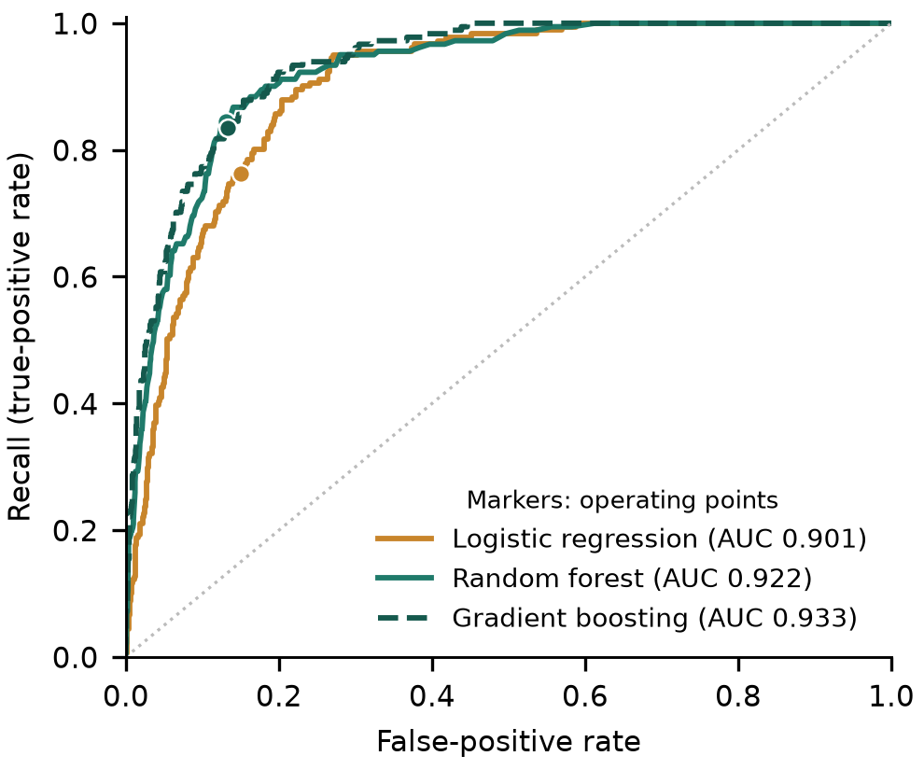
Fig. 2. ROC curves on the test set. Markers show each model's cross-validated operating point (the Random Forest and Gradient Boosting markers nearly coincide).
Table III and Fig. 2 compare ranking quality independent of any threshold. Gradient Boosting has the highest ROC-AUC (0.933), followed by the Random Forest (0.922) and logistic regression (0.901). Paired bootstrap differences show that the gap between Gradient Boosting and the Random Forest is small but its interval excludes zero (ΔAUC = +0.011, 95% CI 0.004–0.018; Δaverage precision = +0.043, 95% CI 0.006–0.079), and both tree ensembles outperform logistic regression (Random Forest − logistic regression: ΔAUC = +0.021, 95% CI 0.009–0.034). The Random Forest is the model deployed in the prototype because the dashboard was built around it; the evidence here does not show it to be superior to Gradient Boosting, which would be a drop-in replacement. Recall at the default 0.5 threshold differs widely between models (Table III) because their probability outputs are scaled differently, so threshold-dependent figures should be compared only at matched operating rules, as in Table II.
B. Input Influence
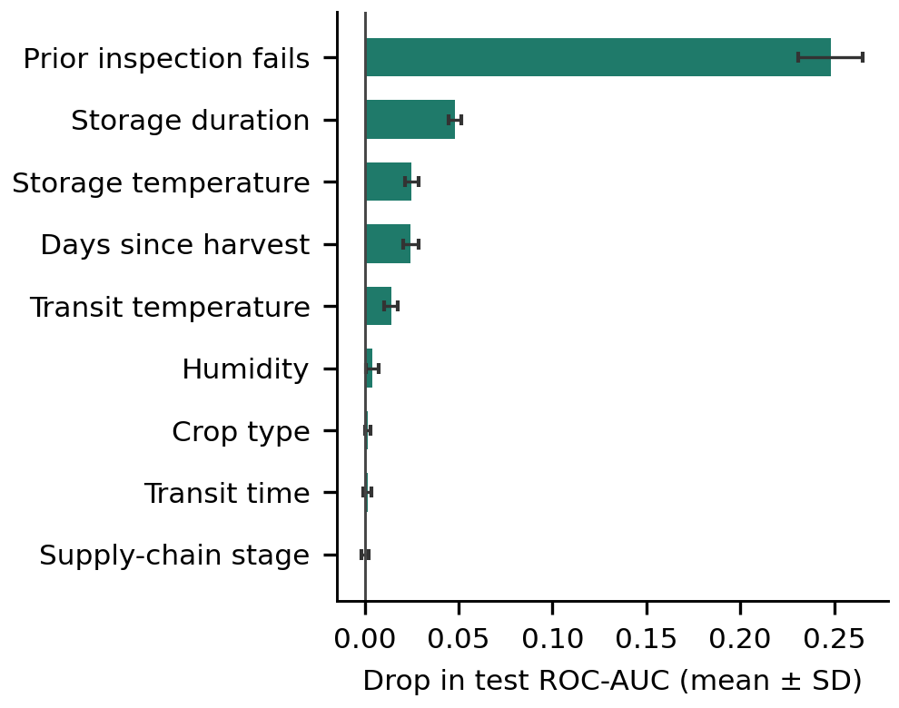
Fig. 3. Permutation importance of the Random Forest inputs on the test set (mean ± SD over 20 repeats).
Fig. 3 shows permutation importance for the Random Forest. Prior inspection failures dominate (mean ROC-AUC drop 0.248), followed by storage duration (0.048). Storage temperature (0.025) and days since harvest (0.024) are indistinguishable given a standard deviation of about 0.004 across repeats, with transit temperature (0.014) below them; Gradient Boosting gives the same ordering. The prominence of prior failures is partly a property of the synthetic data: 2.1% of batches with no prior failure are contaminated, against 29.9% of batches with at least one. The agreement with the factors identified by Wu and Wang [5] is therefore expected by construction and is not independent validation.
C. Limitations
Several limitations apply. First, all model results come from synthetic data whose labels are generated from the same inputs, so they do not establish real-world performance; validation on real, labeled inspection data is required. Wu and Wang [5] report 75.4% recall and 71.9% precision on real regulatory inspection data, but those figures are not comparable with ours, which are synthetic and tuned to a recall target, and we cite them only as context for the recall–precision trade-off. Second, the test set holds only 181 contaminated batches, so the intervals in Table II are wide (roughly ±5 points on recall). Third, at 11.3% prevalence the chosen operating point flags about 21% of batches, a workload that real inspection capacity may not allow. Fourth, in the prototype most storage and transport records of the demonstration batches share placeholder values, a labelled synthetic table supplies any input that is missing, and the dashboard shows the model probability with illustrative bands at 0.30 and 0.60 and a class label at 0.5 rather than the 0.30 operating point; scores for demonstration batches are therefore not food-safety verdicts. Finally, records enter the database through scripts, without authentication or tamper protection.
VI. CONCLUSION AND FUTURE WORK
This paper presented a relational database system that unifies full farm-to-retail food traceability with an integrated, batch-level contamination risk score, directly addressing a gap identified across both the traceability and machine-learning-for-food-safety literature. A working prototype with a Streamlit dashboard and a Random Forest risk model trained on a synthetic dataset demonstrate the feasibility of the approach: under a protocol that gives all models the same class weighting and selects thresholds from training data only, the Random Forest detects 84.5% of contaminated batches (95% CI 79.0–89.8%) at 45.1% precision, comparable to Gradient Boosting and better than logistic regression. These figures describe performance on synthetic data only, and validation on real, labeled inspection data remains necessary before any conclusion about real-world performance.
Future work includes migrating the prototype to a cloud-hosted PostgreSQL instance with live API access and adding data-entry forms, authentication, and tamper protection; retraining the risk model on a larger and, where available, real-world labeled dataset with hyperparameter optimization; aligning the dashboard's alert threshold with the validated operating point; and extending the existing QR-code traceability to retailer and consumer workflows so that a batch's full history and risk status can be retrieved at the point of sale.
REFERENCES
[1] J. Tang, "Food Supply Chain Traceability System Based on Blockchain Technology," Applied and Computational Engineering, vol. 8, pp. 311–317, 2023.
[2] R. Zhong, X. Xu, and L. Wang, "Food Supply Chain Management: Systems, Implementations, and Future Research," Industrial Management & Data Systems, vol. 117, no. 9, pp. 2085–2114, 2017.
[3] X. Zhou and Z. Xu, "Traceability in Food Supply Chains: A Systematic Literature Review and Future Research Directions," International Food and Agribusiness Management Review, vol. 25, no. 2, 2022.
[4] M. Thakur, "Operational Techniques for Implementing Traceability in Bulk Product Supply Chains," Ph.D. dissertation, Iowa State University, 2010.
[5] D. Wu and Y. Wang, "Food Safety Risk Prediction and Regulatory Strategies Based on Machine Learning: Evidence from Agricultural Products," Frontiers in Sustainable Food Systems, vol. 10, art. 1838879, 2026.
[6] M. T. Deshmukh et al., "Towards Intelligent Food Safety: Machine Learning Approaches for Aflatoxin Detection and Risk Prediction," Trends in Food Science & Technology, vol. 161, art. 105055, 2025.
[7] F. Pedregosa et al., "Scikit-learn: Machine Learning in Python," Journal of Machine Learning Research, vol. 12, pp. 2825–2830, 2011.

