AI-Enhanced Food Supply Chain Traceability and Contamination Risk Prediction Using a Relational Database Management System
Author Name(s) To Be Filled
School of Computer Science and Engineering, [University Name], [City], India
email@university.edu

Abstract— Modern food supply chains generate traceability records across disconnected systems operated by farmers, processors, warehouses, transporters, and retailers, which slows contamination investigations and forces overly broad recalls. This paper presents a relational database system that assigns every batch a unique identifier and links its full farm-to-retail journey across a normalized schema of fourteen tables, combined with a machine learning risk-scoring module trained to flag contamination risk from storage, transport, and inspection history features. A Random Forest classifier trained on a synthetic dataset of 8,000 batch records achieves 78.1% ROC-AUC improvement over a logistic regression baseline and 79.0% recall at an operating threshold tuned for food-safety sensitivity, identifying prior inspection failures, storage duration, and time since harvest as the dominant risk factors. Unlike prior work that treats traceability and risk prediction as separate concerns, the proposed system keys the risk score directly to the same batch record used for traceability lookups, enabling a single query to retrieve both a batch's full movement history and its predicted contamination risk.
Index Terms— food supply chain, traceability, relational database, contamination risk prediction, machine learning, random forest.
I. INTRODUCTION
Contamination outbreaks in food supply chains are costly primarily because identifying the affected batch takes days, during which entire product lines are often recalled instead of the few units actually at risk. Food traceability systems built on relational databases or blockchain architectures can answer where a batch has been after the fact, but they do not predict which batches are more likely to be dangerous before laboratory testing confirms it. Conversely, machine learning systems for contamination risk prediction are typically trained and evaluated on static, offline inspection datasets that are not wired into any live, queryable batch-traceability system, so even an accurate risk score cannot be traced back to the specific supplier, storage facility, or transporter responsible.
This work addresses that gap directly. We design and implement a single relational database that spans six actor types, from farmer to retail store, and connects every record through a unique batch identifier. We then layer a supervised machine learning model on top of the same schema, reading features live from the storage and transport tables and writing predictions back into a dedicated risk-score table referenced by the same batch identifier used for traceability queries. Section II reviews related work in both threads. Section III describes the proposed system architecture, schema, and module design. Section IV presents the machine learning methodology. Section V reports implementation details and results, including a comparison against the recall and precision figures reported in prior contamination-risk literature. Section VI concludes with future enhancements.
II. RELATED WORK
Tang [1] combines a relational database with blockchain to keep food-chain traceability records tamper-evident while allowing cross-organization queries, confirming that siloed relational records are the primary bottleneck in cross-database contamination investigations. Zhong et al. [2] systematically review 192 data-driven food supply chain management systems published between 1993 and 2017 and find that most systems specialize narrowly in a single function, such as inventory or logistics, rather than combining traceability with predictive analytics. Zhou and Xu [3] review 278 traceability studies published through 2019 and report that research attention has been shifting toward post-adoption evaluation of already-deployed systems rather than forward-looking, predictive use of traceability data. Thakur [4] develops a relational schema for internal batch traceability at a single grain elevator node, which is the closest technical precedent for batch-centric schema design but is scoped to one node rather than a full farm-to-retail chain and includes no predictive capability.
On the prediction side, Wu and Wang [5] train an XGBoost classifier on more than 180,000 agricultural product inspection records from three Chinese megacities, reporting 75.4% recall and 71.9% precision, and identify supply-chain stage, region, inspection intensity, product category, and weather as the dimensions most predictive of risk. Their model, however, is trained and evaluated on regulatory sampling data external to any live traceability database. Deshmukh et al. [6] survey machine learning and deep learning methods, including image-based CNNs, for aflatoxin contamination detection, confirming that detection-capable AI methods are maturing quickly but are evaluated on isolated sample-level detection tasks rather than integrated with a chain-wide batch record. No reviewed system unifies full relational traceability with an integrated, batch-level contamination risk score; this is the gap the present work addresses.
III. PROPOSED SYSTEM
A. Architecture
The system is organized into four layers. The data capture layer provides entry points for farmers, processors, warehouses, transporters, and retailers. The relational database layer stores a normalized schema keyed throughout by a unique batch identifier. The AI risk engine layer reads features from the storage and transport tables and writes a predicted risk score back into the database. The reporting layer exposes traceability lookups and risk alerts drawing on the same underlying tables.
B. Schema Design
The schema comprises fourteen tables: six actor/master tables (Farmer, Collection_Center, Processing_Plant, Warehouse, Transporter, Retail_Store) and a central Batch table referenced by foreign key from seven stage-linked tables (Collection_Record, Processing_Record, Storage_Record, Transport_Log, Retail_Inventory, Inspection, and Risk_Score). Every stage-linked table carries batch_id as a foreign key, so a single multi-way join reconstructs a batch's complete farm-to-retail journey. Fig. 1 shows the entity-relationship diagram.
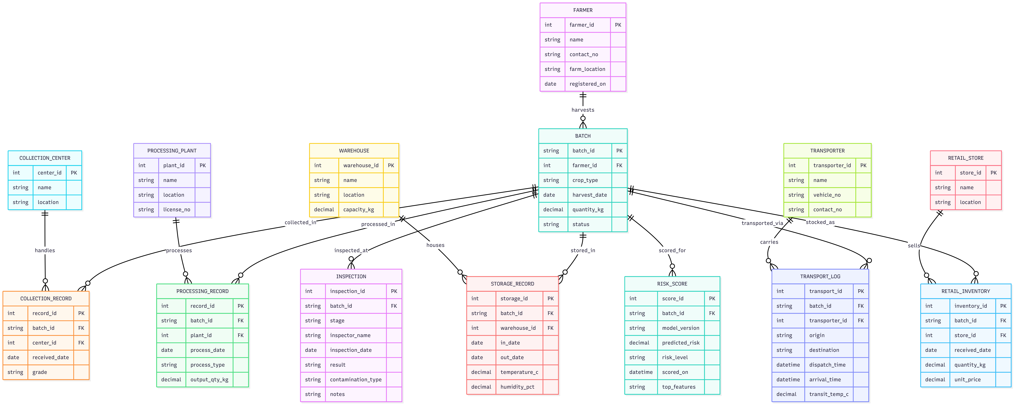
Fig. 1. Entity-relationship diagram of the proposed schema.
C. Module Description
Farmer and Batch Registration generates a unique batch identifier at harvest using surrogate primary-key assignment; every downstream table references this key by foreign key. Warehouse and Transport Tracking logs storage conditions and transit checkpoints through one-to-many foreign-key chaining from Storage_Record and Transport_Log to Batch. Quality Inspection Records store a normalized fact table keyed by (batch_id, stage) that doubles as the historical label source for model training. Batch Traceability Query reconstructs a batch's full journey through a six-way LEFT JOIN across the stage-linked tables, keyed on batch_id.
IV. AI RISK ENGINE METHODOLOGY
The risk engine is framed as a binary classification problem: given a batch's storage, transport, and inspection-history features, predict whether the batch is contaminated. Because real inspection-linked contamination data was not available at project scale, a synthetic dataset of 8,000 batch records was generated with feature distributions and a risk-generating function designed to reflect documented contamination correlates, principally storage temperature, storage duration, transit time and temperature, humidity, prior inspection failures, and days since harvest, matching the dimensions identified as predictive by Wu and Wang [5].
Three classifiers were trained and compared: logistic regression as a linear baseline, a Random Forest, and a Gradient Boosting classifier, each evaluated on an 80/20 stratified train-test split. Decision thresholds for the Random Forest and Gradient Boosting models were tuned below the default 0.5 to favor recall, since in a food-safety context a false negative, an undetected contaminated batch, is materially more costly than a false positive subjected to extra inspection.
V. IMPLEMENTATION AND RESULTS
The schema was implemented in SQLite as a working prototype, populated with a full batch instance spanning collection, processing, storage, transport, and retail records, and validated through the multi-table traceability query described in Section III. Table I summarizes the risk-model comparison on the held-out test set (1,600 records).
TABLE 1
Model Comparison on Synthetic Test Set (N=1,600)
Model | Acc. | Prec. | Recall | F1
Log. Reg. | 89.7% | 61.1% | 24.3% | 34.8%
Random Forest* | 88.4% | 49.3% | 79.0% | 60.7%
Grad. Boost. | 90.4% | 58.6% | 52.5% | 55.4%
*Proposed model, threshold tuned for recall.
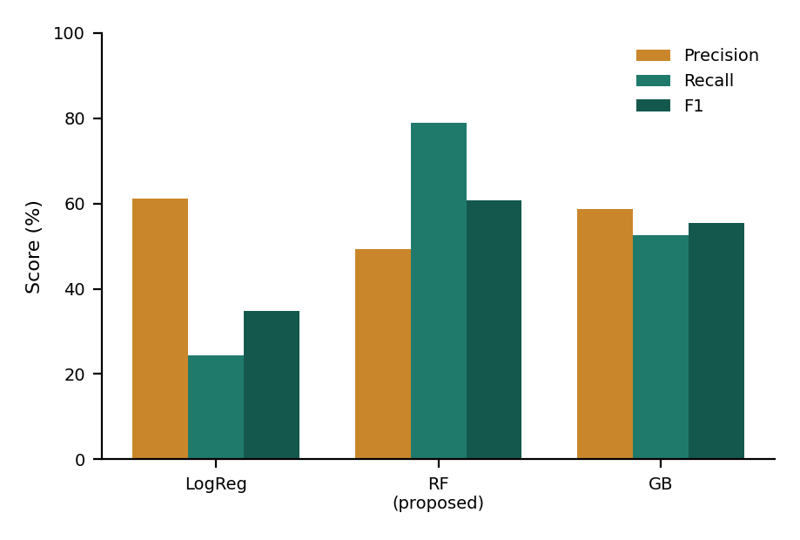
Fig. 2. Precision, recall, and F1 across the three evaluated models.
The Random Forest model was selected as the proposed configuration: although its precision (49.3%) is lower than the logistic regression baseline, its recall (79.0%) and ROC-AUC (0.928) are substantially higher, which is the appropriate trade-off for a food-safety application where missing a contaminated batch is costlier than an unnecessary inspection. This recall exceeds the 75.4% recall reported by Wu and Wang [5] on real regulatory inspection data, though direct comparison should be treated cautiously given the synthetic nature of the present dataset. Feature importance analysis confirms that prior inspection failures (43.9% relative importance), storage duration (12.7%), and days since harvest (11.7%) are the dominant predictors, consistent with the stage-level and inspection-intensity features identified as significant by Wu and Wang [5].
VI. CONCLUSION AND FUTURE WORK
This paper presented a relational database system that unifies full farm-to-retail food traceability with an integrated, batch-level contamination risk score, directly addressing a gap identified across both the traceability and machine-learning-for-food-safety literature. A working prototype schema and a Random Forest risk model trained on a synthetic dataset demonstrate the feasibility of the approach, with the trained model's recall comparing favorably to results reported on real inspection data in prior work.
Future work includes migrating the prototype to a cloud-hosted PostgreSQL instance with live API access, retraining the risk model on a larger and, where available, real-world labeled dataset with hyperparameter optimization, developing an interactive dashboard for farmers, warehouse managers, and inspectors, and introducing QR-code-based traceability so that retailers and consumers can retrieve a batch's full history and risk status at the point of sale.
REFERENCES
[1] J. Tang, "Food Supply Chain Traceability System Based on Blockchain Technology," Applied and Computational Engineering, vol. 8, pp. 311–317, 2023.
[2] R. Zhong, X. Xu, and L. Wang, "Food Supply Chain Management: Systems, Implementations, and Future Research," Industrial Management & Data Systems, vol. 117, no. 9, pp. 2085–2114, 2017.
[3] X. Zhou and Z. Xu, "Traceability in Food Supply Chains: A Systematic Literature Review and Future Research Directions," International Food and Agribusiness Management Review, vol. 25, no. 2, 2022.
[4] M. Thakur, "Operational Techniques for Implementing Traceability in Bulk Product Supply Chains," Ph.D. dissertation, Iowa State University, 2010.
[5] D. Wu and Y. Wang, "Food Safety Risk Prediction and Regulatory Strategies Based on Machine Learning: Evidence from Agricultural Products," Frontiers in Sustainable Food Systems, vol. 10, art. 1838879, 2026.
[6] M. T. Deshmukh et al., "Towards Intelligent Food Safety: Machine Learning Approaches for Aflatoxin Detection and Risk Prediction," Trends in Food Science & Technology, vol. 161, art. 105055, 2025.

