**COMPUTER HARDWARE SOFTWARE WORKSHOP ( COCSC19 )**

**Title: Tiny ML mini project**



Submitted by :

Amar Kumar Tarei : 2021UCS1614

Shreyansh Agrawal : 2021UCS1612

Ayushi Singh : 2021UCS1616

**Task:** Utilizing TinyML library, develop a project on a single board computer or microcontroller

**Topic and background**: Water scarcity is infamous topic of concern and so is the soil fertility, and proper irrigation, both go hand in hand with each other, manual ways are although quite satisfactory but in order to move towards the perfect care of both the soil irrigator methods and water balance, we created a soil moisture sensor and water flow rate predictor, that will sense the soil moisture content from five depths, and predicts the rate of flow.

**Technicalities and other requirements**: Machine learning algorithm linear regression is used. And for the stimulation purpose edge computing devices Arduino is used, for enabling connects jump wires is used, and a breadboard. Code for Arduino is written for its stimulation. Various other platforms like edge impulse can also be used.

Methodology: collected the dataset of soil moisture from different websites and integrated it in one excel file.

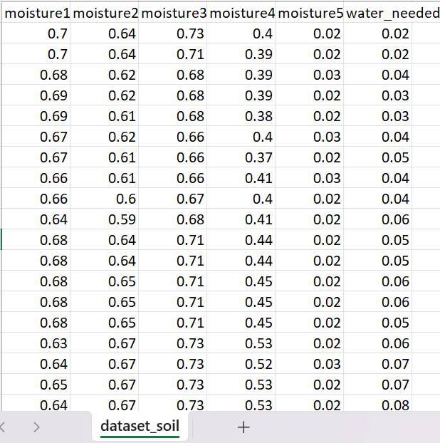

This dataset comprises of 1000 entries, with output of each flow of water required.

Next we trained the linear regression model, and got the weights.

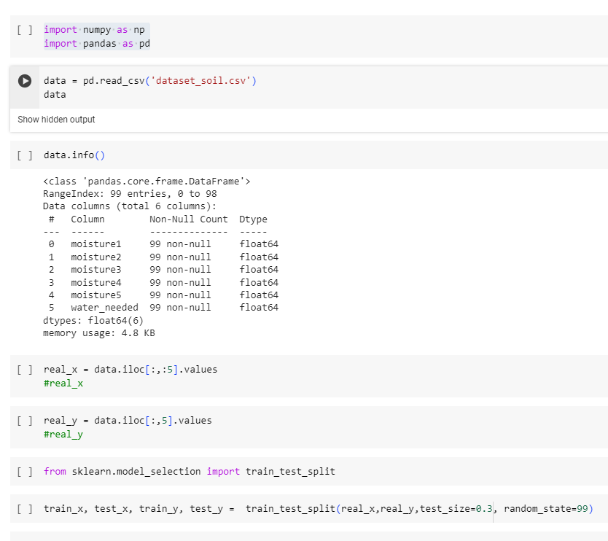

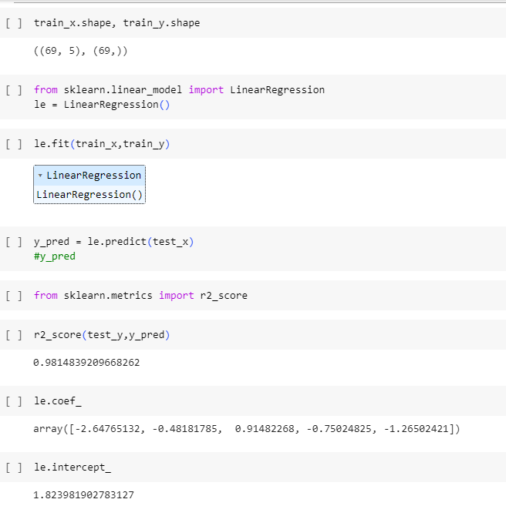

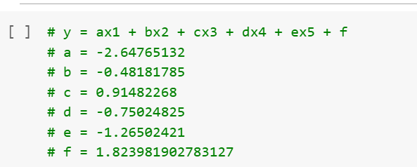

After that we moved to tinkercad stimulation website and made our connections,

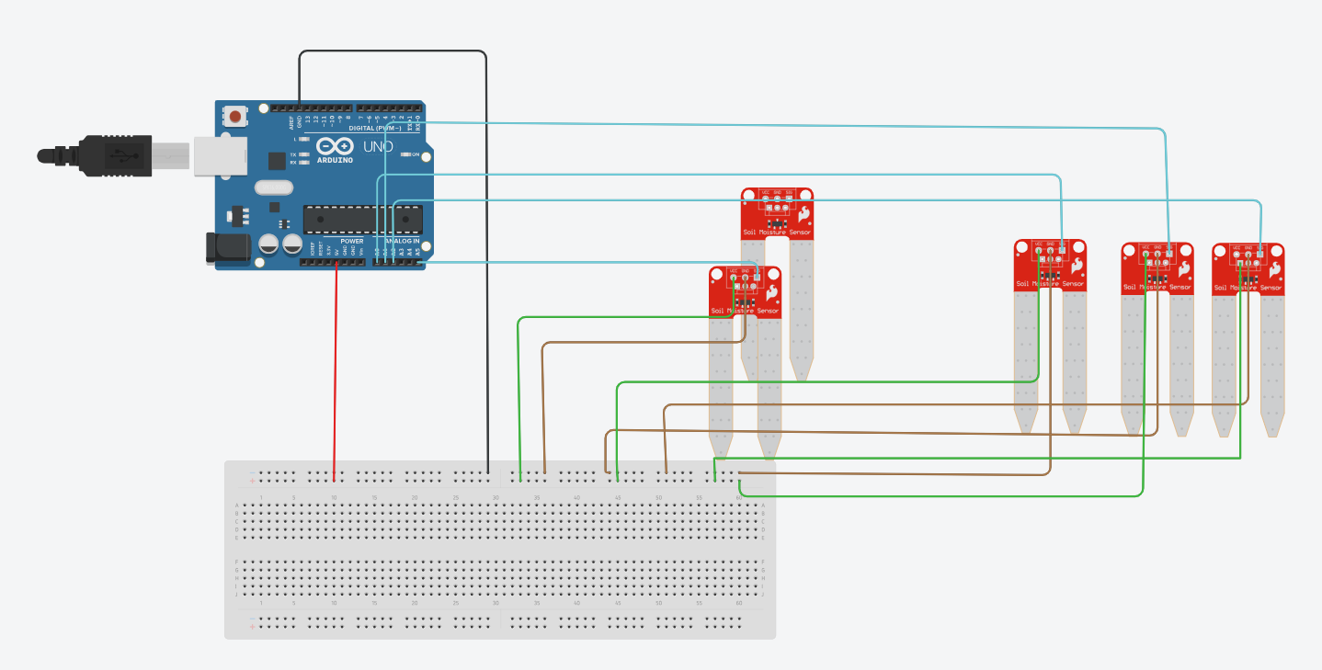

After this click on code 🡪text🡪provide the code for stimulation in Arduino

int ms1,ms2,ms3,ms4,ms5;

float a1,a2,a3,a4,a5,x;

float ans=0;

void setup(){

Serial.begin(9600);

}

void loop(){

ms1= analogRead(A0);

ms2= analogRead(A1);

ms3= analogRead(A2);

ms4= analogRead(A3);

ms5= analogRead(A5);

a1 = ms1/539.00;

a2 = ms2/539.00;

a3 = ms3/539.00;

a4 = ms4/539.00;

a5 = ms5/539.00;

x = -2.64765132*a1 -0.48181785*a2 + 0.91482268*a3 -0.75024825*a4 -1.26502421*a5 + 1.823981902783127;

//ans = max(ans,x);

if(x<0){

Serial.print("No need of water \n");

}

else{

Serial.print("need water by rate ");

Serial.print(x);

Serial.print("\n");

}

delay(1000);

}

**Link to stimulation:** <https://www.tinkercad.com/things/bhIKM8LDsFv-ingenious-hillar-inari/editel?sharecode=cmyhJ4DiEmuEYEI4hlAnWZUXMXG_4n0qcVNufPBwUzk>

Next click on start stimulation and click on serial monitor and move the slider to adjust the input change in output will be reflected.

**Stimulation code:**

