**COMPUTER HARDWARE SOFTWARE WORKSHOP ( COCSC19 )**

**Title: Power BI tool;**

**UNIT -3**



Submitted by :

Amar Kumar Tarei: 2021UCS1614

Shreyansh Agrawal: 2021UCS1612

Ayushi Singh: 2021UCS1616

**PRACTICAL 03: -**

**1.Explore Power View, Power Query**  
Create a table Employee (empid, gender, department, salary, country, year_of_joining)  
connect to Employee data file.  
Remove missing gender and department values.  
Extract year_of_joining column and visualize number of employees w.r.t year of experience in the company.  
Perform self-join using Power Query.  
Aggregate salary with gender and Visualize using Pie chart.  
  
**2. Visualize the result of any Machine Learning algorithm on any dataset of your choice in PowerBI.**

**EMPLOYEE DATA SET:-**

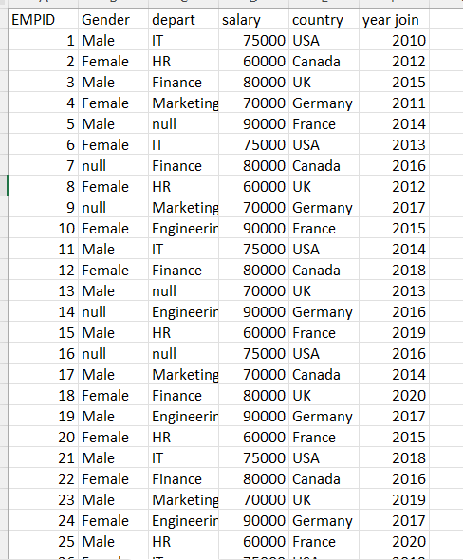

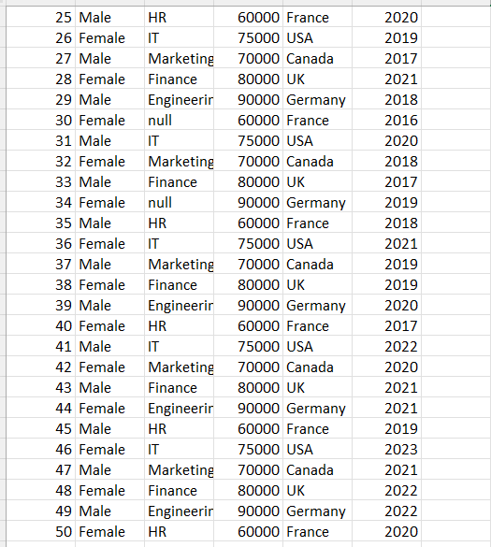

Loading the dataset in powerbi :

1. Click on get data, and make sure file extension is csv(comma separated) and select suitable employee file.

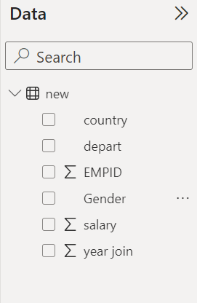

**Removing missing values on gender and department**

1. Click transform data on navigation, a power query window will pop up with the selected dataset (containing null values).

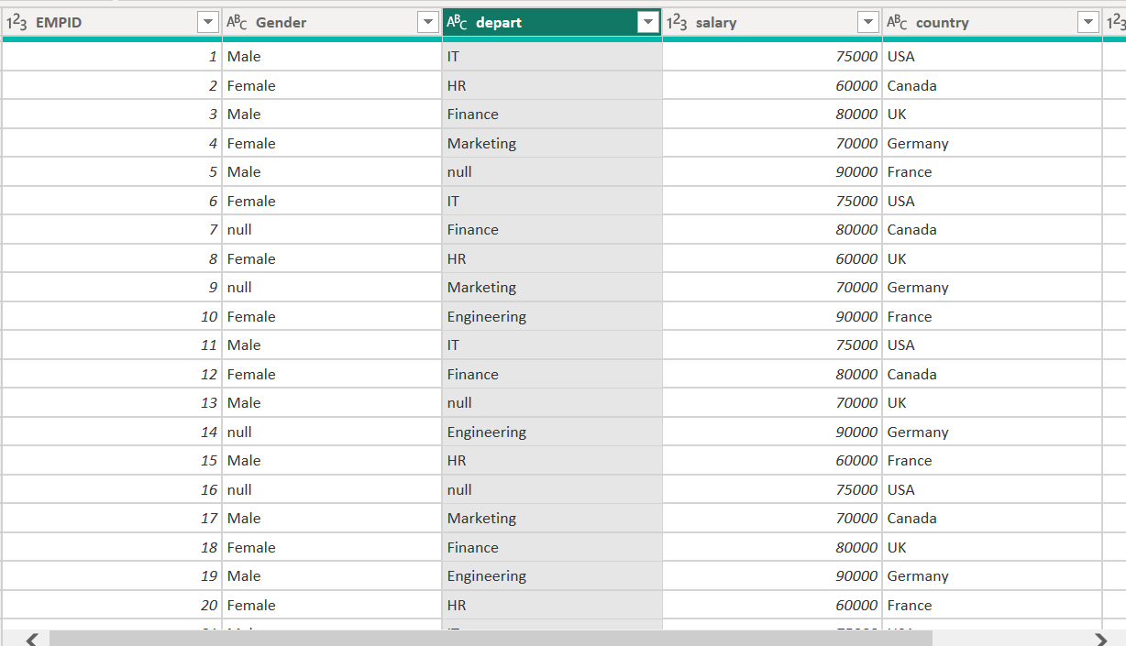

1. Click on gender and unselect the null values from checkbox, click ok. Do same for department.

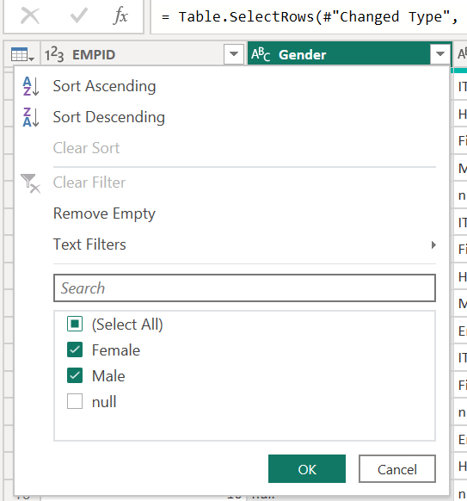

1. Results: size reduces from 50 rows to 42 rows.

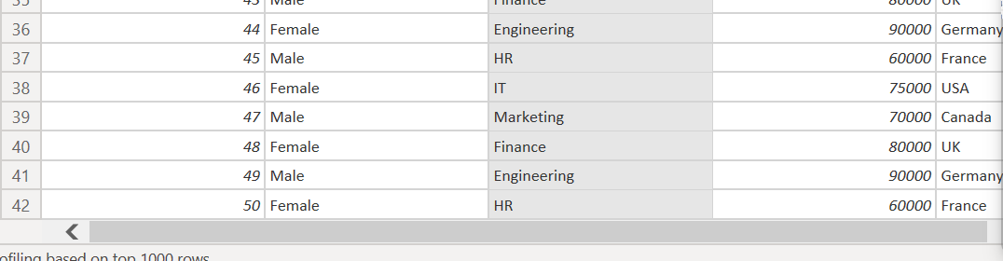

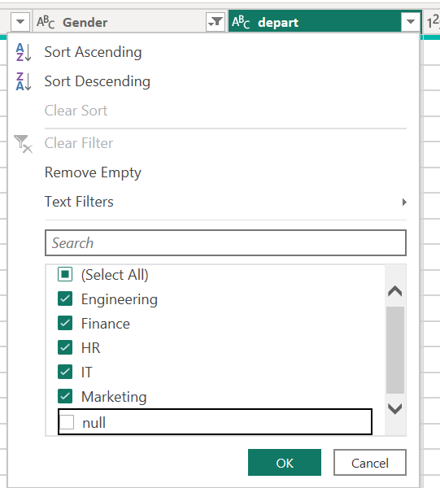

**Extract year_of_joining column.**

1. Click on choose column from the power query editor window.

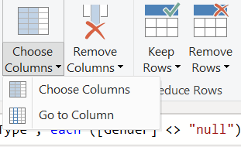

1. Click on year of joining column, click ok.

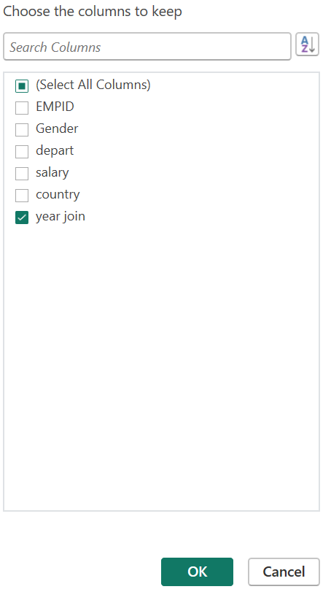

Output : year of joining column is extracted.

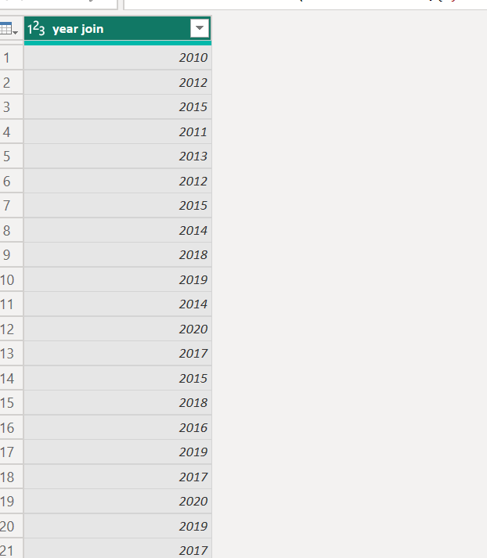

**Visualize number of employees w.r.t year of experience in the company.**

1. **Click on group by, click ok.**

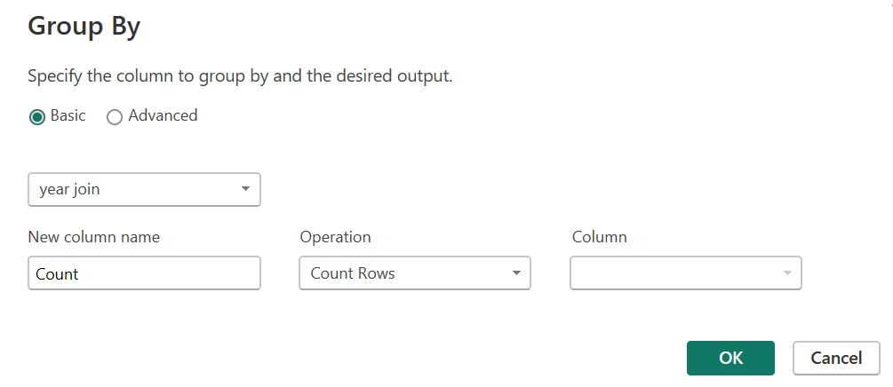

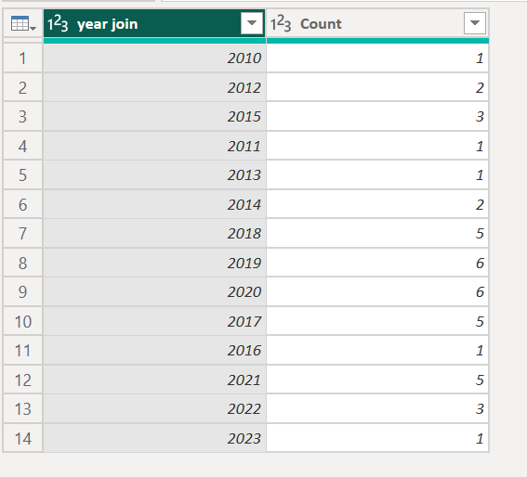

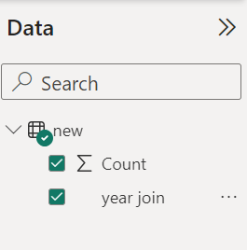

Visualisation

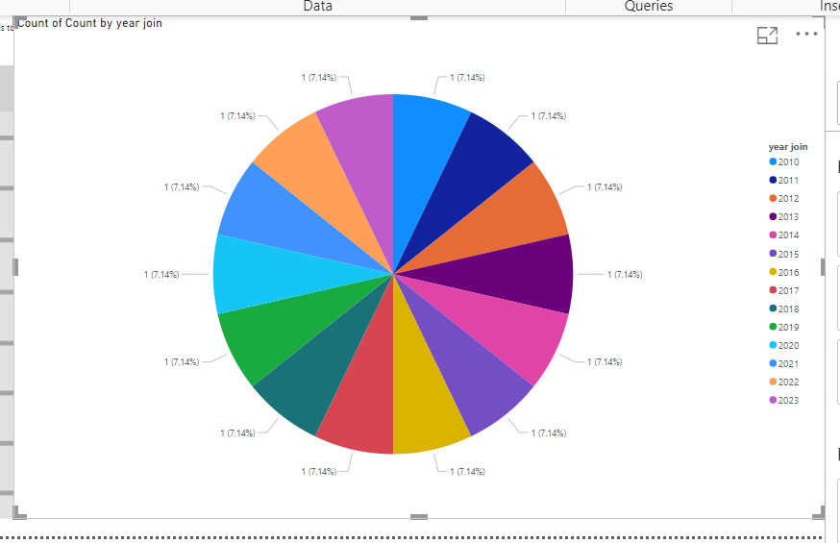

**Perform self-join using Power Query.**

1. Click on merge queries, then merge new queries.

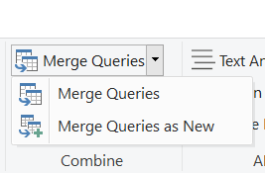

1. Select new table on second choice and select empid on both tables, click ok.

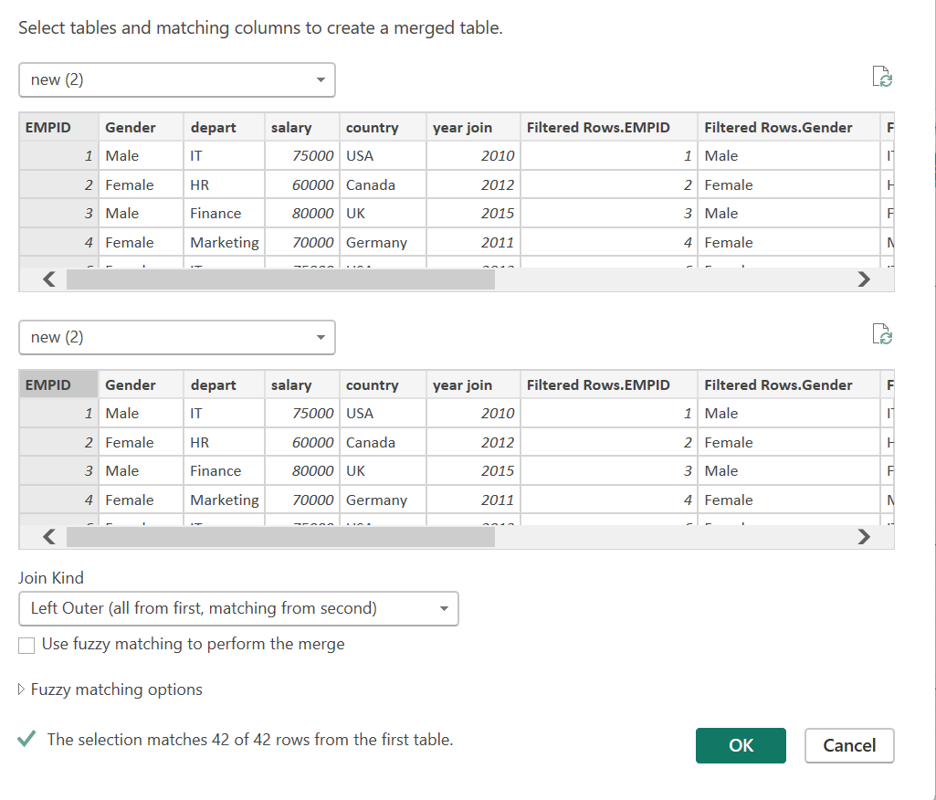

Output : self join table

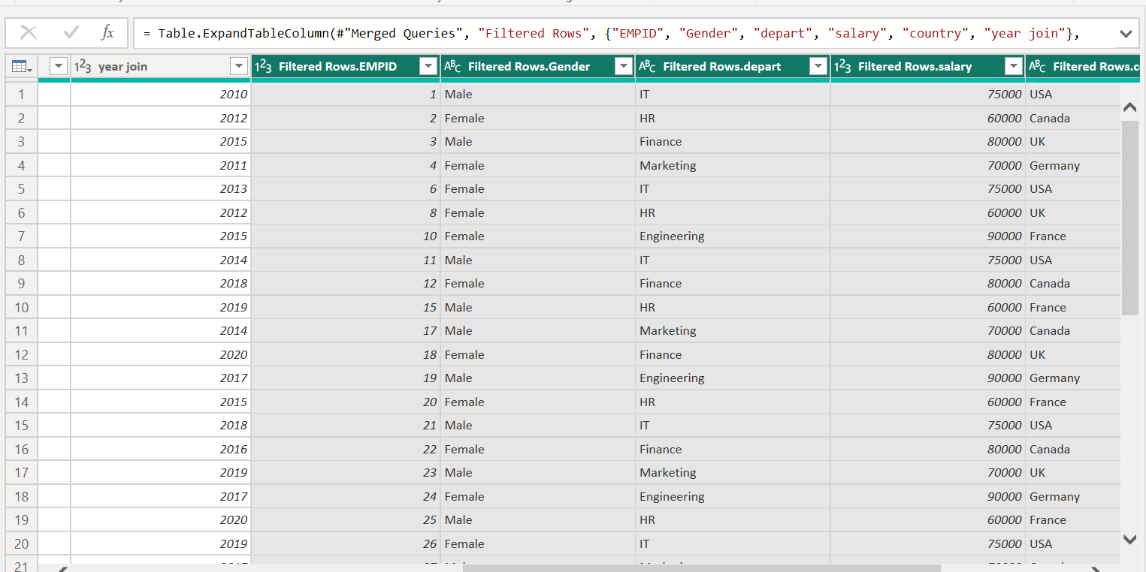

Aggregate salary with gender and Visualize using Pie chart.

1. Select gender and salary and un-summarise the gender category and summate the salary.

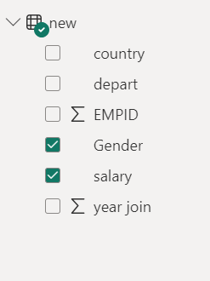

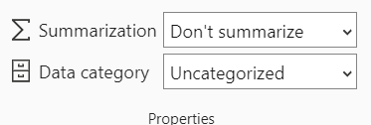

Output:

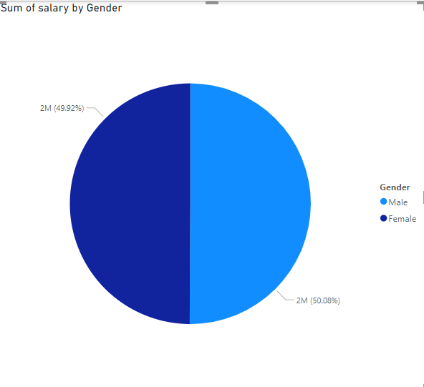

**Visualize the result of any Machine Learning algorithm on any dataset of your choice in PowerBI**

1. Load the dataset.
2. Click on data transform a new powerbi query terminal will pop up and then click pyscript.

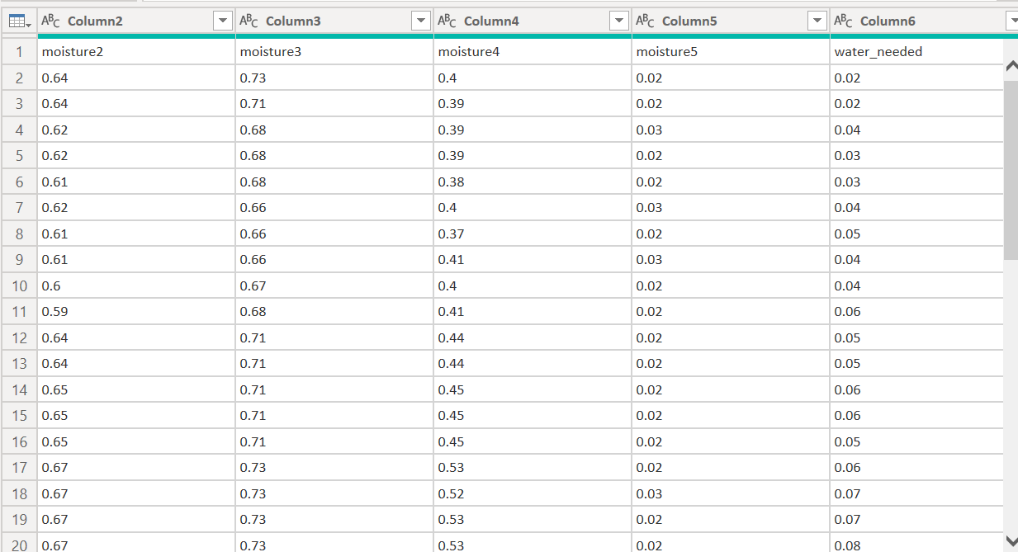

1. Install necessary libraries in the terminal, which you have used.

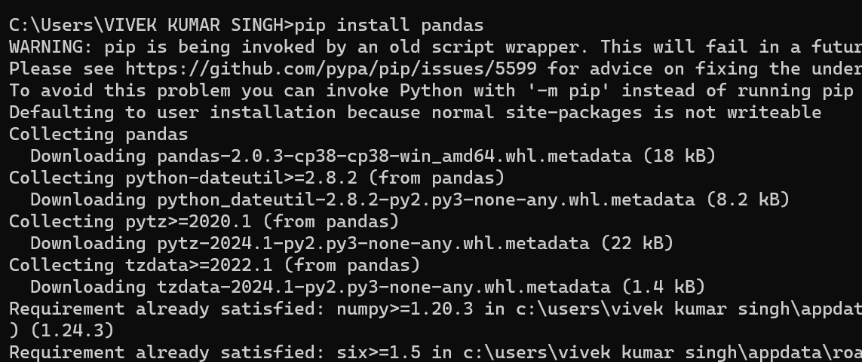

1. Paste the code on pyscript 🡪 click ok.

# 'dataset' holds the input data for this script

import numpy as np

import pandas as pd

dataset = pd.read_csv(r'C:\Users\VIVEK KUMAR SINGH\Desktop\powerbi\dataset_soil.csv')

real_x = dataset.iloc[:,:5].values

real_y = dataset.iloc[:,5].values

real_x

from sklearn.model_selection import train_test_split

train_x, test_x, train_y, test_y = train_test_split(real_x,real_y,test_size=0.1, random_state=99)

from sklearn.linear_model import LinearRegression

le = LinearRegression()

le.fit(train_x,train_y)

y_pred = le.predict(test_x)

y_pred

y_out = le.predict(real_x)

dataset['prediction']=y_out

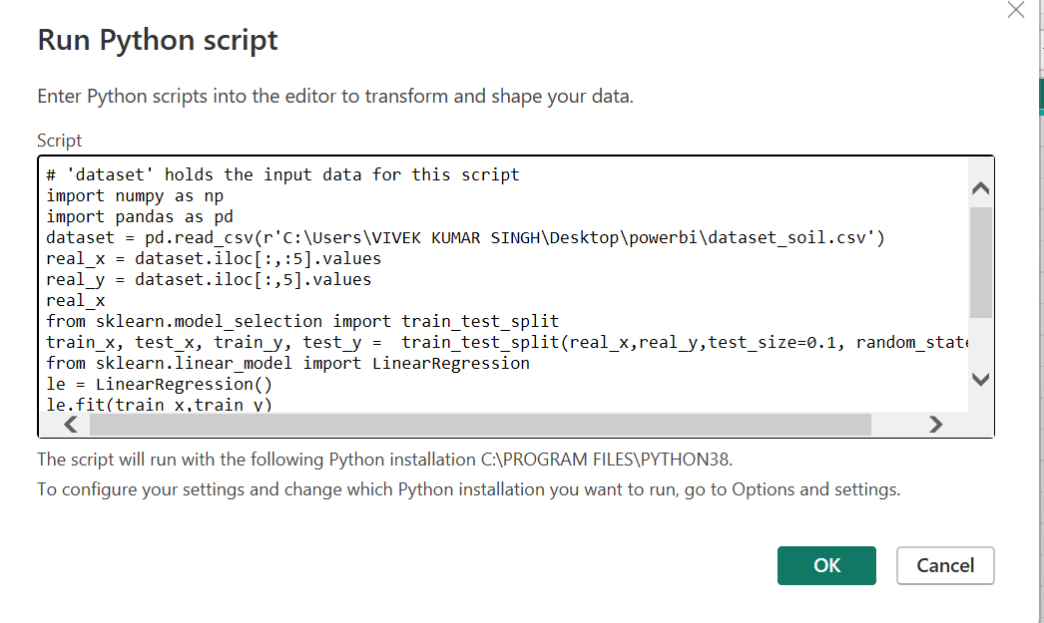

1. Save changes to the file.

Prediction column will be added.

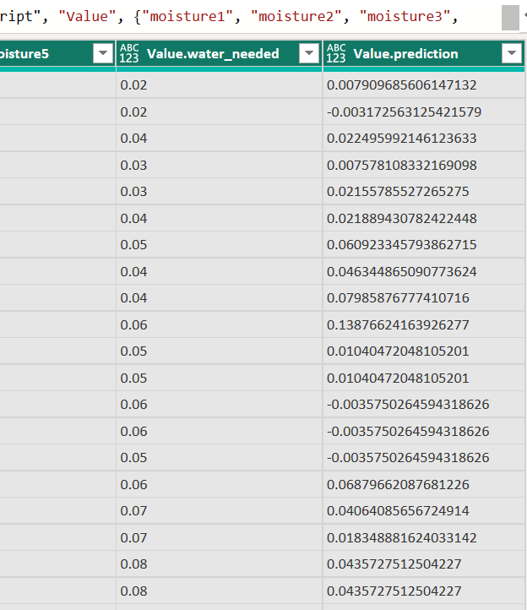

1. Apply various visualisation plot using the predicted value and the input value.

Depth 1 vs predicted value🡪

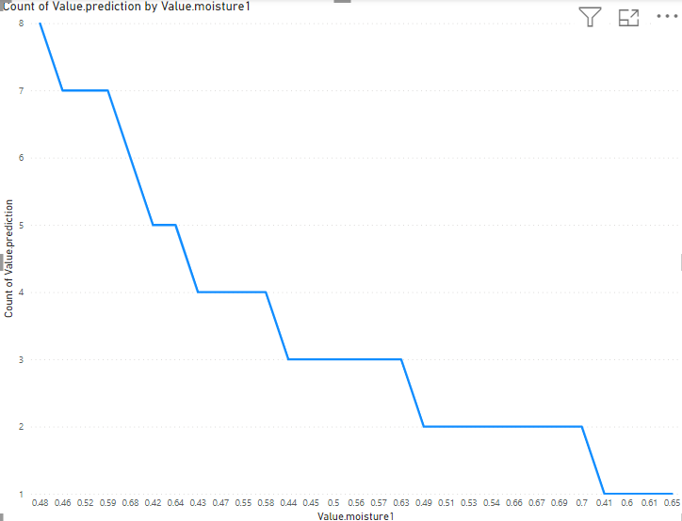

Depth2 vs prediction

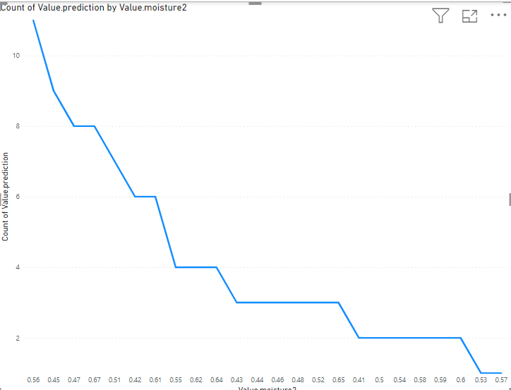

Depth3 vs prediction

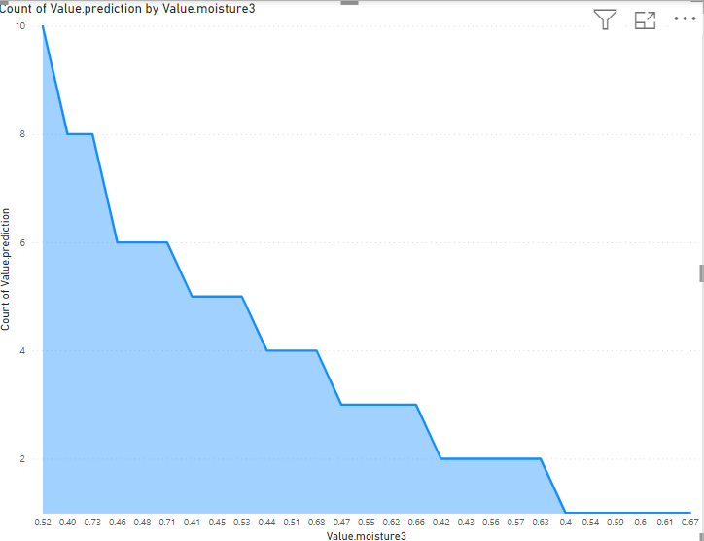

Funnel view for depth4

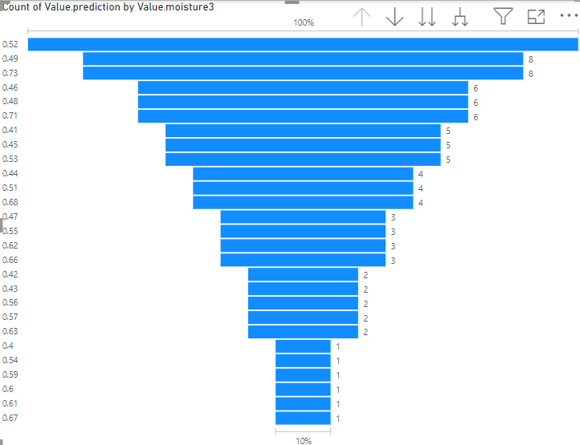

Ribbon chart

