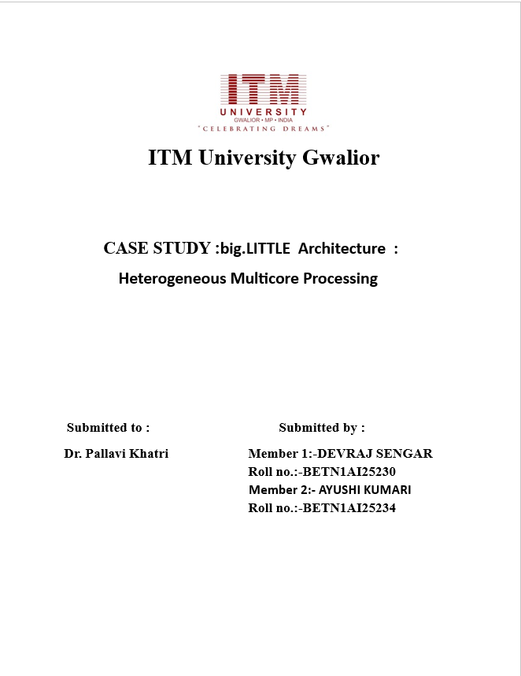

big.LITTLE Architecture : Heterogeneous
Multicore Processing

ABSTRACT
ARM’s big.LITTLE architecture introduces a solution to optimize power consumption by selecting the core type most suitable for a level of processing load along with high performance. Using heterogeneous multi-core processing having high performance cortex-A15 with power efficient cortex-A7 is what big.LITTLE architecture follows to have power efficient system on chip which is demanded by today’s smart phones. For smooth functioning and effective data transferring big.LITTLE uses GIC-400 and CCI-400 interfaces to interface between two processors. Present smart phones using big.LITTLE technology having cluster migration as their operating mode, But using global task scheduling method as operating mode of smart phones in which cores gets individually activated or deactivated according to workload can give even further improvement in power consunmption.

1.INTRODUCTION
As the need for higher performance is increasing day by day, the battery life (capacity) of that system must also be increased accordingly. But the actual problem comes in the size of the batery which cannot be altered a lot because of the small size of the mobile phones. So, to overcome this problem we need an archietecture which can provide us with high performance as well lower power consumption.
Previously in most of the mobile phones, a processor giving higher performance or fast processing (Big procesors)are not power efficient like ARM cortex A-15 .And processors consuming less power (Little processor)do not provide fast processing like ARM cortex A-7.
Thus, our goal cannot be achieved by using processors of same type. To overcome this problem ARM series launched a technology termed as “big.LITTLE technology” which is a hetrogeneous processing architecture which uses two types of processor giving performance driven by big processor and power efficient little processor.

2.Problem Statement
Earlier smartphones used homogeneous processors, whose cores were of the same type.
Problem;
- High performance → Battery drainage
- Low power mode → inferior performance
- There was rapid heating of the devices

Therefore, there was a need for a solution that would:
- Deliver a high level of performance when required
- Save power while running light tasks
- Reduce overheating

3.Proposed Solution: big.LITTLE Architecture
The ARM presented a processor design that has two types of cores.
1.Big cores.
Example: ARM Cortex-A15.
- Fast rates.
- Gaming, video editing, heavy apps.
- Power consumption

2.Small Cores
An example: ARM Cortex-A7.
- Energy efficiency.
- For calls, text messages, background applications.
- Reduce power consumption;
They are both in the same chip and share the same instruction set so switching is not a problem. 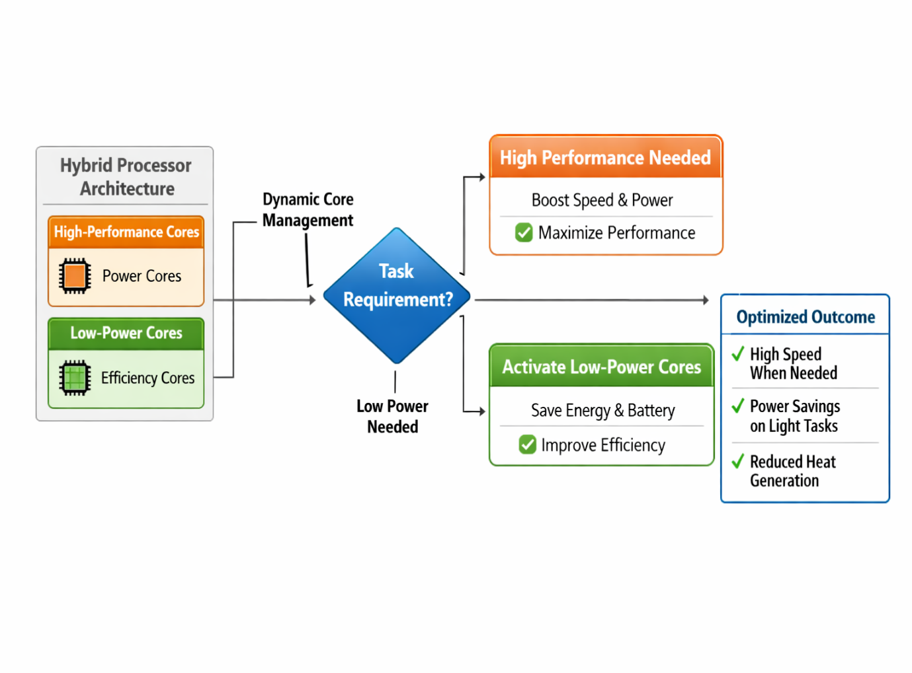
4.What is Heterogeneous Computing?
The heterogeneous computing refers to the use of different types of processors or cores in a single computing system in regards to optimizing the overall performance and energy saving metrics.
Instead of relying on like cores that have equal power and speed, the system combines;
- Performance cores (for heavy graphics like gaming, video editing, multitasking).
- Energy-efficient cores (lightweight tasks such as messaging, internet browsing, keeping applications running in the background).
For example, in Arm Holdings’s big.LITTLE architecture, complex applications are run on high-performance “big” cores, whereas simple applications are run on energy-efficient “LITTLE” cores.
Why is this important?
if all the cores of a processor is to be powerful, then the device:
- It consumes more battery juice.
- It produces more heat.
- It reduces the efficiency
performance-wise:
In heterogeneous computing, the system is supposed to switch between cores intelligently based on workloads.
- The smart task allocating is Power conservation.
- Battery life keeps improving
- Keeps the performance smooth.

5.How It Works ?
A better example of heterogeneous computing is a normal day’s use of a smartphone. These modern processors (for example, those produced by Arm Holdings) pair high-performance cores to power-conserving cores to allocate tasks optimally.

Situation 1: Viewing WhatsApp or Surfing the Internet Only LITTLE (energy-saving) cores are active. The tasks are elementary (reading or rewriting messages, scrolling, basic apps). In general, the rate of battery consumption is minimal. The device does not heat up. Since the volume of work is insignificant, there is no sense in activating powerful cores. That saves energy” (“Phone”).

Situation 2: Playing a Game or Watching Heavy Apps High-performance (big) cores are activated. Require high graphics, speedy processing, and multitasking. This provides a seamless game and performance experience. Battery drainage increases (if only necessary). Strong cores are enabled only when there is a need for high performance.

Situation 3: Phone Is Idle (Screen Off) Big cores are off. These functions operate on the LITTLE cores (notification, synchronization of accounts, updating processes). Power wastage is little as can be. The result extends the standby and battery charge time.

Who Is Responsible for All That?
The operating system (OS) switches this switching automatically. This is decided by the workload, and the switching is done on the basis of which core is relevant and should be working. When to do core switching, when to disable the unused cores.
Such automatic balancing ensures: optimized battery life, smooth performance, reduced overheat, and best use of system resources.

6. Architectural Description
The most important point for big.LITTLE architecture to work efficiently is both the processors should be interfaced coherently so that they can transfer information to each other. So in big.LITTLE they are tied together via two interfaces called CoreLink CCI-400 and GIC-400 interrupt control, provided by ARM, in which “cache coherent interconnect” provides seamless data transfer between clusters.
CoreLink provides dynamically configurable interrupt distribution to all the cores through which it can share 480 interrupts to cortex-A15 and cortex-A7.
The programmable nature of GIC-400 allows interrupts to be migrated between any cores in the two clusters

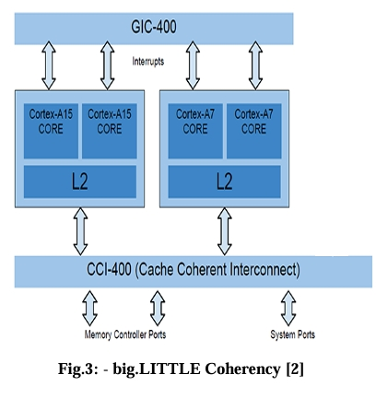
7.The performance analysis of ARM big.LITTLE

Clock Speed and Voltage (DVFS) :

- They usually run on different frequencies and voltages (Dynamic Voltage and Frequency Scaling – DVFS).

- Performance vs. Efficiency: ‘Big’ cores (e.g., Cortex-A15/A57) are clocked at higher maximum frequencies and are optimized for bursty/intensive workloads such as gaming and browsing, whereas ‘LITTLE’ cores (e.g., Cortex-A7/A53) maintain lower CPU clocks to maximize power efficiency on background workloads.

- Performance Implication: The independent dual-speed performance means the system can keep the E-Cores running at minimum power state while completely turning off the ‘big’ cores or quickly increasing the ‘big’ cores when needed.

IPC / CPI (Instructions per Cycle / Clock):

- IPC heterogeneity: a big core has a complex pipeline, for example, 15–24 stages, with higher IPC, and the instruction throughput per clock cycle is high.

- CPI Efficiency: ‘LITTLE’ cores are in-order, basic (8–10 stages) pipelines with less power, IPC rates but better efficiency per instruction (energy-wise).

- Result: Compared to a ‘little core’, a ‘big’ core can deliver up to 2x the performance per unit MHz while ‘LITTLE’ core can 3x the economy.

Cache Hierarchy :

- Coherent Interconnect: Big.LITTLE needs to have a cache coherence system, which may be inclusive of the Cache Coherent Interconnect (CCI) to ensure that transmissions of data between the ‘big’ and ‘LITTLE’ cores do not corrupt any data.

- Shared/Private Setup: The L1 caches are private to each core, L2 caches are private or shared within the cluster, and a bulky L3 or snoop control unit is shared with all the cores for data consistency.

- Performance: Cache coherence is a critical aspect, the overhead of migrating tasks on big and LITTLE clusters is squeezed to ~20 microseconds using the coherent interconnect.

Parallelism (Cores, Threads) :

- Global Task Scheduling (GTS/HMP): The modern big.LITTLE makes use of Heterogeneous Multi-Processing (HMP), meaning all cores can be running simultaneously, with scheduling being done by the Operating System based on the load.

- Load Balancing: Intensive threads are dispatched in ‘big’ cores and background processes (UI rendering, audio) run in ‘LITTLE’ cores.

- Performance Impact: This allows the throughput to follow a massively parallel style of execution and at the same time optimize the overall SoC power budget, which is often better than symmetric, high-power approaches alone.

Power Consumption :

- Power Efficiency: The primary goal is to reduce power ‘LITTLE’ cores are designed to be extremely power efficient (3 times more power efficient than ‘big’ cores.

- Energy savings: Under certain circumstances, migrating workloads to ‘LITTLE’ cores can save up to 75 per cent of power compared to the conventional processors that rely solely on high performance.

- Thermal Limits: The architecture enables high speed within the stringent mobile thermal limits, allowing the system not to overheat but still produce bursts of high speed.

Scalability :

Flexible Configuration: The architecture supports a flexible configuration of the number of cores in operation (2+4, 4+4, 4+8 cores).

Global Task Scheduling (GTS): GTS differs from the relatively inflexible cluster migration mode by allowing the numbers of the big cores and little cores to be unequal, which enhance the flexibility and scalability options in the SoC design.

Performance Growth: As the workloads spiral, the operating system can hand out more ‘big’ cores to the workload, which is infinitely more scalable than a fixed limited core design.

Features: | b.i.g. (Little Architecture) (ARM / (Heterogeneous)) | Symmetric Multiprocessing (Traditional)
Type of core: | It is Heterogeneous .It consists different cores big and small. | It is homogeneous . Its all cores are identical.
Performance: | Its performance is high. But, the tasks must match with the type of the core. | Its performance is consistant . but, it is inefficient.
Power Efficiency: | Its efficiency is high because it uses very less power. | Its efficiency is lower because it uses very high power.
Ideal Use Case: | It is ideally used in mobiles, laptops , lot. | It is ideally used in servers , desktops , work stations.
Primary Goal: | Its primary goal is to maximize power efficiency. | Its primary goal is to maximize sustained Performance.
Core Count: | Its core count is Often 8+ (e.g., 4+4 or 1+7) | Its core count is between  4-16.
8.Comparison Table: big.LITTLE vs. Alternative Technologies

9. Real-World Usage
The big.LITTLE architecture is arguably the most common design used in modern smartphone processors. This is majorly attributed to the cleats and their inability to connect.
Below are few most popular processors with the help of this technology:
- Samsung Exynos Manufactured Processors.
- Qualcomm’s Snapdragon processors.

Most modern smartphones today are designed around this heterogeneous core design (a mixture of performance cores and efficiency cores). This allows coordinating performance scaling based on user activity.

10. Benefits
Below are some significant advantages of big.LITTLE architecture;
- Battery Efficiency Low power cores are supplied for simple tasks and hence, any unnecessary battery loss is cut-off.
- High Performance When gaming, video editing, or using heavy apps, high-performance cores kick in.
- Reduced Heat Production Core switching guarantees that high power levels are not maintained at all times, thus reducing overheating.
- Smooth Multitasking Both the functions – process in the background and running applications, complement each other and don’t compromise speed.
- Enhanced User Experience They are ensured to get the best possible performance and efficiency, without having to manually tweak any settings.

Overall, it makes a smart equilibrium between power and performance.

11.Challenges
The big.LITTLE architecture has a few challenges that are worth noting.
- Complex Scheduling System A complex scheduling system is required where the operating system makes an intelligent decision to utilize cores at the right time.
- Needs OS Support Proper implementation of this method demands efficient operating system optimization.
- Higher Chip Design Complexity It adds to the development complexity of combining the two entirely different core types on the same chip.

12. Conclusion

Heterogeneous computing can be best seen in real world applications as the architectural design of ARM big.LITTLE.
It includes in an intelligent combination:
- Performance Cores – These heavy-duty cores handle gaming, video editing, and other such tasks.
- Power Efficiency–Power-efficient cores are assigned to process the light and background tasks to save the battery power.
- Thermal Management – An intelligent switching of cores leads to redundancy in heat production.
Thus, it dynamically switches between performance cores and efficiency cores at any time to ensure an optimal user experience.
Due to this intelligent design, a modern smartphone with heavy applications can not only run smoothly and multitask at the same time, and at the same time the battery will last for a long time without the user having to manually control the performance.
ARM big.LITTLE architecture has therefore significantly contributed to making modern smartphones faster, smarter, and more conscious of battery use.

13.References
- Brian Jeff, ARM: Advances in big. LITTLE Technology for power and energy saving.
- Hexus: Tech explained –ARM big. LITTLE processing, 24 October 2013, 16:41 http://hexus. net/tech/tech-explained/cpu/48693-tech-explained-arm-biglittle-processing/.
- White paper -2013 http://img. hexus. net/v2/press_releases/arm/big. LITTLE. Whitepaper. pdf.
- Peter Greenhalgh, ARM big. LITTLE processing with ARM cortex-A15 and A-7, September 2011.
- Article : http://www. anand tech. com/tag/samsung.
- “Vampir - performance optimization.” https://www.vampir.eu/, November 2015

