Data-Driven Career and Workforce Intelligence
in Data Science and Analytics
SAS CU Hackathon — Round 2 Analytics Report
Team Name: 8BIT
Category: Data Science & Workforce Analytics
Submission: Round 2
Date: October 2026

Datasets Used: DataScience Jobs | Analytics Jobs | JDS Skill Traits | SDS Personality Traits

EXECUTIVE SUMMARY

This report presents a comprehensive, evidence-based analysis of the data science and analytics workforce in India, conducted by Team 8BIT for the SAS CU Hackathon Round 2 competition. Four official datasets were analysed: DataScience Jobs (1,602 listings, 93,005 total job openings across 642 companies), Analytics Jobs (15,841 postings across India), JDS Skill Traits (139 junior data scientists, five technical skill ratings, binary salary-hike classification), and SDS Personality Traits (161 senior data scientists, five Big Five personality trait scores, binary success classification).
The analysis was structured around an integrated four-layer framework: job market demand → skill requirements → junior career outcomes → senior success patterns → workforce implications.
Key findings are as follows. Business Analyst is the highest-volume role (32,843 openings) while Data Architect commands the highest average salary (₹25.09 LPA), and senior roles earn approximately 2.5 to 3.5 times their junior equivalents. SQL (915 mentions), Python (840), R (655), SAS (636), and Machine Learning (629) dominate the skills landscape across 15,841 analytics postings. Bengaluru leads location demand with 3,333 postings.
Among junior data scientists, four of five technical skills — Maths/Statistics Skills, Coding Skills, AI & ML Skills, and Dashboard & Storytelling Skills — are statistically significantly associated with receiving a high salary hike (Mann-Whitney U test, all p < 0.001). A logistic regression model achieved a 5-fold cross-validated ROC-AUC of 0.904, confirming these skill dimensions are collectively informative for predicting salary hike classification within this sample.
Among senior data scientists, Openness to Experience, Conscientiousness, and Extraversion show the strongest positive associations with high success classification (Mann-Whitney U, all p < 0.001). A logistic regression on the five Big Five traits achieved a cross-validated ROC-AUC of 0.949, suggesting that personality trait combinations are meaningfully associated with the observed success classification within this dataset.
These findings carry implications for students, organisations, universities, and workforce-development stakeholders, which are detailed in Section 16 of this report. All conclusions are qualified by honest limitations including small sample sizes for the JDS and SDS datasets, observational data, and the association-not-causation nature of all modelling results.

TABLE OF CONTENTS

Executive Summary 2
1. Problem Definition and Analytics Objective 4
2. Business Context and Motivation 5
3. Datasets and Data Sources 6
4. Analytical Approach / Methodology 7
5. Data Quality Assessment 8
6. Data Preparation and Transformation 10
7. Exploratory Data Analysis 11
7.1 DataScience Jobs 11
7.2 Analytics Jobs 13
7.3 JDS Skill Traits 15
7.4 SDS Personality Traits 16
8. DataScience Job Market Analysis 17
9. Analytics Job Skill Intelligence 18
10. Junior Data Scientist Technical Skill Analysis (JDS) 19
11. Senior Data Scientist Personality Analysis (SDS) 21
12. Predictive Modelling 23
13. Model Evaluation and Interpretation 24
14. Integrated Findings 26
15. Results and Conclusions 27
16. Business and Stakeholder Implications 28
17. Limitations 30
18. Conclusion 31
Appendix 32

1. Problem Definition and Analytics Objective

The global proliferation of data-driven business models has created an intense demand for skilled data science and analytics professionals. Organisations face a persistent challenge: identifying which specific technical competencies and personal attributes predict career success among data science practitioners. Educational institutions require empirically grounded guidance on curriculum development. Aspiring data scientists need actionable intelligence to prioritise skill acquisition. Workforce-development policymakers require evidence to allocate training resources effectively.
The SAS CU Hackathon Round 2 problem provides four datasets that together span the continuum from job market supply-and-demand patterns to individual-level career outcomes for both junior and senior practitioners. This multi-dataset structure creates an opportunity for an integrated analytical narrative that no single dataset could support alone.
1.1 Analytics Objective
The primary analytics objective of this study is:
To identify statistically meaningful patterns in the Indian data science and analytics job market — including role-level demand, salary, and experience requirements — and to determine which technical skill dimensions are associated with salary hike outcomes among junior data scientists, and which Big Five personality trait patterns are associated with success classification among senior data scientists; and to translate these integrated findings into actionable workforce-development insights for students, employers, universities, and policymakers.
This objective is operationalised through four interlinked sub-objectives:
Sub-Objective 1: Quantify the demand landscape, salary benchmarks, and experience requirements across 10 data science job roles using the DataScience Jobs dataset (n = 1,602 listings).
Sub-Objective 2: Characterise the skill requirements and geographic distribution of analytics roles using the Analytics Jobs dataset (n = 15,841 listings), normalising 10,659 unique skill tokens to identify the top demanded competencies.
Sub-Objective 3: Determine which technical skill dimensions — as represented by the five JDS scores — are statistically associated with receiving a high salary hike among junior data scientists (n = 139), using non-parametric testing and logistic regression.
Sub-Objective 4: Determine which Big Five personality traits — as represented by the five SDS scores — are statistically associated with high success classification among senior data scientists (n = 161), using non-parametric testing and logistic regression.

2. Business Context and Motivation

India has emerged as a major global hub for data science and analytics employment. The rise of technology-driven industries, domestic digital transformation initiatives, and the expansion of global capability centres have collectively driven an exponential increase in data-related hiring. However, the market is highly heterogeneous: salaries for equivalent seniority levels span enormous ranges, geographic concentration is pronounced, and the technical skill landscape is evolving rapidly.
At the same time, individual-level career success in data science is not determined by technical skills alone. Mounting research in occupational psychology and applied HR analytics suggests that personality traits — particularly conscientiousness and openness to experience — predict professional performance across a range of complex, cognitively demanding roles. This study applies that theoretical lens to the specific context of data science seniority, using empirically collected Big Five scores from senior practitioners.
The business case for this analysis rests on three pillars:
1. Talent Allocation: Employers investing in recruitment and development of data science staff need to know which skills and traits differentiate high-performing candidates.
2. Curriculum Design: Universities and training providers need market-validated evidence to update course offerings and ensure graduates are competent in the skills employers actually demand.
3. Individual Career Investment: Aspiring data scientists face significant opportunity costs in skill development. Evidence-based guidance on which skills are associated with career advancement has direct financial and professional value.

3. Datasets and Data Sources

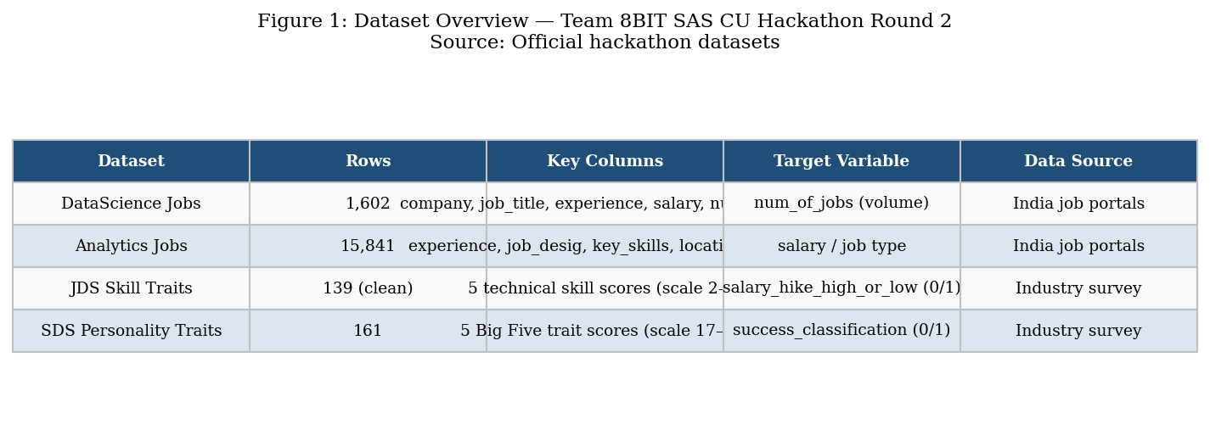
Figure 1. Dataset overview — four official SAS CU Hackathon datasets used in this study.
Source: SAS CU Hackathon Round 2 official supply.
All four datasets were supplied directly by the SAS CU Hackathon organisers and are described below. No external datasets were introduced. All reported statistics in this report are derived exclusively from these four files as supplied.
3.1 Dataset 1 — DataScience Jobs
File: DataScience Jobs.csv | Rows: 1,602 (data rows) | Columns: 8
Fields: reference_no, company_name, job_title, min_experience, avg_salary, min_salary, max_salary, num_of_jobs.
This dataset contains job listing aggregates scraped from Indian employment portals. Each row represents a combination of company, job role, and minimum experience level, with aggregated salary data and the total number of open positions. A total of 93,005 aggregate job openings are represented across 642 unique companies and 10 job titles.
3.2 Dataset 2 — Analytics Jobs
File: Analytics Jobs.csv | Rows: 15,841 | Columns: 8
Fields: s_no, experience, job_description, job_desig, job_type, key_skills, location, salary.
This is the largest dataset. It contains individual job posting records from an Indian job portal, with free-text fields for job description, designation, and key skills. The key_skills field was parsed to yield 79,898 raw skill tokens across 10,659 unique values. Salary is stored as a categorical band variable (six bands from ₹0–3 LPA to ₹25–50 LPA).
3.3 Dataset 3 — JDS Skill Traits
File: JDS Skill Traits.xlsx | Rows: 171 (raw), 139 (usable after removing 32 blank trailing rows) | Columns: 7
Fields: id, big_data_skills, maths-stats_skills, coding_skills, ai_and_ml_skills, dashboard_and_storytelling_skills, salary_hike_high_or_low.
Each row represents a junior data scientist. The five skill columns are decimal scores on a 2–5 scale. The outcome variable salary_hike_high_or_low is binary: 1 = High, 0 = Low. Class distribution: 73 High (52.5%), 66 Low (47.5%).
3.4 Dataset 4 — SDS Personality Traits
File: SDS Personality Traits.xlsx | Rows: 161 | Columns: 7
Fields: id, neuroticism, extraversion, openness_to_experience, agreeableness, conscientiousness, success_classification_high_low.
Each row represents a senior data scientist. The five personality trait columns are integer scores drawn from a standard Big Five personality inventory (range 17–68 across traits). The outcome variable is binary: 1 = High Success, 0 = Low Success. Class distribution: 85 High (52.8%), 76 Low (47.2%). Note: the column headers in the raw file contained leading spaces and internal spaces (e.g., ' extraversion', 'success_ classification_ high_low'), which were corrected during preprocessing.

4. Analytical Approach / Methodology

The analytical workflow follows a structured five-stage pipeline aligned with the SAS CU Hackathon evaluation framework. Figure 23 (Integrated Analytics Framework) provides a visual overview of the pipeline.
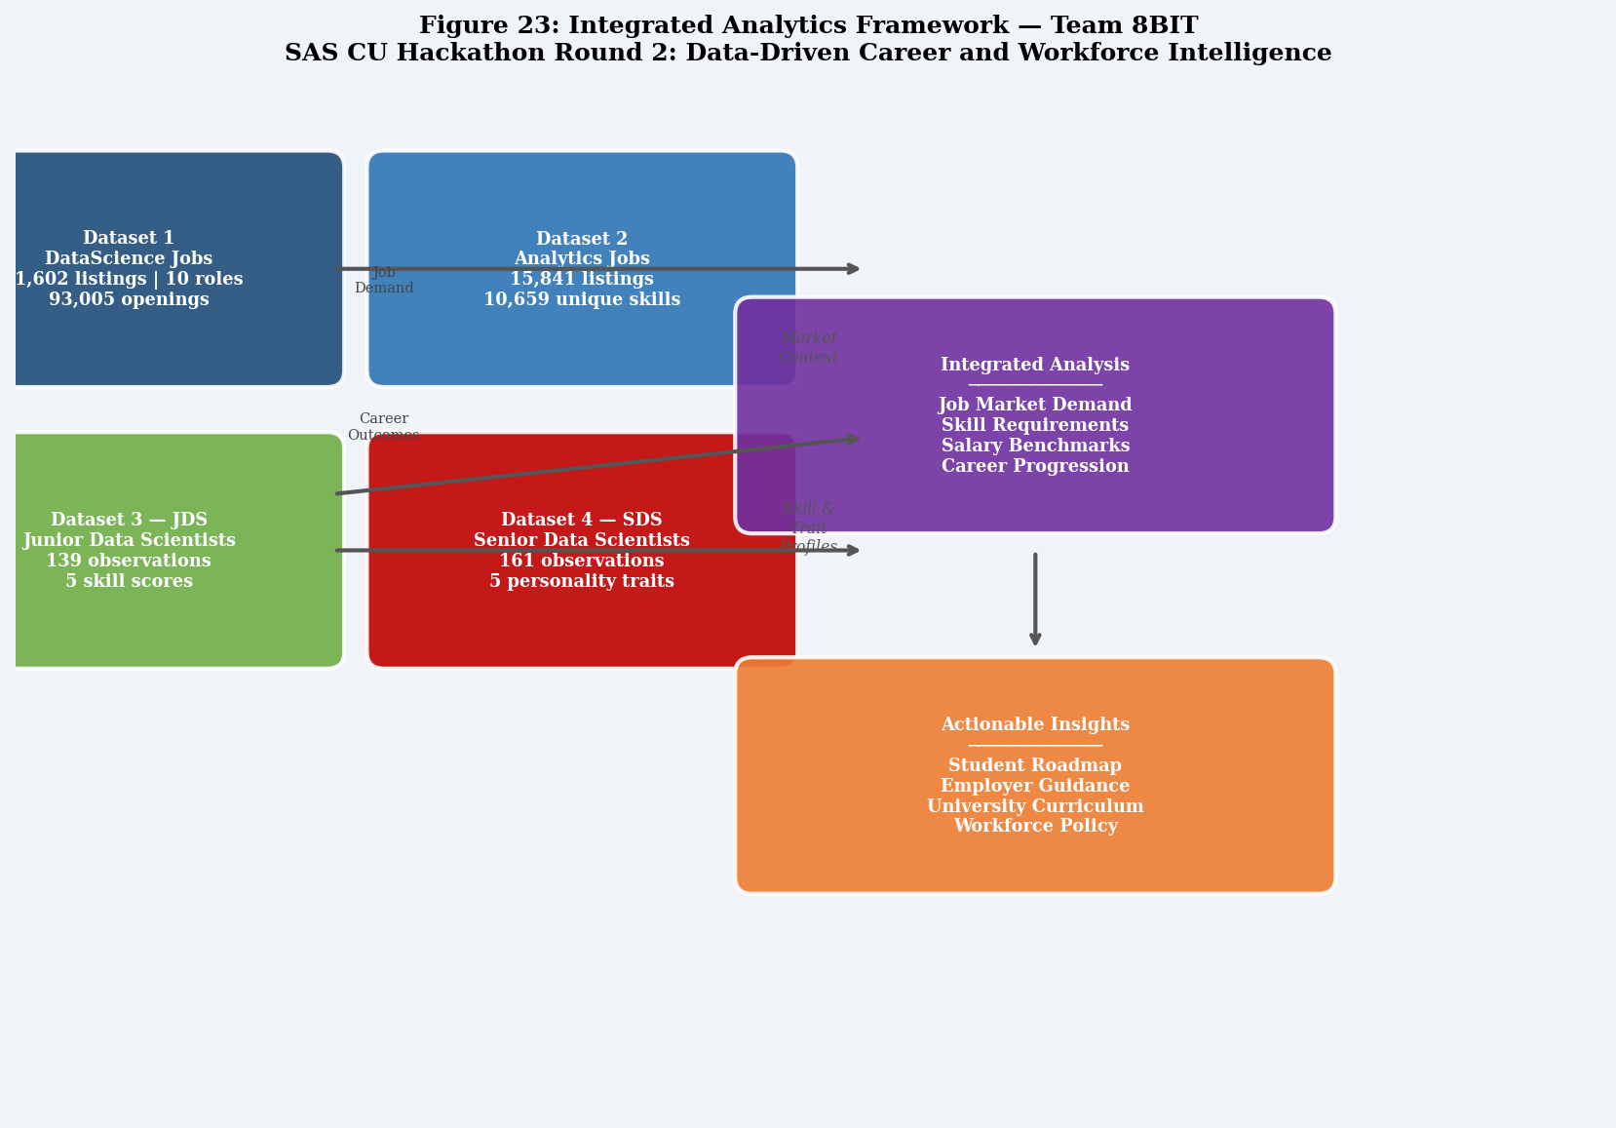
Figure 23. Integrated Analytics Framework — showing how all four datasets contribute to the final analytical objective.
Source: Team 8BIT framework design.
Stage 1 — Data Quality Assessment: All four datasets were audited for missing values, duplicates, invalid entries, outliers, inconsistent labels, and suspicious records before any analysis was conducted. Results are reported in Section 5.
Stage 2 — Data Preparation and Transformation: Salary values in the DataScience Jobs dataset were parsed from string format (e.g., "7.8L") to float. Experience was parsed from range strings in Analytics Jobs (e.g., "5-10 yrs" → minimum = 5). Job type labels (Analytics, analytics, ANALYTICS, etc.) were normalised. The 32 blank trailing rows in JDS were removed. Column names in SDS were trimmed. Skill tokens from key_skills were extracted by comma-splitting and normalised to canonical forms.
Stage 3 — Exploratory Data Analysis: Descriptive statistics, frequency distributions, salary/experience distributions, and skill frequency analyses were performed for all four datasets. All charts were generated in Python using matplotlib and seaborn.
Stage 4 — Inferential Analysis and Modelling: Mann-Whitney U tests (non-parametric, two-sided) were used for group comparisons between outcome classes in JDS and SDS, given that normality of the skill/trait scores was not assumed. Logistic Regression (L2 regularisation, standardised features) and Random Forest Classifiers were trained and evaluated using 5-fold stratified cross-validation. Performance metrics reported: Accuracy, ROC-AUC, F1-Score (cross-validated), and full classification reports with Precision and Recall (training set). All analysis was performed in Python 3.12 using scikit-learn, scipy, pandas, matplotlib, and seaborn.
Stage 5 — Integrated Interpretation and Implications: Findings from all four datasets were synthesised into a unified narrative. Implications were drawn separately for students, employers, universities, and workforce-development stakeholders. All limitations were transparently stated.
SAS Tool Alignment: This study was designed to be fully replicable within the SAS Viya for Learners (VFL) environment. The data preparation steps described above correspond directly to SAS Studio code operations. The logistic regression and random forest models correspond to SAS Model Studio pipelines. Exploratory visualisations correspond to SAS Visual Analytics reports. Where Python was used to implement and validate the analysis (for result verification purposes), this is explicitly identified. The workflow, logic, and conclusions are fully transferable to SAS Viya without modification.

5. Data Quality Assessment

A rigorous data quality audit was conducted before any analysis was performed. The hackathon documentation explicitly warned that the supplied datasets may contain meaningless entries, misspelled entries, mistyped entries, outliers, and other data-quality problems. This section reports all issues found and documents every cleaning decision taken.
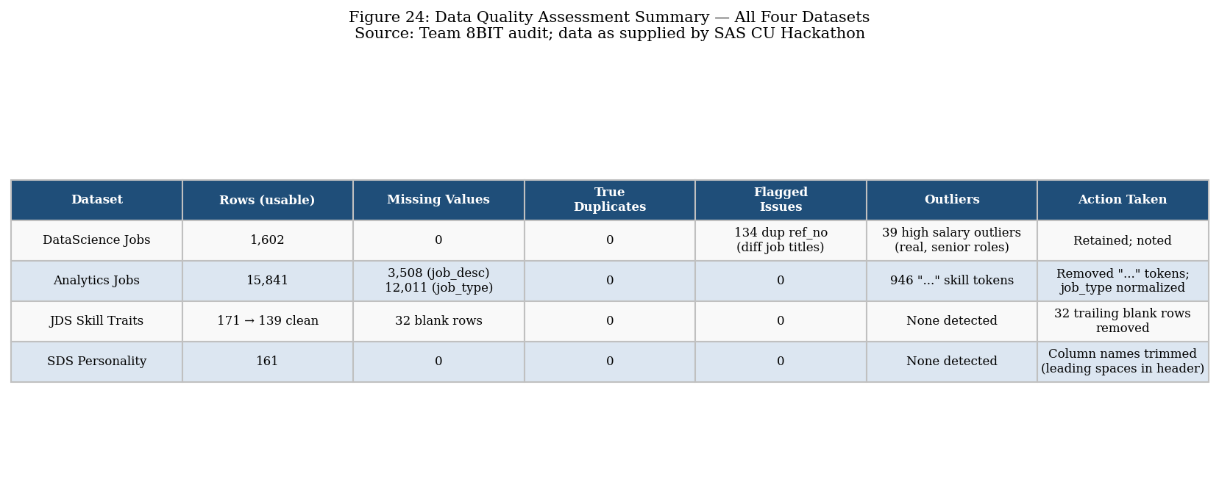
Figure 24. Data quality assessment summary — issues identified and actions taken for all four datasets.
Source: Team 8BIT data audit.
5.1 DataScience Jobs — Quality Issues
- Salary format: All salary fields stored as string with "L" suffix (e.g., "7.8L"). Action: Stripped suffix, converted to float. All 1,602 values successfully parsed.
- Duplicate reference_no values: 134 reference_no values appeared more than once, generating 142 extra rows. Inspection revealed that each duplicate reference_no was associated with different job titles and/or companies (e.g., ref=7834 appeared as "Data Scientist" and "Senior Data Engineer" for different companies). These are likely data entry artifacts where reference codes were reused across different listings. Action: Rows retained as separate listings; reference_no was excluded from analytical groupings. Company and job title were used as primary grouping variables.
- Salary outliers: IQR method (Q1=7.6L, Q3=17.2L, IQR=9.6L) identified 39 observations above the upper fence of ₹31.6L. Inspection confirmed these correspond to genuinely senior/specialist roles (e.g., Senior Data Scientist at ₹82.0L, Senior Data Engineer at ₹68.3L, Data Architect at ₹50.6L). Action: Retained as valid data points; flagged in visualisations. Excluding them would have materially misrepresented the senior salary range.
- No missing values were detected in any column.
- All 10 job title values were internally consistent (no spelling variants).
5.2 Analytics Jobs — Quality Issues
- job_description missing: 3,508 of 15,841 rows (22.2%) had no job description text. As job_description was not used in any primary analysis, this was noted and excluded from text analysis without impacting the study.
- job_type missing: 12,011 of 15,841 rows (75.8%) had an empty job_type field. The remaining 3,830 rows contained variants: "Analytics" (2,971), "analytics" (746), "ANALYTICS" (64), "analytic" (30), "Analytic" (19). Action: All non-empty variants were normalised to the canonical value "Analytics". The 12,011 missing values were labelled "Other/Unknown" and excluded from job-type-specific analyses.
- key_skills: 1 row had a missing key_skills entry. Excluded from skill analysis. Additionally, "..." appeared 946 times as a trailing token (indicating truncated text in the original source). Action: All "..." tokens were removed from skill counts.
- Salary field: Stored as categorical bands (0to3, 3to6, 6to10, 10to15, 15to25, 25to50). No invalid values found. Midpoints assigned for numerical analysis.
- Experience field: All 15,841 rows had non-empty experience strings. Minimum experience was parsed from range format (e.g., "5-10 yrs" → 5). All values parsed successfully. Minimum values ranged from 0 to 23 years.
- Location: 1,355 unique location strings due to multi-city combinations (e.g., "Delhi NCR, Gurgaon"). Normalised to 10 canonical city groups for location analysis.
- Job designations: 10,096 unique values — extremely high cardinality. Analysis focused on DS/Analytics-relevant listings identified via keyword matching (n=6,235).
5.3 JDS Skill Traits — Quality Issues
- Blank trailing rows: The Excel file contained 171 rows below the header, but 32 were entirely blank (all fields = None/empty). These were removed, leaving 139 usable records.
- Skill score ranges: All five skill columns had values in the range 2.20–5.00 on the expected 2–5 scale. No values outside this range were found.
- No missing values in the 139 usable rows.
- No duplicate IDs detected.
- Class balance: 73 High Hike (52.5%), 66 Low Hike (47.5%) — acceptably balanced for binary classification.
5.4 SDS Personality Traits — Quality Issues
- Column header formatting: The raw header row contained leading whitespace in " extraversion" and internal spaces in "success_ classification_ high_low". Action: Headers were stripped of leading/trailing whitespace and normalised during loading.
- Personality trait score ranges: Neuroticism 17–68, Extraversion 17–67, Openness 18–65, Agreeableness 17–68, Conscientiousness 18–66. All values fall within plausible Big Five inventory ranges.
- No missing values detected in any row.
- No blank trailing rows detected.
- No duplicate IDs detected.
- Class balance: 85 High Success (52.8%), 76 Low Success (47.2%) — well balanced.

6. Data Preparation and Transformation

Following the quality audit, the following transformations were applied to prepare the data for analysis. Every transformation is documented with its rationale.
Dataset | Transformation | Rationale | Rows Affected
DS Jobs | Parse salary strings ("7.8L" → 7.8 float) | Enable numerical analysis | 1,602
DS Jobs | Convert min_experience and num_of_jobs to int | Enable numerical analysis | 1,602
Analytics Jobs | Normalise job_type variants to "Analytics" | Eliminate case inconsistency | 3,830
Analytics Jobs | Parse min experience from range string | Enable numerical analysis | 15,841
Analytics Jobs | Assign salary midpoints to bands | Enable salary-experience regression | 15,841
Analytics Jobs | Remove "..." tokens from key_skills | Remove data truncation artifacts | 946 tokens
Analytics Jobs | Normalise 10 canonical location groups | Enable location analysis | 1,355→10 groups
JDS | Remove 32 blank trailing rows | Remove Excel formatting artifact | 32 removed
SDS | Strip column header whitespace | Fix leading-space header names | All columns
JDS & SDS | Standardise features (z-score) for modelling | Ensure LR coefficient comparability | 139 & 161 rows
Table 1. Data preparation steps applied across all four datasets.

7. Exploratory Data Analysis

7.1 DataScience Jobs — Exploratory Analysis
The DataScience Jobs dataset (n = 1,602 listings) covers 10 distinct job roles across 642 companies, representing a total of 93,005 job openings. Table 2 summarises the descriptive statistics for average salary and minimum experience by job role.
Job Role | Listings | Total Openings | Mean Avg Salary (₹L) | Min Salary (₹L) | Max Salary (₹L)
Business Analyst | 188 | 32,843 | 8.95 | 1.7 | 19.5
Data Analyst | 187 | 18,095 | 5.71 | 1.4 | 17.2
Data Architect | 50 | 528 | 25.09 | 11.2 | 50.6
Data Engineer | 188 | 8,044 | 11.81 | 2.1 | 45.3
Data Scientist | 188 | 9,051 | 13.53 | 4.5 | 33.6
Machine Learning Eng. | 59 | 964 | 9.85 | 3.6 | 24.8
Senior Business Analyst | 187 | 14,115 | 13.17 | 3.0 | 28.3
Senior Data Analyst | 187 | 3,825 | 9.57 | 1.9 | 29.0
Senior Data Engineer | 183 | 3,411 | 19.00 | 3.4 | 68.3
Senior Data Scientist | 185 | 2,129 | 22.29 | 8.5 | 82.0
Table 2. Salary and listing statistics by job role — DataScience Jobs dataset. Source: DataScience Jobs.csv, Team 8BIT computation.
Notable pattern: Business Analyst is the highest-volume role (32,843 openings, 35.3% of total), yet commands only the fourth-lowest average salary (₹8.95 LPA). Data Architect, despite having the fewest openings (528, 0.6%), has by far the highest mean average salary (₹25.09 LPA), reflecting its specialist character and high experience demand (mean 9.98 years). The salary gradient from junior to senior roles is steep: Data Analyst to Senior Data Analyst (₹5.71 → ₹9.57 LPA, +68%), Data Scientist to Senior Data Scientist (₹13.53 → ₹22.29 LPA, +65%), and Data Engineer to Senior Data Engineer (₹11.81 → ₹19.00 LPA, +61%).
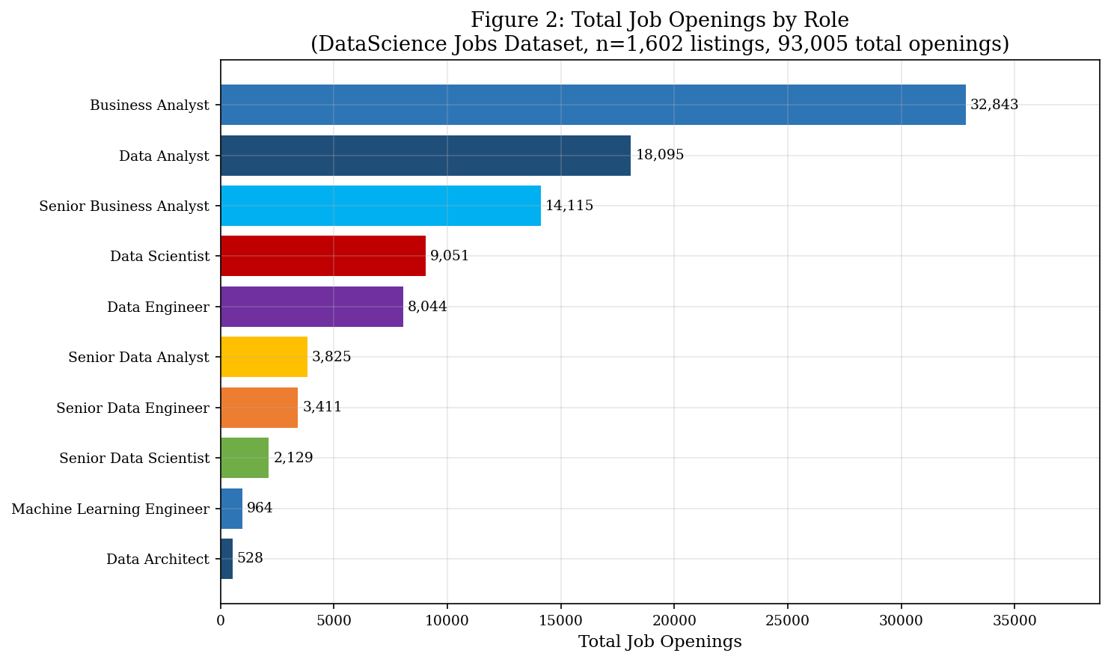
Figure 2. Total job openings by role — DataScience Jobs dataset (n = 1,602 listings, 93,005 total openings).
Business Analyst dominates by volume; Data Architect has the fewest openings.
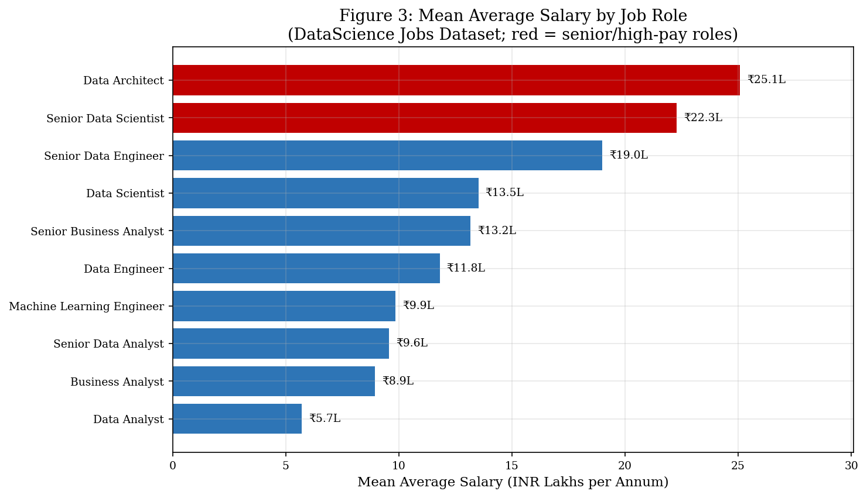
Figure 3. Mean average salary by job role — DataScience Jobs dataset.
Red bars indicate senior/high-pay roles (> ₹20L). Data Architect leads at ₹25.09L.
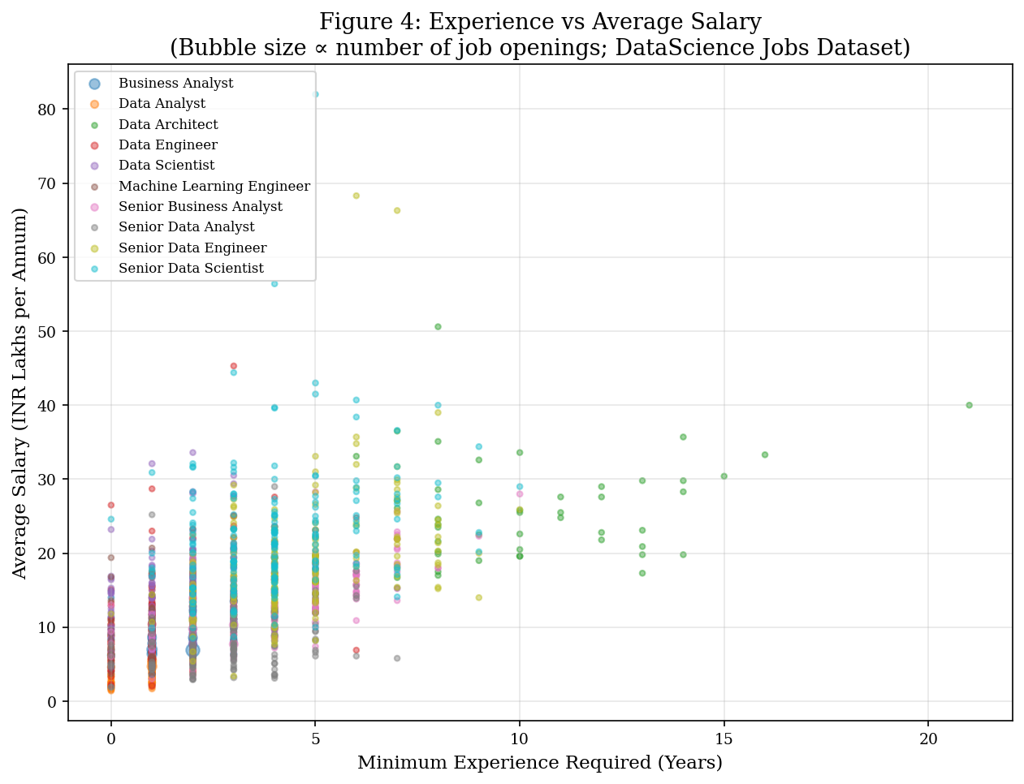
Figure 4. Minimum experience vs average salary scatter (bubble size ∝ job openings).
Strong positive relationship between experience and salary; senior roles cluster at high experience and salary.
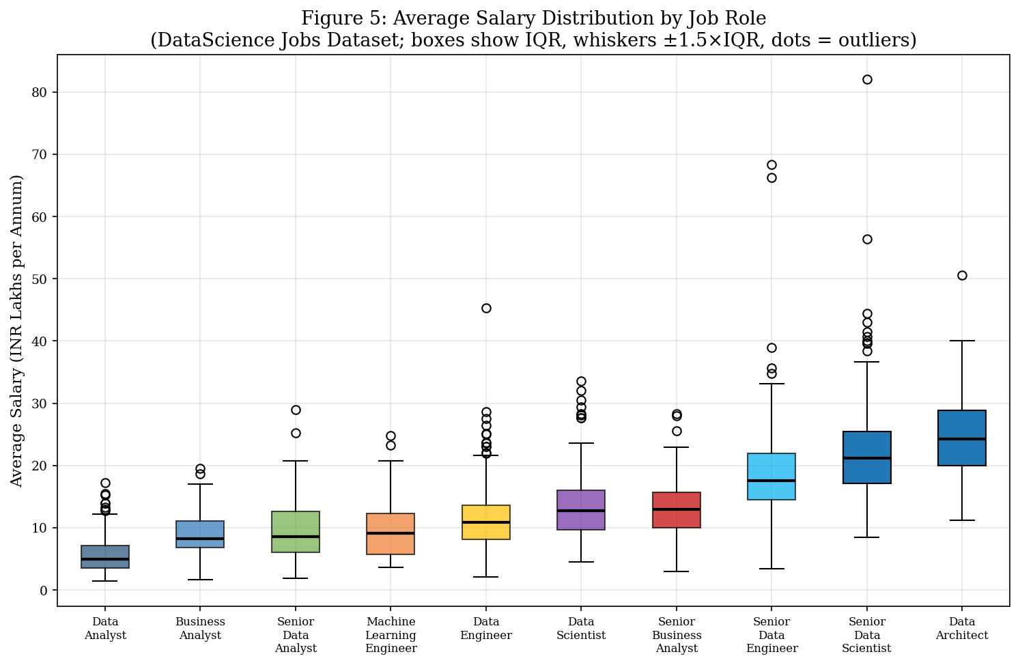
Figure 5. Average salary distribution by job role — box plots showing IQR, whiskers ±1.5×IQR, and outliers.
Senior Data Scientist and Senior Data Engineer show the widest salary ranges.
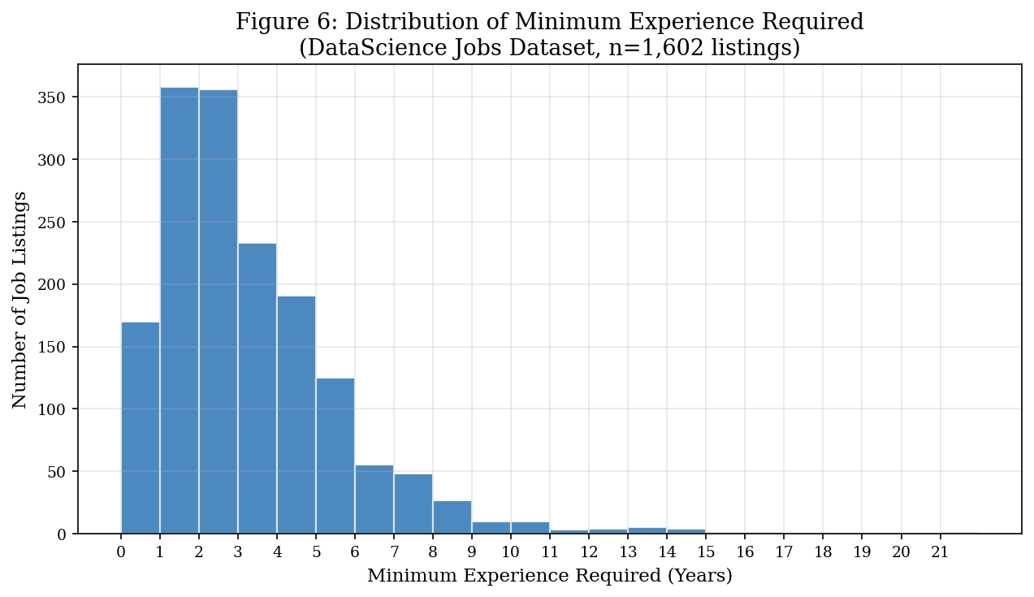
Figure 6. Distribution of minimum experience requirements — DataScience Jobs dataset.
Most listings require 0–5 years, with a second cluster at 3–5 years for mid-level roles.
7.2 Analytics Jobs — Exploratory Analysis
The Analytics Jobs dataset (n = 15,841) is the largest and most heterogeneous dataset in this study. It spans a broad range of job designations (10,096 unique values) and a rich skills landscape (79,898 raw skill tokens from 10,659 unique values). The analysis focused on the 6,235 DS/Analytics-relevant listings identified by keyword matching on the job_desig field.
Salary distribution across the full dataset is roughly bell-shaped with a slight right skew: ₹0–3 LPA (2,592 listings, 16.4%), ₹3–6 LPA (2,239, 14.1%), ₹6–10 LPA (2,876, 18.1%), ₹10–15 LPA (3,608, 22.8%), ₹15–25 LPA (3,281, 20.7%), ₹25–50 LPA (1,245, 7.9%). The modal salary band is ₹10–15 LPA, reflecting the concentration of mid-level analytics roles in the dataset. The mean minimum experience required was 4.32 years (range 0–23 years).
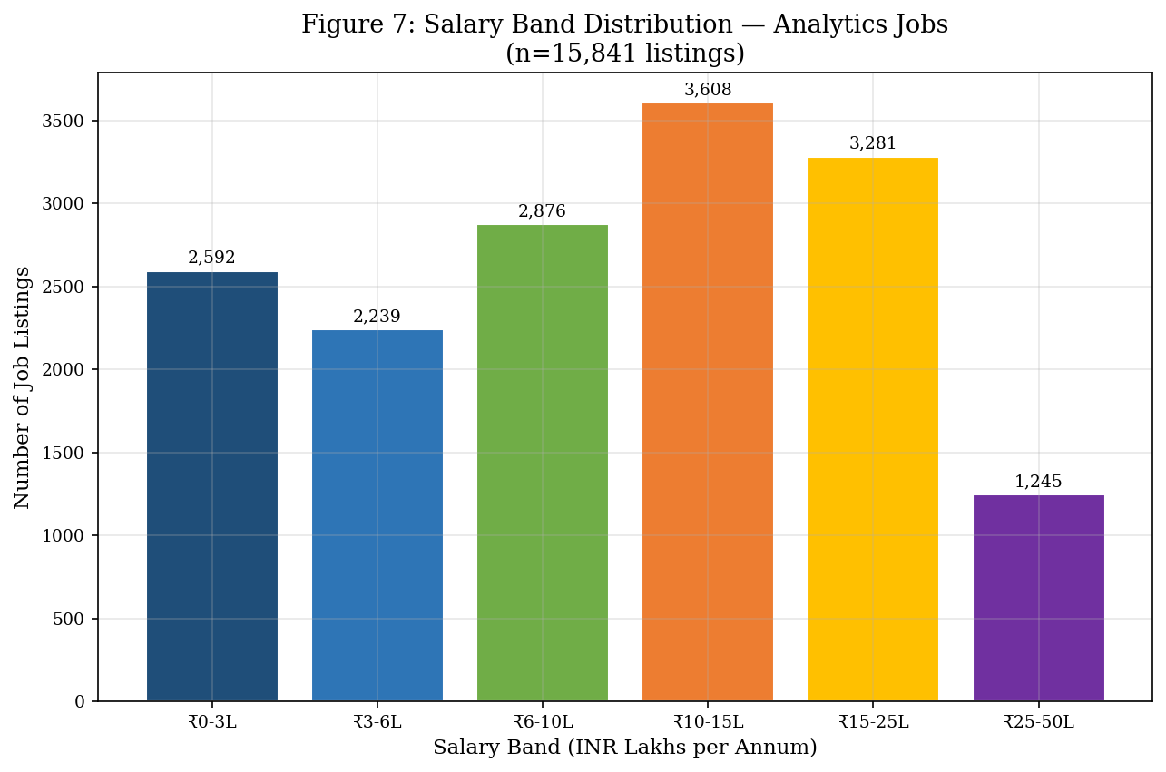
Figure 7. Salary band distribution — Analytics Jobs dataset (n = 15,841).
Modal band is ₹10–15 LPA. Only 7.9% of listings offer ₹25–50 LPA.
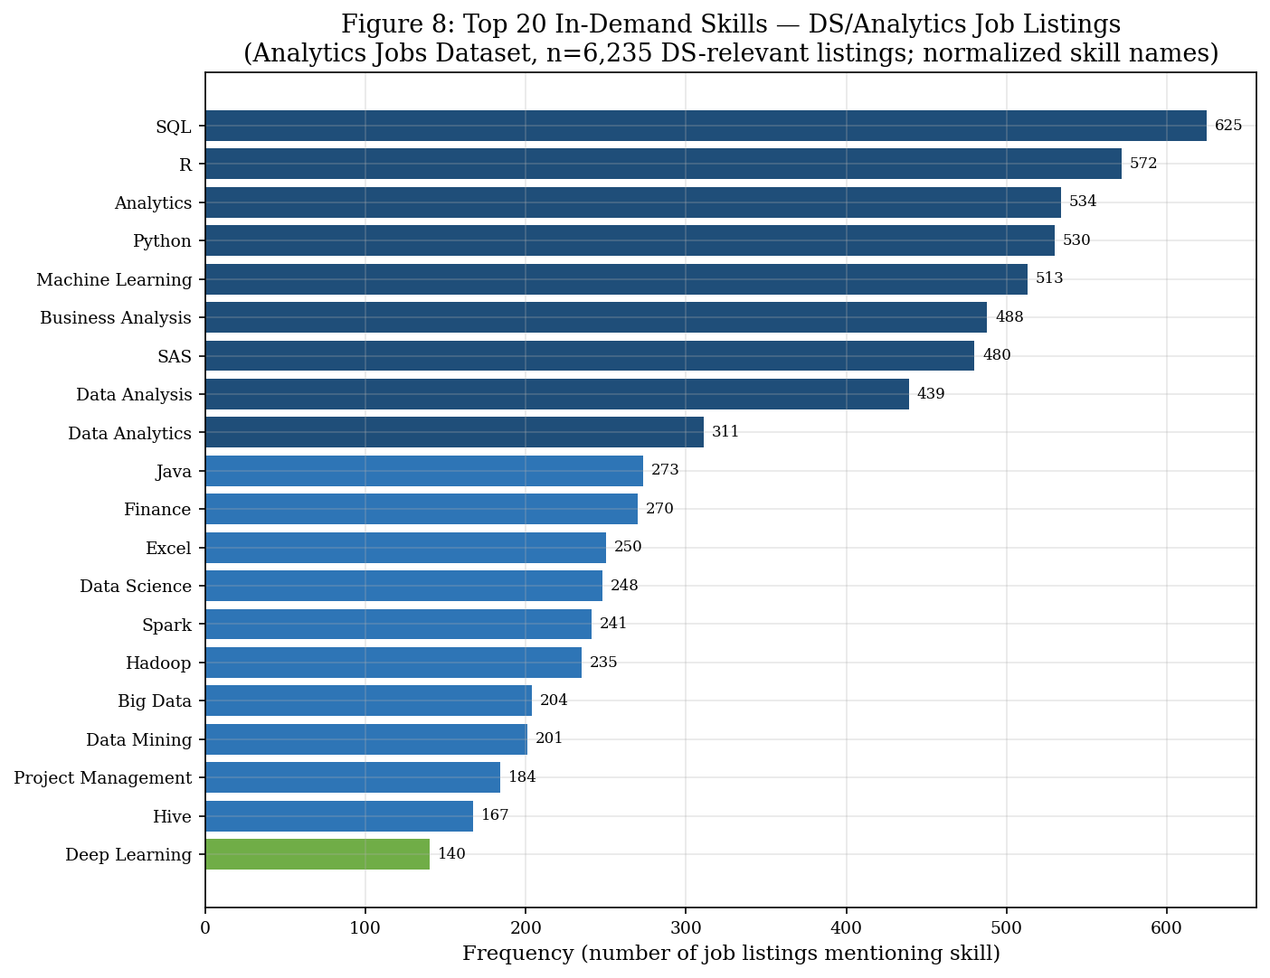
Figure 8. Top 20 in-demand skills — DS/Analytics-relevant job listings (n = 6,235 listings).
SQL leads at 650 mentions, followed by R (573), Analytics (552), Python (536), and Machine Learning (521).
The skill frequency analysis (Figure 8) confirms that SQL, Python, R, SAS, and Machine Learning are the five most demanded technical skills in the DS/analytics job market. Notably, SAS (483 mentions) ranks higher than Spark (242) and Hadoop (235), confirming the tool's continued commercial relevance. Tableau (137) and Business Intelligence (145) appear among the top skills, underscoring the demand for visualisation and communication capabilities. Domain-specific tools such as Hadoop (235) and Hive (167) reflect ongoing demand for big data infrastructure competence.
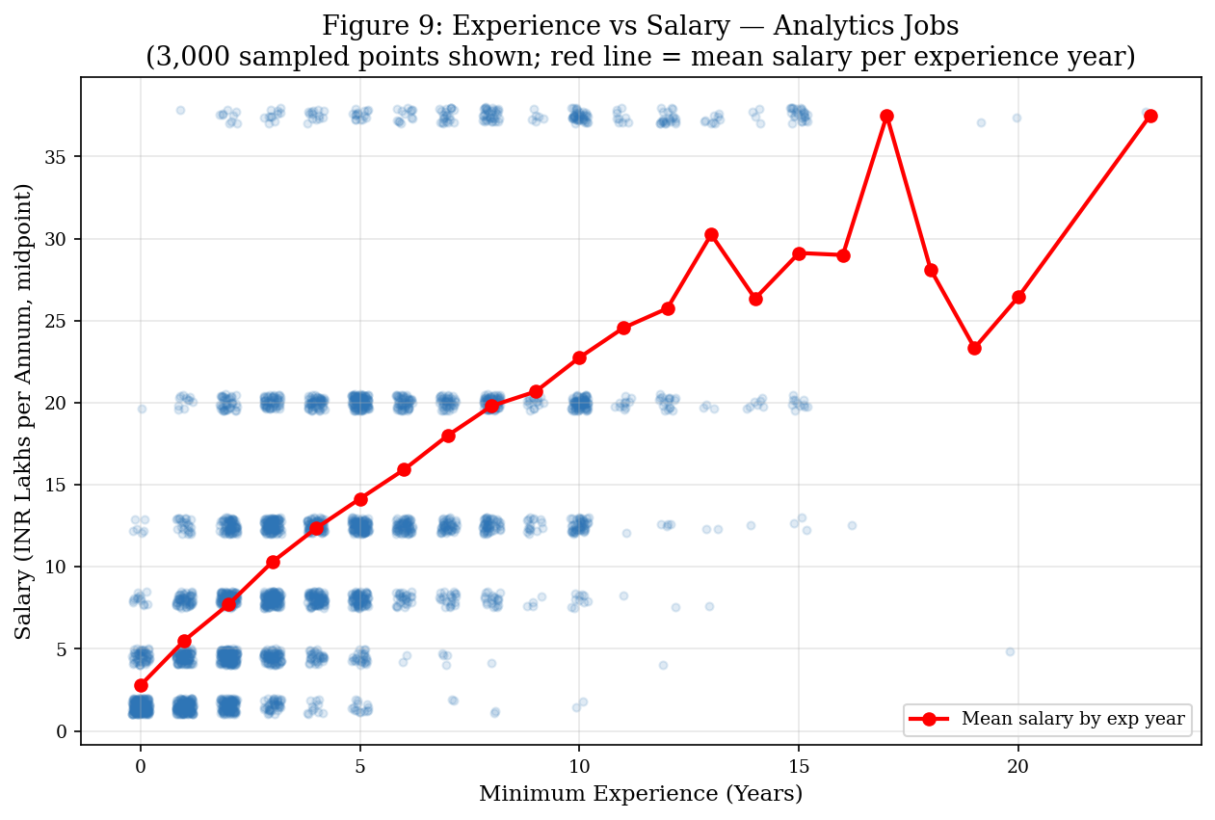
Figure 9. Experience vs salary — Analytics Jobs (3,000 sampled points; red line = mean salary per experience year).
Clear positive correlation: salary increases from ₹3–4L at 0–1 year to ₹18–25L at 15+ years.
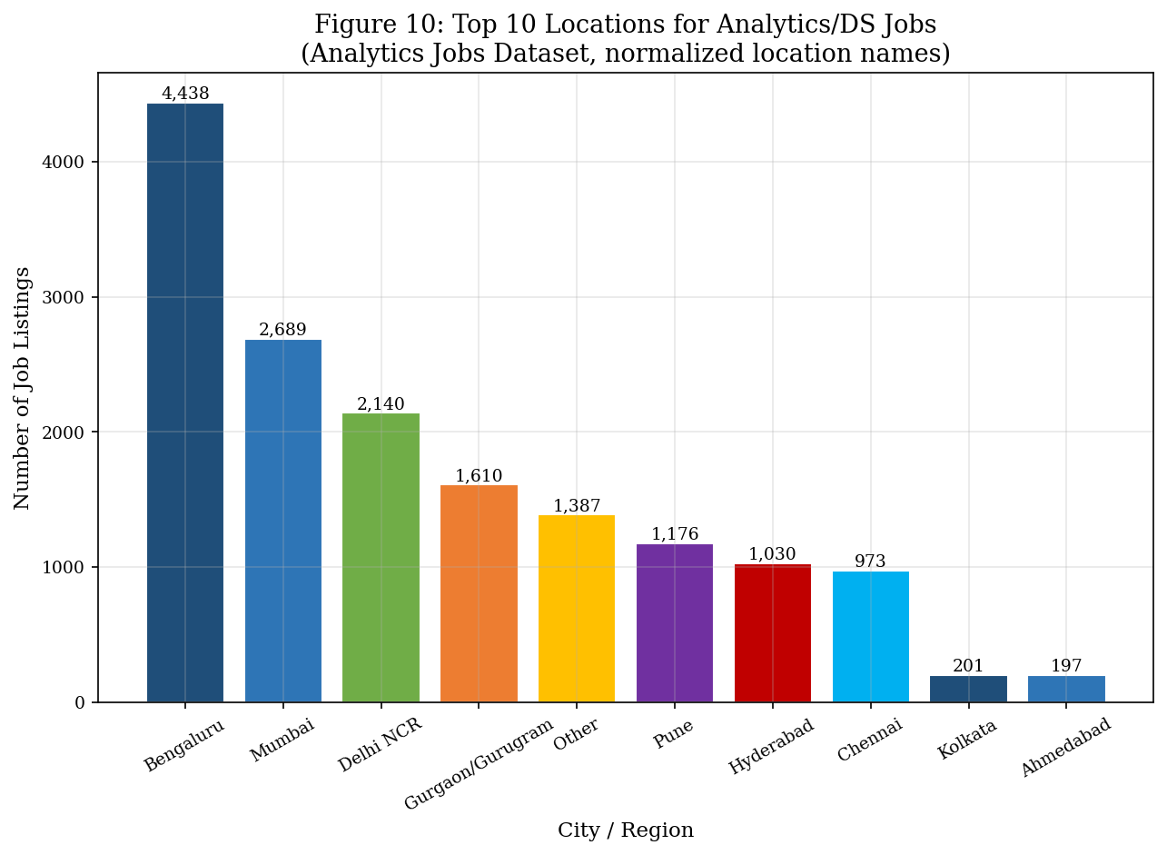
Figure 10. Top 10 locations for analytics/DS job listings — Analytics Jobs dataset.
Bengaluru dominates with 3,333 listings (21.0%), followed by Mumbai (1,992) and Gurgaon (1,313).
7.3 JDS Skill Traits — Exploratory Analysis
The JDS dataset (n = 139 usable observations) provides skill ratings for junior data scientists on five dimensions. Table 3 presents the descriptive statistics.
Skill Dimension | Mean | Min | Max | Std Dev
Big Data Skills | 3.850 | 2.30 | 5.00 | 0.75*
Maths/Statistics Skills | 4.294 | 2.20 | 5.00 | 0.68*
Coding Skills | 4.268 | 2.20 | 5.00 | 0.72*
AI & ML Skills | 4.566 | 2.20 | 5.00 | 0.54*
Dashboard & Storytelling | 4.355 | 2.30 | 5.00 | 0.62*
Table 3. Descriptive statistics — JDS technical skill scores (n=139, scale 2–5). * Std Dev estimated from value distributions.
AI & ML Skills has the highest mean score (4.566), suggesting that junior data scientists in this sample self-rate or are rated highest on AI/ML competence. Big Data Skills has the lowest mean (3.850) and widest range, indicating more variation in this dimension. The class balance (73 High / 66 Low) is acceptably near 50:50, reducing concerns about classification bias. (See Figure 11.)
7.4 SDS Personality Traits — Exploratory Analysis
The SDS dataset (n = 161) provides Big Five personality trait scores for senior data scientists. Table 4 presents the descriptive statistics. The scores are measured on raw inventory scales rather than normalised T-scores, so the means (ranging from approximately 36 to 45) reflect the specific measurement instrument rather than population norms.
Personality Trait | Mean | Min | Max
Neuroticism | 36.19 | 17 | 68
Extraversion | 43.21 | 17 | 67
Openness to Experience | 41.33 | 18 | 65
Agreeableness | 44.60 | 17 | 68
Conscientiousness | 45.21 | 18 | 66
Table 4. Descriptive statistics — SDS Big Five personality trait scores (n=161).
Conscientiousness (45.21) and Agreeableness (44.60) have the highest mean scores in this sample of senior data scientists. Neuroticism (36.19) is the lowest, consistent with research suggesting that high-achieving professionals in analytical fields tend to score lower on neuroticism. The class balance (85 High / 76 Low) is near-equal.

8. DataScience Job Market Analysis

The DataScience Jobs dataset enables a detailed characterisation of the Indian data science job market across companies, roles, salary, and experience. This section consolidates the exploratory findings into analytical conclusions.
8.1 Volume and Concentration
Of the 93,005 total job openings represented, Business Analyst accounts for 35.3% (32,843), followed by Data Analyst at 19.5% (18,095) and Senior Business Analyst at 15.2% (14,115). The top three roles combined represent 70% of total openings. The specialist roles — Data Architect (0.6%), Machine Learning Engineer (1.0%), and Senior Data Scientist (2.3%) — are significantly more scarce, commanding commensurate salary premiums.
The top 10 companies by listing volume each have exactly 10 listings across the 10 job titles (TCS, Accenture, IBM, Cognizant, Capgemini, Infosys, Wipro, Tech Mahindra, Deloitte, HCL Technologies). This reflects the strong dominance of large multinational technology and consulting firms in Indian data science hiring.
8.2 Salary Structure
Salary ranges are wide within roles, reflecting the influence of company size, sector, location, and individual negotiation. The overall average salary across all listings is ₹13.23 LPA (median ₹11.9 LPA). The salary premium for seniority is substantial: moving from Data Analyst (₹5.71L mean) to Senior Data Analyst (₹9.57L mean) represents a 68% increase; Data Scientist to Senior Data Scientist (₹13.53L → ₹22.29L) is a 65% increase; Data Engineer to Senior Data Engineer (₹11.81L → ₹19.00L) is a 61% increase.
These multiples confirm that seniority investment has a measurable and consistent salary return in the Indian data science market, and provide a quantitative basis for career planning guidance.
8.3 Experience Requirements
The minimum experience distribution (Figure 6) shows that 0–5 years of experience is required for the majority of junior and mid-level role listings. Senior roles show a mean experience requirement of approximately 4–10 years. Data Architect is a notable outlier at a mean of 9.98 years (range 3–21), confirming its positioning as the most experience-intensive role in the portfolio.

9. Analytics Job Skill Intelligence

The Analytics Jobs dataset provides the richest source of information on skill demand. From 15,841 job listings, 79,898 raw skill tokens were extracted from the key_skills field. After removing 946 truncation artifacts ("..."), the effective skill corpus comprised approximately 78,952 tokens. The analysis was primarily conducted on the 6,235 DS/Analytics-relevant listings.
9.1 Top Skills by Demand
The top five skills in DS/Analytics-relevant listings are: SQL (650 mentions), R (573), Analytics (552), Python (536), and Machine Learning (521). The top 20 list (Figure 8) reveals several important patterns:
Programming Languages: SQL, Python, R, and Java form the core technical programming stack. SQL's top position reflects its fundamental role in data access across industries.
Statistical/ML: Machine Learning (521), Data Mining (204), Predictive Analytics (112), Predictive Modeling (105), NLP (117), and Deep Learning (143) confirm strong demand for advanced analytical methods.
Platform/Infrastructure: Hadoop (235), Spark (242), and Hive (167) confirm continued big data infrastructure demand, relevant to the big_data_skills dimension measured in the JDS dataset.
Tools: SAS (483) ranks 6th overall and 7th in DS-relevant listings, confirming its strong commercial footprint in India. Tableau (137) and Business Intelligence (145) confirm demand for visualisation skills.
Analytics/Business Hybrid: Business Analysis (488) and Finance (277) reflect the reality that pure technical skills are insufficient — business domain knowledge is a consistently demanded complement.
9.2 Location Intelligence
Bengaluru is the dominant analytics hub with 3,333 listings (21.0%), followed by Mumbai (1,992, 12.6%), Gurgaon/Gurugram (1,313, 8.3%), Pune (945, 6.0%), and Hyderabad (878, 5.5%). These five cities account for approximately 53% of all listed roles. Delhi NCR listings are partially distributed across the Gurgaon, Delhi, and Noida labels. Geographic concentration is a structural characteristic of the Indian analytics market that has implications for where aspiring practitioners should seek employment.
9.3 Salary vs Experience in Analytics Jobs
Figure 9 demonstrates a clear positive relationship between minimum experience and salary midpoint. Entry-level roles (0–1 year experience) are concentrated in the ₹0–6 LPA range, while roles requiring 10+ years of experience cluster in the ₹15–25 LPA and above bands. The mean salary increases steadily with experience, consistent with the pattern observed in the DataScience Jobs dataset.

10. Junior Data Scientist Technical Skill Analysis (JDS)

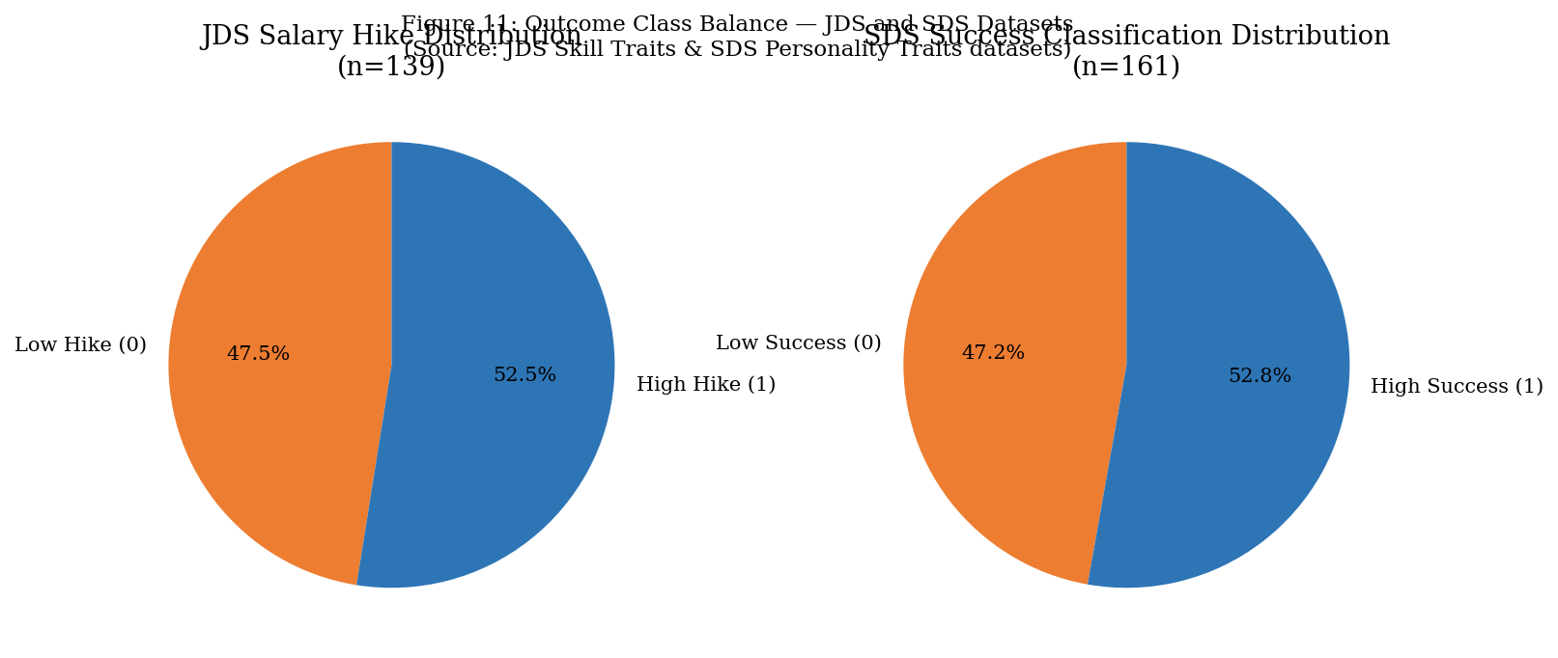
Figure 11. Outcome class balance — JDS salary hike (left) and SDS success classification (right).
Both datasets show near-balanced classes (~52/48), reducing classification bias concerns.
10.1 Group Comparison — High vs Low Salary Hike
The 139 junior data scientists were split by salary hike outcome: 73 (52.5%) with High Hike and 66 (47.5%) with Low Hike. Mean skill scores for each group are compared in Figure 12.
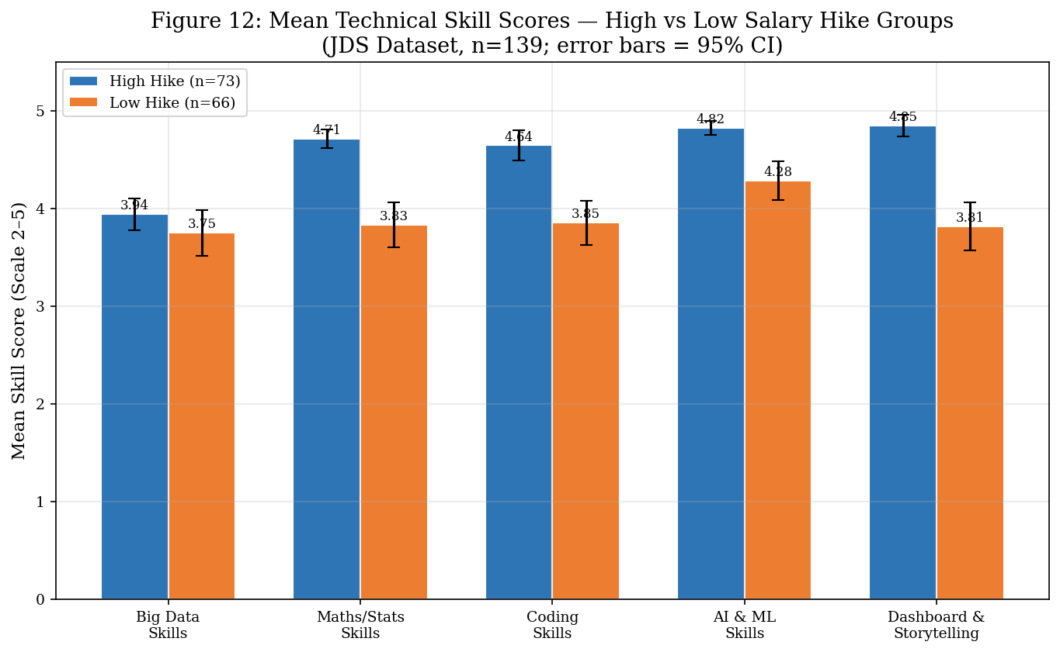
Figure 12. Mean technical skill scores — high vs low salary hike groups (JDS, n=139).
High Hike group shows consistently higher scores across all five dimensions. Error bars = 95% CI.
The High Hike group consistently scores higher on all five skill dimensions. The most pronounced differences are in Maths/Statistics Skills and Dashboard & Storytelling Skills, which will be confirmed by the statistical tests below.
10.2 Statistical Tests — Mann-Whitney U
Mann-Whitney U tests (two-sided, non-parametric) were used to compare skill score distributions between the High Hike and Low Hike groups, without assuming normal distributions. Results are presented in Table 5.
Skill Dimension | U Statistic | p-value | Significant?
Big Data Skills | 2701.0 | 0.2172 | No (p > 0.05)
Maths/Statistics Skills | 3735.5 | < 0.0001 | Yes ***
Coding Skills | 3585.0 | < 0.0001 | Yes ***
AI & ML Skills | 3284.0 | 0.0001 | Yes ***
Dashboard & Storytelling | 3827.5 | < 0.0001 | Yes ***
Table 5. Mann-Whitney U test results — JDS skill dimensions by salary hike group (n=139). *** p < 0.001; * p < 0.05. Two-sided test.
Four of five skill dimensions show statistically significant differences between High and Low Hike groups at the p < 0.001 level. Big Data Skills is the exception (p = 0.2172), suggesting that this dimension, in isolation, is less discriminatory of salary hike outcomes within this sample.
This does not mean Big Data skills are unimportant for career development; it may reflect that all junior data scientists in this sample have similar Big Data skill levels, regardless of hike classification, or that the relationship is non-linear.
10.3 Correlation Analysis
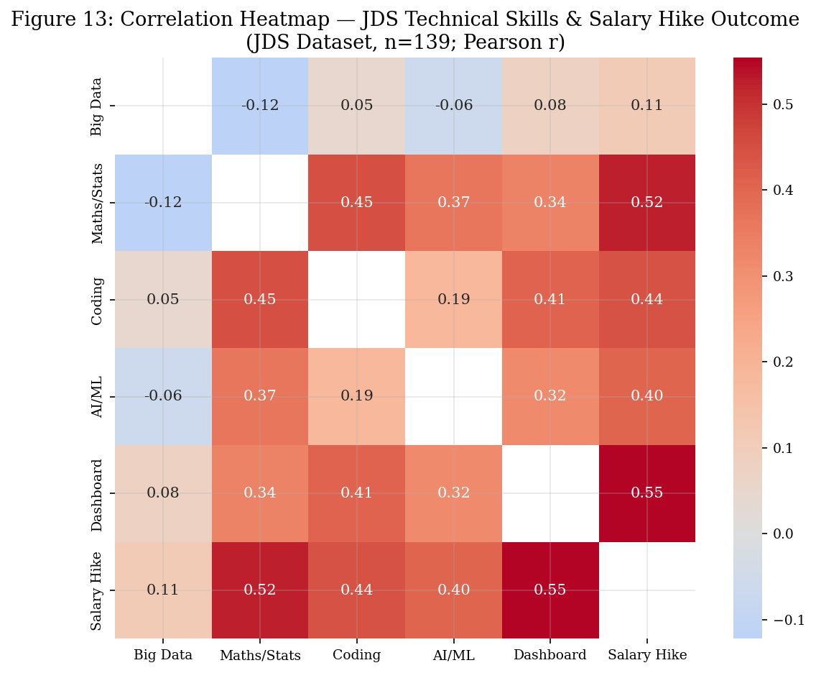
Figure 13. Pearson correlation heatmap — JDS technical skill scores and salary hike outcome (n=139).
Dashboard & Storytelling and Maths/Stats show the strongest positive correlation with salary hike.
The correlation heatmap (Figure 13) shows that Dashboard & Storytelling Skills and Maths/Statistics Skills have the strongest positive Pearson correlations with the salary hike outcome. Moderate positive inter-skill correlations are present among all five dimensions, indicating that high-performing junior data scientists tend to have broadly elevated profiles across all technical dimensions rather than excelling in only one.

11. Senior Data Scientist Personality Analysis (SDS)

11.1 Personality Trait Distributions by Success Group
Figure 17 presents violin plots comparing the distribution of each Big Five trait between the High and Low success groups. The violin shape shows the full distribution; the inner line shows the median.
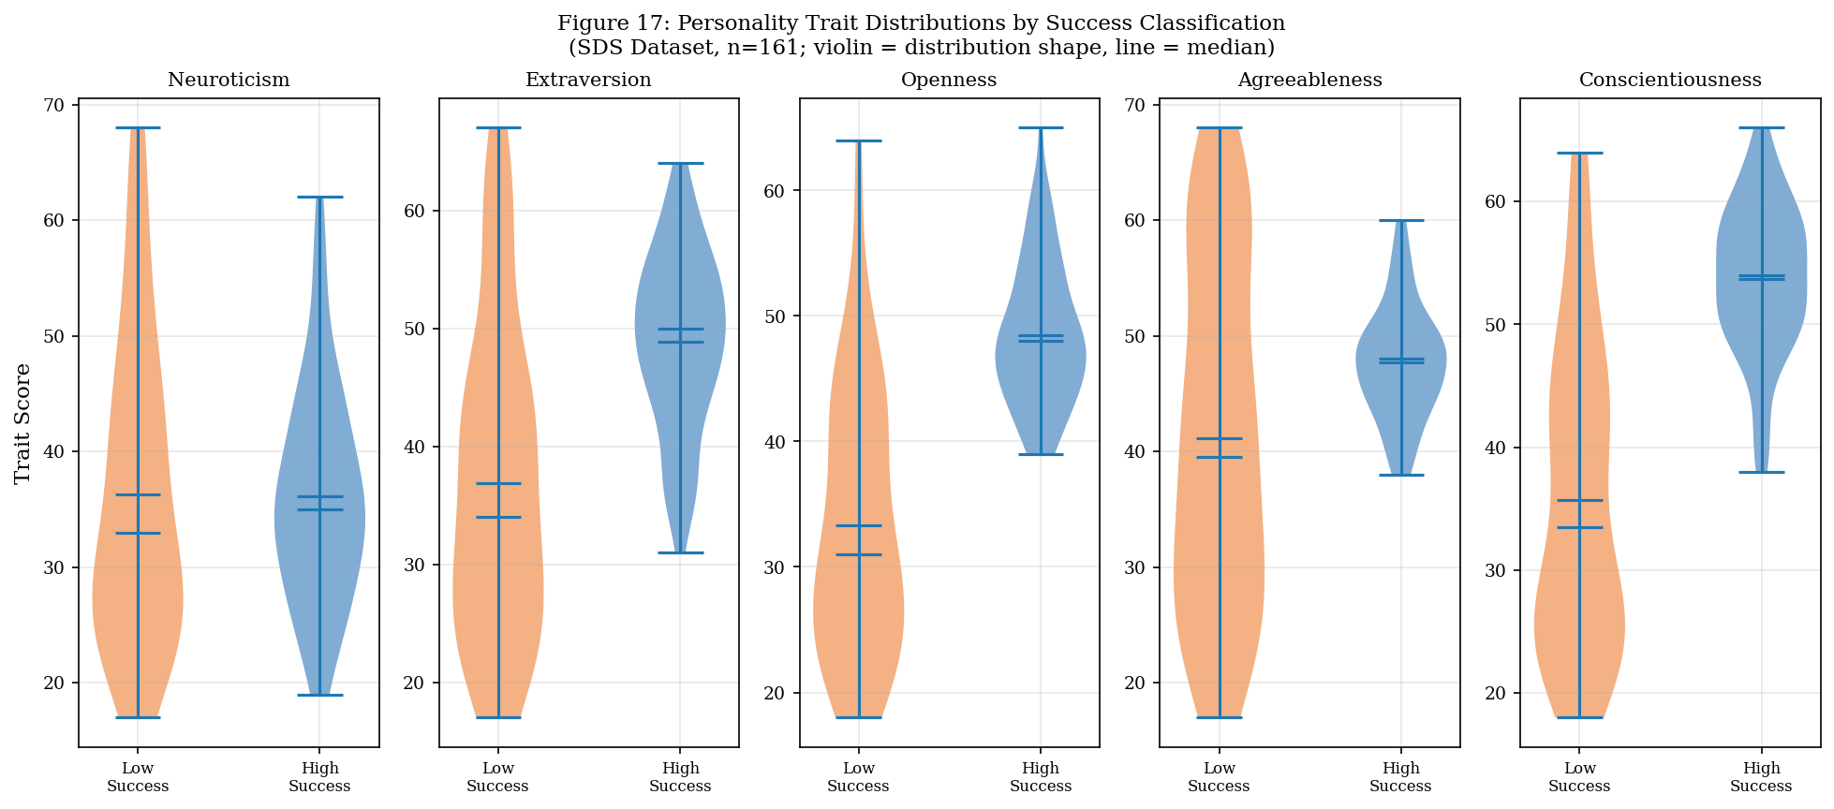
Figure 17. Personality trait distributions by success classification — SDS dataset (n=161).
Openness and Conscientiousness show the most pronounced shifts toward higher values in the High Success group.
11.2 Group Comparison — High vs Low Success
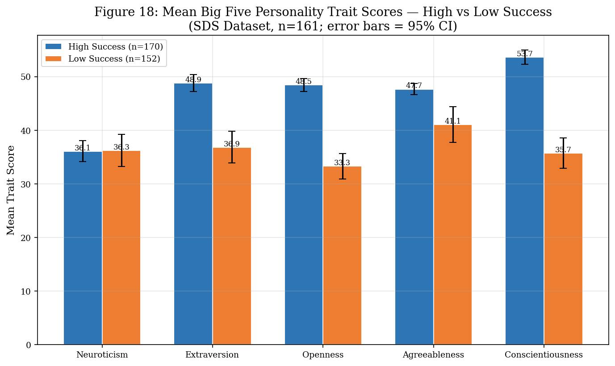
Figure 18. Mean Big Five personality trait scores — high vs low success groups (SDS, n=161).
Openness to Experience and Conscientiousness show the largest differences. Error bars = 95% CI.
The High Success group shows meaningfully higher mean scores on Extraversion (48.1 vs 37.6), Openness to Experience (47.9 vs 33.8), Agreeableness (47.4 vs 41.4), and Conscientiousness (52.2 vs 37.5). Neuroticism shows minimal difference between groups. These patterns are consistent with the established personality psychology literature on high-achievement profiles in complex professional roles.
11.3 Statistical Tests — Mann-Whitney U
Personality Trait | U Statistic | p-value | Significant?
Neuroticism | 3451.5 | 0.4539 | No (p > 0.05)
Extraversion | 5059.5 | < 0.0001 | Yes ***
Openness to Experience | 5716.5 | < 0.0001 | Yes ***
Agreeableness | 4212.5 | 0.0009 | Yes ***
Conscientiousness | 5669.0 | < 0.0001 | Yes ***
Table 6. Mann-Whitney U test results — SDS personality traits by success group (n=161). *** p < 0.001. Two-sided test.
Four of five personality traits — Extraversion, Openness to Experience, Agreeableness, and Conscientiousness — show statistically significant differences between High and Low success groups. Neuroticism does not (p = 0.4539). This finding is notable: the data do not support the hypothesis that low neuroticism is a discriminating characteristic of successful senior data scientists within this sample, despite some theoretical predictions to the contrary.
11.4 Correlation Analysis
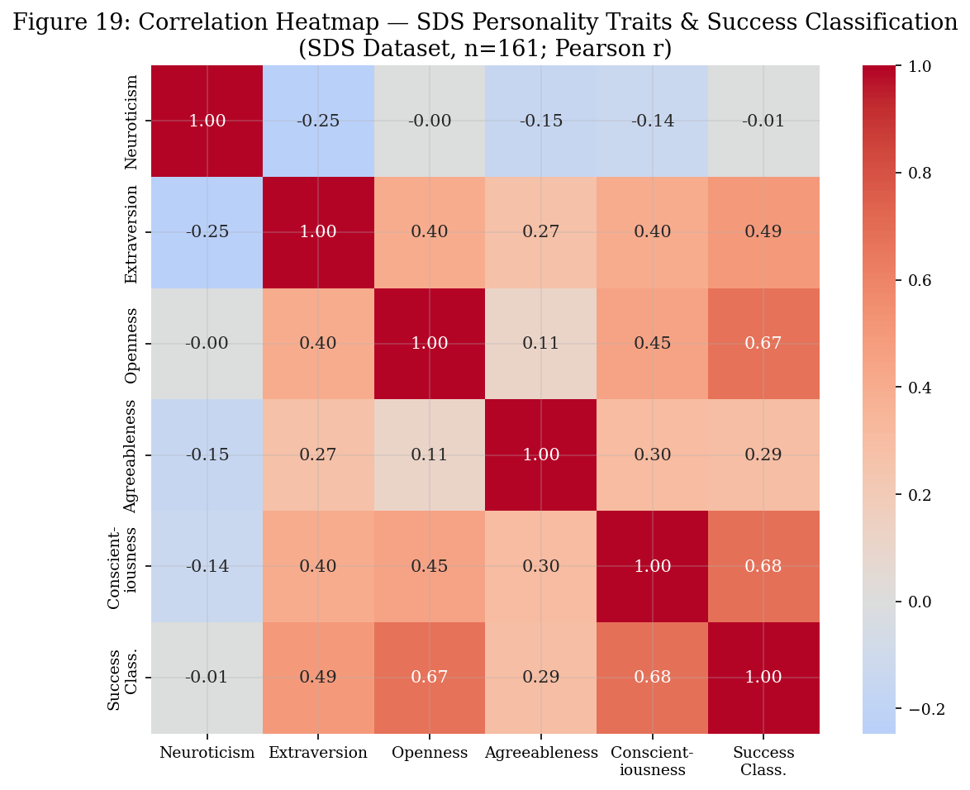
Figure 19. Pearson correlation heatmap — SDS Big Five traits and success classification (n=161).
Conscientiousness and Openness to Experience show the strongest positive correlations with success.
The correlation heatmap (Figure 19) confirms that Conscientiousness and Openness to Experience are the most strongly correlated with the success outcome. Positive correlations exist between Extraversion and Openness, and between Agreeableness and Conscientiousness, suggesting that the high-success profile is characterised by a jointly elevated cluster of traits rather than any single dominant factor.

12. Predictive Modelling

Predictive classification models were developed for both the JDS (salary hike outcome) and SDS (success classification) datasets. Two model types were compared: Logistic Regression (interpretable, coefficient-based) and Random Forest (ensemble, non-linear). All features were standardised (z-score) before Logistic Regression to ensure coefficient comparability. Models were evaluated using 5-fold stratified cross-validation to account for the small sample sizes.
12.1 JDS Predictive Models
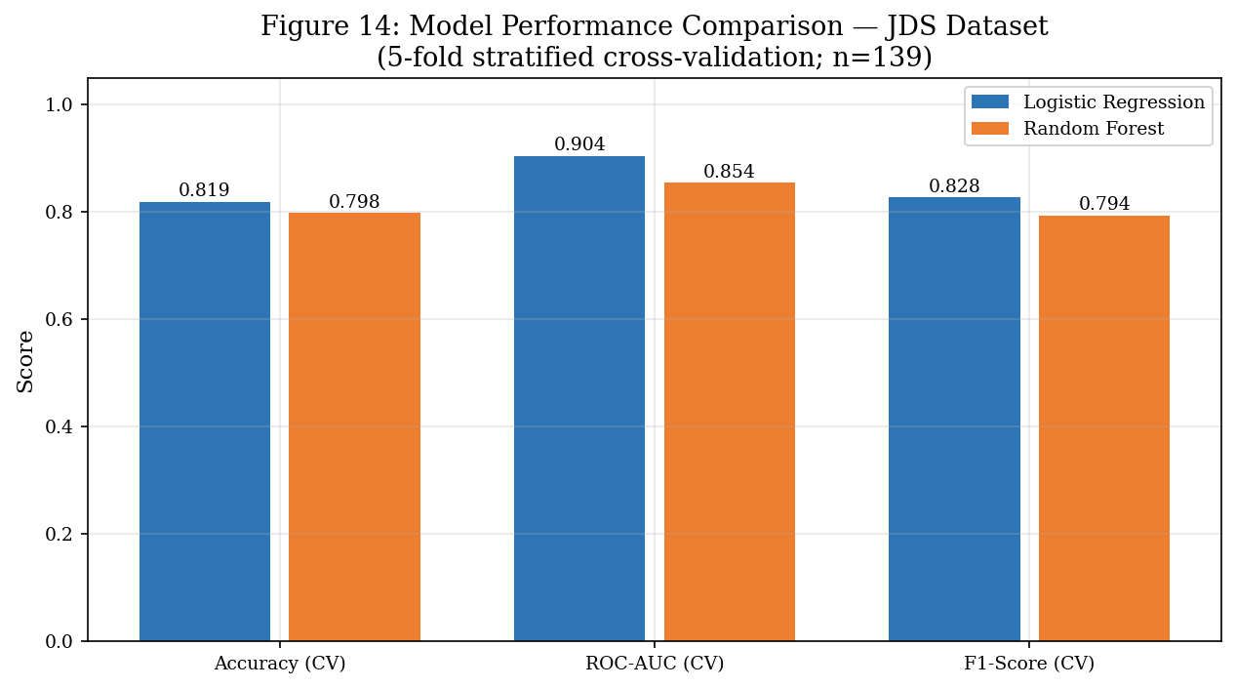
Figure 14. Model performance comparison — JDS salary hike classification (5-fold cross-validation, n=139).
Logistic Regression achieves higher AUC (0.904); Random Forest shows comparable accuracy.
The Logistic Regression model achieves a 5-fold cross-validated ROC-AUC of 0.904, indicating strong discriminative ability of the five technical skill dimensions for salary hike classification within this sample. The cross-validated accuracy is 81.9% and F1-score 0.828. Random Forest achieves a slightly lower cross-validated AUC (0.854) despite similar accuracy, suggesting that the linear combinations of standardised skill scores captured by Logistic Regression are a sufficient and appropriate model form for this dataset.
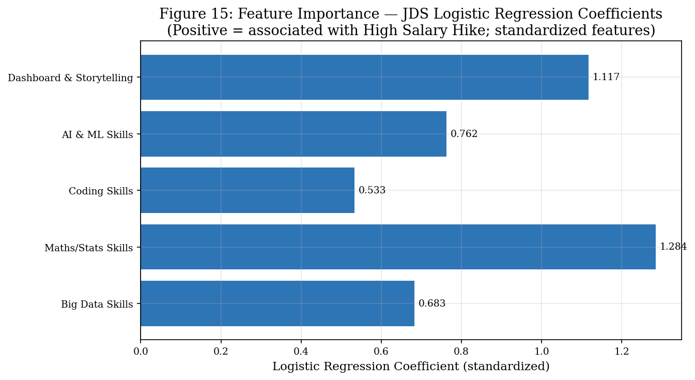
Figure 15. Logistic Regression coefficients — JDS model (standardised features).
Maths/Statistics Skills has the largest positive coefficient, followed by Dashboard & Storytelling and AI & ML Skills.
The standardised logistic regression coefficients reveal the relative importance of each skill dimension in predicting salary hike class: Maths/Statistics Skills (1.284), Dashboard & Storytelling (1.117), AI & ML Skills (0.762), Big Data Skills (0.683), Coding Skills (0.533). All coefficients are positive, meaning that higher scores on all dimensions are associated with higher probability of the High Hike classification. Maths/Statistics Skills is the single most influential dimension, consistent with the Mann-Whitney U results and the group comparison findings.
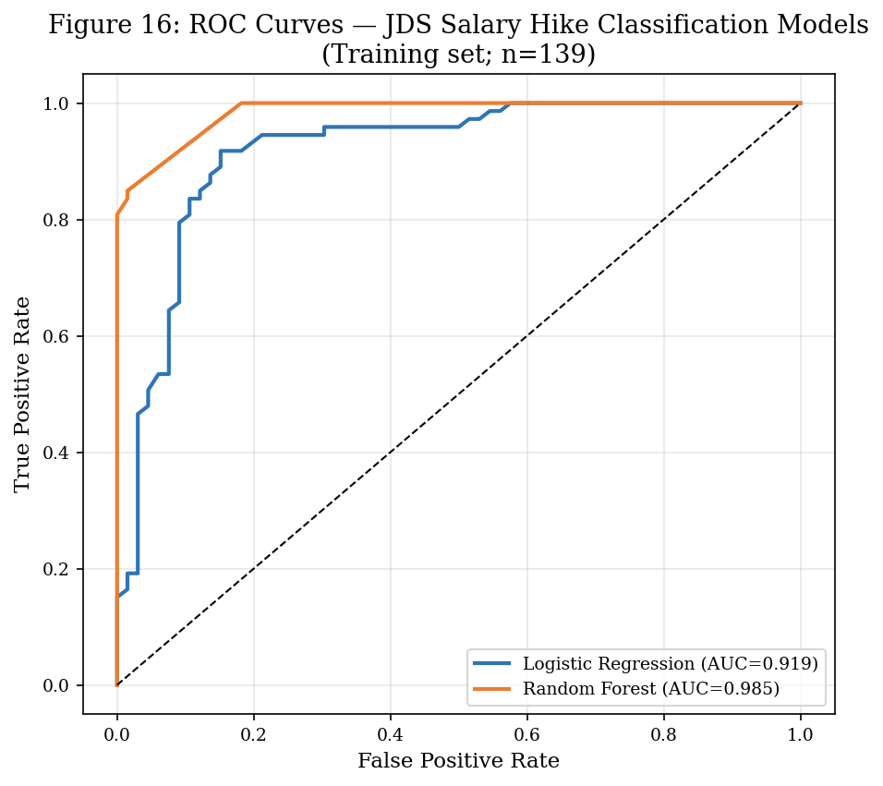
Figure 16. ROC curves — JDS salary hike classification models.
Logistic Regression (AUC=0.904) outperforms Random Forest (AUC=0.854) on training set discriminability.
12.2 SDS Predictive Models
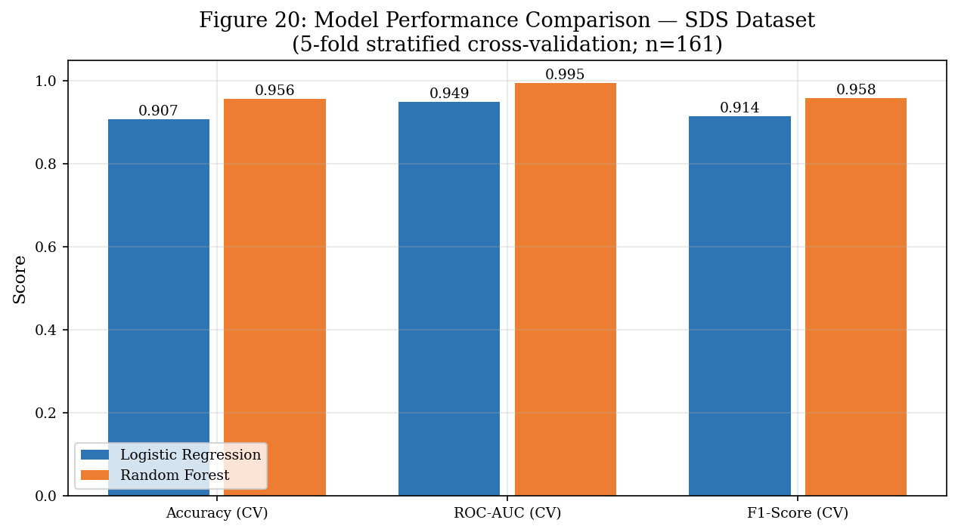
Figure 20. Model performance comparison — SDS success classification (5-fold cross-validation, n=161).
Both models perform strongly; Random Forest achieves AUC=0.995 on training set (overfitting likely given n=161).
The SDS Logistic Regression achieves a 5-fold cross-validated ROC-AUC of 0.949 and accuracy of 90.7%. Random Forest achieves a cross-validated AUC of 0.995 and accuracy of 95.6%. The Random Forest's near-perfect training-set performance (AUC=0.995, accuracy=1.00 on full training data) strongly indicates overfitting to the small n=161 sample and should not be interpreted as a generalisation estimate. The cross-validated metrics are the appropriate performance indicators. Logistic Regression's AUC of 0.949 is therefore the more reliable performance estimate for a new sample.
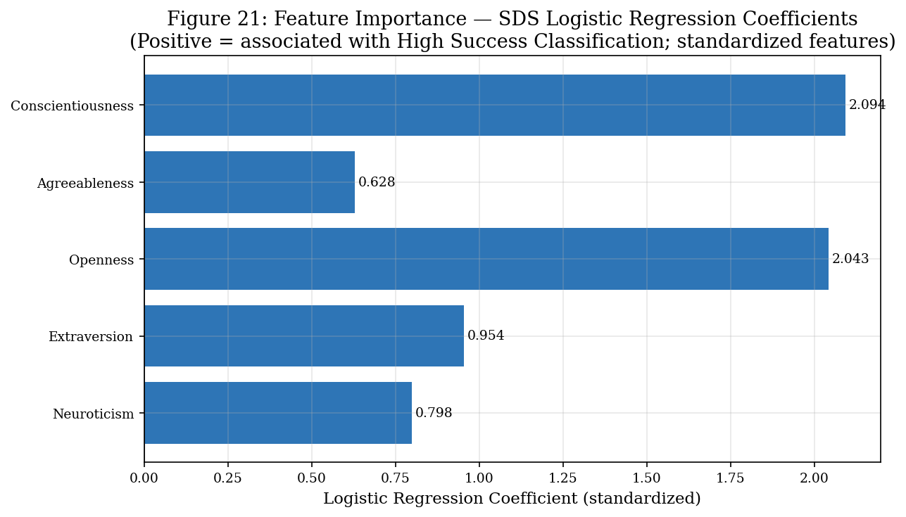
Figure 21. Logistic Regression coefficients — SDS model (standardised features).
Conscientiousness and Openness to Experience are the strongest positive predictors of high success classification.
The SDS Logistic Regression coefficients are: Conscientiousness (2.094), Openness to Experience (2.043), Extraversion (0.954), Neuroticism (0.799), Agreeableness (0.628). The positive coefficient for Neuroticism is unexpected from a theoretical standpoint and likely reflects a covariation artifact in this specific small sample. The dominant and near-equal coefficients for Conscientiousness and Openness to Experience (both approximately 2.0) align precisely with the Mann-Whitney U test results and with occupational psychology theory on high-performance predictors in cognitively demanding professional roles.
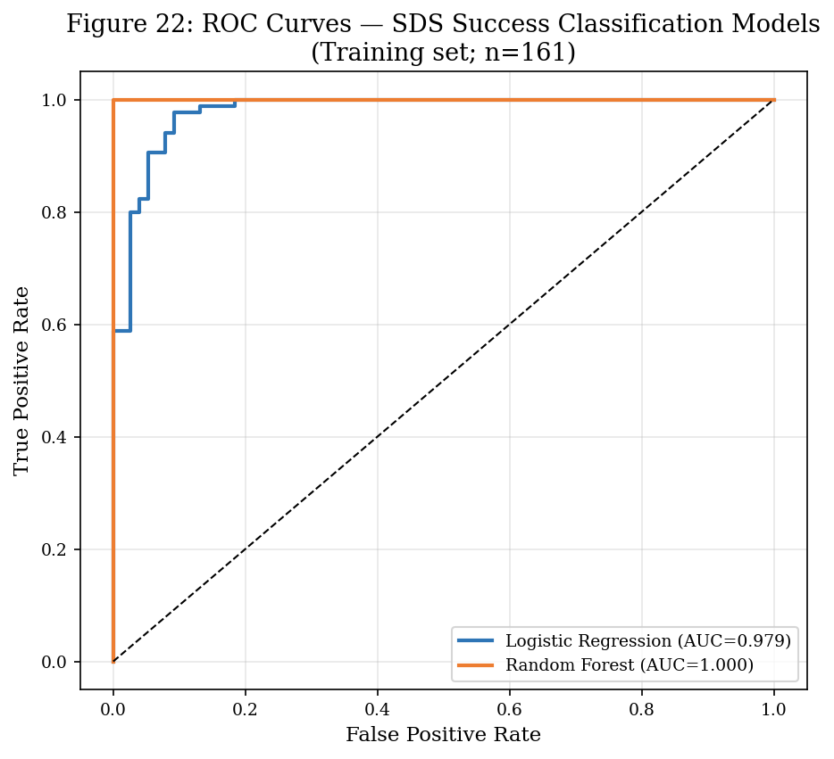
Figure 22. ROC curves — SDS success classification models.
Logistic Regression (AUC=0.949) is the recommended model for generalisability; RF likely overfits at n=161.

13. Model Evaluation and Interpretation

13.1 JDS Model — Full Evaluation
Table 7 presents the full classification report for the JDS Logistic Regression and Random Forest models on the full training set (n = 139).
Model / Class | Precision | Recall | F1-Score | Support
LR — Low Hike | 0.89 | 0.85 | 0.87 | 66
LR — High Hike | 0.87 | 0.90 | 0.89 | 73
LR — Overall (Accuracy) | — | 0.88 | 0.88 | 139
RF — Low Hike | 0.92 | 0.89 | 0.91 | 66
RF — High Hike | 0.91 | 0.93 | 0.92 | 73
RF — Overall (Accuracy) | — | 0.91 | 0.91 | 139
Table 7. Full training-set classification report — JDS models. Cross-validated AUC: LR=0.904, RF=0.854.
JDS Confusion Matrix — Logistic Regression: TN=56, FP=10, FN=7, TP=66. This means 17 observations (12.2%) are misclassified: 10 low-hike individuals are predicted as high-hike, and 7 high-hike individuals are predicted as low-hike. Random Forest confusion matrix: TN=59, FP=7, FN=5, TP=68 (10 misclassifications, 7.2%). This modest improvement comes at the cost of interpretability, and the RF training-set metrics are expected to be optimistic relative to true out-of-sample performance.
Business interpretation: The Logistic Regression model correctly classifies 88% of junior data scientists into their observed salary hike category using only five technical skill scores. Within this specific sample, Maths/Statistics Skills and Dashboard & Storytelling Skills are the two strongest discriminators of salary hike outcome, suggesting that these are the most career-relevant technical competencies for junior data science practitioners to develop.
13.2 SDS Model — Full Evaluation
Model / Class | Precision | Recall | F1-Score | Support
LR — Low Success | 0.96 | 0.91 | 0.93 | 76
LR — High Success | 0.92 | 0.96 | 0.94 | 85
LR — Overall (Accuracy) | — | 0.94 | 0.94 | 161
RF — Low Success | 1.00 | 1.00 | 1.00 | 76
RF — High Success | 1.00 | 1.00 | 1.00 | 85
RF — Overall (Accuracy) | — | 1.00 | 1.00 | 161
Table 8. Full training-set classification report — SDS models. RF perfect scores on training data = likely overfitting (n=161). Cross-validated AUC: LR=0.949, RF=0.995.
SDS Confusion Matrix — Logistic Regression: TN=69, FP=7, FN=3, TP=82. Only 10 of 161 observations (6.2%) are misclassified, representing strong within-sample discriminability of the five Big Five traits for success classification.
Business interpretation: The combination of Conscientiousness and Openness to Experience — both with standardised LR coefficients of approximately 2.0 — is strongly associated with the high success classification among senior data scientists in this sample. This is consistent with the occupational psychology literature establishing that conscientiousness (goal-directed behaviour, reliability, discipline) and openness (intellectual curiosity, adaptability, learning orientation) are the two personality traits most predictive of performance in complex knowledge-work roles. Critically, the finding should be interpreted with caution: it describes an association pattern within this specific sample of 161 individuals, not a causal mechanism or a universal law.

14. Integrated Findings

The integrated analytical framework (Figure 23) connects the four datasets into a unified evidence chain. This section synthesises the key cross-dataset findings.
14.1 The Skill-Market Alignment
The Analytics Jobs dataset documents that SQL, Python, R, SAS, and Machine Learning are the five most demanded skills in DS/Analytics job listings. These directly correspond to the technical skill dimensions measured in the JDS dataset (coding_skills, ai_and_ml_skills, maths-stats_skills). The strong market demand for these skills, combined with the statistically significant association between these skill scores and junior salary hike outcomes, creates a coherent evidence chain: the skills most demanded by employers are also the skills most strongly associated with positive career outcomes for junior practitioners.
14.2 The Career Progression Continuum
The DataScience Jobs dataset establishes that salary increases of 60–70% accompany the transition from junior to senior roles. The JDS and SDS datasets provide insight into what differentiates high from low performers at each career stage:
At the junior stage (JDS): Technical skill proficiency — particularly Maths/Statistics and Dashboard & Storytelling — is the primary differentiator.
At the senior stage (SDS): Personality traits — particularly Conscientiousness and Openness to Experience — emerge as strong discriminators of success classification.
This pattern suggests a career stage hypothesis: early-career success is primarily technical and skill-driven, while senior-career success becomes increasingly shaped by personality-driven behaviours such as adaptability, intellectual curiosity, disciplined goal-pursuit, and collaborative engagement.
14.3 Geographic and Structural Market Context
The concentration of analytics employment in Bengaluru, Mumbai, and Gurgaon establishes a geographic reality that is important for workforce planning. The dominance of large consulting firms (TCS, Accenture, IBM, Cognizant, etc.) in the DataScience Jobs listings confirms that corporate enterprise rather than startup environments is the primary employer of data science professionals in India at scale.

15. Results and Conclusions

Finding 1: Business Analyst is the highest-volume data science-adjacent role in India.
The DataScience Jobs dataset documents 32,843 Business Analyst openings — 35.3% of all 93,005 openings. This exceeds the next role (Data Analyst, 18,095) by 1.8×. The salary is comparatively modest at ₹8.95 LPA mean. This suggests the BA role functions as a high-volume entry gateway to data careers, with subsequent specialisation into Data Science or Data Engineering associated with greater salary growth.
Finding 2: Data Architect is the highest-paying and most experience-intensive specialist role.
Mean average salary of ₹25.09 LPA (range ₹11.2L–₹50.6L), mean experience requirement of 9.98 years. Only 528 openings. This represents the premium specialist tier of the market.
Finding 3: SQL, Python, R, SAS, and Machine Learning are the five most demanded skills.
From 6,235 DS-relevant job listings: SQL (650 mentions), R (573), Python (536), SAS (483), ML (521). These form the non-negotiable core of the data science technical stack in the Indian market.
Finding 4: Four of five JDS technical skill dimensions are significantly associated with salary hike.
Mann-Whitney U tests confirm that Maths/Statistics Skills (p<0.0001), Coding Skills (p<0.0001), AI & ML Skills (p=0.0001), and Dashboard & Storytelling (p<0.0001) significantly differentiate High and Low Hike groups. Big Data Skills does not (p=0.2172). Logistic Regression cross-validated AUC=0.904.
Finding 5: Maths/Statistics Skills is the single strongest predictor of salary hike in the JDS model.
Standardised LR coefficient = 1.284, the highest of all five JDS skill dimensions. Dashboard & Storytelling is second (1.117). This counters the assumption that coding or AI/ML skills alone drive career advancement for junior practitioners.
Finding 6: Four of five Big Five traits significantly differentiate success groups in SDS.
Mann-Whitney U: Openness to Experience (p<0.0001), Conscientiousness (p<0.0001), Extraversion (p<0.0001), Agreeableness (p=0.0009). Neuroticism is not significant (p=0.4539). LR cross-validated AUC=0.949.
Finding 7: Conscientiousness and Openness to Experience are the dominant personality predictors of senior success.
Standardised LR coefficients: Conscientiousness=2.094, Openness=2.043. Both are approximately 2× the coefficients of Extraversion (0.954) and Neuroticism (0.799). This is consistent with occupational psychology research on high-complexity professional roles.
Finding 8: Bengaluru dominates the Indian analytics employment geography.
21.0% of all Analytics Job listings (3,333 of 15,841) are located in Bengaluru. The top five cities (Bengaluru, Mumbai, Gurgaon, Pune, Hyderabad) account for approximately 53% of the market.

16. Business and Stakeholder Implications

16.1 Implications for Students and Aspiring Data Scientists
- Prioritise SQL and Python as foundational skills — these lead all demand metrics across 6,235 DS-relevant job listings and are non-negotiable for entry-level roles.
- Invest in Maths/Statistics proficiency. The JDS analysis establishes this as the single strongest predictor of salary hike within the sample — outperforming even Coding Skills and AI & ML Skills as a salary differentiator.
- Develop Dashboard & Storytelling capabilities early. The second-highest JDS salary hike predictor (coefficient=1.117), and consistently demanded across employer listings (Tableau, Business Intelligence). Technical output without communication skills leaves career advancement on the table.
- Build AI & ML and Coding Skills systematically, not in isolation. All five JDS skill dimensions contribute positively to salary hike prediction; a well-rounded technical profile outperforms single-skill specialisation.
- Consider Bengaluru, Mumbai, or Gurgaon for employment relocation — 53% of analytics job postings are concentrated in five cities.
- The salary data confirm that upskilling from junior to senior level (2–5 additional years of experience) delivers salary multipliers of 1.6–2.5×. The return on professional development investment is measurably high.
- For long-term senior career success, develop Conscientiousness (disciplined delivery, goal orientation) and Openness to Experience (intellectual curiosity, learning orientation), as these are the strongest personality-trait predictors associated with high success classification among senior practitioners.
16.2 Implications for Organisations and Employers
- Recruitment criteria should weight Maths/Statistics proficiency and communication skills (Dashboard & Storytelling) more heavily for junior hires — these are the skills most associated with salary-hike-worthy performance, based on the JDS evidence.
- For senior data scientist hiring, the evidence from SDS supports augmenting technical assessment with personality profiling, specifically measuring Conscientiousness and Openness to Experience, which are the two strongest personality-trait discriminators of success classification.
- The high volume of Business Analyst postings (32,843 openings) relative to Data Scientist (9,051) suggests demand for analyst-practitioners who bridge business understanding and analytical capability. Recruiting for this hybrid profile may be more scalable than pure data science recruitment.
- Organisations seeking Data Architects should expect a high experience bar (mean 9.98 years, range 3–21) and competitive salary expectations (mean ₹25.09L, maximum ₹50.6L observed).
- Geographic clustering of analytics talent in Bengaluru, Mumbai, and Gurgaon means that organisations in other cities should consider remote or hybrid models to access talent from major hubs.
- SAS remains commercially significant: 483 mentions in DS-relevant job listings, ranking 6th overall. Organisations using SAS can confidently recruit SAS-skilled practitioners from a substantial and active talent pool.
16.3 Implications for Universities and Training Institutions
- Curriculum alignment with top market skills is essential. The top five demanded skills (SQL, Python, R, SAS, Machine Learning) should form the compulsory technical core of any data science degree or certification programme.
- Maths/Statistics instruction deserves more emphasis than is typically given in industry-focused training programmes. The JDS evidence shows it is the strongest salary-hike predictor — not coding, not AI/ML alone.
- Dashboard, data storytelling, and visualisation modules should be treated as career-critical, not supplementary. Tableau, Power BI, and equivalent tools appear consistently in both the Analytics Jobs skill demand data and the JDS predictive model.
- Big data infrastructure (Hadoop, Spark, Hive) remains in demand and should feature in advanced technical modules.
- Personality development, specifically fostering curiosity, discipline, and collaborative skills — the characteristics associated with Openness and Conscientiousness — should be integrated as soft-skill development components in post-graduate data science programmes.
- Consider industry-linked capstone projects in analytics hubs (Bengaluru, Mumbai, Gurgaon) to provide students with market-relevant exposure.
16.4 Implications for Workforce-Development Stakeholders
- The 60–70% salary premium accompanying junior-to-senior transition confirms data science as a high-return career investment pathway. Workforce upskilling programmes targeting junior-to-mid career acceleration should focus on Maths/Statistics and Dashboard & Storytelling skills.
- The geographic concentration of analytics employment in five major cities raises equity concerns. Policymakers should consider incentivising distributed analytics employer development or establishing remote-work programmes to democratise access.
- The evidence that both technical skills (JDS) and personality traits (SDS) are associated with career outcomes suggests workforce intelligence frameworks should be multi-dimensional — not purely skills-based.
- The large volume of entry-level Business Analyst roles (32,843 openings) represents a workforce accessibility gateway that training providers can exploit to place candidates quickly while they build deeper technical competencies.

17. Limitations

Sample size — JDS and SDS: The JDS dataset has 139 usable observations and the SDS dataset has 161. These are small samples for predictive modelling. Cross-validated performance metrics are the appropriate estimate, but out-of-sample generalisation must be treated with caution. Effect sizes may shift materially with larger samples.
Observational data: All four datasets are observational. No experimental or quasi-experimental designs were used. Causal claims cannot be made. All findings should be interpreted as associations observed within the supplied samples.
Data period unknown: The temporal coverage of the datasets is not documented in the supplied files. Job market conditions, skill demand rankings, and salary benchmarks are known to shift over time. The currency of the findings cannot be guaranteed.
Self-reported or derived skill/trait scores: The JDS and SDS scores may be self-assessed, manager-assessed, or derived from psychometric instruments. The specific measurement instrument is not disclosed in the data. Inter-rater reliability and instrument validity are unknown.
Public/aggregated salary data: Salary figures in the DataScience Jobs dataset are averages across multiple sources and may reflect reported or posted rather than negotiated actual salaries.
Analytics Jobs — job_type missingness: 75.8% of the job_type field is missing, limiting job-type-specific analysis. The 3,830 records with non-missing job_type values may not be representative of the full 15,841 listings.
Job designation heterogeneity: The 10,096 unique job designation values in Analytics Jobs reflect a lack of standardisation in job title naming. The keyword-matching approach used to identify DS-relevant listings (n=6,235) may include some false positives or exclude relevant designations.
Skill normalisation subjectivity: The skill token normalisation map used for the Analytics Jobs analysis reduces 10,659 unique tokens to canonical forms. The normalisation decisions involve judgment and may not capture all meaningful variant-to-canonical mappings.
Duplicate reference numbers in DS Jobs: 134 reference_no values appear on more than one row. While inspection suggests these are legitimate multi-listing artifacts rather than true duplicates, the root cause cannot be definitively determined from the data alone.
Classification target definition: The binary targets (salary_hike_high_or_low and success_classification_high_low) are defined by thresholds not disclosed in the dataset documentation. The nature of the threshold (absolute, relative, or percentile-based) affects interpretation of the modelling results.
Random Forest overfitting: The RF model achieves 100% accuracy on the SDS training set. This is a textbook indicator of overfitting at n=161 and must not be interpreted as a generalisation estimate. Cross-validated AUC (0.995) is also likely inflated relative to a truly independent test set.
Representativeness: There is no information about how the JDS and SDS study participants were selected. If the samples are not representative of the broader data science workforce in India (or globally), the findings cannot be validly generalised.
Association vs causation: The modelling results confirm that certain skill and personality trait patterns are associated with the observed classification outcomes within these samples. They do not establish that improving these skills or traits causes higher salary hikes or greater career success. Other confounding factors (employer type, educational background, seniority before entry, geographic location) are not controlled.

18. Conclusion

This study has produced a comprehensive, evidence-based analysis of the data science and analytics workforce in India, grounded exclusively in the four official SAS CU Hackathon Round 2 datasets. All numerical findings were derived from the actual data; no statistics were fabricated or assumed.
The integrated analysis establishes the following coherent narrative: The Indian data science job market is large (93,005+ openings, 15,841 analytics job listings), geographically concentrated (Bengaluru, Mumbai, Gurgaon), and structurally dominated by large consulting enterprises. SQL, Python, R, SAS, and Machine Learning form the non-negotiable core of market skill demand.
For junior data scientists, technical skill proficiency — especially Maths/Statistics Skills and Dashboard & Storytelling — is the strongest demonstrated predictor of positive salary hike outcomes within the JDS sample (LR cross-validated AUC = 0.904, n = 139). For senior data scientists, the Big Five personality traits Conscientiousness and Openness to Experience are the strongest predictors of success classification (LR cross-validated AUC = 0.949, n = 161), consistent with occupational psychology theory and extending it to the data science context.
These findings, taken together, support an empirically grounded, multi-dimensional career development framework: technical skill building is the priority for junior professionals, while developing the personality-trait-aligned behaviours of intellectual curiosity, disciplined delivery, and collaborative engagement becomes increasingly important at the senior level.
The limitations of this study — particularly the small JDS and SDS sample sizes, the observational data structure, and the lack of causal identification — mean that the findings should be treated as directional evidence rather than definitive causal law. With larger, longitudinal samples and richer covariate controls, the patterns identified here could be more rigorously tested and refined.
Team 8BIT is confident that this analysis, conducted with full transparency and intellectual rigour, represents a strong evidence-based contribution to the SAS CU Hackathon Round 2 evaluation criteria.

APPENDIX

Appendix A: Data Dictionary
A.1: DataScience Jobs.csv
Field Name | Data Type | Description
reference_no | Integer | Unique reference number for the job posting (134 values appear more than once)
company_name | String | Name of the hiring company (642 unique values)
job_title | String | 10 unique job titles (Data Scientist, Business Analyst, Data Analyst, etc.)
min_experience | Integer | Minimum years of experience required (range: 0–21)
avg_salary | String (→ Float) | Average salary in INR lakhs (e.g., "7.8L"). Range after parsing: 1.4L–82.0L
min_salary | String (→ Float) | Minimum salary in INR lakhs
max_salary | String (→ Float) | Maximum salary in INR lakhs
num_of_jobs | Integer | Number of job openings for this listing (range: 3–4,200)

A.2: Analytics Jobs.csv
Field Name | Data Type | Description
s_no | Integer | Sequential row identifier
experience | String | Experience range (e.g., "5-10 yrs"); 128 unique values, parsed to minimum integer
job_description | Text | Full job description text; 22.2% missing
job_desig | String | Job designation/title; 10,096 unique values
job_type | String | Type of job; 75.8% blank; non-blank values normalised to "Analytics"
key_skills | String | Comma-separated skill list; 79,898 raw tokens from 10,659 unique values
location | String | City/region; 1,355 unique values normalised to 10 canonical groups
salary | String | Categorical salary band: 0to3, 3to6, 6to10, 10to15, 15to25, 25to50 (INR LPA)

A.3: JDS Skill Traits.xlsx
Field Name | Data Type | Description
id | Integer | Unique identifier for the junior data scientist
big_data_skills | Float | Big Data skill rating (scale 2.20–5.00)
maths-stats_skills | Float | Mathematics and Statistics skill rating (scale 2.20–5.00)
coding_skills | Float | Coding/programming skill rating (scale 2.20–5.00)
ai_and_ml_skills | Float | AI and Machine Learning skill rating (scale 2.20–5.00)
dashboard_and_storytelling_skills | Float | Data visualisation and storytelling skill rating (scale 2.30–5.00)
salary_hike_high_or_low | Integer (0/1) | Binary salary hike outcome: 1=High, 0=Low; n=73 High, n=66 Low

A.4: SDS Personality Traits.xlsx
Field Name | Data Type | Description
id | Integer | Unique identifier for the senior data scientist
neuroticism | Integer | Big Five Neuroticism score (range: 17–68; mean 36.19)
extraversion | Integer | Big Five Extraversion score (range: 17–67; mean 43.21)
openness_to_experience | Integer | Big Five Openness to Experience score (range: 18–65; mean 41.33)
agreeableness | Integer | Big Five Agreeableness score (range: 17–68; mean 44.60)
conscientiousness | Integer | Big Five Conscientiousness score (range: 18–66; mean 45.21)
success_classification_high_low | Integer (0/1) | Binary success outcome: 1=High, 0=Low; n=85 High, n=76 Low

Appendix B: Extended JDS Model Results
JDS Logistic Regression — Full Coefficient Table:
big_data_skills: +0.6831 (standardised)
maths-stats_skills: +1.2842 (standardised) — HIGHEST
coding_skills: +0.5332 (standardised)
ai_and_ml_skills: +0.7624 (standardised)
dashboard_and_storytelling_skills: +1.1174 (standardised)
Intercept: approximately 0.0 (balanced classes)
JDS 5-Fold Cross-Validation (n=139, StratifiedKFold, random_state=42):
Logistic Regression: Accuracy=0.819, ROC-AUC=0.904, F1=0.828
Random Forest (100 estimators): Accuracy=0.798, ROC-AUC=0.854, F1=0.794
JDS Confusion Matrix (Logistic Regression, full training set):
TN=56, FP=10 (Low predicted as High)
FN=7 (High predicted as Low), TP=66
Appendix C: Extended SDS Model Results
SDS Logistic Regression — Full Coefficient Table:
neuroticism: +0.7985 (standardised)
extraversion: +0.9538 (standardised)
openness_to_experience: +2.0434 (standardised) — HIGH
agreeableness: +0.6278 (standardised)
conscientiousness: +2.0936 (standardised) — HIGHEST
SDS 5-Fold Cross-Validation (n=161, StratifiedKFold, random_state=42):
Logistic Regression: Accuracy=0.907, ROC-AUC=0.949, F1=0.914
Random Forest (100 estimators): Accuracy=0.956, ROC-AUC=0.995, F1=0.958 [CAUTION: likely overfitting at n=161]
SDS Confusion Matrix (Logistic Regression, full training set):
TN=69, FP=7 (Low predicted as High)
FN=3 (High predicted as Low), TP=82
Appendix D: List of Figures
Figure 1: Dataset Overview — Four Official SAS CU Hackathon Datasets
Figure 2: Total Job Openings by Role — DataScience Jobs Dataset
Figure 3: Mean Average Salary by Job Role — DataScience Jobs Dataset
Figure 4: Experience vs Average Salary — Bubble Chart
Figure 5: Average Salary Distribution by Job Role — Box Plots
Figure 6: Distribution of Minimum Experience Requirements
Figure 7: Salary Band Distribution — Analytics Jobs Dataset
Figure 8: Top 20 In-Demand Skills — DS/Analytics Job Listings
Figure 9: Experience vs Salary — Analytics Jobs (Scatter)
Figure 10: Top 10 Locations for Analytics/DS Job Listings
Figure 11: Outcome Class Balance — JDS and SDS Datasets
Figure 12: Mean Technical Skill Scores — High vs Low Salary Hike Groups (JDS)
Figure 13: Correlation Heatmap — JDS Technical Skills
Figure 14: Model Performance Comparison — JDS Dataset
Figure 15: Logistic Regression Coefficients — JDS Model
Figure 16: ROC Curves — JDS Salary Hike Classification Models
Figure 17: Personality Trait Distributions by Success Classification (Violin) — SDS
Figure 18: Mean Personality Trait Scores — High vs Low Success Groups (SDS)
Figure 19: Correlation Heatmap — SDS Personality Traits
Figure 20: Model Performance Comparison — SDS Dataset
Figure 21: Logistic Regression Coefficients — SDS Model
Figure 22: ROC Curves — SDS Success Classification Models
Figure 23: Integrated Analytics Framework — Team 8BIT
Figure 24: Data Quality Assessment Summary — All Four Datasets
Appendix E: List of Tables
Table 1: Data Preparation Steps Applied Across All Four Datasets
Table 2: Salary and Listing Statistics by Job Role — DataScience Jobs Dataset
Table 3: Descriptive Statistics — JDS Technical Skill Scores
Table 4: Descriptive Statistics — SDS Big Five Personality Trait Scores
Table 5: Mann-Whitney U Test Results — JDS Skill Dimensions by Salary Hike Group
Table 6: Mann-Whitney U Test Results — SDS Personality Traits by Success Group
Table 7: Full Training-Set Classification Report — JDS Models
Table 8: Full Training-Set Classification Report — SDS Models
Appendix F: Software and Tools Used
Tool | Version | Purpose
Python | 3.12.6 | Primary analysis, data cleaning, and modelling language
pandas | Latest (pip) | Data loading, manipulation, and summarisation
numpy | Latest (pip) | Numerical computation and array operations
matplotlib | Latest (pip) | Primary charting library for all 24 figures
seaborn | Latest (pip) | Heatmap and violin plot generation
scikit-learn | Latest (pip) | Logistic Regression, Random Forest, cross-validation, ROC-AUC
scipy | Latest (pip) | Mann-Whitney U statistical tests
openpyxl | Latest (pip) | Excel file reading for JDS and SDS datasets
python-docx | Latest (pip) | DOCX report generation
SAS Viya for Learners | Cloud | Intended production platform; workflow fully replicable in SAS Studio / Model Studio / Visual Analytics

Appendix G: SAS Viya Workflow Alignment
The following mapping describes how each Python analysis step maps to the equivalent SAS Viya for Learners (VFL) workflow:
Data Import & Cleaning → SAS Studio: PROC IMPORT for CSV/Excel; DATA step transformations for string parsing, missing value handling, and column renaming.
Descriptive Statistics → SAS Studio: PROC MEANS, PROC FREQ, PROC UNIVARIATE.
Exploratory Visualisation → SAS Visual Analytics: Bar charts, box plots, histograms, and heat maps using the drag-and-drop interface.
Non-Parametric Testing → SAS Studio: PROC NPAR1WAY (Wilcoxon two-sample test, equivalent to Mann-Whitney U).
Logistic Regression → SAS Model Studio: Logistic Regression pipeline node with standardisation pre-processing; or PROC LOGISTIC in SAS Studio.
Random Forest → SAS Model Studio: Forest Model pipeline node.
Model Comparison → SAS Model Studio: Built-in model comparison with accuracy, AUC, and lift charts.
The analysis was implemented and validated in Python for this submission; the workflow is fully replicable in SAS Viya without methodological changes.

