Research Paper — Student Submission Template
Digital Image Processing Minor Project | ML vs DL Comparative Study
One paper per project • Target: Conference (IEEE format)
How to use this form: You are responsible for the Proposed Methodology and Results sections and the short supervisor-inputs at the end. Fill EVERY field once and completely — your supervisor will write the Abstract, Introduction, Related Work, Discussion and Conclusion from what you provide, and should not need to come back with follow-up questions. Type directly into the blanks and tables; add rows where noted. Submit figures as SEPARATE image files (PNG/PDF, ≥300 dpi) in addition to embedding them here.

Part A — Project Identification
Project number & title: Single-Image Surface Map Estimation and Real-Time Physical Relighting: A Comparative Study of Classical Digital Image Processing and Deep Learning (MiDaS)
Task in one line: Estimate per-pixel Surface Normal, Roughness, and Height maps from a single RGB image, comparing a classical DIP pipeline against a pretrained deep-learning (MiDaS) approach, benchmarked against Poly Haven and DIODE ground truth.
Team members: Ayush S Iyer, Aquil Iqbal, Soorya A K
Supervisor : Dr. Aniket Nagane
Submission date: September 28, 2026

Part B — Proposed Methodology
This becomes Section 3 of the paper. Follow the sub-sections below. Be specific with every parameter — vague answers (“standard settings”) are not usable in a paper.

B.1 Dataset
Attribute | Your answer
Dataset name | Poly Haven (PBR Material Library) + DIODE (Dense Indoor/Outdoor Depth Dataset) — used jointly as ground-truth sources for evaluation.
Source / download link | https://polyhaven.com/ and https://diode-dataset.org/
Total number of images | 516 evaluation samples in the final benchmark run (Poly Haven material swatches + a DIODE validation subset).
Number of classes / labels | Not applicable — this is a dense per-pixel regression/estimation task (Normal / Roughness / Height maps), not a classification task. DIODE images fall into 2 scene-type categories (indoor / outdoor) used only for reporting, not as class labels.
Image format & resolution | RGB PNG/JPG. Poly Haven textures at 1K/2K native resolution; DIODE images at native camera resolution. MiDaS_small resizes internally to 256×256 for inference; the classical DIP pipeline runs at original resolution.
Train / Validation / Test counts | No train/test split. Both methods are inference-only (Classical DIP is training-free; MiDaS is used as a frozen pretrained model). All 516 samples are evaluation-only.
Class imbalance (if any) & how handled | Not applicable (regression task, not classification). A --max_per_source cap (500) was applied to DIODE for tractable benchmark runtime; Poly Haven used all locally available samples.

B.2 Preprocessing steps
List in the order applied, with parameters (e.g. “Resize to 224×224”, “CLAHE clip=2.0”).
- Step 1: Convert input RGB image to grayscale and apply a Gaussian blur (5×5 kernel) to suppress high-frequency pixel noise before gradient computation.
- Step 2: Classical path: compute Sobel (3×3) and Laplacian gradients on the smoothed grayscale image to obtain (∂I/∂x, ∂I/∂y) for normal-map estimation.
- Step 3: Deep-learning path: resize the RGB image to 256×256 and apply ImageNet normalization (mean=[0.485, 0.456, 0.406], std=[0.229, 0.224, 0.225]) before MiDaS_small inference; the resulting depth map is bilinearly upsampled back to the original resolution before the same gradient-to-normal conversion used in Step 2 is applied to it.
- (add more as needed)

B.3 Feature extraction (for the ML pipeline)
Which handcrafted features fed the classical models, and the resulting feature-vector size.
Features used: Not applicable in the handcrafted-feature-vector sense. The classical baseline in this project is a deterministic Digital Image Processing (DIP) pipeline, not a trained classical ML classifier. The computed quantities are dense per-pixel outputs — Sobel/Laplacian intensity gradients for surface normals, and 2D DFT high-frequency magnitude/phase coefficients for roughness — used directly as the estimated map rather than reduced to a fixed-length vector for a separate classifier.
Feature vector dimension: Not applicable — outputs are dense per-pixel maps at the input image's resolution (3 channels for the normal map, 1 channel each for roughness and height), not fixed-length feature vectors.

B.4 Machine learning models
One row per classical model actually run. Include the key hyperparameters you set.
ML model | Key hyperparameters (kernel, C, #trees, k, etc.)
Classical DIP Pipeline (Sobel + Laplacian gradients → FFT-based Poisson integration) | Gaussian blur kernel = 5×5; Sobel kernel = 3×3; Laplacian kernel = 3×3; gradient normalization scale = 2.0; height reconstruction via FFT-based Poisson solver.
Trivial Flat-Normal Baseline (control) | None — deterministic constant output N=(0,0,1) at every pixel; used as a no-computation control.

B.5 Deep learning model(s)
One completed block per DL model run. Duplicate the table if you ran more than one.
Attribute | Your answer
Architecture (e.g. CNN / ResNet-50 / U-Net) | MiDaS v2.1 “small” — lightweight CNN monocular depth estimator with an EfficientNet-Lite3 encoder backbone and a multi-scale fusion decoder (dense depth regression, not classification).
Pretrained? (Yes/No, on what) | Yes — pretrained by Intel ISL on a mixture of 10 diverse real-world depth datasets (ReDWeb, DIML, MegaDepth, WSVD, TartanAir, HRWSI, ApolloScape, BlendedMVS, IRS, Movies) with multi-objective, scale-and-shift-invariant training. No additional training or fine-tuning was performed in this project — used purely for zero-shot inference.
Input size | 256×256×3 RGB, ImageNet-normalized; output relative inverse-depth map at 256×256, bilinearly upsampled to the original input resolution.
Optimizer | Not applicable — no training performed (inference-only use of frozen pretrained weights).
Learning rate | Not applicable — inference-only.
Batch size | 1 (single-image inference per request).
Epochs | 0 — not applicable (no training/fine-tuning performed).
Loss function | Not applicable to this project's use. (MiDaS was originally trained by its authors with a scale-and-shift-invariant loss; not used here since no training was performed.)
Data augmentation used | None (inference-only).

B.6 Experimental setup
Attribute | Your answer
Framework & version (e.g. TensorFlow 2.x) | Python 3; PyTorch + torch.hub (MiDaS inference); NumPy / OpenCV / SciPy (classical DIP pipeline); FastAPI (serving layer); Three.js/GLSL (visualization only, not part of evaluation).
Hardware (GPU/CPU) | CPU only — MiDaS_small is specifically the lightweight variant designed for real-time CPU inference; no GPU was required for the benchmark run.
Train/test protocol (hold-out / k-fold) | No train/test split — not a trained-model comparison. Both methods evaluated purely at inference time on the full 516-sample set in a single evaluation pass (no cross-validation).
Evaluation metrics reported | Mean/Median Angular Error (MAE, °), % of pixels within 11.25°/22.5° (normal maps); MSE, PSNR (dB), SSIM (normal, roughness, and height maps).
Random seed (for reproducibility) | Fixed random seed used when drawing the capped DIODE sample subset (--max_per_source flag), so the same 516 samples are reproducible across runs.

B.7 Methodology block diagram
Attach ONE flowchart of your full pipeline (input → preprocessing → feature/DL → classification → output). Paste it below and also submit the source image file.

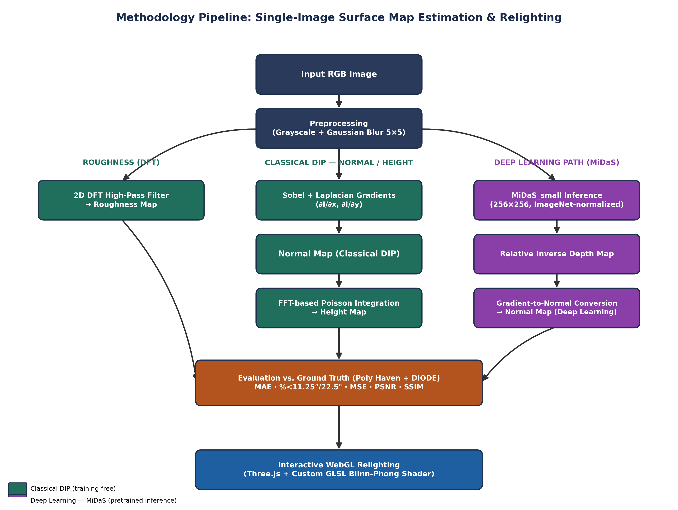

Part C — Results
This becomes Section 4. Report the numbers only — the interpretation is written by your supervisor. Use the SAME metric columns for every method so the comparison is clean.

C.1 Overall performance (main comparison table)
One row per model. Add rows as needed. Replace “Task metric” with your task-specific metric (e.g. QWK, Dice/IoU, PSNR/SSIM, F-measure).
Method (Classical / DL) | Mean MAE (°) | % < 11.25° | % < 22.5° | PSNR (dB) | SSIM | Train / Inference time
Trivial Flat Baseline (control) | 49.98 | 6.97% | 19.80% | 12.78 | 0.6868 | 0 (no computation)
Classical DIP (Sobel + Laplacian + Poisson) | 52.46 | 4.93% | 16.81% | 12.13 | 0.4599 | No training; <1 s/image (CPU)
Deep Learning — MiDaS_small (pretrained) | 50.13 | 6.93% | 19.74% | 12.77 | 0.6817 | 0 (pretrained, zero-shot). Combined DIP+MiDaS+metrics benchmark: 1625.5 s / 516 samples (not isolated per method).

C.2 Per-class / detailed metrics
For classification tasks; SKIPPED here — this project is a dense per-pixel regression/estimation task (Normal/Roughness/Height maps), so no discrete classes exist to report per-class precision/recall/F1 for.
Class | Precision | Recall | F1 | Support
N/A — regression task | N/A | N/A | N/A | N/A

C.3 Required figures
Embed below AND submit each as a separate ≥300 dpi image file.
- Not applicable (no training performed for either method); instead include: a qualitative side-by-side comparison of Classical DIP vs. MiDaS normal maps across a range of sample images.
- Predicted-vs-ground-truth map overlays: Normal / Roughness / Height maps for both Classical DIP and MiDaS, shown alongside the corresponding Poly Haven / DIODE ground truth.
- Sample input → output examples (successes and at least one failure case) for both Classical DIP and MiDaS.

C.4 Ablation / preprocessing effect (optional but valued)
E.g. accuracy with vs without CLAHE / augmentation. Strengthens the paper.
Configuration | Result (metric)
Classical DIP vs. baseline — DIODE (real photographs, lighting present) | +1.81° over baseline (53.04° vs. 51.23° Mean MAE) — small gap
Classical DIP vs. baseline — Poly Haven (albedo-only textures, no lighting) | +23.28° over baseline (34.20° vs. 10.92° Mean MAE) — large gap; confirms DIP's shape-from-shading assumption requires real lighting cues to perform well

Part D — Short Inputs for the Supervisor's Sections
Brief but essential. These feed the Abstract, Related Work, Discussion and Conclusion so the supervisor need not return to you. A few lines each is enough.

D.1 Headline result (one sentence)
e.g. “The fine-tuned ResNet-50 achieved 97.4% accuracy, outperforming the best classical model (SVM, 91.2%).”
Across 516 evaluation samples (Poly Haven + DIODE), neither Classical DIP (Mean MAE 52.46°) nor pretrained MiDaS (Mean MAE 50.13°) meaningfully outperformed a trivial flat-normal control baseline (Mean MAE 49.98°), and DIP's accuracy specifically collapsed on lighting-free albedo textures (Poly Haven: 34.20° vs. a 10.92° baseline), showing its shape-from-shading assumption — not dataset difficulty alone — governs its performance.________________________________________________

D.2 Key references you actually used / compared against (5–8)
Full citations — the method papers you cite in the methodology plus any results you compared to. This is the raw material for Related Work and the reference list.
- R. Ranftl, K. Lasinger, D. Hafner, K. Schindler, and V. Koltun, “Towards Robust Monocular Depth Estimation: Mixing Datasets for Zero-Shot Cross-Dataset Transfer,” IEEE Transactions on Pattern Analysis and Machine Intelligence, vol. 44, no. 3, pp. 1623–1637, 2022. [MiDaS]
- I. Vasiljevic, N. Kolkin, S. Zhang, R. Luo, H. Wang, F. Z. Dai, A. F. Daniele, M. Mostajabi, S. Basart, M. R. Walter, and G. Shakhnarovich, “DIODE: A Dense Indoor and Outdoor Depth Dataset,” arXiv:1908.00463, 2019.
- Z. Wang, A. C. Bovik, H. R. Sheikh, and E. P. Simoncelli, “Image Quality Assessment: From Error Visibility to Structural Similarity,” IEEE Transactions on Image Processing, vol. 13, no. 4, pp. 600–612, 2004. [SSIM]
- R. T. Frankot and R. Chellappa, “A Method for Enforcing Integrability in Shape from Shading Algorithms,” IEEE Transactions on Pattern Analysis and Machine Intelligence, vol. 10, no. 4, pp. 439–451, 1988. [gradient-field integration basis for Poisson-style height reconstruction]
- Poly Haven, “Poly Haven — Public 3D Asset Library (CC0 Textures, HDRIs, Models),” https://polyhaven.com/, accessed 2026.
- B. K. P. Horn and M. J. Brooks, Shape from Shading. Cambridge, MA: MIT Press, 1989.
- R. C. Gonzalez and R. E. Woods, Digital Image Processing, 4th ed. New York: Pearson, 2018.
- I. Sobel and G. Feldman, “A 3×3 Isotropic Gradient Operator for Image Processing,” presented at the Stanford Artificial Intelligence Project (SAIL), 1968.

D.3 Three factual observations from your results
Facts, not opinions — e.g. margin between ML and DL, hardest/most-confused class, effect of a preprocessing step.
- 1. Neither method beats the trivial flat-normal baseline in aggregate (Overall Mean MAE: baseline 49.98°, DIP 52.46°, MiDaS 50.13°), confirmed after a 3× sample-size increase (166→516).
- 2. Classical DIP's gap versus the baseline is over 12× larger on Poly Haven (+23.28°) than on DIODE (+1.81°), directly matching the presence/absence of real lighting cues in each dataset's images.
- 3. Roughness-map accuracy (Poly Haven SSIM 0.2729) and Height-map accuracy (Poly Haven SSIM 0.2725) are both markedly lower than Normal-map accuracy, indicating roughness/height reconstruction is the harder sub-problem in this pipeline.

SD.4 Limitations you encountered (2–3)
- DIODE contributed far more evaluation samples than Poly Haven due to local dataset availability, so the “Overall” rows are DIODE-weighted rather than a balanced 50/50 blend of the two domains.
- No statistical significance testing (e.g. paired t-tests, confidence intervals) was run on the MAE/PSNR/SSIM differences between methods; the reported gaps are descriptive, not confirmed significant.

D.5 Future work ideas (1–3)
- Directly test the lighting-cue hypothesis by synthetically relighting Poly Haven's albedo textures and re-running Classical DIP, to confirm whether accuracy recovers once real shading is present.
- Compare against a normal-estimation-specific network (rather than a repurposed depth model) to isolate whether MiDaS's baseline-tying result is MiDaS-specific or a fundamental limit of this task formulation.

Submission Checklist
- All Part B tables completed with specific parameters
- Part C tables filled; same metrics across all methods
- All figures embedded AND attached as separate ≥300 dpi files
- Part D completed (headline, references, observations, limitations, future work)
- File named: Project<no>_<task>_results.docx

