**SE - Experiment No. 5**

**Div: B Batch:B3**

**Team Members:**

Dhruv Bheda: 60004200102

Sahej Jain: 60004200111

Ayush Jain: 60004200132

Varun Vekaria: 60004200167

________________________________________________________________

**Aim:** Estimate effort and cost required using FP/COCOMO for the project. Create WBS and Gantt Chart for the same. Use PM Tool to depict a project plan.

**Theory:**

**Work Breakdown Structure**:

### Work Breakdown Statement

A work breakdown statement (WBS) is a categorized list of tasks with an estimate of resources required to complete the task. An example WBS appears below.

|  |  |  |  |  |  |
| --- | --- | --- | --- | --- | --- |
| **WBS #** | **Task Description** | **Est Person -Hrs** | **Who** | **Resources** | **M&S** |
| 5 | Profile motor power |  |  |  |  |
| 5.1 | Design test stand | 20 | SE, JM | Pro/E |  |
| 5.2 | Build test stand | 15 | SE, JM | Frame & brake parts | $35 |
| 5.3 | Test 3 motors | 3 | SE, JM | Stroboscope | $75 |
| 5.4 | Plot torque vs. speed | 2 | JM | Excel |  |

(M&S = Materials & Supplies)

**Gantt Chart Basics**

Gantt charts are a project planning tool that can be used to represent the timing of tasks required to complete a project. Because Gantt charts are simple to understand and easy to construct, they are used by most project managers for all but the most complex projects.

In a Gantt chart, each task takes up one row. Dates run along the top in increments of days, weeks or months, depending on the total length of the project. The expected time for each task is represented by a horizontal bar whose left end marks the expected beginning of the task and whose right end marks the expected completion date. Tasks may run sequentially, in parallel or overlapping.

As the project progresses, the chart is updated by filling in the bars to a length proportional to the fraction of work that has been accomplished on the task. This way, one can get a quick reading of project progress by drawing a vertical line through the chart at the current date. Completed tasks lie to the left of the line and are completely filled in. Current tasks cross the line and are behind schedule if their filled-in section is to the left of the line and ahead of schedule if the filled-in section stops to the right of the line. Future tasks lie completely to the right of the line.

In constructing a Gantt chart, keep the tasks to a manageable number (no more than 15 or 20) so that the chart fits on a single page. More complex projects may require subordinate charts which detail the timing of all the subtasks which make up one of the main tasks. For team projects, it often helps to have an additional column containing numbers or initials which identify who on the team is responsible for the task.

Often the project has important events which you would like to appear on the project timeline, but which are not tasks. For example, you may wish to highlight when a prototype is complete or the date of a design review. You enter these on a Gantt chart as "milestone" events and mark them with a special symbol, often an upside-down triangle.

**For Estimation**

1. Use FP / COCOMO model to estimate Effort and subsequently Cost required to develop the project.
2. Show all the tables and steps of the estimation model.

FP Estimation:

**External Inputs:** User registration/login, Product Search, Add Product to cart, Checkout Process, Payment processing

**External Inquiry:** Product details, Order Tracking

**Internal Logical Files:** User Profile data, Product catalog data, Order history data

**External Outputs:** Order Confirmation, Payment receipt, Shipping Confirmation, Order cancellation.

**External interface files:** None

|  |  |  |  |  |  |
| --- | --- | --- | --- | --- | --- |
| **Information Domain Value** | **Count** | **Simple** | **Average** | **Complex** | **Total** |
| External Inputs | 5 | 3 | **4** | 6 | 5*4 = 20 |
| External Inquiry | 2 | 4 | **5** | 7 | 2*5 = 10 |
| Internal logical Files | 3 | 3 | **4** | 6 | 3*4 = 12 |
| External Outputs | 4 | 7 | **10** | 15 | 4*10 = 40 |
| External Interface Files | 0 | 5 | **7** | 10 | 0*7 = 0 |
| **Total** | | | | | **82** |

Total Count: 82

**Value Adjustment Factors:**

The Fi (i = 1 to 14) are value adjustment factors (VAF) based on responses to the following questions:

1. **Does the system require reliable backup and recovery?**

* 4 - Reliable backup and recovery is critical for an e-commerce platform, as it deals with sensitive information such as customer profiles, payment information, and order history.

1. **Are specialized data communications required to transfer information to or from the application**?

* 3 - An e-commerce platform may require specialized data communications to integrate with external systems such as payment gateways, shipping providers, and other third-party services.

1. **Are there distributed processing functions**

* 4 - An e-commerce platform may have distributed processing functions to handle high traffic and distribute workload across multiple servers or nodes.

1. **Is performance critical?**

* 4 - Performance is a critical factor for an e-commerce platform, as it directly impacts user experience and customer satisfaction.

1. **Will the system run in an existing, heavily utilized operational environment?**

* 4 - An e-commerce platform is likely to run in an existing, heavily utilized operational environment to ensure availability and reliability

1. **Does the system require online data entry?**

* 5 - An e-commerce platform requires online data entry, as it deals with real-time transactions and updates to customer accounts, orders, and inventory.

1. **Does the online data entry require the input transaction to be built over multiple screens or operations?**

* 2 - Online data entry for an e-commerce platform may require input transactions to be built over multiple screens or operations, such as selecting products, entering delivery and payment details, and confirming orders.

1. **Are the ILFs updated online?**

* 5 - Updating ILFs online can ensure that the system operates with up-to-date information and avoids errors or inconsistencies

1. **Are the inputs, outputs, files, or inquiries complex?**

* 3 - Inputs, outputs, files, and inquiries in an e-commerce platform can be complex due to the variety of data and operations involved, such as customer details, product listings, order processing, and payment processing

1. **Is the internal processing complex?**

* 4 - Internal processing in an e-commerce platform like Amazon can be complex due to the business logic and rules involved, such as order processing, payment processing, inventory management, and recommendation systems.

1. **. Is the code designed to be reusable?**

* 3- Code reusability is an important aspect of software engineering that can save time and effort in developing and maintaining software systems.

1. **Are conversion and installation included in the design?**

* 3 - Conversion and installation are important aspects of the software development process, particularly for complex systems like an e-commerce platform.

1. **Is the system designed for multiple installations in different organizations?**

* 4 - If the system is designed for multiple installations in different organizations, it will require additional effort to make it adaptable to different environments and configurations.

1. **Is the application designed to facilitate change and ease of use by the user**

* 4 - User experience and ease of use are critical factors in the success of any software application.

**Σ (Fi ) = 53**

The estimated number of FP is derived:

FP estimated = count-total x [0.65 + 0.01 x Σ (Fi )] =

= 82* [0.65 + 0.01 x 53] = 96.76

**Therefore, FP estimated is 96.76 function points.**

**WBS:**

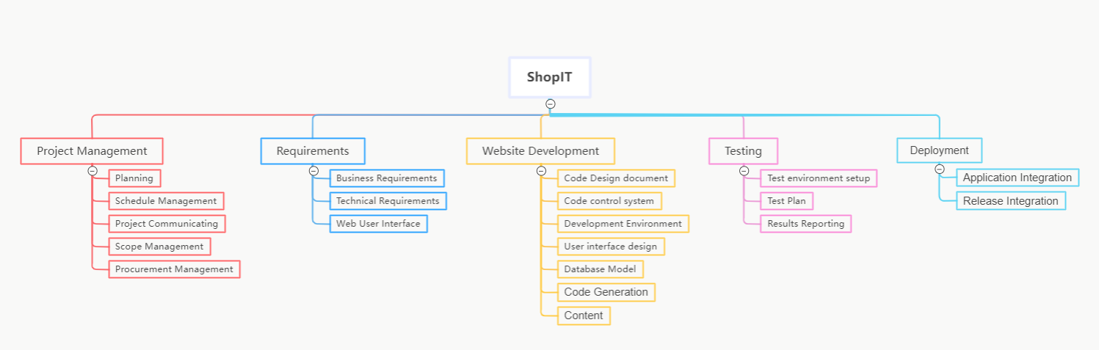

1.1. Project Management

1.2. Requirements

1.2.1. Business

1.2.1.1. Domain Name

1.2.1.2. Marketing

1.2.1.3. Process

1.2.1.3.1. Customer Ordering

1.2.1.3.2.Order delivering

1.2.1.3.3. Order Fulfillment

1.2.1.3.4. Existing Systems Integration

1.2.1.3.4.1. Shipping

1.2.1.3.4.2. Financial

1.2.1.3.4.3.Item details and critical data

1.2.1.3.4.4. Payment

1.2.1.4. Operations Management/Site Maintenance

1.2.2. Technical

1.2.2.1. Security

1.2.2.2. Network

1.2.2.2.1. Hosting

1.2.2.2.2. Platform

1.2.3. Web User Interface

1.2.3.1. Unrestricted Content

1.2.3.2. Restricted Content

1.2.3.3. eCommerce Capabilities

1.3. Website Development

1.3.1. Create Code Design Document

1.3.2. Code Control System

1.3.3. Development Environment

1.3.4. User Interface Design

1.3.5. Database Model

1.3.6. Code Generation

1.3.6.1. Release Testing

1.3.6.2. Bug Fixes

1.3.7. Content

1.3.7.1. Product Catalog

1.3.7.1.1. Descriptions

1.3.7.1.2. Images

1.4. Website Testing

1.4.1. Test Environment Setup

1.4.2. Test Plan

1.4.3. Results Reporting

1.5. Website Deployment

1.5.1. Application Integration

1.5.2. Release Documentation

**Gantt Chart:**

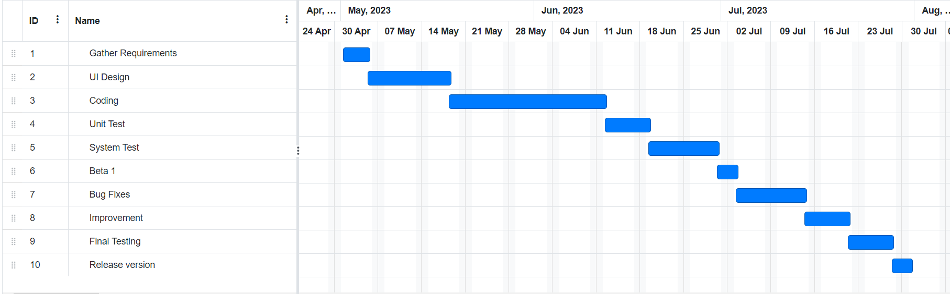

**Conclusion:**

Thus, we are able to estimate effort required for our project and also create Gantt Chart.